Image Comparison Program - User Manual

The image comparison program is designed to compare the pixel images of DICOM files before and after the de-identification process, revealing the changes made. Two versions of the program were developed: The Python script run_DICOMImgCmp.py compares pixel images before and after DICOM de-identification in a single-threaded process, saving the results to a PDF file. The Python script run_DICOMImgCmp_multiT.py performs the same comparison using a multi-threaded approach, with the results saved in multiple PDF files.

**Requirement**

Two datasets must be stored in the file system, and their paths should be specified in the configuration file, which is passed to the programs as an execution parameter. See the details of the configuration file in the section below. Additionally, to run the image comparison programs, a UID mapping file in CSV format must be provided in the configuration file.

**UID Mapping File**

The UID mapping file contains the old and new study, series, and instance UIDs for the two datasets. The mapping file should look similar to the image below, using the same column headers, “id_old” (pre-de-identified UID) and “id_new” (post de-identified UID)

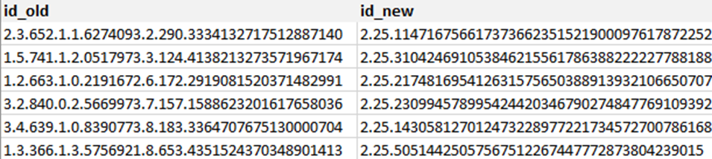

**Configuration file**

The configuration file must contain the following information, please refer to the template config_example_linux.json at [https://github.com/CBIIT/MIDI/blob/main/midi3/imageCmp/config_example_linux.json and config_example_win.json](https://github.com/CBIIT/MIDI/blob/main/midi3/imageCmp/config_example_linux.json%20and%20config_example_win.json) at <https://github.com/CBIIT/MIDI/blob/main/midi3/imageCmp/config_example_win.json>.

|  |  |  |
| --- | --- | --- |
| Configuration Parameter | Description | Used by |
| run_name | Job name | both |
| input_data_path | path to the folder containing de-identified DICOM images | both |
| output_data_path | path to the output | both |
| uid_mapping_file | File path to the UID mapping file | both |
| log_path | path to the logs | both |
| pre_deID_data_path | path to the pre-de-identified dataset | both |
| multiprocessing_cpus | The number of threads used to run the program | run_DICOMImgCmp_multiT.py |

**Execution**

To run run_DICOMImgCmp.py, in the command line, enter

*python run_DICOMImgCmp.py config_example_linux.json*

To run_DICOMImgCmp_multiT.py, in the command line, enter

*python run_DICOMImgCmp_multiT.py config_example_linux.json*

**Output**

**The image comparison programs will list all changed images by the de-identification process, showing the image before the de-identification process and after the de-identification process alone with the third image showing only the changed area. See example below:**

**Source Code Location**

**The code and readme file are kept in Githup at** <https://github.com/CBIIT/MIDI/tree/main/midi3/imageCmp>