P30 Cancer Center Support Grant Administrative Supplements to NCI-designated Cancer Centers not affiliated with the Experimental Therapeutics Clinical Trials Network (ETCTN) to support participation in the ETCTN

Key Dates
Release Date: March 2, 2016
Request Receipt Date: April 19, 2016 by 5 p.m. EDT
Earliest Anticipated Start Date for Awards: June 1, 2016

Purpose
The National Cancer Institute (NCI) announces the opportunity for administrative supplement funding to promote collaborations between NCI-designated Cancer Centers (NCI-CCs) and CTEP’s Experimental Therapeutics Clinical Trials Network (ETCTN). This is a 3-year pilot program. The short-term goals of this Early Drug Development Opportunity (EDDO) program are to provide additional sites for select ETCTN trials that require screening for rare tumors, and to provide increased access among NCI-CC’s to agents under NCI development. The long-term goal is to accelerate the development of NCI-IND agents in rare cancer types to improve the outcome of cancer therapy.

Background

The NCI’s Early Therapeutics Development Program sponsored by the Cancer Therapy Evaluation Program (CTEP) in the Division of Cancer Treatment and Diagnosis (DCTD) has contributed to the clinical development of many anticancer agents. This Program has the unique ability to quickly take advantage of new scientific opportunities to promote therapeutic innovations. It melds partnerships with pharmaceutical companies developing novel agents with specialized clinical trial expertise found in academic medical centers to leverage development of a particular agent or novel agent combinations. NCI accepts new agents into its portfolio through the NCI’s Experimental Therapeutics (NExT) program, and develops Collaborative Research and Development Agreements (CRADAs) with pharmaceutical companies and academic investigators. Through its Experimental Therapeutics Clinical Trials Network (ETCTN), NCI creates a drug development plan (DDP) that includes phase 1 and phase 2 studies which are an essential part of the CTEP drug development process. The phase 2 program investigators provide access to disease-oriented clinics in clinical sites, and expertise in conducting phase 2 studies. These studies are designed to provide a sufficiently unequivocal signal of clinical benefit to justify definitive large multi-institutional phase 3 trials designed to demonstrate improved outcomes and change the standards of practice.

The current ETCTN consists of 12 UM1 grantee Lead Academic Organizations and their affiliates that are funded to conduct studies of NCI-IND agents with a phase 1 emphasis. These UM1 grantees have recently incorporated a separate ETCTN Phase 2 Program that had consisted of 7 contract holders at academic medical centers and their affiliates. The ETCTN thus provides the major clinical trials infrastructure and laboratory support that allows CTEP to conduct complex early phase trials in its partnerships with industry. The ETCTN phase 1 and phase 2 programs have mechanisms to support sites for investigator effort and patient accrual to ETCTN studies.

Administrative Supplements

Currently, approximately half of NCI-CC’s are included in the ETCTN, either by holding a UM1 grant or as an affiliate of a UM1 grantee. These NCI-CCs have the opportunity to open ETCTN trials at their sites, and to receive support for clinical research-related costs for accrual to these studies. The purpose of this solicitation is to allow additional NCI-CCs that are currently not involved in the ETCTN to participate in ETCTN studies for patient populations with rare cancers.

The ETCTN trials eligible for accrual under this initiative will be selected by the ETCTN program staff. By casting a wider net, the goal is to accelerate accrual, shorten the duration of select ETCTN rare disease studies, and rapidly achieve the objectives of the study. Each NCI-CC awarded an administrative supplement will be expected to open the selected ETCTN studies at their site. The minimum accrual rate for each awardee is 3 patient accruals per year, and the goal is 5 patient accruals per year. Supplement awardees are required to accept “The NCI’s Adult Central Institutional Review Board (CIRB) – Early Phase Emphasis” as the IRB of record for these studies

In addition these supplements may also be awarded to NCI-designated cancer centers formerly affiliated with the ETCTN N01 phase 2 contract program that have lost ETCTN affiliation during the phase 2 reorganization process. These NCI-CC’s must have a record of significant accrual to N01 studies during the most recent contract period.

Eligible Institutions

All clinical and comprehensive NCI-designated cancer centers that are not currently affiliated with ETCTN UM1 program are eligible to apply.

Application Instructions

Applications should demonstrate how the NCI-CC will be able to accrue patients to ETCTN studies. Relevant information will include the number of patients seen annually and the standard-of-care screening practice of oncology patients at each institution, including molecular characterization of tumors. The application should also include documentation of the recent experience of the NCI-CC in early phase therapeutic studies, to demonstrate the ability to safely conduct these types of clinical trials.

The administrative supplement award is not intended to pay for screening. It is intended to support institutions that provide tumor characterization services for patients, and can therefore identify patients eligible for ETCTN studies. The ability to conduct tumor characterization services provides evidence that the institution will more likely be able to accrue patients to ETCTN studies.

Terms and Conditions of Funding and Allowable Costs

The budget should justify all the direct and indirect costs. A maximum of $50,000 in total costs will be available annually for each supplement. The award period will be for 3 years. Non-competing Type 5 (RPPR – Research Performance Progress Report) will not be approved if the accrual minimum goal is not met. Up to 15 awards will be made. The NCI-CC will be expected to conform to all ETCTN processes and procedures, including the use of the Central IRB, the OPEN registration system, Medidata Rave for data management, and CTEP-AERS for adverse event reporting.

Supplement Award Application Procedures

- Cover Letter
A cover letter should accompany each application and include the following:
  - Request for an administrative supplement to support the project
  - Title of the supplement
  - P30 grant number
  - Contact information for the Center Director and the Project Leader
  - Signatures of the Center Director and the Authorized Organizational Representative (AOR)

- Application
  - Standard PHS 398 (pgs 1-5)
    - Item 2: check yes and provide the title indicated in the cover letter, 1.b.
    - Item 7A-8B, denote the direct and total costs for the project. Total costs may not exceed $50,000 annually.
    - The authorized institutional grants official must sign the face page.
    - Include a detailed budget description.
    - Provide NIH biographical sketches for the P30 center director and the P30 supplement principal investigator.

- Summary of the Project
Section 1: The applicant should describe the number and types of oncology patients seen annually, and the tumor characterization practices and capacities at the NCI-CC. The narrative should explain how the NCI-CC will be able to enroll the goal of 5 patients per year to ETCTN studies selected to be included in this program. The chart in Template 1 should be included in this section. Page limit: 5; font: 11pt.

Section 2: The applicant must also address procedures and policies relevant to ETCTN participation to facilitate clinical trial protocol development, safety, and timely protocol conduct to demonstrate the capability to safely conduct early phase clinical trials. Page limit: 5; font: 11pt.

At a minimum, address the following aspects:
- Procedures to ensure the observance of all applicable regulations for the protection of human subjects, clinical trial protocol requirements, and tracking of study modifications/amendments
- Conflict of Interest policy ensuring there is no reasonable expectation that the design, conduct, and/or reporting of research conducted by the ETCTN will be biased by any conflicting financial interest of an investigator
- Mitigation of risks to successful clinical trial completion
- Coordination of various aspects associated with the conduct of Phase 2 clinical trials, including but not limited to: acquiring and handling biospecimens, conducting appropriate pharmacokinetic and pharmacodynamic analyses, incorporating imaging endpoints, etc.
- Plans to maintain the proficiency of site personnel in managing ETCTN Phase 2 clinical trials, including actions/commitments to facilitate the professional development of participating junior investigators
- Benchmarks to be used for assessing Program performance
- Procedures for complying with auditing requirements and responding expeditiously to any deficiencies identified during an audit.

Section 3: The applicant must also address research pharmacy management. Page limit: 5; font: 11pt.

- Access to approved protocol documents, amendments, and notification of protocol activation at the site. Notification of patient enrollment to a given protocol, including notification of signed informed consent prior to agent dispensing.
- Availability of agents when needed. Ability to order and receive agent(s) from the supplier as instructed in the clinical protocol. Procedures regarding authorized dispensing of investigational agents to eligible study subjects on approved protocols and procedures for reconciling deviations.
- Policies and procedures related to safe transport of investigational agents within the facility. Proper documentation of agent transfer to another NCI-sponsored trial and/or final disposition of investigational agents.
- Adherence to local, state, and federal regulations and laws related to investigational agents. Policies and procedures for safe and secure handling, preparation, and disposal of dangerous goods, hazardous substances and infectious substances.
- Procedures for assuring that the site complies with CTEP requirements described in the DCTD Investigators' Handbook for storage and accounting for investigational agents [including NCI/NIH/HHS Drug Accountability Records (DAR) procedures] and comply with FDA requirements for investigational agents.
- Procedures to ensure NCI-supplied investigational agents are prescribed only by physicians who are registered and have an active investigator registration status with the Pharmaceutical Management Branch, CTEP.
- Standard Operating Procedures (SOPs) and procedures related to investigational agent management, including agent receipt, accountability, and final disposition.
- Training of staff and training materials

- Justification of Staff
Attach CV of the supplement PI. Note that in order to qualify for a supplement, the name of an individual must be proposed at the time of submission.

Application Submission

Applications for these administrative supplements should be submitted by April 5, 2016. Applications may be submitted as a signed, scanned PDF to nga.nguyen2@nih.gov.

Review Criteria

Applications will be reviewed based on the potential and ability of each site to identify patients for ETCTN studies, the potential of each site to enroll these patients on ETCTN studies, and the ability to safely conduct early phase clinical trials. In addition, applications from former N01 ETCTN sites will be evaluated on the number of currently open ETCTN phase 2 studies and the NCI-CC’s record of accrual to ETCTN phase 2 studies.

Awards

Awards will be based on responsiveness to the aims of this announcement and the availability of funds.

Reporting Requirements/Deliverables

As part of the progress report (RPPR – Research Performance Progress Report) for the parent cancer center grant, include information on what has been accomplished via the administrative supplement, including number of ETCTN studies opened and number of patients accrued to those studies during the funding period. A copy of the annual progress report for the P30 administrative supplement for ETCTN participation should be sent to Dr. Jeffrey Moscow via email at jeffrey.moscow@nih.gov

Questions
Please contact Dr. Jeffrey Moscow (Telephone: 240-276-6565 Email: jeffrey.moscow@nih.gov) for questions related to the ETCTN or the NCI Program Director for your P30 CCSG award (telephone 240-276-5600).

Template 1: Early Phase Clinical Research Activity Summary

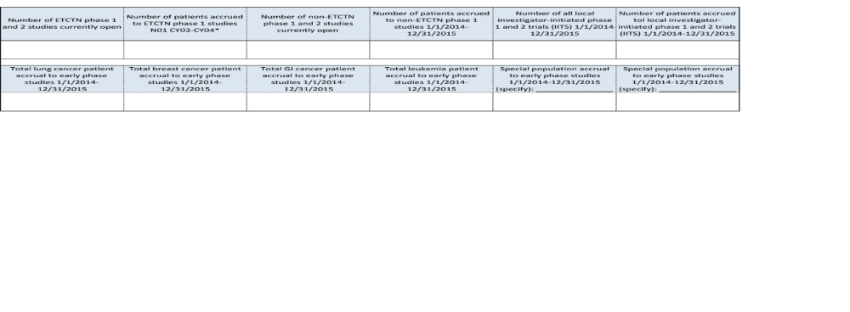Fill out table for the NCI-CC. Only NCI-CCs previously affiliated with the ETCTN N01 contract program should fill in ETCTN columns.

