Table of Contents

Screen Shot of EXTCRS01 2

Overview 2

Forms Startup 2

Main Menu 3

Exit Button 3

Data Fields (#1) 3

Record processing 3

Buttons (#2) 4

View Journal 4

The Data Fields 4

Newer/Older Buttons 4

Close Window Button 4

Progress field (#3) 5

TRIGGER CODE 6

PRE-INSERT 6

PRE-UPDATE 6

PRE-DELETE 7

Detailed analysis of EXTCRS01.FMB

Note: Used TEXTPAD to look inside form as the 6i Form Builder was unable to read form.

# Screen Shot of EXTCRS01

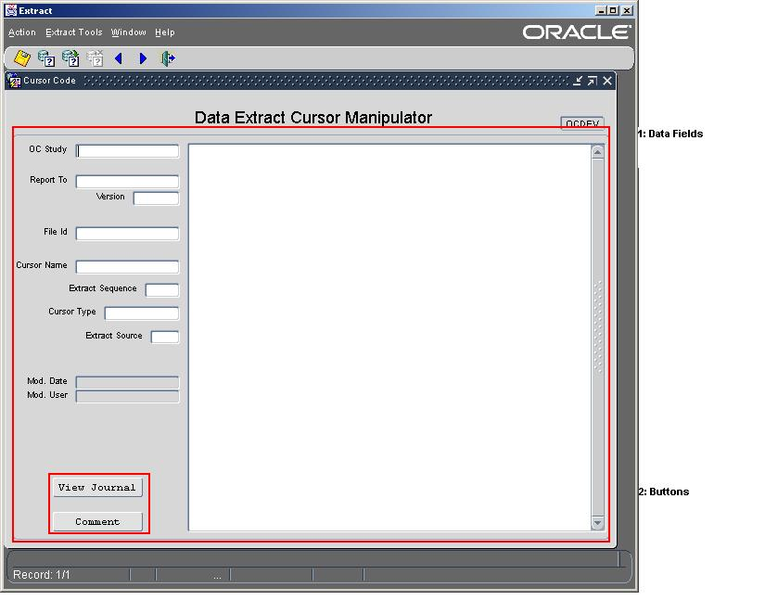

# Overview

This form is used to manipulate the cursor SQL code for a File Id of a defined extraction. It also allows the user to see previous version of the same cursor.

# Forms Startup

1. Security Checked at form startup. The following query checks userid to see if user is valid for APPLICATION. (WHEN-NEW-FORM-INSTANCE)

SELECT '1' INTO T_WHAT

FROM CT_EXT_ACCOUNTS

WHERE (USER_NAME = USER or User = 'CTEXT_T')

AND ROWNUM = 1;

1. Menu Actions are turn off that would normally allow queries and editing.

# Main Menu

The main menu controls what other screens can be selected. They are controlled through ROLES. Only certain Oracle ROLES granted to the user would allow access. See EXTMENU1_Analysis for more information.

# Exit Button

The exit button is used to close the application. When closing the application, the screen is checked for existing non-committed transactions and will not quite until the transactions are committed or rolled back.

# Data Fields (#1)

There are 9 enterable fields that make up the data field for a cursor definition. They are stored in the table CT_EXT_CRS_CTL.

Functions required: Enter Query, EDIT/UPDATE, DELETE (May have to look into ROLE based display of these options)

Note: When a record is modified, the “before modified” version of the record must be copied to the Cursor Journal table. Also, a Comment must be captured when a record is modified.

|  |  |  |
| --- | --- | --- |
| Screen Field | Table Column | Description |
| OC Study | OC_STUDY | Study identifier |
| Report To | REPORT_TO | The Report Type of the definition |
| Version | VERSION | The Version of the Report Type |
| File Id | FILE_ID | The File Type Identifier |
| Cursor Name | CRS_NAME | The name of the cursor |
| Extract Sequence | EXT_SEQ | The sequence in which to execute this cursor when there are more than one cursor associated to a File Id. |
| Cursor Type | CRS_TYPE | The type of cursor defined. Mainly NORMAL, COM, NORMAL_DEL, COM_DEL, LAB_OTHER, etc. See below for Cursor Type and Execution |
| Extract Source | EXT_SOURCE | The Extract Source type, “N”,”O” or “Y”. See below for Extract Source details |
| “Cursor Code” | TEXT | This is the actual SQL code that makes up the select statement to extract the data. NOTE: This is stored in a LONG column. |
| Mod. Date | MODIFIED_BY | User who last modified the record. |
| Mod. User | MODIFIED_DATE | The date the records was modified. |
|  | CREATE_BY | User who created record, NOT DISPLAYED |
|  | CREATION_DATE, | Date record created, NOT DISPLAYED |
|  | NOTE | Comment field used to explain/describe modifications NOT DISPLAYED. |

### Record processing

DELETES: Before a record is committed as a delete from the table, a copy of it is placed into the Journal Table, and journaling information is stored with the record. See PRE-DELETE trigger for entire PL/SQL code.

UPDATES: Before a record is committed as an update, a copy of it is placed into the Journal Table, and journaling information is stored with the record. See PRE-UPDATE trigger for entire PL/SQL code.

INSERTS: Before a new record is committed, a copy of it is placed into the Journal Table, and journaling information is stored with the record. See PRE-UPDATE trigger for entire PL/SQL code.

# Buttons (#2)

### View Journal

The View Journal Button is used to query past cursor definitions versions.

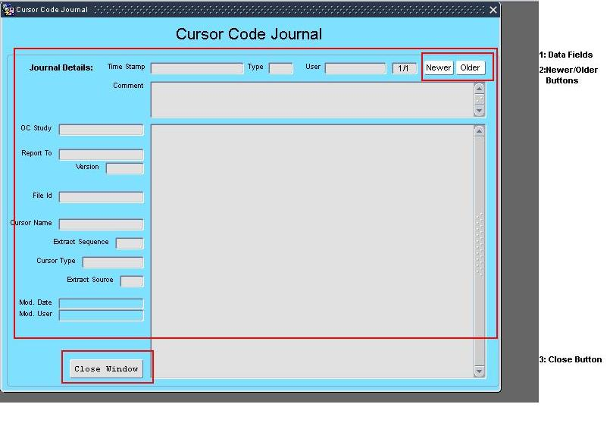

* Only fires if OC_STUDY, REPORT_TO, VERSION, and CRS_NAME fields have been entered.
* Displays all journal entries for the cursor displayed, using the following query:

where CT_EXT_CRS_CTL$JN.OC_STUDY = :CT_EXT_CRS_CTL.OC_STUDY

and CT_EXT_CRS_CTL$JN.REPORT_TO= :CT_EXT_CRS_CTL.REPORT_TO

and CT_EXT_CRS_CTL$JN.VERSION = :CT_EXT_CRS_CTL.VERSION

and CT_EXT_CRS_CTL$JN.CRS_NAME = :CT_EXT_CRS_CTL.CRS_NAME

#### The Data Fields

The data fields are read-only and come from the table CT_EXT_CRS_CTL$JN. Data is sorted by most recent record.

#### Newer/Older Buttons

These buttons will traverse the user through the journal records.

#### Close Window Button

This button is used to close the journal window and return the user to the primary data entry form.

### Comment

The comment button is used to place a comment on the current record. Comments are also collected during updates and deletes.

# TRIGGER CODE

#### PRE-INSERT

DECLARE

T_TEXT VARCHAR2(120) := ' ';

BEGIN

T_TEXT := ' Inserting journaling information failed.';

Insert into CT_EXT_CRS_CTL$JN (

JN_OPERATION ,JN_TIMESTAMP

,JN_SN

,JN_ORACLE_USER

,OC_STUDY ,REPORT_TO

,VERSION ,FILE_ID

,CRS_NAME ,CRS_TYPE

,EXT_SEQ ,TEXT

,EXT_SOURCE ,NOTE )

VALUES (

'INS' ,SYSDATE

,TO_NUMBER(TO_CHAR(SYSDATE, 'YYYYMMDDHH24MISS'))

,USER

,:CT_EXT_CRS_CTL.OC_STUDY ,:CT_EXT_CRS_CTL.REPORT_TO

,:CT_EXT_CRS_CTL.VERSION ,:CT_EXT_CRS_CTL.FILE_ID

,:CT_EXT_CRS_CTL.CRS_NAME ,:CT_EXT_CRS_CTL.CRS_TYPE

,:CT_EXT_CRS_CTL.EXT_SEQ ,:CT_EXT_CRS_CTL.TEXT

,:CT_EXT_CRS_CTL.EXT_SOURCE ,:CT_EXT_CRS_CTL.NOTE

);

IF NVL(:CT_EXT_CRS_CTL.NOTE,' ') <> NVL(:CT_EXT_CRS_CTL.NOTE_DISPLAY,' ') THEN

:CT_EXT_CRS_CTL.NOTE_DISPLAY := :CT_EXT_CRS_CTL.NOTE;

END IF;

EXCEPTION

WHEN OTHERS THEN

MESSAGE(T_TEXT, ACKNOWLEDGE);

RAISE FORM_TRIGGER_FAILURE;

END;

#### PRE-UPDATE

DECLARE

T_TEXT VARCHAR2(120) := ' ';

H_OC_STUDY CT_EXT_CRS_CTL.OC_STUDY%Type;

H_REPORT_TO CT_EXT_CRS_CTL.Report_to%Type;

H_VERSION CT_EXT_CRS_CTL.Version%Type;

H_FILE_ID CT_EXT_CRS_CTL.File_id%Type;

H_CRS_NAME CT_EXT_CRS_CTL.Crs_name%Type;

H_CRS_TYPE CT_EXT_CRS_CTL.Crs_type%Type;

H_EXT_SEQ CT_EXT_CRS_CTL.Ext_seq%Type;

H_TEXT CT_EXT_CRS_CTL.Text%Type;

H_EXT_SOURCE CT_EXT_CRS_CTL.Ext_source%Type;

H_NOTE CT_EXT_CRS_CTL.Note%Type;

H_Mod_by CT_EXT_CRS_CTL.Modified_by%Type;

H_Mod_date CT_EXT_CRS_CTL.Modified_date%Type;

h_rowid varchar2(30) :=NAME_IN(:SYSTEM.CURRENT_BLOCK || '.ROWID');

BEGIN

T_TEXT := ' Updating journaling information failed.';

:ct_ext_CRS_ctl.modified_by := user;

:ct_ext_CRS_ctl.modified_date := sysdate;

select OC_STUDY, REPORT_TO, VERSION, FILE_ID,

CRS_NAME, CRS_TYPE, EXT_SEQ, TEXT, EXT_SOURCE, NOTE,

MODIFIED_BY, MODIFIED_DATE

into H_OC_STUDY, H_REPORT_TO, H_VERSION, H_FILE_ID,

H_CRS_NAME, H_CRS_TYPE, H_EXT_SEQ, H_TEXT, H_EXT_SOURCE, H_NOTE,

H_MOD_BY, H_MOD_DATE

from CT_EXT_CRS_CTL

where rowid = h_rowid;

Insert into CT_EXT_CRS_CTL$JN (

JN_OPERATION ,JN_TIMESTAMP

,JN_SN

,JN_ORACLE_USER

,OC_STUDY ,REPORT_TO

,VERSION ,FILE_ID

,CRS_NAME ,CRS_TYPE

,EXT_SEQ ,TEXT

,EXT_SOURCE ,NOTE

,MODIFIED_BY ,MODIFIED_DATE )

VALUES (

'UPD' ,SYSDATE

,TO_NUMBER(TO_CHAR(SYSDATE, 'YYYYMMDDHH24MISS'))

,USER

,H_OC_STUDY ,H_REPORT_TO

,H_VERSION ,H_FILE_ID

,H_CRS_NAME ,H_CRS_TYPE

,H_EXT_SEQ ,H_TEXT

,H_EXT_SOURCE ,H_NOTE

,H_MOD_BY ,H_MOD_DATE );

IF NVL(:CT_EXT_CRS_CTL.NOTE,' ') <> NVL(:CT_EXT_CRS_CTL.NOTE_DISPLAY,' ') THEN

:CT_EXT_CRS_CTL.NOTE_DISPLAY := :CT_EXT_CRS_CTL.NOTE;

END IF;

EXCEPTION

WHEN OTHERS THEN

MESSAGE(T_TEXT, ACKNOWLEDGE);

RAISE FORM_TRIGGER_FAILURE;

END;

#### PRE-DELETE

DECLARE

T_TEXT VARCHAR2(120) := ' ';

H_OC_STUDY CT_EXT_CRS_CTL.OC_STUDY%Type;

H_REPORT_TO CT_EXT_CRS_CTL.Report_to%Type;

H_VERSION CT_EXT_CRS_CTL.Version%Type;

H_FILE_ID CT_EXT_CRS_CTL.File_id%Type;

H_CRS_NAME CT_EXT_CRS_CTL.Crs_name%Type;

H_CRS_TYPE CT_EXT_CRS_CTL.Crs_type%Type;

H_EXT_SEQ CT_EXT_CRS_CTL.Ext_seq%Type;

H_TEXT CT_EXT_CRS_CTL.Text%Type;

H_EXT_SOURCE CT_EXT_CRS_CTL.Ext_source%Type;

H_NOTE CT_EXT_CRS_CTL.Note%Type;

H_Mod_by CT_EXT_CRS_CTL.Modified_by%Type;

H_Mod_date CT_EXT_CRS_CTL.Modified_date%Type;

h_rowid varchar2(30) :=NAME_IN(:SYSTEM.CURRENT_BLOCK || '.ROWID');

BEGIN

T_TEXT := ' Deleting journaling information failed.';

select OC_STUDY, REPORT_TO, VERSION, FILE_ID,

CRS_NAME, CRS_TYPE, EXT_SEQ, TEXT, EXT_SOURCE, NOTE,

MODIFIED_BY, MODIFIED_DATE

into H_OC_STUDY, H_REPORT_TO, H_VERSION, H_FILE_ID,

H_CRS_NAME, H_CRS_TYPE, H_EXT_SEQ, H_TEXT, H_EXT_SOURCE, H_NOTE,

H_MOD_BY, H_MOD_DATE

from CT_EXT_CRS_CTL

where rowid = h_rowid;

Insert into CT_EXT_CRS_CTL$JN (

JN_OPERATION ,JN_TIMESTAMP

,JN_SN

,JN_ORACLE_USER

,OC_STUDY ,REPORT_TO

,VERSION ,FILE_ID

,CRS_NAME ,CRS_TYPE

,EXT_SEQ ,TEXT

,EXT_SOURCE ,NOTE

,MODIFIED_BY ,MODIFIED_DATE )

VALUES (

'DEL' ,SYSDATE

,TO_NUMBER(TO_CHAR(SYSDATE, 'YYYYMMDDHH24MISS'))

,USER

,H_OC_STUDY ,H_REPORT_TO

,H_VERSION ,H_FILE_ID

,H_CRS_NAME ,H_CRS_TYPE

,H_EXT_SEQ ,H_TEXT

,H_EXT_SOURCE ,H_NOTE

,H_MOD_BY ,H_MOD_DATE );

IF NVL(:CT_EXT_CRS_CTL.NOTE,' ') <> NVL(:CT_EXT_CRS_CTL.NOTE_DISPLAY,' ') THEN

:CT_EXT_CRS_CTL.NOTE_DISPLAY := :CT_EXT_CRS_CTL.NOTE;

END IF;

EXCEPTION

WHEN OTHERS THEN

MESSAGE(T_TEXT, ACKNOWLEDGE);

RAISE FORM_TRIGGER_FAILURE;

END;