Table of Contents

Screen Shot of EXTSET01 2

Overview 2

Forms Startup 2

Main Menu 3

Exit Button 3

Setup Criteria (#1) 3

Submit Button (#2) 3

Submit Button 3

Progress (#3) 4

TRIGGER CODE 5

SUBMIT BUTTON 5

Detailed analysis of EXTCTL01.FMB

Note: Used TEXTPAD to look inside form as the 6i Form Builder was unable to read form.

# Screen Shot of EXTCTL01

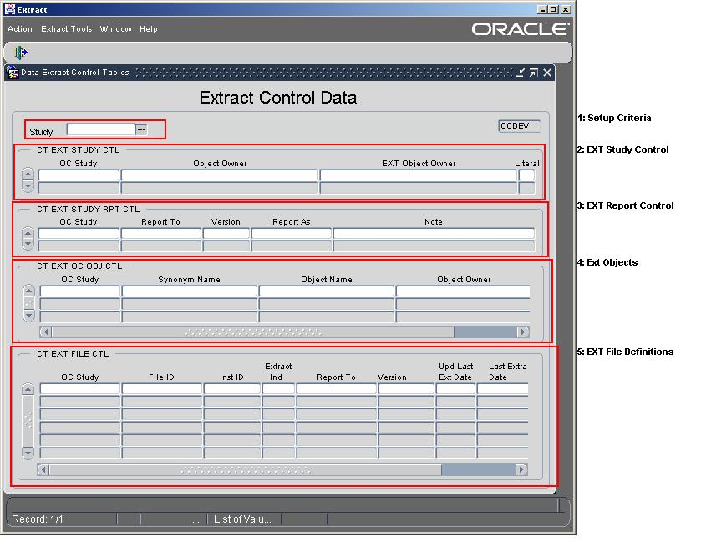

# Overview

This form is used to display the control tables data for a study defined for extraction. It can also be used to identify/select FILES to NOT extract.

# Forms Startup

1. Security Checked at form startup. The following query checks userid to see if user is valid for APPLICATION. (WHEN-NEW-FORM-INSTANCE)

SELECT '1' INTO T_WHAT

FROM CT_EXT_ACCOUNTS

WHERE (USER_NAME = USER or User = 'CTEXT_T')

AND ROWNUM = 1;

1. Menu Actions are turn off that would normally allow queries and editing.

# Main Menu

The main menu controls what other screens can be selected. They are controlled through ROLES. Only certain Oracle ROLES granted to the user would allow access. See EXTMENU1_Analysis for more information.

# Exit Button

The exit button is used to close the application. When closing the application, the screen is checked for existing non-committed transactions and will not quite until the transactions are committed or rolled back.

# Setup Criteria (#1)

There is only one field that make up the seteup criteria, Study.

1. Study: The list of studies defined for extraction that the user has access to:

SELECT distinct OC_STUDY FROM CT_EXT_STUDY_SEC_VW ORDER BY 1

# Extract Study Control Section (#2)

This section displays the values found in the table CT_EXT_STUDY_CTL for the study entered in the Setup Criteria section. This section USUALLY has only ONE record and is created during the Add a Study function. Functions required EDIT/UPDATE, DELETE (May have to look into ROLE based display of these options)

|  |  |  |
| --- | --- | --- |
| Screen Field | Table Column | Description |
| OC Study | OC_STUDY | Study identifier |
| Object Owner | OC_OBJECT_OWNER | Database Schema of the views the Extract Views will be based on (Typically the $SNAPSHOT owner. |
| EXT Object Owner | EXT_OBJECT_OWNER | Database Schema of the Extract Objects (Typically, *STUDY_EXT)* |
| Literal | SPECIAL_LITERAL | ? |
|  | CREATE_BY | User who created record, NOT DISPLAYED |
|  | CREATION_DATE | Date record created, NOT DISPLAYED |
|  | EXT_OBJECT_OWNER_TS | Database table space where extract objects are created, typically “TEST_DATA”; NOT DISPLAYED. |

# Report Section (#3)

This section displays the different report type that the study has been set up for and the values are stored in the table CT_EXT_STUDY_RPT_CTL. This section typically has one or two records that are created during the Add a Study function. Record functions required EDIT/UPDATE, DELETE (May have to look into ROLE based display of these options)

|  |  |  |
| --- | --- | --- |
| Screen Field | Table Column | Description |
| OC Study | OC_STUDY | Study identifier |
| Report To | REPORT_TO | The Report Type of the definition |
| Version | VERSION | The Version of the Report Type |
| Report As | REPORT_AS | The study identifier used INSIDE the extracted data |
| Note | NOTE | ?? |
|  | CREATE_BY | User who created record, NOT DISPLAYED |
|  | CREATION_DATE, | Date record created, NOT DISPLAYED |
|  | MRN_INST_CD | ?? |

# OC Objects Section (#4)

This section displays the different C3D Oracle Clinical objects needed by the extraction of the study, and the order in which they should be created. These records are held in the table CT_EXT_OC_OBJ_CTL. This section typically has roughly 5 records that are created during the Add a Study function. Record functions required EDIT/UPDATE, DELETE (May have to look into ROLE based display of these options)

|  |  |  |
| --- | --- | --- |
| Screen Field | Table Column | Description |
| OC Study | OC_STUDY | Study identifier |
| Synonym Name | SYNONYM_NAME | The synonym name for the object found in OBJECT_NAME. Synonyms are owned by the Extract Owner found in the table above CTPEXTPSTUDY_RPT_CTL.EXT_OBJECT_OWNER |
| Object Name | OBJECT_NAME | The name of the database object that is being defined |
| Object Owner | OBJECT_OWNER | The owner of the database object that is being defined |
| Crt Seq | CRT_SEQ | The Sequence number in which to create the synonym. This is needed in case a synonym is dependent on another. |
|  | CREATE_BY | User who created record, NOT DISPLAYED |
|  | CREATION_DATE, | Date record created, NOT DISPLAYED |

# Extract Files Section (#4)

This section displays each of the different “Report To”/Version file types that data will be extracted for. These records are held in the table CT_EXT_FILE_CTL. This section has many records that are created during the Add a Study function. Record functions required EDIT/UPDATE, DELETE (May have to look into ROLE based display of these options) Only certain fields can be updated, if allowed (EXT_IND, UPD_LAST_EXT_DATE)

|  |  |  |
| --- | --- | --- |
| Screen Field | Table Column | Description |
| OC Study | OC_STUDY | Study identifier |
| File ID | FILE_ID | The File Type Identifier |
| Inst ID | INST_ID | The Institution Report Code used inside the data to be reported. Used by certain “Report To” types |
| Extract Ind | EXT_IND | Extraction Indicator controls where the File ID is extracted and report |
| Report To | REPORT_TO | The Report Type of the definition |
| Version | VERSION | The Version of the Report Type |
| Upd Last Ext Date | LAST_EXT_DATE | The date of the Last Extraction of data |
| Last Extract Date | CURRENT_EXT_DATE | The data cutoff date of the SNAPSHOT views being used by the Extraction |
| Current Extract Date | UPD_LAST_EXT_DATE | Flag used to control the updating of the LAST_EXT_DATE filed of the record. |
|  | EXTRACT_MODE | The Extraction Mode used during the most recent extraction, NOT DISPLAYED |
|  | CREATE_BY | User who created record, NOT DISPLAYED |
|  | CREATION_DATE, | Date record created, NOT DISPLAYED |