Table of Contents

Screen Shot of EXTSET01 2

Overview 2

Forms Startup 2

Main Menu 3

Exit Button 3

Setup Criteria (#1) 3

Submit Button (#2) 3

Submit Button 3

Progress (#3) 4

TRIGGER CODE 5

SUBMIT BUTTON 5

Detailed analysis of EXTSET02.FMB

Note: Used TEXTPAD to look inside form as the 6i Form Builder was unable to read form.

# Screen Shot of EXTSET02

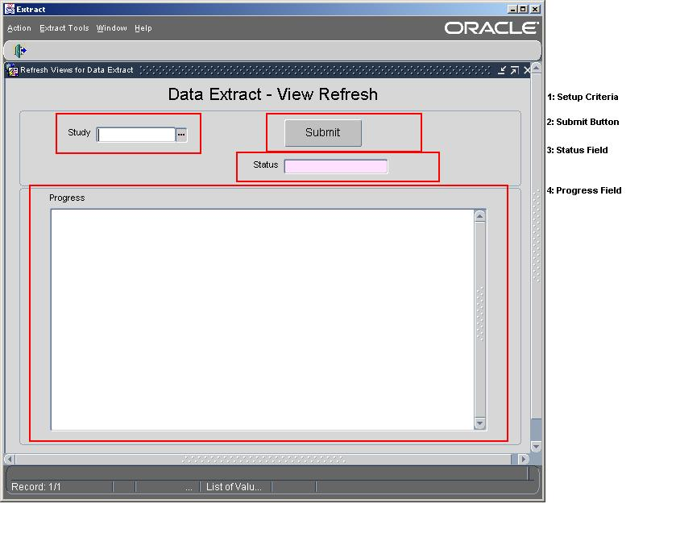

# Overview

This form is used to refresh (rebuild) the extract views. This is done where the definition for the views is altered.

# Forms Startup

1. Security Checked at form startup. The following query checks userid to see if user is valid for APPLICATION. (WHEN-NEW-FORM-INSTANCE)

SELECT '1' INTO T_WHAT

FROM CT_EXT_ACCOUNTS

WHERE (USER_NAME = USER or User = 'CTEXT_T')

AND ROWNUM = 1;

1. Menu Actions are turn off that would normally allow queries and editing.

# Main Menu

The main menu controls what other screens can be selected. They are controlled through ROLES. Only certain Oracle ROLES granted to the user would allow access. See EXTMENU1_Analysis for more information.

# Exit Button

The exit button is used to close the application. When closing the application, the screen is checked for existing non-committed transactions and will not quite until the transactions are committed or rolled back.

# Setup Criteria (#1)

There is only one field that make up the seteup criteria, Study.

1. Study: The list of studies defined for extraction that the user has access to:

SELECT distinct OC_STUDY FROM CT_EXT_STUDY_SEC_VW ORDER BY 1

1. Status: Output Field. Updated with running/final status of execution of the “Submit” button.

# Submit Button (#2)

#### Submit Button

The Submit Button is used to recreate the extraction views using the definitions for the study. It is the only function of this form.

1. Only fires if STUDY is not null
2. Processing Starts by executing the following:

EXT_MISC_PKG.P_CRT_STUDY_VW(T_OC_STUDY, 'N', NULL)

# Progress field (#3)

The Progress field contains a running commentary of the steps executed and automatically refreshes. As each step requires a previous step, this will need to be scrutinized closely.

# TRIGGER CODE

#### SUBMIT BUTTON

DECLARE

T_OC_STUDY VARCHAR2(30);

T_ACTION VARCHAR2(60);

crlf varchar2(2) := Chr(10);

BEGIN

GO_FIELD('CG$CTRL.RUN_PROGRESS');

:CG$CTRL.RUN_STATUS_TEXT := 'IN PROGRESS';

:CG$CTRL.RUN_PROGRESS := NULL;

------------

IF RTRIM(:CG$CTRL.STUDY) IS NULL THEN

MESSAGE(' Please select a study. ', ACKNOWLEDGE);

RETURN;

END IF;

------------

IF GET_ITEM_PROPERTY('CG$CTRL.BUT_SUBMIT',ENABLED) = 'TRUE' THEN

SET_ITEM_PROPERTY('CG$CTRL.BUT_SUBMIT',ENABLED,PROPERTY_FALSE);

END IF;

--------------------------------------------

T_OC_STUDY := RTRIM(LTRIM(:CG$CTRL.STUDY));

--------------------------------------------

--3. Setting up study extract views ----

T_ACTION := 'Setting up study extract views ';

:CG$CTRL.RUN_PROGRESS := :CG$CTRL.RUN_PROGRESS||crlf||

T_ACTION;

Synchronize;

-- EXT_MISC_PKG.P_GEN_LAB_OTH_VW_TEXT(T_OC_STUDY); -- PRC 12/08/03 : Removed Rebuilding of View Code

-- PRC 06/10/06: Can pass NULL for version, because the Lab Other Option is set to 'N'.

EXT_MISC_PKG.P_CRT_STUDY_VW(T_OC_STUDY, 'N', NULL);

:CG$CTRL.RUN_PROGRESS := :CG$CTRL.RUN_PROGRESS||crlf||

'-- SUCCESS.';

Synchronize;

----------------------------------------------------

:CG$CTRL.RUN_STATUS_TEXT := 'SUCCESS';

/*:CG$CTRL.RUN_PROGRESS := :CG$CTRL.RUN_PROGRESS||crlf||

'..SUCCESS.';*/

IF GET_ITEM_PROPERTY('CG$CTRL.BUT_SUBMIT',ENABLED) = 'FALSE' THEN

SET_ITEM_PROPERTY('CG$CTRL.BUT_SUBMIT',ENABLED,PROPERTY_TRUE);

END IF;

EXCEPTION

WHEN OTHERS THEN

:CG$CTRL.RUN_STATUS_TEXT := 'FAIL';

:CG$CTRL.RUN_PROGRESS := :CG$CTRL.RUN_PROGRESS||crlf||

'-- FAILURE.'||crlf||

'SQLError: '||crlf||

Substr(SQLERRM, 1, 250);

Synchronize;

IF GET_ITEM_PROPERTY('CG$CTRL.BUT_SUBMIT',ENABLED) = 'FALSE' THEN

SET_ITEM_PROPERTY('CG$CTRL.BUT_SUBMIT',ENABLED,PROPERTY_TRUE);

END IF;

RAISE;

END;