Table of Contents

Screen Shot of EXTVIEW02 2

Overview 2

Forms Startup 2

Main Menu 3

Exit Button 3

Data Fields (#1) 3

Record processing 3

Buttons (#2) 3

View Journal 3

The Data Fields 4

Newer/Older Buttons 4

Close Window Button 4

Comment 4

TRIGGER CODE 5

PRE-INSERT 5

PRE-UPDATE 5

PRE-DELETE 6

Detailed analysis of EXTVIEW02.FMB

Note: Used TEXTPAD to look inside form as the 6i Form Builder was unable to read form.

# Screen Shot of EXTVIEW02

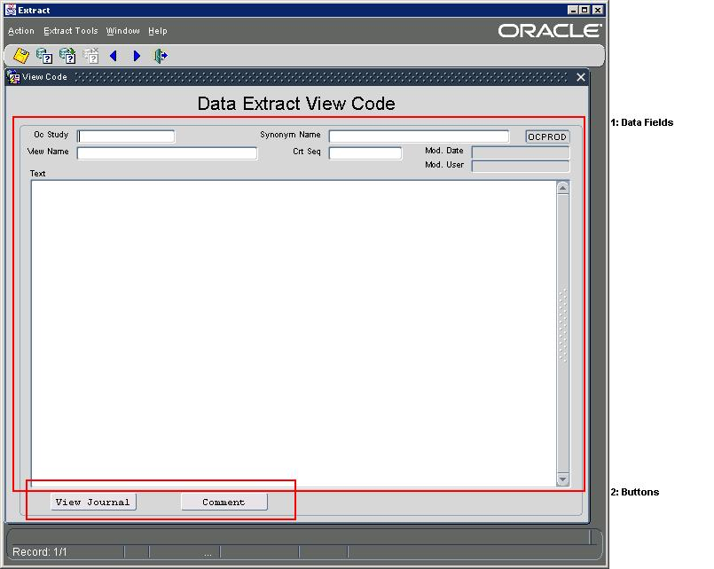

# Overview

This form is used to manipulate the cursor SQL code for a File Id of a defined extraction. It also allows the user to see previous version of the same cursor.

# Forms Startup

1. Security Checked at form startup. The following query checks userid to see if user is valid for APPLICATION. (WHEN-NEW-FORM-INSTANCE)

SELECT '1' INTO T_WHAT

FROM CT_EXT_ACCOUNTS

WHERE (USER_NAME = USER or User = 'CTEXT_T')

AND ROWNUM = 1;

1. Menu Actions are turn off that would normally allow queries and editing.

# Main Menu

The main menu controls what other screens can be selected. They are controlled through ROLES. Only certain Oracle ROLES granted to the user would allow access. See EXTMENU1_Analysis for more information.

# Exit Button

The exit button is used to close the application. When closing the application, the screen is checked for existing non-committed transactions and will not quite until the transactions are committed or rolled back.

# Data Fields (#1)

There are 7 enterable fields that make up the data field for a cursor definition. They are stored in the table CT_EXT_VW_CTL.

Functions required: Enter/execute Query, EDIT/UPDATE, DELETE (May have to look into ROLE based display of these options)

Note: When a record is modified, the “before modified” version of the record must be copied to the Cursor Journal table. Also, a Comment must be captured when a record is modified.

|  |  |  |
| --- | --- | --- |
| Screen Field | Table Column | Description |
| OC Study | OC_STUDY | Study identifier |
| View Name | VIEW_NAME | The name of the view object. |
| Synonym Name | SYNONYM_NAME | The Synonym name of the view object |
| Crt Seq | CRT_SEQ | The sequence number order in which the View should be created. |
| Text | TEXT | This is the actual SQL code that makes up the select statement that will build the view. NOTE: This is stored in a LONG column. |
| Mod. Date | MODIFIED_BY | User who last modified the record. |
| Mod. User | MODIFIED_DATE | The date the records was modified. |
|  | CREATE_BY | User who created record, NOT DISPLAYED |
|  | CREATION_DATE, | Date record created, NOT DISPLAYED |
|  | NOTE | Comment field used to explain/describe modifications NOT DISPLAYED. |

### Record processing

DELETES: Before a record is committed as a delete from the table, a copy of it is placed into the Journal Table, and journaling information is stored with the record. See PRE-DELETE trigger for entire PL/SQL code.

UPDATES: Before a record is committed as an update, a copy of it is placed into the Journal Table, and journaling information is stored with the record. See PRE-UPDATE trigger for entire PL/SQL code.

INSERTS: Before a new record is committed, a copy of it is placed into the Journal Table, and journaling information is stored with the record. See PRE-UPDATE trigger for entire PL/SQL code.

# Buttons (#2)

### View Journal

The View Journal Button is used to query past cursor definitions versions.

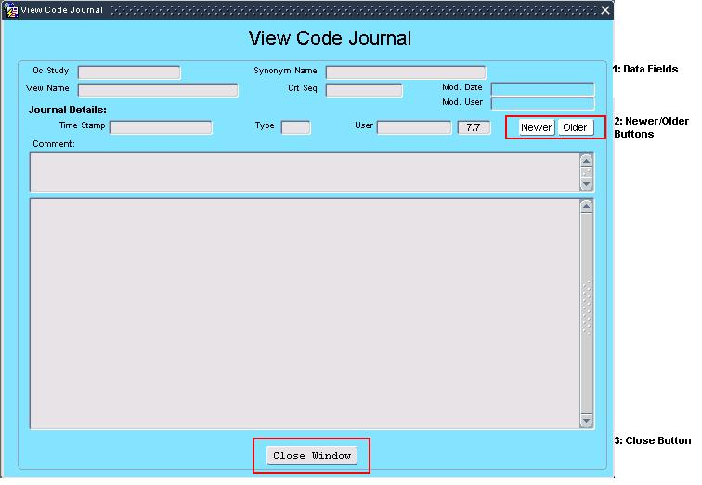

* Only fires if OC_STUDY and VIEW_NAME fields have been entered.
* Displays all journal entries for the cursor displayed, using the following query:

where CT_EXT_VW_CTL$JN.OC_STUDY = :CT_EXT_VW_CTL.OC_STUDY

and CT_EXT_VW_CTL$JN.VIEW_NAME = :CT_EXT_VW_CTL.VIEW_NAME

#### The Data Fields

The data fields are read-only and come from the table CT_EXT_VW_CTL$JN. Data is sorted by most recent record.

#### Newer/Older Buttons

These buttons will traverse the user through the journal records.

#### Close Window Button

This button is used to close the journal window and return the user to the primary data entry form.

### Comment

The comment button is used to place a comment on the current record. Comments are also collected during updates and deletes.

# TRIGGER CODE

#### PRE-INSERT

DECLARE

T_TEXT VARCHAR2(120) := ' ';

BEGIN

T_TEXT := ' Inserting journaling information failed.';

Insert into CT_EXT_VW_CTL$JN (

JN_OPERATION ,JN_TIMESTAMP

,JN_SN

,JN_ORACLE_USER

,OC_STUDY ,VIEW_NAME

,CRT_SEQ ,TEXT

,SYNONYM_NAME ,CREATE_BY

,CREATION_DATE ,NOTE )

VALUES (

'INS' ,SYSDATE

,TO_NUMBER(TO_CHAR(SYSDATE, 'YYYYMMDDHH24MISS'))

,USER

,:CT_EXT_VW_CTL.OC_STUDY ,:CT_EXT_VW_CTL.VIEW_NAME

,:CT_EXT_VW_CTL.CRT_SEQ ,:CT_EXT_VW_CTL.TEXT

,:CT_EXT_VW_CTL.SYNONYM_NAME ,USER

,SYSDATE ,:CT_EXT_VW_CTL.NOTE

);

IF NVL(:CT_EXT_VW_CTL.NOTE, ' ') <> NVL(:CT_EXT_VW_CTL.NOTE_DISPLAY, ' ') THEN

:CT_EXT_VW_CTL.NOTE_DISPLAY := :CT_EXT_VW_CTL.NOTE;

END IF;

EXCEPTION

WHEN OTHERS THEN

MESSAGE(T_TEXT, ACKNOWLEDGE);

RAISE FORM_TRIGGER_FAILURE;

END;

#### PRE-UPDATE

DECLARE

T_TEXT VARCHAR2(120) := ' ';

H_OC_STUDY CT_EXT_VW_CTL.OC_STUDY%Type;

H_VIEW_NAME CT_EXT_VW_CTL.View_Name%Type;

H_CRT_SEQ CT_EXT_VW_CTL.CRT_SEQ%Type;

H_SYNONYM_NAME CT_EXT_VW_CTL.Synonym_Name%Type;

H_CREATE_BY CT_EXT_VW_CTL.Create_By%Type;

H_CREATION_DATE CT_EXT_VW_CTL.Creation_Date%Type;

H_TEXT CT_EXT_VW_CTL.Text%Type;

H_NOTE CT_EXT_VW_CTL.Note%Type;

H_Mod_by CT_EXT_VW_CTL.Modified_by%Type;

H_Mod_date CT_EXT_VW_CTL.Modified_date%Type;

h_rowid varchar2(30) :=NAME_IN(:SYSTEM.CURRENT_BLOCK || '.ROWID');

BEGIN

T_TEXT := ' Updating journaling information failed.';

:ct_ext_vw_ctl.modified_by := user;

:ct_ext_vw_ctl.modified_date := sysdate;

select OC_STUDY, VIEW_NAME, CRT_SEQ, TEXT,

SYNONYM_NAME, CREATE_BY, CREATION_DATE, NOTE,

MODIFIED_BY, MODIFIED_DATE

into H_OC_STUDY, H_VIEW_NAME, H_CRT_SEQ, H_TEXT,

H_SYNONYM_NAME, H_CREATE_BY, H_CREATION_DATE, H_NOTE,

H_MOD_BY, H_MOD_DATE

from CT_EXT_VW_CTL

where rowid = h_rowid;

Insert into CT_EXT_VW_CTL$JN (

JN_OPERATION ,JN_TIMESTAMP

,JN_SN

,JN_ORACLE_USER

,OC_STUDY ,VIEW_NAME

,CRT_SEQ ,TEXT

,SYNONYM_NAME ,CREATE_BY

,CREATION_DATE ,NOTE

,MODIFIED_BY ,MODIFIED_DATE )

VALUES (

'UPD' ,SYSDATE

,TO_NUMBER(TO_CHAR(SYSDATE, 'YYYYMMDDHH24MISS'))

,USER

,H_OC_STUDY ,H_VIEW_NAME

,H_CRT_SEQ ,H_TEXT

,H_SYNONYM_NAME ,H_CREATE_BY

,H_CREATION_DATE ,H_NOTE

,H_MOD_BY ,H_MOD_DATE);

IF NVL(:CT_EXT_VW_CTL.NOTE, ' ') <> NVL(:CT_EXT_VW_CTL.NOTE_DISPLAY, ' ') THEN

:CT_EXT_VW_CTL.NOTE_DISPLAY := :CT_EXT_VW_CTL.NOTE;

END IF;

EXCEPTION

WHEN OTHERS THEN

MESSAGE(T_TEXT, ACKNOWLEDGE);

RAISE FORM_TRIGGER_FAILURE;

END;

#### PRE-DELETE

DECLARE

T_TEXT VARCHAR2(120) := ' ';

H_OC_STUDY CT_EXT_VW_CTL.OC_STUDY%Type;

H_VIEW_NAME CT_EXT_VW_CTL.View_Name%Type;

H_CRT_SEQ CT_EXT_VW_CTL.Crt_Seq%Type;

H_SYNONYM_NAME CT_EXT_VW_CTL.Synonym_Name%Type;

H_CREATE_BY CT_EXT_VW_CTL.Create_By%Type;

H_CREATION_DATE CT_EXT_VW_CTL.Creation_Date%Type;

H_TEXT CT_EXT_VW_CTL.Text%Type;

H_NOTE CT_EXT_VW_CTL.Note%Type;

H_Mod_by CT_EXT_VW_CTL.Modified_by%Type;

H_Mod_date CT_EXT_VW_CTL.Modified_date%Type;

h_rowid varchar2(30) :=NAME_IN(:SYSTEM.CURRENT_BLOCK || '.ROWID');

BEGIN

T_TEXT := ' Deleting journaling information failed.';

select OC_STUDY, VIEW_NAME, CRT_SEQ, TEXT,

SYNONYM_NAME, CREATE_BY, CREATION_DATE, NOTE,

MODIFIED_BY, MODIFIED_DATE

into H_OC_STUDY, H_VIEW_NAME, H_CRT_SEQ, H_TEXT,

H_SYNONYM_NAME, H_CREATE_BY, H_CREATION_DATE, H_NOTE,

H_MOD_BY, H_MOD_DATE

from CT_EXT_VW_CTL

where rowid = h_rowid;

Insert into CT_EXT_VW_CTL$JN (

JN_OPERATION ,JN_TIMESTAMP

,JN_SN

,JN_ORACLE_USER

,OC_STUDY ,VIEW_NAME

,CRT_SEQ ,TEXT

,SYNONYM_NAME ,CREATE_BY

,CREATION_DATE ,NOTE

,MODIFIED_BY ,MODIFIED_DATE )

VALUES (

'DEL' ,SYSDATE

,TO_NUMBER(TO_CHAR(SYSDATE, 'YYYYMMDDHH24MISS'))

,USER

,H_OC_STUDY ,H_VIEW_NAME

,H_CRT_SEQ ,H_TEXT

,H_SYNONYM_NAME ,H_CREATE_BY

,H_CREATION_DATE ,H_NOTE

,H_MOD_BY ,H_MOD_DATE);

IF NVL(:CT_EXT_VW_CTL.NOTE, ' ') <> NVL(:CT_EXT_VW_CTL.NOTE_DISPLAY, ' ') THEN

:CT_EXT_VW_CTL.NOTE_DISPLAY := :CT_EXT_VW_CTL.NOTE;

END IF;

EXCEPTION

WHEN OTHERS THEN

MESSAGE(T_TEXT, ACKNOWLEDGE);

RAISE FORM_TRIGGER_FAILURE;

END;