Lab Load Interface
User Guide

Version No: 0.3
Last Modified: 08/12/2005

Author : Patrick Conrad; Sirisha Yerredu
Team : C3D Support
Client : National Cancer Institute - Center for Bioinformatics,
National Institutes of Health,
US Department of Health and Human Services

Document History

Document Location
The most current version of this document is located in CVS under LabLoadInterface/doc

Revision History
Version Number | Revision Date | Author | Summary of Changes
0.1 | 08/12/05 | Patrick Conrad  Sirisha Yerredu | Initial draft.
0.2 | 08/19/05 | Patrick Conrad | Accepted CSM/QA revisions, removed empty table entries, updated Introduction/Purpose.
0.3 | 8/22/05 | Patrick Conrad | Updated using comments from Christo Andonyadis

Review
Name | Team/Role | Version | Date Reviewed | Reviewer Comments
Eric Copen | CSM/QA | 0.1 | 12/18/05

Related Documents
More information can be found in the following related LLI documents:

Document Name

Table of Contents
1. Introduction 4
1.1 Purpose 4
1.2 Scope 4
1.3 Definitions, Acronyms, and Abbreviations 4
1.4 LLI Overview 4
1.4.1 What is it? 4
1.4.2 What does it do? 4
1.4.3 What do I need to know to use it? 4
1.4.4 How do you access it? 4
1.5 Background 5
1.5.1 Lab Load Records 5
1.5.2 Available Studies 5
2. Modes of Operation 5
2.1 Read-Only Mode 5
2.2 Reviewer Mode 5
3. Using LLI 6
3.1 Search 7
3.1.1 General Searching 7
3.1.2 Date Searches 8
3.1.3 Search Results 9
3.1.4 Sorting Search Results 9
3.1.5 Actions and Action Buttons 10
3.2 Work Cart 11
3.2.1 Action Buttons 12
3.2.2 Radio Buttons 12
3.2.3 Sorting Search Results 13
3.3 Load Cart 14
3.3.1 General Searching 14
3.3.2 Sorting Search Results 15
3.3.3 Action Buttons 16
3.4 All Labs 17
3.4.1 General Searching 17
3.4.2 Search Results 18
3.4.3 Sorting Search Results 18
3.4.4 Actions and Action Buttons 19

LLI User Guide

Introduction

Purpose
The Lab Load Interface (LLI) is an Oracle Forms Web-based application that is part of a series of C3D Support Utilities developed for NCICB. The LLI allows Data Managers of Clinical Studies contained within the C3D arena to review and identify specific Lab Test Result data downloaded from the Clinical Data Warehouse. Data Managers can then mark specific Lab Test Result data for loading into their respective Clinical Studies for further analysis and interpretation. The Lab Loader Utility performs the actual loading of the data, in the background, through a nightly scheduled batch job.

Scope
This guide’s intended audience is all users of the LLI. This guide provides an overview of the application, outlines a suggested workflow, and explains how to perform all LLI operations.

Definitions, Acronyms, and Abbreviations
The following list contains definitions of terms, acronyms and abbreviations used throughout the document:
LLI | Lab Load Interface: Utility allows review and selection of Lab Test Results for loading to C3D (Oracle Clinical)
C3D | Cancer Central Clinical Database
OCTRN | C3D Training arena, include databases, interfaces and utilities.
CDW | Clinical Data Warehouse

LLI Overview

What is it?
It is a web-based application used as an interface between the end-user and available Lab Test Results downloaded from the Clinical Data Warehouse.

What does it do?
The Lab Loader Interface provides functionality for the review and selection of Lab Test Results for processing and loading into C3D. There are two modes of operation: Read-only and Reviewer. Based upon the privilege granted, the interface allows the user to either review lab results or review and process Lab Results.

What do I need to know to use it?
The interface is very user-friendly, but you will need a C3D userid and password, as well as some general knowledge of Lab Testing with regard to OC study significance and placement. You will also need to have access to the application granted to your C3D userid.

How do you access it?
The only current version of LLI available is found on the Training Middle Tier (OCTRN). Use the following URL to access the application:
http://octrials-train.nci.nih.gov/opa45/labloadinter.htm

Once the URL is loaded, some additional Java applet downloads may occur. Press the Login button to fully access the application.

Background

Lab Load Records
Lab Load records are Lab Test Result records that have been loaded into a holding area from various outside sources, and processed for the following:
- Study and patient assignment
- Lab Panel assignment
- UOM preference assignment
- Data validation
- On/Off Study Date checking

Once the Lab Test Result records are processed, they are available for review using the LLI. From here, the records can be marked for loading into C3D, or archived.

Available Studies
The Lab Loader Interface engages the same security scheme found within C3D to ensure that a particular user is only allowed access to studies to which they have been granted access. This also applies to C3D group security and super-user authority. Additionally, Read-only and Reviewer modes further enhance application security.

Modes of Operation

Read-Only Mode
The Read-only mode is used when the user is granted only the LABLOAD role. In this mode the user can query Lab Result records, but cannot manipulate their active status, nor flag records for loading. Every screen of the application is available, but most Action buttons are not available.

Reviewer Mode
The Reviewer mode is available when the user is granted the role LABLOAD_REVIEW. In this mode, the user can query Lab Result records for review, archive records that should not be loaded and most importantly, mark records for loading into C3D. All Action buttons are available to users in the Reviewer mode.

Using LLI
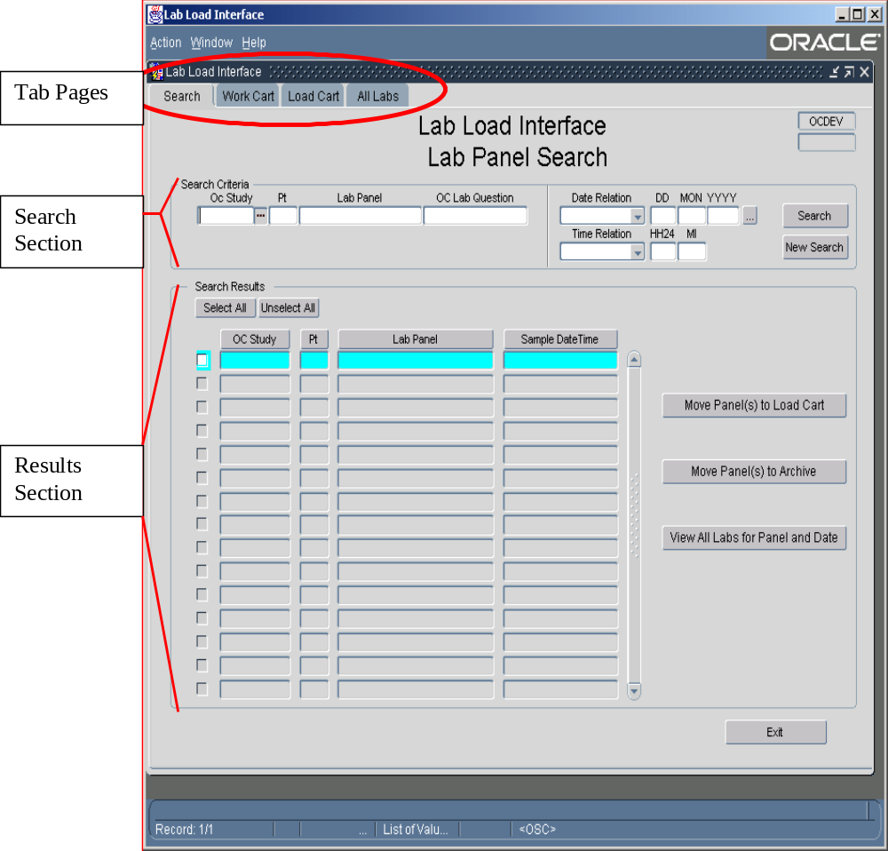LLI consists of a single Oracle Forms Web application that uses a TAB based form separated into the following functions: Search, Work Cart, Load Cart and All Labs. Each Tab Page consists of two sections where users enter search criteria and view results in a simple table layout format.

Search
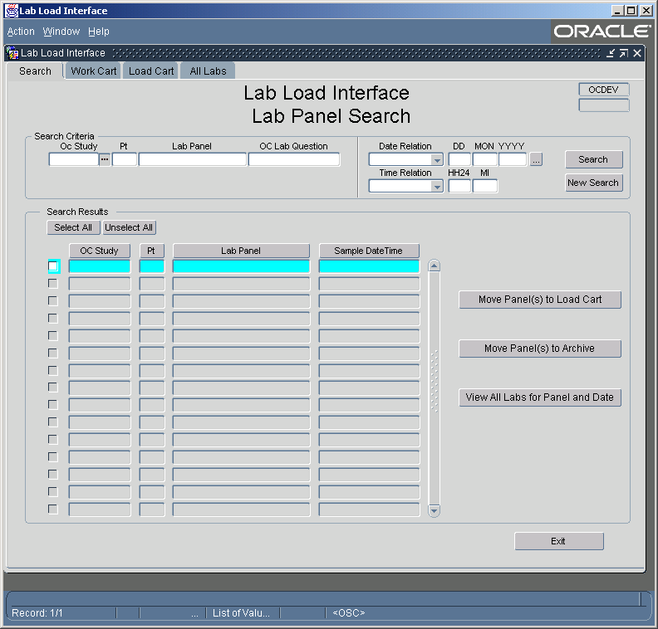

General Searching
For the most part, searching will be performed at a Study or Study and Patient level where the desired results correspond with a specific study and/or patient. Perform a seach by entering the desired value into the desired search field and pressing the Search button. Use the New Search button to clear all search criteria. In the Read-Only mode, the buttons Move Panel(s) to Load Cart and Move Panel(s) to Archive are not available.
Upon entering a successful search, results appear in the Search Results section. The results are at the Lab Panel level. See View All Labs for Panel and Date below for viewing actual Lab Result records.

OC Study
Use the OC Study field to enter the appropriate study. To expedite searching, this field is required A LOV (List of Values) is available for this field; it presents a list of Studies requiring review and accessible to the user.

Pt
Use the Pt field to enter OC Patient Position. The LOV for this field will return either a combination of Study and Patients that are ready for review and accessible by the user, or a list of Patients of the entered study, if the OC Study field has a value. It should be noted that values of Pt are sorted numerically.

Lab Panel
The Lab Panel field is used to search for specific Lab Panels (OC DCM Names). The LOV has similar behavior as that of Pt in that the list will contain all distinct Lab Panels across all accessible studies, or all distinct Lab Panels for the entered Study (OC Study), or all distinct Lab Panels for the entered patient / study (Pt and OC Study). The list of values is sorted by Study, Pt and Lab Panel. You may return results for a specific Lab Panel across all accessible studies by entering only Lab Panel into the search criteria and pressing the Search button.

OC Lab Question
Use the OC Lab Question field to search for Lab Panels that contain a specific OC Lab Question. This field also has an LOV with similar behavior as that of Lab Panel and Pt. The LOV will return either distinct OC Lab Questions across all accessible studies, across a specific study, for the entered Study and Patient, or for the entered Study, Patient and Lab Panel. Also, as with Lab Panel, it is possible to return all Lab Panels across all accessible studies where the OC Lab Question is on that panel, by entering only OC Lab Question into the search criteria and pressing the Search button.

Date Searches
Several methods were employed in the Date Search option to allow for a variety of queries to be used. Wildcards as well as “before and after” options exist, as well as a few date short cuts.

Simple Dates
Dates can be entered partially or in whole. Month can be entered either numerically or with the normal 3-character representation. Year can be entered as either a 2-digit or 4-digit number, with LLI converting a 2-digit year into a 4-digit year using Oracle’s RRRR “century rollover” conversion. Partial dates will be treated as a “like” query, with the missing elements of date receiving wild card values during actual query execution.

Date Relation
The date relation field contains search operators that are to be applied during queries using dates. “On or Before” will cause only those records to return where the lab test sample date is equal to or less than the criteria date. Similarly, “On or After” will return records where the lab test sample date is equal to or greater than the criteria date. If no date relation is entered, the relation will be evaluated to either “equal to” when whole dates are used or “like” when partial dates are employed.

Date Short-cuts
The date fields also offer special short-cut notation to represent dates. Entering a “T” into the day field (DD) will convert the search field to today’s date. Entering a negative number into the same day field will convert the search fields to today’s date minus the number entered into the day field. Likewise, a positive number, (must be prefixed with “+”) will returned today’s date plus the number entered.

Time Searches
As with Date Searches, several methods were employed in the Time Search option. Wildcards as well as “before and after” options exist, as well as a few date short cuts.

Entering Time
Time can be entered partially or completely. All time values are numeric, and will be validated upon selection of the Search button. Partial time will be treated as a “like” query, with the missing elements of time receiving wild card values during actual query execution.

Time Relation
The time relation field is the same as that of date relation. “On or Before” will cause only those records to return where the sample time is equal to or less than the criteria time. Similarly, “On or After” will return records where the lab test sample time is equal to or greater than the criteria time. If no time relation is entered, the relation will be evaluated to either “equal to” when whole time is used or “like” when partial time is employed.

Date and Time Searches
Combinations of Date and Time can be used. Additionally, the Date and Time Relation does not have to be the same when employing dates and times. It is possible to look for any “March after lunch” Lab result by entering “MAR” in the Month field of date, selecting “LIKE” in the Date Relation field, entering “12” and “00” in the Hour and Minute search fields of time, and choosing the “On or After” Time Relation criteria.

Search Results
The Search Results section displays search results. From here you may perform additional processing.

Sorting Search Results
Each column in the search results has a button for a heading. By pressing these buttons, the results can be sorted differently. Press the column button once to sort the results in ascending order. Press the same column button a second time to sort the results in descending order. Pressing the same column button a third time returns the results to the default sort method.
- Default Sort Method: The default sort order is “OC Study”, numeric “Pt”, “Lab Panel” and date “Sample DateTime”. This is the primary sort when none of the Sort Buttons have been selected. Numeric PT denotes that numbers sort naturally 1, 2, 3 , 4… instead of alphanumerically 1, 10, 11, 12…
- OC Study Sort: Selecting this button the first time, Sort is “OC Study” ascending, numeric “Pt”, “Lab Panel” and date “Sample DateTime”. Selecting the button again results in the same results except “OC Study” is descending.
- Pt Sort: Selecting this button the first time, sort method is numeric “Pt” ascending, “OC Study”, “Lab Panel” and date “Sample DateTime”. Selecting the button again results in the same results except “Pt” is descending.
- Lab Panel Sort: Selecting this button the first time, Sort is “Lab Panel” ascending, “OC Study”, numeric “Pt” and date “Sample DateTime”. Selecting the button again results in the same results except “Lab Panel” is descending.
- Sample DateTime Sort: Selecting this button the first time, Sort is “Sample DateTime” ascending, “OC Study”, numeric “Pt” and “Lab Panel”. Selecting the button again results in the same results except “Sample DateTime” is descending.

Actions and Action Buttons
Depending on the access mode of the user, different action buttons will be available. In Read-Only mode, the following action buttons will NOT be available:
- Move Panel(s) to Load Cart
- Move Panel(s) to Archive

Select All
The Select All button is used to select all of the records in the Search Results section. A selected record is denoted with a check in the box located to the far left of each record.

Unselect All
The Unselect All button is used to remove the record from selection. The box located that the far left of the record should be empty.

View All Labs for Panel and Date
This action allows the user to view the individual Lab Test Results in detail for the Panel and Date selected. When invoked, the user is taken to the Work Cart tab, and the individual Lab Test Results will be displayed. There are three methods by which the user can invoke this action.
- By double clicking on a record in the list of Search Results
- By activating a record with a single click (the record will be high-lighted with blue), and pressing the Work Cart tab.
- By activating a record with a single click (the record will be high-lighted with blue), and pressing the View All Labs for Panel and Date button.

Move Panel(s) to Load Cart
This button is used to change the status of individually selected Lab Result records from the status “Review” to “To Load”. This will effectively place the Lab Result record into the Load Cart, which can then be view via the Load Cart Tab. When selecting this button, the user will be given a dialogue window stating the number of records successfully moved to the Load Cart. If no records are selected for action, a similar dialog window will appear that that nothing was marked for processing.

Move Panel(s) to Archive
This button is used to change the status of individually selected Lab Result records from the status “Review” to “Archive”. The status “Archive” is used to denote those Lab Result records that should no longer be consider for processing byt the Lab Loader utility. When selecting this button, the user will be given a dialogue window stating the number of records successfully archived. If no records are selected for action, a similar dialog window will appear that that nothing was marked for processing.

Work Cart

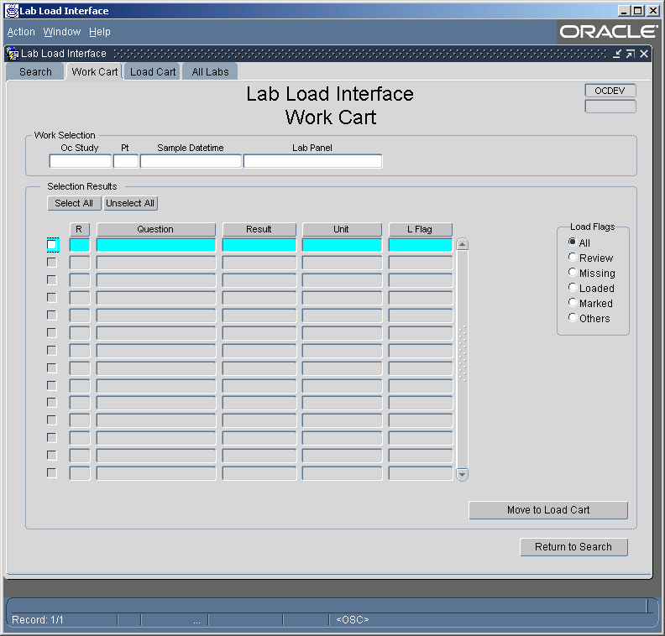

The Work Cart tab displays all of the Lab Test Result Records that are associated with the lab panel selected from the Search Tab. The Lab Panel will be shown in the ”Work Selection” section, while the result details will be display in the “Selection Results” section. These results can include records that were previously loaded, already marked for loading, flagged with errors or missing from the panel. Panels are based upon the C3D DCM definition.
By default, all detail record status types will be displayed and can be controlled via the “Load Flags” radio buttons. Included statuses are ready for review, were previously loaded, and already marked for loading, flagged with errors or missing from the panel.
Navigation to Work Cart is possible from Search Tab through either the Action Button ‘View All Labs for Panel and Date’, or by highlighting a search result and selecting the “Work Cart” tab.

Action Buttons

Select All
The Select All button is used to select all of the records in the Search Results section. A selected record is denoted with a check in the box located to the left of each record.

Unselect All
The Unselect All button is used to remove the record from selection. The box located that the left of the record should be empty

Move To Load Cart
This button is used to change the status of individually selected Lab Result records from the status “Review” to the status “To Load”. Records marked with the “To Load” status will appear on the “Load Cart” tab. Only those Lab Result records having a status of “To Load” will be processed for loading into C3D. When selecting this button, the user will be given a dialogue window stating the number of records successfully moved to the load cart. If no records are selected for action, a similar dialog window will appear that that nothing was marked for processing. The Load flag of these Lab Tests will also change from “REVIEW” to “TO LOAD”.

Radio Buttons

All
This is the default Radio Button used for displaying search results. Search results will be based on the Lab Panel and Sample date time selected in the Search tab. This displays all the records and can include: ready for review, previously loaded, marked for loading, flagged with error or missing from panel.

Review
Selection of this Radio Button displays only those Lab Tests that have a status of “Ready for Review”. The Lab Loader applies this status to all successfully processed Lab Test records of studies that require reviewing.

Missing
Selection of this Radio Button displays only those Lab Tests that are deemed missing. Missing is defined as “Lab Tests that are defined as part of the Lab Panel within C3D, but the corresponding Lab Test Result is not included within the Sample Date and Time as the rest of the Lab Result records”.

Loaded
Selection of this Radio Button displays only those the Lab Result records that have been successfully loaded into C3D.

Marked
Selection of this Radio Button displays only those the Lab Result records that has been mark for loading.

Others
Selection of this Radio Button displays only those the Lab Result records that are flagged with Errors, or any other Status not mentioned above.

Technical Note
The following shows a list of the current used status and their Lab Loader LOAD_FLAG equivalent:
Status | NCI_LABS - LOAD_FLAG
Review | R
To Load | L
Error | E
Duplicate | X
Load Confirmed | C
Update Confirmed | U
Missing | There is no equivalent value

Sorting Search Results
Each of the columns of the search results section has a button as a column heading. By pressing these buttons, the results can be sorted differently. Pressing the column button once sorts the results in ascending order. Pressing the same column button a second time sorts the results in descending order. Pressing the same column button a third time returns the results to the default sort method.
- Default Sort Method: The default sort method is Repeat Sequence (R) and Load Flag (Status).
- Repeat Sequence (“R”): Selecting this button the first time, sort is Repeat Sequence and Load Flag (Status). Selecting the button again results in Descending order. Selecting the Button again returns the sort to the Default method.
- OC Lab Question: Selecting this button the first time, Sort is OC Lab Question ascending, Repeat Sequence, and Load Flag. Selecting the button again results in Descending order. Selecting the Button again returns the sort to the Default method.
- Result: Selecting this button the first time, Sort is Result ascending, Repeat Sequence and Load Flag. Selecting the button again results in descending order. Selecting the Button again returns the sort to the Default method.
- Unit: Selecting this button the first time, Sort is Unit Ascending, Repeat Sequence and Load Flag. Selecting the button again results in descending order. Selecting the Button again returns the sort to the Default method.
- L Flag (Load Flag or Status): Selecting this button the first time, Sort is Load Flag ascending and Repeat Sequence. Selecting the button again results in descending order. Selecting the Button again returns the sort to the Default method.

Load Cart

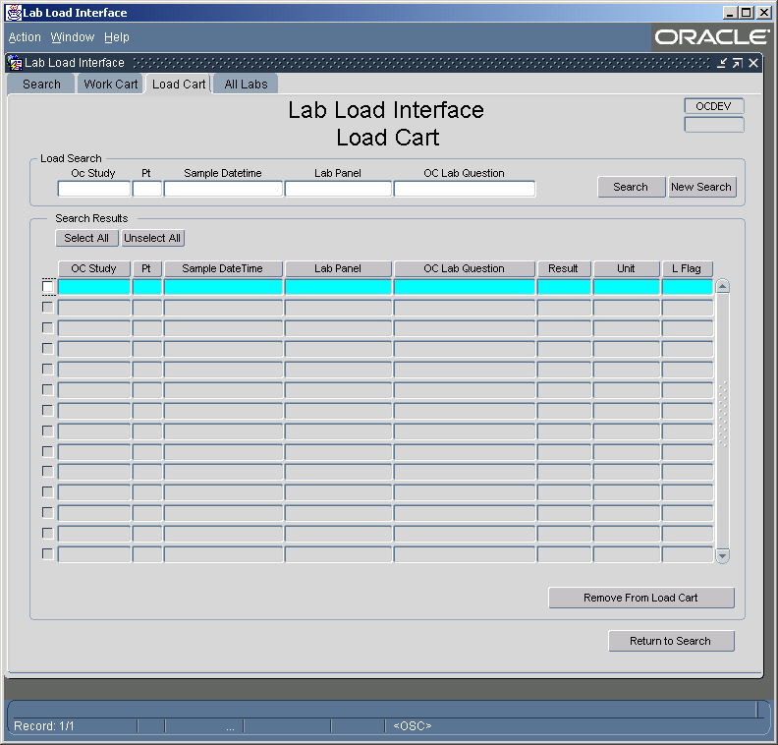

General Searching
By default, the first time entering into the Load Cart tab, all Lab Test Result records that have been marked for loading (To Load), will appear in the Search Results section. Additional filtering of this data can be perform by entering the desired values into the available search fields of the “Load Search” section and pressing the Search button. To clear all search criteria and results, use the New Search button.
Upon entering a successful search, results will appear in the Search Results section. The results are at the Lab Test Result level.

OC Study
The OC Study field is used to enter the study to search for. An LOV (List of Values) is available for this field and will contain a list of Studies to which the user has access.

Pt
The Pt field is used to enter OC Patient Position. The LOV for this field will return either a combination of Study and Patients that the user has access to or a list of Patients of the entered study, if the OC Study field has a value.

Sample DateTime
The Sample DateTime field is used to search for a specific sample date and time. The LOV will provide a distinct list of Study, Pt, Sample Date and Times.

Lab Panel
The Lab Panel field is used to search for specific Lab Panels (OC DCM Names). The LOV has similar behavior as that of Pt in that the list will contain all distinct Lab Panels across all accessible studies, or all distinct Lab Panels for the entered Study (OC Study), or all distinct Lab Panels for the entered patient / study (Pt and OC Study). The list of values is sorted by Study, Pt and Lab Panel. It is possible to return for a specific Lab Panel across all accessible studies by entering only Lab Panel into the search criteria and pressing the Search button.

OC Lab Question
The OC Lab Question field is used to search for Lab Panels that contain a specific OC Lab Question. This field also has an LOV with similar behavior as that of Lab Panel and Pt. The LOV will return either distinct OC Lab Questions across all accessible studies, across a specific study, for the entered Study and Patient, or for the entered Study, Patient and Lab Panel. Also, as with Lab Panel, it is possible to return all Lab Panels across all accessible studies where the OC Lab Question is on that panel, by entering only OC Lab Question into the search criteria and pressing the Search button.

Sorting Search Results
Each of the columns of the search results section has a button for a column heading. By pressing these buttons, the results can be sorted differently. Pressing the column button once sorts the results in ascending order. Pressing the same column button a second time sorts the results in descending order. Pressing the same column button a third time returns the results to the default sort method.
- Default Sort Method: The default sort order is “OC Study”, numeric “Pt”, date “Sample DateTime”, “Lab Panel”, “OC Lab Question”. This is the primary sort when none of the Sort Buttons have been selected. Numeric PT denotes that numbers sort naturally 1, 2, 3 , 4… instead of alphanumerically 1, 10, 11, 12…
- OC Study Sort: Selecting this button the first time, Sort is “OC Study” ascending, numeric “Pt”, date “Sample DateTime”, “Lab Panel”, “OC Lab Question”. Selecting the button again results in the same results except “OC Study” is descending.
- Pt Sort: Selecting this button the first time, sort method is numeric “Pt” ascending, “OC Study”, date “Sample DateTime”, “Lab Panel”, “OC Lab Question”. Selecting the button again results in the same results except “Pt” is descending.
- Sample DateTime: Selecting this button the first time, sort method is numeric date “Sample DateTime” ascending, “OC Study”, “Pt” ascending, “Lab Panel”, “OC Lab Question”. Selecting the button again results in the same results except “Pt” is descending.
- Lab Panel Sort: Selecting this button the first time, Sort is “Lab Panel” ascending, “OC Study”, numeric “Pt”, date “Sample DateTime”, “OC Lab Question”. Selecting the button again results in the same results except “Lab Panel” is descending.
- OC Lab Question: Selecting this button first time, Sort is “OC Lab Question” ascending, “OC Study”, numeric “Pt”, date “Sample DateTime”, “Lab Panel”. Selecting the button again results in the same results except “OC Lab Question” is descending.
- Result: Selecting this button first time, Sort is “Result” ascending, “OC Study”, numeric “Pt”, date “Sample DateTime”, “Lab Panel”, “OC Lab Question”. Selecting the button again results in the same results except “Result” is descending.
- Unit: Selecting this button first time, Sort is “Unit” ascending, “OC Study”, numeric “Pt”, date “Sample DateTime”, “Lab Panel”, “OC Lab Question”. Selecting the button again results in the same results except “Unit” is descending.
- L Flag: Selecting this button first time, Sort is “L Flag” ascending, “OC Study”, numeric “Pt”, date “Sample DateTime”, “Lab Panel”, “OC Lab Question”. Selecting the button again results in the same results except “L Flag” is descending.

Action Buttons

Select All
The Select All button is used to select all of the records in the Search Results section. A selected record is denoted with a check in the box located to the left of each record.

Unselect All
The Unselect All button is used to remove the record from selection. The box located that the left of the record should be empty

Remove from Load Cart
This button is used to change the status of individually selected Lab Result records from the status “To Load”, back to the status “Review”. This in effect, prevents the record from being processed for loading into C3D. When selecting this button, the user will be given a dialogue window stating the number of records successfully removed to the load cart. If no records are selected for action, a similar dialog window will appear that that nothing was marked for processing. The Load Flag (Status) for Lab Test Result records processed with this action button will change from “To Load” to “Review”, and the records will no longer appear in the Load Cart.

All Labs

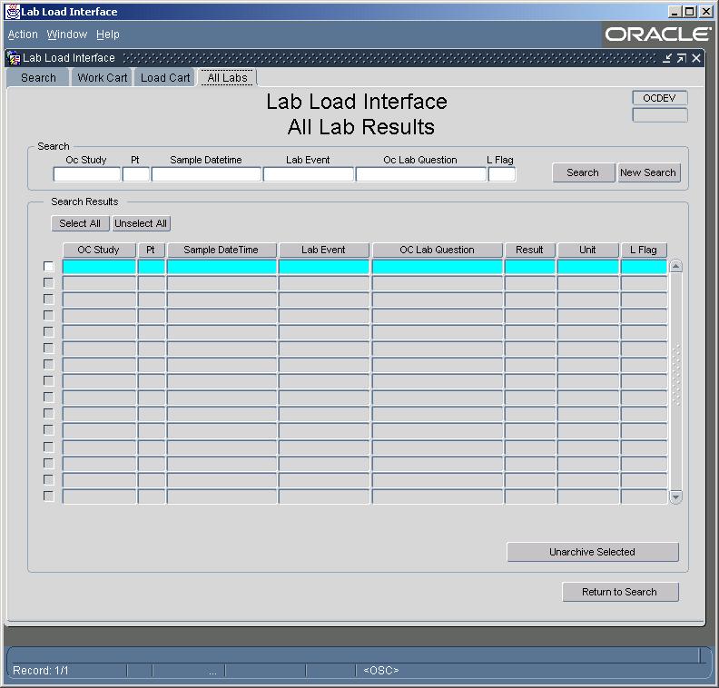

General Searching
The All Lab Results tab provides access to all of a study’s Lab Test Result records. Use caution when performing searches from here, as the large amount of data available can cause queries to execute for extended periods of time. Performing a search is a simple as entering the desired values into the search fields and pressing the Search button. Results will appear in the Search Results section. To clear all search criteria, press the New Search button.

OC Study
The OC Study field is used to enter the study to search for. To expedite searching, this field is required when performing searches. An LOV (List of Values) is available for this field and will contain a list of Studies to which the user has access.

Pt
The Pt field is used to enter OC Patient Position. The LOV for this field will return either a combination of Study and Patients that are accessible by the user or a list of Patients of the entered study, if the OC Study field has a value. It should be noted that values of Pt are sorted numerically.

Sample DateTime
The Sample DateTime field is used to enter SampleDatetime of the Labs. The LOV for this field will return either a combination of Study, Patients and SampleDateTime that are accessible by the User or a list of Sample DateTimes of the entered study and Patient, if the OC Study field and the Patient fields have values.

Lab Event
The Lab Event field is used to search for specific Lab Events (OC DCM Names). The LOV has similar behavior as that of Sample DateTime in that the list will contain all distinct Lab Events across all accessible studies or all distinct Lab Events for the entered Study (OC Study) or all distinct Lab Events for the entered patient / study (Pt and OC Study) or all distinct Lab Events for the entered Patient / Study / Sample DateTime (OC Study, Pt And Sample DateTime). The list of values is sorted by Study, Pt, Sample DateTime and Lab Event. It is possible to return for a specific Lab Event across all accessible studies by entering only Lab Event into the search criteria and pressing the Search button.

OC Lab Question
The OC Lab Question field is used to search for a specific OC Lab Question. This Field does not have any LOV attached to it.

L Flag
The L Flag field is used to search for Lab Result records based on Load Status. This field does not currently have and LOV. By entering the specific Load flag and pressing the search field displays all the Labs with the entered Load Flag.

Search Results
Search results are displayed in the Search Results section. From here, additional processing can be performed.

Sorting Search Results
Each of the columns of the search results has a button for a heading. By pressing these buttons, the results can be sorted differently. Pressing the column button once sorts the results in ascending order. Pressing the same column button a second time sorts the results in descending order. Pressing the same column button a third time returns the results to the default sort method.
- Default Sort Method: The default sort order is “OC Study”, numeric “Pt”, date “Sample DateTime”, “Lab Event” and “OC Lab Question”. This is the primary sort when none of the Sort Buttons have been selected. Numeric PT denotes that numbers sort naturally 1, 2, 3, 4… instead of alphanumerically 1, 10, 11, 12…
- OC Study Sort: Selecting this button the first time, Sort is “OC Study” ascending, numeric “Pt”, date “Sample DateTime”, “Lab Panel”, “OC Lab Question”. Selecting the button again results in the same results except “OC Study” is descending.
- Pt Sort: Selecting this button the first time, sort method is numeric “Pt” ascending, “OC Study”, date “Sample DateTime”, “Lab Panel”, “OC Lab Question”. Selecting the button again results in the same results except “Pt” is descending.
- Sample DateTime: Selecting this button the first time, sort method is numeric date “Sample DateTime” ascending, “OC Study”, “Pt” ascending, “Lab Panel”, “OC Lab Question”. Selecting the button again results in the same results except “Pt” is descending.
- Lab Panel Sort: Selecting this button the first time, Sort is “Lab Panel” ascending, “OC Study”, numeric “Pt”, date “Sample DateTime”, “OC Lab Question”. Selecting the button again results in the same results except “Lab Panel” is descending.
- OC Lab Question :Selecting this button first time, Sort is “OC Lab Question” ascending, “OC Study”, numeric “Pt”, date “Sample DateTime”, “Lab Panel”. Selecting the button again results in the same results except “OC Lab Question” is descending.
- Result: Selecting this button first time, Sort is “Result” ascending, “OC Study”, numeric “Pt”, date “Sample DateTime”, “Lab Panel”, “OC Lab Question”. Selecting the button again results in the same results except “Result” is descending.
- Unit: Selecting this button first time, Sort is “Unit” ascending, “OC Study”, numeric “Pt”, date “Sample DateTime”, “Lab Panel”, “OC Lab Question”. Selecting the button again results in the same results except “Unit” is descending.
- L Flag: Selecting this button first time, Sort is “L Flag” ascending, “OC Study”, numeric “Pt”, date “Sample DateTime”, “Lab Panel”, “OC Lab Question”. Selecting the button again results in the same results except “L Flag” is descending.

Actions and Action Buttons
Depending on the access mode of the user, different action buttons will be available

Select All
The Select All button is used to select all of the records in the Search Results section. A selected record is denoted with a check in the box located to the far left of each record.

Unselect All
The Unselect All button is used to remove the record from selection. The box located that the far left of the record should be empty.

Unarchive Selected
This button is used to change the status of individually selected Lab Result records from the status “Archive”, back to the status “New”. The status “New” is the primary selection status of any new record, needing process by the Lab Loader utility. Records are set back to ‘New’ to ensure that the record is reprocessed by the Lab Loader utility. This ensures that any changes to study definition, or Lab Loader utility control changes, are applied to the record.
When selecting this button, the user will be given a dialogue window stating the number of records successfully unarchived. If no records are selected for action, a similar dialog window will appear that that nothing was marked for processing.

