UML Model Browser Help Topics
Overview of the UML Model Browser
Searching for UML Models
- Basics of Searching
- Using the Search Page
- Using the Search Tree
Viewing the Details of a UML Model: Class Search
Viewing the Details of a UML Model: Attribute Search

Back to Help Topics

An Overview of the UML Model Browser
The UML Model Browser is a new application that is introduced in caCore release 3.1. The UML Model Browser is a web-based tool designed to let UML Model user/owner search for and view UML model components loaded in the caDSR database. It is an intuitive way to view UML classes, attributes, the association between classes and attributes, and their related ISO Components
The UML Model Browser opens to the Search page. This page contains the main Navigation Menu, the UML Model Search Tree, and the Basic Class/Attribute Search Pane. The UML Model Search tree displays all the current caDSR Contexts at the top level. Under each caDSR context, it lists all the UML classes loaded in that context, grouped by project, subproject and package. Here is an example of an UML search tree.
caDSR Context
caCore
Projects
caCore
Sub Projects
caDSR
Packages
gov.nih.nci.cabio.domain
Agent
Clone

Users can search for groups of classes by navigating the tree and clicking on a context, project, subproject or package. They can also search for groups of attributes by clicking on a class in the tree. The search criteria for class and attribute include
- Attribute name - text field, * can be used as wildcard
- Class name - text field, * can be used as wildcard
- Project - drop down combo box,
When a project is selected, the options for sub project and package changes accordingly
- Project Version - text field, * can be used as wildcard
- Sub Project - drop down combo box, when a sub project is selected, the options for package changes accordingly
- Package - drop down combo box
The class search result displays the following attributes for each class matching the search criteria:
- Class Name: The Class Name is Hyperlinked to its Attribute list in the attribute tab.
- Project Name,
- Project Version,
- Workflow Status
- Sub Project Name,
- Package Name,
- Object Class Public ID: The Object Class Public ID is hyperlinked to the CDE Browser Object Class Details.
- Object Class Version.

The attribute search result displays the following attributes for each attribute matching the search criteria:
- Attribute name,
- Data Type,
- Definition,
- Data Element Name,
- Data Element Public ID: The Data Element Public ID is hyperlinked to CDE browser CDE Details screen for the associated UML Model
- Project Name,
- Sub Project Name,
- Package name .

The UML Model Browser opens to the UML Model Search page. This page contains the main Navigation Menu, the caDSR Search Tree, and the Basic UML Model Search Pane.
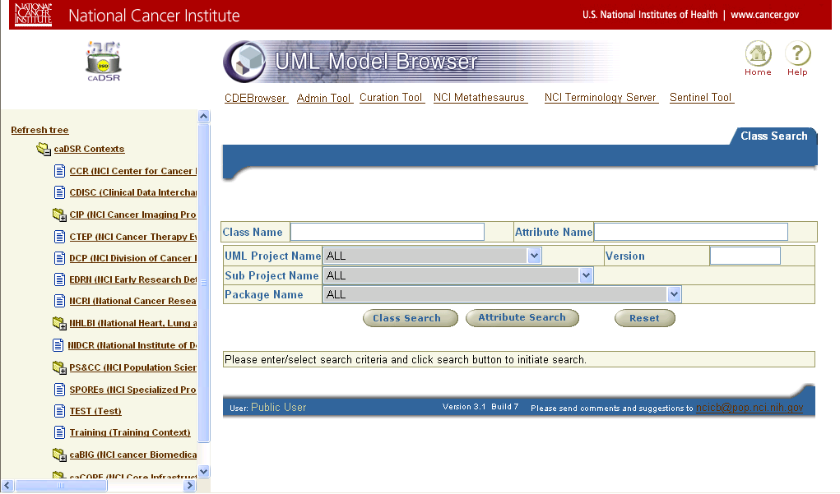
caDSR Search Tree: Displays all the current caDSR Contexts Users can search for groups of UML Models by navigating the tree.
Navigation Menu: Use these buttons to navigate to the CDE Browser, Admin Tool, Curation Tool, etc. or Home (back to this page)
UML Model Search Pane: This is the main search window. Users looking for UML Models can enter a key word or phrase. See below for more help on searching.

Back to Help Topics

Searching for UML Models
There are several different ways to search for UML Models. The best way to search will depend on what you are trying to find.
- Generally, if you are looking for a collection of UML Models (for example, if you are trying to find the UML Models associated with an organization), you should use the caDSR Search Tree.
- Otherwise, your best bet is to search by keyword using the Class Search.

Regardless of which method you use to search for UML Models, the results of your search will always appear in the UML Model Search Results table.

Back to Help Topics

The Basics of Searching

Using the Search Page
To enter a query into the UML Model Browser, just type in the term you want to search on click either the Class Search or the Attribute Search button).
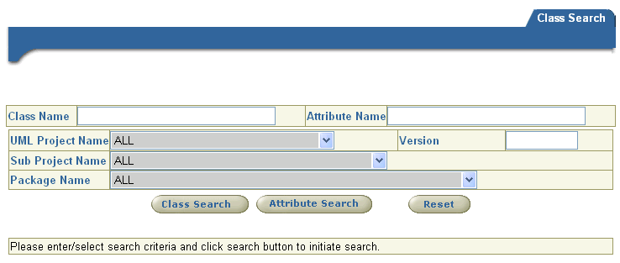
Click the Attribute Search button to select Models by searching Attribute names using on the search criteria.
Click the Reset button to clear existing search criteria and prepare for a new search
Click the Class Search button to select Models by searching Class names using on the search criteria.
Enter a class name or fragment; the asterisk (*) can be used as a wild card character.

The Browser searches for an exact match of the search term(s) in the class name (Class Search) or attribute name (Attribute Search). Attribute names can be included for a Class Search.

Capitalization
UML Model Browser searches are not case sensitive. The Browser ignores capital letters when searching for UML Models. “Concept” and “concept” return the same matches.

Using Wildcards to Broaden a Search
To broaden your search, use the wildcard character (*). The wildcard character can be used more than once within a search term.
Tips on Using Wildcards
- To search for a UML Model that contains the word “concept” somewhere in a Class name put a wildcard before and after the search term.
- To search for UML Models that contain a Class name that starts with the word Concept, put a wildcard after the search term.
- To search for matching phrases, use wildcards to bridge words. For example, using *value*domain* will return a matches for “EnumeratedValueDomain”, “ValueDomain”, “ValueDomainRelationship”, etc.

Searching for UML Models using the caDSR Search Tree
The caDSR Search Tree lists the names of the different Contexts in caDSR and displays the various groupings of UML Models within each Context. You can use the caDSR Contexts to help you quickly find collections of UML Models.
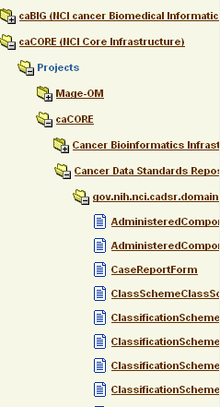
Below the Context level are branches that correspond to groupings of UML Models within the Context. Groupings can be any of the following types: Project, [optional Subproject], and Package
Top-level nodes in the tree correspond to Contexts in the caDSR.
Note: Click on a collapsed folder (
) to expand it.
Click the hypertext label to restrict your Class search to the UML Models in the selected group.

Click the hypertext label to restrict your search to the selected Class

Back to Help Topics

Search Results Table: UML Models meeting the specified search criteria display in the search results table.

The UML Models Search Results Table
UML Models that match your search criteria are displayed in the search results table.
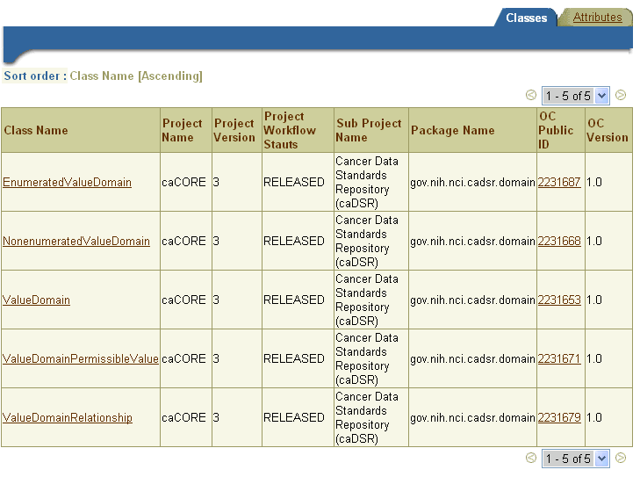
Displays the number of matching UML Models. A maximum of 40 records are shown on a page. When the record count is greater than 40, the search results are paginated across multiple pages.
Click on Class Name name to view its details
Clicking on the Object Class Public ID will open the caDSR Object Class browser with the details for the object class

Back to Help Topics

Viewing the Details of a UML Model : Class Search
The multi-tabbed UML Model Details page displays the details of the UML Model Class you have selected to review.
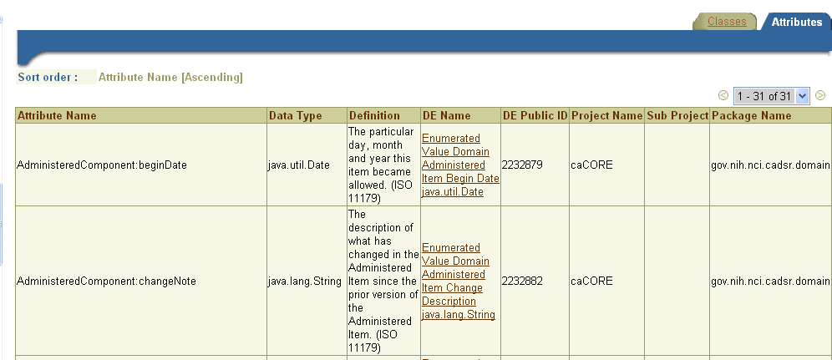
Attributes are shown as the detail for a Class search.
Clicking the Data Element (DE) name will link to the CDE Browser Data Element Details page for that Data Element

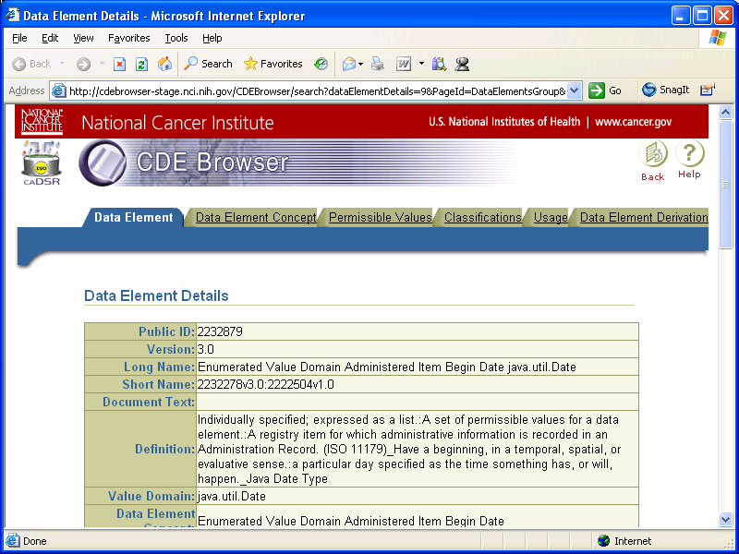

Back to Help Topics

Viewing the Details of a UML Model : Attribute Search
The multi-tabbed UML Model Details page displays the attribute names that match the search text provided. Enter the attribute name text (wilcards supported) and click the Attribute Search button.
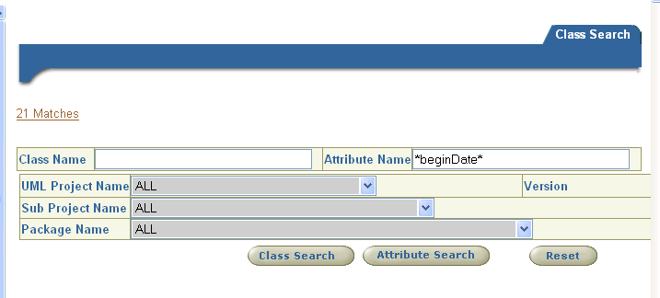
Enter the search text for attributes and click the Attribute Search button

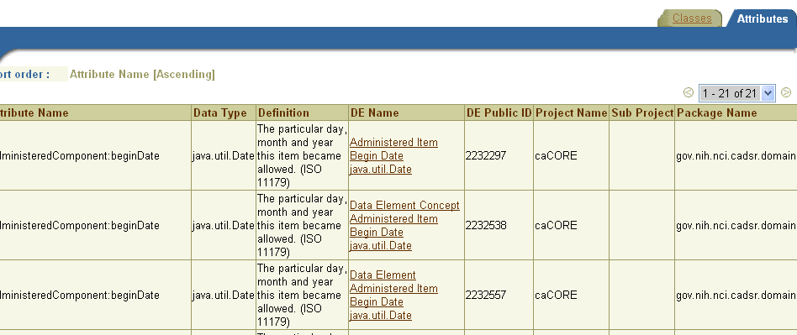
Clicking the Data Element (DE) name will link to the CDE Browser Data Element Details page for that Data Element

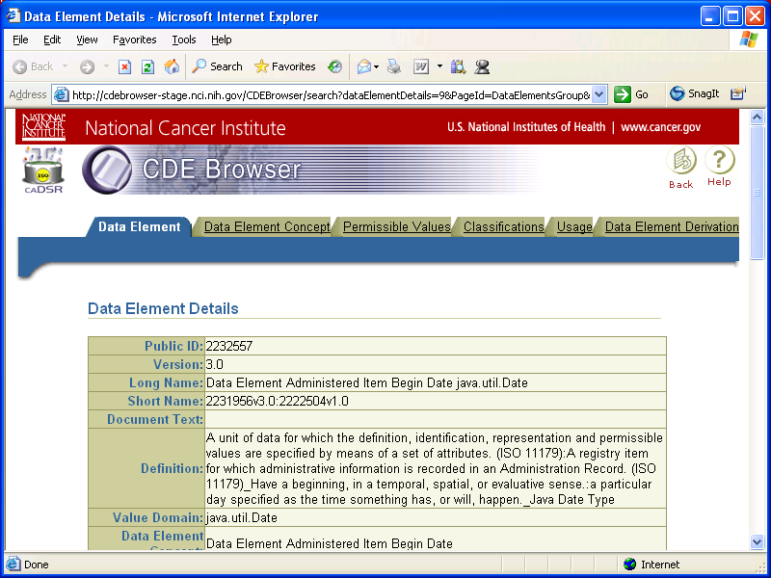

Back to Help Topics

