# ISB-CGC caNanoLab Project Local Development Notes

The isb-cgc forked caNanoLab project is at <https://github.com/isb-cgc/cananolab>

Since our code is mainly deployed on the Google Cloud, making it work locally needs some additional steps and workarounds for now. Here are some notes that may be helpful to get it working locally.

My environment is:

* OS: macOS Catalina version 10.15.7
* IDE: IntelliJ IDEA 2021.2.3
* Web Server: WildFly 23.0.2.Final
* Local DB: mysql Ver 8.0.26 for macos10.15 on x86_64 (Homebrew)
* I also use MySQLWorkbench to view and edit the local database

There are workarounds files needed. I checked them in a branch of master called “**master-local-deploy**”. I usually keep it up to date with master by pulling master and merging master into this branch. **But the workaround changes should not go back into master**. So I usually git checkout a new branch from this branch and make my changes. And when I am ready to create a PR, I will use a script to reset the not related workaround files to master’s version. This document is also checked into this branch.

## Steps:

**Sync and branch off “master-local-deploy”.**

**Prepare Local Database**

1. Create a local mySQL database called “canano”. Make its user name and password to be “root” and “password”. Or you can use other username and password, but make sure to update them in *software/cananolab-webapp/build.properties* file.
2. Import the test DB into this database by running:  
   > mysql -u root -ppassword canano < /db-scripts/2.4.0/UnitTest.sql
3. Sometimes you will get JDBC error when you log in caNano website locally. This happened to me when I restart my machine. You can run SET GLOBAL time_zone = '+0:00' in your mySQL terminal to fix it.

**Prepare WildFly local server:**

1. Download and unzip WildFly 23.0.2.Final from <https://www.wildfly.org/downloads/>
2. Make some changes to the unzipped WildFly version, because mySQL JDBC driver is not included by default:
   1. Copy “localDev/Local_JDBC_Setup/mysql/” folder to be under “WildFly23.0.2.Final/modules/system/layers/base/com/” It should look like this

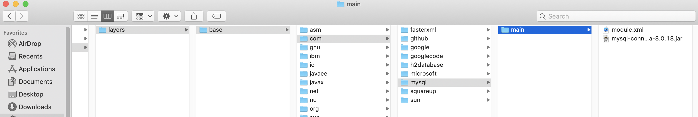

* 1. Copy the two xml files in “localDev/Local_JDBC_Setup” to “WildFly23.0.2.Final/standalone/configuration”. This will add the mySQL JDBC drivers to the configuration.

1. Run WildFly local server by:

WildFly23.0.2.Final/bin/>./standalone.sh --server-config=standalone-full.xml

The server should now run on localhost:8080. You can also run “WildFly23.0.2.Final/bin/add-user.sh” to add an admin user to the local server.

**Build and Deploy caNano code:**

1. Go to cananolab/software/cananolab-webapp, and run “ant deploy_local” there.

cananolab/software/cananolab-webapp> ant deploy_local

This will build the project and copy the artifact to a folder you define in **build.properties** and the property **file.repository.dir**

1. Sometimes you need to manually copy “software/cananolab-webapp/lib/mysql-socket-factory-connector-j-8-1.4.1-jar-with-driver-and-dependencies.jar” to your “local/content/artifact” folder. It will only need once.
2. Go to cananolab/software, and run “deploy-change.sh” there.

cananolab/software> ./deploy-change.sh”

This will deploy the artifact to your running WildFly server.

1. If it is success, you can open your browser and go to <http://127.0.0.1:8080/#/> to use the webapp.

**Development:**

1. Make code change in IntelliJ IDEA.
2. Do step 7-10 to test your change.
3. When ready, you can use this command to reset the files you do not want to merge into master:

git checkout origin/master -- $(<filesToRevert.txt)

filesToRevert.txt include each line of the file paths you want to reset to master’s version.

1. Make a PR to master.