TUS-CPS User’s Conference Supplemental Material

Phoenix, AZ 6/9/09
Hilary Tindle, MD, MPH

Unique Features of the 2003 Tobacco Use Supplement to the Current Population Survey: A Case Study of Switching to Lights and Incident Smoking Cessation

Co-investigators: Dr. Saul Shiffman, Dr. Anne Hartman, and Dr. James Bost
(Under Review, Tobacco Control)

Background and Introduction
Light cigarettes, also called “lights,” are used to refer to cigarettes that yield lower tar and nicotine when smoked in the Federal Trade Commission Cigarette Test Method. Lights were introduced in the 1960’s to target so-called “health conscious” smokers, and now make up almost 90% of the US market share. However, the totality of evidence supports no health benefits to smoking light cigarettes.[1, 2] At the same time, misconceptions about lights persist,[3, 4] and switching to lights to reduce health risk is also common.[5, 6] The prevalence of ever-switching has been repeatedly measured at about 30-40% of adult ever-smokers.[5, 6] Switchers express more interest in quitting[5, 7, 8] and make more quit attempts,[7] but prior evidence suggests that switchers are less likely to quit smoking.[3, 5, 6] Yet all prior studies were limited by the lack of information on reasons for switching to lights. Our aim was to assess reasons for switching and determine the association between switching to lights and 1) making a quit attempt and 2) successful smoking cessation. Our aim for this study was to replicate prior work from the National Health Interview Survey and broaden our inquiry using the 2003 Tobacco Use Special Cessation Supplement (TUS), which featured a larger sample size and additional questions on reasons for switching to lights. We then determined the association between switching to lights and 1) making a quit attempt and 2) successful smoking cessation.

Methods
The unique questions on lights in the 2003 Tobacco Use Supplement (TUS) allowed us to test the hypothesis that quit attempts and smoking cessation would vary by reason for switching to lights. Respondents who were ever-smokers (e.g., both current and former smokers) were asked, “Have you ever switched from a stronger cigarette to a lighter cigarette for at least 6 months?” Those who had ever switched were then asked if they switched for 1) harm reduction, 2) to quit smoking, 3) for better flavor, all possible combinations of these reasons, or none of these reasons. Analyses were restricted to ever-smokers who were smoking in 2002 and provided complete information in 2003, thus allowing a longitudinal assessment of making a 1) quit attempt and 2) smoking cessation between 2002 – 2003.

Results
There were 31,639 ever-smokers who reported in 2003 that they were smoking in 2002. Thirty-nine percent, or 12,238 of these reported that they had switched to lights at some point in the past, and provided reasons for switching. Figure 1 demonstrates the breakdown of reasons for switching among those who had ever switched. In this pie chart the slices correspond to the prevalence of switching to lights for each of 8 possible reasons (to quit smoking, harm reduction, flavor, quit smoking + harm reduction, quit smoking + flavor, harm reduction + flavor, all 3 reasons, and none of these reasons). The denominator of the pie is 12,238, or the 39% of the total sample who had ever switched. Flavor was the most common reason for switching. Many respondents indicated multiple reasons for switching to light cigarettes.

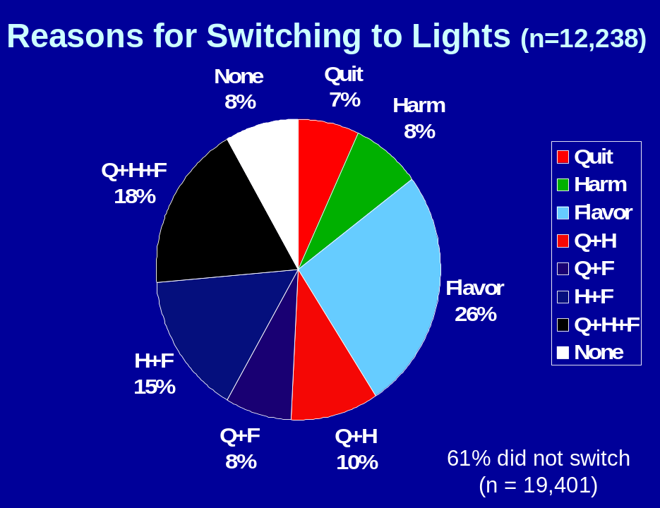

Switchers were also more likely to make a quit attempt (adjusted odds ratio 1.51, p < 0.01) but less likely to successfully quit smoking (AOR 0.43, p < 0.01) between 2002 and 2003. Adjusted odds of successful smoking cessation were markedly reduced among those who had switched to quit smoking (AOR = 0.29, p < 0.01) or for flavor (AOR = 0.46, p < 0.01), but not among those who had switched for harm reduction (AOR = 0.97, NS).

Conclusion
Ever-switching to lights was common, and was similar to what has been found from other large datasets.^{5,6} Overall odds of switching were markedly reduced among those who had switched to lights for any reason, also confirming our earlier results from the NHIS.[6]. The reduction in odds of cessation appeared to be driven by those who switched to lights to quit smoking and who switched to lights for better flavor. The 2003 TUS offered an unprecedented richness of questions on lights, as well as questions on other so-called “harm reduction” products. Other strengths of the dataset include its large size, national representation, and capability to link to items in the Current Population Survey. These and other unique features will be discussed during the conference today.

References
1. Benowitz, N.L., et al., Smokers of low-yield cigarettes do not consume less nicotine. N Engl J Med, 1983. 309(3): p. 139-42.
2. Harris, J.E., et al., Cigarette tar yields in relation to mortality from lung cancer in the cancer prevention study II prospective cohort, 1982-8. Bmj, 2004. 328(7431): p. 72.
3. Haddock CK, L.H., Klesges RC, Peterson AL, Scarinci IC, Modified Tobacco Use and Lifestyle Change in Risk-Reducing Beliefs about Smoking. American Journal of Preventive Medicine, 2004. 27(1): p. 35-41.
4. Shiffman, S., et al., Smokers' beliefs about "Light" and "Ultra Light" cigarettes. Tob Control, 2001. 10 Suppl 1: p. i17-23.
5. Giovino, G., Attitudes, Knowledge, and Beliefs About Low-Yield Cigarettes Among Adolescents and Adults. The FTC Cigarette Test Method for Determining Tar, Nicotine, and Carbon Monoxide Yields of U.S. Cigarettes, 1996. Monograph No. 7: p. 39-57.
6. Tindle HA, R.N., Davis RB, Barbeau EM, Kawachi I, Shiffman S, Cessation Among Smokers of "Light" Cigarettes: Results from the 2000 National Health Interview Survey. American Journal of Public Health, 2006. 96(8): p. 1498-1504.
7. Haddock, C.K., et al., An examination of cigarette brand switching to reduce health risks. Ann Behav Med, 1999. 21(2): p. 128-34.
8. Hyland, A., et al., Switching to lower tar cigarettes does not increase or decrease the likelihood of future quit attempts or cessation. Nicotine Tob Res, 2003. 5(5): p. 665-71.

