

Software Architecture Document
Version 1

September 10, 2003

Table of Contents
Table of Contents
1.Introduction 3
1.1 Definitions, Acronyms, and Abbreviations……………………………………………………………….3
2.Background 4
3.Architectural Goals and Constraints 4
3.1 Architectural Goals………………………………………………………………………………………..4
3.2 Architectural Constraints………………………………………………………………………………..5
4.Architectural Representation 6
4.1 Application Layers………………………………………………………………………………………….6
4.2 Design Patterns Applied to Application Layers………………………………………………………….7
5.Use-Case View 13
5.1 Introduction………………………………………………………………………………………………13
5.2 Pilot Release Use Cases…………………………………………………………………………………..13
6.Logical View 14
6.1 Subsystems…………………………………………………………………………………………………14
7.Deployment View 19
7.1 Deployment Diagram………………………………………………………………………………………19
7.2 Deployment Products and Framework Versions………………………………………………………..20
8.Data View 20

Figures

Figure 1. DESIGN_DOCUMENT_TEMPLATE Architecture Layers 7
Figure 2. General MVC System Flow 8
Figure 3. Presentation Layer Framework Sequence 11
Figure 4. DESIGN_DOCUMENT_TEMPLATE Pilot Use Cases 13
Figure 5. Case Management Subsystem Value Objects 15
Figure 6. Workflow Subsystem class model 16
Figure 7. Routing Sequence 17
Figure 8. DESIGN_DOCUMENT_TEMPLATE Conceptual Authorization Model 19
Figure 9. DESIGN_DOCUMENT_TEMPLATE Deployment View 19
Figure 10. Primary DESIGN_DOCUMENT_TEMPLATE database entities 21

Document Overview

Change Record
Date | Author(s) | Document  Version | Change Reference (Major Changes)

Reviewers
Name | Position | Document  Version | Date  Reviewed

Introduction
This document provides an overview of the DESIGN_DOCUMENT_TEMPLATE (DESIGN_DOCUMENT_TEMPLATE) encompassing architecture, design pattern usage, and high level module design. The application is being developed as a Java 2 Enterprise Edition (J2EE) application with defined presentation, business and data access (persistence) layers. It is intended to capture and convey the significant architectural decisions that have been made on the system. While the architecture may evolve based on the requirements of a given iteration, the baseline architecture to be followed is set forth in this document. The document also includes the functional design information, but is limited to functionality target for the pilot release.

Definitions, Acronyms, and Abbreviations
- caCORE (cancer core applications)
- DESIGN_DOCUMENT_TEMPLATE (DESIGN_DOCUMENT_TEMPLATE): Adverse events reporting system being developed for the National Cancer Institute Division of Cancer Prevention.
- CMP (Container Managed Persistence)
- DCP (Division of Cancer Prevention)
- DESK (DCP Enterprise System Knowledgebase)
- EJB (Enterprise Java Bean)
- EVS (Enterprise Vocabulary Service)
- J2EE (Java 2 Enterprise Edition): A specification from Sun Microsystems that defines a set of services and standards that conforming implementations must meet. J2EE encompasses many specifications all oriented to enterprise-focused needs. It defines a tiered environment for applications to produce standardized, reusable and modular software.
- JBoss – Open source Java application server
- JDBC (Java Database Connectivity)
- JDO (Java Data Objects)
- JavaServer Pages Standard Tag Library (JSTL)
- NCICB (National Cancer Institute Center for Bioinformatics)

Background
DESIGN_DOCUMENT_TEMPLATE is an adverse events reporting system designed for multiple purposes. First, it is designed to meet the adverse reporting needs of the Division of Cancer Prevention (DCP). Second, it will provide the J2EE foundation to which current Oracle-based DESK applications will be migrated to. Third, it is being designed to allow for customization since it will be released as open source on the NCICB web site. The DESIGN_DOCUMENT_TEMPLATE code base may be used to create separate versions or implementations of the base functionality. Because of this, application flexibility and extendibility is a priority. Fourth, DESIGN_DOCUMENT_TEMPLATE will integrate with caCORE and will be developed using Java and J2EE.

Architectural Goals and Constraints
This section lists goals and constraints of the architecture and how DESIGN_DOCUMENT_TEMPLATE is addressing or is affected by each.

Architectural Goals
1. Ensure the platform addresses enterprise level of service requirements: Performance, Scalability, Reliability, Availability, Extendibility, Maintainability, Manageability, and Security.
- While DESIGN_DOCUMENT_TEMPLATE will initially roll out to a small user base, it will be architected for much more demanding environments. DESIGN_DOCUMENT_TEMPLATE is able to meet several of the enterprise requirements by virtue of deploying on a complete J2EE application server. The J2EE specification and JBoss implementation address scalability, manageability and security. Scalability and availability are addressed using JBoss clustering. Manageability is addressed using JBoss’ Java Management Extensions (JMX) implementation. Security is addressed by the J2EE specification and JBoss implementation.
- The DESIGN_DOCUMENT_TEMPLATE code base will address the performance, reliability, extendibility and maintainability. J2EE design patterns and best practices will be utilized throughout the application.
2. Define clear application layers delineating architectural role and functionality
- A benefit of J2EE is that it defines a component-based architecture with specifications for each major architectural functionality
- DESIGN_DOCUMENT_TEMPLATE is designed using a layered architecture. Presentation logic is developed in the web container and business logic is developed in the EJB container. Within each container, objects have defined roles and responsibilities.
3. Integrate well with NCICB’s caCORE applications
- caCORE provides HTML, XML and Java interfaces to EVS and caBIO. DESIGN_DOCUMENT_TEMPLATE will access caCORE using its Java supplied interfaces.
4. Provide an expandable applications platform and a complete framework to which DESK applications can migrate to
- Because DESK applications will eventually move onto a J2EE architecture, utilizing the breath of the J2EE specification as part of the baseline architecture will allow later applications to take advantage of the most applicable J2EE service. Established NCICB applications were restricted to J2EE web container use due to the lack of viable open source complete J2EE implementations. Because that is no longer the case, a wider set of technologies is now practical to implement.
5. Utilize industry supported specifications and open source technologies whenever possible
- DESIGN_DOCUMENT_TEMPLATE is designed for the J2EE 1.3 specification. Sun Microsystems, in coordination with the Java community, publishes the J2EE specifications and vendors (including Sun) compete on the implementation. Many J2EE application servers are available in today’s marketplace. With NCICB’s commitment to open source technologies, the DESIGN_DOCUMENT_TEMPLATE team and NCICB have chosen to implement the application using the JBoss 3.2 J2EE application server, bundled with the Apache Tomcat J2EE web container. Because DESIGN_DOCUMENT_TEMPLATE’ code base is compliant with the specifications, if at some point NCICB or a cancer center prefers to move to another application server implementation, it is possible to migrate the application without major changes to the core code base.
- The DESIGN_DOCUMENT_TEMPLATE web application framework is implemented using the open source Apache Struts framework.

Architectural Constraints
1. A common NCICB authentication and authorization security module is in the early stages of design
- While a common and pluggable NCICB security module will aid the DESIGN_DOCUMENT_TEMPLATE architecture, it will not be available in time for the first DESIGN_DOCUMENT_TEMPLATE release. Because of this, the DESIGN_DOCUMENT_TEMPLATE security module will be very limited until the module is developed, unless time constraints force DESIGN_DOCUMENT_TEMPLATE to deploy to production in advance of the common module. At this time, it is not efficient to develop a comprehensive DESIGN_DOCUMENT_TEMPLATE-specific module before the common specification is complete.
2. The caCORE platform is in the process of maturing with several working groups in progress, including security, version control, UI standards and data harmonization
- As part of NCICB's common data element (CDE) harmonization effort, DCP is in the process of identifying and validating the CDE's within the DESK and DESIGN_DOCUMENT_TEMPLATE systems. This is an ongoing process, as the original DESK data model has evolved from the guidelines set by caCORE's Data Standards Repository (caDSR). Therefore, as the process for the curation (submission, review, approval, implementation, and maintenance) for CDE's within NCICB's csDSR becomes better understood, changes in the DESIGN_DOCUMENT_TEMPLATE data model will continue to be a factor after the initial release of DESIGN_DOCUMENT_TEMPLATE.
- NCICB is proactively determining how DESIGN_DOCUMENT_TEMPLATE and other applications must comply with data exchange and confidentiality standards such as HL7 and HIPAA. Because working groups are currently determining how to comply with the standards, DESIGN_DOCUMENT_TEMPLATE architecture does not reflect this input. In the future, its possible that the architecture or functional modules will need to be modified to comply with NCICB’s selected direction on these issues.
3. Database persistence options were influenced by the desire to utilize supported specifications and production-ready open source options
- J2EE applications have many options available for database persistence. Some options, such as CMP (Container Managed Persistence) EJBs are supported within the J2EE specification. Other options such as Java Data Objects (JDO) are published Java specifications but outside of the J2EE specification. In addition, developers can custom code a JDBC persistence layer or use an open source persistence project such as the Apache Object Relational Broker (OJB) or Hibernate.
Because DESIGN_DOCUMENT_TEMPLATE is primarily a transaction-based system implemented on a full J2EE application server, any of the above options could be used for persistence. Of these choices, JDO was an initially compelling candidate to review in detail. However, no compliant and reputable open source projects were found to offer compliant specifications. While the Apache Object Relational Bridge project provides a robust broker persistence architecture, its JDO implementation is Sun’s JDO reference implementation, which is not open source and not intended for production use. OJB’s underlying persistence framework is also a viable option and it is based on the Object Data Management Group (ODMG) standard. However, it is not yet widely used and there is no guarantee that a JDO compliant version will be released since it is open source and version 1.0 is only now nearing release.
Based on these factors and because a production-ready EJB CMP implementation available for use in JBoss, EJB CMP has been chosen for DESIGN_DOCUMENT_TEMPLATE persistence needs at this time. EJB 2.0 CMP provides reliability, maintainability and potential portability between databases. CMP is a supported persistence option in JBoss and it is part of the J2EE specification so J2EE application servers will support it moving forward. Since DESIGN_DOCUMENT_TEMPLATE will implement its persistence option behind an EJB Session bean, the persistence method utilized can also change later if needed.

Architectural Representation

Application Layers
The DESIGN_DOCUMENT_TEMPLATE architecture is based on a n-tier architecture that assigns responsibilities to separate application layers. This fosters a loosely coupled and tightly cohesive architecture in which objects in each layer are focused on specific architectural responsibilities yet cleanly integrate with the other layers.
The diagram below illustrates the following horizontally across the diagram.
- Logical Layer - the logical layer is implementation independent and defines the major application layers.
- Physical Implementation – the physical implementation of the logic layers in the DESIGN_DOCUMENT_TEMPLATE J2EE application are provided. In a J2EE web application, the main physical applications containers are the web container and the EJB container. Each are provided with the products being utilized.
- DESIGN_DOCUMENT_TEMPLATE Technologies – some of the major technologies used to implement each logic layer in the physical implementation are provided.

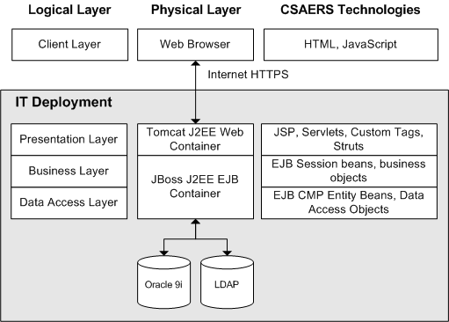
Figure 1. DESIGN_DOCUMENT_TEMPLATE Architecture Layers

Design Patterns Applied to Application Layers
This section of the document describes the architecture and the implementation within each application layer. The major products, frameworks and patterns used in the implementation are described. In addition, to review additional detail on the patterns and mechanisms, please review the Developer Guidelines document.

Client Layer
The DESIGN_DOCUMENT_TEMPLATE client layer will be implemented as a HTML web application. DESIGN_DOCUMENT_TEMPLATE will support the browser and user interface standards put forward by the NCICB User Interface working group and will incorporate NCICB’s 508 compliance guidelines. However, the interface in the pilot release may be incomplete regarding the guidelines since the working group is still in process and the team is working toward its delivery dates. Later releases will address any issues found with compliance in the first release.
Initial guidance is that browse support will include Microsoft Internet Explorer 5.x+, Mozilla 1.1+ and Netscape 6.0+ (Netscape is built on the Mozilla code base). Note that Netscape Navigator 4.x will not be supported.
The application client layer will utilize HTML and style sheets. To support a lightweight tabbed interface, it may also use JavaScript for submitting forms via a hyperlink. This approach will be compared to using image buttons for form submittal. JavaScript validations will not be completed in the browser.

Presentation Layer
The presentation layer will be developed on a J2EE 1.3 implementation using JSP, JSP custom tag and servlet technologies. The JBoss 3.2.1 application server bundles Apache Tomcat 4.1.24 web container in its implementation. In this default configuration, Tomcat and JBoss share the same JVM and Tomcat delegates J2EE authentication / authorization to JBoss services.

Web Application Framework Approach
DESIGN_DOCUMENT_TEMPLATE is using the Model View Controller design pattern implemented in the Apache Struts (http://jakarta.apache.org/struts/) web application framework. Model 2 is a term used to indicate that the web-adapted version of the classic MVC pattern is being implemented.

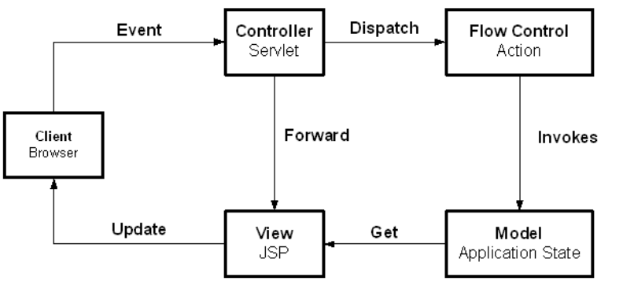
Figure 2. General MVC System Flow

MVC separates presentation-oriented responsibilities from application specific processing / controller responsibilities and business domain specific model. As a result, application maintainability is improved. In a MVC-based J2EE web application, JSPs are the “view” (web page presentation); a Java servlet is the “controller” and processes and delegates requests to Java components; and the “model” or business logic is implemented using business delegate Java objects with EJBs.
In addition to the Struts MVC implementation, DESIGN_DOCUMENT_TEMPLATE implements the J2EE Composite View Pattern (http://developer.java.sun.com/developer/restricted/patterns/CompositeView.html) using the Tiles framework distributed with Struts.
The Composite View pattern is used to combine modular, atomic portions of a web page view into a single, composite web page view. The component portions of the web page are maintained separately and combined to display the complete view to the user. Use of this pattern aids because a small set of common templates can be established that are utilized or extended for many web pages. At runtime, the template applies the atomic page components, such as headers or footers, to create the viewed page. With this approach, different and dynamic atomic view components can be combined into one complete page.
DESIGN_DOCUMENT_TEMPLATE is using this approach by creating the Tiles framework included with Struts to create dynamic views. The DESIGN_DOCUMENT_TEMPLATE framework creates several base layouts that are comprised of different JSP components. These layouts are extended for use in the actual page displays with the default tiles replaced with the appropriate tile for the given display.
In addition to Struts and Tiles, the web application will utilize the JavaServer Pages Standard Tag Library (JSTL) and will include additional custom tags to be implemented as needed. An example usage for a custom tag would be to provide a custom tag for the common security module that enables or disables text based on a role or privilege.

Additional Presentation Layer Design Pattern Usage
In addition to the MVC-based Struts framework used for View and Controller components of MVC, DESIGN_DOCUMENT_TEMPLATE will employ several other design patterns in the presentation layer. In a Struts application, the Struts controller calls Struts Action classes to perform processing in response to a screen display, link or form submit to the controller. Some applications code the business logic directly in the Action class. However, because DESIGN_DOCUMENT_TEMPLATE is using a layered architecture, the Struts Action class will only focus on the workflow of the application and will make business requests to classes associated with the business layer of the application.

Business Delegate Pattern
The business delegate pattern (http://developer.java.sun.com/developer/restricted/patterns/BusinessDelegate.html ) is used to reduce coupling between the presentation layer and the business (also known as model or domain) layer. The business delegate hides the underlying implementation and details for accessing business services. In a J2EE application, the delegate is somewhat like a proxy object in that it provides an interface accessed by its clients but it normally delegates its implementation to other classes. This is normally a EJB Session bean.
For DESIGN_DOCUMENT_TEMPLATE, the presentation layer executes in a J2EE web container and the business, model or domain layer is implemented in a J2EE EJB container. The business delegate allows classes running in the web application to execute the business services in a simpler approach. The delegate handles communication details such as JNDI lookup. The delegate can also encapsulate business layer decisions such as when to cache or retrieve data locally instead of going to business classes contained in EJBs. The presentation client does not need to be aware of these details.

Service Locator Pattern
The service locator pattern (http://developer.java.sun.com/developer/restricted/patterns/ServiceLocator.html) is used to hide the complexities of interacting directly with JNDI, EJB and JMS components. The service locator can re-use object instances and cache home objects as needed. As a result, the client logic needed to invoke these services is reduced. While the pattern itself is logically part of the business layer because its role is to access business services, it is often instantiated in the web container or other business layer client application.

Session Data Manager Pattern
A web application’s javax.servelt.http.HTTPSession object can be used to set and get objects specific to a user session. The session is convenient to access since it is accessible in each request. As a result, it is very easy to add or remove items to the session. This ease of use results in a lack of control over how the session is being used by developers. In addition, adding attributes to the session requires retrieving the key for the object. Instead of adding objects directly to the session, a Session Data Manager object is introduced that contains the logic to get and set objects from the session.
This lightweight object provides the application team with additional visibility as to how the session is being utilized because session objects are saved and retrieved from a central point. In addition, adding the wrapper provides a central way to change how session data is stored. For example, an application may wish to persist highly critical session data to a database or cache large session objects in an external cache and only store the session key in the session itself. This functionality is possible behind a Session Data Manager object.

Presentation Layer Sequence Diagram
The diagram below illustrates an example interaction between the major classes in the presentation framework. Please note that the sequence is drawn from a specification perspective to provide an overview of the normal sequence between these important classes.

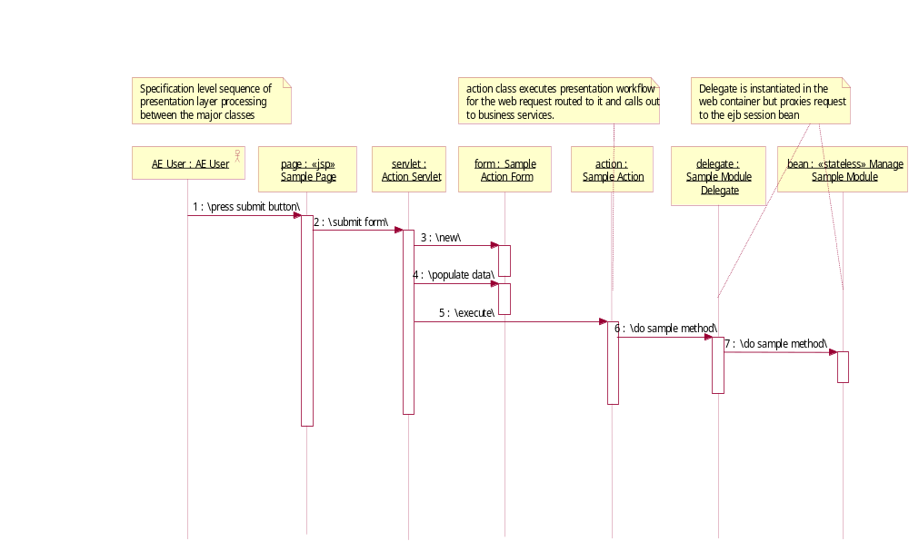
Figure 3. Presentation Layer Framework Sequence

Business Layer
The business layer executes the business logic of the application. The business layer is presentation independent because presentation-specific workflow is not built into these classes. As a result, it is possible to provide several separate presentations for the same application. caBIO takes this approach by providing Java, XML and HTML presentation options to the business classes.
DESIGN_DOCUMENT_TEMPLATE utilizes the JBoss EJB container to house the application’s business logic. In the typical scenario, the business delegate will call a stateless session bean acting in the Session Façade (described below) role. The façade will then delegate to the appropriate business classes that process the request and retrieve or store the data.

Session Façade Pattern
The session façade design pattern (http://developer.java.sun.com/developer/restricted/patterns/SessionFacade.html) is used to encapsulate the complexity of interactions between business objects in a workflow. The façade or boundary class, hides these interactions and provides a simpler, course-grained access to clients. As a result, coupling between business and presentation layers is reduced, transaction control is centralized, and fewer interfaces are exposed to the client.
The implementation of the session façade pattern often includes a stateless session bean itself and one or more business objects that execute the actual business processing. In this case, the façade is lightweight, performs security and other transaction services but delegates implementation of the method to a business object that interacts with other business objects or EJBs.
In DESIGN_DOCUMENT_TEMPLATE, course-grained domain modules expose their functionality via session façade stateless session beans in the EJB container. The presentation layer will have a business delegate boundary counterpart that interacts with the session façade.

Value Object Pattern
The J2EE Value Objects design pattern (http://developer.java.sun.com/developer/restricted/patterns/ValueObject.html) is used to encapsulate business data. It is frequently used when passing data from one application layer to another in order to provide generic and consolidated access to data from layer to layer. Value objects are generally lightweight, serializable and contain private data with public assessors.
In CSEARS, several types of value objects are used;
- Business Value Objects – DESIGN_DOCUMENT_TEMPLATE uses generic value objects to encapsulate business data transferred between the web layer and the business layer. These value objects contain no struts specific, JDBC-specific or EJB-specific information. They contain business data with the appropriate assessors.
- Entity Bean Value Objects – DESIGN_DOCUMENT_TEMPLATE generates values objects for each entity bean in the system. These values may be used to retrieve or set data to an entity bean in a bulk operation. In EJB 1.x implementations, entity beans required this design pattern to minimize the number of calls to entity beans. However, in EJB 2.x implementation, this pattern is not as applicable since local interfaces are used. Fine grain calls from the session bean to the entity bean are now practical. Use of the entity bean value objects is now more a matter of preference and convenience in the implementation.
- Struts Form Beans – In the presentation layer, a form of value object is used within the Struts web application framework. In Struts, the value object pattern is implemented using the name Form Bean. When displaying a page, Struts creates form beans and loads the bean with data in its action classes for display on the JSP. When processing a web request, Struts transfers the request’s parameters into a form bean for processing by the Action class. Note the form beans are specific to Struts and are only used within the Struts application classes.

Data Access Layer
The data access layer’s responsibility is to retrieve information from an external data store and return that information in a generic way. In DESIGN_DOCUMENT_TEMPLATE, the primary approach for this is via container managed persistence. Using

Data Access Objects Pattern
In DESIGN_DOCUMENT_TEMPLATE, the DAO pattern will be used to access the database using JDBC when entity bean access is not efficient or desirable.
The data access object pattern (http://developer.java.sun.com/developer/restricted/patterns/DataAccessObject.html) is used to encapsulate all access to a data source. While the object contains data source technology-specific logic in the object to interact with the external data source, clients are shielded from these details. Instead, clients typically provide and receive technology independent value objects containing the data.

Use-Case View

Introduction
Use cases and their related diagrams will be used to document the business and user requirements for DESIGN_DOCUMENT_TEMPLATE. Rational RequisitePro will be used to manage use case requirements and ensure traceability. In turn, Rational XDE will be used to develop detailed use case diagrams.
For each use case, the following components are described.
1. Brief Description – Describes the use case at a high level and its overall purpose.
2. Basic Flow of Events – Outlines the basic pathway of the use case, describing what the actor does and what the system does in response
3. Alternative Flows – Outlines the alternate pathways of the use case.
4. Subflows – Outlines the subflows within the use case.
5. Preconditions – Describes the conditions required prior to the use case for it to take place.
6. Postconditions – Describes the possible states that a system can be in immediately after the completion of a use case.
7. Extension Points – Describes the points of extension of the use case.
8. Special Requirements – Describes any nonfunctional requirements specific to the use case.
9. Use Case Requirements – Describes the functional requirements specific to the use case.
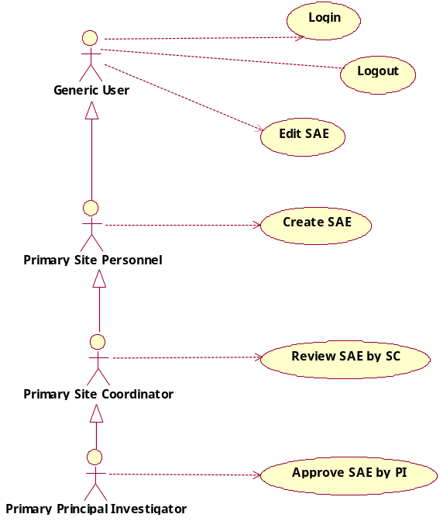
Figure 4. DESIGN_DOCUMENT_TEMPLATE Pilot Use Cases

Pilot Release Use Cases
The use cases supported in the Pilot release are shown in the diagram below.

Login User (Research Sites Only)
This use case describes the event of a user logging into DESIGN_DOCUMENT_TEMPLATE, accessing their home page and inbox. For each DESIGN_DOCUMENT_TEMPLATE user group, there is a corresponding home page and inbox. This use case details the basic flow of events for these different scenarios.

Create SAE
This use case identifies the process whereby Site Personnel conduct data entry of a new Serious Adverse Event Report (SAE) into the DESIGN_DOCUMENT_TEMPLATE system and route it to the Site Coordinator for review.

Edit SAE (Research Sites Only)
This use case describes the process whereby a user edits an SAE report and saves the changes.

Review SAE by Site Coordinator
This use case describes the process whereby a Site Coordinator reviews and indicates approval of an SAE Report from the study or protocol for which he/she is the coordinator, and routes it to the Principal Investigator for approval.

Approve SAE by Principle Investigator
This use case describes when a Principal Investigator reviews and indicates approval of an SAE Report from the study or protocol for which he/she is responsible, and routes it to the Regulatory Reviewer for review.

Log Off User
This use case describes the event of a user logging out of DESIGN_DOCUMENT_TEMPLATE.

Logical View
This section describes the significant functional subsystems and services in the application.

Subsystems

Adverse Event Case Management Subsystem
The AE Case management subsystem provides operations for persisting and retrieving adverse event case reports to the business layer. Queries for multiple case reports are executed here, as is straightforward retrieval by primary key or persistent storage of a case report.

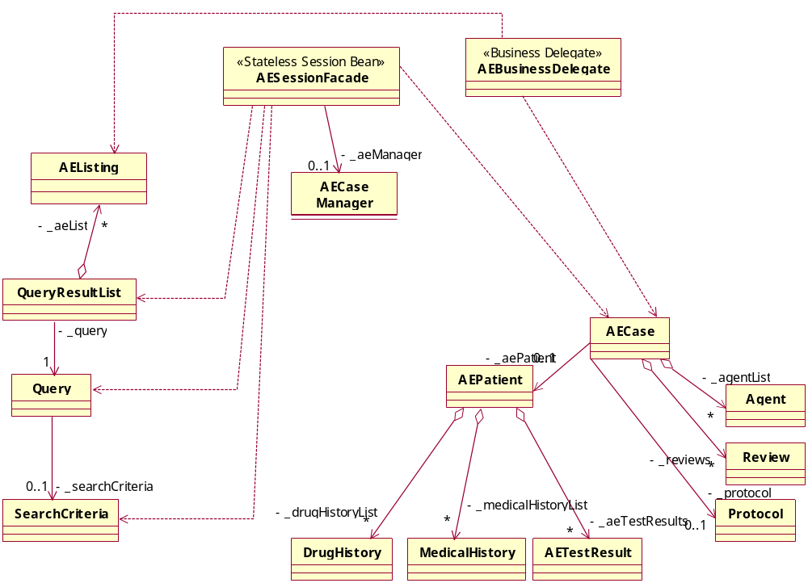
Figure 5. Case Management Subsystem Value Objects

The AE Case Management Subsystem contains the value objects that represent the contents of an adverse event case report form within the business layer, and some classes for object management and operations. These value objects are not tied to a presentation format or a persistence technique, and are therefore independent of both. They are used to communicate the case report data between the presentation and business layers.
The AESessionFacade class is an implementation of the Session Facade pattern (book ref?). It is used here to present a single point of access to the business operations that need to be performed on the value objects, and to hide the details of persisting and retrieving these objects between sessions. Examples of operations it will provide include creating, storing, retrieving, and routing adverse event case reports.
The AEBusinessDelegate class is an implementation of the Business Delegate pattern (book ref?). It provides a simplified interface to the business layer for the presentation layer. It actually resides within the presentation layer, but it is shown here in this diagram for clarity.
The query classes are designed to support future sharing and persistence of user queries. SearchCriteria objects contain the search criteria as specified and presented to the user. Query objects add the context needed to execute the query, taking into account the scope of data that the user is allowed to see. For example, a user might be limited to searching only those protocols to which he belongs. QueryResultList objects contain a list of small, lightweight objects that describe case reports at a high level, just enough information to distinguish them and display them to the user in a list format.

Routing and Workflow Management Subsystem
The routing and workflow management subsystem handles the workflow path of a case report over its lifetime. The workflow defines who should be in possession of and contributing to the content of a case report at any given moment, and who should receive ownership next. It also provides validation of the content of a case report, to ensure consistency and coherence.
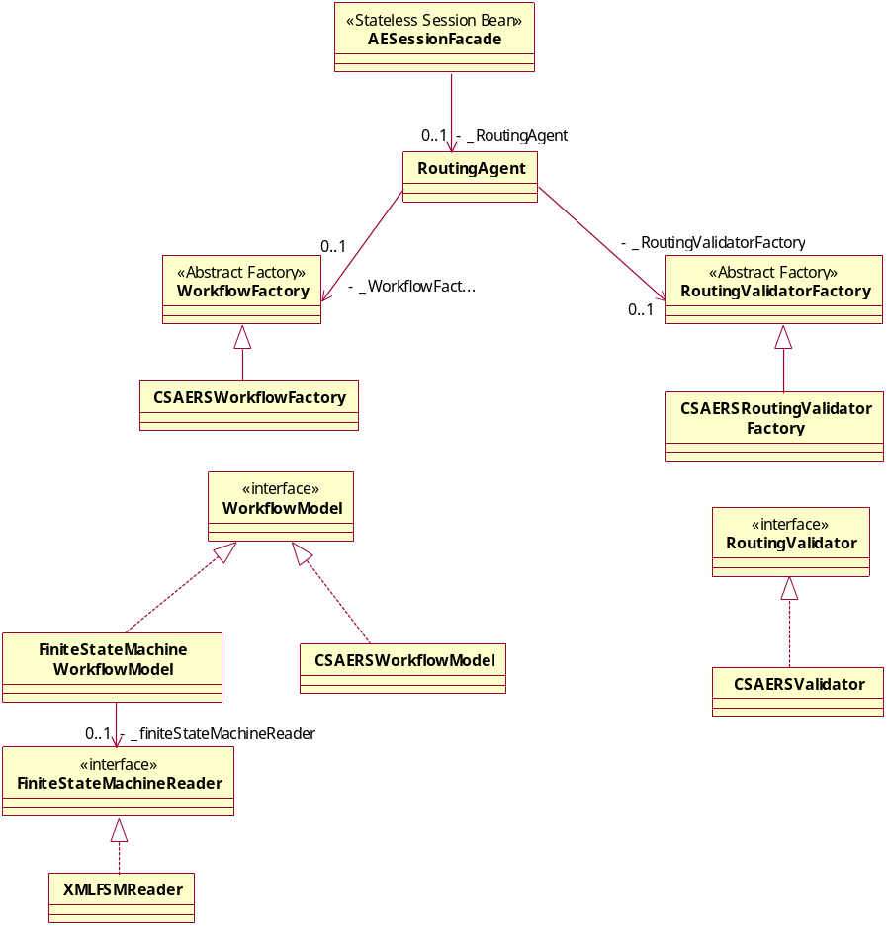
Figure 6. Workflow Subsystem class model

The workflow and routing subsystem is designed to be easily extensible with new workflow models, representations, and new validation strategies. The Abstract Factory pattern is employed here to separate the code that makes use of workflow operations from the implementation details that will differ from one installation to another.
A WorkflowModel implementation must support a certain basic structure. A workflow consists of states and actions that govern how an adverse case report form moves from one state to another. There are three types of actions: those that simply transition from one state to another (simple actions), those that transition back to the same state (reflexive actions) and those that can transition from any state to a well-defined state. Some additional data that supports contextualized validation (some actions require validation, some do not) is also present. There are also role assignments to states that are used to decide to whom a transitioned case report should belong.
We can implement a general, flexible workflow model with the State Machine pattern, and use an XML file for persistent representation. In the near term, we will implement a Java code-based workflow model to represent the DCP adverse event workflow.
A RoutingValidator implementation must be able to say, for a given case report in a certain state, whether or not the data within the case report is valid before performing a specified action. The method for doing this may vary. In the near term, we will implement this in Java code.
This framework supports the following routing technique:
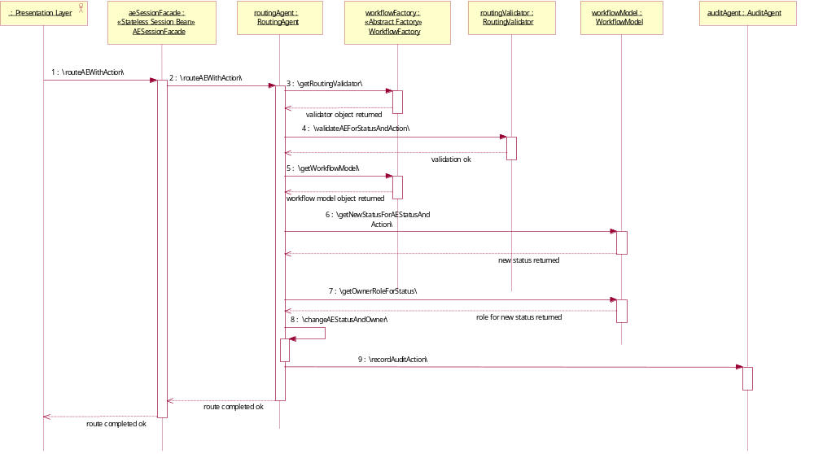
Figure 7. Routing Sequence

This technique will allow for flexible workflow definition, with any number of states, global and local actions, actions that may change the content of a case report without changing its state, any degree of validation from simple consistency checks to complex analysis. It isolates changes in workflow from the rest of the system, so another group can easily deploy a new workflow.

Security Module
DESIGN_DOCUMENT_TEMPLATE will be a secure application that integrates with the NCICB authentication infrastructure. While the existing Oracle-based DESK application authentication and authorization services are tightly coupled to the database, DESIGN_DOCUMENT_TEMPLATE will use an approach that leverages the institute-wide LDAP directory service. While for the time being this means that the users will be required to maintain one password for the Oracle-based DESK applications and one for DESIGN_DOCUMENT_TEMPLATE, the DESIGN_DOCUMENT_TEMPLATE user id and password combination is stored in LDAP and many future NCI applications will leverage this approach. In addition, use of NCI’s LDAP infrastructure will support internal and external users across Java and non-Java applications.

JBoss is flexible in regards to authentication and authorization. It supports both LDAP and database authentication mechanisms. For the pilot, DESIGN_DOCUMENT_TEMPLATE will not likely use either approach since the security working group is currently meeting to determine the best approach to use across teams. A simple text file approach for user ids, passwords and roles will likely be used. This approach is fully supported in JBoss when teams are in development and require simple J2EE authentication. The LDAP approach will be introduced based on a review of the DESIGN_DOCUMENT_TEMPLATE schedule and the common security module’s schedule.

Application authorization is a DESIGN_DOCUMENT_TEMPLATE requirement that will also be dependent on the common security module to be developed based on the security working group’s application. The DESIGN_DOCUMENT_TEMPLATE team was originally going to develop a common authorization module to be used across DESIGN_DOCUMENT_TEMPLATE and future DCP J2EE applications. However, because other teams have similar needs, a common module among teams will be developed. The DESIGN_DOCUMENT_TEMPLATE team has been contributing to this effort.
DESIGN_DOCUMENT_TEMPLATE has the authorization needs to be addressed by the security module:
1. Security service is comprised of both a runtime authorization component and a user-provisioning module for adding users to the system.
2. Module allows user to be associated to multiple applications.
3. Each application may be configured to support one single role or multiple roles.
4. Each role assigned to a user can be filtered by other data (e.g.: administrator role assigned to user Joe for Rockville office 1234 only).
5. Role and privilege information is retrieved by an application using the data filter.
6. Multiple application roles can share privileges.
7. Application clients can choose to store role-only information or role/privilege information in the module.
8. Support Web container, EJB container and client application access to the security module.
9. Applications must log into the security service. Applications can only access user information specific to their application. They cannot access user information for other applications.
Using the authorization security service application, DESIGN_DOCUMENT_TEMPLATE will provide an application security client that addresses DESIGN_DOCUMENT_TEMPLATE application requirements. DESIGN_DOCUMENT_TEMPLATE will likely log into the common security application on startup and retrieve the application’s role and privilege, which will be stored application-wide. Use-specific information will be retrieved on each user’s login. Programmatic security will be completed locally using the retrieved objects.
1. User roles and authorizations are protocol-based.
2. Declarative security will be used for access. When DESIGN_DOCUMENT_TEMPLATE only require role-based checks, declarative security can be used.
3. For protocol-specific security checks, programmatic security will be executed. User id, role and privilege information will be checked by protocol to determine access.
4. JSP custom tags will be used to check for roles and/or privileges in the web application. Tags should include or exclude content based on result of security checks.
The diagram below illustrates the DESIGN_DOCUMENT_TEMPLATE conceptual database design presented to the working group. The actual database design will differ from this conceptual model but the common model incorporates role, privilege, user and data filter concepts.
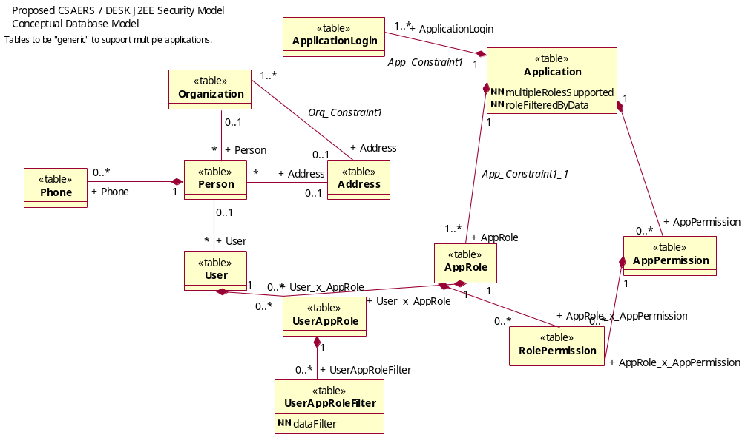
Figure 8. DESIGN_DOCUMENT_TEMPLATE Conceptual Authorization Model

Deployment View

Deployment Diagram
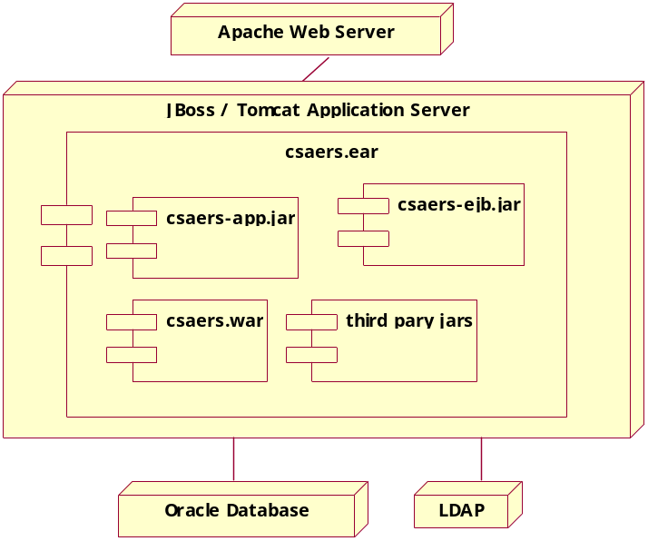
Figure 9. DESIGN_DOCUMENT_TEMPLATE Deployment View
DESIGN_DOCUMENT_TEMPLATE will deploy using standard J2EE practices. When moving to production an EAR file will be provided that is deployed to the JBoss application server. The EAR file contains the following components:
- DESIGN_DOCUMENT_TEMPLATE-app.jar – All general DESIGN_DOCUMENT_TEMPLATE application logic non-specific to an application layer is contained in the app jar.
- DESIGN_DOCUMENT_TEMPLATE-ejb.jar – Contains the DESIGN_DOCUMENT_TEMPLATE EJB-specific classes and supporting classes
- DESIGN_DOCUMENT_TEMPLATE.war – Contains the DESIGN_DOCUMENT_TEMPLATE web application-specific classes and web server document classes.
- third party jars – All third-party jars used by the application are also loaded in the EAR file. No third party jar files are contained in the ejb jar or war files. Instead, the manifest files of each component references the dependent jars, which are contained directly in the EAR file.

Deployment Products and Framework Versions
DESIGN_DOCUMENT_TEMPLATE implements the following APIs and versions. As new versions are released or are supported by NCICB, the products will be updated after a determination that the versions do not cause problems in the application.
Name | Version | Provider | Description
Java SDK | 1.4.1_X | Sun Microsystems | JDK that the application runs. Deployed version dependent on NCICB standard at time of deployment. (java.sun.com/j2se/1.4.1/index.html)
Java J2EE Specification | 1.3 | Sun Microsystems | J2EE specification version supported in JBoss 3.2.1. Note: This is a specification included in JBoss
JBoss | 3.2.1 | JBoss Group open source | J2EE application server. (www.jboss.org)
Tomcat | 4.1.24 | Apache open source | J2EE web container that ships integrated with JBoss. (jakarta.apache.org/tomcat)
Struts | 1.1 | Apache open source | Web application framework (jakarta.apache.org/struts)
Commons | various | Apache open source | Common utilities required by Struts and utilized by DESIGN_DOCUMENT_TEMPLATE. Includes: beanutils, collections, digester, logging
JSTL | 1.0.3 | Apache open source | Apache implementation of Sun JSTL specification
JDBC | 9i | Oracle | All Java driver for Oracle database
LDAP | TBD | Novell | NCICB authentication (to be used in later release)
Log4J | 1.2.7 | Apache open source | Logging API. Also used by JBoss
Velocity | 1.3 | Apache open source | Development use for generating Java classes
xdoclet | 1.2b3 | SourceForge open source | Development and build use to create EJB classes and descriptors

Data View
DESIGN_DOCUMENT_TEMPLATE will store its persistent data in an Oracle 9i database. The data model is based on the MEDWatch form for Adverse Event Reporting and the database will be E2B compliant. The DCP implementation will retrieve protocol and patient information on a read-only basis from related DESK systems. This data is retrieved views
The primary approach for persisting and retrieving information will be EJB 2.0 CMP. When queries require SQL that EJB-QL does not support, standard SQL JDBC will be used for select. Regardless of the persistence method, the persistence layer will be located behind a session façade bean and all data will be returned using value objects created provide independence from the persistence mechanism. Because of this, the persistence approach can be changed without impacting the web application client.
Below is an entity relationship diagram displaying the primary classes in the DESIGN_DOCUMENT_TEMPLATE data model. Many lookup and other secondary tables have been excluded in the diagram to focus on the main database entities in the system.
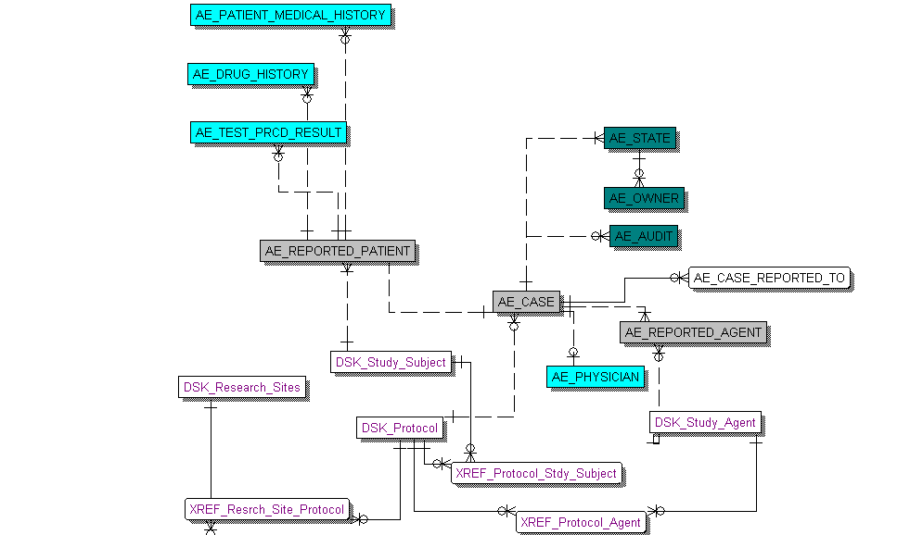
Figure 10. Primary DESIGN_DOCUMENT_TEMPLATE database entities

Data Model Summary Points
        - AE_CASE is the primary table in the application. This corresponds to an adverse events case.
        - AE_REPORTED_PATIENT captures event-specific patient information and links to a patient already associated with the protocol. Any medical history, drug history or procedure information related to the event is captured in the associated tables.
        - An adverse events case has a workflow in which the case goes through several reviews and approvals. AE_STATE tracks each step in the process. AE_OWNER is used because a case can be re-assigned while in a given state.
        - AE_REPORTED_AGENT captures agent information for the reported event. The agent is also linked back to protocol.
        - Tables prefixed with DSK_ represent DESK-related information that is read-only from DESIGN_DOCUMENT_TEMPLATE standpoint. This information is obtained from DESK or from other applications. Views are provided in the DCP implementation. Tables would be used in an open source implementation when DESK information is not available for integration from another system.

