
Common Security Module
Reference Implementation Guide

Version No: 0.2
Last Modified: 2/24/05

Author : Vinay Kumar, Eric Copen, Kalpesh Patel
Team : Common Security Module (CSM)
Purchase Order# 34552
Client : Nation Cancer Institute - Center for Bioinformatics,
National Institutes of Health,
US Department of Health and Human Services

Document History

Document Location
The most current version of this document is located in CVS under security/docs.

Revision History
Version Number | Revision Date | Author | Summary of Changes
0.1 | 2/24/05 | Vinay Kumar, Eric Copen, Kalpesh Patel | Initial Table of Contents

Review
Name | Team/Role | Version | Date Reviewed | Reviewer Comments

Related Documents
More information can be found in the following related CSM documents:

Document Name
CSM Guide for Application Developers
UPT User Guide
These and other documents can be found on the CSM website: http://ncicb.nci.nih.gov/core/CSM
Table of Contents
1. Introduction 4
2. Objective 4
3. Executive summary 4
4. The RI application 4
5. Installing the application 4
5.1 System Requirements 4
5.2 Downloading the Reference Implementation 4
5.3 Installing the MySQL Database 4
5.4 Installing the Java 2 Platform, Standard Edition 4
5.5 Installing JBoss Application Server 5
5.6 Deploying the Reference Implementation Application 5
5.6.1 Deploying the WAR file 5
6. Installing the authorization schema 6
7. Configuring the environment 6
7.1.1 Configuring the properties files 6
8. Business scenario (Introduction to the application) 7
8.1 Use case model 8
8.2 Description of use cases 9
8.3 Business rules 9
8.4 Security requirements 9
9. Using the RI application (ABC) 9
10. Using UPT to administer security for the RI application 9
11. Implementation of business scenarios using CSM 9
11.1 Use of three managers in RI 9
12. The best practices 9
13. Things to avoid 9
14. Appendix 9

CSM Reference Implementation Guide

Introduction

Objective

Executive summary

The RI application

Installing the application

System Requirements
The instructions assume you will be deploying and executing the Reference Implementation application on a Windows platform. The instructions given in this document are also applicable, to a great extent, to a UNIX/Linux platform.
The core software requirements:
- MySQL Database (version 4.0 recommended)
Installation
- J2SE 1.4.2
Installation
- JBoss Application Server (version 4.0 recommended)
Installation

Downloading the Reference Implementation

  - Download and save the CSM_RI_rel_3.0.zip file containing the Reference Implementation application files.
  - Extract the zip file into a folder of your own choosing, such as c:\CSM_RI. The path to this folder will be referred to as: “[REFIMPL_HOME]”

NOTE Instructions for deploying the Reference Implementation are provided in Section 7, Deploying the Reference Implementation Application.

Installing the MySQL Database
- Download and save MySQL database http://www.mysql.com/downloads/mysql-4.0.html
- (Optional) Download and save MySQL Control Center zip file for Windows from http://www.mysql.com/downloads/mysqlcc.html
- (Optional) Install MySQL and the Control Center by following the instruction from http://www.mysql.com/doc/en/index.html.
- Below are the steps and the SQL script that will create the proper database and associated tables:
  - Run “database_install.bat” found in the [REFIMPL_HOME]\db folder. Before running, you may need to modify the script to point to your [MYSQL_HOME] installation directory. This will create the app_grants_gov database and associated tables.
  - If you are NOT using the default installation of the MySql database then you MUST:
    - Modify the script to use a valid a user name and password for the mysql database.
    - GRANT access to the database for the user of choice.

Installing the Java 2 Platform, Standard Edition
- Go to http://java.sun.com.
- Click on the “J2SE (Core/Desktop)”.
- On the next page, click on the “J2SE 1.4.2” link.
- On the download page, click on the “Java 2 Platform, Standard Edition version 1.4.2” link for Windows.
- On the next page, click on SDK “Download” to the right of the “32-bit/64-bit for Windows/Linux/Solaris SPARC 32-bit for Solaris x86” field.
- Go to the bottom of the next page and click on the “ACCEPT” radio button.
- Download and save the .exe file. This file will take a bit longer to download due to its size.
- Create a java directory on your C:\ drive (i.e., c:\java). You can also choose a location where you normally install your Java 2 Platform software.
- Find and execute the file that was downloaded. Install j2sdk into the directory you have created/selected in step 9. The path to your installation directory is referred to as: “[JAVA_HOME]”.
- Create an Environment variable for Java from Control Panel→System→Advanced with “Variable Name” of JAVA_HOME and “Variable Value” of “c:\java\j2sdk1.4.2_05” (i.e., the path to the folder where you installed J2SE 1.4.2).

Installing JBoss Application Server
- Go to JBoss.org and download version 4.0 of the application server.
- Install JBoss according to the instructions. For documentation see this site.

Deploying the Reference Implementation Application
The Reference Implementation application is being provided as Web Archive (WAR) files. Installation of the reference implementation is straight forward and involves deploying the war files and modifying some configuration properties. The next two subsections explain this process in greater detail.

Deploying the WAR file

To deploy the war files copy the csm-ri.war from the [REFIMPL_HOME]\build folder to the following folder: {jboss-home}/server/standard/deploy. The application files will automatically be deployed upon the next startup of JBoss. To start JBoss go to {jboss-home}/bin and double-click on run.bat.

Installing the authorization schema

Configuring the environment

Configuring the properties files
Configure the following property files for the reference implementation.

Property File | Location | Description | Modifications
soap_server.properties | <tomcat>\webapps\app-s2s-client\WEB-INF | Defines properties for connecting to the applicant s2s server | By default, the application is configured to connect to localhost:8080. Modify the SOAP_HOST property to connect the client to a different IP address or hostname (computer name)  The ENCODING_TYPE property controls the SOAP attachment encapsulation format (DIME or MIME). The default is DIME.  In addition, SSL configuration properties are contained within this property file. See Section 9. for more information about ssl configuration.
application.properties | <tomcat>\webapps\app-s2s-server\WEB-INF | Defines the properties for connecting to the mysql database | By default, the application is configured to connect to the MySql database on localhost:3306.  If the MySql database is installed on a separate host or port then modify the DB_URL property.  If the target MySql database requires a user name and password then modify the  DB_USER_NAME and DB_PASSWORD properties.  PRODUCTION_MODE property should ALWAYS be set to ‘false’ for RI users
log4jConfig.xml | <tomcat>\webapps\app-s2s-client\WEB-INF  and  <tomcat>\webapps\app-s2s-server\WEB-INF | Defines the configuration for Apache Log4J | To create the log4j debug files, the value of the “File” parameter MUST be modified to specify a valid directory and file name on the host machine.  Below is the default setting:  <param name="File" value="C:/tomcat/jakarta-tomcat-4.1.30/logs/app-s2s-client-debug.log"/>

Business scenario (Introduction to the application)
The Employee Records System allows HR, managers, and employees to access and modify employee records that include demographic and personal information. The application limits access based on the user’s relationship to the record – employing permission checks on the element or attribute level. Because the application requires fine-grain security it effectively exhibits the capabilities of the Common Security Service.
Functional Requirements
Record
- Create
- View
- Modify
- Delete
- Search
Project
- Create
- Associate project with employee
- Remove project/employee association

Employee Record
The employee record consists of the following:
- User name
- Password
- Last name
- First name
- Middle initial
- Street address
- City
- State code
- Zip
- Phone number
- Email address
- Social Security Number
- Salary
- Business Unit
- Management indicator (yes or no)
- Assigned Projects
- Available Projects

Use case model
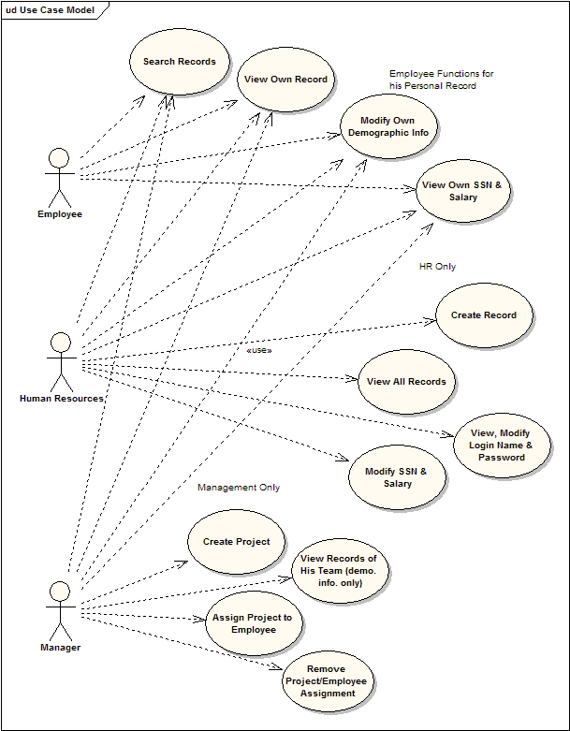

Description of use cases

Employees, whether they are HR managers, managers, or regular employees, can only access the information they need and can only perform the operations their function necessitates. For example, only an HR manager can create an employee record. Only a manager can create and assign projects to the employees that report to him or her. The below use cases are grouped by function:
Regular Employee
- Search records
- View own record including SSN & Salary
- Modify own demographic information

HR Manager
An HR Manager possesses the same rights as a regular employee, and can also:
- Create a new record
- View the records of all employees
- View and modify a user’s login name and password
- Modify a user’s Social Security Number and salary

Manager
The ABC Toy Company has three primary managers for IT, Human Resources, and Business Deveopment. Along with the same rights as a regular employee, these managers can also perform the following team management functions:
- Create a new project with a description
- View records of those employees on his/her team
- Assign projects to employees
- Remove projects from employees (unassign)

Business rules

Security requirements
Within any company and ABC Toy Company in particular, demographic, personal, and compensation related information needs to be secure. Imagine the consequences if an employee could view or even change salaries. This could potentially cause chaos and have both immediate and long-term consequences including lost pay, bitterness, turnover, etc. Identity theft is also a concern with the Social Security information the Employee Records System holds. Keeping these concerns in mind, ABC has identified the following major security requirements:
Regular Employee
A regular employee can not:
- Modify her own SSN and Salary
- Modify his project assignments
- View or modify any other record but his own
- Create a record
- Create a project

HR Manager:
HR Managers can update the information in every record except project assignments. SSN and salary pose two unique problems which are resolved creatively. Although an HR manager should be able to update a new SSN and/or salary, they should not have access to view this information if not necessary. Therefore in the ABC Toy Company application HR managers can not view the prior entered data but they may enter in newly acquired information and update the record. The employee will see the new SSN or salary when she opens her record.
HR Managers can not:
- View previously entered SSN and salary fields
- Create a project
- Modify project assignments

Manager
Managers can not:
- Create a record
- View or modify records of those employees not on his team
- View the SSN and salary of those on the team
- Modify team record information other than project assignments

In addition to these security requirements, the Employee Records System has the following general security requirements:

Using the RI application (ABC)

Using UPT to administer security for the RI application

Implementation of business scenarios using CSM

Use of three managers in RI

The best practices

Things to avoid

Appendix

