

Software Architecture Document
Version 1.1

May 27, 2005

Table of Contents
Table of Contents
Table of Contents ii
Document Overview 4
Change Record 4
Reviewers 4
Introduction 5
Purpose 5
Definitions, Acronyms, and Abbreviations 5
caCORE SDK 6
Background 6
Problem Scenario 6
Proposed Solution 7
Session Management : Where is the User ? 10
Step toward Write APIs and Transaction Management 13
Simple Writable APIs (SWA) 13
Putting it all Together 14
Components 16
Environment 17
Scope 18
In Scope 18
Out of Scope 18
SDK Integration Design 19
Changes to the OR Mapping file 19
Changes to the generated ApplicationServiceProvider Class 19
Changes to the generated Domain Objects 20
Merging of the ListProxy and SDKListProxy 20
Merging of the ApplicationService and SDKApplicationService 21
Introducing a Writable Flag 22
Setting the Security Off by Default 23
Merge the build process 24
Secure Business Methods at the Object as well as Method Level 24
Merge and Code Clean 25
Enhance the Error Reporting Mechanism 25
Add Methods for XML Communications 26

Document Overview

Change Record
Date | Author(s) | Document  Version | Change Reference (Major Changes)
 | Vinay Kumar | 0.1 | Initial draft
5/17/05 | Eric Copen, Satish Patel | 1.0 | Text changes and formatting
5/27/05 | Eric Copen | 1.1 | Conversion to NCICB template
9/29/05 | Kunal Modi | 1.2 | Changes for the 3.1 Release – Added SDK Integration section

Reviewers
Name | Position | Document  Version | Date  Reviewed
Satish Patel | caMatch/Developer | 0.1 | 5/17/05
Eric Copen | QA/Developer | 0.1, 1.0 | 05/13/05, 5/17/05

Introduction
caCORE SDK follows the Model Driven Architecture (MDA) approach. It automatically generates a set of APIs from the model defined in UML. This design document highlights some of the enhancements that should be introduced in SDK to make it more usable, including session management, writable APIs, and CSM Security.

Purpose
The purpose of this document is to propose the design solution to introduce the writable APIs with CSM enabling of SDK.

Scope
This document now reflects design changes for the CSM 3.1 release. The major design addition is SDK Integration, which describes in detail how CSM will merge the CSM-SDK Adaptor into the SDK, resulting in a single product with a single build file.

Definitions, Acronyms, and Abbreviations
- AOP – Aspect Oriented Programming
- CSM – Common Security Module
- SDK – Software Development Kit
- API – Application Programming Interface
- EA – Enterprise Architect, a tool for UML modeling
- MVC – Model-View-Controller, a design pattern
- BO – Business Object

caCORE SDK

Background
Currently the caCORE SDK generates the set of APIs for the server and client side. The server side APIs run behind a HTTP server which has a proxy interface for querying the data. The proxy interface has only one method called “query”.
The “query” method takes a request as a parameter and sends the response with the result of the query.

Request
Response
HTTP Server

API.jar
Client

Figure 1 Existing Architecture

Problem Scenario
The present architecture supports only one method though a proxy interface, however more methods can be introduced. Therefore, the interface definition has to change. There might be different types of business requests sent to the HTTP server. Depending upon the type of business request, there could be number of methods introduced in the proxy interface. These methods can be processed by implementing a number of if/else statements or a command pattern for handling these requests.

Proposed Solution
There is a front controller pattern that can solve these kinds of problems. Please see the picture below:

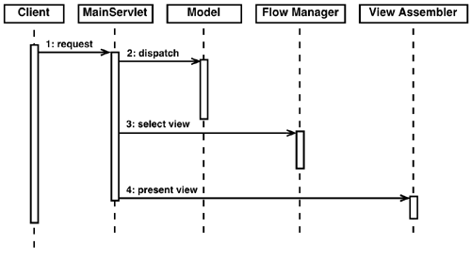
Figure 2 Controller Pattern

Approach

There are two ways to implement the Front Controller Pattern. The first option is to create a self-developed implementation of this pattern. The advantage is no dependence on an external framework. The second, preferred option is to use an existing framework that provides the necessary capability – Struts. Struts is a framework based on the MVC pattern (Model-View-Controller). caCORE SDK can customize the Struts implementation to disregard the View layer since it is not needed, but use the Response layer. The Response layer will react dependent upon the incoming request.

Advantages
Using Struts we can gain central control of request handling. This is a crucial part of the design; where we can embed the user information for SECURITY CONTEXT in the current thread. This way at any point during method execution, we have access to the caller of the code. This will help us decide if the caller can perform that operation. Please refer to the figure below:
Client
Controller
Session
Request
getUser
Embed in Thread
:business_Object
CSM
Check authorization

Figure 3 Embedding of User Information

When the request comes from the client to the Controller, the user information which was stored in the Session earlier, can be embedded in the thread (LocalThread); it can be retrieved at a later stage without depending upon Request or Session. This will decouple the business layer from any HTTP-specific dependency.
Just before the business method is called, an interceptor will intercept the execution and first check if this method can be called by the caller. If the caller is authorized then it will execute the method, if not it will just return a security exception. This can be achieved with security Aspect. This way the business layer does not need to handle the security explicitly.
See the below diagram for more details:

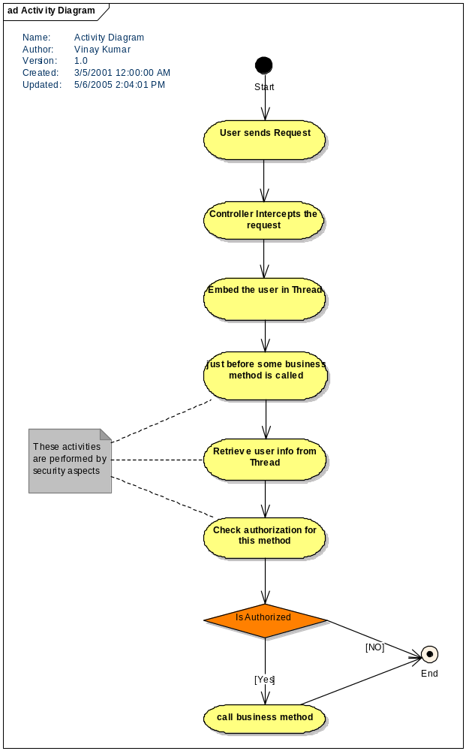
Figure 4 Activity Diagram

Session Management : Where is the User ?
The generated APIs can be hosted in some web container, if not the application server because the entry point is a servlet. If you are using the servlet then we can make use of the HTTP session for session management. However, since the client is an application and not a browser, it becomes cumbersome to support the server-side sessions.
To resolve this problem, we can make use of HTTPClient project from Apache Software Foundation. This is an open-source project that provides very rich APIs to manage HTTP protocol from client-side. There are multiple ways to manage sessions on the server-side, including cookies, hidden fields, URL rewriting, etc. Since we are handling HTTP requests from an application, with the help of HTTPClient, we can make use of cookies to assist with session management. A unique session key can be generated from the Controller for each client when a request for login is made. The generated session key can be sent to the client in the form of a cookie or an object, and used in the subsequent calls to track user session.
But still the issue of user context propagation remains unsolved. The code below demonstrates how we will solve the problem of user context propagation:

Utility code:
public class MethodExecutor {
private static final ThreadLocal threadLocal = new ThreadLocal();
public static User getInstance() {
User identity = (User) threadLocal.get();
}
public static void init(User user) {
threadLocal.set(user);
}
public static void release() {
threadLocal.set(null);
}

Controller code:
User user = (User) session.get("user");
MethodExecutor.init(user);
Call to the business object methods:
(This is called just before returning the response to the user)
MethodExecutor.release();

Security Aspect code:
User user = MethodExecutor.getInstance();

A proxy layer called Remote Service Layer will be provided to keep track of the user with every request coming in. This layer in turn will call the real application service layer.
Application service interface and RemoteService interface may look like this:

Public interface ApplicationService {
Public Patient createPatient(Patient pt);

Public void removePatient(Patient pt);
}

Public interface RemoteService{
Public User login(String userId, String password);

Public Patient createPatient(Patient pt, String sessionId);

Public void removePatient(Patient pt, String sessionId);

}

Client Application

mgr.createPatient()
Client Proxy
makeRemoteObject()
sendRemoteObject()
getRemoteObject()
returnBusinessObject

Service Layer Proxy
getRemoteObject()
getBusinessObject
callBusinessMethod()
makeRemoteObject()
returnBusinessObject()

Server Application

mgr.createPatient()
1
2
3
4
5
6

Figure 5 Session Management Using Proxies

The client application and the server application should be independent of the protocol used for communication. To meet this requirement, the proxies will be required on the client and the server side, which know how to make remote calls and handle remote calls respectively. On one hand, the server side proxy will be exposed as ApplicationService to the client, while on the other hand the client proxy will be exposed as RemoteService which will know how to communicate with the server. Since the client proxy and the application service proxy manage the communication and the method call interaction, the underlying application will not be required to know the details of the wire protocol. However, one will eventually be free to replace one wire protocol with another with very little modification.

In order to achieve seamless integration of client and server-side applications, any call made by the client application for the server application will be wrapped inside the RemoteObject by the RemoteService or client proxy. The RemoteObject will contain information such as which method to call on the server-side, user session information, etc. The RemoteObject will be hidden from both the client application and server application. When the ApplicationService receives a request with RemoteObject, it unwraps all the parameters and makes a call to the appropriate method in the server-side application.

Step Toward Write APIs and Transaction Management
At present, SDK generates query-only APIs for objects defined in the UML model. Writing to the persistence layer is one of the requirements that have arisen. The domain model is generated as POJO (Plain old java objects) or Java beans, which are not transaction aware. Handling the pure POJOs is easier for developers, however while persisting them, transaction management can prove a difficult challenge. Hibernate provides a wrapper around transaction management APIs but it might require coding from the developer. For generated code from SDK, we want to stay away from programmatic transaction management. The declarative transaction management is the preferred approach. One of the options to tackle this problem is to use Spring framework, which provides a transaction management abstraction layer. By using Spring, in the future a different underlying transaction management can be used simply by changing the configuration file.

Simple Writable APIs (SWA)
The first step toward Writable APIs and Transaction Management is creating a simple writable API which can perform simple CRUD operations. These CRUD operations can be exposed as a Persistence Manager service layer or any other business service. The idea behind this is to enable it for distributed computing.
The Persistence layer can have the following methods:
public Object createObject(Object obj) throws <<someException>>

public Object updateObject (Object obj) throws <<someException>>

public void removeObject(Object obj) throws <<someException>>

public <<List>> getObjects(Object obj) throws <<someException>>

public <<List>> getObjects(<<some Criteria>> sc) throws <<someException>>

public void addChildren(Object parent, List children, String childrenPropName) throws <<someException>>

public void removeChildren(Object parent, List children, String childrenPropName) throws <<someException>>

<<List>> has been shown above to indicate that a custom proxy List can be used if the result set is large.

Putting it all Together
caCORE SDK will generate the APIs from the model definition in XMI format. The generated APIs will consist of the following:
- Domain Objects
- Server-Side APIs
- Client-Side APIs
- Service Layer
- DAO Layer
- All configuration files
- CSM integration code

At present the service is exposed through a proxy interface using HTTP tunneling, which limits the client to be only a java-based HTTP client. Ideally the server-side application should be accessible by clients that use RMI, HTTP, or Web Service protocol. Depending upon the system requirement, one should be able to choose the preferred client. However, the nature of client should not affect the server-side application.
BO
BO
S
E
R
V
I
C
E

L
A
Y
E
R
RMI
CLIENT
HTTP CLIENT
WEB SERVICE
CLIENT
WEB CLIENT
LOCAL JAVA CLIENT

Domain objects

B
U
S
I
N
E
S
S

DELEGATE

S
ECUR
I
T
Y

L
A
Y
E
R

D
A
O

L
A
Y
E
R

Figure 6 Distributed Computing with Different Clients

The Security layer proposed here is security level 1 only.

Although we propose to support different types of clients, for the current release we would limit to HTTP Client only. Spring framework which uses HTTPClient will be used for remoting. Please see the diagram below:

SERVICE INTERFACE
SERVICE INTERFACE
SPRING Remoting
HTTP INVOKER LAYER
HTTPSERVICE EXPORTER
HTTPClient Layer

Client Web Server
Figure 7 HTTP Remoting

Components
The following diagram shows the different components involved in the architecture:

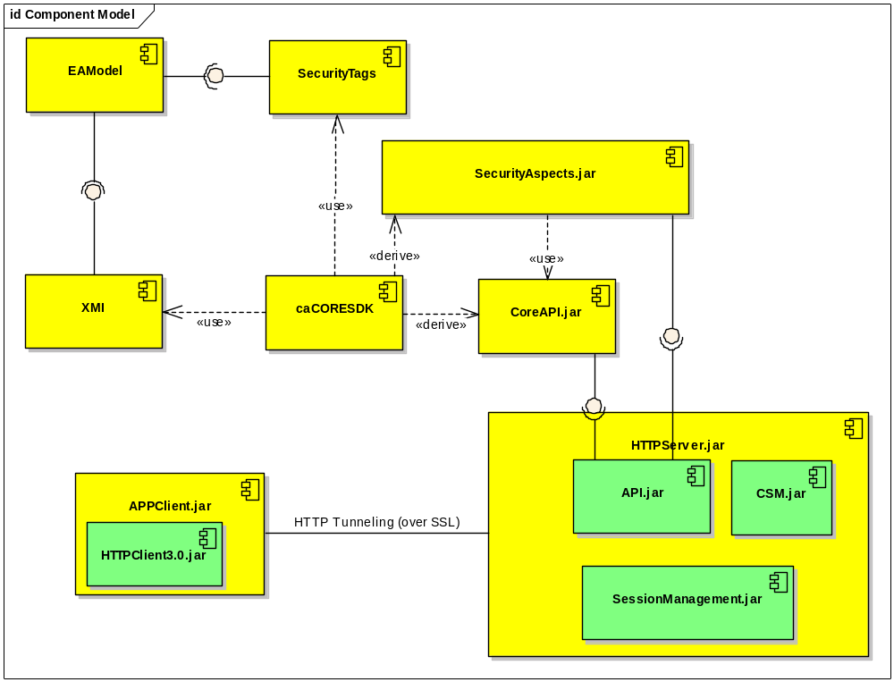
Figure 8 Component Model

Environment
Following is the list of the environment components required for this architecture:
- JDK 1.4.2.x
- JBoss 4.x
- EA 4.5
- Spring 1.1.5
- HTTPClient 3.0

Scope

In Scope
- HTTPClient will be provided to access service interface
- CSM will be integrated for method level only (level 1 or level 0)
- Write API will be provided
- Session Management will be provided

Out of Scope
- AOP integration will not be provided in this release (No Aspects)
- RMI Client will not be provided
- Web services Client will not be provided

SDK Integration Design

Changes to the OR Mapping File
The OR Mapping files generated from the new integrated SDK should not be “read-only” as before. In order for writable APIs to work, these OR mapping files need to be made “read-write”. Also the mutable property should be changed from “false” to “true”. The code generator class “UML13HBMTransformer” also requires this change. Figure 9 shows the necessary changes to this file:

Before:
Element classEl = new Element(classElName);
mappingEl.addContent(classEl);
classEl.setAttribute("name", klass.getName()+"Impl");
classEl.setAttribute("table", table.getName());
classEl.setAttribute("mutable","false");
String cacheName = "cache";
Element cache = new Element(cacheName);
cache.setAttribute("usage", "read-only");
classEl.addContent(0,cache);

After:
Element classEl = new Element(classElName);
mappingEl.addContent(classEl);
classEl.setAttribute("name", klass.getName()+"Impl");
classEl.setAttribute("table", table.getName());
classEl.setAttribute("mutable","true");
String cacheName = "cache";
Element cache = new Element(cacheName);
cache.setAttribute("usage", "read-write");
classEl.addContent(0,cache);
Figure 9 Changes to OR Mapping Files

Changes to the Generated ApplicationServiceProvider Class
The auto-generated ApplicationServiceProvider Class needs to be modified to effectively utilize the integrated environment. This class provides the correct instance of the ApplicationService Class based on the configuration. The methods of this class should be made static, thereby avoiding the need to instantiate them each time they are called. Also, this class needs to be enhanced to provide a local instance on the server-side when called. A new static method, getLocalApplicationService, needs to be added. This method will instantiate an instance of the ApplicationServiceImpl class and return the instance to the user. If unable to instantiate the local instance, the method will throw an appropriate exception.

Changes to the Generated Domain Objects
The caCORE SDK generated domain objects use the caCORE SDK client for the purpose of obtaining the subsequent children objects. However, after integration a new common integrated client will be generated. The domain objects will need to call the new client to obtain the children objects. For this requirement the “BeanImpl.javajet” JET template requires an update. We need to modify the call to obtain the handle to the ApplicationService so that it uses the ApplicationServiceProvider. Note that this requires changes throughout the template in multiple places. The ApplicationServiceProvider Class generation needs to change so that the getApplicationService method becomes static.

Before:
public java.util.Collection get<%=capFirst(otherEnd.getName())%>(){
try{
if(<%=otherEnd.getName()%>.size() == 0) {}
} catch(Exception e) {
ApplicationService applicationService = ApplicationService.getApplicationService();
try {

<% if (!isAbstract.equals("abstract")) {%>
After:
public java.util.Collection get<%=capFirst(otherEnd.getName())%>(){
try{
if(<%=otherEnd.getName()%>.size() == 0) {}
} catch(Exception e) {
ApplicationService applicationService = ApplicationServiceProvider.getApplicationService();
try {

<% if (!isAbstract.equals("abstract")) {%>
Figure 10 Changes to the Generated Domain Objects

Merging of the ListProxy and SDKListProxy
SDKListProxy was written as a wrapper over the existing caCORE ListProxy. Now with the integrated solution the SDKListProxy should retire while the caCORE ListProxy should be enhanced to make use of the newly integrated client for connection to the server. For a purpose similar to the design above all the calls for obtaining the ApplicationService instance should be modified. Note that these changes need to be made throughout the class:

Before:
public java.util.Collection get<%=capFirst(otherEnd.getName())%>(){
if (hasAllRecords_)
{
realSize_=listChunk_.size();
} else
{
ApplicationService appService = ApplicationService.getApplicationService();
if(appService == null)
{
appService = ApplicationService.getRemoteInstance(getServerAddress());
}
After:
public java.util.Collection get<%=capFirst(otherEnd.getName())%>(){
if (hasAllRecords_)
{
realSize_=listChunk_.size();
} else
{
ApplicationService appService = ApplicationServiceProvider.getApplicationService();
if(appService == null)
{
appService = ApplicationService.getRemoteInstance(getServerAddress());
}
Figure 11 Merging of the ListProxy and SDKListProxy

Merging of the ApplicationService and SDKApplicationService
SDKApplicationService was written as a wrapper over the existing caCORE ApplicationService. Now with the integrated solution the SDKApplicationService will retire while the caCORE ListProxy will be enhanced to integrate the CSM security features. The proposed design is to change the current ApplicationService Class from a class to an interface. There will be a new class ApplicationSericeImpl which will created this class will be similar to the SDKApplicationService. It will implement the ApplicationService Interface. The current ApplicationService Class will be renamed ApplicationServiceBusinessImpl and this will be managed by the caCORE Team. The ApplicationServiceImpl class will perform all the security and session checks before forwarding the call to the respective method of the ApplicationServiceBusinessImpl.

Also – based on the Writable Flag the ApplicationService Interface will contain the methods for creating, updating, and deleting objects. This has to be generated at run-time based on the input from the user.

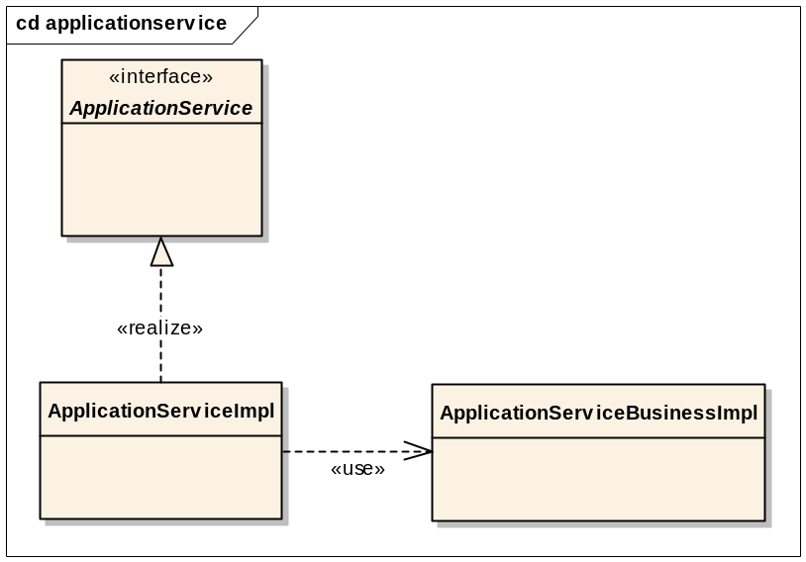

Figure 12 Relationship of Classes and Interface

Introducing a Writable Flag
In the current CSM SDK Adapter, the writable APIs are generated and enabled as part of the ApplicationService Interface. This needs to be modified such that the writable APIs should be generated only if the user selects the Writable API option. The user’s input will be provided as an argument to the program that will generate all the classes. Based on this input the methods for the writable APIs, named createObject, removeObject and updateObject, `1ill be inject in the ApplicationService Interface. The actual ApplicaitonServiceImpl class will always contain the implementation for these methods. However since the interface it implements will not have these methods, the client application cannot access them. The implementation for the methods in the ApplicationServiceImpl class mentioned above will be very similar to the following:
:
:
public Object createObject(Object obj) throws ApplicationException {
return sdkDAO.createObject(obj);
}
public Object updateObject(Object obj) throws ApplicationException {
return sdkDAO.updateObject(obj);
}
public void removeObject(Object obj) throws ApplicationException {
sdkDAO.removeObject(obj);
}
public List getObjects(Object obj) throws ApplicationException {
return sdkDAO.getObjects(obj);
}
:
:

Setting the Security Off by Default
Currently by default the security is enabled and if the user wants to disable the security then he needs to modify the configuration files. As the part of the integrated SDK this would put additional burden on the users which generally want to use the application in public domain and do not need security. Hence by default the security would be turned off. This requires changes to the to the “getSecurityLevel” method of the “SecurityEnabler” of the CSM SDK Adapter. The logic should changed to such that when no security is configured then the level should be defaulted to “0” rather than “1” as shown below

Before:
public int getSecurityLevel(){
if(securityLevel==999){
String str = System.getProperty("gov.nih.nci.sdk.remote."+applicationContextName+".securityLevel");
try{
Integer it = new Integer(str);
int level = it.intValue();
if(level>2||level<0){
securityLevel=1;
}else{
securityLevel=level;
}
}catch(Exception ex){
securityLevel =1;
}

}
return securityLevel;
}
After:
public int getSecurityLevel(){
if(securityLevel==999){
String str = System.getProperty("gov.nih.nci.sdk.remote."+applicationContextName+".securityLevel");
try{
Integer it = new Integer(str);
int level = it.intValue();
if(level>2||level<0){
securityLevel=1;
}else{
securityLevel=level;
}
}catch(Exception ex){
securityLevel =0;
}

}
return securityLevel;
}
Figure 13 Changing Security Default

Merge the build process
<<>>

Secure Business Methods at the Object as well as Method Level
Currently the Business methods (methods from the caCORE’s ApplicationService) are secured only at the method level. Therefore if the user has access to a method then he can execute this method for all the objects within that method. For example if the user has access on the Query method, then user can query for any of the domain objects. This is not a secured environment as we can not control the access at the domain object level. Hence the CSM SDK Code generation should be enhanced to provide this object level security. For this the code generation needs to be enhanced such that generated code passes the domain object as the “protection element”. The fully qualified name of the domain object should be used as the protection element object id. This object id should be retrieved either directly from the class name (passed to the method) or obtained indirectly using reflection. Also all the query and search methods will use a common privilege “READ”. The below code shows how the output of the code generator allows object level security for the business methods of the caCORE’s ApplicationService. Note that this would also require a change in the way Authorization Policy is configured for an application through UPT. Now the fully qualified domain object names should be entered as protection elements to which the user is given privileges.

Before:

public List query(String sessionKey,Object arg1,int arg2,int arg3,String arg4) throws ApplicationException{

if(securityEnabler.getSecurityLevel()>0){ if(!securityEnabler.hasAuthorization(sessionKey,"gov.nih.nci.system.applicationservice.SDKApplicationService.query","EXECUTE")){
throw new ApplicationException("Either you are not in session or you don't have privilege to execute this method");
}
}
return applicationService.query(arg1,arg2,arg3,arg4);
}

After:

public List query(String sessionKey,Object arg1,int arg2,int arg3,String arg4) throws ApplicationException{

if(securityEnabler.getSecurityLevel()>0){
// str4 is the Target Class Name passed as parameter for the method
if(!securityEnabler.hasAuthorization(sessionKey, arg4, "READ")){
throw new ApplicationException("Either you are not in session or you don't have privilege to execute this method");
}
}
return applicationService.query(arg1,arg2,arg3,arg4);
}
Figure 14 Securing Methods at the Object Level

Merge and Code Clean
The source code of both CSM SDK Adapter and the caCORE Toolkit needs to be merged. The CSM SDK Code should be re-factored such that it fits in the existing packaging structure of the caCORE Toolkit. The ideal way is to keep all the code from the CSM SDK Adapter in the package which contains “csm” to identify the code. This way there is a clear separation of the code and both the teams can work together on the same product without impeding each other’s progress.
Also, as part of the integration several modules and code will be retired. Following are some of the modules which are identified to be removed:

- CSM SDK Adapter
  - SDKListProxy
  - SDKApplicationService

- caCORE Toolkit
  - HTTP Server & Client

This list will be finalized at the time of development.

Enhance the Error Reporting Mechanism
Currently the CSM SDK Adapter error reporting is very high level. This needs to be revised and made more appropriate and descriptive. For example when the user executes method on which he does not have permission or he is not in session, in both cases the system throws an error stating “Either you are not in session or you don't have privilege to execute this method”. This way the client application can not distinguish whether the user session timed out or the user did not have sufficient privileges.
The SecurityEnabler class will be modified to throw exceptions depicting the actual cause of failure. This should appropriately be trapped in the ServerImpl class generated and transmitted to the client. The hasPermission methods should now throw an ApplicationException if the user does not have permission.

public boolean hasAuthorization(String sessionKey,String protectionElementName,String privilege) throws ApplicationException
{
:
:
}
Figure 15 Throwing the ApplicationException exception

Also the CSM SDK Code generation should be enhanced such that the generated code now uses try/catch around the call to the hasPermission method of the SecurityEnabler

Before:
public List query(String sessionKey,Object arg1,int arg2,int arg3,String arg4) throws ApplicationException{

if(securityEnabler.getSecurityLevel()>0){ if(!securityEnabler.hasAuthorization(sessionKey,"gov.nih.nci.system.applicationservice.SDKApplicationService.query","EXECUTE")){
throw new ApplicationException("Either you are not in session or you don't have privilege to execute this method");
}
}
return applicationService.query(arg1,arg2,arg3,arg4);
}

After:
public List query(String sessionKey,Object arg1,int arg2,int arg3,String arg4) throws ApplicationException
{
if(securityEnabler.getSecurityLevel()>0)
{
try
{
securityEnabler.hasAuthorization(sessionKey,"gov.nih.nci.system.applicationservice.SDKApplicationService.query","EXECUTE"))
}
catch (ApplicationException ae)
{
// log the Exception occurred
throw ae;
}
}
return applicationService.query(arg1,arg2,arg3,arg4);
}
Figure 16 Try and Catch Blocks

Add Methods for XML Communications
<<TBD>>

