

Software Architecture Document
Version 1.1

May 27, 2005

Table of Contents
Table of Contents
Table of Contents ii
Document Overview 3
Change Record 3
Reviewers 3
Introduction 4
Purpose 4
Definitions, Acronyms, and Abbreviations 4
caCORE SDK 5
Background 5
Problem Scenario 5
Proposed Solution 6
Session Management : Where is the User ? 9
Step toward Write APIs and Transaction Management 12
Simple Writable APIs (SWA) 12
Putting it all Together 13
Components 15
Environment 16
Scope 17
In Scope 17
Out of Scope 17

Document Overview

Change Record
Date | Author(s) | Document  Version | Change Reference (Major Changes)
 | Vinay Kumar | 0.1 | Initial draft
5/17/05 | Eric Copen, Satish Patel | 1.0 | Text changes and formatting
5/27/05 | Eric Copen | 1.1 | Conversion to NCICB template

Reviewers
Name | Position | Document  Version | Date  Reviewed
Satish Patel | caMatch/Developer | 0.1 | 5/17/05
Eric Copen | QA/Developer | 0.1, 1.0 | 05/13/05, 5/17/05

Introduction
caCORE SDK follows the Model Driven Architecture (MDA) approach. It automatically generates a set of APIs from the model defined in UML. This design document highlights some of the enhancements that should be introduced in SDK to make it more usable.

Purpose
The purpose of this document is to propose the design solution to introduce the writable APIs with CSM enabling of SDK.

Definitions, Acronyms, and Abbreviations
- AOP – Aspect Oriented Programming
- CSM – Common Security Module
- SDK – Software Development Kit
- API – Application Programming Interface
- EA – Enterprise Architect, a tool for UML modeling
- MVC – Model-View-Controller, a design pattern
- BO – Business Object

caCORE SDK

Background
Currently the caCORE SDK generates the set of APIs for the server and client side. The server side APIs run behind a HTTP server which has a proxy interface for querying the data. The proxy interface has only one method called “query”.
The “query” method takes a request as a parameter and sends the response with the result of the query.

Request
Response
HTTP Server

API.jar
Client

Figure 1 Existing Architecture

Problem Scenario
The present architecture supports only one method though a proxy interface, however more methods can be introduced. Therefore, the interface definition has to change. There might be different types of business requests sent to the HTTP server. Depending upon the type of business request, there could be number of methods introduced in the proxy interface. These methods can be processed by implementing a number of if/else statements or a command pattern for handling these requests.

Proposed Solution
There is a front controller pattern that can solve these kinds of problems. Please see the picture below:

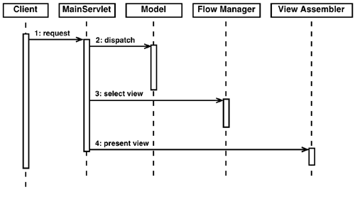
Figure 2 Controller Pattern

Approach

There are two ways to implement the Front Controller Pattern. The first option is to create a self-developed implementation of this pattern. The advantage is no dependence on an external framework. The second, preferred option is to use an existing framework that provides the necessary capability – Struts. Struts is a framework based on the MVC pattern (Model-View-Controller). caCORE SDK can customize the Struts implementation to disregard the View layer since it is not needed, but use the Response layer. The Response layer will react dependent upon the incoming request.

Advantages
Using Struts we can gain central control of request handling. This is a crucial part of the design; where we can embed the user information for SECURITY CONTEXT in the current thread. This way at any point during method execution, we have access to the caller of the code. This will help us decide if the caller can perform that operation. Please refer to the figure below:
Client
Controller
Session
Request
getUser
Embed in Thread
:business_Object
CSM
Check authorization

Figure 3 Embedding of User Information

When the request comes from the client to the Controller, the user information which was stored in the Session earlier, can be embedded in the thread (LocalThread); it can be retrieved at a later stage without depending upon Request or Session. This will decouple the business layer from any HTTP-specific dependency.
Just before the business method is called, an interceptor will intercept the execution and first check if this method can be called by the caller. If the caller is authorized then it will execute the method, if not it will just return a security exception. This can be achieved with security Aspect. This way the business layer does not need to handle the security explicitly.
See the below diagram for more details:

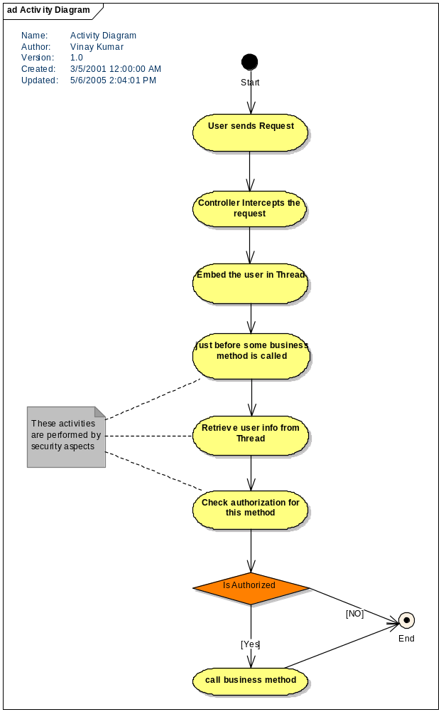
Figure 4 Activity Diagram

Session Management : Where is the User ?
The generated APIs can be hosted in some web container, if not the application server because the entry point is a servlet. If you are using the servlet then we can make use of the HTTP session for session management. However, since the client is an application and not a browser, it becomes cumbersome to support the server-side sessions.
To resolve this problem, we can make use of HTTPClient project from Apache Software Foundation. This is an open-source project that provides very rich APIs to manage HTTP protocol from client-side. There are multiple ways to manage sessions on the server-side, including cookies, hidden fields, URL rewriting, etc. Since we are handling HTTP requests from an application, with the help of HTTPClient, we can make use of cookies to assist with session management. A unique session key can be generated from the Controller for each client when a request for login is made. The generated session key can be sent to the client in the form of a cookie or an object, and used in the subsequent calls to track user session.
But still the issue of user context propagation remains unsolved. The code below demonstrates how we will solve the problem of user context propagation:

Utility code:
public class MethodExecutor {
private static final ThreadLocal threadLocal = new ThreadLocal();
public static User getInstance() {
User identity = (User) threadLocal.get();
}
public static void init(User user) {
threadLocal.set(user);
}
public static void release() {
threadLocal.set(null);
}

Controller code:
User user = (User) session.get("user");
MethodExecutor.init(user);
Call to the business object methods:
(This is called just before returning the response to the user)
MethodExecutor.release();

Security Aspect code:
User user = MethodExecutor.getInstance();

A proxy layer called Remote Service Layer will be provided to keep track of the user with every request coming in. This layer in turn will call the real application service layer.
Application service interface and RemoteService interface may look like this:

Public interface ApplicationService {
Public Patient createPatient(Patient pt);

Public void removePatient(Patient pt);
}

Public interface RemoteService{
Public User login(String userId, String password);

Public Patient createPatient(Patient pt, String sessionId);

Public void removePatient(Patient pt, String sessionId);

}

Client Application

mgr.createPatient()
Client Proxy
makeRemoteObject()
sendRemoteObject()
getRemoteObject()
returnBusinessObject

Service Layer Proxy
getRemoteObject()
getBusinessObject
callBusinessMethod()
makeRemoteObject()
returnBusinessObject()

Server Application

mgr.createPatient()
1
2
3
4
5
6

Figure 5 Session Management Using Proxies

The client application and the server application should be independent of the protocol used for communication. To meet this requirement, the proxies will be required on the client and the server side, which know how to make remote calls and handle remote calls respectively. On one hand, the server side proxy will be exposed as ApplicationService to the client, while on the other hand the client proxy will be exposed as RemoteService which will know how to communicate with the server. Since the client proxy and the application service proxy manage the communication and the method call interaction, the underlying application will not be required to know the details of the wire protocol. However, one will eventually be free to replace one wire protocol with another with very little modification.

In order to achieve seamless integration of client and server-side applications, any call made by the client application for the server application will be wrapped inside the RemoteObject by the RemoteService or client proxy. The RemoteObject will contain information such as which method to call on the server-side, user session information, etc. The RemoteObject will be hidden from both the client application and server application. When the ApplicationService receives a request with RemoteObject, it unwraps all the parameters and makes a call to the appropriate method in the server-side application.

Step toward Write APIs and Transaction Management
At present, SDK generates query-only APIs for objects defined in the UML model. Writing to the persistence layer is one of the requirements that have arisen. The domain model is generated as POJO (Plain old java objects) or Java beans, which are not transaction aware. Handling the pure POJOs is easier for developers, however while persisting them, transaction management can prove a difficult challenge. Hibernate provides a wrapper around transaction management APIs but it might require coding from the developer. For generated code from SDK, we want to stay away from programmatic transaction management. The declarative transaction management is the preferred approach. One of the options to tackle this problem is to use Spring framework, which provides a transaction management abstraction layer. By using Spring, in the future a different underlying transaction management can be used simply by changing the configuration file.

Simple Writable APIs (SWA)
The first step toward Writable APIs and Transaction Management is creating a simple writable API which can perform simple CRUD operations. These CRUD operations can be exposed as a Persistence Manager service layer or any other business service. The idea behind this is to enable it for distributed computing.
The Persistence layer can have the following methods:
public Object createObject(Object obj) throws <<someException>>

public Object updateObject (Object obj) throws <<someException>>

public void removeObject(Object obj) throws <<someException>>

public <<List>> getObjects(Object obj) throws <<someException>>

public <<List>> getObjects(<<some Criteria>> sc) throws <<someException>>

public void addChildren(Object parent, List children, String childrenPropName) throws <<someException>>

public void removeChildren(Object parent, List children, String childrenPropName) throws <<someException>>

<<List>> has been shown above to indicate that a custom proxy List can be used if the result set is large.

Putting it all Together
caCORE SDK will generate the APIs from the model definition in XMI format. The generated APIs will consist of the following:
- Domain Objects
- Server-Side APIs
- Client-Side APIs
- Service Layer
- DAO Layer
- All configuration files
- CSM integration code

At present the service is exposed through a proxy interface using HTTP tunneling, which limits the client to be only a java-based HTTP client. Ideally the server-side application should be accessible by clients that use RMI, HTTP, or Web Service protocol. Depending upon the system requirement, one should be able to choose the preferred client. However, the nature of client should not affect the server-side application.
BO
BO
S
E
R
V
I
C
E

L
A
Y
E
R
RMI
CLIENT
HTTP CLIENT
WEB SERVICE
CLIENT
WEB CLIENT
LOCAL JAVA CLIENT

Domain objects

B
U
S
I
N
E
S
S

DELEGATE

S
ECUR
I
T
Y

L
A
Y
E
R

D
A
O

L
A
Y
E
R

Figure 6 Distributed Computing with Different Clients

The Security layer proposed here is security level 1 only.

Although we propose to support different types of clients, for the current release we would limit to HTTP Client only. Spring framework which uses HTTPClient will be used for remoting. Please see the diagram below:

SERVICE INTERFACE
SERVICE INTERFACE
SPRING Remoting
HTTP INVOKER LAYER
HTTPSERVICE EXPORTER
HTTPClient Layer

Client Web Server
Figure 7 HTTP Remoting

Components
The following diagram shows the different components involved in the architecture:

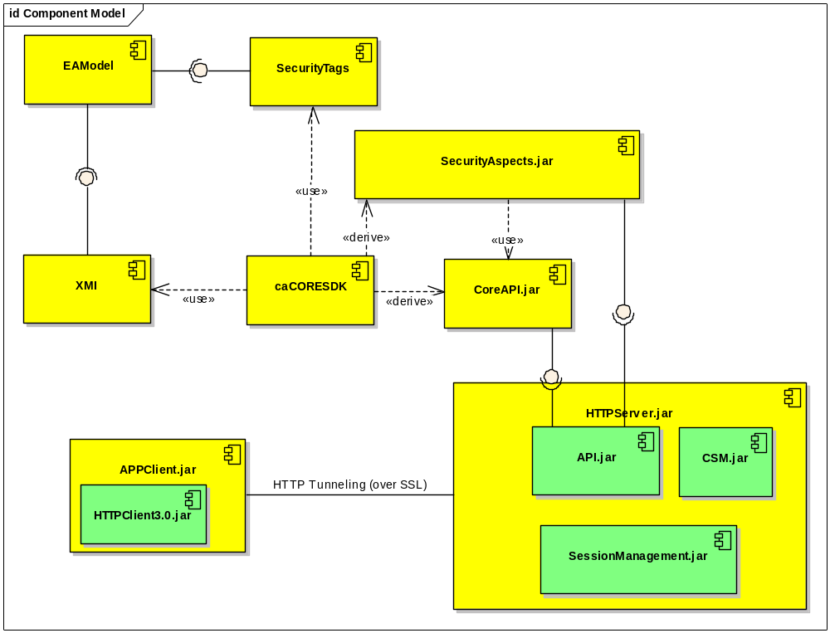

Environment
Following is the list of the environment components required for this architecture:
- JDK 1.4.2.x
- JBoss 4.x
- EA 4.5
- Spring 1.1.5
- HTTPClient 3.0

Scope

In Scope
- HTTPClient will be provided to access service interface
- CSM will be integrated for method level only (level 1 or level 0)
- Write API will be provided
- Session Management will be provided

Out of Scope
- AOP integration will not be provided in this release (No Aspects)
- RMI Client will not be provided
- Web services Client will not be provided

