Architecture Specification
for
Product XYZ Version A Release B

Last Updated: April 28, 2005
(This date is automatically updated to the Last Saved Date when
the Table of Contents is regenerated (select all and right mouse
click in the document, select the Update Fields option (or select F9)).
To just update the Date and Time field, highlight the date
and time, do a right mouse click, and select “Update Field”. This should
be done after the document has been updated and saved.
This will also work on the Date and Time and Page
Number fields in the footer of the document
The Table of Contents must be regenerated every time the document
is saved. If the user chooses to manually enter the dates, as opposed
to using automatically generated dates, then both the date on the
cover and the dates in all footer sections must be updated manually. )

Owner: name
Telephone: number
Email: address

Manugistics, Inc.
2115 East Jefferson Street
Rockville, Maryland 20852

Note: Master document is the on-line version. It supersedes all previous updates. Users should not make unauthorized alterations. Users must determine the current version and completeness prior to use. The user must discard obsolete documents.

CONTENTS
1 Purpose 6
2 System architecture 7
2.1 Overall architecture 7
2.2 WebWorks architecture usage 8
2.3 Internationalization support 9
2.4 Third-party tool dependencies/requirements 9
DOCUMENT CONTROL 11
DOCUMENT APPROVAL 12

List of TABLES
Table 1 - Sample Table Name 8
Table 2 –Title Document Change Log 11

LIST OF FIGURES
Figure 1 - Sample Figure 8

[PLEASE REMOVE THE FOLLOWING “DOCUMENT FORMAT” INSTRUCTIONS IN YOUR RELEASE DOCUMENTATION]

Document Format
The (title) document should contain all of the sections contained in this (title) document template. DO NOT DELETE SECTIONS THAT DO NOT APPLY TO THE PRODUCT RELEASE BEING SPECIFIED, but rather indicate in the section that it was intentionally left blank. Leaving the section in the document rather than deleting it, reduces confusion for reviewers who may not be sure if the section was intentionally deleted or just omitted.

This template includes red text providing directions. This text should be removed from the actual document created using the template. The titles in this document also have red text to indicate where specific document titles need to be provided. These titles should be changed to black text in the actual document.

Purpose

This architecture specification contains information on the architecture of a specific product for a specific release. This document should describe the major components that make up the product, any interfaces to other products, 3rd party tool requirements or dependencies, and any intra or interprocess communication.

The intended audience for this document includes, but is not limited to, the development team, management, other development teams, product support technical personnel, technical communication, and technical consultants.

System architecture

Overall architecture
This section should provide a high-level overview of how the functionality and responsibilities of the system were partitioned and then assigned to subsystems or components. Don't go into too much detail about the individual components themselves, as these should be covered in the Implementation specification for each feature. The main purpose here is to gain a general understanding of how and why the system was decomposed, and how the individual parts work together to provide the desired functionality.

At the top-most level:
- Describe the major responsibilities that the software must undertake (such as batch processes, messaging) and the various roles that the system (or portions of the system) must play.
- Describe how the system was broken down into its components/subsystems (identifying each top-level component/subsystem and the roles/responsibilities assigned to it).
- Include information on the database access/persistence mechanism of the product.
- Describe how the higher-level components collaborate with each other in order to achieve the required results. Include interfaces to other products or common components, such as the WebWorks components or other 3rd party tools.
- Describe the system’s failover and clustering mechanisms (for example, does it rely exclusively on WebLogic).
- JMS Queue/topic usage

Provide a diagram of the major system components. An example of the J2EE architecture is shown below as an example of the level of architecture desired.

Insert Figure Here

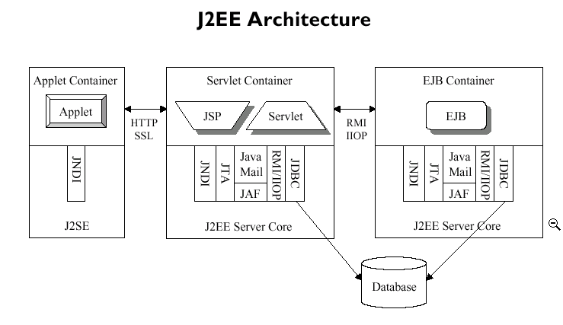
Figure 1 - Sample Figure

WebWorks architecture/standards usage

Describe the integration or use of the Webworks components and standards. Define which WebWorks components are being used and if any of those components are being extended in the product. If desired, use the following table to note the level of usage/compliance instead of adding text.

Table 1 – WebWorks architecture/standards usage
WebWorks component | Level of use | Notes
J2EE architecture
Common security model
Authorization: features
Authorization: Entities
Authorization: Tables
Authorization: Columns
Auditing
Event service
UI extension
JSP/servlet framework
Single sign-on
Authentication
Viewpoint components
templates
Style sheet
Login
Home page
Menu
Error page
Error message popup
Date field
Lookup
User settings
Favorites/Directory
Tabbed bar
Grid
Graph
Grid header/footer
Graph header/footer
UI HTML guidelines
Service launch
Web Services/XML APIs
DOM convenience layer
Java/XML bindings
Integration APIs
Interface generation program (IGP)
Data division utility (DDU)
Integration business objects (IBO)
JMS utilities
Java coding standards
Installation framework/deployment framework
Internationalization
Number formatting flexibility (10.000 or 10,000)
Currency formatting and flexibility (allows multiple currencies
Date and time format flexibility
Unit of measure conversion (if applicable)
Number formatting flexibility (10.000 or 10,000)
Externalization of text into resource bundles/external files
Double-byte enabled

Level of use:
Fully uses/complies
Partially uses/complies
Does not use/comply

Performance considerations
In this section, describe how the product is architected for scalability. Also note any known limits to the product’s performance and scalability.

Third-party tool dependencies/requirements
In this section, describe the 3rd party tools that the product depends upon, including the version. Be sure to include the database drivers that are supported. Use the table below.

Table 3 – 3rd-party tool requirements/dependencies
Tool | Version | Used for
WebLogic | 6.1 SP2 | Application server
Oracle | 9.0.1.3 | Database management system
Oracle type 2 driver (OCI)

DOCUMENT CONTROL
Change History
Content changes to this document from the previous to the current level are indicated by revision bars (|) unless a complete rewrite is indicated.

Table 2 –Title Document Change Log
Version/Date | Author | Change Description and Explanation | D - Draft  A - For Review/ Approval  R - Re-Approval, Plan of Record Change
mm/dd/yy | name | text | D/A/R
Note: If this document has been inspected, please indicate the inspection date that each version is based on in the “Change Description and Explanation” area. Entries in this log must be maintained for at least 3 years.

DOCUMENT APPROVAL
Approvers List
The individuals listed in this section constitute the approvers list for the Title document. Written approval must be received from all approvers prior to the initiation of the next steps in the Product Launch Process.

(List names from Product Launch Process Responsibility Matrix)

Title | Name
Technical Director (for the product)
Senior Development Manager (for the product) | name
Solutions Manager (for the product) | name

Reviewers List
The individuals listed in this section constitute the reviewers list for the Title document. Formal approval is not required from the reviewers, however, it is desirable to have all reviewers review and comment on the document. Reviewers may choose to concentrate on reviewing only those sections that are in their area of responsibility, rather than the entire document.

(List names from Product Launch Process Responsibility Matrix)

Title | Name
Development Manager(s) for the product | name
WebWorks architecture steering committee representative | name
Development team | name

The End of Document indicator must remain in the document if single sequential page numbering is used. If page numbering style “X of Y” is used (e.g. 1 of 50), then the End Of Document indicator may be removed.
Note: When using the page numbering style “X of Y”, Microsoft Word does not automatically update the total number of pages (i.e. the Y value) when viewing the document in Page Layout format. To update the total number of pages in Page Layout format, the user must select the View Normal option and then the View Page Layout option. The page numbers are always printed correctly.

END OF DOCUMENT

