

Software Architecture Document
Version 1.1

May 26, 2005

Table of Contents
Table of Contents
Table of Contents ii
Document Overview 4
Change Record 4
Reviewers 4
Introduction 5
Overview 5
Purpose and Objective 5
Scope 5
Definitions, Acronyms, and Abbreviations 5
Background 7
Architectural Goals and Constraints 8
Architectural Goals 8
Architectural Constraints 9
Architectural Representation 10
Application Layers 10
Design Patterns Applied to Application Layers 10
Use Case View 14
Introduction 14
Use Cases 14
Actors 16
Use Case groups 16
Use Case Realizations 16
3.0.1 Affected Use Cases 17
Logical View 19
Logical Model 19
Process View 21
Deployment View 23
Deployment Diagram 23
Data View 24

Document Overview

Change Record
Date | Author(s) | Document  Version | Change Reference (Major Changes)
10-27-04 | Kunal Modi | 0.1
11-24-04 | Kunal Modi | 0.2
01-06-04 | Vinay Kumar, Kunal Modi, Eric Copen | 1.0
05-24-05 | Eric Copen | 1.1

Reviewers
Name | Position | Document  Version | Date  Reviewed
Kunal Modi | Software Developer
Vinay Kumar | Software Architect
Brian Husted | Software Architect
Kalpesh Patel | Program Manager

Introduction

Overview
This Software Architecture Document provides software architecture and high level design for the Common Security Module (CSM) system. This document will be used as a recommendation and guideline by the development team to develop detail design for the system. It emphasizes the architecturally significant parts of the design model.

Purpose and Objective
The purpose of this document is to provide high-level architectural guidelines for the security framework.
This document’s intended audience includes the CSM Program manager, the Security Working Group and the development team members of the task.

Scope
This document builds upon the 3.0 phase of the CSM task, adding 3.0.1 specific details. During phase 3.0 the team implemented Authentication and Authorization Use Cases as well as the User Provisioning tool. During phase 3.0.1, the goals are to create and incorporate standard privileges, provide a reporting utility for the UPT, and ensure browser and database compatibility.

Definitions, Acronyms, and Abbreviations

Term | Description
Protected Element | Protected element is a data set that has a controlled access as per the roles and privileges. A protected element can be any object also. Basically it is a conceptual entity that an application will associate with any piece of data that it wants to protect.
Protection group | Used to group protected elements together so that all may be assigned to a Role/user at once. Also allows the Role/User to access future protected elements that do not exist yet.
Role | The role is to be seen in the context of an application and /or protection group. A role is assigned to user to grant them privileges on particular protection group.
Privilege | Privilege is a kind of operation that can be performed on any data.
User | The user is a user for an application or for a system or both.
Application | Any software or set of software's to achieve some business or technical goals.
Systems | Any module, an application or set of connected modules
Message | A message (text message) that flows between applications or systems
SSO | Single Sign On. Using SSO a user has to sign on once and after that user can switch between applications without being challenged again until and unless the session expires.
Encryption | A process by which any readable information becomes unreadable

- caCORE (cancer core applications)
- EJB (Enterprise Java Bean)
- EVS (Enterprise Vocabulary Service)
- J2EE (Java 2 Enterprise Edition): A specification from Sun Microsystems that defines a set of services and standards that conforming implementations must meet. J2EE encompasses many specifications all oriented to enterprise-focused needs. It defines a tiered environment for applications to produce standardized, reusable and modular software.
- JBoss – Open source Java application server
- JDBC (Java Database Connectivity)
- JDO (Java Data Objects)
- JavaServer Pages Standard Tag Library (JSTL)
- NCICB (National Cancer Institute Center for Bioinformatics)

Background
The CSM provides application developers with powerful security tools in a flexible delivery. CSM provides solutions for Authentication, Authorization, and User Provisioning. CSM is flexible enough to allow application developers to integrate security with minimal coding effort. It is being designed to allow for customization since it will be released as open source on the NCICB web site. The CSM code base may be used to create separate versions or implementations of the base functionality. Because of this, application flexibility and extendibility is a priority. Fourth, CSM will integrate with caCORE and will be developed using Java and J2EE.

Architectural Goals and Constraints
This section lists goals and constraints of the architecture and how CSM is addressing or is affected by each.

Architectural Goals
1. Ensure the platform addresses enterprise level of service requirements: Performance, Scalability, Reliability, Availability, Extendibility, Maintainability, Manageability, and Security.
- CSM is able to meet several of the enterprise requirements by virtue of deploying on a complete J2EE application server. The J2EE specification and JBoss implementation address scalability, manageability and security. Scalability and availability are addressed using JBoss clustering. Manageability is addressed using JBoss’ Java Management Extensions (JMX) implementation. Security is addressed by the J2EE specification and JBoss implementation.
- The CSM code base will address the performance, reliability, extendibility and maintainability. J2EE design patterns and best practices will be utilized throughout the application.
2. Define clear application layers delineating architectural role and functionality
- A benefit of J2EE is that it defines a component-based architecture with specifications for each major architectural functionality
- CSM is designed using a layered architecture. Presentation logic is developed in the web container and business logic is developed separately.
3. Integrate well with NCICB’s caCORE applications
- caCORE provides HTML, XML and Java interfaces to EVS and caBIO. CSM will access caCORE using its Java supplied interfaces.
4. Utilize industry supported specifications and open source technologies whenever possible
- CSM is designed for the J2EE 1.4 specification. Sun Microsystems, in coordination with the Java community, publishes the J2EE specifications and vendors (including Sun) compete on the implementation. Many J2EE application servers are available in today’s marketplace. With NCICB’s commitment to open source technologies, the CSM team and NCICB have chosen to implement the application using the JBoss 3.2 J2EE application server, bundled with the Apache Tomcat J2EE web container. Because CSM’s code base is compliant with the specifications, if at some point NCICB or a cancer center prefers to move to another application server implementation, it is possible to migrate the application without major changes to the core code base.
- The CSM web application framework is implemented using the open source Apache Struts framework.

Architectural Constraints
1. Standards Compliance
- NCICB is proactively determining how CSM and other applications must comply with data exchange and confidentiality standards such as HL7 and HIPAA. Because working groups are currently determining how to comply with the standards, CSM architecture does not reflect this input. In the future, its possible that the architecture or functional modules will need to be modified to comply with NCICB’s selected direction on these issues.

Architectural Representation

Application Layers
The CSM architecture is based on a n-tier architecture that assigns responsibilities to separate application layers. This fosters a loosely coupled and tightly cohesive architecture in which objects in each layer are focused on specific architectural responsibilities yet cleanly integrate with the other layers.
The diagram below illustrates the following horizontally across the diagram.
- Logical Layer - the logical layer is implementation independent and defines the major application layers.
- Physical Implementation – the physical implementation of the logic layers in the CSM J2EE application are provided. In a J2EE web application, the main physical application container is the web container. Each is provided with the products being utilized.
- CSM Technologies – some of the major technologies used to implement each logic layer in the physical implementation are provided.

Design Patterns Applied to Application Layers
This section of the document describes the architecture and the implementation within each application layer. The major products, frameworks and patterns used in the implementation are described. In addition, to review additional detail on the patterns and mechanisms, please review the Developer Guidelines document.

Client Layer
The CSM client layer will be implemented as a HTML web application. CSM will support the browser and user interface standards put forward by the NCICB User Interface working group and will incorporate NCICB’s 508 compliance guidelines. However, the interface in the pilot release may be incomplete regarding the guidelines since the working group is still in process and the team is working toward its delivery dates. Later releases will address any issues found with compliance in the first release.
Initial guidance is that browse support will include Microsoft Internet Explorer 5.x+, Mozilla 1.1+ and Netscape 6.0+ (Netscape is built on the Mozilla code base). Note that Netscape Navigator 4.x will not be supported.
The application client layer will utilize HTML and style sheets. To support a lightweight tabbed interface, it may also use JavaScript for submitting forms via a hyperlink. This approach will be compared to using image buttons for form submittal. JavaScript validations will not be completed in the browser.

Presentation Layer
The presentation layer will be developed on a J2EE 1.4 implementation using JSP, JSP custom tag and servlet technologies. The JBoss 3.2.1 application server bundles Apache Tomcat 4.1.24 web container in its implementation. In this default configuration, Tomcat and JBoss share the same JVM and Tomcat delegates J2EE authentication / authorization to JBoss services.

Web Application Framework Approach
CSM is using the Model View Controller design pattern implemented in the Apache Struts (http://jakarta.apache.org/struts/) web application framework. Model 2 is a term used to indicate that the web-adapted version of the classic MVC pattern is being implemented.

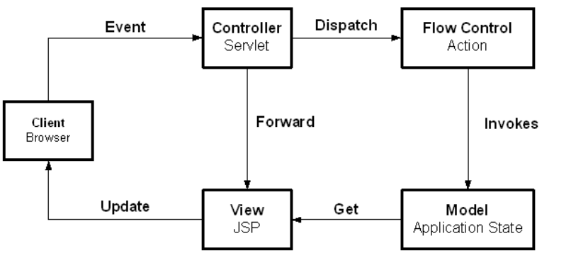
Figure 1. General MVC System Flow

MVC separates presentation-oriented responsibilities from application specific processing / controller responsibilities and business domain specific model. As a result, application maintainability is improved. In a MVC-based J2EE web application, JSPs are the “view” (web page presentation); a Java servlet is the “controller” and processes and delegates requests to Java components; and the “model” or business logic is implemented using business delegate Java objects with EJBs.
In addition to the Struts MVC implementation, CSM implements the J2EE Composite View Pattern (http://developer.java.sun.com/developer/restricted/patterns/CompositeView.html) using the Tiles framework distributed with Struts.
The Composite View pattern is used to combine modular, atomic portions of a web page view into a single, composite web page view. The component portions of the web page are maintained separately and combined to display the complete view to the user. Use of this pattern aids because a small set of common templates can be established that are utilized or extended for many web pages. At runtime, the template applies the atomic page components, such as headers or footers, to create the viewed page. With this approach, different and dynamic atomic view components can be combined into one complete page.
CSM is using this approach by creating the Tiles framework included with Struts to create dynamic views. The CSM framework creates several base layouts that are comprised of different JSP components. These layouts are extended for use in the actual page displays with the default tiles replaced with the appropriate tile for the given display.
In addition to Struts and Tiles, the web application will utilize the JavaServer Pages Standard Tag Library (JSTL) and will include additional custom tags to be implemented as needed. An example usage for a custom tag would be to provide a custom tag for the common security module that enables or disables text based on a role or privilege.

Additional Presentation Layer Design Pattern Usage
In addition to the MVC-based Struts framework used for View and Controller components of MVC, CSM will employ several other design patterns in the presentation layer. In a Struts application, the Struts controller calls Struts Action classes to perform processing in response to a screen display, link or form submit to the controller. Some applications code the business logic directly in the Action class. However, because CSM is using a layered architecture, the Struts Action class will only focus on the workflow of the application and will make business requests to classes associated with the business layer of the application.

Business Delegate Pattern
The business delegate pattern (http://developer.java.sun.com/developer/restricted/patterns/BusinessDelegate.html ) is used to reduce coupling between the presentation layer and the business (also known as model or domain) layer. The business delegate hides the underlying implementation and details for accessing business services. In a J2EE application, the delegate is somewhat like a proxy object in that it provides an interface accessed by its clients but it normally delegates its implementation to other classes. This is normally a EJB Session bean.
For CSM, the presentation layer executes in a J2EE web container and the business, model or domain layer is implemented in a J2EE EJB container. The business delegate allows classes running in the web application to execute the business services in a simpler approach. The delegate handles communication details such as JNDI lookup. The delegate can also encapsulate business layer decisions such as when to cache or retrieve data locally instead of going to business classes contained in EJBs. The presentation client does not need to be aware of these details.

Service Locator Pattern
The service locator pattern (http://developer.java.sun.com/developer/restricted/patterns/ServiceLocator.html) is used to hide the complexities of interacting directly with JNDI, EJB and JMS components. The service locator can re-use object instances and cache home objects as needed. As a result, the client logic needed to invoke these services is reduced. While the pattern itself is logically part of the business layer because its role is to access business services, it is often instantiated in the web container or other business layer client application.

Session Data Manager Pattern
A web application’s javax.servelt.http.HTTPSession object can be used to set and get objects specific to a user session. The session is convenient to access since it is accessible in each request. As a result, it is very easy to add or remove items to the session. This ease of use results in a lack of control over how the session is being used by developers. In addition, adding attributes to the session requires retrieving the key for the object. Instead of adding objects directly to the session, a Session Data Manager object is introduced that contains the logic to get and set objects from the session.
This lightweight object provides the application team with additional visibility as to how the session is being utilized because session objects are saved and retrieved from a central point. In addition, adding the wrapper provides a central way to change how session data is stored. For example, an application may wish to persist highly critical session data to a database or cache large session objects in an external cache and only store the session key in the session itself. This functionality is possible behind a Session Data Manager object.

Presentation Layer Sequence Diagram
The diagram below illustrates an example interaction between the major classes in the presentation framework. Please note that the sequence is drawn from a specification perspective to provide an overview of the normal sequence between these important classes.

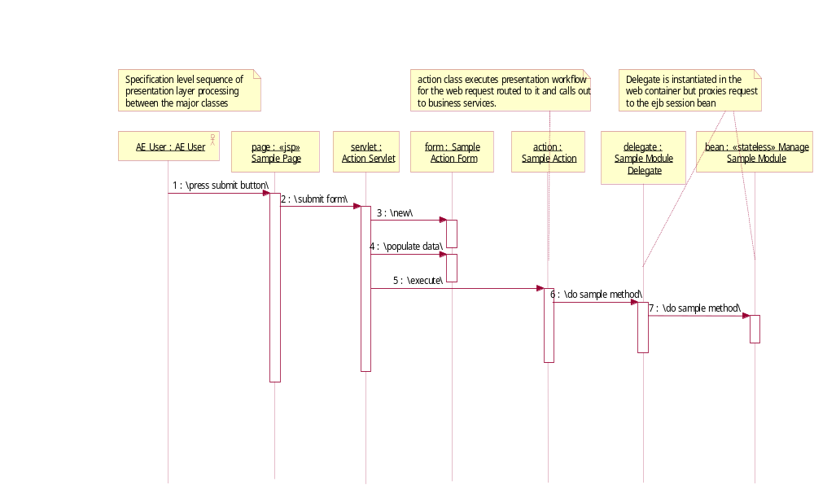
Figure 2. Presentation Layer Framework Sequence

Business Layer
The business layer executes the business logic of the application.

- Struts Form Beans – In the presentation layer, a form of value object is used within the Struts web application framework. In Struts, the value object pattern is implemented using the name Form Bean. When displaying a page, Struts creates form beans and loads the bean with data in its action classes for display on the JSP. When processing a web request, Struts transfers the request’s parameters into a form bean for processing by the Action class. Note the form beans are specific to Struts and are only used within the Struts application classes.

Data Access Layer
The data access layer’s responsibility is to retrieve information from an external data store and return that information in a generic way.

Use Case View

Introduction
Use cases and their related diagrams will be used to document the business and user requirements for CSM. Enterprise Architect will be used to manage use case requirements and ensure traceability. EA will also be used to develop detailed use case diagrams.
For each use case, the following components are described.
1. Brief Description – Describes the use case at a high level and its overall purpose.
2. Basic Flow of Events – Outlines the basic pathway of the use case, describing what the actor does and what the system does in response
3. Alternative Flows – Outlines the alternate pathways of the use case.
4. Subflows – Outlines the subflows within the use case.
5. Preconditions – Describes the conditions required prior to the use case for it to take place.
6. Postconditions – Describes the possible states that a system can be in immediately after the completion of a use case.
7. Extension Points – Describes the points of extension of the use case.
8. Special Requirements – Describes any nonfunctional requirements specific to the use case.
9. Use Case Requirements – Describes the functional requirements specific to the use case.

Use Cases
CSM Use Cases can be grouped into multiple major sets based on actors and functionality. The below diagram illustrates the required use cases:

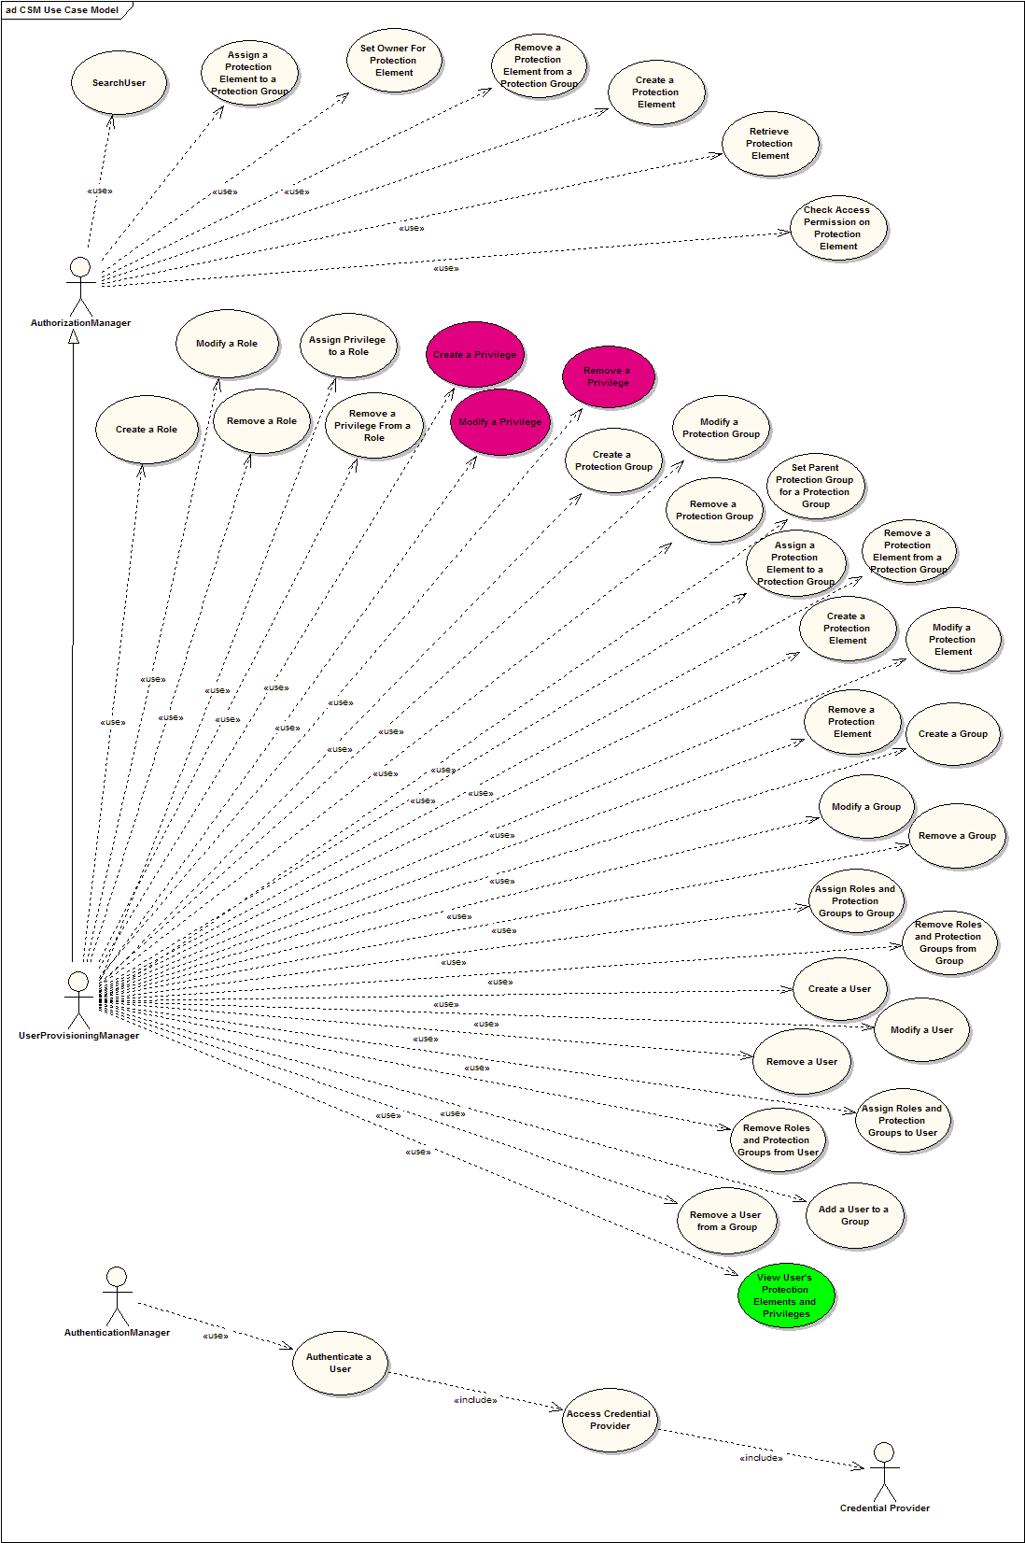
Figure 3. CSM Use Cases

Actors
Authentication Manager – An actor who uses the Common Security Module application for the purpose of authenticating user credentials
Authorization Manager – An actor who uses the Common Security Module application for the purpose of authorizing the user actions on various protected resources
User Provisioning Manager – An actor who uses the User Provisioning Tool to configure the authorization data in the CSM database. It extents the Authorization Manager
User – A user of the client application
System – The CSM Application on whole with hard worker
Credential Providers – The actual data stores where the user login credentials are stored and will be authenticated against

Use Case groups
Use Cases implemented in Phase 3.0:
Authentication - refers to the validation and verification of a user’s credentials.
- Reliably and securely determine access to an application
- System to system authentication

Authorization - grants access to various protection elements (methods, objects and data).
- Protect privileged resources from unauthorized users
- Associate user roles with distinctly defined privileges
- Ability to set access control for datasets

User Provisioning Tool – allows to configure the authorization data for the user in the schema
- Web enabled application
- Access to multiple user repositories
- Provide tools to add, modify, read or delete user authorization data

Logging – allows the tracking of user login as well as authorization actions at a central location

Use Case Realizations
This section illustrates how the software works by providing realization of the use cases selected for the first iteration and explains how the various design model elements contribute to their functionality.
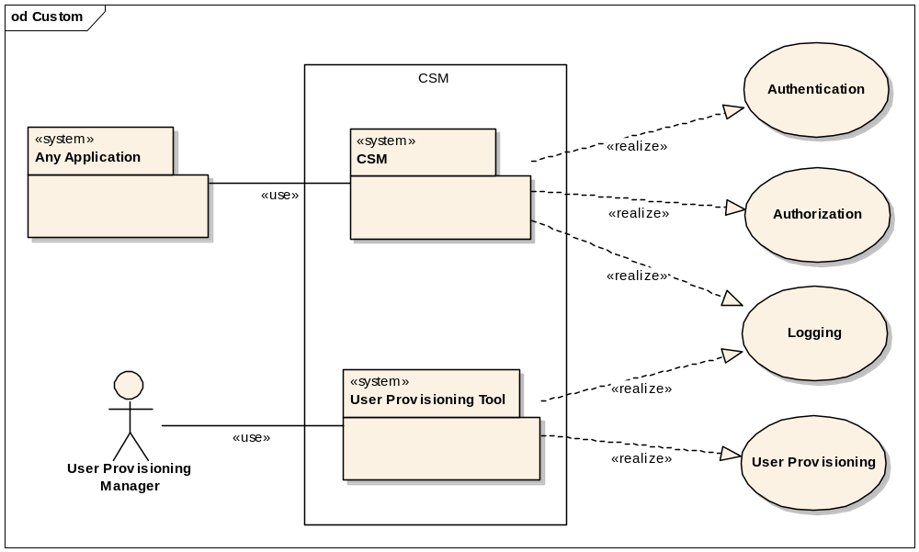
Figure 4. Use Case Realization View
The Authentication and Authorization Use Cases will be realized through the CSM library component. This component will be accessible only by the application with a specially defined role.
The User Provisioning Use Case will be realized through the User Provisioning Tool application. This will be a web application which will be accessible to the users with the role of User Provisioning Manager.
The Logging Use Cases will be realized by both the CSM library component and the User Provisioning Tool. It will track all the authentication and authorization activities for the CSM at the same time will log all the changes made to the authorization schema by the User Provisioning Manager.

3.0.1 Affected Use Cases

These three use cases may be deprecated due to the new requirement to standardize privileges:

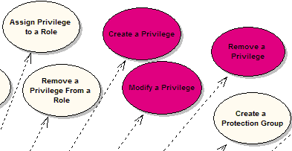

This use case will be added to cover the reporting requirement:

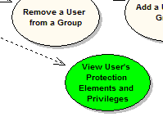

Logical View
Logical View of the design model, such as its decomposition into subsystems and packages will be determined during the development phase of the task.

Logical Model

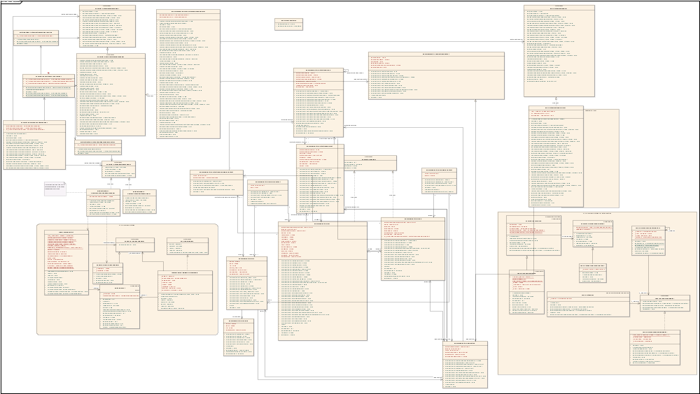

Figure 4. Detail Class Diagram
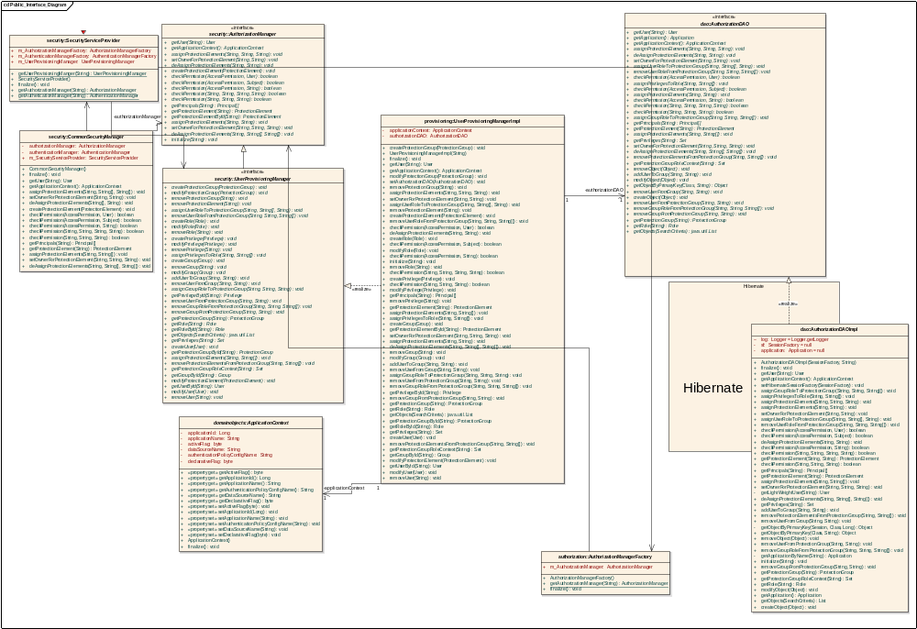
Figure 5. Programming Interface Diagram
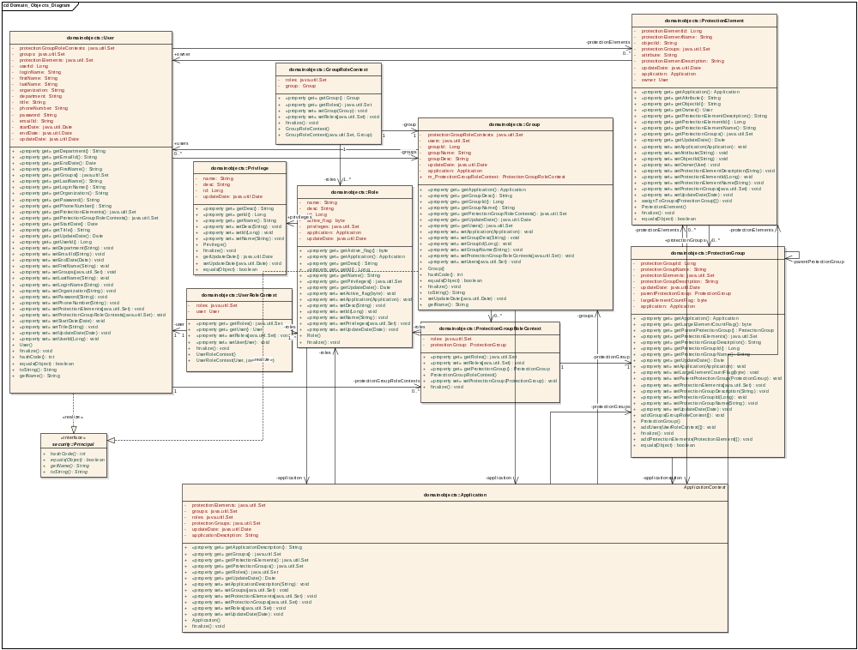
Figure 5. Object Model Diagram

Process View
The Security service can be used through different managers. These managers are made available through public interfaces. Mainly three managers are exposed.
- AuthenticationManager
- AuthorizationManager
- UserProvisoingManager
The Security module can be used for standalone java application and as well as for J2EE applications. The one security module can serve number of applications at the same time. The application developers have to get handle to the appropriate manager to work with. The security module works in the context of an application. In other words the managers are application context specific irrespective of how the authorization schema is shared. The authorization schema may or may not be shared between different applications. At the same time number of applications might be hosted in one application server.
This entire configuration is done through a system wide ApplicationSecurityConfig.XML file.
The following diagram will help in understanding the internal working of getting handle to appropriate manager in the context of an application.
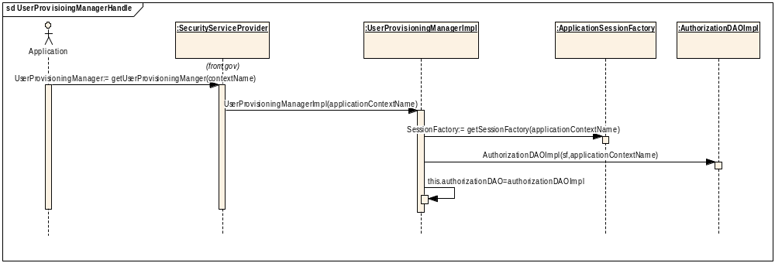
Figure 6.

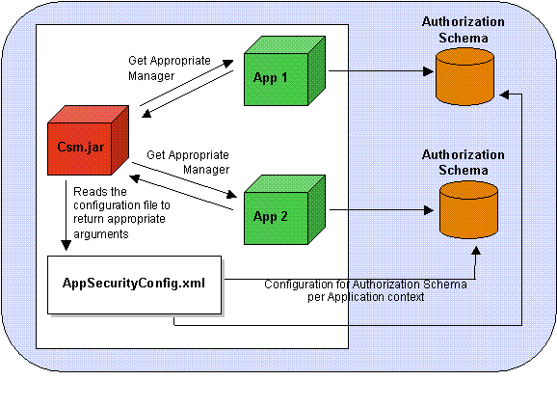

Deployment View

Deployment Diagram
This section describes the physical network (hardware) configurations on which the software is deployed and run.
For the CSM first phase environment the following deployment configuration into the production environment is proposed:
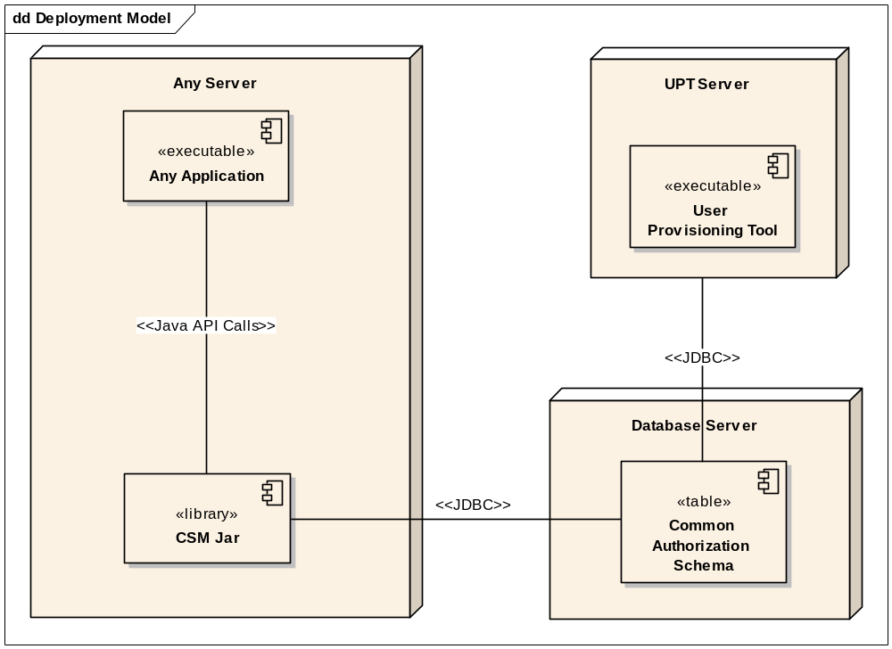
Figure 8.

CSM system will be deployed as following:
- The CSM jar will be deployed on the same server where the application is hosted. The CSM Service will be available as a library which will be place in the class path of the application. It will run in the same container as the application and will be accessed by the making JAVA API calls.
- The User Provisioning Tool will be hosted on a separate server as a web application. The users will be able to access the application using the browsers.
- The Common Authorization Schema Database will be hosted on a database server. It could be hosted on the same database as the application or hosted on a separate database (MySQL)

Data View
Derived from Design Model below is the preliminary Data Model design.
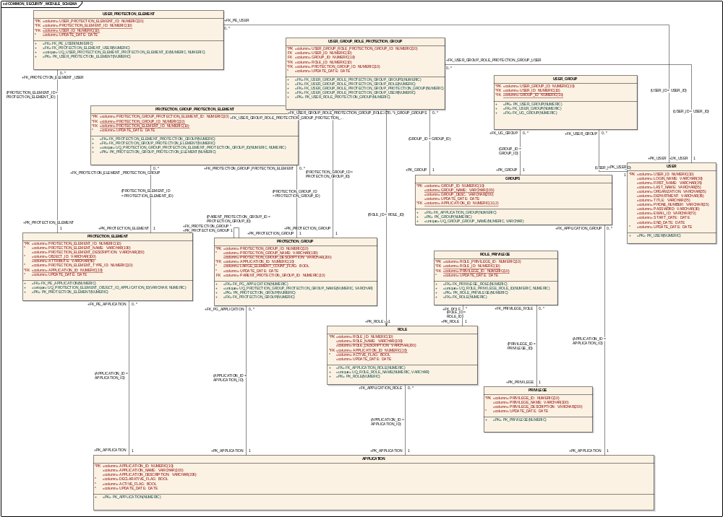
Figure 9.

