
Common Security Module
Auditing and Logging Design

Version No: 0.1
Last Modified: 9/22/2005

Author : Vinay Kumar
Team : Common Security Module (CSM)
Purchase Order# 34552
Client : National Cancer Institute - Center for Bioinformatics,
National Institutes of Health,
US Department of Health and Human Services

Document History

Document Location
The most current version of this document is located in CVS under security/docs.

Revision History
Version Number | Revision Date | Author | Summary of Changes
0.1 | 9/22/05 | Vinay Kumar

Review
Name | Team/Role | Version | Date Reviewed | Reviewer Comments
Eric Copen | QA | 0.1 | 9/22/05 | Updated formatting, text, etc.

Related Documents
More information can be found in the following related CSM documents:

Document Name

Table of Contents
1. Introduction 2
2. Problem Statement 2
3. Audit and Logging Requirements 2
4. Analysis 2
5. Use Cases 2
5.1 Actors 2
6. Design 2

Auditing and Logging Design

Introduction
In an effort to make CSM compliant with CFR 21 / Part 11, CSM will provide auditing and logging functionality. This document describes the associated problem statement, requirements, analysis, and use cases, and explains the design.

Problem Statement
Currently CSM uses log4j for application logging. But for CFR 21 / Part 11 some specific messages are to be logged in a specific way. All the objects should be logged in a manner so that they can be audited in a later stage.

Audit and Logging Requirements
The CSM application will log certain events including:
- Login
- Log out
- Login attempt
- Login failure
- User lock out

For object auditing the following should be logged:
- Object state at the time of insertion
- Object state before update
- Object state after update
- Object state before deletion
- Mark the state of the object as deleted when the object is deleted.

All the above object state logging should be done with the user’s information and the time stamp.

Analysis
CSM is capable of logging events with log4j. The only required change is to log specific events. The logger will be called at specific points in the application.
CSM does not currently provide functionality for auditing objects. For persistence CSM uses MySql 4.11, which does not currently support the concept of triggers. So there is no way to store the states of the objects in a database during transactions. Only through the application layer can this be accomplished.

Use Cases
This section describes the use cases that have emerged from the requirements.

Actors
- CSMEventLogger
  - CSMEventLogger will log the events in the way specified by CFR 21 / Part 11.

- ObjedtStateLogger
  - ObjectStateLogger will log the state of the object during the transaction.

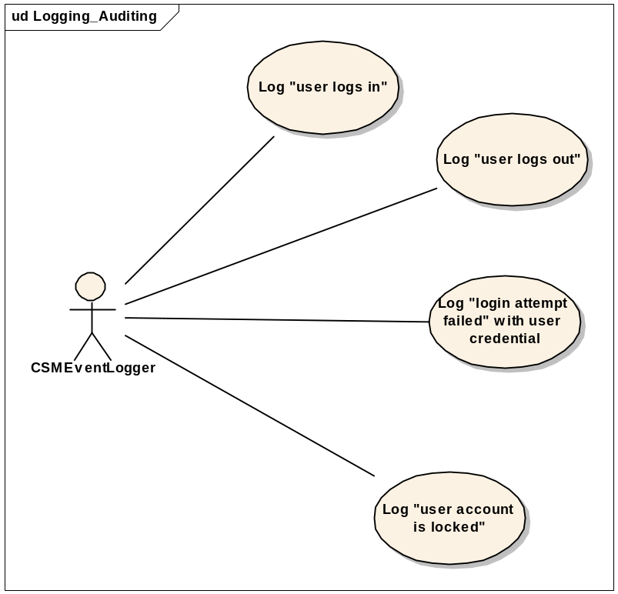

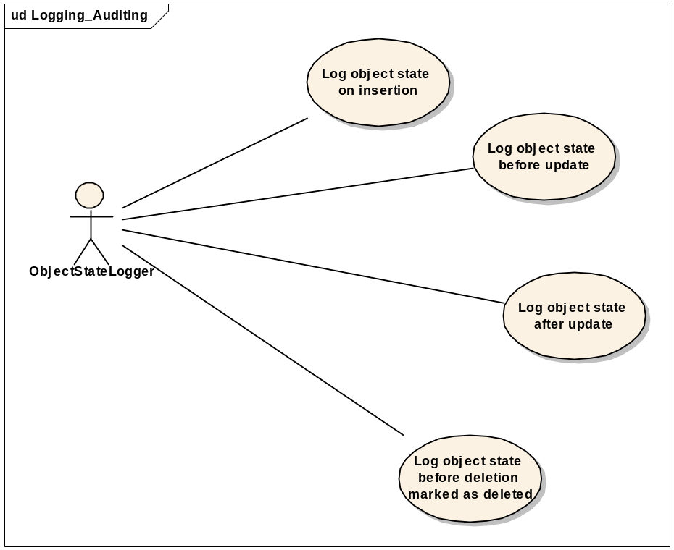

Design
CSM uses Hibernate for persisting objects. Hibernate’s architecture is based on AOP and event model. There are some standard transaction events defined in Hibernate, namely preInsert, postInsert, preUpdate, postUpdate etc… These events are thrown at the time of the respective action. Being an open architecture, Hibernate provides a transaction interceptor interface, which is defined in “org.hibernate.Interceptor”. This allows applications designers to implement this interceptor if needed. This implemented interceptor intercepts all these events and gives the designers the opportunity to access the objects at this juncture. For logging the object state, this is perfect place to plug in the logic. This interceptor provides all the necessary methods of the transaction. These methods can be implemented to address our requirements.
Please see the diagram below:

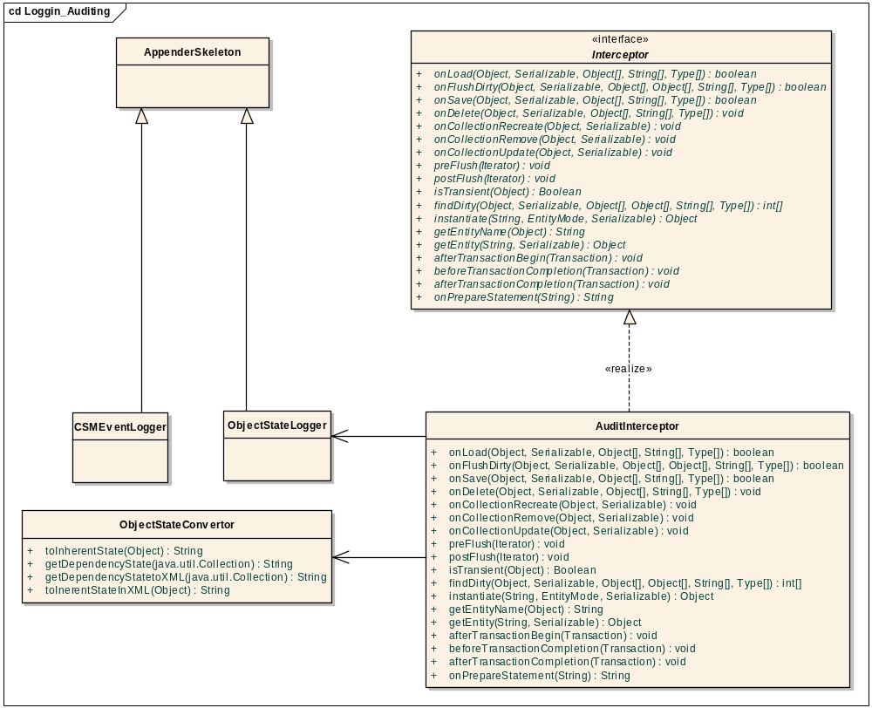

In the above diagram ApplenderSkeleton is an abstract class from log4j, which allows us to write custom appenders. In our case we will use this class to write two appenders: 1) CSMEventLogger and 2) ObjectStateLogger.
The interface interceptor is from Hibernate and can be found at “org.hibernate.Interceptor”. The AuditIneterceptor is the actual implementation of the interceptor interface. This is where all the logic will go. ObjectStateConvertor is a utility class which will convert an object state to the string or to an xml document. This class will be used in the interceptor to change the state of the object for logging purposes.
The object state will have two components:
- The object itself (called inherent state)
- The children (dependent objects)

When an object is transformed to a state, it will log the actual state of the object (no IDs). The dependent objects will be logged with their IDs only.
For your reference, see the reference implementation of this interceptor at this address: http://www.Hibernate.org/318.html. Our design will vary from this implementation. There is no need for domain objects to implement the Auditable interface, and dependent objects do not have to implement the Component interface. The ObjectStateConvertor will take care of this and additionally extract the data using reflection.
The user name has to be propagated to the interceptor for logging purposes. For this, ThreadLocal should be used. The username can be attached as an attribute and then cleared after use.

