Use Case AdminI Document

caLIMS2

DOCUMENT REVISION HISTORY
Version Number | Date | Description
1.0 | June 30th 2006 | - Draft
1.1 | July 4th | - Added Equipment and Laboratory Management Use cases.
1.2 | July 6th | - Added Use case diagrams and Activity diagram.
1.3 | July 10th | - Modified based on the review comments.
1.4 | July 12th | - Diagrams Updated.
1.5 | July 13th | - Added Unit Management Use Case.
1.6 | July 16th | - Added Message Management Use Case.
1.7 | Aug 24th | - Synchronized this document with EA diagram.
1.8 | September 25th | - Added missing use cases.
1.9 | October 15th | - Final revisions.
2.0 | October 25th | - Updated all the diagrams.
2.1 | January 26th | - Revised Modify/Copy Use Cases. Added possible Object fields.
3.0 | 9/3/2009 | - Revised per updated input from team, Working Group and LS GT; name change to caLIMS2, Assay changed to Method; diagrams updated.

Background/Summary

The goal of the caLIMS2 Project is to produce an open access, near commercial grade Laboratory Information Management System (LIMS) that is caBIG “silver” compliant. The LIMS will allow: a) management of laboratory personnel, equipment, inventory, samples and documents; b) adaptive workflow; c) integration with laboratory equipment and software; and d) generation of standard and custom reports.

The caBIG Common Security Model (CSM) will be leveraged to provide fine-grained security. A single instance of caLIMS2 will be capable of hosting multiple laboratories, collaborations, and customers.

caLIMS2 will be designed to allow easy customization and expansion. Users will be able to tailor the LIMS to their specific laboratory methods, protocols and workflows. The application will possess well-defined APIs to facilitate the integration of new equipment, analytical tools and data sources.
Table of Contents

Background/Summary 1
1 Introduction 3
1.1 Overview 3
1.2 Related Documents 3
1.3 System-wide Assumptions. 3
1.4 System Flow. 4
2 Actors and Goals 6
2.1 User 6
2.2 External System Actors 8
3 Use Cases 9
4 Overall Requirements 73
4.1 Requirements Prioritization 73
5 Data Definitions 74
6 Sign Off 75
6.1 Approval 75

Introduction

Overview
caLIMS2 is a core Laboratory Information Management System designed to allow a high degree of user customization and easy integration with laboratory equipment, analytical tools and data sources. This document defines the functional requirements of the caLIMS2 system.

Related Documents

Document Name | Version | Location
caLIMS2 Goals and Requirement document | 1.0 | http://gforge.nci.nih.gov/docman/view.php/166/2544/GoalsNCI_NCICB_LIMS_Project1.5.doc
caBIG Compatibility Guidelines | 2.0 | https://cabig.nci.nih.gov/guidelines_documentation/caBIGCompatGuideRev2_final.pdf
Common Security Module(CSM) and User Provisioning Tool (UPT) | 3.1 | http://ncicb.nci.nih.gov/infrastructure/cacore_overview/csm
GNU Unit | 1.0 | http://www.gnu.org/software/units/units.html
Enterprise Vocabulary Service (EVS) | 3.2 | http://ncicb.nci.nih.gov/NCICB/infrastructure/cacore_overview/vocabulary
Quartz | 1.5.2 | http://www.opensymphony.com/quartz/
OpenMQ | 4.1 | http://incubator.apache.org/activemq/
Unified code for units of measure (UCUM) | 1.6 | http://aurora.regenstrief.org/UCUM/ucum.html
Clinical Laboratory Improvement Amendments (CLIA) | 2004 codification | http://www.phppo.cdc.gov/clia/regs/toc.aspx
Health Level 7 | 3 | http://www.hl7.org/Library/standards.cfm
caARRAY | 1.3.1 | http://caarray.nci.nih.gov
Barcodes |  | http://www.aimglobal.org/technologies/barcode/
Electronic Signatures |  | http://www.itl.nist.gov/fipspubs/fip186.htm

System-wide Assumptions.

Assumption | Description
User is a generic Actor
Warning for Modify | - The System warns the User that the modified data will be lost if the User does not submit the changes.  - Require User Confirmation before committing changes.
Duplication Check for Add or Modify. | The System checks for uniqueness of name/label attribute of all entities.  Note: Other attributes may also be marked as unique and hence the system would check for a unique entry in the data source.
Copy function | The System would check for uniqueness of predefined attributes. This may be enforced via ManageNamingConvention, at the data model or at the user interface.
Warning for Delete | Require User Confirmation before committing delete.
Treating Software as Equipment | A software API that interacts with a LIMS adapter is considered Equipment.
Data Integrity check | The System performs a data integrity check prior to the modify and delete actions.
As a special case allow Validation on all attributes for uniqueness. | The System checks all attributes for uniqueness in selected use cases.
Adapter | The adapter may be unidirectional or bidirectional.
Standard and Advanced Search | - The Search Component would be used in almost all the modules such as Personnel Management, Organization Management etc.,  - The Standard search would be specific to the context where it is used. For example if a standard Search is used in Personnel Management then the search component by default queries Personnel entity.  - Advanced Search uses Query Management Use case to manage complex queries.
Case sensitive search on String type. | - User has the option of performing case sensitive or insensitive string searches.  - The default behavior is case insensitive.
System Error | The System errors do NOT include  - Data integrity errors.  - Invalid data type entry.
GUI centric Use case | These use cases assume the system is GUI based.  For programmatic access the use cases needed to be modified.
CSM is required | The Common Security Module is a subsystem.
Invalid Data Error | The system re-displays the page with previously entered data and highlights  any erroneous field(s).
Management Action | Actions such as Add, Modify and Delete would be presented in a matrix  layout.
Barcoding | Reading a barcode label can be used to populate the value to an Entity’s  attribute in an interface.
Logging and Audit trail | Common Logging Module (CLM) would be the secondary actor for capturing  Logging and Audit trail information.
Standards Compliancy | The intent is to include the following standards  - CLIA  - HL7v3  - Electronic signature standards.
Generic Use Cases | - ManageReport  - ManageSearch  - ManageQuery  - ManageSummary  - ManageNamingConvention  - ManageMetadata  - ManageMessage  - MangeFileTransporter  - ManageStatus  These are generic use cases that may be associated to any entity in the  System.
Hierarchical privileges | UPT allows the establishment of a hierarchical privilege structure (e.g. Manager inherits all characteristics of a Researcher).
Viewing entities | Users with view privilege of an Entity in UPT may be handled by removing edit feature in a Modify use case. This function may also be achieved by designing entity specific summary.
Assigning entities | Duplicate assignment of one Entity to another may be prevented by using UI objects such as Multiple Select box.

System Flow.
Figure 1-1 shows the Activity diagram in a high-level flow of events for caLIMS2 application. A User with the required privileges may be able to access the Administration module of the system and perform different functionalities. Manage activity includes Add, Delete, Modify, Copy and/or Assign functionalities. User may perform one of the manage functionalities on a given activity.
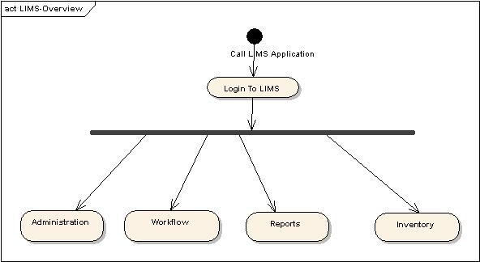
Figure 1-1 High level LIMS Application flow
Figure 1-1 is a high level diagram depicting the application flow and does not show the detail flow of action for an individual activity. The privileged User may select any of the following modules:
    - Administration
    - Workflow
    - Inventory
    - Report
Each module leads to multiple manage activity. Detailed description of an individual activity in a module is defined in the use case section of an individual module’s Use Case document.

Actors and Goals

User
A User can be authenticated against the caLIMS2 installation and can interact with the system. Different Actors are listed below. Figure 2-1 represents the actors in a UML view of the actors.

Actor | Description
User | Base User from which all LIMS actors are derived. User is a generic term that is used in this document to denote an actor with appropriate privilege to perform the activity described in a Use Case.
Super User | User who has access to all the projects, all of the lab info, and all activities in the LIMS system. This User may be assigned to SuperAdmin role in UPT.
Group Director * | User who is the supervisor of a set of labs; for example: an NCI Lab Chief, a university Department Head or a Clinical Trials Program Manager.
Principal Investigator | Individual who runs a single lab or core facility. A Principal Investigator is responsible for the design of scientific/technical conduct, administrative conduct, final approval and reporting of research projects.
Manager | Individual who is responsible for the overall development and implementation of laboratory policies and projects. The Lab Manager may perform experiments and/or supervise/approve others to run experiments.
Researcher | Individual who is responsible for sample preparation, running experiments/Methods, recording results and observations. A Researcher is generally supervised by a Lab Manager, Staff Scientist or PI.
Staff Scientist * | Individual who designs and performs experiments. A Staff Scientist is generally supervised by a Principal Investigator. A Staff Scientist may supervise Researchers, Graduate Students and Students.
Postdoc * | Individual with a doctoral degree who designs and performs experiments. A Postdoc is generally supervised by a Principal Investigator. A Postdoc may supervise Graduate Students and Students.
Bioinformatician | Individual who designs and performs 'dry lab' experiments and data analyses. A Bioinformatician is generally supervised by a Principal Investigator and may supervise Graduate Students, Postdocs, and Students.
Student * | Undergraduate or High School student who performs experiments. A Student may be supervised by a Principal Investigator, Manager, Staff Scientist, Postdoc or Graduate Student.
Graduate Student * | Individual working toward a doctoral degree who designs and performs experiments. A Graduate Student is usually supervised by a Principal Investigator and/or a Postdoc.
Guest | Individual who has read-only access to a subset of data in the LIMS.
Collaborator | Individual affiliated with another Laboratory or Organization who supplies samples, performs specific experiments of relevance to the laboratory, records results, and/or drafts reports.
Administrator | User who installs, configures, updates, and troubleshoots the system.
Customer | Individual who places customer requests, provides samples, reviews data, and receives reports on a fee-for-service basis.
SafetyOfficer * | Individual who is responsible for designing lab safety protocols and ensuring that the safety protocols are followed.
BusinessManager * | Individual who is responsible for managing interactions with customers.
InventoryManager * | Individual who enters samples, supplies and reagents into the LIMS.
CSM/UPT | NCICB Common Security Module / User Provisioning Tool
CLM | NCICB Common Logging Module
AnalysisTool | Data analysis application that interacts with the System through an API.
Equipment | Laboratory equipment that interacts with the System through an adapter module.
caBIGApplication | caBIG compliant application that interacts with the System through an API.
* Optional actors that are not part of a default caLIMS2 installation may be added per customer need.
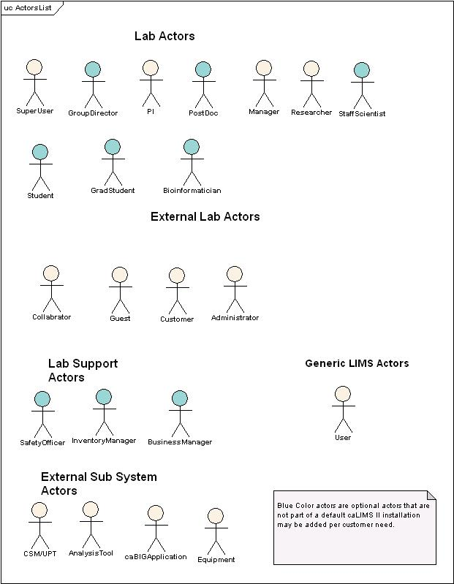
Figure 2-1 List of Actors

External System Actors
CSM is the caBIG Common Security Model application. caLIMS2 uses CSM as an external system actor to manage Users, privileges, roles and groups, and to authenticate Users. Other external systems actors include CLM, Equipment, caArray, caTissue, and Analysis Tools.

Use Cases
The following figure indicates the use cases of the system. The whole system has been divided into four modules.
- Administration
- Inventory
- Workflow
- Report

3.1 Administration:
The Administration module is a group of high-level functionalities. Access to administration module is provided to a restricted set of actors such as Lab Manager, Super User and Administrator. Figure 3-1 provides a high level view of the Administration module and its major uses. Use Cases that are marked yellow and are arranged in a rectangle called caLIMS2 System belong to the caLIMS2 application. These Use Cases will be discussed in detail. Use Cases that are grouped under the rectangle CSM/UPT System are assumed to be implemented in Common Security Model.
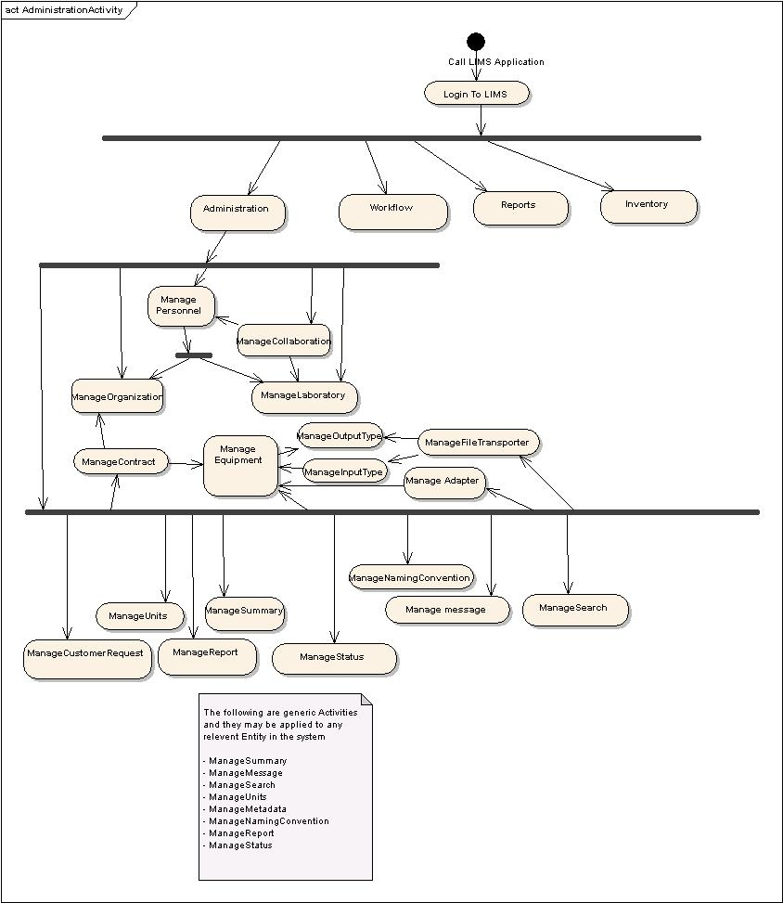
Figure 3-1 caLIMS2 Administration Flow
The use cases under the Administration module are categorized into 13 different groups:
- Laboratory Management
- Personnel Management
- Equipment Management
- Units Management
- FileTransporter Management
- Message Management
- Naming Convention Management
- MetaData Management
- Laboratory Standards Management
- Barcoding Management
- Customer Request Management
- Billing Management
- Status Management

Groups 1 thru 4 are described in detail below in this document (Administration1). Groups 5 thru 13 are described in Administration2 document.

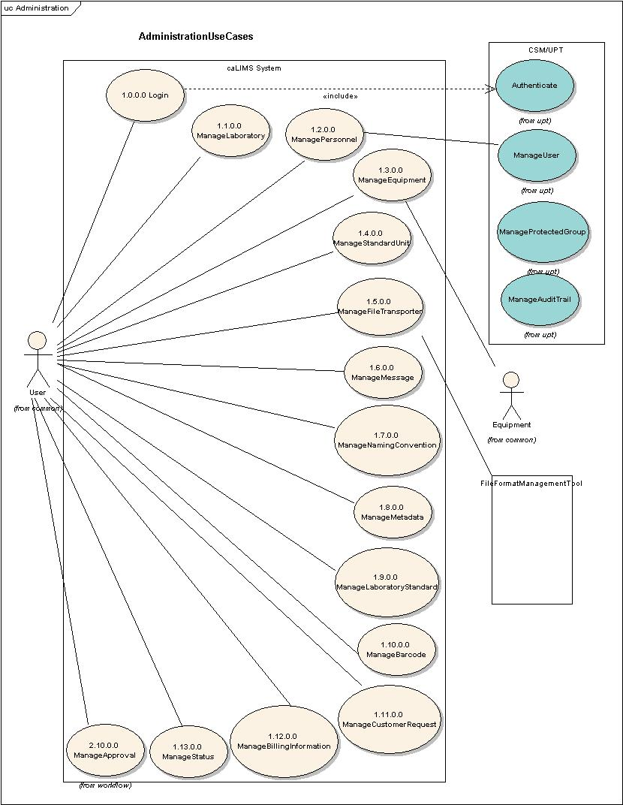
Figure 4-1 High-Level Administration Use Case Diagram

Use Case Name | Login
Use Case ID | 1.0.0.0
Primary Actor | User
Brief Description | The Login Use Case allows previously registered Users to authenticate and access the system.
Pre-conditions | - User has accepted the security encryption certificate.  - User has been given the account information by the system administrator.
Flow of Events | - User enters login account information including username and password.  - User submits the Login request.  - The CSM system authenticates the login information.  - The system grants the authenticated User access to the LIMS.
Post Conditions | Success Condition:  - User is granted entry.  Error Condition:  - Authentication failed.  - Invalid Login information.  - System error.
Alternative Courses of Action | Conditions 2 & 3:  The system throws an exception, displays an error message, and re-displays the  Login page for data entry  Condition 4:  The system throws a System error. Contact the system administrator.
Issues | - The Login use case is dependant on the authentication use case of the UPT system.
Special Requirements | - User has 128 bit encryption supported web browser.  - User has connected to internet via the default port.  - The caLIMS2 system needs to be seamlessly logging into UPT if the User has privilege.

Use Case Name | AccessUPT
Use Case ID | 1.0.1.0
Primary Actor | User
Brief Description | The AccessUPT Use Case allows previously registered UPT Users to authenticate and access UPT from the system.
Pre-conditions | - User has successfully logged into the system.  - User has privilege to access UPT interface.
Flow of Events | - User selects the Administration section.  - User selects the Access UPT action.  - The system seamlessly renders UPT application page based on privilege.
Post Conditions | Success Condition:  - User is granted access and presented with UPT home page.  Error Condition:  - System error.
Alternative Courses of Action | Condition 2:  The system throws a System error. Contact the system administrator.
Issues
Special Requirements | - Single sign-on has to be designed with UPT tool. The system needs to be seamlessly logging into UPT if the User has privilege. For example after the User successfully logs into caLIMS2 system, based on the privilege for that User, the User may start accessing UPT from the system.

Use Case Name | RequestUserAccount
Use Case ID | 1.0.2.0
Primary Actor | User
Brief Description | The RequestUserAccount Use Case allows anonymous Users to request a login account from the system help desk.
Pre-conditions | - User has accepted the security encryption certificate.  - User has been given the registration form.  - User accepts the registration condition.
Flow of Events | - User enters registration information (e.g. username, password, firstName, lastName, email).  - User submits the new account request.
Post Conditions | Success Condition:  - User submits the request successfully.  Error Condition:  - Invalid registration information (e.g. username or email is already used).  - System error.
Alternative Courses of Action | Conditions 1:  The system throws an exception, displays an error message, and re-displays the  User registration page for data entry.  Condition 2:  The system throws a System error. Contact the system administrator.
Issues | This is a configurable feature which may be chosen during installation.
Special Requirements

3.1.1 Laboratory Management:
Figure 4-2 illustrates the Laboratory Management group of use cases. This is a subset of the Administration module and includes Use Cases to manage:
    - Laboratory
    - Personnel
    - Organization
    - Collaboration
    - Contract
The Primary actor is any User with the privilege to access a particular use case and the Common Security Module (CSM) is a secondary actor.

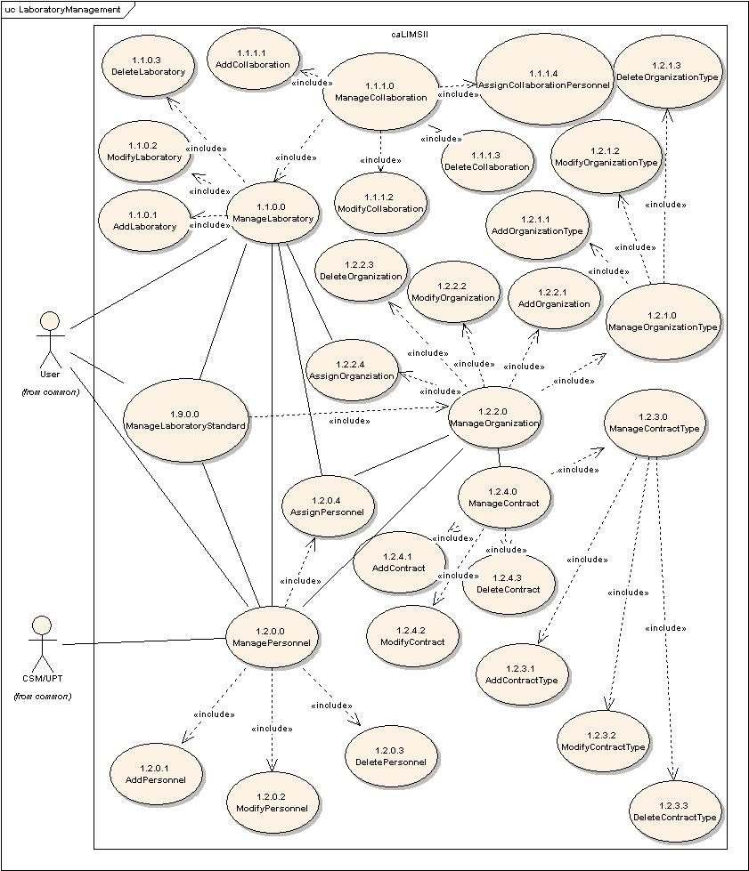
Figure 4-2 Detailed view of Laboratory Use Case Diagram.

Use Case Name | ManageLaboratory
Use Case ID | 1.1.0.0
Primary Actor | Users
Brief Description | The ManageLaboratory Use Case allows Users to add, modify or delete a Laboratory.
Pre-conditions | - User has logged into the system.  - User has privileges to perform the ManageLaboratory action.
Flow of Events | - User selects the ManageLaboratory action.  - User is presented with a list of actions User has privilege to perform.  - User adds (ID: 1.1.0.1), modifies (ID: 1.1.0.2) or deletes (ID: 1.1.0.3) a Laboratory.  - User submits the information.
Post Conditions | Success Condition:  - User has added, modified, or deleted Laboratory information.  Error Condition:  - System Error.
Alternative Courses of Action | Error Condition 2:  The system throws a System error. Contact the system administrator.
Issues
Special Requirements

Use Case Name | AddLaboratory
Use Case ID | 1.1.0.1
Primary Actor | Users
Brief Description | The AddLaboratory Use Case allows Users to add a new Laboratory to the system.
Pre-conditions | - User has logged into the system.  - User has privileges to perform the ManageLaboratory action.  - User has privileges to perform the AddLaboratory action.
Flow of Events | - User selects the ManageLaboratory action.  - User selects the AddLaboratory action.  User adds the required information for a new Laboratory (e.g. name, label, description, parentOrganization, principalInvestigator, address, phoneNumber, faxNumber, website, contactPerson).  - User submits information for a new Laboratory.
Post Conditions | Success Condition:  - User has added a new Laboratory to the system.  Error Condition:  - Invalid Laboratory information.  - Duplicate Laboratory information.  - System Error.
Alternative Courses of Action | Error Condition 2:  The system throws an Invalid Laboratory exception and re-displays the Add Laboratory interface for corrected information.  Error Condition 3:  The system throws a Duplicate Laboratory exception and re-displays the Add Laboratory interface for corrected information.  Error Condition 4:  The system throws a System error. Contact the system administrator.
Issues
Special Requirements

Use Case Name | ModifyLaboratory
Use Case ID | 1.1.0.2
Primary Actor | Users
Brief Description | The ModifyLaboratory Use Case allows Users to modify information for an existing Laboratory in the system.
Pre-conditions | - User has logged into the system.  - User has privileges to perform the ManageLaboratory action.  - User has privileges to perform the ModifyLaboratory action.  - User has privileges to modify one or more Laboratories.  - Modifying mutable fields of the chosen Laboratory does not affect System data integrity.
Flow of Events | - User selects the ManageLaboratory action.  - User selects the ModifyLaboratory action.  - User is presented with a list of Laboratories the User has privileges to modify.  - User selects a Laboratory to modify.  - User is presented with a list of fields for the chosen Laboratory.  - User modifies the value of one or more mutable fields of the chosen Laboratory.  - User submits the modified Laboratory information.
Post Conditions | Success Condition:  - User has modified information for a Laboratory.  Error Condition:  - Invalid Laboratory information.  - System Error.
Alternative Courses of Action | Error Condition 2:  System throws Invalid Laboratory exception message and re-displays the  ModifyLaboratory interface for corrected information.  Error Condition 3:  The system throws a System error. Contact the system administrator.
Issues | TBD
Special Requirements | 1) Check for Data integrity on fields other than id.

Use Case Name | DeleteLaboratory
Use Case ID | 1.1.0.3
Primary Actor | Users
Brief Description | The DeleteLaboratory Use Case allows Users to remove an existing Laboratory from the system.
Pre-conditions | - User has logged into the system  - User has privileges to perform the ManageLaboratory action.  - User has privileges to perform the DeleteLaboratory action.  - User has privileges to delete one or more Laboratories.  - Deleting the chosen Laboratory does not affect System data integrity.
Flow of Events | - User selects the ManageLaboratory action.  - User selects the DeleteLaboratory action.  - User is presented with a list of Laboratories the User has privileges to delete.  - User submits a request to delete a chosen Laboratory from the system.
Post Conditions | Success Condition:  - User has deleted a Laboratory from the system.  Error Condition:  - System Error.
Alternative Courses of Action | Error Condition 2 :  The system throws a System error. Contact the system administrator.
Issues | TBD
Special Requirements | TBD

Use Case Name | ManageCollaboration
Use Case ID | 1.1.1.0
Primary Actor | Users
Brief Description | The ManageCollaboration Use Case allows Users to add, modify, delete or assign Collaborations to the system.
Pre-conditions | - User has logged into the system.  - User has privileges to perform the ManageCollaboration activity.  - Eligible Laboratories have been entered into the system.
Flow of Events | - User selects the ManageCollaboration action.  - User is presented with a list of actions User has privilege to perform.  - AddCollaboration (ID: 1.1.1.1) or ModifyCollaboration (ID: 1.1.1.2) or DeleteCollaboration (ID: 1.1.1.3) or AssignCollaborationPersonnel (ID: 1.1.1.4).
Post Conditions | Success Condition:  - User has added, modified, deleted or assigned collaboration information.  Error Condition:  - System error.
Alternative Courses of Action | Error Condition 2:  The system throws a System error. Contact the system administrator.
Issues | - The system should generate a warning if the User attempts to exit before submitting a request.  - Standard behavior.  - NB: Defining a Collaboration should include collaboration name, collaboration summary, and possibly additional collaboration documents such as Memoranda of Understanding (MOAs), Material Transfer Agreements (MTAs), Cooperative Research and Development Agreements (CRADAs), etc.  - NB: Members of collaborations may share equipment, supplies, samples, and data.  - NB: Members of collaborations may upload samples, project notes/summaries/reports, reagents, and/or supplies.  - NB: Members of collaborations could perform experiments, analyze data, approve data, and generate project reports.  - NB: Laboratories are assigned to Collaborations; specific personnel in laboratories are assigned to Collaborations. Authority and permission states are defined by roles and groups in UPT.
Special Requirements | TBD

Use Case Name | AddCollaboration
Use Case ID | 1.1.1.1
Primary Actor | Users
Brief Description | The AddCollaboration Use Case allows users to add/define a Collaboration to the system.
Pre-conditions | - User has logged into the system.  - User has privileges to perform the ManageCollaboration functionality.  - User has privileges to perform the AddCollaboration functionality.  - Eligible Laboratories have been entered into the system.
Flow of Events | - User selects the ManageCollaboration component of the system.  - User selects the AddCollaboration action.  - User adds new information for a Collaboration (e.g. name, label, description, laboratory (2 .. n), administeringLaboratory, collaborationLeader).  - User submits the information for a new Collaboration.
Post Conditions | Success Condition:  - User has added a new Collaboration to the system.  Error Condition:  - Invalid Collaboration information.  - Duplicate Collaboration information.  - System error.
Alternative Courses of Action | Error Condition 2:  The system throws an Invalid Collaboration exception and re-displays the AddCollaboration screen for corrected data entry.  Error Condition 3:  The system throws a Duplicate Collaboration exception and re-displays the AddCollaboration screen for corrected data entry.  Error Condition 4:  The system throws a System error. Contact the system administrator.
Issues
Special Requirements | - A Collaboration may be an association between two or more laboratories.

Use Case Name | ModifyCollaboration
Use Case ID | 1.1.1.2
Primary Actor | Users
Brief Description | The ModifyCollaboration Use Case allows Users to modify preexisting collaborations in the system.
Pre-conditions | - User has logged into the system.  - User has privileges to perform the ManageCollaboration action.  - User has privileges to perform the ModifyCollaboration action.  - User has privileges to modify one or more Collaborations.  - Modifying mutable Collaboration fields does not affect system data integrity.
Flow of Events | - User selects the ManageCollaboration component of the system.  - User selects the ModifyCollaboration action.  - User is presented with a list of Collaborations the User has privileges to modify.  - User selects a Collaboration to modify.  - User modifies the value of one or more mutable fields of the chosen Collaboration.  - User submits the modified Collaboration information.
Post Conditions | Success Condition:  - User has modified information for a Collaboration in the system.  Error Condition:  - Invalid Collaboration information.  - System error.
Alternative Courses of Action | Error Condition 2:  The system throws an Invalid Collaboration information exception and redisplays the ModifyCollaboration page for corrected data entry.  Error Condition 3:  The system throws a System error. Contact the system administrator.
Issues
Special Requirements | 1) Validation required for fields other than primary key.

Use Case Name | DeleteCollaboration
Use Case ID | 1.1.1.3
Primary Actor | Users
Brief Description | The DeleteCollaboration Use Case allows Users to remove an existing Collaboration from the system.
Pre-conditions | - User has logged into the system.  - User has privileges to perform the ManageCollaboration action.  - User has privileges to perform the DeleteCollaboration action.  - User has privileges to delete one or more Collaborations.  - Deleting the chosen Collaboration does not affect system data integrity.
Flow of Events | - User selects the ManageCollaboration component of the system.  - User selects the DeleteCollaboration action.  - User is presented with a list of Collaborations the User has privileges to delete.  - User submits a request to delete a chosen Collaboration from the system.
Post Conditions | Success Condition:  - User has deleted the chosen Collaboration from the system  Error Condition:  - System error.
Alternative Courses of Action | Error Condition 2:  The system throws a System error. Contact the system administrator.
Issues
Special Requirements

Use Case Name | AssignCollaborationPersonnel
Use Case ID | 1.1.1.4
Primary Actor | Users
Brief Description | The AssignCollaborationPersonnel Use Case allows Users to assign Personnel to a Collaboration.
Pre-conditions | - User has logged into the system.  - Personnel are registered in the system.  - User has privileges to perform the AssignCollaborationPersonnel action.  - User has privileges to associate the chosen Personnel and the selected Collaboration.  - Assigning Collaboration Personnel does not affect System data integrity.
Flow of Events | - User selects the ManageCollaboration action.  - User is presented with a list of Collaborations the User has privilege on.  - User selects a Collaboration.  - User selects the AssignCollaborationPersonnel action.  - User is presented with a list of available Personnel belonging to Laboratories that are part of the selected Collaboration.  - User associates selected Personnel with the chosen Collaboration.  - User submits the information.
Post Conditions | Success Condition:  - User has associated Personnel with a chosen Collaboration.  Error Conditions  - System error.
Alternative Courses of Action | Error Condition 2:  The system throws a System error. Contact the system administrator.
Issues
Special Requirements | TBD

Use Case Name | ManagePersonnel
Use Case ID | 1.2.0.0
Primary Actor | Users
Brief Description | The ManagePersonnel Use Case allows Users to add, modify delete or assign Users to organizations and/or laboratories.
Pre-conditions | - User has logged into the system.  - User has privileges to perform the ManagePersonnel activity.
Flow of Events | - User selects the ManagePersonnel action.  - User is presented with a list of actions User has privileges to perform.  - AddPersonnel (ID: 1.2.0.1) or ModifyPersonnel (ID: 1.2.0.2) or DeletePersonnel (ID: 1.2.0.3) or AssignPersonnel (ID: 1.2.0.4 )
Post Conditions | Success Condition:  - User has added, modified, deleted or assigned User information.  Error Condition:  - Invalid information.  - System error.
Alternative Courses of Action | Error Condition 2:  The system throws an exception.  Error Condition 3:  The system throws a System error. Contact the system administrator.
Issues
Special Requirements | This use case would hold the User info of both UPT Users and non-UPT Users and the system would have an association with CSM at the Data base level.

Use Case Name | AddPersonnel
Use Case ID | 1.2.0.1
Primary Actor | Users
Brief Description | The AddPersonnel Use Case allows Users to add new Personnel to a Laboratory and/or Organization.
Pre-conditions | - User has logged into the system.  - User has privileges to perform ManagePersonnel action.  - User has privileges to assign Personnel to an existing Laboratory and/or Organization.  - User has privileges to perform the AddPersonnel action.
Flow of Events | - User selects the ManagePersonnel action.  - User selects the AddPersonnel action.  - User adds information for new Personnel (username, firstName, middleInitial, lastName, phoneNumber1, phoneNumber2, faxNumber, email1, email2, address, secondaryContact).  - User assigns Personnel to an existing Laboratory and/or Organization.  - User submits the information.
Post Conditions | Success Condition:  - User has added Personnel information to the system.  Error Condition:  - Invalid Personnel information.  - Duplicate Personnel information.  - System error.
Alternative Courses of Action | Error Condition 2:  The system throws an Invalid Personnel exception and re-displays the AddPersonnel screen for corrected data entry.  Error Condition 3:  The system throws a Duplicate Personnel exception and re-displays the AddPersonnel screen for corrected data entry.  Error Condition 4:  The system throws a System error. Contact the system administrator.
Issues | 1. This Use Case is dependent on AssignPersonnel (ID 1.2.0.4), since all  Personnel must be associated with Laboratories or Organizations.
Special Requirements | - This use case is associated with the CSM’s ManageUser Use Case.  - The Personnel Skills would be configured as Roles in CSM.

Use Case Name | ModifyPersonnel
Use Case ID | 1.2.0.2
Primary Actor | Users
Brief Description | The ModifyPersonnel Use Case allows Users to modify information for an existing Personnel.
Pre-conditions | - User has logged into the system.  - User has privileges to perform ManagePersonnel action.  - User has privileges to perform the ModifyPersonnel action.  - User has privileges to assign Personnel to the chosen Laboratory and/or Organization.  - User has privileges to modify the chosen Personnel.  - Modifying mutable Personnel fields does not affect System data integrity.
Flow of Events | - User selects the ManagePersonnel action.  - User selects the ModifyPersonnel action.  - User is presented with a list of Personnel the User has privilege to modify.  - User selects Personnel to modify.  - User modifies one or more mutable fields of the chosen Personnel.  - User submits the modified Personnel information.
Post Conditions | Success Condition:  - User has modified Personnel information.  Error Condition:  - Invalid Personnel information.  - System error.
Alternative Courses of Action | Error Condition 2:  The system throws an Invalid Personnel exception and re-displays the ModifyPersonnel screen for corrected data entry.  Error Condition 3:  The system throws a System error. Contact the system administrator.
Issues | TBD
Special Requirements | - This use case is associated with the CSM’s ManageUser Use Case.  - The Personnel Skills would be configured as Roles in CSM.

Use Case Name | DeletePersonnel
Use Case ID | 1.2.0.3
Primary Actor | Users
Brief Description | The DeletePersonnel Use Case allows Users to remove Personnel from the system.
Pre-conditions | - User has logged into the system.  - User has privileges to perform ManagePersonnel action.  - User has privileges to perform the DeletePersonnel action.  - User has privileges to delete the chosen Personnel.  - Deleting Personnel does not affect System data integrity.
Flow of Events | - User selects the ManagePersonnel action.  - User selects the DeletePersonnel action.  - User is presented with a list of Personnel the User has privilege to delete.  - User submits a request to delete chosen Personnel from the system.
Post Conditions | Success Condition:  1. User has deleted the selected Personnel from the system.  Error Condition:  2. System error.
Alternative Courses of Action | Error Condition 2:  The system throws a System error. Contact the system administrator.
Issues | TBD
Special Requirements | - This use case is associated with the UPT’s ManageUser Use Case.  - The Personnel Skills would be configured as Roles in UPT.

Use Case Name | AssignPersonnel
Use Case ID | 1.2.0.4
Primary Actor | Users
Brief Description | The AssignPersonnel Use Case allows Users to assign a Personnel to a Laboratory and/or Organization.
Pre-conditions | - User has logged into the system  - User has privileges to access the ManagePersonnel functionality  - User has privileges to access the AssignPersonnel functionality.  - User has privileges to assign the chosen Personnel to the chosen Laboratory and/or Organization.  - Assigning Personnel to the chosen Laboratory and/or Organization does not affect System data integrity.
Flow of Events | - User selects ManagePersonnel functionality.  - User selects AssignPersonnel functionality.  - User is presented with a list of Personnel and Laboratories the User has privileges to associate.  - User submits a request to assign selected Personnel to a Laboratory.
Post Conditions | Success Condition:  - User has associated a Personnel with a Laboratory or Organization.  Error Conditions  - The Personnel has already been assigned to the Laboratory or Organization.  - System Error.
Alternative Courses of Action | Error Condition 2:  The system throws a Duplicate Personnel Assignment exception and re-displays the AssignPersonnel screen.  Error Condition 3:  The system throws a System error. Contact the system administrator.
Issues | 1. Need to devise rules for assigning Personnel. A User should not be assigned  to more than one Laboratory. Assignment, however, should be nested so a  User in Laboratory X is also a member of Organizations that include the  Laboratory (e.g. Department).
Special Requirements | The User should be able to select multiple Personnel from the available list to make the assignment.

Use Case Name | ManageOrganizationType
Use Case ID | 1.2.1.0
Primary Actor | Users
Brief Description | The ManageOrganizationType Use Case manages a list of organization types to be associated with organizations. It allows Users to add, modify, delete or assign an organization type to an Organization.
Pre-conditions | - User has logged into the system.  - User has privileges to access the ManageOrganizationType functionality.
Flow of Events | - User selects the ManageOrganizationType action.  - User is presented with a list of actions User has privileges to perform.  - User adds (ID: 1.2.1.1), modifies (ID: 1.2.1.2) or deletes (ID: 1.2.1.3).  - User submits the information.
Post Conditions | Success Condition:  - User has added, modified or deleted OrganizationType information.  Error Condition:  - System Error.
Alternative Courses of Action | Error Condition 2:  The system throws a System error. Contact the system administrator.
Issues | 1) Note: A Laboratory is treated as an Entity distinct from an Organization.
Special Requirements | TBD

Use Case Name | AddOrganizationType
Use Case ID | 1.2.1.1
Primary Actor | Users
Brief Description | The AddOrganizationType Use Case allows Users to add an new Organization Type to the system. OrganizationTypes may include: Vendor, Research Institute, Division and Branch.
Pre-conditions | - User has logged into the system.  - User has privileges to access the ManageOrganizationType functionality.  - User has privileges to perform the AddOrganizationType action.
Flow of Events | - User selects the ManageOrganizationType action.  - User selects the AddOrganizationType action.  - User adds information for a new OrganizationType (e.g. name, label, description).  - User submits the information.
Post Conditions | Success Condition:  - User has added OrganizationType information to the system.  Error Condition:  - Invalid OrganizationType information  - Duplicate OrganizationType information  - System Error.
Alternative Courses of Action | Error Condition 2:  The system throws an Invalid Organization Type exception and re-displays the AddOrganizationType interface for corrected data entry.  Error Condition 3:  The system throws a Duplicate Organization Type exception and re-displays the AddOrganizationType interface for corrected data entry.  Error Condition 4:  The system throws a System error. Contact the system administrator.
Issues
Special Requirements | TBD

Use Case Name | ModifyOrganizationType
Use Case ID | 1.2.1.2
Primary Actor | Users
Brief Description | The ModifyOrganizationType Use Case allows Users to modify an existing OrganizationType in the system.
Pre-conditions | - User has logged into the system.  - User has privileges to access the ManageOrganizationType functionality  - User has privileges to access the ModifyOrganizationType functionality.  - User has privileges to modify one or more OrganizationType.  - Modifying mutable OrganizationType fields does not affect System data integrity.
Flow of Events | - User selects the ManageOrganizationType action.  - User selects the ModifyOrganizationType action.  - User is presented with a list of OrganizationTypes the User has privileges to modify.  - User selects an OrganizationType to modify.  - User modifies one or more mutable fields of the chosen OrganizationType.  - User submits the modified OrganizationType information.
Post Conditions | Success Condition:  - User has modified an OrganizationType.  Error Condition:  - Invalid OrganizationType information.  - System Error.
Alternative Courses of Action | Error Condition 2 :  System throws Invalid OrganizationType exception message and re-displays the  ModifyOrganizationType interface for corrected data entry.  Error Condition 3:  The system throws a System error. Contact the system administrator.
Issues | TBD
Special Requirements | 1) Check for Data integrity on fields other than id.

Use Case Name | DeleteOrganizationType
Use Case ID | 1.2.1.3
Primary Actor | Users
Brief Description | The DeleteOrganizationType Use Case allows Users to remove an existing OrganizationType from the system
Pre-conditions | - User has logged into the system  - User has privileges to access the ManageOrganizationType functionality.  - User has privileges to access the DeleteOrganizationType functionality.  - User has privileges to delete one or more OrganizationTypes.  - Deleting the chosen OrganizationType does not affect System data integrity.
Flow of Events | - User selects the ManageOrganizationType action.  - User selects the DeleteOrganizationType action.  - User is presented with a list of OrganizationTypes the User has privileges to delete.  - User submits a request to delete a chosen OrganizationType.
Post Conditions | Success Condition:  - User has deleted the chosen OrganizationType.  Error Condition:  - System Error.
Alternative Courses of Action | Error Condition 2 :  The system throws a System error. Contact the system administrator.
Issues | TBD
Special Requirements | TBD

Use Case Name | ManageOrganization
Use Case ID | 1.2.2.0
Primary Actor | Users
Brief Description | The ManageOrganization Use Case manages a list of Organizations to be associated with a Laboratory. It allows Users to add, modify, delete or assign an Organization to a Laboratory.
Pre-conditions | - User has logged into the system.  - User has privileges to perform the ManageOrganization action.  - The System has a valid OrganizationType (ID: 1.2.1.0).
Flow of Events | - User Selects Manage Organization functionality  - User is presented with a list of actions User has privileges to perform.  - User adds (ID: 1.2.2.1), modifies (ID: 1.2.2.2), deletes (ID: 1.2.2.3), or assigns (ID: 1.2.2.4) an Organization.  - User submits the information.
Post Conditions | Success Condition:  - User has added, modified, deleted or assigned Organization information.  Error Condition:  - System Error.
Alternative Courses of Action | Error Condition 2:  The system throws a System error. Contact the system administrator.
Issues | TBD
Special Requirements | TBD

Use Case Name | AddOrganization
Use Case ID | 1.2.2.1
Primary Actor | Users
Brief Description | The AddOrganization Use Case allows Users to add an new Organization to the system.
Pre-conditions | - User has logged into the system.  - User has privileges to access the ManageOrganization functionality.  - User has privileges to access the AddOrganization functionality.  - User has privileges to the one or more OrganizationType.
Flow of Events | - User selects the ManageOrganization action.  - The use selects the AddOrganization function.  - User adds information for a new Organization (e.g. name, label, description, address, phoneNumber, faxNumber, email, website, contactPerson)..  - User selects available OrganizationType.  - User submits the information for a new Organization.
Post Conditions | Success Condition:  - User has added a new Organization to the system.  Error Condition:  - Invalid Organization information  - Duplicate Organization information  - System Error.
Alternative Courses of Action | Error Condition 2:  The system throws an Invalid Organization exception and re-displays the AddOrganization screen for corrected data entry.  Error Condition 3:  The system throws a Duplicate Organization exception and re-displays the AddOrganization screen for corrected data entry.  Error Condition 4:  The system throws a System error. Contact the system administrator.
Issues
Special Requirements | 1) Validation required for fields other than primary key.

Use Case Name | ModifyOrganization
Use Case ID | 1.2.2.2
Primary Actor | Users
Brief Description | The ModifyOrganization Use Case allows Users to modify an existing Organization in the system.
Pre-conditions | - User has logged into the system  - User has privileges to access the ManageOrganization functionality.  - User has privileges to assign the chosen OrganizationType.  - User has privileges to access the ModifyOrganization functionality.  - User has privileges to modify one or more Organization.  - Modifying mutable Organization fields does not affect System data integrity.
Flow of Events | - User selects the ManageOrganization action.  - User selects the ModifyOrganization functionality.  - User is presented with a list of Organizations the User has privileges to modify.  - User selects an Organization to modify.  - User modifies one or more mutable Organization fields.  - User submits the modified Organization information.
Post Conditions | Success Condition:  - User has modified an Organization in the system.  Error Condition:  - Invalid Organization information.  - System Error.
Alternative Courses of Action | Error Condition 2 :  System throws Invalid Organization exception and re-displays the  ManageOrganization screen for corrected data entry.  Error Condition 3:  The system throws a System error. Contact the system administrator.
Issues
Special Requirements | TBD

Use Case Name | DeleteOrganization
Use Case ID | 1.2.2.3
Primary Actor | Users
Brief Description | The DeleteOrganization Use Case allows Users to remove an existing Organization  from the system.
Pre-conditions | - User has logged into the system.  - User has privileges to access the ManageOrganization functionality.  - User has privileges to access the DeleteOrganization functionality.  - User has privileges to delete one or more Organizations.  - Deleting the chosen Organization does not affect System data integrity.
Flow of Events | - User selects the ManageOrganization functionality.  - User selects the Delete Organization functionality.  - User is presented with a list of Organizations the User has privileges to delete.  - User submits a request to delete a chosen Organization from the system.
Post Conditions | Success Condition:  - User has deleted the selected Organization from the system.  Error Condition:  - System Error.
Alternative Courses of Action | Error Condition 2 :  The system throws a System error. Contact the system administrator.
Issues | TBD
Special Requirements | TBD

Use Case Name | AssignOrganization
Use Case ID | 1.2.2.4
Primary Actor | Users
Brief Description | The AssignOrganization Use Case allows Users to assign an Organization to a Laboratory.
Pre-conditions | - User has logged into the system.  - User has privileges to access the ManageOrganization functionality.  - User has privileges to access the AssignOrganization functionality.  - User has privileges to assign one or more Organizations to one or more Laboratories.  - Assigning the chosen Organization to the chosen Laboratory does not affect System data integrity.
Flow of Events | - User selects ManageOrganization functionality.  - User selects AssignOrganization functionality.  - User is presented with a list of Organizations and Laboratories the User has privileges to associate.  - User selects an Organization and a Laboratory to associate.  - User submits a request to assign the chosen Organization to the chosen Laboratory.
Post Conditions | Success Condition:  - User has associated the chosen Organization with the selected Laboratory.  Error Conditions  - The Organization has already been assigned to the Laboratory.  - System Error.
Alternative Courses of Action | Error Condition 2:  The system throws a Duplicate Organization Assignment exception and re-displays the AssignOrganization screen for corrected data entry.  Error Condition 3:  The system throws a System error. Contact the system administrator.
Issues | 1) This use case is flexible enough to be accessed via ManageLaboratory in a Lab Centric LIMS or via ManageOrganization in Organization centric LIMS.  2) An Organization can be assigned to another Organization (i.e. a CoreFacility can be assigned to a Division).
Special Requirements

Use Case Name | ManageContractType
Use Case ID | 1.2.3.0
Primary Actor | Users
Brief Description | The ManageContractType Use Case allows Users to add, modify, or delete ContractTypes or assign ContractTypes to Contracts.
Pre-conditions | - User has logged into the system.  - User has privileges to perform the ManageContractType activity.
Flow of Events | - User selects the ManageContractType action.  - User is presented with a list of actions User has privileges to perform.  - User performs the AddContractType (ID: 1. 2.3.1) or ModifyContractType (ID: 1. 2.3.2) or DeleteContractType (ID: 1. 2.3.3) action.  - User submits information.
Post Conditions | Success Condition:  - User has added, modified or deleted ContractType information.  Error Condition:  - Invalid information.  - System error.
Alternative Courses of Action | Error Condition 2:  The system throws an exception.  Error Condition 3:  The system throws a System error. Contact the system administrator.
Issues | - ContractTypes include: service/maintenance contract (for equipment), per incident contract (for equipment), vendor contract (for equipment, supplies, services), customer contract (to provide services).  - ContractType may be an agreement such as an MTA, CDA, CRADA etc.,
Special Requirements | TBD

Use Case Name | AddContractType
Use Case ID | 1.2.3.1
Primary Actor | Users
Brief Description | The AddContractType Use Case allows Users to add a new ContractType to the system.
Pre-conditions | - User has logged into the system.  - User has privileges to perform the ManageContractType action.  - User has privileges to perform the AddContractType action.
Flow of Events | - User selects the ManageContractType.  - User selects the AddContractType action.  - User adds information for a new ContractType (e.g. name, label, description).  - User submits the information.
Post Conditions | Success Condition:  - User has added a new ContractType to the system.  Error Condition:  - Invalid ContractType information.  - Duplicate ContractType information.  - System error.
Alternative Courses of Action | Error Condition 2:  The system throws an Invalid ContractType exception and re-displays the AddContractType screen for corrected data entry.  Error Condition 3:  The system throws a Duplicate ContractType exception and re-displays the AddContractType screen for corrected data entry.  Error Condition 4:  The system throws a System error. Contact the system administrator.
Issues
Special Requirements

Use Case Name | ModifyContractType
Use Case ID | 1.2.3.2
Primary Actor | Users
Brief Description | The ModifyContractType Use Case allows Users to modify preexisting ContractTypes.
Pre-conditions | - User has logged into the system.  - User has privileges to perform the ManageContractType action.  - User has privileges to perform the ModifyContractType action.  - User has privileges to modify one or more ContractTypes.  - Modifying mutable fields of the chosen ContractType does not affect System data integrity.
Flow of Events | User selects the ManageContractType action component of the system.  - User selects the ModifyContractType action.  - User is presented with a list of ContractTypes the User has privileges to modify.  - User selects a ContractType to modify.  - User modifies one or more mutable fields of the chosen ContractType.  - User submits the information.
Post Conditions | Success Condition:  - User has modified the chosen ContractType.  Error Condition:  - Invalid ContractType information.  - System error.
Alternative Courses of Action | Error Condition 2:  The system throws an Invalid ContractType exception and re-displays the ModifyContractType screen for corrected data entry.  Error Condition 3:  The system throws a System error. Contact the system administrator.
Issues | TBD
Special Requirements | TBD

Use Case Name | DeleteContractType
Use Case ID | 1.2.3.3
Primary Actor | Users
Brief Description | The DeleteContractType Use Case allows Users to remove an existing ContractType from the system.
Pre-conditions | - User has logged into the system.  - User has privileges to perform the ManageContractType action.  - User has privileges to perform the DeleteContractType action.  - User has privileges to delete one or more ContractTypes.  - Deleting the chosen ContractType does not affect System data integrity.
Flow of Events | - User selects the ManageContractType action.  - User selects the DeleteContractType action.  - User is presented with a list of ContractTypes the User has privileges to delete.  - User submits a request to delete a chosen ContractType from the system.
Post Conditions | Success Condition:  - User has deleted the selected ContractType from the system  Error Condition:  - System error.
Alternative Courses of Action | Error Condition 2:  The system throws a System error. Contact the system administrator.
Issues
Special Requirements

Use Case Name | ManageContract
Use Case ID | 1.2.4.0
Primary Actor | Users
Brief Description | The ManageContract Use Case allows Users to add, modify or delete contracts on Equipment, Organizations, Methods, Supplies, Samples, etc.
Pre-conditions | - User has logged into the system.  - User has privileges to perform the ManageContract activity.
Flow of Events | - User selects the ManageContract action.  - User is presented with a list of actions User has privileges to perform.  - AddContract (ID: 1.2.4.1) or ModifyContract (ID: 1.2.4.2) or DeleteContract (ID: 1.2.4.3).  - User submits information.
Post Conditions | Success Condition:  - User has added, modified or deleted Contract information.  Error Condition:  - Invalid information.  - System error.
Alternative Courses of Action | Error Condition 2:  The system throws an exception.  Error Condition 3:  The system throws a System error. Contact the system administrator.
Issues | - Need comprehensive list of system objects that are associated with contracts...
Special Requirements | A contract may be between two or more parties (labs, organizations).

Use Case Name | AddContract
Use Case ID | 1.2.4.1
Primary Actor | Users
Brief Description | The AddContract Use Case allows Users to add a Contract to the system and to assign a subject and parties to the contract.
Pre-conditions | - User has logged into the system.  - The appropriate ContractType is registered in the system.  - User has privileges to assign the chosen ContractType.  - User has privileges to perform the ManageContract activity.  - User has privileges to perform the AddContract action.  - User has privileges to assign the Entity and parties (Organization, Lab or Personnel) to a contract.
Flow of Events | - User selects the ManageContract action.  - User selects the AddContract action.  - User adds information for a new Contract (e.g. name, label, description, startDate, endDate, contractDocument, recipientContactPerson, supplierContactPerson, contracted).  - User assigns a ContractType to Contract.  - User assigns an Entity to the Contract.  - User assigns parties to the Contract.  - User submits the information.
Post Conditions | Success Condition:  - User has added a new Contract to the system.  Error Condition:  - Invalid Contract information.  - Duplicate Contract information.  - System error.
Alternative Courses of Action | Error Condition 2:  The system throws an Invalid Contract exception and re-displays the AddContract screen for corrected data entry.  Error Condition 3:  The system throws a Duplicate Contract exception and re-displays the AddContract screen for corrected data entry.  Error Condition 4:  The system throws a System error. Contact the system administrator.
Issues
Special Requirements | 1. Validate Contract number to avoid duplicating a contract.

Use Case Name | ModifyContract
Use Case ID | 1.2.4.2
Primary Actor | Users
Brief Description | The ModifyContract Use Case allows Users to modify an existing Contract.
Pre-conditions | - User has logged into the system.  - User has privileges to perform the ManageContract activity.  - User has privileges to perform the ModifyContract action.  - User has privileges to assign the chosen ContractType.  - User has privilege to modify one or more Contracts.  - Modifying mutable fields of the chosen Contract information does not affect System data integrity.
Flow of Events | - User selects the ManageContract action.  - User selects the ModifyContract action.  - User is presented with a list of Contracts the User has privileges to modify.  - User chooses a Contract to modify.  - User modifies one or more mutable fields of the chosen Contract.  - User submits the modified Contract information.
Post Conditions | Success Condition:  - User has modified the chosen Contract.  Error Condition:  - Invalid Contract information.  - System error.
Alternative Courses of Action | Error Condition 2:  The system throws an Invalid Contract exception and re-displays the ModifyContract screen for corrected data entry.  Error Condition 3:  The system throws a System error. Contact the system administrator.
Issues | 1. The System may restrict assigning certain fields.
Special Requirements | 1. Validate Contract number to avoid duplicating a contract.

Use Case Name | DeleteContract
Use Case ID | 1.2.4.3
Primary Actor | Users
Brief Description | The DeleteContract Use Case allows Users to remove an existing Contract from the system.
Pre-conditions | - User has logged into the system.  - User has privileges to perform the ManageContract activity.  - User has privileges to perform the DeleteContract action.  - User has privileges to delete one or more Contracts.  - Deleting the chosen Contract does not affect system data integrity.
Flow of Events | - User selects the ManageContract action.  - User selects the DeleteContract action.  - User is presented with a list of Contracts the User has privileges to delete.  - User submits a request to delete a selected Contract from the system.
Post Conditions | Success Condition:  - User has deleted a selected Contract from the system.  Error Condition:  - System error.
Alternative Courses of Action | Error Condition 2:  The system throws a System error. Contact the system administrator.
Issues | TBD
Special Requirements | TBD

    - Equipment Management:
Figure 4-3 illustrates the Equipment Management group of use cases. This is a sub set of the Administration module and includes the following:
    - Equipment Management
    - Storage Location Management
    - Adapter Management
    - Input Type Management
    - Output Type Management
The Primary actor is any User with the privilege to access a particular use case and the secondary actor includes Equipment and its associated data analysis software.

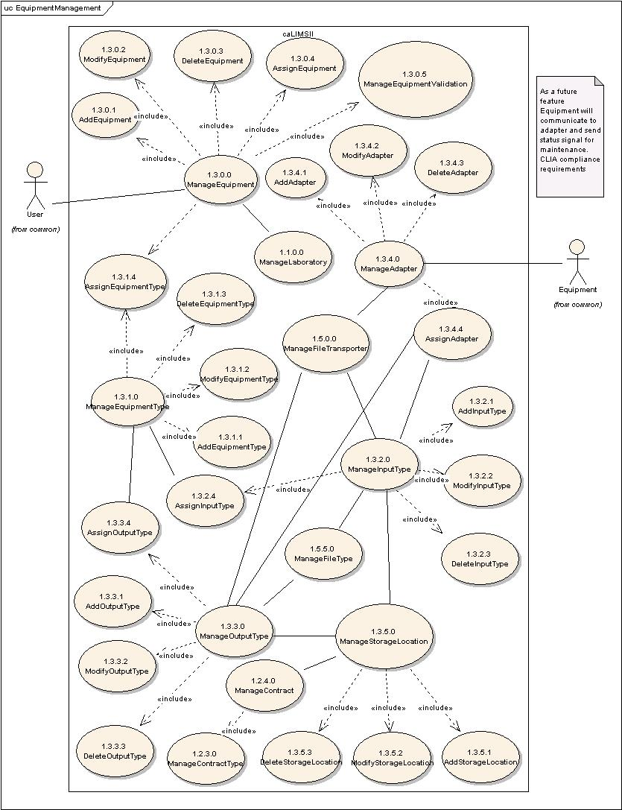
Figure 4-3 Detailed view of Equipment Use Case Diagram

Use Case Name | ManageEquipment
Use Case ID | 1.3.0.0
Primary Actor | Users
Brief Description | The ManageEquipment Use Case allows Users to add, modify, or delete Equipment.  For example, Equipment can be an AB 3100 automated sequencer, an Affymetrix GeneChip Scanner, or a -80 C laboratory freezer.
Pre-conditions | - User has logged into the system.  - User has privileges to perform the ManageEquipment activity.
Flow of Events | - User selects ManageEquipment action.  - User is presented with a list of actions User has privileges to perform.  - User may perform any of the following allowed actions.  AddEquipment (ID: 1.3.0.1) or ModifyEquipment (ID: 1.3.0.2),  DeleteEquipment (ID: 1.3.0.3) or AssignEquipment (ID: 1.3.0.4).
Post Conditions | Success Condition:  - User has added, modified, deleted, or assigned Equipment information.  Error Condition:  - Invalid information.  - System error.
Alternative Courses of Action | Error Condition 2:  The system throws an exception and re-displays for corrected data entry.  Error Condition 3:  The system throws a System error. Contact the system administrator.
Issues
Special Requirements

Use Case Name | AddEquipment
Use Case ID | 1.3.0.1
Primary Actor | Users
Brief Description | AddEquipment Use Case allows Users to add new equipment to the system.  For example, Equipment can be an AB 3100 automated sequencer, an Affymetrix GeneChip Scanner, or a -80 C laboratory freezer.
Pre-conditions | - User is logged into the system.  - User has privilege to perform ManageEquipment functionality.  - User has privilege to perform AddEquipment functionality.  - The system has a valid EquipmentType. Refer ManageEquipmentType Use Case (ID: 1.3.1.0).
Flow of Events | - User selects Administration component of the system.  - User selects ManageEquipment action.  - User selects AddEquipment action.  - User provides identification and related information for Equipment (e.g. name, label, description, manufacturer, model, serialNumber, propertyID, contactPerson, trainingManual).  - User submits the new Equipment information.
Post Conditions | Success Condition:  - User has added new Equipment to the system.  Error Condition:  - Invalid Equipment information.  - Duplicate Equipment information.  - System error.
Alternative Courses of Action | Condition 2:  The system throws an Invalid Equipment exception message and re-displays the AddEquipment page for corrected data entry.  Condition 3:  The system throws Duplicate Equipment exception message and re-displays the AddEquipment page.  Condition 4:  The system throws a System error. Contact the system administrator.
Issues
Special Requirements | - The system allows Users to perform batch uploads of Equipment.  - Refer to Use Cases specific to batch upload.  - The System allows Users to add Equipment by interfacing with barcode scanners.  - The location of Equipment is specified via the ManageStorageLocation Use Case (1.3.5.0).

Use Case Name | ModifyEquipment
Use Case ID | 1.3.0.2
Primary Actor | Users
Brief Description | ModifyEquipment Use Case allows Users to modify existing Equipment in the system.
Pre-conditions | - User is logged into the system.  - User has privilege to perform ManageEquipment activity.  - User has privilege to perform ModifyEquipment action.  - User has privilege to modify one or more pieces of Equipment.  - Modifying mutable fields of the chosen Equipment does not affect system data integrity.
Flow of Events | - User selects ManageEquipment functionality.  - User selects the ModifyEquipment action.  - User is presented with a list of Equipment User has privilege to modify.  - User selects a piece of Equipment to modify.  - User modifies one or more mutable fields of the the selected Equipment.  - User submits the modified Equipment information.
Post Conditions | Success Condition:  - User has modified the chosen existing piece of Equipment.  Error Condition:  - Invalid Equipment information.  - System Error
Alternative Courses of Action | Condition 2:  The system throws an Invalid Equipment exception message and re-displays the  ModifyEquipment page for corrected data entry.  Condition 3:  The system throws a System error. Contact the system administrator.
Issues
Special Requirements | The System allows Users to access the ModifyEquipment functionality by interfacing with barcode scanners.

Use Case Name | DeleteEquipment
Use Case ID | 1.3.0.3
Primary Actor | Users
Brief Description | DeleteEquipment Use Case allows Users to delete existing Equipment from the system
Pre-conditions | - User is logged into the system.  - User has privilege to perform ManageEquipment action.  - User has privilege to perform DeleteEquipment action.  - User has privilege to delete one or more pieces of Equipment.  - Deleting the chosen Equipment does not affect system data integrity.
Flow of Events | - User selects EquipmentManagement section.  - User is presented with a list of Equipment the User has privilege to delete.  - User submits a request to delete a chosen piece of Equipment.
Post Conditions | Success Condition:  - User has deleted the chosen Equipment from the system.  Error Condition:  - System Error
Alternative Courses of Action | Condition2:  The system throws a System error. Contact the system administrator.
Issues
Special Requirements

Use Case Name | AssignEquipment
Use Case ID | 1.3.0.4
Primary Actor | Users
Brief Description | The AssignEquipment Use Case allows Users to assign Equipment to a Laboratory, Collaboration, Project, or a Run.
Pre-conditions | - User has logged into the system.  - User has privilege to perform the ManageEquipment action.  - The Equipment is registered in the system.  - User has privilege to AssignEquipment action.  - User has privilege to assign the one or more Equipment items to one or more Entities.
Flow of Events | - User selects the ManageEquipment action.  - User selects the AssignEquipment action.  - User selects the EquipmentType.  - User is presented with a list of Equipment items the User has privilege to associate.  - User is presented with a list of Laboratories, Collaborations, Projects, and Runs the User has privilege to associate.  - User associates one or more Equipment items with one or more Laboratories, Collaborations, Projects, or Runs.  - User submits the information.
Post Conditions | Success Condition:  - User has associated chosen Equipment with one or more Laboratories, Collaborations, Projects, or Runs.  Error Conditions  - Duplicate Equipment Assignment.  - System error.
Alternative Courses of Action | Error Condition 2:  The system throws a Duplicated Equipment Association exception and re-displays the AssignEquipment interface for corrected data entry.  Error Condition 3:  The system throws a System error. Contact the system administrator.
Issues
Special Requirements | 1) Equipment may be assigned to a Project, Laboratory, Method, LabProcedure, or Run.  2) Certain Equipment items may be assigned to specific experiments that follow standards such as CLIA.

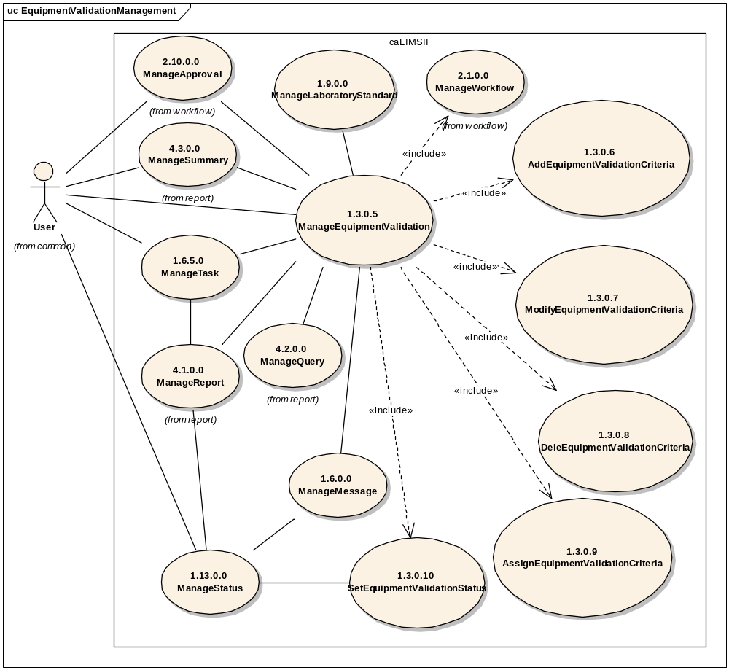
Figure 4-4 Detailed view of Equipment Validation Use Case Diagram.

Use Case Name | ManageEquipmentValidation
Use Case ID | 1.3.0.5
Primary Actor | Users
Brief Description | The ManageEquipmentValidation Use Case allows Users to add, modify, delete, or assign EquipmentValidationCriteria and to set EquipmentValidationStatus.
Pre-conditions | - User has logged into the system.  - User has privileges to perform the ManageEquipmentValidation activity.
Flow of Events | - User selects ManageEquipmentValidation action.  - User may perform any of the following allowed actions:  AddEquipmentValidationCriteria (ID: 1.3.0.6),  ModifyEquipmentValidationCriteria (ID: 1.3.0.7), DeleteEquipmentValidationCriteria (ID: 1.3.0.8),  AssignEquipmentValidationCriteria (ID: 1.3.0.9) or  SetEquipmentValidationStatus (ID: 1.3.0.10).
Post Conditions | Success Condition:  - User has added, modified, deleted, assigned EquipmentValidationCriteria information or set EquipmentValidationStatus.  Error Condition:  - Invalid information.  - System error.
Alternative Courses of Action | Error Condition 2:  The system throws an exception and re-displays for corrected data entry.  Error Condition 3:  The system throws a System error. Contact the system administrator.
Issues
Special Requirements | Status may include  1) Active  2) Inactive  3) Suspended  4) Pending  5) Critical

Use Case Name | AddEquipmentValidationCriteria
Use Case ID | 1.3.0.6
Primary Actor | Users
Brief Description | AddEquipmentValidationCriteria Use Case allows Users to add new EquipmentValidationCriteria to the system.
Pre-conditions | - User is logged into the system.  - User has privilege to perform ManageEquipmentValidation functionality.  - User has privilege to perform AddEquipmentValidationCriteria functionality.
Flow of Events | - User selects Administration component of the system.  - User selects ManageEquipmentValidation action.  - User selects AddEquipmentValidationCriteria action.  - User provides information for the EquipmentValidationCriteria (e.g. name, label, description, validationDate, expirationDate, validator).  - User submits the information.
Post Conditions | Success Condition:  - User has added information for the EquipmentValidationCriteria to the system.  Error Condition:  - Invalid EquipmentValidationCriteria information.  - Duplicate EquipmentValidationCriteria information.  - System error.
Alternative Courses of Action | Condition 2:  The system throws an Invalid EquipmentValidationCriteria exception message and re-displays the AddEquipmentValidationCriteria page for corrected data entry.  Condition 3:  The system throws Duplicate EquipmentValidationCriteria exception message and re-displays the AddEquipmentValidationCriteria page.  Condition 4:  The system throws a System error. Contact the system administrator.
Issues
Special Requirements

Use Case Name | ModifyEquipmentValidationCriteria
Use Case ID | 1.3.0.7
Primary Actor | Users
Brief Description | ModifyEquipmentValidationCriteria Use Case allows Users to modify existing EquipmentValidationCriteria in the system.
Pre-conditions | - User is logged into the system.  - User has privilege to perform ManageEquipmentValidation activity.  - User has privilege to perform ModifyEquipmentValidationCriteria action.  - User has privilege to modify one or more EquipmentValidationCriteria.  - Modifying mutable fields of the chosen EquipmentValidationCriteria does not affect system data integrity.
Flow of Events | - User selects the ManageEquipmentValidationCriteria functionality.  - User selects the ModifyEquipmentValidationCriteria action.  - User is presented with a list of EquipmentValidationCriteria the User has privilege to modify.  - User selects an EquipmentValidationCriteria to modify.  - User modifies one or more mutable fields of the chosen EquipmentValidationCriteria.  - User submits the modified EquipmentValidationCriteria information.
Post Conditions | Success Condition:  - User has modified information for a chosen EquipmentValidationCriteria.  Error Condition:  - Invalid EquipmentValidationCriteria information.  - System Error
Alternative Courses of Action | Condition 2:  The system throws an Invalid EquipmentValidationCriteria exception message and re-displays the ModifyEquipmentValidationCriteria page for corrected data entry.  Condition 3:  The system throws a System error. Contact the system administrator.
Issues
Special Requirements

Use Case Name | DeleteEquipmentValidationCriteria
Use Case ID | 1.3.0.8
Primary Actor | Users
Brief Description | DeleteEquipmentValidationCriteria Use Case allows Users to delete existing EquipmentValidationCriteria from the system
Pre-conditions | - User is logged into the system.  - User has privilege to perform ManageEquipmentValidationCriteria action.  - User has privilege to perform DeleteEquipmentValidationCriteria action.  - User has privilege to delete one or more EquipmentValidationCriteria.  - Deleting the chosen EquipmentValidationCriteria does not affect system data integrity.
Flow of Events | - User selects ManageEquipmentValidationCriteria section.  - User is present with a list of EquipmentValidationCriteria the User has privilege to delete.  - User submits a request to delete a chosen EquipmentValidationCriteria.
Post Conditions | Success Condition:  - User has deleted the chosen EquipmentValidationCriteria from the system.  Error Condition:  - System Error
Alternative Courses of Action | Condition2:  The system throws a System error. Contact the system administrator.

Use Case Name | AssignEquipmentValidationCriteria
Use Case ID | 1.3.0.9
Primary Actor | Users
Brief Description | The AssignEquipmentValidationCriteria Use Case allows Users to assign EquipmentValidationCriteria to one or more Activities (Laboratory Methods or Analyses).
Pre-conditions | - User has logged into the system.  - User has privilege to perform the ManageEquipmentValidationCriteria action.  - The EquipmentValidationCriteria is registered in the system.  - User has privilege to AssignEquipmentValidationCriteria action.  - User has privilege to assign one or more EquipmentValidationCriteria to one or more Activities.
Flow of Events | - User selects the ManageEquipmentValidationCriteria action.  - User selects the AssignEquipmentValidationCriteria action.  - User is presented with a list of EquipmentValidationCriteria the User has privilege to associate.  - User is presented with a list of Activities the User has privilege to associate.  - User associates one or more EquipmentValidationCriteria with one or more Activities.  - User submits the information.
Post Conditions | Success Condition:  - User has associated the chosen EquipmentValidationCriteria with the chosen Activities.  Error Conditions  - Duplicate Assignment.  - System error.
Alternative Courses of Action | Error Condition 2:  The system throws a Duplicated EquipmentValidationCriteria Association exception and re-displays the AssignEquipmentValidationCriteria interface for corrected data entry.  Error Condition 3:  The system throws a System error. Contact the system administrator.
Issues | Activities are defined in the Workflow Module (see ID: 2.3.0.0).
Special Requirements | 1) Certain EquipmentValidationCriteria may be assigned to a specific activity that follows standards such as CLIA or Lab SOPs.

Use Case Name | SetEquipmentValidationStatus
Use Case ID | 1.3.0.10
Primary Actor | System
Brief Description | The SetEquipmentValidationStatus Use Case sets the status (ManageStatus ID: 1.13.0.0) value dynamically to a specific criteria associated to an Equipment. For example, Equipment may have the “validated” status for CLIA compliance.
Pre-conditions | - User has logged into the system.  - The EquipmentValidationCriteria is registered in the system.
Flow of Events | - The System sets EquipmentValidationStatus value dynamically.
Post Conditions | Success Condition:  - EquipmentValidationStatus information is populated dynamically.  Error Conditions  - System error.
Alternative Courses of Action | Error Condition 2:  The system throws a System error. Contact the system administrator.
Issues | - After EquipmentValidation is performed and the results are logged, the system sets the Status(es).  - Equipment that fails validation would appear “grayed out” in the UI.  - A User with appropriate privileges (e.g. Manager, Superuser) should be able to override the validation Status to allow Equipment to be used in a LabProcedure.
Special Requirements

Use Case Name | ManageEquipmentType
Use Case ID | 1.3.1.0
Primary Actor | Users
Brief Description | The ManageEquipmentType Use Case allows Users to add, modify or delete EquipmentTypes. For example the EquipmentType for an AB 3100 can be 3100 Sequencer or 3100 Genotyper; assigning of an EquipmentType associates the allowable InputTypes and OutputTypes to the Equipment.
Pre-conditions | - User has logged into the system.  - User has privileges to perform the ManageEquipmentType activity.
Flow of Events | - User selects ManageEquipmentType action.  - User is presented with a list of actions User has privileges to perform .  - User may perform any of the following actions.  AddEquipmentType (ID: 1.3.1.1) or ModifyEquipmentType (ID:  1.3.1.2) or DeleteEquipmentType (ID: 1.3.1.3) or AssignEquipmentType  (ID: 1.3.1.4).
Post Conditions | Success Condition:  - User has added, modified, deleted or assigned EquipmentType information.  Error Condition:  - Invalid information.  - System error.
Alternative Courses of Action | Error Condition 2:  The system throws an exception and re-displays for corrected data entry.  Error Condition 3:  The system throws a System error. Contact the system administrator.
Issues
Special Requirements

Use Case Name | AddEquipmentType
Use Case ID | 1.3.1.1
Primary Actor | User
Brief Description | AddEquipmentType Use Case allows Users to add a new EquipmentType to the system
Pre-conditions | - User has logged into the system.  - User has privilege to perform ManageEquipmentType functionality.  - Appropriate OutputTypes and InputTypes are registered in the system  - User has privilege to assign one or more OutputTypes and InputTypes to an EquipmentType.  - User has privilege to perform AddEquipmentType functionality.
Flow of Events | - User selects ManageEquipmentType component of the system.  - User selects AddEquipmentType action.  - User adds information for a new EquipmentType (e.g. name, label, description).  - User assigns InputType and OutputType to the EquipmentType.  - User submits information for the new EquipmentType.
Post Conditions | Success Condition:  - User has added new EquipmentType information to the system.  Error Condition:  - Invalid Equipment Type information.  - Duplicate Equipment Type information.  - System error.
Alternative Courses of Action | Condition 2:  The system throws an Invalid EquipmentType exception message and re-displays the AddEquipmentType page for corrected data entry.  Condition 3:  The system throws Duplicate EquipmentType exception message and re-displays the AddEquipmentType page.  Condition 4:  The system throws a System error. Contact the system administrator.
Issues
Special Requirements

Use Case Name | ModifyEquipmentType
Use Case ID | 1.3.1.2
Primary Actor | Users
Brief Description | ModifyEquipmentType Use Case allows Users to modify an existing EquipmentType in the system.
Pre-conditions | - User is logged into the system.  - User has privilege to access ManageEquipmentType function.  - User has privilege to perform ModifyEquipmentType action.  - User has privilege to modify one or more EquipmentTypes.  - Modifying mutable fields of the chosen EquipmentType does not affect the system.
Flow of Events | - User selects the ManageEquipmentType functionality.  - User selects the ModifyEquipmentType action.  - User is presented with a list of EquipmentTypes the User has privilege to modify.  - User selects an EquipmentType to modify.  - User modifies one or more mutable fields of the chosen EquipmentType.  - User submits the modified EquipmentType information.
Post Conditions | Success Condition:  - User has modified the chosen EquipmentType.  Error Condition:  - Invalid EquipmentType information.  - System Error
Alternative Courses of Action | Condition 2:  The system throws an Invalid EquipmentType exception message and  re-displays the ModifyEquipmentType page for corrected data entry.  Condition 3:  The system throws a System error. Contact the system administrator.
Issues
Special Requirements

Use Case Name | DeleteEquipmentType
Use Case ID | 1.3.1.3
Primary Actor | Users
Brief Description | DeleteEquipmentType Use Case allows Users to delete existing EquipmentType in the system.
Pre-conditions | - User is logged into the system.  - User has privilege to perform ManageEquipmentType action.  - User has privilege to perform DeleteEquipmentType action.  - User has privilege to delete one or more EquipmentTypes.  - Deleting the chosen EquipmentType does not affect system data integrity.
Flow of Events | - User selects the ManageEquipmentType functionality.  - User selects the DeleteEquipmentType action.  - User is presented with a list of EquipmentTypes the User has privilege to delete.  - User submits a request to delete one or more chosen EquipmentTypes.
Post Conditions | Success Condition:  - User has deleted the chosen EquipmentType from the system.  Error Condition:  - System Error
Alternative Courses of Action | Condition2:  The system throws a System error. Contact the system administrator.
Issues
Special Requirements

Use Case Name | AssignEquipmentType
Use Case ID | 1.3.1.4
Primary Actor | Users
Brief Description | The AssignEquipmentType Use Case allows Users to assign an EquipmentType to an Equipment item. For example EquipmentType for AB 3100 can be 3100 Sequencer or 3100 Genotyper. Assigning an EquipmentType associates the allowable InputTypes and OutputTypes to an Equipment item.
Pre-conditions | - User has logged into the system.  - User has privilege to perform the ManageEquipmentType action.  - User has privilege to perform the AssignEquipmentType action.  - The EquipmentType is registered in the system (ID: 1.3.1.0).  - The Equipment is registered in the system (ID: 1. 3.0.1).  - User has privilege to assign one or more EquipmentTypes to one or more Equipment items.
Flow of Events | - User selects the ManageEquipmentType action.  - User selects the AssignEquipmentType action.  - User is presented with a list of EquipmentTypes the User has privilege to associate.  - User is presented with a list of Equipment the User has privilege to associate with an EquipmentType.  - User associates one or more EquipmentTypes with one or more Equipment items.  - User submits the information.
Post Conditions | Success Condition:  - User has associated the chosen EquipmentType with the selected Equipment.  Error Conditions  - The EquipmentType has already been assigned to the Equipment item.  - System error.
Alternative Courses of Action | Error Condition 2:  The system throws a Duplicated EquipmentTypeAssociation exception and re-displays the Add/ModifyEquipment interface for corrected data entry.  Error Condition 3:  The system throws a System error. Contact the system administrator.
Issues
Special Requirements | TBD

Use Case Name | ManageInputType
Use Case ID | 1.3.2.0
Primary Actor | Users
Brief Description | The ManageInputType Use Case allows Users to add, modify, assign or delete an InputType to the system.
Pre-conditions | - User has logged into the system.  - User has privileges to perform the ManageInputType activity.
Flow of Events | - User selects ManageInputType action.  - User is presented with a list of actions User has privileges to perform.  - User may perform one of the following actions.  AddInputType (ID: 1.3.2.1), ModifyInputType (ID: 1.3.2.2),  DeleteInputType (ID: 1.3.2.3) or AssignInputType (ID: 1.3.2.4).
Post Conditions | Success Condition:  - User has added, modified, deleted or assigned InputType information.  Error Condition:  - Invalid information.  - System error.
Alternative Courses of Action | Error Condition 2:  The system throws an exception.  Error Condition 3:  The system throws a System error. Contact the system administrator.
Issues | - note: Inputs may be data streams, files or physical entities (e.g. DNA).  - note: analytic software has inputs.  - note: data sources may have inputs.  - note: storage Locations do not have inputs.
Special Requirements | TBD

Use Case Name | AddInputType
Use Case ID | 1.3.2.1
Primary Actor | Users
Brief Description | The AddInputType Use Case allows Users to add an InputType to the system.
Pre-conditions | - User has logged into the system.  - User has privileges to perform the ManageInputType action.
Flow of Events | - User selects the ManageInputType action.  - User selects the AddInputType action.  - User adds information for a new InputType (e.g. name, label, description).  - User submits the information.
Post Conditions | Success Condition:  - User has added a new InputType to the system.  Error Condition:  - Invalid InputType information.  - Duplicate InputType information.  - System error.
Alternative Courses of Action | Error Condition 2:  The system throws an Invalid InputType exception and re-displays the AddInputType interface for correct data entry.  Error Condition 3:  The system throws a Duplicate InputType exception and re-displays the AddInputType interface for correct data entry.  Error Condition 3:  The system throws a System error. Contact the system administrator.
Issues | TBD
Special Requirements | TBD

Use Case Name | ModifyInputType
Use Case ID | 1.3.2.2
Primary Actor | Users
Brief Description | The ModifyInputType Use Case allows Users to modify an existing InputType in the system.
Pre-conditions | - User has logged into the system.  - User has privileges to perform the ManageInputType action.  - User has privilege to perform the ModifyInputType action.  - User has privilege to modify one or more InputTypes.  - Modifying mutable fields of the chosen InputType does not affect system data integrity.
Flow of Events | - User selects the ManageInputType action.  - User selects the ModifyInputTypes action.  - User is presented with a list of InputTypes for which the User has privilege to modify.  - User selects an Input Type to modify.  - User modifies one or more mutable fields of the selected InputType.  - User submits the information.
Post Conditions | Success Condition:  - User has modified the chosen InputType.  Error Condition:  - Invalid InputType information.  - Duplicate InputType information.  - System error.
Alternative Courses of Action | Error Condition 2:  The system throws an Invalid InputType exception and re-displays the ModifyInputType interface for correct data entry.  Error Condition 3:  The system throws a Duplicate InputType exception and re-displays the ModifyInputType interface for correct data entry.  Error Condition 4:  The system throws a System error. Contact the system administrator.
Issues
Special Requirements | TBD

Use Case Name | DeleteInputType
Use Case ID | 1.3.2.3
Primary Actor | Users
Brief Description | The DeleteInputType Use Case allows Users to remove an existing InputType from the system.
Pre-conditions | - User has logged into the system.  - User has privileges to perform the ManageInputType action.  - User has privileges to perform the DeleteInputType action.  - User has privileges to delete one or more InputTypes.  - Deleting the chosen InputType does not affect system data integrity.
Flow of Events | - User selects the ManageInputType action.  - User selects the DeleteInputType action.  - User is presented with a list of InputTypes the User has privilege to delete.  - User submits a request to delete a selected InputType from the system.
Post Conditions | Success Condition:  - User has deleted the selected InputType from the system  Error Condition:  - System error.
Alternative Courses of Action | Error Condition 2:  The system throws a System error. Contact the system administrator.
Issues | TBD
Special Requirements | TBD

Use Case Name | AssignInputType
Use Case ID | 1.3.2.4
Primary Actor | Users
Brief Description | The AssignInputType Use Case allows Users to assign an InputType to an EquipmentType.
Pre-conditions | - User has logged into the system.  - User has privilege to perform the ManageInputType action.  - The InputType is registered in the system.  - The EquipmentType is registered in the system.  - User has privilege to Assign InputType action.  - User has privilege to assign the chosen InputType to the chosen EquipmentType.
Flow of Events | - User selects the ManageInputType action.  - User selects the AssignInputType action.  - User is presented with a list of InputTypes the User has privilege to associate.  - User is presented with a list of EquipmentTypes the User has privilege to associate with an InputType.  - User chooses one or more InputTypes to assign to one or more EquipmentTypes.  - User submits the information.
Post Conditions | Success Condition:  - User has associated a chosen InputType with a chosen EquipmentType.  Error Conditions  - Duplicate Assignment.  - System error.
Alternative Courses of Action | Error Condition 2:  The system throws a Duplicated InputType Association exception and re-displays the AssignInputType interface for corrected data entry.  Error Condition 3:  The system throws a System error. Contact the system administrator.
Issues
Special Requirements

Use Case Name | ManageOutputType
Use Case ID | 1.3.3.0
Primary Actor | Users
Brief Description | The ManageOutputType Use Case allows Users to add, modify, delete or assign Equipment OutputTypes to the system or assign OutputTypes to EquipmentTypes.
Pre-conditions | - User has logged into the system.  - User has privileges to perform the ManageOutputType activity.
Flow of Events | - User selects the ManageOutputType functionality  - User is presented with a list of actions User has privileges to perform.  - User may perform any of the following actions: AddOutputType (ID: 1.3.3.1), ModifyOutputType (ID: 1.3.3.2), DeleteOutputType (ID: 1.3.3.3) or AssignOutputType (ID: 1.3.3.4) .
Post Conditions | Success Condition:  - User has added, modified, deleted or assigned OutputType information.  Error Condition:  - Invalid information.  - System error.
Alternative Courses of Action | Error Condition 2:  The system throws an exception.  Error Condition 3:  The system throws a System error. Contact the system administrator.
Issues | - The system should generate a warning if the User attempts to exit before submitting a request.  - Note: Outputs may be data streams, files or physical entities (e.g. DNA).  - Note: analytic software and data sources have outputs.  - Note: storage Locations do not have outputs.
Special Requirements | TBD

Use Case Name | AddOutputType
Use Case ID | 1.3.3.1
Primary Actor | Users
Brief Description | The AddOutputType Use Case allows Users to add an OutputType to the system.
Pre-conditions | - User has logged into the system.  - User has privileges to perform the ManageOutputType action.  - User has privilege to perform the AddOutputType action.
Flow of Events | - User selects the ManageOutputType component of the system.  - User selects the AddOutputType action.  - User adds new information for an OutputType (e.g. name, label, description).  - User submits the information.
Post Conditions | Success Condition:  - User has added OutputType information to the system.  Error Condition:  - Invalid OutputType information.  - Duplicate OutputType information.  - System error.
Alternative Courses of Action | Error Condition 2:  The system throws an Invalid OutputType exception and re-displays the AddOutputType interface for correct data entry.  Error Condition 3:  The system throws a Duplicate OutputType exception and re-displays the AddOutputType interface for correct data entry.  Error Condition 4:  The system throws a System error. Contact the system administrator.
Issues | - Is there an association between the AddOutputType and ManageAdapter Use Cases? Yes
Special Requirements | TBD

Use Case Name | ModifyOutputType
Use Case ID | 1.3.3.2
Primary Actor | Users
Brief Description | The ModifyOutputType Use Case allows Users to modify preexisting OutputTypes in the system.
Pre-conditions | - User has logged into the system.  - User has privileges to perform the ManageOutputType action.  - User has privilege to perform the ModifyOutputType action.  - User has privilege to modify one or more OutputTypes.  - Modifying mutable fields of the chosen OutputType does not affect system data integrity.
Flow of Events | - User selects the ManageOutputType component of the system.  - User selects the ModifyOutputType action.  - User is presented with a list of OutputTypes that the User has privilege to modify.  - User selects an OutputType to modify.  - User modifies information for the chosen OutputType.  - User submits the information.
Post Conditions | Success Condition:  - User has modified information for the chosen OutputType.  Error Condition:  - Invalid OutputType information.  - Duplicate OutputType information [?].  - System error.
Alternative Courses of Action | Error Condition 2:  The system throws an Invalid OutputType exception and re-displays the ModifyOutputType interface for correct data entry.  Error Condition 3:  The system throws an Duplicate OutputType exception and re-displays the ModifyOutputType interface for correct data entry.  Error Condition 4:  The system throws a System error. Contact the system administrator.
Issues
Special Requirements | TBD

Use Case Name | DeleteOutputType
Use Case ID | 1.3.3.3
Primary Actor | Users
Brief Description | The DeleteOutputType Use Case allows Users to remove an existing OutputType from the system.
Pre-conditions | - User has logged into the system.  - User has privilege to perform the ManageOutputType action.  - User has privilege to perform the DeleteOutputType action.  - User has privilege to delete one or more OutputTypes.  - Deleting the chosen OutputType does not affect system data integrity.
Flow of Events | - User selects the ManageOutputType component of the system.  - User selects the DeleteOutputType action.  - User is presented with a list of OutputTypes the User has privilege to delete.  - User submits a request to delete a selected OutputType from the system.
Post Conditions | Success Condition:  - User has deleted a selected OutputType from the system  Error Condition:  - System error.
Alternative Courses of Action | Error Condition 2:  The system throws a System error. Contact the system administrator.
Issues | TBD
Special Requirements | TBD

Use Case Name | AssignOutputType
Use Case ID | 1.3.3.4
Primary Actor | Users
Brief Description | The AssignOutputType Use Case allows Users to assign an OutputType to an EquipmentType.
Pre-conditions | - User has logged into the system.  - User has privilege to perform the ManageOutputType action.  - The OutputType is registered in the system.  - The EquipmentType is registered in the system.  - User has privilege to AssignOutputType action.  - User has privilege to assign the chosen OutputType to the chosen EquipmentType.
Flow of Events | - User selects the ManageOutputType action.  - User selects the AssignOutputType action.  - User is presented with a list of EquipmentTypes the User has privilege to associate.  - User selects an EquipmentType.  - User is presented with a list of OutputTypes the User has privilege to associate.  - User associates one or more OutputTypes with the selected EquipmentType.  - User submits the information.
Post Conditions | Success Condition:  - User has associated one or more OutputTypes with a selected EquipmentType.  Error Conditions  - Duplicate Assignment.  - System error.
Alternative Courses of Action | Error Condition 2:  The system throws a Duplicated OutputType Association exception and re-displays the AssignOutputType interface for corrected data entry.  Error Condition 3:  The system throws a System error. Contact the system administrator.
Issues
Special Requirements

Use Case Name | ManageAdapter
Use Case ID | 1.3.4.0
Primary Actor | Users
Brief Description | The ManageAdapter Use Case manages a set of interfaces (adapters) between the system and the InputType/OutputTypes of an EquipmentType. It allows Users to add, modify, delete or assign an adapter. Example: the AB 3100 Sequencer (EquipmentType) has a unique adapter called AB_3100_Sequencer for handling OutputType AB3100.ab1. An Adapter does not include parsing software – the Adapter would provide a bridge between an Equipment’s API/software and a FileTransporter/FileParser.
Pre-conditions | - User has logged into the system  - User has privileges to assign existing OutputTypes and InputTypes.  - User has privileges to access the ManageAdapter functionality
Flow of Events | - User selects Manage Adapter component.  - User is presented with a list of actions User has privileges to perform  - User adds (ID: 1.3.4.1), modifies (ID: 1.3.4.2), deletes (ID: 1.3.4.3) or assigns an Adapter to an InputType or OutputType (ID 1.3.4.4).  - User submits the information.
Post Conditions | Success Condition:  - User has added, modified, deleted or assigned Adapter.  Error Condition:  - System Error.
Alternative Courses of Action | Error Condition 2 :  The system throws a System error. Contact the system administrator.
Issues
Special Requirements | TBD

Use Case Name | AddAdapter
Use Case ID | 1.3.4.1
Primary Actor | Users
Brief Description | The AddAdapter Use Case allows Users to define an Adapter for an Input or OutputType.
Pre-conditions | - User has logged into the system.  - User has privileges to access the ManageAdapter functionality.  - User has privileges to access the AddAdapter functionality.
Flow of Events | - User selects the ManageAdapter action.  - User selects the AddAdapter action.  - User adds information for a new Adapter (e.g. name, label, description, version, parameters, methods, FileTransporter, contactPerson, trainingManual).  - User submits the information.
Post Conditions | Success Condition:  - User has added a new Adapter to the system.  Error Condition:  - Invalid Adapter information.  - Duplicate Adapter information.  - System Error.
Alternative Courses of Action | Error Condition 2:  The system throws an Invalid Adapter exception and re-displays the AddAdapter interface for corrected data entry.  Error Condition 3:  The system throws a Duplicate Adapter exception and re-displays the AddAdapter interface for corrected data entry.  Error Condition 4:  The system throws a System error. Contact the system administrator.
Issues
Special Requirements | TBD

Use Case Name | ModifyAdapter
Use Case ID | 1.3.4.2
Primary Actor | Users
Brief Description | The ModifyAdapter Use Case allows Users to modify an existing Adapter in the system.
Pre-conditions | - User has logged into the system.  - User has privileges to access the ManageAdapter functionality.  - User has privileges to access the ModifyAdapter functionality.  - User has privileges to modify one or more Adapters.  - Modifying mutable fields of the selected Adapter does not affect system data integrity.
Flow of Events | - User selects the ManageAdapter action.  - The use selects the ModifyAdapter action.  - User is presented with a list of Adapters the User has privileges to modify.  - User selects an Adapter to modify.  - User modifies one or more mutable fields of the chosen Adapter.  - User submits the information.
Post Conditions | Success Condition:  - User has modified the chosen Adapter.  Error Condition:  - Invalid Adapter information.  - System Error.
Alternative Courses of Action | Error Condition 2 :  System throws Invalid Adapter exception message and re-displays the ModifyAdapter interface for corrected data entry.  Error Condition 3:  The system throws a System error. Contact the system administrator.
Issues
Special Requirements | 1. Capture allowable values for an Adapter Input/Output.

Use Case Name | DeleteAdapter
Use Case ID | 1.3.4.3
Primary Actor | Users
Brief Description | The DeleteAdapter Use Case allows Users to remove an existing Adapter from the system
Pre-conditions | - User has logged into the system.  - User has privileges to access the ManageAdapter functionality.  - User has privileges to DeleteAdapter functionality.  - User has privileges to delete one or more Adapters.  - Deleting the selected Adapter does not affect system data integrity.
Flow of Events | - User selects the ManageAdapter action.  - The User selects the DeleteAdapter action.  - User is presented with a list of Adapters the User has privileges to delete.  - User submits a request to delete a chosen Adapter from the system.
Post Conditions | Success Condition:  - User has deleted the selected Adapter from the system  Error Condition:  - System Error.
Alternative Courses of Action | Error Condition 2 :  The system throws a System error. Contact the system administrator.
Issues | TBD
Special Requirements | TBD

Use Case Name | AssignAdapter
Use Case ID | 1.3.4.4
Primary Actor | Users
Brief Description | The AssignAdapter Use Case allows Users to assign an Adapter to Input and/or OutputType(s). Example: AB 3100 Sequencer (EquipmentType) is assigned to a unique Adapter called AB_3100_Sequencer for handling OutputType AB3100.ab1
Pre-conditions | - User has logged into the system.  - User has privileges to access the ManageAdapter functionality.  - User has privileges to access the AssignAdapter functionality.  - The Adapter is registered in the system.  - The InputType/OutputType is registered in the system.  - User has privileges to associate one or more Adapters with one or more InputTypes or OutputTypes.  - Assigning the selected Adapter does not affect System Data integrity.  - Assigning the selected Adapter does not violate adapter assignment rules.
Flow of Events | - User selects the ManageAdapter action.  - User selects the AssignAdapter action.  - User is presented with a list of Adapters, InputTypes and OutputTypes that the User has privileges to associate.  - User assigns an Adapter to one or more Input and/or OutputTypes.  - User submits the assignment information.
Post Conditions | Success Condition:  - User has assigned an Adapter to Input and/or OutputTypes.  Error Conditions  - The Adapter assignment has already been performed.  - System Error.
Alternative Courses of Action | Error Condition 2:  The system throws a Duplicate Adapter Assignment message and re-displays the AssignAdapter Interface for corrected data entry.  Error Condition 3:  The system throws a System error. Contact the system administrator
Issues | - Unidirectional adapters should be specified as Input or OutputType Adapters.
Special Requirements | - Capture the allowable values for an adapter Input and/or OutputTypes.  - Define Adapter Assignment Rules (#6 under PreConditions).

Use Case Name | ManageStorageLocation
Use Case ID | 1.3.5.0
Primary Actor | Users
Brief Description | The ManageStorageLocation (examples: Freezer, Cold Room, Liquid Nitrogen Storage Tank, Laboratory Shelf, etc.) Use Case allows Users to add, modify or delete a StorageLocation.
Pre-conditions | - User has logged into the system.  - User has privileges to perform the ManageStorageLocation activity.
Flow of Events | - User selects ManageStorageLocation action.  - User is presented with a list of actions User has privileges to perform.  - User may perform any of the following actions:  AddStorageLocation (ID: 1.3.5.1), ModifyStorageLocation (ID: 1.3.5.2) or  DeleteStorageLocation (ID: 1.3.5.3).
Post Conditions | Success Condition:  - User has added, modified or deleted StorageLocation information.  Error Condition:  - Invalid information.  - System error.
Alternative Courses of Action | Error Condition 2:  The system throws an exception and re-displays for corrected data entry.  Error Condition 3:  The system throws a System error. Contact the system administrator.
Issues
Special Requirements

Use Case Name | AddStorageLocation
Use Case ID | 1.3.5.1
Primary Actor | Users
Brief Description | AddStorageLocation Use Case allows Users to add a new Storage Location to the system.
Pre-conditions | - User has logged into the system.  - User has privilege to the ManageStorageLocation functionality.  - User has privilege to the AddStorageLocation functionality.
Flow of Events | - User selects ManageStorageLocation action.  - User selects AddStorageLocation action.  - User adds information for a new StorageLocation (e.g. name, label, description, address, building, room [may be subdivided as 1A, 1B, etc.], bay, shelf, temperature, humidity, contactPerson).  - User submits the information.
Post Conditions | Success Condition:  - User has added new StorageLocation information to the system.  Error Condition:  - Invalid StorageLocation information  - Duplicate StorageLocation information  - System error.
Alternative Courses of Action | Condition 2:  The system throws an Invalid Storage Location exception message and re-displays the AddStorageLocation page for corrected data entry.  Condition 3:  The system throws Duplicate Storage Location exception message and re-displays the AddStorageLocation page.  Condition 4:  The system throws a System error. Contact the system administrator.
Issues
Special Requirements

Use Case Name | ModifyStorageLocation
Use Case ID | 1.3.5.2
Primary Actor | Users
Brief Description | ModifyStorageLocation Use Case allows Users to modify information for an existing StorageLocation in the system.
Pre-conditions | - User is logged into the system.  - User has privilege to access ManageStorageLocation function.  - User has privilege to perform ModifyStorageLocation action.  - User has privilege to modify one or more StorageLocations.  - Modifying mutable fields of the chosen StorageLocation does not affect system data integrity.
Flow of Events | - User selects ManageStorageLocation action.  - User is presented with a list of StorageLocation the User has privilege to modify.  - User selects on a StorageLocation to modify.  - User modifies one or more mutable fields of the chosen StorageLocation.  - User submits the modified StorageLocation information.
Post Conditions | Success Condition:  - User has modified the chosen StorageLocation.  Error Condition:  - Invalid StorageLocation information.  - System Error
Alternative Courses of Action | Condition 2:  The system throws an Invalid Storage Location exception message and re-displays the ModifyStorageLocation page for corrected data entry.  Condition 3:  The system throws a System error. Contact the system administrator.
Issues
Special Requirements

Use Case Name | DeleteStorageLocation
Use Case ID | 1.3.5.3
Primary Actor | Users
Brief Description | DeleteStorageLocation Use Case allows Users to delete an existing StorageLocation from the system.
Pre-conditions | - User is logged into the system.  - User has privilege to perform ManageStorageLocation action.  - User has privilege to perform DeleteStorageLocation action.  - User has privilege to delete one or more StorageLocations.  - Deleting the chosen StorageLocation does not affect system data integrity.
Flow of Events | - User selects StorageLocationManagement action.  - User is presented with a list of StorageLocations the User has privilege to delete.  - User submits a request to delete a chosen StorageLocation.
Post Conditions | Success Condition:  - User has deleted the chosen StorageLocation from the system.  Error Condition:  - System Error
Alternative Courses of Action | Condition2:  The system throws a System error. Contact the system administrator.
Issues
Special Requirements

    - Unit Management:
Figure 4-5 illustrates the Unit Management group of use cases. This is a sub set of Administration module and includes the following use cases:
    - ManageUnitType
    - ManageBaseUnit
    - ManageStandardUnit
The Primary actor is any User with the privilege to access a particular use case and the secondary actor includes Enterprise Vocabulary Services (EVS) and GNU Unit (an Open Source Unit Engine).

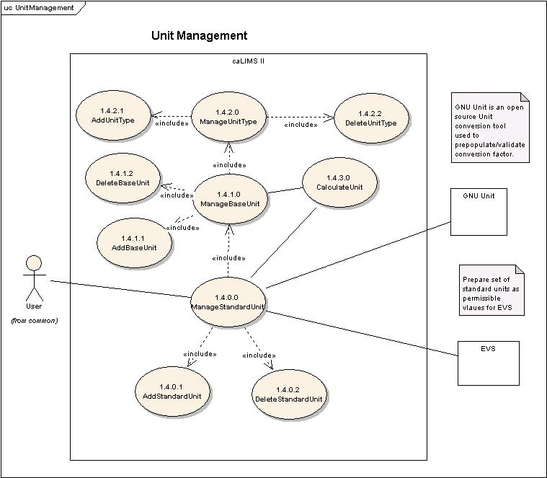

Figure 4-5 Detailed view of Unit Management Use Case

Use Case Name | ManageStandardUnit
Use Case ID | 1.4.0.0
Primary Actor | Users
Brief Description | The ManageStandardUnit Use Case allows Users to add or delete a StandardUnit to the system.
Pre-conditions | - User has logged into the system.  - User has privileges to perform the ManageStandardUnit activity.
Flow of Events | - User selects ManageStandardUnit action.  - User is presented with a list of actions User has privileges to perform.  - User may perform any of the following actions:  AddStandardUnit (ID: 1.4.0.1) or DeleteStandardUnit (ID: 1.4.0.2).
Post Conditions | Success Condition:  - User has added or deleted StandardUnit information.  Error Condition:  - System error.
Alternative Courses of Action | Error Condition 2:  The system throws a System error. Contact the system administrator.
Issues
Special Requirements | TBD

Use Case Name | AddStandardUnit
Use Case ID | 1.4.0.1
Primary Actor | Users
Brief Description | The AddStandardUnit Use Case allows Users to add a StandardUnit to the system.
Pre-conditions | - User has logged into the system.  - User has privileges to perform the ManageStandardUnit action.  - An appropriate BaseUnit and UnitType are registered in the system.  - User has privileges to perform AddStandardUnit action.
Flow of Events | - User selects the ManageStandardUnit action.  - User selects the AddStandardUnit action.  - User is presented with a list of BaseUnits and UnitTypes.  - User is presented with a list of verified Units from external systems such as EVS and GNU Unit.  - User selects a Unit to designate as a new StandardUnit in the system.  - User submits new StandardUnit information (e.g. name, label, description, baseUnit, conversionFactor, source).
Post Conditions | Success Condition:  - User has added StandardUnit information to the system.  Error Condition:  - Duplicate StandardUnit information.  - Invalid StandardUnit information.  - System error.
Alternative Courses of Action | Error Condition 2:  The system throws a Duplicate StandardUnit exception and re-displays the AddStandardUnit interface for correct data entry.  Error Condition 3:  The system throws an Invalid StandardUnit exception and re-displays the AddStandardUnit interface for correct data entry.  Error Condition 4:  The system throws a System error. Contact the system administrator.
Issues | TBD
Special Requirements | The system would be distributed with LPG’s configuration files pre-populated with list of LPG’s StandardUnits.  Our Goal is to use EVSTree to browse Vocabularies that are related to Units.

Use Case Name | DeleteStandardUnit
Use Case ID | 1.4.0.2
Primary Actor | Users
Brief Description | The DeleteStandardUnit Use Case allows Users to remove an existing StandardUnit from the system.
Pre-conditions | - User has logged into the system.  - User has privileges to perform the ManageStandardUnit action.  - User has privileges to perform the DeleteStandardUnit action.  - User has privileges to delete one or more StandardUnits.  - Deleting the chosen StandardUnit does not affect system data integrity.
Flow of Events | - User selects the ManageStandardUnit action.  - User is presented with a list of StandardUnits the User has privilege to delete.  - User submits a request to delete a chosen StandardUnit from the system.
Post Conditions | Success Condition:  - User has deleted the chosen StandardUnit from the system  Error Condition:  - System error.
Alternative Courses of Action | Error Condition 2:  The system throws a System error. Contact the system administrator.
Issues | TBD
Special Requirements | TBD

Use Case Name | ManageBaseUnit
Use Case ID | 1.4.1.0
Primary Actor | Users
Brief Description | The ManageBaseUnit Use Case allows Users to add or delete a BaseUnit to the system. It is mandatory to have a unique BaseUnit for every UnitType.
Pre-conditions | - User has logged into the system.  - User has privileges to perform the ManageBaseUnit activity.
Flow of Events | - User selects ManageBaseUnit action.  - User is presented with a list of actions User has privileges to perform.  - User may perform any of the following actions:  AddBaseUnit (ID: 1.4.1.1) or DeleteBaseUnit (ID: 1.4.1.2).
Post Conditions | Success Condition:  - User has added or deleted BaseUnit information.  Error Condition:  - System error.
Alternative Courses of Action | Error Condition 2:  The system throws a System error. Contact the system administrator.
Issues
Special Requirements | TBD

Use Case Name | AddBaseUnit
Use Case ID | 1.4.1.1
Primary Actor | Users
Brief Description | The AddBaseUnit Use Case allows Users to add a BaseUnit to the system.
Pre-conditions | - User has logged into the system.  - User has privileges to perform the ManageBaseUnit action.  - The system has a valid UnitType.  - User has privileges to perform AddBaseUnit action.
Flow of Events | - User selects the ManageBaseUnit action.  - User selects the AddBaseUnit action.  - User selects a UnitType.  - User is presented with a list of verified Units of the selected UnitType from external systems such as EVS and GNU Unit.  - User selects a Unit to designate as a new BaseUnit in the system.  - User submits information for the new BaseUnit (e.g. name, label, description, source).
Post Conditions | Success Condition:  - User has added BaseUnit information to the system.  Error Condition:  - Invalid BaseUnit information.  - Duplicate BaseUnit information.  - System error.
Alternative Courses of Action | Error Condition 2:  The system throws an Invalid BaseUnit exception and re-displays the AddBaseUnit interface for correct data entry.  Error Condition 3:  The system throws a Duplicate BaseUnit exception and re-displays the AddBaseUnit interface for correct data entry.  Error Condition 4:  The system throws a System error. Contact the system administrator.
Issues | There must be a unique BaseUnit defined for each UnitType in the system.
Special Requirements | 1) This use case expects predefined compound units configured in Systems like EVS.

Use Case Name | DeleteBaseUnit
Use Case ID | 1.4.1.2
Primary Actor | Users
Brief Description | The DeleteBaseUnit Use Case allows Users to remove an existing BaseUnit from the system.
Pre-conditions | - User has logged into the system.  - User has privileges to perform the ManageBaseUnit action.  - User has privileges to perform the DeleteBaseUnit action.  - User has privileges to delete one or more BaseUnits.  - Deleting the selected BaseUnit does not affect system data integrity.
Flow of Events | - User selects the ManageBaseUnit action.  - User selects the DeleteBaseUnit action.  - User is presented with a list of BaseUnits the User has privilege to delete.  - User submits a request to delete the selected BaseUnit from the system.
Post Conditions | Success Condition:  - User has deleted the selected BaseUnit from the system.  Error Condition:  - System error.
Alternative Courses of Action | Error Condition 2:  The system throws a System error. Contact the system administrator.
Issues | TBD
Special Requirements | TBD

Use Case Name | ManageUnitType
Use Case ID | 1.4.2.0
Primary Actor | Users
Brief Description | The ManageUnitType Use Case allows Users to add or delete a UnitType to the system.
Pre-conditions | - User has logged into the system.  - User has privileges to perform the ManageUnitType activity.
Flow of Events | - User selects ManageUnitType action.  - User is presented with a list of actions User has privileges to perform.  - User may perform any of the following actions:  AddUnitType (ID: 1.4.2.1) or DeleteUnitType (ID: 1.4.2.2).
Post Conditions | Success Condition:  - User has added or deleted UnitType information from the system.  Error Condition:  - System error.
Alternative Courses of Action | Error Condition 2:  The system throws a System error. Contact the system administrator.
Issues
Special Requirements | TBD

Use Case Name | AddUnitType
Use Case ID | 1.4.2.1
Primary Actor | Users
Brief Description | The AddUnitType Use Case allows Users to add a UnitType to the system.
Pre-conditions | - User has logged into the system.  - User has privileges to the ManageUnitType action.  - User has privileges to the AddUnitType action.
Flow of Events | - User selects the ManageUnitType action.  - User selects the AddUnitType action.  - User adds information for a new UnitType (e.g. name, label, description).  - User submits the information for a new UnitType.
Post Conditions | Success Condition:  - User has added a new UnitType to the system.  Error Condition:  - Invalid UnitType information.  - Duplicate UnitType information.  - System error.
Alternative Courses of Action | Error Condition 2:  The system throws an Invalid UnitType exception and re-displays the AddUnitType interface for correct data entry.  Error Condition 3:  The system throws a Duplicate UnitType exception and re-displays the AddUnitType interface for correct data entry.  Error Condition 4:  The system throws a System error. Contact the system administrator.
Issues | Attributes may include label, preferred name, and description etc.,
Special Requirements | The System performs case insensitive duplicate check among existing UnitTypes.

Use Case Name | DeleteUnitType
Use Case ID | 1.4.2.2
Primary Actor | Users
Brief Description | The DeleteUnitType Use Case allows Users to remove an existing UnitType from the system.
Pre-conditions | - User has logged into the system.  - User has privileges to perform the ManageUnitType action.  - User has privileges to perform the DeleteUnitType action.  - User has privileges to delete one or more UnitTypes.  - Deleting the selected UnitType does not affect system data integrity.
Flow of Events | - User selects the ManageUnitType action.  - User selects the DeleteUnitType action.  - User is presented with a list of UnitTypes the User has privilege to delete.  - User submits a request to delete the selected UnitType from the system.
Post Conditions | Success Condition:  - User has deleted the selected UnitType from the system  Error Condition:  - System error.
Alternative Courses of Action | Error Condition 2:  The system throws a System error. Contact the system administrator.
Issues | TBD
Special Requirements | TBD

Use Case Name | CalculateUnit
Use Case ID | 1.4.3.0
Primary Actor | Users
Brief Description | The CalculateUnit Use Case allows Users to calculate from one StandardUnit to another StandardUnit.
Pre-conditions | - User has logged into the system.  - User has privileges to perform the CalculateUnit action.
Flow of Events | - User selects the CalculateUnit action.  - User enters the value.  - User selects From Unit from the list presented by the system.  - User selects To Unit from the list presented by the system.  - User submits the information.
Post Conditions | Success Condition:  - User is presented with a value calculated to the new unit.  Error Condition:  - Invalid Unit information.  - System error.
Alternative Courses of Action | Error Condition 2:  The system throws an Invalid Unit exception and re-displays the CalculateUnit interface for correct data entry.  Error Condition 3:  The system throws a System error. Contact the system administrator.
Issues | TBD
Special Requirements | TBD

Use cases for remaining sections of Administration are continued in the AdministrationII document (caLIMSII_Use_Case_AdminII.doc).

Sign Off

Approval

LPG Rep Print Name Date
NCICB Rep Print Name Date
SAIC Rep Print Name Date

