1.0 Inventory:
The Inventory module is a group of high-level functionalities for activities related to sample and LabSupply management. In addition, they include activities related to containers, aliquots, working stocks, and orders. Access to the Inventory module is provided to a set of actors such as Lab Manager, InventoryManager, Researcher, StaffScientist, Super User, and Administrator. Figure 1-0 provides a high level view of the Inventory module and its major uses.

The use cases under the Inventory module are categorized into 9 different groups:
- Container Management
- Sample Management
- Sample Aliquot Management
- Working Stock Management
- Supply Management
- Reagent Management
- Reagent Aliquot Management
- Order Management
- FillPattern Management

Groups 1 thru 9 are described in detail below in this document.

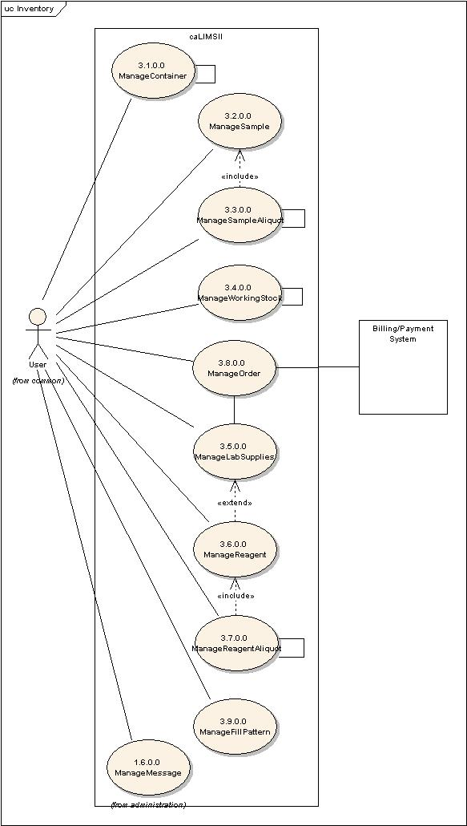
Figure 1-0 High level view of Inventory Use Case Diagram.

1.1 Sample Management:

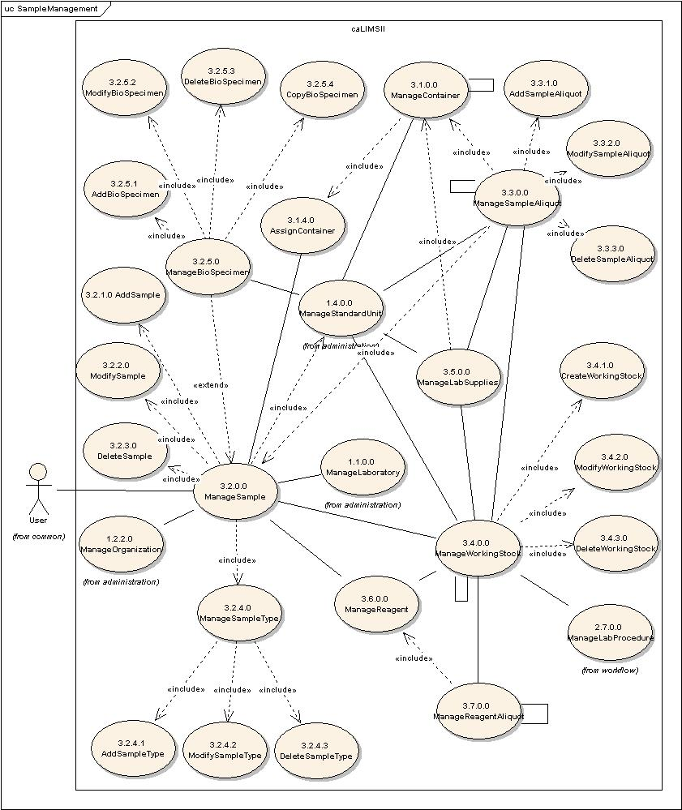
Figure 1-1 Detailed Sample Management Use Case Diagram.

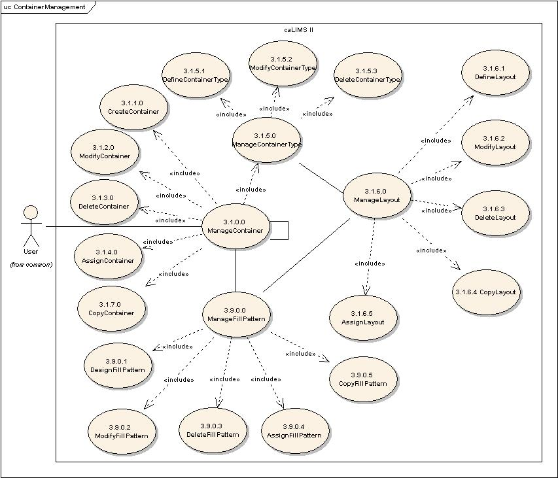
Figure 1-1a Detailed Container Management Use Case Diagram.

Use Case Name | ManageContainer
Use Case ID | 3.1.0.0
Primary Actor | Users
Brief Description | The ManageContainer Use Case allows users to create, modify, delete, copy or assign a Container. Containers can be created separately (as empty containers) and can be then assigned to a reagent, sample etc. A container may contain another container(s) (e.g., a plate container has wells; a rack can hold boxes; a box can hold tubes, etc.).
Pre-conditions | - User has logged into the system.  - User has privileges to perform the ManageContainer action.  - The System has a valid ContainerType (ID:3.1.5.1).
Flow of Events | - User Selects Manage Container functionality.  - User is presented with a list of actions for which the user has privileges.  - User creates (ID: 3.1.1.0), modifies (ID: 3.1.2.0), deletes (ID: 3.1.3.0), copies (ID:3.1.7.0) or assigns (ID: 3.1.4.0) a Container.  - User submits the information.
Post Conditions | Success Condition:  - User has created, modified, deleted, copied or assigned Container.  Error Condition:  - System Error.
Alternative Courses of Action | Error Condition 2:  The system throws a System error. Contact the system administrator.
Issues | TBD
Special Requirements | An individual container will be captured as an atomic unit. In the case of a 96-well plate, each well is a separate simple container that is contained (in a fixed position) within the larger 96-well complex container. Under this arrangement, the simple containers within a complex container do not need to be identical – a 10x10 box, for example, may contain 2 ml, 1 ml and 0.5 ml tubes.  A FillPattern(byRow, byColumn, z-Pattern, Random, etc.) is associated with a Container.

Use Case Name | CreateContainer
Use Case ID | 3.1.1.0
Primary Actor | Users
Brief Description | The CreateContainer Use Case allows Users to add a new Container to the System.
Pre-conditions | - User has logged into the system.  - User has privileges to access the ManageContainer functionality.  - User has privileges to access the CreateContainer functionality.  - User has privileges to the chosen ContainerType.  - User has privileges to the chosen Layout.
Flow of Events | - User selects the ManageContainer action.  - The use selects the CreateContainer function.  - User adds information for a new Container (For example: containerType (simple and complex containers have different sets of attributes), subContainerMaxCapacity, {Unit, Quantity}, subContainerMinCapacityl, {Unit, Quantity}, containerLayout, containerID ,containerName, containerStatus [?], containerCapacity [positions], containerStorageLocation, containerPositionDimensionOne, containerPositionDimensionTwo, oneDimensonCapacity [Unit, Quantity], twoDimensionCapacity [unit, quantity], transferEventParameters, reuseableFlag, assignmentHistory,).  - User selects available ContainerType.  - User selects available Layout.  - User submits the information for a new Container.
Post Conditions | Success Condition:  - User has added a new Container.  Error Condition:  - Invalid Container information  - Duplicate Container information  - System Error.
Alternative Courses of Action | Error Condition 2:  The system throws an Invalid Container exception and re-displays the CreateContainer screen for corrected data entry.  Error Condition 3:  The system throws a Duplicate Container exception and re-displays the CreateContainer screen for corrected data entry.  Error Condition 4:  The system throws a System error. Contact the system administrator.
Issues | - Layout defines how samples/reagents are ‘laid out’ in the container. (e.g.: 8x12 96-well plate; 4x3 12-well plate; 3x4 12-well plate; 4x5 rack; 10x10 2ml box.)  - Invalid container information: As an example: select container type as single tube but layout for plate or select 2 ml tube and maximum volume of 5 ml.
Special Requirements

Use Case Name | ModifyContainer
Use Case ID | 3.1.2.0
Primary Actor | Users
Brief Description | The ModifyContainer Use Case allows Users to modify an existing Container in the system.
Pre-conditions | - User has logged into the system  - User has privileges to access the ManageContainer functionality.  - User has privileges to access the ModifyContainer functionality.  - User has privileges to modify one or more Containers.  - Modifying mutable fields of the Container does not affect system data integrity.
Flow of Events | - User selects the ManageContainer action.  - User selects the ModifyContainer functionality.  - User is presented with a list of Containers the User has privileges to modify.  - User chooses a Container to modify.  - User modifies one or more mutable fields.  - for the chosen Container.  - User submits the information.
Post Conditions | Success Condition:  - User has modified the chosen Container.  Error Condition:  - Invalid Container information.  - System Error.
Alternative Courses of Action | Error Condition 2 :  System throws Invalid Container exception and re-displays the  ModifyContainer screen for corrected data entry.  Error Condition 3:  The system throws a System error. Contact the system administrator.
Issues | - We could have a number of default containers defined in the basic caLIMS2 system that could be then modified to use in adding for specific containers in a project (similar to our template Project/Method concept). Some containers will be rather complex to define and users will want to just modify an existing template.  - However, if a container is already assigned to an entity, only mutable attributes could be modified – for example, the location of a container may change during the course of a project or the status of a container may change from available to assigned to discarded, etc.
Special Requirements | To change the Container’s ContainerType a pre-condition is that the User has privilege to modify the chosen ContainerType information.

Use Case Name | DeleteContainer
Use Case ID | 3.1.3.0
Primary Actor | Users
Brief Description | The DeleteContainer Use Case allows Users to remove an existing Container from the system.
Pre-conditions | - User has logged into the system.  - User has privileges to access the ManageContainer functionality.  - User has privileges to access the DeleteContainer functionality.  - User has privileges to delete one or more Containers.  - Deleting the chosen Container does not affect System data integrity.
Flow of Events | - User selects the ManageContainer functionality.  - User selects the DeleteContainer functionality.  - User is presented with a list of Containers the User has privileges to delete.  - User selects a Container to delete.  - User submits a request to delete the chosen Container from the system.
Post Conditions | Success Condition:  - User has deleted the selected Container.  Error Condition:  - System Error.
Alternative Courses of Action | Error Condition 2 :  The system throws a System error. Contact the system administrator.
Issues | - This use case would be to correct an erroneous entry.  - If a container is used in the laboratory and is no longer viable ( example: sequencing reaction plate) and has been physically discarded, then the containerStatus would change to ‘discarded’ by use of the AssignStatus Use Case
Special Requirements

Use Case Name | AssignContainer
Use Case ID | 3.1.4.0
Primary Actor | Users
Brief Description | The AssignContainer Use Case allows Users to assign a Container to a LabSupply, Sample, Reagent or another Container.
Pre-conditions | - User has logged into the system.  - User has privileges to access the ManageContainer functionality.  - User has privileges to access the AssignContainer functionality.  - User has privileges to assign the chosen Container to the chosen Entity.  - Assigning Container to Entity does not affect System data integrity.
Flow of Events | - User selects ManageContainer functionality.  - User selects AssignContainer functionality.  - User is presented with a list of Containers and Entities the User has privileges to associate.  - User submits a request to assign a selected Container to a selected Entity.
Post Conditions | Success Condition:  - User has associated a selected Container with a selected Entity.  Error Conditions:  - System Error.
Alternative Courses of Action | Error Condition 2:  The system throws a System error. Contact the system administrator.
Issues | - A container assigned to an entity should not come up on the list of ‘available containers’ for assignment.  - Most Containers may not be reassigned. This would be determined by the statusFlag = Resusable?  - Do we need an ‘un-assign’ use case? (Scenario: run has been set up and plates assigned but a failure in an earlier step cancels the downstream steps and reagents/plates need to be re-assigned.
Special Requirements

Use Case Name | ManageContainerType
Use Case ID | 3.1.5.0
Primary Actor | Users
Brief Description | The ManageContainerType Use Case allows Users to define, modify or delete a ContainerType.
Pre-conditions | - User has logged into the system.  - User has privileges to access the ManageContainerType functionality.
Flow of Events | - User selects the ManageContainerType action.  - User is presented with a list of actions for which the user has privileges.  - User defines (ID: 3.1.5.1), modifies (ID: 3.1.5.2) or deletes (ID: 3.1.5.3) a ContainerType.  - User submits the information.
Post Conditions | Success Condition:  - User has defined, modified, or deleted a ContainerType.  Error Condition:  - System Error.
Alternative Courses of Action | Error Condition 2:  The system throws a System error. Contact the system administrator.
Issues | Note:  - ContainerType is assigned to a Container while creating a new Container (ID 3.1.1.0).  - ContainerType is divided into Simple (single) and Complex (multiple) and each of those are sub-divided into more specific ContainerTypes (see DefineContainerType UC 3.1.5.1).
Special Requirements

Use Case Name | DefineContainerType
Use Case ID | 3.1.5.1
Primary Actor | Users
Brief Description | The DefineContainerType Use Case allows Users to add a new ContainerType to the System. ContainerTypes include: 384 well plate, 96 well plate, etc.
Pre-conditions | - User has logged into the system.  - User has privileges to access the ManageContainerType functionality.  - User has privileges to perform the DefineContainerType action.
Flow of Events | - User selects the ManageContainerType action.  - User selects the DefineContainerType action.  - User adds information for a new ContainerType. (For example: ContainerType – divided into Simple and Complex. Example types:  Simple (single) – Tube, Box, affymetrixArray, microarray, Slide, Column, Bottle; Complex (multiple) – Plate, 24-well, 48-well, 96-well, 96PCR,  96UV, 96Deep2ml, 96MilliporeFilter, 384-well, IlluminaPlate [?], Pack, Box [10x10Freezer, 9x9Freezer], Rack.  - User submits the information.
Post Conditions | Success Condition:  - User has defined ContainerType information to the system.  Error Condition:  - Invalid ContainerType information  - Duplicate ContainerType information  - System Error.
Alternative Courses of Action | Error Condition 2:  The system throws an Invalid Container Type exception and re-displays the DefineContainerType interface for corrected data entry.  Error Condition 3:  The system throws a Duplicate Container Type exception and re-displays the DefineContainerType interface for corrected data entry.  Error Condition 4:  The system throws a System error. Contact the system administrator.
Issues
Special Requirements

Use Case Name | ModifyContainerType
Use Case ID | 3.1.5.2
Primary Actor | Users
Brief Description | The ModifyContainerType Use Case allows Users to modify an existing ContainerType in the system.
Pre-conditions | - User has logged into the system.  - User has privileges to access the ManageContainerType functionality.  - User has privileges to access the ModifyContainerType functionality.  - User has privileges to modify the chosen ContainerType.  - Modifying mutable fields of the ContainerType does not affect System data integrity.
Flow of Events | - User selects the ManageContainerType action.  - User selects the ModifyContainerType action.  - User is presented with a list of ContainerTypes the User has privileges to modify.  - User selects a ContainerType to modify  - User modifies one or more mutable fields.for the chosen ContainerType.  - User submits the information.
Post Conditions | Success Condition:  - User has modified ContainerType information in the system.  Error Condition:  - Invalid ContainerType information.  - System Error.
Alternative Courses of Action | Error Condition 2 :  System throws Invalid ContainerType exception message and re-displays the  ModifyContainerType interface for corrected data entry.  Error Condition 3:  The system throws a System error. Contact the system administrator.
Issues | Define which attributes can be mutable.
Special Requirements

Use Case Name | DeleteContainerType
Use Case ID | 3.1.5.3
Primary Actor | Users
Brief Description | The DeleteContainerType Use Case allows Users to remove an existing ContainerType from the system.
Pre-conditions | - User has logged into the system  - User has privileges to access the ManageContainerType functionality.  - User has privileges to access the DeleteContainerType functionality.  - User has privileges to delete one of more ContainerType(s).  - Deleting the ContainerType does not affect System data integrity.
Flow of Events | - User selects the ManageContainerType action.  - User selects the DeleteContainerType action.  - User is presented with a list of ContainerTypes the User has privileges to delete.  - User selects a Container Type to delete.  - User submits a request to delete the chosen ContainerType.
Post Conditions | Success Condition:  - User has deleted the chosen Container Type from the system.  Error Condition:  - System Error.
Alternative Courses of Action | Error Condition 2 :  The system throws a System error. Contact the system administrator.
Issues
Special Requirements

Use Case Name | ManageLayout
Use Case ID | 3.1.6.0
Primary Actor | Users
Brief Description | The ManageLayout Use Case allows Users to define, modify, delete, copy or assign a Layout. Layout refers to the arrangement of a container (for example: a single tube or a 96-well plate of PCR tubes arranged in 8 rows (A-H) by 12 columns (1-12)).
Pre-conditions | - User has logged into the system.  - User has privileges to perform the ManageLayout action.  - The System has a valid Container (ID: 3.1.0.0).
Flow of Events | - User Selects Manage Layout functionality.  - User is presented with a list of actions for which the user has privileges.  - User defines (ID: 3.1.6.1), modifies (ID: 3.1.6.2), deletes (ID: 3.1.6.3), copies (ID: 3.1.6.4), or assigns (ID: 3.1.6.5) a Layout.-  - User submits the information.
Post Conditions | Success Condition:  - User has defined, modified, deleted, copied, or assigned a Layout.  Error Condition:  - System Error.
Alternative Courses of Action | Error Condition 2:  The system throws a System error. Contact the system administrator.
Issues | - Layout can be though of as generic, although usually refers to a multi-sample container.  - A Layout can also be used in combination with FileTransporter to direct the import of a list of samples into a plate set (eg if the list is imported in a row by row, col by col, or Z- pattern).
Special Requirements

Use Case Name | DefineLayout
Use Case ID | 3.1.6.1
Primary Actor | Users
Brief Description | The DefineLayout Use Case allows Users to define a new Layout to the System. A Layout is assigned to a Container or can be used to define an association of a sample plate with a PlateRecord.
Pre-conditions | - User has logged into the system.  - User has privileges to access the ManageLayout functionality.  - User has privileges to access the DefineLayout functionality.
Flow of Events | - User selects the ManageLayout action.  - User selects the DefineLayout function.  - User adds information for a new Layout (For example: name, label, description, dimension1, dimension2, dimension3 (?), contactPerson.).  - User submits the information for a new Layout.
Post Conditions | Success Condition:  - User has defined a Layout.  Error Condition:  - Invalid Layout information.  - Duplicate Layout information.  - System Error.
Alternative Courses of Action | Error Condition 2:  The system throws an Invalid Layout exception and re-displays the DefineLayout screen for corrected data entry.  Error Condition 3:  The system throws a Duplicate Layout exception and re-displays the DefineLayout screen for corrected data entry.  Error Condition 4:  The system throws a System error. Contact the system administrator.
Issues
Special Requirements

Use Case Name | ModifyLayout
Use Case ID | 3.1.6.2
Primary Actor | Users
Brief Description | The ModifyLayout Use Case allows Users to modify an existing Layout in the System.
Pre-conditions | - User has logged into the system.  - User has privileges to access the ManageLayout functionality.  - User has privileges to access the ModifyLayout functionality.  - User has privileges to modify one or more Layout(s).  - Modifying mutable fields of the Layout does not affect system data integrity.
Flow of Events | - User selects the ManageLayout action.  - User selects the ModifyLayout functionality.  - User is presented with a list of Layouts the User has privileges to modify.  - User selects a Layout to modify.  - User modifies one or more mutable fields for the chosen Layout.  - User submits the information.
Post Conditions | Success Condition:  - User has modified a Layout.  Error Condition:  - Invalid Layout information.  - System Error.
Alternative Courses of Action | Error Condition 2 :  System throws Invalid Layout exception and re-displays the  ModifyLayout screen for corrected data entry.  Error Condition 3:  The system throws a System error. Contact the system administrator.
Issues
Special Requirements

Use Case Name | DeleteLayout
Use Case ID | 3.1.6.3
Primary Actor | Users
Brief Description | The DeleteLayout Use Case allows Users to remove an existing Layout from the system.
Pre-conditions | - User has logged into the system.  - User has privileges to access the ManageLayout functionality.  - User has privileges to access the DeleteLayout functionality.  - User has privileges to delete one or more Layout(s).  - Deleting the chosen Layout does not affect System data integrity.
Flow of Events | - User selects the ManageLayout functionality.  - User selects the DeleteLayout functionality.  - User is presented with a list of Layouts the User has privileges to delete.  - User selects a Layout to delete.  - User submits a request to delete the chosen Layout from the system.
Post Conditions | Success Condition:  - User has deleted the selected Layout.  Error Condition:  - System Error.
Alternative Courses of Action | Error Condition 2 :  The system throws a System error. Contact the system administrator.
Issues
Special Requirements

Use Case Name | CopyLayout
Use Case ID | 3.1.6.4
Primary Actor | Users
Brief Description | The CopyLayout Use Case allows Users to Copy a Layout.
Pre-conditions | - User has logged into the system.  - User has privileges to access the ManageLayout functionality.  - User has privileges to access the CopyLayout functionality.  - User has privileges to Copy one of more Layout(s).  - Copying the Layout does not affect System data integrity.
Flow of Events | - User selects ManageLayout functionality.  - User selects CopyLayout functionality.  - User is presented with a list of Layouts the User has privileges to copy.  - User selects a Layout to copy.  - User submits a request to copy the chosen Layout.
Post Conditions | Success Condition:  - User has copied the selected Layout.  - User would use the DefineLayout (3.1.6.1) Use Case to submit the new Layout to the system.  Error Conditions  - System Error.
Alternative Courses of Action | Error Condition 3:  The system throws a System error. Contact the system administrator.
Issues
Special Requirements

Use Case Name | AssignLayout
Use Case ID | 3.1.6.5
Primary Actor | Users
Brief Description | The AssignLayout Use Case allows Users to assign a Layout to an Entity (Container, etc.).
Pre-conditions | - User has logged into the system.  - User has privileges to access the ManageLayout functionality.  - User has privileges to access the AssignLayout functionality.  - User has privileges to assign the chosen Layout to the chosen Entity.  - Assigning Layout to Entity does not affect System data integrity.
Flow of Events | - User selects ManageLayout functionality.  - User selects AssignLayout functionality.  - User is presented with a list of Layouts and Entities the User has privileges to associate.  - User submits a request to assign a selected Layout to a selected Entity.
Post Conditions | Success Condition:  - User has associated a selected Layout with a selected Entity.  Error Conditions:  - System Error.
Alternative Courses of Action | Error Condition 2:  The system throws a System error. Contact the system administrator.
Issues | Entities that may have a Layout include: Container, StorageDevice, Equipment, and Laboratory.
Special Requirements

Use Case Name | CopyContainer
Use Case ID | 3.1.7.0
Primary Actor | User
Brief Description | The CopyContainer Use Case allows users to copy an existing Container in the system. When a Container is copied, the system should copy the underlying ContainerType, Layout and FillPattern.
Pre-conditions | - User has logged into the system.  - User has privileges to access the ManageContainer functionality.  - User has privileges to access the CopyContainer functionality.  - User has privileges to copy one or more Containers.
Flow of Events | - User selects the ManageContainer action.  - User selects the CopyContainer action.  - User is presented with a list of Containers the user has privileges to copy.  - User selects a Container to copy.  - User submits a request to copy the chosen Container.
Post Conditions | Success Condition:  - User has copied the chosen Container.  - User would use the CreateContainer (3.1.1.0) Use Case to submit the new Container to the system.  Error Condition:  - System Error.
Alternative Courses of Action | Error Condition 3 :  The system throws a System error. Contact the system administrator.
Issues
Special Requirements | 1. When a Container is copied, the system should copy the underlying ContainerType, Layout and FillPattern.

Use Case Name | ManageSample
Use Case ID | 3.2.0.0
Primary Actor | Users
Brief Description | The ManageSample use case allows Users to manage Samples used in LabProcedures. A biological Sample is derived from a BioSpecimen (tissue or biofluid) and may be used in a Reaction. Samples may include: DNA, RNA, protein or nanoparticles.
Pre-conditions | - User has logged into the system.  - User has privileges to access the ManageSample functionality.
Flow of Events | - User selects the ManageSample action.  - User is presented with a list of actions for which the user has privileges.  - User adds (3.2.1.0), modifies (3.2.2.0) or deletes (3.2.3.0) a Sample.  - User submits Sample information to the system.
Post Conditions | Success Condition:  - User has added, modified or deleted a Sample.  Error Conditions  - System Error.
Alternative Courses of Action | Error Condition 2:  The system throws a System error. Contact the system administrator.
Issues | - The term “Reaction” comes from the Workflow module and refers to any laboratory method/procedure which involves combining reagents and samples and incubation parameters to generate new products.
Special Requirements | - We will be managing samples in batch mode also. This may be accomplished using sample sheets with multiple samples and uploading into the system using FileTransporter.

Use Case Name | AddSample
Use Case ID | 3.2.1.0
Primary Actor | Users
Brief Description | The AddSample Use Case allows Users to enter information about a new Sample into the System.
Pre-conditions | - User has logged into the system.  - User has privileges to access the ManageSample functionality.  - User has privileges to access the AddSample functionality.  - An appropriate SampleType exists in the System.  - User has privileges to associate the SampleType with a Sample.
Flow of Events | - User selects the ManageSample action.  - User selects the AddSample action.  - User selects a SampleType corresponding to the Sample.  - User adds information about a new Sample. For example: name, label, description, sampleID, sampleSource (Vendor, Laboratory, or Organization), sourceLotID, labLotID, barcode, sampleType (serum, plasma, DNA, RNA, tissue, protein, etc.), storageEvents (temperature, medium), availableFlag, expirationDate, preparationDate, biohazardFlag, quantity (microgram, milliliter), transferParameters [relationship to other Samples], qualityIndex (AB260/280, 28S/18S, linkGelImage), linkToResultsDerivedFromSample, thawEventParameters.  - User submits Sample information to the system.
Post Conditions | Success Condition:  - User has added a new Sample.  Error Conditions  - Invalid Sample information.  - Duplicate Sample information.  - System Error.
Alternative Courses of Action | Error Condition 2:  The system throws an Invalid Sample exception and re-displays the AddSample page for corrected data entry.  Error Condition 3:  The system throws a Duplicate Sample exception and re-displays the AddSample page for corrected data entry.  Error Condition 4:  The system throws a System error. Contact the system administrator.
Issues
Special Requirements

Use Case Name | ModifySample
Use Case ID | 3.2.2.0
Primary Actor | Users
Brief Description | The ModifySample Use Case allows users to modify an existing Sample.
Pre-conditions | - User has logged into the system.  - User has privileges to access the ManageSample functionality.  - User has privileges to access the ModifySample functionality.  - User has privileges to modify one or more Sample(s).  - Modifying mutable fields of the Sample does not affect system data integrity.
Flow of Events | - User selects the ManageSample action.  - The use selects the ModifySample action.  - User is presented with a list of Samples the user has privileges to modify.  - User selects a Sample to modify.  - User modifies one or more mutable fields for the chosen Sample.  - User submits the information.
Post Conditions | Success Condition:  - User has modified the chosen Sample.  Error Condition:  - Invalid Sample information.  - System Error.
Alternative Courses of Action | Error Condition 2 :  System throws Invalid Sample exception message and re-displays the  ModifySample interface for corrected data entry.  Error Condition 3:  The system throws a System error. Contact the system administrator.
Issues
Special Requirements

Use Case Name | DeleteSample
Use Case ID | 3.2.3.0
Primary Actor | Users
Brief Description | The DeleteSample Use Case allows users to remove an existing Sample from the system.
Pre-conditions | - User has logged into the system.  - User has privileges to access the ManageSample functionality.  - User has privileges to access the DeleteSample functionality.  - User has privileges to delete one or more Sample(s).  - Deleting the Sample information does not affect system data integrity.
Flow of Events | - User selects the ManageSample action.  - User selects the DeleteSample action.  - User is presented with a list of Samples the user has privileges to delete.  - User selects a Sample to delete.  - User submits a request to delete the chosen Sample from the system.
Post Conditions | Success Condition:  - User has deleted the chosen Sample.  Error Condition:  - System Error.
Alternative Courses of Action | Error Condition 2 :  The system throws a System error. Contact the system administrator.
Issues
Special Requirements

Use Case Name | ManageSampleType
Use Case ID | 3.2.4.0
Primary Actor | Users
Brief Description | The ManageSampleType use case allows Users to manage SampleTypes (e.g. DNA, RNA, protein, nanoparticles).
Pre-conditions | - User has logged into the system.  - User has privileges to access the ManageSampleType functionality.
Flow of Events | - User selects the ManageSampleType action.  - User is presented with a list of actions for which the user has privileges.  - User adds (3.2.4.1), modifies (3.2.4.2) or deletes (3.2.4.3) a SampleType.  - User submits SampleType information to the system.
Post Conditions | Success Condition:  - User has added, modified or deleted a SampleType.  Error Conditions  - System Error.
Alternative Courses of Action | Error Condition 2:  The system throws a System error. Contact the system administrator.
Issues
Special Requirements

Use Case Name | AddSampleType
Use Case ID | 3.2.4.1
Primary Actor | Users
Brief Description | The AddSampleType Use Case allows Users to enter information about a new SampleType into the System.
Pre-conditions | - User has logged into the system.  - User has privileges to access the ManageSampleType functionality.  - User has privileges to access the AddSampleType functionality.
Flow of Events | - User selects the ManageSampleType action.  - User selects the AddSampleType action.  - User adds information for a new SampleType. For example: name, label, description, sampleTypeID.  - User submits SampleType information to the system.
Post Conditions | Success Condition:  - User has added a new SampleType.  Error Conditions  - Invalid SampleType information.  - Duplicate SampleType information.  - System Error.
Alternative Courses of Action | Error Condition 2:  The system throws an Invalid SampleType exception and re-displays the AddSampleType page for corrected data entry.  Error Condition 3:  The system throws a Duplicate SampleType exception and re-displays the AddSampleType page for corrected data entry.  Error Condition 4:  The system throws a System error. Contact the system administrator.
Issues
Special Requirements

Use Case Name | ModifySampleType
Use Case ID | 3.2.4.2
Primary Actor | Users
Brief Description | The ModifySampleType Use Case allows users to modify an existing SampleType.
Pre-conditions | - User has logged into the system.  - User has privileges to access the ManageSampleType functionality.  - User has privileges to access the ModifySampleType functionality.  - User has privileges to modify one or more SampleTypes.  - Modifying mutable fields of the SampleType does not affect system data integrity.
Flow of Events | - User selects the ManageSampleType action.  - The use selects the ModifySampleType action.  - User is presented with a list of SampleTypes the user has privileges to modify.  - User selects a SampleType to modify.  - User modifies one or more mutable fields for the chosen SampleType.  - User submits the information.
Post Conditions | Success Condition:  - User has modified the chosen SampleType.  Error Condition:  - Invalid SampleType information.  - System Error.
Alternative Courses of Action | Error Condition 2 :  System throws Invalid SampleType exception message and re-displays the  ModifySampleType interface for corrected data entry.  Error Condition 3:  The system throws a System error. Contact the system administrator.
Issues
Special Requirements

Use Case Name | DeleteSampleType
Use Case ID | 3.2.4.3
Primary Actor | Users
Brief Description | The DeleteSampleType Use Case allows users to remove an existing SampleType from the system.
Pre-conditions | - User has logged into the system.  - User has privileges to access the ManageSampleType functionality.  - User has privileges to access the DeleteSampleType functionality.  - User has privileges to delete one or more SampleTypes.  - Deleting SampleType information does not affect system data integrity.
Flow of Events | - User selects the ManageSampleType action.  - User selects the DeleteSampleType action.  - User is presented with a list of SampleTypes the user has privileges to delete.  - User selects a SampleType to delete.  - User submits a request to delete a SampleType from the system.
Post Conditions | Success Condition:  - User has deleted a SampleType.  Error Condition:  - System Error.
Alternative Courses of Action | Error Condition 2 :  The system throws a System error. Contact the system administrator.
Issues
Special Requirements

Use Case Name | ManageBioSpecimen
Use Case ID | 3.2.5.0
Primary Actor | Users
Brief Description | The ManageBioSpecimen use case allows Users to manage tissue or biofluid specimens. Samples derived from BioSpecimens can be used in LabProcedure and/or Reactions.
Pre-conditions | - User has logged into the system.  - User has privileges to access the ManageBioSpecimen functionality.
Flow of Events | - User selects the ManageBioSpecimen action.  - User is presented with a list of actions for which the user has privileges.  - User adds (3.2.5.1), modifies (3.2.5.2), deletes (3.2.5.3), or copies (3.2.5.4) a BioSpecimen.  - User submits BioSpecimen information to the system.
Post Conditions | Success Condition:  - User has added, modified or deleted a BioSpecimen.  Error Conditions  - System Error.
Alternative Courses of Action | Error Condition 2:  The system throws a System error. Contact the system administrator.
Issues
Special Requirements

Use Case Name | AddBioSpecimen
Use Case ID | 3.2.5.1
Primary Actor | Users
Brief Description | The AddBioSpecimen Use Case allows Users to enter information about a new BioSpecimen into System.
Pre-conditions | - User has logged into the system.  - User has privileges to access the ManageBioSpecimen functionality.  - User has privileges to access the AddBioSpecimen functionality.
Flow of Events | - User selects the ManageBioSpecimen action.  - User selects the AddBioSpecimen action.  - User enters information for a Biospecimen. For Example: name, label, description, specimenID, barcode, specimenType (serum, plasma, tissue, tumor), tissueSite, pathologyStatus, storageEvents [temperature, medium], available, expirationDate, collectionDate, collectionProtocol, biohazardFlag, quantity [microgram, milliliter], transferParameters [relationship to other Samples], forMIAME [genus, species, strain, cellLine, gender, age, individualID, diseaseState, ethnicity].  - User submits BioSpecimen information to the system.
Post Conditions | Success Condition:  - User has added a new BioSpecimen.  Error Conditions  - Invalid BioSpecimen information.  - Duplicate BioSpecimen information.  - System Error.
Alternative Courses of Action | Error Condition 2:  The system throws an Invalid BioSpecimen exception and re-displays the AddBioSpecimen page for corrected data entry.  Error Condition 3:  The system throws a Duplicate BioSpecimen exception and re-displays the AddBioSpecimen page for corrected data entry.  Error Condition 4:  The system throws a System error. Contact the system administrator.
Issues
Special Requirements | 1. Explore integration of caLIMS2 BioSpecimen with caTissue Core and/or Elmir.

Use Case Name | ModifyBioSpecimen
Use Case ID | 3.2.5.2
Primary Actor | Users
Brief Description | The ModifyBioSpecimen Use Case allows users to modify an existing BioSpecimen.
Pre-conditions | - User has logged into the system.  - User has privileges to access the ManageBioSpecimen functionality.  - User has privileges to access the ModifyBioSpecimen functionality.  - User has privileges to modify one or more BioSpecimen(s).  - Modifying mutable fields of the BioSpecimen does not affect system data integrity.
Flow of Events | - User selects the ManageBioSpecimen action.  - User selects the ModifyBioSpecimen action.  - User is presented with a list of BioSpecimens the User has privileges to modify.  - User selects a BioSpecimen to modify.  - User modifies one or more mutable fields for the chosen BioSpecimen.  - User submits the information.
Post Conditions | Success Condition:  - User has modified a BioSpecimen.  Error Condition:  - Invalid BioSpecimen information.  - System Error.
Alternative Courses of Action | Error Condition 2 :  System throws Invalid BioSpecimen exception message and re-displays the ModifyBioSpecimen interface for corrected data entry.  Error Condition 3:  The system throws a System error. Contact the system administrator.
Issues
Special Requirements

Use Case Name | DeleteBioSpecimen
Use Case ID | 3.2.5.3
Primary Actor | Users
Brief Description | The DeleteBioSpecimen Use Case allows users to remove an existing BioSpecimen from the system.
Pre-conditions | - User has logged into the system.  - User has privileges to access the ManageBioSpecimen functionality.  - User has privileges to access the DeleteBioSpecimen functionality.  - User has privileges to delete the chosen BioSpecimen.  - Deleting BioSpecimen information does not affect system data integrity.
Flow of Events | - User selects the ManageBioSpecimen action.  - User selects the DeleteBioSpecimen action.  - User is presented with a list of BioSpecimens the user has privileges to delete.  - User selects a BioSpecimen to delete.  - User submits a request to delete the chosen BioSpecimen from the system.
Post Conditions | Success Condition:  - User has deleted the chosen BioSpecimen.  Error Condition:  - System Error.
Alternative Courses of Action | Error Condition 2 :  The system throws a System error. Contact the system administrator.
Issues
Special Requirements

Use Case Name | CopyBioSpecimen
Use Case ID | 3.2.5.4
Primary Actor | Users
Brief Description | The CopyBioSpecimen Use Case allows users to copy an existing BioSpecimen in the system. This CopyBioSpecimen utility is used when a new BioSpecimen has similar parameters as an existing BioSpecimen but needs minor modification.
Pre-conditions | - User has logged into the system.  - User has privileges to access the ManageBioSpecimen functionality.  - User has privileges to access the CopyBioSpecimen functionality.  - User has privileges to copy one or more BioSpecimen(s).  - Copying a BioSpecimen does not affect system data integrity.
Flow of Events | - User selects the ManageBioSpecimen action.  - User selects the CopyBioSpecimen action.  - User is presented with a list of BoSpecimens the user has privilege to copy.  - User selects a BioSpecimen to copy.  - User submits a request to copy the chosen BioSpecimen.
Post Conditions | Success Condition:  - User has copied the chosen BioSpecimen.  - User would use the AddBioSpecimen (3.2.5.1) Use Case to submit the new BioSpecimen to the system.  Error Condition:  - System Error.
Alternative Courses of Action | Error Condition 3:  The system throws a System error. Contact the system administrator.
Issues
Special Requirements

Use Case Name | ManageSampleAliquot
Use Case ID | 3.3.0.0
Primary Actor | Users
Brief Description | The ManageSampleAliquot use case allows Users to manage SampleAliquots in the System. Aliquots are not diluted - they are portions of a Sample, Reagent, etc.
Pre-conditions | - User has logged into the system.  - User has privileges to access the ManageSampleAliquot functionality.
Flow of Events | - User selects the ManageSampleAliquot action.  - User is presented with a list of actions for which the user has privileges.  - User adds (3.3.1.0), modifies (3.3.2.0) or deletes (3.3.3.0) SampleAliquot.  - User submits SampleAliquot information to the system.
Post Conditions | Success Condition:  - User has added, modified or deleted a SampleAliquot.  Error Conditions  - System Error.
Alternative Courses of Action | Error Condition 2:  The system throws a System error. Contact the system administrator.
Issues
Special Requirements

Use Case Name | AddSampleAliquot
Use Case ID | 3.3.1.0
Primary Actor | Users
Brief Description | The AddSampleAliquot Use Case allows Users to enter information about new SampleAliquots into the System.
Pre-conditions | - User has logged into the system.  - User has privileges to access the ManageSampleAliquot functionality.  - User has privileges to access the AddSampleAliquot functionality.  - User has privileges on one or more Samples.  - User has privileges to derive a SampleAliquot from the chosen Sample.
Flow of Events | - User selects the ManageSampleAliquot action.  - User selects the AddSampleAliquot action.  - User is presented with a list of samples for which the user has privileges to associate to SampleAliquots.  - User selects a Sample.  - User adds information about a new SampleAliquot for the chosen Sample. For Example: name, label, description, vendorLotID, labLotID, sampleID, aliquotID, quantity [unit, value], sourceContainer [id, dimension1Position, dimension2Position, storageLocation], targetContainer [id, dimension1Position, dimension2Position, storageLocation], timestamp, contactPerson, thawEvent, status, startAliquotCount, endAliquotCount.  - User submits SampleAliquot information to the system.
Post Conditions | Success Condition:  - User has added a new SampleAliquot.  Error Conditions  - Invalid SampleAliquot information.  - Duplicate SampleAliquot information.  - System Error.
Alternative Courses of Action | Error Condition 2:  The system throws an Invalid SampleAliquot exception and re-displays the AddSampleAliquot page for corrected data entry.  Error Condition 3:  The system throws a Duplicate SampleAliquot exception and re-displays the AddSampleAliquot page for corrected data entry.  Error Condition 4:  The system throws a System error. Contact the system administrator.
Issues
Special Requirements | - Allow the User to specify the number of Aliquots to be created from a starting Sample, Reagent or ReactionMix.

Use Case Name | ModifySampleAliquot
Use Case ID | 3.3.2.0
Primary Actor | Users
Brief Description | The ModifySampleAliquot Use Case allows users to modify an existing SampleAliquot.
Pre-conditions | - User has logged into the system.  - User has privileges to access the ManageSampleAliquot functionality.  - User has privileges to access the ModifySampleAliquot functionality.  - User has privileges to modify one of more SampleAliquot(s).  - Modifying mutable fields of the SampleAliquot does not affect system data integrity.
Flow of Events | - User selects the ManageSampleAliquot action.  - The use selects the ModifySampleAliquot action.  - User is presented with a list of SampleAliquots for which the user has privileges.  - User selects a SampleAliquot to modify.  - User modifies one or more mutable fields for the chosen SampleAliquot.  - User submits the information.
Post Conditions | Success Condition:  - User has modified the chosen SampleAliquot.  Error Condition:  - Invalid SampleAliquot information.  - System Error.
Alternative Courses of Action | Error Condition 2 :  System throws Invalid SampleAliquot exception message and re-displays the  ModifySampleAliquot interface for corrected data entry.  Error Condition 3:  The system throws a System error. Contact the system administrator.
Issues
Special Requirements

Use Case Name | DeleteSampleAliquot
Use Case ID | 3.3.3.0
Primary Actor | Users
Brief Description | The DeleteSampleAliquot Use Case allows users to remove an existing SampleAliquot from the system.
Pre-conditions | - User has logged into the system.  - User has privileges to access the ManageSampleAliquot functionality.  - User has privileges to access the DeleteSampleAliquot functionality.  - User has privileges to delete one or more SampleAliquots.  - Deleting the chosen SampleAliquot does not affect system data integrity.
Flow of Events | - User selects the ManageSampleAliquot action.  - User selects the DeleteSampleAliquot action.  - User is presented with a list of SampleAliquots the user has privileges to delete.  - User selects a SampleAliquot to delete.  - User submits a request to delete a SampleAliquot from the system.
Post Conditions | Success Condition:  - User has deleted a SampleAliquot.  Error Condition:  - System Error.
Alternative Courses of Action | Error Condition 2 :  The system throws a System error. Contact the system administrator.
Issues
Special Requirements

Use Case Name | ManageWorkingStock
Use Case ID | 3.4.0.0
Primary Actor | Users
Brief Description | The ManageWorkingStock use case allows Users to manage WorkingStocks in the System. A WorkingStock is an aliquot of a Sample or Reagent that is ready for use in a Reaction or ready to add with other reagents to create another WorkingStock (eg a forwardPCRPrimerWS1 (10 mM) and a reversePCRPrimerWS1 (10 mM) plus sterile water to create a PCRPrimerWS1 for a PCR amplification). A WorkingStock does not require dilution or concentration prior to use.
Pre-conditions | - User has logged into the system.  - User has privileges to access the ManageWorkingStock functionality.
Flow of Events | - User selects the ManageWorkingStock action.  - User is presented with a list of actions for which the user has privileges.  - User creates (3.4.1.0), modifies (3.4.2.0) or deletes (3.4.3.0) WorkingStock.  - User submits WorkingStock information to the system.
Post Conditions | Success Condition:  - User has created, modified or deleted WorkingStock.  Error Conditions  - System Error.
Alternative Courses of Action | Error Condition 2:  The system throws a System error. Contact the system administrator.
Issues
Special Requirements

Use Case Name | CreateWorkingStock
Use Case ID | 3.4.1.0
Primary Actor | Users
Brief Description | The CreateWorkingStock Use Case allows Users to enter information about new WorkingStocks into the System.
Pre-conditions | - User has logged into the system.  - User has privileges to access the ManageWorkingStock functionality.  - User has privileges to access the CreateWorkingStock functionality.  - User has privileges to associate an appropriate Entity or Entities needed for creating a WorkingStock.
Flow of Events | - User selects the ManageWorkingStock action.  - User selects the CreateWorkingStock action.  - User is presented with a list of entities for which the user has privileges to associate to a WorkingStock.  - User adds information for a new WorkingStock. For example: name, label, description, [all Aliquot attributes…], diluent, component(1 .. n) [originalConcentration, workingStockConcentration], sourceID, protocol, labProcedure.  - User submits WorkingStock information to the system.
Post Conditions | Success Condition:  - User has created a new WorkingStock.  Error Conditions  - Invalid WorkingStock information.  - Duplicate WorkingStock information.  - System Error.
Alternative Courses of Action | Error Condition 2:  The system throws an Invalid WorkingStock exception and re-displays the CreateWorkingStock page for corrected data entry.  Error Condition 3:  The system throws a Duplicate WorkingStock exception and re-displays the CreateWorkingStock page for corrected data entry.  Error Condition 4:  The system throws a System error. Contact the system administrator.
Issues | WorkingStock may include Entities such as Sample, Reagent, Container, StorageLocation, etc.
Special Requirements

Use Case Name | ModifyWorkingStock
Use Case ID | 3.4.2.0
Primary Actor | Users
Brief Description | The ModifyWorkingStock Use Case allows users to modify an existing WorkingStock.
Pre-conditions | - User has logged into the system.  - User has privileges to access the ManageWorkingStock functionality.  - User has privileges to access the ModifyWorkingStock functionality.  - User has privileges to modify one or more WorkingStock(s).  - Modifying mutable fields of the WorkingStock does not affect system data integrity.
Flow of Events | - User selects the ManageWorkingStock action.  - The use selects the ModifyWorkingStock action.  - User is presented with a list of WorkingStocks for which the user has privileges.  - User selects a WorkingStock to modify.  - User modifies one or more mutable fields for the chosen WorkingStock.  - User submits the information.
Post Conditions | Success Condition:  - User has modified the chosen WorkingStock.  Error Condition:  - Invalid WorkingStock information.  - System Error.
Alternative Courses of Action | Error Condition 2 :  System throws Invalid WorkingStock exception message and re-displays the  ModifyWorkingStock interface for corrected data entry.  Error Condition 3:  The system throws a System error. Contact the system administrator.
Issues
Special Requirements

Use Case Name | DeleteWorkingStock
Use Case ID | 3.4.3.0
Primary Actor | Users
Brief Description | The DeleteWorkingStock Use Case allows users to remove an existing WorkingStock from the system.
Pre-conditions | - User has logged into the system.  - User has privileges to access the ManageWorkingStock functionality.  - User has privileges to access the DeleteWorkingStock functionality.  - User has privileges to delete one or more WorkingStock(s).  - Deleting WorkingStock information does not affect system data integrity.
Flow of Events | - User selects the ManageWorkingStock action.  - User selects the DeleteWorkingStock action.  - User is presented with a list of WorkingStocks the user has privileges to delete.  - User selects a WorkingStock to delete.  - User submits a request to delete the chosen WorkingStock from the system.
Post Conditions | Success Condition:  - User has deleted the chosen WorkingStock.  Error Condition:  - System Error.
Alternative Courses of Action | Error Condition 2 :  The system throws a System error. Contact the system administrator.
Issues
Special Requirements

Use Case Name | ManageFillPattern
Use Case ID | 3.9.0.0
Primary Actor | Users
Brief Description | The ManageFillPattern Use Case allows Users to design, modify, delete, copy, or assign a FillPattern. FillPatterns can be designed separately (as empty FillPatterns) and can be then assigned to a Container or StorageLocation.  An individual FillPattern will be captured as an atomic unit. In the case of a 96-well plate, each well is a separate simple FillPattern that is contained (in a fixed position) within the larger 96-well complex FillPattern. Under this arrangement, the simple FillPatterns within a complex FillPattern do not need to be identical – a 10x10 box, for example, may contain 2 ml, 1 ml and 0.5 ml tubes.  We could have a number of default FillPatterns defined in the basic caLIMS2 system that could be then modified to use in adding for specific FillPatterns in a project. For example byRowPattern, byColumnPattern, z-Pattern, randomPattern, etc.,
Pre-conditions | - User has logged into the system.  - User has privileges to perform the ManageFillPattern action.
Flow of Events | - User Selects Manage FillPattern functionality.  - User is presented with a list of actions for which the user has privileges.  - User designs (ID: 3.9.0.1), modifies (ID: 3.9.0.2), deletes (ID: 3.9.0.3), assigns (ID: 3.9.0.4) or copies (ID: 3.9.0.5) a FillPattern.  - User submits the information.
Post Conditions | Success Condition:  - User has designed, modified, deleted, assigned, or copied a FillPattern.  Error Condition:  - System Error.
Alternative Courses of Action | Error Condition 2:  The system throws a System error. Contact the system administrator.
Issues | TBD
Special Requirements

Use Case Name | DesignFillPattern
Use Case ID | 3.9.0.1
Primary Actor | Users
Brief Description | The DesignFillPattern Use Case allows Users to design a new FillPattern to the System.
Pre-conditions | - User has logged into the system.  - User has privileges to access the ManageFillPattern functionality.  - User has privileges to access the DesignFillPattern functionality.  - User has privileges to the chosen FillPatternType.  - User has privilege to select a Layout.
Flow of Events | - User selects the ManageFillPattern action.  - The use selects the DesignFillPattern function.  - User adds information for a new FillPattern (For example: FillPattern Name, FillPatternLabel, description, originalLayout, totalNumberOfUnits, selectedArrayOfPositions[][], sequence, etc.,.  - User is presented with a list of Layouts that the user has privilege to select.  - User selects a layout.  - User highlights the layout position in a sequence.  - User submits the information for a new FillPattern.
Post Conditions | Success Condition:  - User has added a new FillPattern.  Error Condition:  - Invalid FillPattern information  - Duplicate FillPattern information  - System Error.
Alternative Courses of Action | Error Condition 2:  The system throws an Invalid FillPattern exception and re-displays the DesignFillPattern screen for corrected data entry.  Error Condition 3:  The system throws a Duplicate FillPattern exception and re-displays the CreateFillPattern screen for corrected data entry.  Error Condition 4:  The system throws a System error. Contact the system administrator.
Issues | - A simple Container, such as a tube, will have a default Layout of “1x1” and a default FillPattern of “1”.
Special Requirements

Use Case Name | ModifyFillPattern
Use Case ID | 3.9.0.2
Primary Actor | Users
Brief Description | The ModifyFillPattern Use Case allows Users to modify an existing FillPattern in the system.
Pre-conditions | - User has logged into the system  - User has privileges to access the ManageFillPattern functionality.  - User has privileges to access the ModifyFillPattern functionality.  - User has privileges to modify one or more FillPatterns.  - Modifying mutable fields of the FillPattern does not affect system data integrity.
Flow of Events | - User selects the ManageFillPattern action.  - User selects the ModifyFillPattern functionality.  - User is presented with a list of FillPatterns the User has privileges to modify.  - User chooses a FillPattern to modify.  - User modifies one or more mutable fields.  - User submits the information.
Post Conditions | Success Condition:  - User has modified the chosen FillPattern.  Error Condition:  - Invalid FillPattern information.  - System Error.
Alternative Courses of Action | Error Condition 2 :  System throws Invalid FillPattern exception and re-displays the  ModifyFillPattern screen for corrected data entry.  Error Condition 3:  The system throws a System error. Contact the system administrator.
Issues
Special Requirements

Use Case Name | DeleteFillPattern
Use Case ID | 3.9.0.3
Primary Actor | Users
Brief Description | The DeleteFillPattern Use Case allows Users to remove an existing FillPattern from the system.
Pre-conditions | - User has logged into the system.  - User has privileges to access the ManageFillPattern functionality.  - User has privileges to access the DeleteFillPattern functionality.  - User has privileges to delete one or more FillPatterns.  - Deleting the chosen FillPattern does not affect System data integrity.
Flow of Events | - User selects the ManageFillPattern functionality.  - User selects the DeleteFillPattern functionality.  - User is presented with a list of FillPatterns the User has privileges to delete.  - User selects a FillPattern to delete.  - User submits a request to delete the chosen FillPattern from the system.
Post Conditions | Success Condition:  - User has deleted the selected FillPattern.  Error Condition:  - System Error.
Alternative Courses of Action | Error Condition 2 :  The system throws a System error. Contact the system administrator.
Issues | Note: a FillPattern that has been used but is no longer valid would be assigned a  Status of ‘inactive’ or ‘invalid’ and not be available for future use but would be held in the system since associatiated with previous data.
Special Requirements

Use Case Name | AssignFillPattern
Use Case ID | 3.9.0.4
Primary Actor | Users
Brief Description | The AssignFillPattern Use Case allows Users to assign a FillPattern to a Container or StorageLocation.
Pre-conditions | - User has logged into the system.  - User has privileges to access the ManageFillPattern functionality.  - User has privileges to access the AssignFillPattern functionality.  - User has privileges to assign the chosen FillPattern to the chosen Container or StorageLocation.  - Assigning FillPattern to Container or StorageLocation does not affect System data integrity.
Flow of Events | - User selects ManageFillPattern functionality.  - User selects AssignFillPattern functionality.  - User is presented with a list of FillPatterns and Container/StorageLocation the User has privileges to associate.  - User submits a request to assign a selected FillPattern to a selected Container/StorageLocation.
Post Conditions | Success Condition:  - User has associated a selected FillPattern with a selected Container or StorageLocation.  Error Conditions:  - System Error.
Alternative Courses of Action | Error Condition 2:  The system throws a System error. Contact the system administrator.
Issues
Special Requirements

Use Case Name | FillPattern
Use Case ID | 3.9.0.5
Primary Actor | User
Brief Description | The CopyFillPattern Use Case allows users to copy an existing FillPattern in the system.
Pre-conditions | - User has logged into the system.  - User has privileges to access the ManageFillPattern functionality.  - User has privileges to access the CopyFillPattern functionality.  - User has privileges to copy one or more FillPatterns.
Flow of Events | - User selects the ManageFillPattern action.  - User selects the CopyFillPattern action.  - User is presented with a list of FillPatterns the user has privileges to copy.  - User selects a FillPattern to copy.  - User submits a request to copy the chosen FillPattern.
Post Conditions | Success Condition:  - User has copied a FillPattern.  - User would use the DesignFillPattern (3.9.0.1) Use Case to submit the new FillPattern to the system.  Error Condition:  - System Error.
Alternative Courses of Action | Error Condition 3 :  The system throws a System error. Contact the system administrator.
Issues
Special Requirements

  - Supply Management:

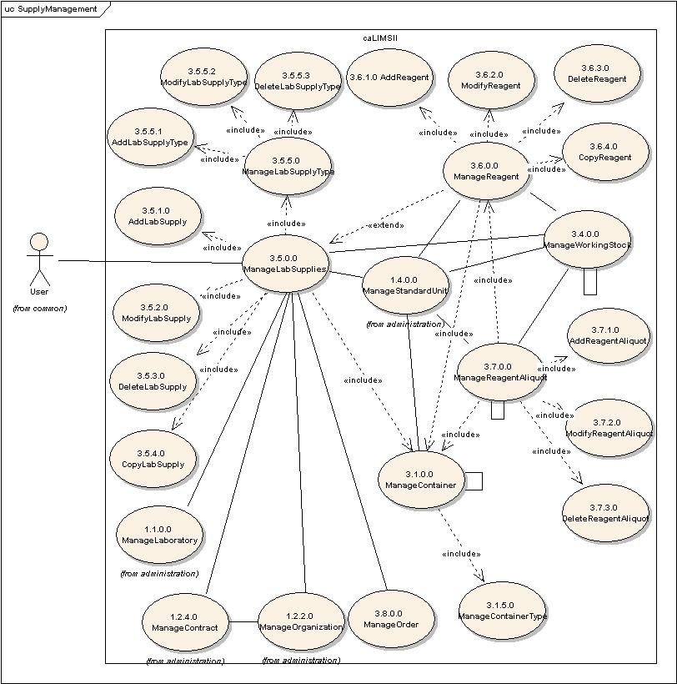
Figure 1-2 Detailed LabSupply Management Use Case Diagram.

Use Case Name | ManageLabSupplies
Use Case ID | 3.5.0.0
Primary Actor | Users
Brief Description | The ManageLabSupplies use case allows Users to add, modify, delete or copy lab Supplies used in the System. A LabSupply is a consumable that is not a component of a Reaction. Examples are: tubes, plates, pipette tips and columns.
Pre-conditions | - User has logged into the system.  - User has privileges to access the ManageLabSupplies functionality.
Flow of Events | - User selects the ManageLabSupplies action.  - User is presented with a list of actions for which the user has privileges.  - User adds (3.5.1.0), modifies (3.5.2.0), deletes (3.5.3.0), or copies (3.5.4.0) a LabSupply.  - User submits LabSupply information to the system.
Post Conditions | Success Condition:  - User has added, modified, deleted, or copied a LabSupply.  Error Conditions  - System Error.
Alternative Courses of Action | Error Condition 2:  The system throws a System error. Contact the system administrator.
Issues
Special Requirements

Use Case Name | AddLabSupply
Use Case ID | 3.5.1.0
Primary Actor | Users
Brief Description | The AddLabSupply Use Case allows Users to enter information about a new LabSupply in the System.
Pre-conditions | - User has logged into the system.  - User has privileges to access the ManageLabSupplies functionality.  - User has privileges to access the AddLabSupply functionality.  - User has privileges to associate one or more LabSupplyType(s) that exist in the System.
Flow of Events | - User selects the ManageLabSupplies action.  - User selects the AddLabSupply action.  - User selects a LabSupplyType appropriate for the new LabSupply.  - User adds information for a new LabSupply. For example: name, label, description, supplyID, barcode, vendorID, vendorLotNumber, labLotNumber, receivedDate, expirationDate, storageConditions, quantity [unit, value, count], containerID, contactPerson (an association?).  - User submits LabSupply information to the system.
Post Conditions | Success Condition:  - User has added a new LabSupply.  Error Conditions  - Invalid LabSupply information.  - Duplicate LabSupply information.  - System Error.
Alternative Courses of Action | Error Condition 2:  The system throws an Invalid LabSupply exception and re-displays the AddLabSupply page for corrected data entry.  Error Condition 3:  The system throws a Duplicate LabSupply exception and re-displays the AddLabSupply page for corrected data entry.  Error Condition 4:  The system throws a System error. Contact the system administrator.
Issues | - Depending on the type of lab, tracking supplies can be important (basic research – not so; core facility – definitely so). In addition, this can be part of quality control (certain pipette tips should only be used with certain robotic systems, for example) and/or cost accounting.  - Some Labs may not wish to track any supplies – in which case, their Projects, Methods, and LabProcedures would be written to not require input of any of these items.
Special Requirements

Use Case Name | ModifyLabSupply
Use Case ID | 3.5.2.0
Primary Actor | Users
Brief Description | The ModifyLabSupply Use Case allows users to modify an existing LabSupply.
Pre-conditions | - User has logged into the system.  - User has privileges to access the ManageLabSupplies functionality.  - User has privileges to access the ModifyLabSupply functionality.  - User has privileges to modify one or more LabSupply.  - Modifying mutable fields of the LabSupply does not affect system data integrity.
Flow of Events | - User selects the ManageLabSupplies action.  - The use selects the ModifyLabSupply action.  - User is presented with a list of Supplies the User has privileges to modify.  - User selects a LabSupply to modify.  - User modifies one or more mutable fields for the chosen LabSupply.  - User submits the information.
Post Conditions | Success Condition:  - User has modified the chosen LabSupply.  Error Condition:  - Invalid LabSupply information.  - System Error.
Alternative Courses of Action | Error Condition 2 :  System throws Invalid LabSupply exception message and re-displays the  ModifyLabSupply interface for corrected data entry.  Error Condition 3:  The system throws a System error. Contact the system administrator.
Issues
Special Requirements

Use Case Name | DeleteSupply
Use Case ID | 3.5.3.0
Primary Actor | Users
Brief Description | The DeleteSupply Use Case allows users to remove an existing LabSupply from the system.
Pre-conditions | - User has logged into the system.  - User has privileges to access the ManageLabSupplies functionality.  - User has privileges to access the DeleteSupply functionality.  - User has privileges to delete one or more LabSupply.  - Deleting LabSupply information does not affect system data integrity.
Flow of Events | - User selects the ManageLabSupplies action.  - User selects the DeleteSupply action.  - User is presented with a list of Supplies the user has privileges to delete.  - User selects a LabSupply to delete.  - User submits a request to delete the chosen LabSupply from the system.
Post Conditions | Success Condition:  - User has deleted the chosen LabSupply.  Error Condition:  - System Error.
Alternative Courses of Action | Error Condition 2 :  The system throws a System error. Contact the system administrator.
Issues
Special Requirements

Use Case Name | CopySupply
Use Case ID | 3.5.4.0
Primary Actor | Users
Brief Description | The CopySupply Use Case allows users to copy an existing LabSupply in the system.
Pre-conditions | - User has logged into the system.  - User has privileges to access the ManageLabSupplies functionality.  - User has privileges to access the CopySupply functionality.  - User has privileges to copy one or more LabSupply(ies).  - Copying a LabSupply does not affect system data integrity.
Flow of Events | - User selects the ManageLabSupplies action.  - User selects the CopySupply action.  - User is presented with a list of Supplies the user has privilege to copy.  - User selects a LabSupply to copy.  - User submits a request to copy the chosen LabSupply.
Post Conditions | Success Condition:  - User has copied the chosen LabSupply.  - User would use the AddLabSupply (3.5.1.0) Use Case to submit the new LabSupply to the system.  Error Condition:  - System Error.
Alternative Courses of Action | Error Condition 3:  The system throws a System error. Contact the system administrator.
Issues
Special Requirements

Use Case Name | ManageLabSupplyType
Use Case ID | 3.5.5.0
Primary Actor | Users
Brief Description | The ManageLabSupplyType use case allows Users to manage a LabSupplyType (e.g. tube, plate, capillary, or column).
Pre-conditions | - User has logged into the system.  - User has privileges to access the ManageLabSupplyType functionality.
Flow of Events | - User selects the ManageLabSupplyType action.  - User is presented with a list of actions for which the user has privileges.  - User adds (3.5.5.1), modifies (3.5.5.2) or deletes (3.5.5.3) a LabSupplyType.  - User submits LabSupplyType information to the system.
Post Conditions | Success Condition:  - User has added, modified or deleted a LabSupplyType.  Error Conditions  - System Error.
Alternative Courses of Action | Error Condition 2:  The system throws a System error. Contact the system administrator.
Issues
Special Requirements

Use Case Name | AddLabSupplyType
Use Case ID | 3.5.5.1
Primary Actor | Users
Brief Description | The AddLabSupplyType Use Case allows Users to enter a new LabSupplyType into the System.
Pre-conditions | - User has logged into the system.  - User has privileges to access the ManageLabSupplyType functionality.  - User has privileges to access the AddLabSupplyType functionality.
Flow of Events | - User selects the ManageLabSupplyType action.  - User selects the AddLabSupplyType action.  - User adds information for a new LabSupplyType. For example: name, label, description, contactPerson.  - User submits LabSupplyType information to the system.
Post Conditions | Success Condition:  - User has added a new LabSupplyType.  Error Conditions  - Invalid LabSupplyType information.  - Duplicate LabSupplyType information.  - System Error.
Alternative Courses of Action | Error Condition 2:  The system throws an Invalid LabSupplyType exception and re-displays the AddLabSupplyType page for corrected data entry.  Error Condition 3:  The system throws a Duplicate LabSupplyType exception and re-displays the AddLabSupplyType page for corrected data entry.  Error Condition 4:  The system throws a System error. Contact the system administrator.
Issues
Special Requirements

Use Case Name | ModifyLabSupplyType
Use Case ID | 3.5.5.2
Primary Actor | Users
Brief Description | The ModifyLabSupplyType Use Case allows users to modify an existing LabSupplyType.
Pre-conditions | - User has logged into the system.  - User has privileges to access the ManageSupplyType functionality.  - User has privileges to access the ModifyLabSupplyType functionality.  - User has privileges to modify one or more LabSupplyType(s).  - Modifying mutable fields of the LabSupplyType does not affect system data integrity.
Flow of Events | - User selects the ManageSupplyType action.  - User selects the ModifyLabSupplyType action.  - User is presented with a list of LabSupplyTypes the user has privileges to modify.  - User selects a LabSupplyType to modify.  - User modifies one or more mutable fields for the chosen LabSupplyType.  - User submits the information.
Post Conditions | Success Condition:  - User has modified the chosen LabSupplyType.  Error Condition:  - Invalid LabSupplyType information.  - System Error.
Alternative Courses of Action | Error Condition 2 :  System throws Invalid LabSupplyType exception message and re-displays the ModifyLabSupplyType interface for corrected data entry.  Error Condition 3:  The system throws a System error. Contact the system administrator.
Issues
Special Requirements

Use Case Name | DeleteSupplyType
Use Case ID | 3.5.5.3
Primary Actor | Users
Brief Description | The DeleteSupplyType Use Case allows users to remove an existing LabSupplyType from the system.
Pre-conditions | - User has logged into the system.  - User has privileges to access the ManageSupplyType functionality.  - User has privileges to access the DeleteSupplyType functionality.  - User has privileges to delete one or more LabSupplyType(s).  - Deleting LabSupplyType information does not affect system data integrity.
Flow of Events | - User selects the ManageSupplyType action.  - User selects the DeleteSupplyType action.  - User is presented with a list of LabSupplyTypes the user has privileges to delete.  - User selects a LabSupplyType to delete.  - User submits a request to delete the chosen LabSupplyType from the system.
Post Conditions | Success Condition:  - User has deleted the chosen LabSupplyType.  Error Condition:  - System Error.
Alternative Courses of Action | Error Condition 2 :  The system throws a System error. Contact the system administrator.
Issues
Special Requirements

Use Case Name | ManageReagent
Use Case ID | 3.6.0.0
Primary Actor | Users
Brief Description | The ManageReagent use case allows Users to manage Reagent used in the System.
Pre-conditions | - User has logged into the system.  - User has privileges to access the ManageReagent functionality.
Flow of Events | - User selects the ManageReagent action.  - User is presented with a list of actions for which the user has privileges.  - User adds (3.6.1.0), modifies (3.6.2.0), deletes (3.6.3.0), or copies (3.6.4.0) a Reagent.  - User submits Reagent information to the system.
Post Conditions | Success Condition:  - User has added, modified, deleted, or copied a Reagent.  Error Conditions  - System Error.
Alternative Courses of Action | Error Condition 2:  The system throws a System error. Contact the system administrator.
Issues | - This is critical for lab QC and troubleshooting. If a tube of reagent becomes contaminated or “goes bad”, many LabProcedures will fail or have spurious results.  - For a basic research – variable in importance; for a core facility – extremely important to make sure the proper reagents are documented; any compliancy issues are followed; and cost accounting is accurate.
Special Requirements

Use Case Name | AddReagent
Use Case ID | 3.6.1.0
Primary Actor | Users
Brief Description | The AddReagent Use Case allows Users to enter a new Reagent in the System.
Pre-conditions | - User has logged into the system.  - User has privileges to access the ManageReagent functionality.  - User has privileges to access the AddReagent functionality.
Flow of Events | - User selects the ManageReagent action.  - User selects the AddReagent action.  - User adds information for a new Reagent. For example: name, label, description, reagentID, barcode, vendorID, vendorLotNumber, labLotNumber, receivedDate, expirationDate, storageConditions, quantity [unit, value, count], contactPerson.  - User submits Reagent information to the system.
Post Conditions | Success Condition:  - User has added a new Reagent.  Error Conditions  - Invalid Reagent information.  - Duplicate Reagent information.  - System Error.
Alternative Courses of Action | Error Condition 2:  The system throws an Invalid Reagent exception and re-displays the AddReagent page for corrected data entry.  Error Condition 3:  The system throws a Duplicate Reagent exception and re-displays the AddReagent page for corrected data entry.  Error Condition 4:  The system throws a System error. Contact the system administrator.
Issues
Special Requirements

Use Case Name | ModifyReagent
Use Case ID | 3.6.2.0
Primary Actor | Users
Brief Description | The ModifyReagent Use Case allows users to modify an existing Reagent.
Pre-conditions | - User has logged into the system.  - User has privileges to access the ManageReagent functionality.  - User has privileges to access the ModifyReagent functionality.  - User has privileges to modify one or more Reagent(s).  - Modifying mutable fields of the Container does not affect system data integrity.
Flow of Events | - User selects the ManageReagent action.  - The use selects the ModifyReagent action.  - User is presented with a list of Reagents the User has privileges to modify.  - User selects a Reagent to modify.  - User modifies one or more mutable fields for the chosen Reagent.  - User submits the modified Reagent information.
Post Conditions | Success Condition:  - User has modified the chosen Reagent.  Error Condition:  - Invalid Reagent information.  - System Error.
Alternative Courses of Action | Error Condition 2 :  System throws Invalid Reagent exception message and re-displays the ModifyReagent interface for corrected data entry.  Error Condition 3:  The system throws a System error. Contact the system administrator.
Issues
Special Requirements

Use Case Name | DeleteReagent
Use Case ID | 3.6.3.0
Primary Actor | Users
Brief Description | The DeleteReagent Use Case allows users to remove an existing Reagent from the system.
Pre-conditions | - User has logged into the system.  - User has privileges to access the ManageReagent functionality.  - User has privileges to access the DeleteReagent functionality.  - User has privileges to delete one or more Reagent(s).  - Deleting Reagent information does not affect system data integrity.
Flow of Events | - User selects the ManageReagent action.  - User selects the DeleteReagent action.  - User is presented with a list of Reagents the user has privileges to delete.  - User selects a Reagent to delete.  - User submits a request to delete the chosen Reagent.
Post Conditions | Success Condition:  - User has deleted the chosen Reagent.  Error Condition:  - System Error.
Alternative Courses of Action | Error Condition 2 :  The system throws a System error. Contact the system administrator.
Issues
Special Requirements

Use Case Name | CopyReagent
Use Case ID | 3.6.4.0
Primary Actor | Users
Brief Description | The CopyReagent Use Case allows users to copy an existing Reagent in the system in order to modify and create new Reagent.
Pre-conditions | - User has logged into the system.  - User has privileges to access the ManageReagent functionality.  - User has privileges to access the CopyReagent functionality.  - User has privileges to copy one or more Reagent(s).  - Copying a Reagent does not affect system data integrity.
Flow of Events | - User selects the ManageReagent action.  - User selects the CopyReagent action.  - User is presented with a list of Reagents the user has privilege to copy.  - User selects a Reagent to copy.  - User submits a request to copy the chosen Reagent.
Post Conditions | Success Condition:  - User has copied the chosen Reagent.  - User would use the AddReagent (3.6.1.0) Use Case to submit the new Reagent to the system.  Error Condition:  - System Error.
Alternative Courses of Action | Error Condition 3 :  The system throws a System error. Contact the system administrator.
Issues
Special Requirements

Use Case Name | ManageReagentAliquot
Use Case ID | 3.7.0.0
Primary Actor | Users
Brief Description | The ManageReagentAliquot use case allows Users to manage ReagentAliquots used in the System.
Pre-conditions | - User has logged into the system.  - User has privileges to access the ManageReagentAliquot functionality.
Flow of Events | - User selects the ManageReagentAliquot action.  - User is presented with a list of actions for which the user has privileges.  - User adds (3.7.1.0), modifies (3.7.2.0) or deletes (3.7.3.0) a ReagentAliquot.  - User submits ReagentAliquot information to the system.
Post Conditions | Success Condition:  - User has added, modified or deleted a ReagentAliquot.  Error Conditions  - System Error.
Alternative Courses of Action | Error Condition 2:  The system throws a System error. Contact the system administrator.
Issues | Examples of the importance of tracking Reagent aliquots:  - Example: In HT sequencing one of the primary QC information inputs is the aliquot/ltot# of the sequencing reagent used.  - Example: Some of the most expensive lab reagents are bought in bulk and then aliquoted before storage in the freezer; to track use of these reagents properly, the LIMS would need to track these aliquots.
Special Requirements

Use Case Name | AddReagentAliquot
Use Case ID | 3.7.1.0
Primary Actor | Users
Brief Description | The AddReagentAliquot Use Case allows Users to enter a new ReagentAliquot in the System.
Pre-conditions | - User has logged into the system.  - User has privileges to access the ManageReagentAliquot functionality.  - User has privileges to access the AddReagentAliquot functionality.
Flow of Events | - User selects the ManageReagentAliquot action.  - User selects the AddReagentAliquot action.  - User adds information for a new ReagentAliquot. For example: name, label, description, reagentID, quantity [unit, value], sourceContainer [id, dimension1Position, dimension2Position, storageLocation], targetContainer [id, dimension1Position, dimension2Position, storageLocation], timestamp, contactPerson, thawEvent, status.  - User submits a new ReagentAliquot to the system.
Post Conditions | Success Condition:  - User has added a new ReagentAliquot.  Error Conditions  - Invalid ReagentAliquot information.  - Duplicate ReagentAliquot information.  - System Error.
Alternative Courses of Action | Error Condition 2:  The system throws an Invalid ReagentAliquot exception and re-displays the AddReagentAliquot page for corrected data entry.  Error Condition 3:  The system throws a Duplicate ReagentAliquot exception and re-displays the AddReagentAliquot page for corrected data entry.  Error Condition 4:  The system throws a System error. Contact the system administrator.
Issues
Special Requirements

Use Case Name | ModifyReagentAliquot
Use Case ID | 3.7.2.0
Primary Actor | Users
Brief Description | The ModifyReagentAliquot Use Case allows users to modify an existing ReagentAliquot.
Pre-conditions | - User has logged into the system.  - User has privileges to access the ManageReagentAliquot functionality.  - User has privileges to access the ModifyReagentAliquot functionality.  - User has privileges to modify one or more ReagentAliquot(s).  - Modifying mutable fields of the ReagentAliquot does not affect system data integrity.
Flow of Events | - User selects the ManageReagentAliquot action.  - User selects the ModifyReagentAliquot action.  - User is presented with a list of ReagentAliquots the User has privileges to modify.  - User selects a ReagentAliquot to modify.  - User modifies one or more mutable fields for the chosen ReagentAliquot.  - User submits the information.
Post Conditions | Success Condition:  - User has modified the chosen ReagentAliquot.  Error Condition:  - Invalid ReagentAliquot information.  - System Error.
Alternative Courses of Action | Error Condition 2 :  System throws Invalid ReagentAliquot exception message and re-displays the ModifyReagentAliquot interface for corrected data entry.  Error Condition 3:  The system throws a System error. Contact the system administrator.
Issues
Special Requirements

Use Case Name | DeleteReagentAliquot
Use Case ID | 3.7.3.0
Primary Actor | Users
Brief Description | The DeleteReagentAliquot Use Case allows users to remove an existing ReagentAliquot from the system.
Pre-conditions | - User has logged into the system.  - User has privileges to access the ManageReagentAliquot functionality.  - User has privileges to access the DeleteReagentAliquot functionality.  - User has privileges to delete one or more ReagentAliquot(s).  - Deleting ReagentAliquot information does not affect system data integrity.
Flow of Events | - User selects the ManageReagentAliquot action.  - User selects the DeleteReagentAliquot action.  - User is presented with a list of ReagentAliquots the user has privileges to delete.  - User selects a ReagentAliquot to delete.  - User submits a request to delete the chosen ReagentAliquot from the system.
Post Conditions | Success Condition:  - User has deleted the chosen ReagentAliquot.  Error Condition:  - System Error.
Alternative Courses of Action | Error Condition 2 :  The system throws a System error. Contact the system administrator.
Issues
Special Requirements

1.3 Order Management:
Figure 1.3 illustrates the Order Management group of use cases. This is a subset of the Inventory module and includes the following:
    - Manage Order
    - Create Order
    - Modify Order
    - Delete Order
    - Copy Order
    - Place Order

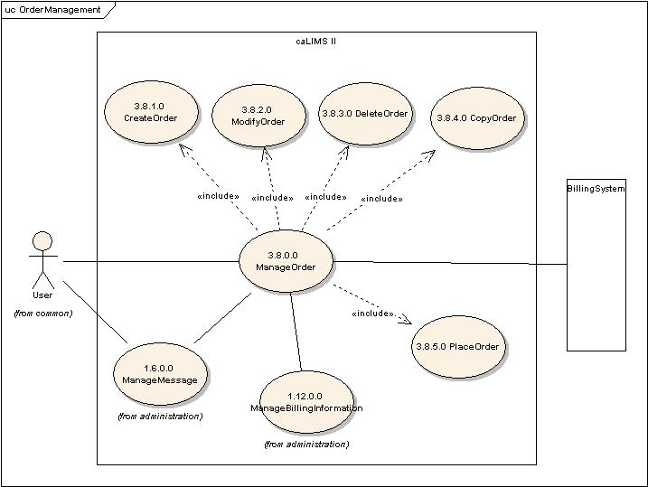
Fig 1-3 Order Management Use Case Diagram.
The Primary actor is any User with privileges to access a particular use case and a secondary actor may include a Billing, Payment and/or Order System and its associated functions. The ManageOrder Use Cases are associated with the ManageMessage (ID: 1.6.0.0) and the ManageBillingInformation (ID: 1.12.0.0) Use Cases.

Use Case Name | ManageOrder
Use Case ID | 3.8.0.0
Primary Actor | Users
Brief Description | The ManageOrder Use Case allows Users to create, modify, delete, copy, or place an Order. An Order can be for supplies, samples, services, or instrument repairs.
Pre-conditions | - User has logged into the system.  - User has privileges to perform the ManageOrder activity.
Flow of Events | - User selects ManageOrder action.  - User is presented with a list of actions for which the user has privileges.  - User may perform any of the following allowed actions:  CreateOrder (ID: 3.8.1.0), ModifyOrder (ID: 3.8.2.0), DeleteOrder (ID:  3.8.3.0), CopyOrder (ID: 3.8.4.0), or PlaceOrder (ID: 3.8.5.0).
Post Conditions | Success Condition:  - User has created, modified, deleted, copied, or placed an Order.  Error Condition:  - Invalid Order information.  - System error.
Alternative Courses of Action | Error Condition 2:  The system throws an exception and re-displays for corrected data entry.  Error Condition 3:  The system throws a System error. Contact the system administrator.
Issues | This Use Case is designed to track orders for supplies and other items for the Laboratory. It should not be confused with Customer Request (when a Lab acting as a service provider accepts a Customer Request (an Order) from a Customer).
Special Requirements | - The System will need to connect to a third party billing system to track payments; the System can be implemented without the billing system to just track orders placed and received.  - Orders will need a status field (submitted, pending, received, paid, etc.).

Use Case Name | CreateOrder
Use Case ID | 3.8.1.0
Primary Actor | Users
Brief Description | CreateOrder Use Case allows Users to create a new Order to the system.
Pre-conditions | - User is logged into the system.  - User has privileges to perform ManageOrder functionality.  - User has privileges to perform CreateOrder functionality.
Flow of Events | - User selects the Inventory component of the system.  - User selects ManageOrder action.  - User selects CreateOrder action.  - User enters information for the new Order. For example: name, label, description, orderID, vendorID, orderDate, estimatedShippingDate, actualShippingDate, receivedDate, orderedBy [person], approvedBy [person], contactPerson, invoiceID, chargeTo, paymentInformation, contractID, items (1 .. n) [amount, cost/item], shipping/handlingCharges, totalCharge, vendorOrderID, cofirmationNumber, quoteDocument, orderDocument, justificationDocument.  - User submits the information.
Post Conditions | Success Condition:  - User has added a new Order.  Error Condition:  - Invalid Order information  - Duplicate Order information  - System error
Alternative Courses of Action | Condition 2:  The system throws an Invalid Order exception message and re-displays the CreateOrder page for corrected data entry.  Condition 3:  The system throws Duplicate Order exception message and re-displays the CreateOrder page.  Condition 4:  The system throws a System error. Contact the system administrator.
Issues
Special Requirements

Use Case Name | ModifyOrder
Use Case ID | 3.8.2.0
Primary Actor | Users
Brief Description | ModifyOrder Use Case allows Users to modify an existing Order in the system.
Pre-conditions | - User is logged into the system.  - User has privileges to perform ManageOrder activity.  - User has privileges to perform ModifyOrder action.  - User has privileges to modify one or more Order(s).  - Modifying mutable fields of the Container does not affect system data integrity.
Flow of Events | - User selects Inventory component of the system.  - User selects ManageOrder functionality.  - User selects ModifyOrder functionality.  - User is presented with a list of Orders that the user has privileges to modify.  - User selects an Order to modify.  - User modifies one or more mutable fields for the chosen Order.  - User submits the modified Order information.
Post Conditions | Success Condition:  - User has modified the selected Order.  Error Condition:  - Invalid Order information.  - System Error
Alternative Courses of Action | Condition 2:  The system throws an Invalid Order exception message and re-displays the  ModifyOrder page for corrected data entry.  Condition 3:  The system throws a System error. Contact the system administrator.
Issues
Special Requirements

Use Case Name | DeleteOrder
Use Case ID | 3.8.3.0
Primary Actor | Users
Brief Description | The DeleteOrder Use Case allows Users to delete an existing Order from the system.
Pre-conditions | - User is logged into the system.  - User has privileges to perform ManageOrder action.  - User has privileges to perform DeleteOrder action.  - User has privileges to delete one or more Order(s).  - Deleting the selected Order does not affect system data integrity.
Flow of Events | - User selects Inventory component of the system.  - User selects ManageOrder section.  - User selects DeleteOrder section.  - User is presented with a list of Orders that the User has privileges to delete.  - User selects the Order to be deleted.  - User submits a request to delete the selected Order from the system.
Post Conditions | Success Condition:  - User has deleted the selected Order.  Error Condition:  - System Error
Alternative Courses of Action | Condition 2:  The system throws a System error. Contact the system administrator.
Issues
Special Requirements

Use Case Name | CopyOrder
Use Case ID | 3.8.4.0
Primary Actor | Users
Brief Description | The CopyOrder Use Case allows Users to Copy an existing Order to create a new Order in the system.
Pre- Conditions | - User has logged into the system.  - User has privileges to perform the ManageOrder action.  - User has privileges to perform the CopyOrder action.  - User has privileges to Copy one or more Order(s).
Flow of Events | - User selects Inventory component of the system.  - User selects the ManageOrder component of the system.  - User selects the CopyOrder action.  - User is presented with a list of Orders that the User has privileges to copy.  - User selects an Order to copy.  - User submits a request to copy the chosen Order.
Post Conditions | Success Message:  - User has copied the chosen Order.  - User would use the AddOrder (3.8.1.0) Use Case to submit the new Order to the system.  Error Message:  - System error
Alternative Courses of Action | Error Message 3:  The system throws a System error. Contact the system administrator.
Issues
Special Requirements

Use Case Name | PlaceOrder
Use Case ID | 3.8.5.0
Primary Actor | Users
Brief Description | The PlaceOrder Use Case allows Users to place an Order with a Vendor or service provider. This could be in the form of printing an Order Request, emailing a Purchase Request to a Purchasing Agent, or contacting an InventoryManager with the Order information.
Pre-conditions | - User has logged into the system.  - User has privileges to perform the ManageOrder action.  - User has privileges to PlaceOrder action.  - User has privileges to place one or more Order(s).
Flow of Events | - User selects Inventory component of the system.  - User selects the ManageOrder action.  - User selects the PlaceOrder action.  - User is presented with a list of Orders the User has privileges to place.  - User selects the Order to be placed.  - User submits the PlaceOrder action.
Post Conditions | Success Condition:  - User has placed an Order.  Error Conditions  - System error
Alternative Courses of Action | Error Condition 2:  The system throws a System error. Contact the system administrator.
Issues
Special Requirements | - A completely automated order processing will require interfacing with an external billing/payment system.  - The Method of placing an order will be dependent on the means available to the system. At a minimum, a default Purchase Request form should be completed and printed with the Order information.  - To cancel an order the privileged User would modify the Order’s status to “Canceled”.

