1.0 Report:
The Report module is a group of high-level functionalities. Access to Report module is provided to a set of multiple actors. Figure 1-0 provides a high level view of the Report module and its major uses. Use Cases that are arranged in a rectangle called caLIMS2 System belong to the caLIMS2 application. These Use Cases will be discussed in detail. Functionalities that are represented by the ReportFormattingTool rectangle are assumed to be implemented by third-party software.
This document describes the Report module and includes the following:
    - Report Management
    - Query Management
    - Summary Management
    - Search Management
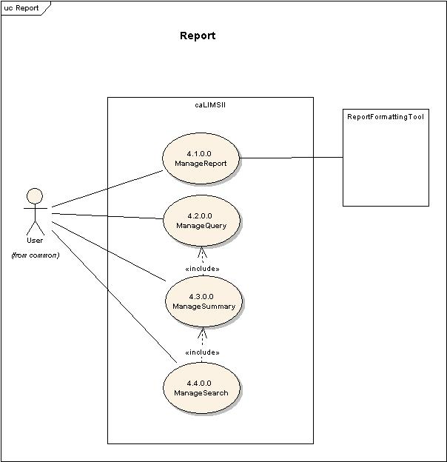
Figure 1-0 High level view of Report Use Case Diagram.

  - Report Management:
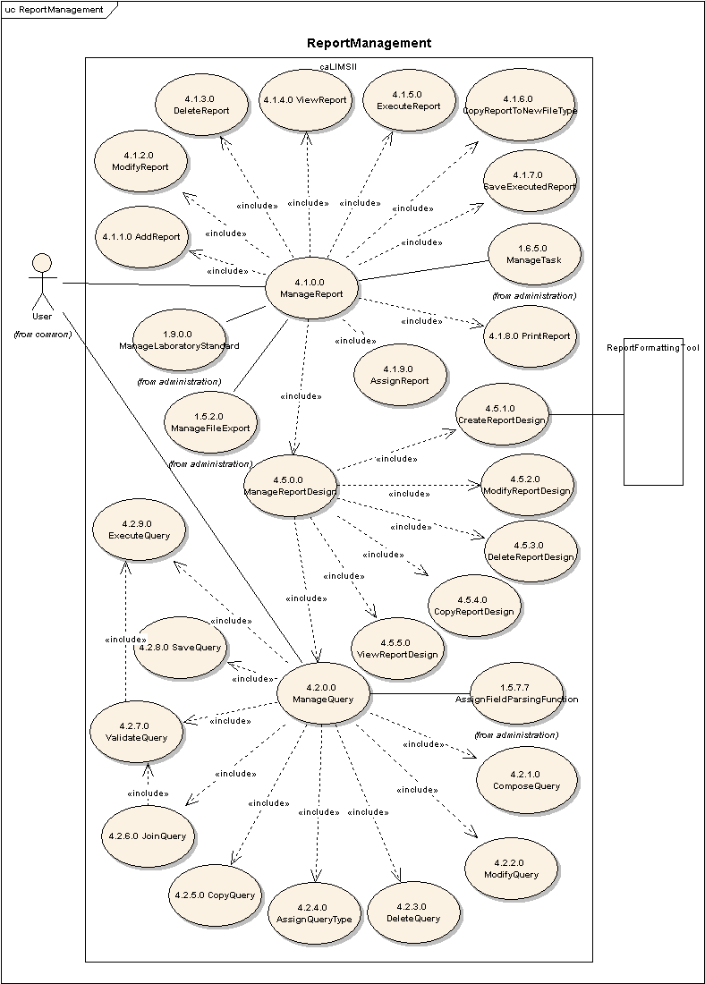
Figure 1-1 Detailed Report Management Use Case Diagram.

Use Case Name | ManageReport
Use Case ID | 4.1.0.0
Primary Actor | Users / System
Brief Description | The ManageReport use case allows users and/or the System to generate Reports for Entities in the System. A Report is the formatted output of a Query. For example Monthly Report generated for Project.
Pre-conditions | - User has logged into the system.  - User has privileges to access the ManageReport functionality.  - User has privileges to access the one or more ReportDesign.
Flow of Events | - User selects the ManageReport action.  - User is presented with a list of actions for which the user has privileges.  - User adds (4.1.1.0), modifies (4.1.2.0), deletes (4.1.3.0), views (4.1.4.0), executes (4.1.5.0), copies to a new FileType (4.1.6.0), saves (4.1.7.0), prints (4.1.8.0), or assigns (4.1.9.0) Report or manages ReportDesign (4.5.0.0).  - User submits Report information to the system.
Post Conditions | Success Condition:  - User has added, modified, deleted, viewed, executed, exported, saved, printed or assigned a Report or managed a ReportDesign.  Error Conditions  - System Error.
Alternative Courses of Action | Error Condition 2:  The system throws a System error. Contact the system administrator.
Issues | Note:  1) ExportFile(1.5.2.2) Use Case allows exporting Report files from the system to a client system.  2) This use case depends on the FileTransporter.
Special Requirements | 1. ManageReport may have association to ManageFileTransporter to allow a User to insert a file from the File system into a Report.  2. When a Report is copied, the system should copy the underlying Query and ReportDesign.  3. When a Report is added, a location in the filesystem is specified so the Report will be persisted. This location may be temporary.  4. AssignReport is used to associate a Report with a Project, Method, LabProcedure, Run, Equipment or other Entity (like a Summary). A Report is a physical file in the Virtual File System referenced at the associated Entity.

Use Case Name | AddReport
Use Case ID | 4.1.1.0
Primary Actor | Users
Brief Description | The Add Report Use Case allows users to add a new Report associated with an existing ReportDesign.
Pre-conditions | - User has logged into the system  - User has privileges to access the ManageReport functionality.  - User has privileges to access the AddReport functionality.  - User has privileges to access one or more ReportDesigns.  - User has privileges on one or more Queries.
Flow of Events | - User selects the ManageReport component of the system.  - User selects the AddReport action.  - User is presented with a list of ReportDesigns that can be associated with a Report.  - User selects a ReportDesign.  - User adds information for a new Report (for example Name, FileType, Virtual File System Location, description, createdBy, approvedBy, createDate, version, etc.,)  - User submits new Report information.
Post Conditions | Success Condition:  - User has added new a Report to the system.  Error Conditions  - Invalid Report information.  - Duplicate Report information.  - System Error.
Alternative Courses of Action | Error Condition 2:  The system throws an Invalid Report exception and re-displays the AddReport page for corrected data entry.  Error Condition 3:  The system throws Duplicate Report exception message and re-displays the AddReport page.  Error Condition 4:  The system throws a System error. Contact the system administrator.
Issues | Note:  1) User selects a Report Name, FileType, Virtual File System Location, etc., while submitting AddReport.  2) We need to explore the capabilities of Reporting tool.
Special Requirements | 1. Note that all ReportDesigns are associated with Queries; by selecting a ReportDesign the User also selects a Query.  2. There is a one-to-one association between Report and ReportDesign.  3. When a Report is added, the System by default should only grant privileges to the creator. It would be the creator’s option to extend the privileges to other users.

Use Case Name | ModifyReport
Use Case ID | 4.1.2.0
Primary Actor | Users
Brief Description | The ModifyReport Use Case allows users to modify an existing Report.
Pre-conditions | - User has logged into the system.  - User has privileges to access the ManageReport functionality.  - User has privileges to access the ModifyReport functionality.  - User has privileges to modify one or more Reports.  - Modifying mutable fields of the chosen Report does not affect system data integrity.
Flow of Events | - User selects the ManageReport component of the system.  - User selects the ModifyReport action.  - User is presented with a list of Reports the User has privileges to modify.  - User selects a Report to modify.  - User modifies mutable fields of the chosen Report.  - User submits modified Report information.
Post Conditions | Success Condition:  - User has modified the chosen Report.  Error Condition:  - Invalid Report information.  - System Error.
Alternative Courses of Action | Error Condition 2 :  System throws an Invalid Report exception message and re-displays the ModifyReport interface for corrected data entry.  Error Condition 3:  The system throws a System error. Contact the system administrator.
Issues
Special Requirements

Use Case Name | DeleteReport
Use Case ID | 4.1.3.0
Primary Actor | Users
Brief Description | The DeleteReport Use Case allows users to remove an existing Report from the system.
Pre-conditions | - User has logged into the system.  - User has privileges to access the ManageReport functionality.  - User has privileges to access the DeleteReport functionality.  - User has privileges to delete one or more Reports.  - Deleting the chosen Report does not affect system data integrity.
Flow of Events | - User selects the ManageReport component of the system.  - User selects the DeleteReport action.  - User is presented with a list of Reports the user has privileges to delete.  - User selects a Report to delete.  - User submits a request to delete the chosen Report from the system.
Post Conditions | Success Condition:  - User has deleted the chosen Report.  Error Condition:  - System Error.
Alternative Courses of Action | Error Condition 2 :  The system throws a System error. Contact the system administrator.
Issues
Special Requirements

Use Case Name | ViewReport
Use Case ID | 4.1.4.0
Primary Actor | Users
Brief Description | The ViewReport Use Case allows users to view a saved Report or a Report in progress.
Pre-conditions | - User has logged into the system.  - User has privileges to access the ManageReport functionality.  - User has privileges to access the ViewReport functionality.  - User has privileges to view one or more Reports.
Flow of Events | - User selects the ManageReport component of the system.  - User selects the ViewReport action.  - User is presented with a list of Reports the user has privilege to view.  - User selects a Report to view.  - User submits a request to view the chosen Report.
Post Conditions | Success Condition:  - User has viewed the selected Report.  Error Condition:  - System Error.
Alternative Courses of Action | Error Condition 2 :  The system throws a System error. Contact the system administrator.
Issues | 1. Report is Executed by the System prior to viewing.
Special Requirements | 1) ViewReport should allow viewing of Reports with either "executed" or "in-progress" Status.  Scenario 1:  While viewing a "in-progress" Report, the view interface would have an option to ModifyReportDesign.  Scenario 2:  While viewing a "saved" Report, the User may select “Okay”. If the User is not satisfied the User would have to modify and re execute the Report.

Use Case Name | ExecuteReport
Use Case ID | 4.1.5.0
Primary Actor | Users / System
Brief Description | The ExecuteReport Use Case allows users to generate a Report. Every time ExecuteReport is called the System generates a new Report.
Pre-conditions | - User has privilege to the ManageReport functionality.  - User has privilege to the ExecuteReport functionality.  - User has privileges to execute one or more Report.
Flow of Events | - User selects the ManageReport component of the system.  - User selects the ExecutetReport action.  - User is presented with a list of Reports the user has privilege to execute.  - User selects a Report to execute.  - User submits a request to execute the chosen Report.
Post Conditions | Success Condition:  - User has executed a Report.  Error Condition:  - System Error.
Alternative Courses of Action | Error Condition 2 :  The system throws a System error. Contact the system administrator.
Issues | Note:  - ExecuteReport may be used in other modules.
Special Requirements | 1) This Use Case may also be executed by the system automatically.  2) System needs a Naming Convention associated with Report to generate Report files with unique names.

Use Case Name | CopyReportToNewFileType
Use Case ID | 4.1.6.0
Primary Actor | Users
Brief Description | The CopyReportToNewFileType Use Case allows users to generate an existing Report in a new FileType. Examples include generating a PDF version of a an existing MS Word Report.
Pre-conditions | - User has logged into the system.  - User has privileges to access the ManageReport functionality.  - User has privileges to access the CopyReportToNewFileType functionality.  - User has privileges to access one or more executed Report saved in the System.  - User has privileges to access one or more FileTypes in the System.
Flow of Events | - User selects the ManageReport component of the system.  - User selects the CopyReportToNewFileType action.  - User is presented with a list of saved Reports the user has privilege to change FileType.  - User selects a Report to copy to a new FileType.  - User is presented with a list of FileTypes the user has privilege to select.  - User selects a FileType from the presented list.  - User submits a request to copy the chosen Report to the new FileType.
Post Conditions | Success Condition:  1. User has created a copy of the selected Report in the chosen FileType.  Error Condition:  2. Duplicate Copied Report.  3. System Error.
Alternative Courses of Action | Error Condition 2:  The system throws Duplicate Copied Report exception message and re-displays the CopyReportToNewFileType page.  Error Condition 3:  The system throws a System error. Contact the system administrator.
Issues | - FileType is a mandatory field while exporting a Report. There may be a default FileType associated to Report.
Special Requirements | 1. The CopyReportToNewFileType Use case may let the User chose to save the copied report in the new FileType.

Use Case Name | SaveExecutedReport
Use Case ID | 4.1.7.0
Primary Actor | Users / System
Brief Description | The SaveExecutedReport Use Case allows users to save an executed Report in the filesystem.
Pre-conditions | - User has logged into the system.  - User has privileges to access the ManageReport functionality.  - User has privileges to save one or more executed Reports.
Flow of Events | - User selects the ManageReport component of the system.  - User is presented with a list of executed Reports the user has privilege to save.  - User selects a Report to save.  - User submits a request to save the chosen Report.
Post Conditions | Success Condition:  - User has saved the chosen executed Report.  Error Condition:  - Duplicate saved Report.  - System Error.
Alternative Courses of Action | Error Condition 2 :  The system throws a Duplicate Saved Report error and redisplays the SaveExecutedReport interface for corrected information.  Error Condition 3 :  The system throws a System error. Contact the system administrator.
Issues | Note:  After execution the Report file is buffered for a pre-defined length of time (a default will be configured when the System is built). To save the Report permanently in the System SaveExecutedReport Use Case must be performed.
Special Requirements | The system should persist the snapshot of Data that was used to generate the Report.

Use Case Name | PrintReport
Use Case ID | 4.1.8.0
Primary Actor | Users
Brief Description | The PrintReport Use Case allows users to print a Report.
Pre-conditions | - User has logged into the system.  - User has privileges to perform the PrintReport activity on one or more executed Reports.
Flow of Events | - User is presented with a list of executed Reports that the user has privilege to print.  - User selects a Report to print.  - User selects printing options.  - User submits the request to print.
Post Conditions | Success Condition:  1. User has printed the selected Report.  Error Condition:  2. System error.
Alternative Courses of Action | Error Condition 2:  The system throws a System error. Contact the system administrator.
Issues
Special Requirements

Use Case Name | AssignReport
Use Case ID | 4.1.9.0
Primary Actor | Users
Brief Description | The AssignReport Use Case allows users to associate a Report with a Project, Method, LabProcedure, Run, Equipment or other Entities.
Pre-conditions | - User has logged into the system.  - User has privileges to access the ManageReport functionality.  - User has privileges to access the AssignReport functionality.  - User has privileges to assign a Report to an Entity.  - Assigning the chosen Report to the chosen Entity does not affect System data integrity.
Flow of Events | - User selects ManageReport functionality.  - User selects AssignReport functionality.  - User is presented with a list of Reports and Entities the User has privileges to associate.  - User submits a request to assign a selected Report to a selected Entity.
Post Conditions | Success Condition:  - User has associated a selected Report with a selected Entity.  Error Conditions:  - System Error.
Alternative Courses of Action | Error Condition 2:  The system throws a System error. Contact the system administrator.
Issues | A Report may be associated with multiple Entities.
Special Requirements | A Report that is assigned to an entity may or may not have been executed at the time assignment. For example a standing monthly Report would be executed last working day of each month.

Use Case Name | ManageReportDesign
Use Case ID | 4.5.0.0
Primary Actor | Users / System
Brief Description | The ManageReportDesign use case allows users to specify ReportDesigns. A ReportDesign is the formatted output of one or more Queries. A ReportDesign may include additional elements such as Figures, Graphs, Tables, etc.,
Pre-conditions | - User has logged into the system.  - User has privileges to access the ManageReportDesign functionality.  - User has privileges to access to one or more Queries.
Flow of Events | - User selects the ManageReportDesign action.  - User is presented with a list of actions for which the user has privileges.  - User creates (4.5.1.0), modifies (4.5.2.0), deletes (4.5.3.0), copies (4.5.4.0) or views (4.5.5.0) ReportDesign.  - User submits Report information to the system.
Post Conditions | Success Condition:  - User has created, modified, deleted, copied or viewed a ReportDesign.  Error Conditions  - System Error.
Alternative Courses of Action | Error Condition 2:  The system throws a System error. Contact the system administrator.
Issues
Special Requirements | A ReportDesign should allow the user to add free text areas, labels, images, etc.  A ReportDesign should allow the user to insert documents.  A ReportDesign may include the output of one or more Queries.

Use Case Name | CreateReportDesign
Use Case ID | 4.5.1.0
Primary Actor | Users
Brief Description | The CreateReportDesign Use Case allows users to specify the layout of a Report. This use case depends on a FileFormatTool Actor.
Pre-conditions | - User has logged into the system.  - User has privileges to access the ManageReportDesign functionality.  - User has privileges to access the CreateReportDesign functionality.  - User has privileges to access one or more Queries.
Flow of Events | - User selects the ManageReportDesign action.  - User selects the CreateReportDesign action.  - User is presented with a list of Queries the user has privileges to assign.  - User selects one or more Queries.  - User specifies the design via a FileFormattingTool.  - User adds information for a new ReportDesign.(e.g. name, label, description, createdBy, createdDate, Id, version, etc.,)  - User submits the ReportDesign information.
Post Conditions | Success Condition:  - User has created a ReportDesign.  Error Condition:  - Duplicate Report Design Information.  - System Error.
Alternative Courses of Action | Error Condition 2:  The system throws Duplicate Report Design exception message and re-displays the CreateReportDesign interface for corrected information.  Error Condition 3 :  The system throws a System error. Contact the system administrator.
Issues
Special Requirements

Use Case Name | ModifyReportDesign
Use Case ID | 4.5.2.0
Primary Actor | Users
Brief Description | The ModifyReportDesign Use Case allows users to modify an existing ReportDesign.
Pre-conditions | - User has logged into the system.  - User has privileges to access the ManageReportDesign functionality.  - User has privileges to access the ModifyReportDesign functionality.  - User has privileges to modify one or more ReportDesigns.  - Modifying mutable fields of the chosen ReportDesign does not affect system data integrity.
Flow of Events | - User selects the ManageReportDesign component of the system.  - User selects the ModifyReportDesign action.  - User is presented with a list of ReportDesigns the user has privileges to modify.  - User selects a ReportDesign to modify.  - User modifies mutable fields of the chosen ReportDesign.  - User submits modified ReportDesign information.
Post Conditions | Success Condition:  - User has modified the chosen ReportDesign.  Error Condition:  - Invalid ReportDesign information.  - System Error.
Alternative Courses of Action | Error Condition 2 :  System throws an Invalid ReportDesign exception message and re-displays the ModifyReportDesign interface for corrected data entry.  Error Condition 3:  The system throws a System error. Contact the system administrator.
Issues
Special Requirements

Use Case Name | DeleteReportDesign
Use Case ID | 4.5.3.0
Primary Actor | Users
Brief Description | The DeleteReportDesign Use Case allows users to remove an existing ReportDesign from the system.
Pre-conditions | - User has logged into the system.  - User has privileges to access the ManageReportDesign functionality.  - User has privileges to access the DeleteReportDesign functionality.  - User has privileges to delete one or more ReportDesigns.  - Deleting the chosen ReportDesign does not affect system data integrity.
Flow of Events | - User selects the ManageReportDesign component of the system.  - User selects the DeleteReportDesign action.  - User is presented with a list of ReportDesigns the user has privileges to delete.  - User selects a ReportDesign to delete.  - User submits a request to delete the chosen ReportDesign.
Post Conditions | Success Condition:  - User has deleted the chosen ReportDesign.  Error Condition:  - System Error.
Alternative Courses of Action | Error Condition 2 :  The system throws a System error. Contact the system administrator.
Issues
Special Requirements

Use Case Name | CopyReportDesign
Use Case ID | 4.5.4.0
Primary Actor | Users
Brief Description | The CopyReportDesign Use Case allows users to Copy a ReportDesign.  When the User copies a ReportDesign the System would also copy the underlying Queries.
Pre-conditions | - User has logged into the system.  - User has privileges to access the ManageReportDesign functionality.  - User has privileges to access the CopyReportDesign functionality.  - User has privileges to Copy one of more ReportDesign(s).
Flow of Events | - User selects ManageReportDesign functionality.  - User selects CopyReportDesign functionality.  - User is presented with a list of ReportDesigns the user has privileges to copy.  - User selects a ReportDesign to copy.  - User submits the request to copy the selected ReportDesign.
Post Conditions | Success Condition:  - User has copied the selected ReportDesign.  - User would execute the CreateReportDesign(4.5.1.0) Use Cases to submit a new ReportDesign to the system.  Error Conditions  2. Invalid ReportDesign Information..  3. System Error.
Alternative Courses of Action | Error Condition 2:  The system throws an Invalid ReportDesign exception and re-displays the CopyReportDesign screen for corrected data entry.  Error Condition 3:  The system throws a System error. Contact the system administrator.
Issues
Special Requirements | When the User copies a ReportDesign the System should also copy the underlying Queries.

Use Case Name | ViewReportDesign
Use Case ID | 4.5.5.0
Primary Actor | Users
Brief Description | The ViewReportDesign Use Case allows users to view a ReportDesign.
Pre-conditions | - User has logged into the system.  - User has privileges to access the ManageReportDesign functionality.  - User has privileges to access the ViewReportDesign functionality.  - User has privileges to view one or more ReportDesigns.
Flow of Events | - User selects the ManageReportDesign component of the system.  - User selects the ViewReportDesign action.  - User is presented with a list of ReportDesigns the user has privilege to view.  - User selects a ReportDesign to view.  - User submits a request to view the chosen ReportDesign.
Post Conditions | Success Condition:  - User has viewed the selected ReportDesign.  Error Condition:  - System Error.
Alternative Courses of Action | Error Condition 2 :  The system throws a System error. Contact the system administrator.
Issues
Special Requirements | - ViewReportDesign needs to be rendered in a separate pop-up window.  - The System should have a TestReportDesign action which would call ViewReport Use Case.

Use Case Name | ManageQuery
Use Case ID | 4.2.0.0
Primary Actor | Users / System
Brief Description | The ManageQuery use case allows users and/or the System to perform Queries against Entities in the system.
Pre-conditions | - User has logged into the system.  - User has privileges to access the ManageQuery functionality.
Flow of Events | - User selects the ManageQuery action.  - User is presented with a list of actions for which the user has privileges.  - User composes (4.2.1.0), modifies (4.2.2.0), deletes (4.2.3.0), copies (4.2.5.0), joins (4.2.6.0), validates (4.2.7.0), saves (4.2.8.0) or executes (4.2.9.0) a Query or User assigns a QueryType (4.2.4.0) to a Query.  - User submits information to the system.
Post Conditions | Success Condition:  - User has added, modified, deleted, copied, joined, validated, saved or executed a Query or has assigned a QueryType to a Query.  Error Conditions  - System Error.
Alternative Courses of Action | Error Condition 2:  The system throws a System error. Contact the system administrator.
Issues | Note:  The capabilities of ManageQuery function would depend on Object Relational Mapping.
Special Requirements | 1. The ValidateQuery use case (4.2.7.0) is automatically performed by the System at the end of the ComposeQuery, ModifyQuery, CopyQuery and JoinQuery use cases.  2. The ValidateQuery use case depends on the ExecuteQuery (4.2.9.0) use case. A Query must be successfully executed in order to be validated.  3. Every Query must be assigned a QueryType (4.2.4.0). Successful completion of the AssignQueryType use case is required to complete the ComposeQuery, ModifyQuery, CopyQuery and JoinQuery use cases.

Use Case Name | ComposeQuery
Use Case ID | 4.2.1.0
Primary Actor | Users
Brief Description | The ComposeQuery Use Case allows users to create a Query against one or more Entities in the system.
Pre-conditions | - User has logged into the system.  - User has privileges to access the ManageQuery functionality.  - User has privileges to access the ComposeQuery functionality.  - User has privileges to access the AssignQueryType functionality.  - User has privileges to assign an appropriate QueryType.  - User has privileges to Query the attributes of one or more Entities.
Flow of Events | - User selects the ManageQuery action.  - User selects the ComposeQuery action.  - User assigns a QueryType to the Query (4.2.4.0).  - User is presented with a list of Entities the user has privileges to query.  - User selects one or more Entities as the subject(s) of the Query.  - User selects Entity attributes and specifies a value or range of values as Query criteria.  - User provides additional information for the Query. For example: Name, description, label, createdDate, createdBy, validityStatus, etc..  - User submits Query information to the System.
Post Conditions | Success Condition:  - User has added a new Query to the system.  Error Conditions  - Invalid Query information.  - Duplicate Query information.  - System Error.
Alternative Courses of Action | Error Condition 2:  The system throws an Invalid Query exception and re-displays the ComposeQuery page for corrected data entry.  Error Condition 3:  The system throws a Duplicate Query exception and re-displays the ComposeQuery screen for corrected data entry.  Error Condition 4:  The system throws a System error. Contact the system administrator.
Issues | 1) Queries may be composed using an external QueryBuildingTool.
Special Requirements

Use Case Name | ModifyQuery
Use Case ID | 4.2.2.0
Primary Actor | Users
Brief Description | The ModifyQuery Use Case allows users to modify an existing Query.
Pre-conditions | - User has logged into the system.  - User has privileges to access the ManageQuery functionality.  - User has privileges to access the ModifyQuery functionality.  - User has privileges to modify one or more Queries.  - Modifying mutable fields of the chosen Query does not affect system data integrity.
Flow of Events | - User selects the ManageQuery action.  - The user selects the ModifyQuery action.  - User is presented with a list of Queries the user has privileges to modify.  - User selects a Query to modify.  - User modifies one or more mutable fields for the chosen Query.  - User submits modified Query information for the chosen Query.
Post Conditions | Success Condition:  - User has modified the chosen Query.  Error Condition:  - Invalid Query information.  - System Error.
Alternative Courses of Action | Error Condition 2 :  System throws an Invalid Query exception message and re-displays the ModifyQuery interface for corrected data entry.  Error Condition 3:  The system throws a System error. Contact the system administrator.
Issues
Special Requirements

Use Case Name | DeleteQuery
Use Case ID | 4.2.3.0
Primary Actor | Users
Brief Description | The DeleteQuery Use Case allows users to remove an existing Query from the system.
Pre-conditions | - User has logged into the system.  - User has privileges to access the ManageQuery functionality.  - User has privileges to access the DeleteQuery functionality.  - User has privileges to delete one or more Queries.  - Deleting the chosen Query does not affect system data integrity.
Flow of Events | - User selects the ManageQuery action.  - User selects the DeleteQuery action.  - User is presented with a list of Queries the user has privileges to delete.  - User selects a Query to delete.  - User submits a request to delete the chosen Query.
Post Conditions | Success Condition:  - User has deleted the chosen Query.  Error Condition:  - System Error.
Alternative Courses of Action | Error Condition 2 :  The system throws a System error. Contact the system administrator.
Issues
Special Requirements

Use Case Name | AssignQueryType
Use Case ID | 4.2.4.0
Primary Actor | Users
Brief Description | The AssignQueryType Use Case allows users to specify a predefined QueryType for a Query. Possible QueryTypes are Simple and Compound (may be extended to others).
Pre-conditions | - User has logged into the system.  - User has privileges to access the ManageQuery functionality.  - User has privileges to access the AssignQueryType functionality.  - User has privileges to assign one or more QueryTypes.  - Assigning the chosen QueryType does not affect system data integrity.
Flow of Events | - User selects the ManageQuery action.  - User selects compose (4.2.1.0), modify (4.2.2.0) or copy (4.2.5.0) Query action.  - User selects the AssignQueryType action.  - User is presented with a list of QueryTypes the User has privilege to assign.  - User associates a chosen QueryType to the Query.
Post Conditions | Success Condition:  - User has assigned a QueryType to a Query in the system.  Error Condition:  - System Error.
Alternative Courses of Action | Error Condition 3 :  The system throws a System error. Contact the system administrator.
Issues | 1. Possible QueryTypes include Simple and Compound. We may also extend this to other Filter types.  2. QueryTypes are pre-loaded into the system.3. All Queries must have a QueryType.
Special Requirements | The System may validate the QueryType as Simple or Complex based on the Query Object that has been selected. This might need a predefined business rule in the assignQueryType function.

Use Case Name | CopyQuery
Use Case ID | 4.2.5.0
Primary Actor | Users
Brief Description | The CopyQuery Use Case allows users to copy an existing Query in the system.
Pre-conditions | - User has logged into the system.  - User has privileges to access the ManageQuery functionality.  - User has privileges to access the CopyQuery functionality.  - User has privileges to copy one or more Queries.
Flow of Events | - User selects the ManageQuery action.  - User selects the CopyQuery action.  - User is presented with a list of Queries the user has privilege to copy.  - User selects a Query to copy.  - User submits a request to copy the chosen Query.
Post Conditions | Success Condition:  - User has copied the chosen Query.  - User would use the ComposeQuery use case (4.2.1.0) to submit the new Query to the system.  Error Condition:  - System Error.
Alternative Courses of Action | Error Condition 3 :  The system throws a System error. Contact the system administrator.
Issues
Special Requirements

Use Case Name | JoinQuery
Use Case ID | 4.2.6.0
Primary Actor | Users
Brief Description | The JoinQuery Use Case allows users to join two or more Queries to form a complex Query.
Pre-conditions | - User has logged into the system.  - User has privileges to access the ManageQuery functionality.  - User has privileges to access the JoinQuery functionality.  - User has privileges to join two or more Queries.
Flow of Events | - User selects the ManageQuery action.  - User selects the JoinQuery action.  - User is presented with a list of Queries the user has privilege to join.  - User selects the Queries to join.  - The System preselects a QueryType as Complex to the joined Query.  - User selects the operand [AND, OR,NOT etc.] by which the selected Queries are to be joined.  - User submits information for the new joined Query.
Post Conditions | Success Condition:  - User has joined two or more Queries and entered a new complex Query into the system.  Error Condition:  - Invalid Query information.  - Duplicate Query information.  - System Error.
Alternative Courses of Action | Error Condition 2:  The system throws an Invalid Query exception and re-displays the JoinQuery page for corrected data entry.  Error Condition 3:  System throws a Duplicate Query exception message and re-displays the JoinQuery interface for corrected data entry.  Error Condition 4:  The system throws a System error. Contact the system administrator.
Issues | Note:  The capabilities of ManageQuery function would depend on Object Relational Mapping.
Special Requirements

Use Case Name | ValidateQuery
Use Case ID | 4.2.7.0
Primary Actor | System
Brief Description | The ValidateQuery Use Case allows the System to verify that a Query is properly composed.
Pre-conditions | - User is logged into the System.  - User has privileges to access the ManageQuery functionality.  - User has privileges to access the ValidateQuery functionality.  - User has submitted new Query information via the ComposeQuery, ModifyQuery, or JoinQuery use case.
Flow of Events | - User selects the ManageQuery action.  - User selects the ValidateQuery action.  - User submits a Query to the system via Compose/Modify/ Join Query functionality.  - System executes the Query.  - System checks return code of executed Query.
Post Conditions | Success Condition:  - Successful Query execution. The Query is validated.  Error Condition:  - Unsuccessful Query execution.  - System Error.
Alternative Courses of Action | Error Condition 2 :  The system throws an Invalid Query exception and displays the description of error condition and prompts the User to enter corrected Query data.  Error Condition 3 :  The system throws a System error. Contact the system administrator.
Issues
Special Requirements | The Status of the Validated Query needs to be set as “validated”.

Use Case Name | SaveQuery
Use Case ID | 4.2.8.0
Primary Actor | Users / System
Brief Description | The SaveQuery Use Case allows users to save a validated Query.
Pre-conditions | - User has logged into the system.  - User has privileges to access the ManageQuery functionality.  - User has privileges to access the SaveQuery functionality.  - User has privileges to save one or more Queries.  - User/System has validated the chosen Query.  - Saving the chosen Query does not affect system data integrity.
Flow of Events | - User selects the ManageQuery action.  - User creates a valid Query via the ComposeQuery, ModifyQuery, or JoinQuery use case.  - User submits a request to save the chosen Query.
Post Conditions | Success Condition:  - User has saved the chosen Query.  Error Condition:  - System Error.
Alternative Courses of Action | Error Condition 2 :  The system throws a System error. Contact the system administrator.
Issues | Note:  The SaveQuery Use Case may be used for saving both Temporary and Permanent Queries (status flag settings).
Special Requirements

Use Case Name | ExecuteQuery
Use Case ID | 4.2.9.0
Primary Actor | Users / System
Brief Description | The ExecuteQuery Use Case allows users or the System to execute a Query.
Pre-conditions | - User has logged into the system.  - User has privileges to access the ManageQuery functionality.  - User has privileges to access the ExecuteQuery functionality.  - User has privileges to execute one or more Queries.
Flow of Events | - User selects the ManageQuery action.  - User selects the ExecuteQuery action.  - User is presented with a list of Queries the user has privileges to execute.  - User selects a Query to execute.  - User submits a request to execute the chosen Query.
Post Conditions | Success Condition:  - User has executed a chosen Query. Results are displayed if User executes the chosen Query.  Error Condition:  - Invalid Query.  - System Error.
Alternative Courses of Action | Error Condition 2 :  The system throws an Invalid Query exception and re-displays the ComposeQuery, ModifyQuery, or JoinQuery interface for corrected data entry.  Error Condition 3 :  The system throws a System error. Contact the system administrator.
Issues | 1. This Use Case is called by ValidateQuery Use case.
Special Requirements | 1) The System should check for boundary conditions of a Query.

  - Summary Management:

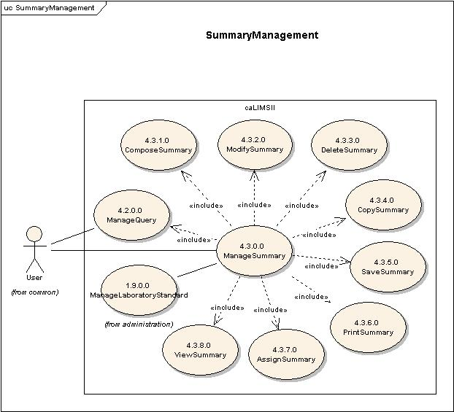
Fig 1-2 Detailed Summary Management Use Case Diagram.

Use Case Name | ManageSummary
Use Case ID | 4.3.0.0
Primary Actor | Users / System
Brief Description | The ManageSummary use case allows users to generate Summaries for Entities in the System. A Summary is the unformatted output of a Query and is displayed in the interface.
Pre-conditions | - User has logged into the system.  - User has privileges to access the ManageSummary functionality.  - User has privileges to access one or more Entities.  - User has privileges to access one or more Queries for the chosen Entities.
Flow of Events | - User selects the ManageSummary action.  - User is presented with a list of actions for which the user has privileges.  - User composes (4.3.1.0), modifies (4.3.2.0), deletes (4.3.3.0), copies (4.3.4.0), saves (4.3.5.0), prints (4.3.6.0), assigns (4.3.7.0) or views (4.3.8.0) the Summary.  - User submits Summary information to the system.
Post Conditions | Success Condition:  - User has composed, modified, deleted, copied, saved, printed, assigned or viewed a Summary.  Error Conditions  - System Error.
Alternative Courses of Action | Error Condition 2:  The system throws a System error. Contact the system administrator.
Issues
Special Requirements | - The Manage Summary Icon may be associated to all the individual entities by default.  - The default Entity that is the subject of a simple Query should be determined by context (e.g. Supplies, Reagents, etc. are available to be queried in Inventory use cases).  - The Summary needs to be rendered in a separate pop-up window.

Use Case Name | ComposeSummary
Use Case ID | 4.3.1.0
Primary Actor | Users
Brief Description | The ComposeSummary Use Case allows users to add a new Summary associated with an existing Entity.
Pre-conditions | - User has logged into the system  - User has privileges to access the ManageSummary functionality.  - User has privileges to access the ComposeSummary functionality.  - User has privileges on one or more Queries.  - User has privileges on one or more Entities.
Flow of Events | - User selects the ManageSummary component of the system.  - User selects the ComposeSummary action.  - User is presented with a list of Queries that can be associated with a Summary.  - User selects one or more Queries.  - User is presented with a list of Entities that can be associated with a Summary.  - User selects one or more Entities for the Summary.  - User enters additional information for the Summary. For example: name, ID, label, description, createdBY, createdDate, etc..  - User submits the new Summary information.
Post Conditions | Success Condition:  - User has added a new Summary.  Error Conditions  - Invalid Summary information.  - Duplicate Summary information.  - System Error.
Alternative Courses of Action | Error Condition 2:  The system throws an Invalid Summary exception and re-displays the ComposeSummary page for corrected data entry.  Error Condition 3:  The system throws a Duplicate Summary exception and re-displays the ComposeSummary page for corrected data entry.  Error Condition 4:  The system throws a System error. Contact the system administrator.
Issues | Note:  1) Filtering and sorting of Summary output is performed in ManageResult Use Case.
Special Requirements | Needs a one-to-many association with Summary and Query.

Use Case Name | ModifySummary
Use Case ID | 4.3.2.0
Primary Actor | Users
Brief Description | The ModifySummary Use Case allows users to modify an existing Summary.
Pre-conditions | - User has logged into the system.  - User has privileges to access the ManageSummary functionality.  - User has privileges to access the ModifySummary functionality.  - User has privileges to modify one or more Summaries.  - Modifying mutable fields of the chosen Summary does not affect system data integrity.
Flow of Events | - User selects the ManageSummary component of the system.  - User selects the ModifySummary action.  - User is presented with a list of Summaries the user has privileges to modify.  - User selects a Summary to modify.  - User modifies ione or more mutable fields for the chosen Summary.  - User submits the modified information for the chosen Summary.
Post Conditions | Success Condition:  - User has modified the chosen Summary.  Error Condition:  - Invalid Summary information.  - System Error.
Alternative Courses of Action | Error Condition 2 :  System throws an Invalid Summary exception message and re-displays the ModifySummary interface for corrected data entry.  Error Condition 3:  The system throws a System error. Contact the system administrator.
Issues | Note:  Modifying a Query is handled via ModifyQuery Use case.
Special Requirements

Use Case Name | DeleteSummary
Use Case ID | 4.3.3.0
Primary Actor | Users
Brief Description | The DeleteSummary Use Case allows users to remove an existing Summary from the system.
Pre-conditions | - User has logged into the system.  - User has privileges to access the ManageSummary functionality.  - User has privileges to access the DeleteSummary functionality.  - User has privileges to delete one or more Summaries.  - Deleting the chosen Summary information does not affect system data integrity.
Flow of Events | - User selects the ManageSummary component of the system.  - User selects the DeleteSummary action.  - User is presented with a list of Summaries the user has privileges to delete.  - User selects a Summary to delete.  - User submits a request to delete the chosen Summary from the system.
Post Conditions | Success Condition:  - User has deleted the chosen Summary.  Error Condition:  - System Error.
Alternative Courses of Action | Error Condition 2 :  The system throws a System error. Contact the system administrator.
Issues
Special Requirements

Use Case Name | CopySummary
Use Case ID | 4.3.4.0
Primary Actor | Users
Brief Description | The CopySummary Use Case allows users to Copy a Summary.
Pre-conditions | - User has logged into the system.  - User has privileges to access the ManageSummary functionality.  - User has privileges to access the CopySummary functionality.  - User has privileges to Copy one or more Summaries.
Flow of Events | - User selects ManageSummary functionality.  - User selects CopySummary functionality.  - User is presented with a list of Summaries the user has privileges to copy.  - User selects a Summary to copy.  - User submits a request to copy the chosen Summary.
Post Conditions | Success Condition:  - User has copied the selected Summary.  - The ComposeSummary use case (4.3.1.0) is used to add the copied Summary as a new Summary.  Error Conditions  - System Error.
Alternative Courses of Action | Error Condition 3:  The system throws a System error. Contact the system administrator.
Issues
Special Requirements | 1) When the User copies a Summary, the System should also copy the underlying Query.

Use Case Name | SaveSummary
Use Case ID | 4.3.5.0
Primary Actor | Users/System
Brief Description | The SaveSummary Use Case allows users to save a Summary.
Pre-conditions | - User has logged into the system.  - User has privileges to access the ManageSummary functionality.  - User has privileges to save one or more Summaries.
Flow of Events | - User selects the ManageSummary component of the system.  - User is presented with a list of Summaries the user has privileges to save.  - User selects a Summary to save.  - User submits a request to save the chosen Summary.
Post Conditions | Success Condition:  - User has saved the chosen Summary.  Error Condition:  - Duplicate saved Summary.  - System Error.
Alternative Courses of Action | Error Condition 2 :  The system throws a Duplicate Saved Summary error and redisplays the SaveSummary interface for corrected information.  Error Condition 3 :  The system throws a System error. Contact the system administrator.
Issues
Special Requirements

Use Case Name | PrintSummary
Use Case ID | 4.3.6.0
Primary Actor | Users
Brief Description | The PrintSummary Use Case allows users to print a Summary.
Pre-conditions | - User has logged into the system.  - User has privileges to perform the ManageSummary activity.  - User has privileges to perform the PrintSummary activity.  - User has selected ViewSummary activity.
Flow of Events | - User selects the PrintSummary functionality.  - User selects printing options.  - User submits a request to print the selected Summary.
Post Conditions | Success Condition:  User has printed the selected Summary.  Error Condition:  System error.
Alternative Courses of Action | Error Condition 2:  The system throws a System error. Contact the system administrator.
Issues | Note:  This Use Case assumes that the User is actively viewing a Summary window which may have options to “Print” or “Close”.
Special Requirements

Use Case Name | AssignSummary
Use Case ID | 4.3.7.0
Primary Actor | Users
Brief Description | The AssignSummary Use Case allows users to assign a Summary to an Entity.  Example Summary can be assigned to an Entitiy such as Project, Personnel, Workflow, etc.
Pre-conditions | - User has logged into the system.  - User has privileges to access the ManageSummary functionality.  - User has privileges to access the AssignSummary functionality.  - User has privileges to assign the chosen Summary to the chosen Entity.  - Assigning the chosen Summary to the chosen Entity does not affect System data integrity.
Flow of Events | - User selects ManageSummary functionality.  - User selects AssignSummary functionality.  - User is presented with a list of Summaries the user has privileges to associate.  - User selects a Summary to associate.  - User is presented with a list of Entities the user has privileges to associate with the chosen Summary.  - User submits a request to assign a selected Entity to a selected Summary.
Post Conditions | Success Condition:  - User has assigned a selected Entity with the chosen Summary.  Error Conditions:  - System Error.
Alternative Courses of Action | Error Condition 2:  The system throws a System error. Contact the system administrator.
Issues | Cardinality between Summary and Entity needs to be revisited. An Entity can be associated to multiple Summaries. Still discussing whether a Summary can be associated to more than one Entities (for example a Project Summary associated with both a project and a collaboration).
Special Requirements

Use Case Name | ViewSummary
Use Case ID | 4.3.8.0
Primary Actor | Users
Brief Description | The ViewSummary Use Case allows users to view a saved Summary or a Summary in progress.
Pre-conditions | - User has logged into the system.  - User has privileges to access the ManageSummary functionality.  - User has privileges to access the ViewSummary functionality.  - User has privileges to view one or more Summaries.
Flow of Events | - User selects the ManageSummary component of the system.  - User selects the ViewSummary action.  - User is presented with a list of Summaries the user has privilege to view.  - User selects a Summary to view.  - User submits a request to view the chosen Summary.
Post Conditions | Success Condition:  User has viewed the selected Summary.  Error Condition:  System Error.
Alternative Courses of Action | Error Condition 2 :  The system throws a System error. Contact the system administrator.
Issues | 1. Summary is Executed by the System prior to viewing.
Special Requirements

  - Search Management:
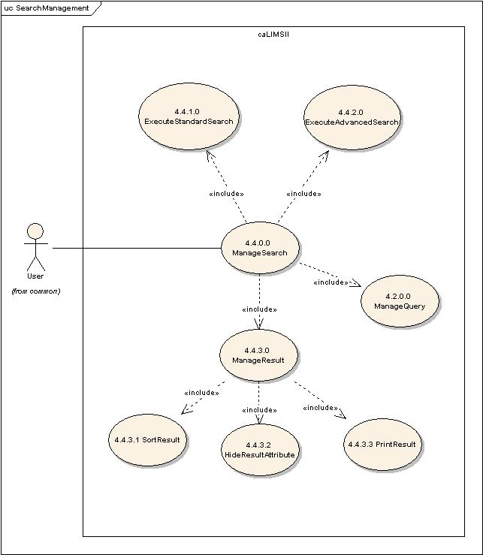
Fig 1-3 Detailed Search Management Use Case Diagram.

Use Case Name | ManageSearch
Use Case ID | 4.4.0.0
Primary Actor | Users / System
Brief Description | The ManageSearch use case allows users to execute standard or advanced searches against Entities in the System or manage Search Results.
Pre-conditions | - User has logged into the system.  - User has privileges to access the ManageSearch functionality.  - User has privileges on one or more Search(es).
Flow of Events | - User selects the ManageSearch action.  - User excecutes Standard (4.4.1.0), Advanced (4.4.2.0) searches or manages a SearchResult (4.4.3.0).  - User submits Search information to the system.
Post Conditions | Success Condition:  - User has executed a standard/advanced search or has managed the results of a Search.  Error Conditions  - System Error.
Alternative Courses of Action | Error Condition 2:  The system throws a System error. Contact the system administrator.
Issues
Special Requirements | 1. The default Entity that is the subject of a simple Query should be determined by context (e.g. Supplies, Reagents, etc. are available to be queried in Inventory use cases).

Use Case Name | ExecuteStandardSearch
Use Case ID | 4.4.1.0
Primary Actor | Users
Brief Description | The ExecuteStandardSearch Use Case allows users to execute a simple Search against the current Entity. A StandardSearch may be executed without selecting a Query. For example if the user is in ManagePersonnel, a default standard search against Personnel may be executed without selecting a query.
Pre-conditions | - User has logged into the system.  - User has privileges to access the ManageSearch functionality.  - User has privileges to access the ExecuteStandardSearch functionality.  - User has privileges to execute the StandardSearch for the chosen Entity.
Flow of Events | - User selects the ManageSearch action.  - User selects the ExecuteStandardSearch action.  - User enters the Search parameters. For example: name, ID, label, description, etc..  - User submits Search information to the System.
Post Conditions | Success Condition:  - User has executed a Standard Search for the Entity.  Error Conditions  - Invalid Search information.  - System Error.
Alternative Courses of Action | Error Condition 2:  The system throws an Invalid Search exception and re-displays the ExecuteStandardSearch page for corrected data entry.  Error Condition 3:  The system throws a System error. Contact the system administrator.
Issues
Special Requirements | - The default Entity that is the subject of a simple Query should be determined by context (e.g. Supplies, Reagents, etc. are available to be queried in Inventory use cases).  - The default value Search criteria could be “*”.

Use Case Name | ExecuteAdvancedSearch
Use Case ID | 4.4.2.0
Primary Actor | Users
Brief Description | The ExecuteAdvancedSearch Use Case allows users to execute a complex Search of the current Entity against other Entities. For example the user may execute an advanced search on a Sample and its associated number of aliquots, container name and working stock name. In this case the user would compose a query that includes Sample and also select individual entity’s attributes that are associated to Sample.
Pre-conditions | - User has logged into the system.  - User has privileges to access the ManageSearch functionality.  - User has privileges to access the ExecuteAdvancedSearch functionality.  - User has privileges to access the chosen Query.  - User has privileges to access the AssignQuery functionality.  - User has privileges to execute the AdvancedSearch associated with the Entity.
Flow of Events | - User selects the ManageSearch action.  - User selects the ExecuteAdvancedSearch action.  - User is presented with a list of Queries User has privilege to execute.  - User selects one or more Queries using AssignQuery action.  - User enters the search information for one or more Entities.  - User submits request to execute AdvancedSearch.
Post Conditions | Success Condition:  - User has executed an Advanced Search for one or more Entities.  Error Conditions  - Invalid Search information.  - System Error.
Alternative Courses of Action | Error Condition 2:  The system throws an Invalid Search exception and re-displays the ExecuteAdvancedSearch page for corrected data entry.  Error Condition 3:  The system throws a System error. Contact the system administrator.
Issues
Special Requirements

Use Case Name | ManageResult
Use Case ID | 4.4.3.0
Primary Actor | Users
Brief Description | The ManageResult use case allows users and/or the System to filter, sort and print Query Results.
Pre-conditions | - User has logged into the system.  - User has privileges to access the ManageResult functionality.  - User has privileges on one or more Result(s).
Flow of Events | - User selects the ManageResult action.  - User sorts (4.4.3.1) or prints (4.1.3.0) a Result or hides Result attributes (4.4.3.2).
Post Conditions | Success Condition:  - User has sorted or printed a Result or has hidden Result attributes.  Error Conditions  - System Error.
Alternative Courses of Action | Error Condition 2:  The system throws a System error. Contact the system administrator.
Issues
Special Requirements

Use Case Name | SortResult
Use Case ID | 4.4.3.1
Primary Actor | Users
Brief Description | The SortResult Use Case allows users to sort the results of a Query.
Pre-conditions | - User has logged into the system.  - User has privileges to access one or more Result(s).  - User has privileges to access the SortResult functionality.  - User has privileges to sort the chosen Query Result.
Flow of Events | - User selects a Result to sort.  - User selects the SortResult action.  - User is presented with a list of attributes of a Result.  - User selects an attribute as the sort key.  - User submits the request to Sort the Query Result.
Post Conditions | Success Condition:  - User has sorted a Query Result.  Error Conditions  - System Error.
Alternative Courses of Action | Error Condition 2:  The system throws a System error. Contact the system administrator.
Issues
Special Requirements

Use Case Name | HideResultAttribute
Use Case ID | 4.4.3.2
Primary Actor | Users
Brief Description | The HideResultAttribute Use Case allows users to hide the selected attributes of a Result.
Pre-conditions | - User has logged into the system.  - User has privileges to access one or more Result(s).  - User has privileges to hide attributes of the chosen Query Result.
Flow of Events | - User selects a Result.  - User selects the HideResultAttribute action.  - User is presented with a list of attributes of the chosen Result.  - User selects one or more attributes and submits the request to hide.
Post Conditions | Success Condition:  - User has hidden one or more attributes of a Result.  Error Conditions  - System Error.
Alternative Courses of Action | Error Condition 2:  The system throws a System error. Contact the system administrator.
Issues
Special Requirements

Use Case Name | PrintResult
Use Case ID | 4.4.3.3
Primary Actor | Users
Brief Description | The PrintResult Use Case allows users to print a Result.
Pre-conditions | - User has logged into the system.  - User has privileges to one or more Result(s).  - User has privileges to perform the PrintResult activity.
Flow of Events | - User selects a Result.  - User selects the PrintResult functionality.  - User selects appropriate printing options.  - User submits request to print the chosen Result.
Post Conditions | Success Condition:  1. User has printed the selected Result.  Error Condition:  2. System error.
Alternative Courses of Action | Error Condition 2:  The system throws a System error. Contact the system administrator.
Issues
Special Requirements

