- Workflow Management:
The Workflow Management module is a group of high-level functionalities for activities related to Workflow in a Laboratory; they include Project, Method, LabProcedure and Run Management. These use cases allow tracking of activities in a wide variety of Laboratory types including small basic research laboratories, Core facilities and high-throughput laboratories, and clinical research laboratories. Workflow management allows authorized users to configure the workflow associated with multiple types of projects. Workflow module is provided to a set of actors including Lab Manager, Researcher, Staff Scientist and PIs. Figure 1-0 provides a high level view of the Workflow module and its major uses.
The use cases under the Workflow module are categorized into 11 different groups:
- Workflow Management
- Process Management
- Activity Management
- Transition Management
- Project Management
- Method Management
- LabProcedure Management
- Run Management
- Reaction Management
- Approval Management
- Project Document Assignment
All of these groups are described in detail below in this document.

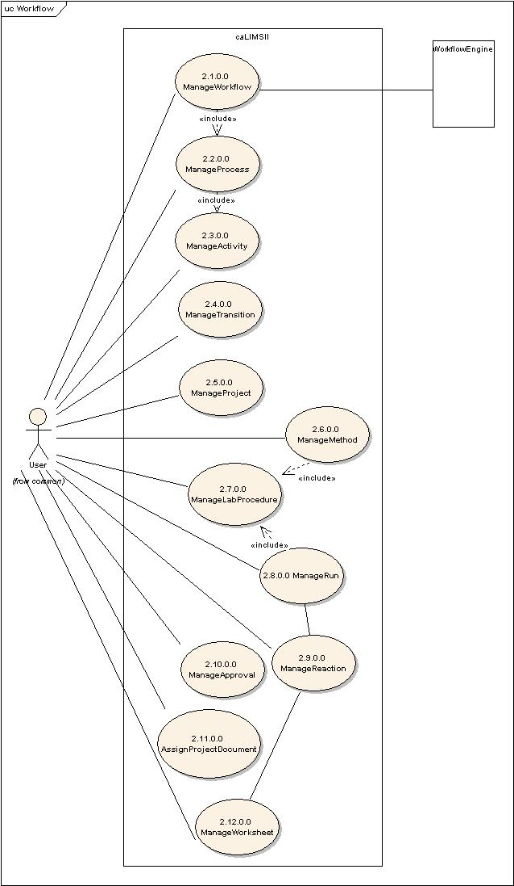
Fig 1-0 High level view of Manage Workflow Use Case Diagram.

1.1 Project Management:

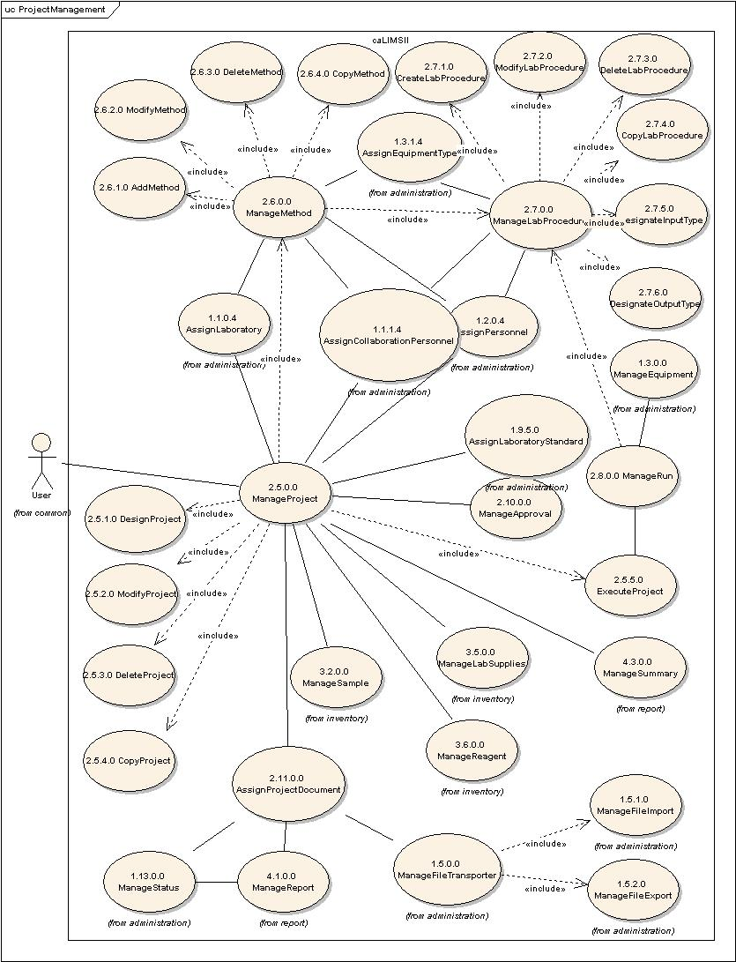

Fig 1-1 Detailed view of Project Management Use Case Diagram.

1.2 Run Management:

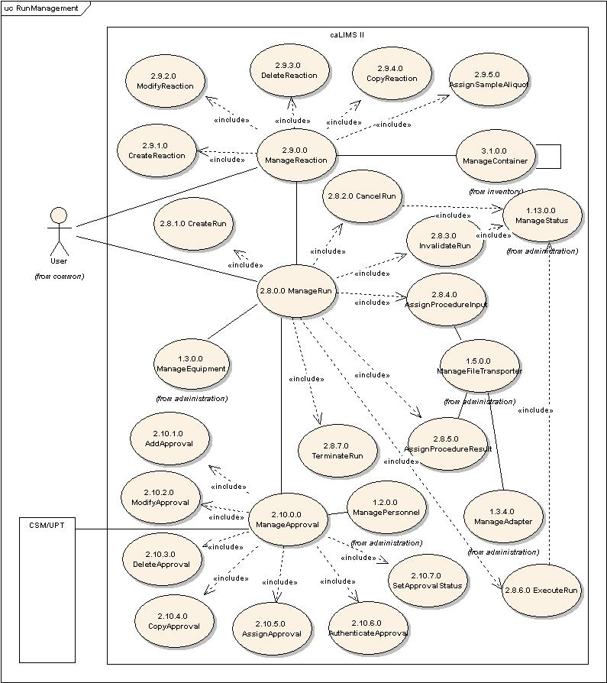

Fig 1-2 Detailed view of Run Management Use Case Diagram.

Use Case Name | ManageProject
Use Case ID | 2.5.0.0
Primary Actor | Users
Brief Description | The ManageProject Use Case allows users to manage Projects.
Pre-conditions | - User has logged into the system.  - User has privileges to access the ManageProject functionality.
Flow of Events | - User selects the ManageProject action.  - User is presented with a list of actions the user has privileges to perform.  - User designs (2.5.1.0), modifies (2.5.2.0), deletes (2.5.3.0), copies (2.5.4.0) or executes (2.5.5.0) a Project.  - User submits Project information to the system.
Post Conditions | Success Condition:  - User has created, modified, deleted, copied or executed a Project.  Error Conditions:  - Invalid Project information.  - System Error.
Alternative Courses of Action | Error Condition 2:  The system throws an Invalid Project exception and re-displays the interface for  corrected data entry.  Error Condition 3:  The system throws a System error. Contact the system administrator.
Issues | Note:  - A Project should have at least one Method. A default Method may be entered as a placeholder to avoid data integrity problems.  - A Project may be assigned “Template” status. Template Projects may be copied but cannot be modified except by a privileged User.  - Samples, Personnel etc., may be assigned to a Project after its creation.
Special Requirements | 1) The system should not allow any user to execute a Template Project.

Use Case Name | DesignProject
Use Case ID | 2.5.1.0
Primary Actor | Users
Brief Description | The DesignProject Use Case allows users to enter information for a new Project into the System.
Pre-conditions | - User has logged into the system.  - User has privileges to access the ManageProject functionality.  - User has privileges to access the DesignProject functionality.  - User has privileges to assign one or more Methods or Analyses to a Project.
Flow of Events | - User selects the ManageProject action.  - User selects the DesignProject action.  - User is presented with a list of Methods and Analyses the user has privileges to assign to a Project.  - User selects one or more Methods and/or Analyses to assign to the Project.  - User adds information for a new Project (e.g. name, label, description, id, projectLeader, collaborationID, laboratoryID, organizationID, projectDocument, expectedStartDate, actualStartDate, expectedCompletionDate, actualCompletionDate, approvalDate, approvedBy, publications, IRBApproval, projectDesigner, fundingCAN, centerNumber, templateFlag).  - User submits Project information to the system.
Post Conditions | Success Condition:  - User has added a new Project.  Error Conditions  - Invalid Project information.  - Duplicate Project information.  - System Error.
Alternative Courses of Action | Error Condition 2:  The system throws an Invalid Project exception and re-displays the DesignProject page for corrected data entry.  Error Condition 3:  The system throws a Duplicate Project exception and re-displays the  DesignProject page for corrected data entry.  Error Condition 4:  The system throws a System error. Contact the system administrator.
Issues | 1) At design time the only components needed are Methods and/or Analyses.  2) The User who designs a Project is captured as “Created By” and tracked by the CLM subsystem.  3) A Curator is an Actor who has privileges to create and modify a “Template” Project.
Special Requirements

Use Case Name | ModifyProject
Use Case ID | 2.5.2.0
Primary Actor | Users
Brief Description | The ModifyProject Use Case allows users to modify an existing Project.
Pre-conditions | - User has logged into the system.  - User has privileges to access the ManageProject functionality.  - User has privileges to access the ModifyProject functionality.  - User has privileges to modify one or more Projects.  - Modifying mutable fields of the chosen Project does not affect system data integrity.
Flow of Events | - User selects the ManageProject action.  - User selects the ModifyProject action.  - User is presented with a list of Projects the user has privileges to modify.  - User selects a Project to modify  - User modifies the value of one or more mutable fields of the chosen Project.  - User submits the modified Project information.
Post Conditions | Success Condition:  - User has modified the chosen Project.  Error Condition:  - Invalid Project information.  - System Error.
Alternative Courses of Action | Error Condition 2 :  System throws Invalid Project exception message and re-displays the  ModifyProject interface for corrected data entry.  Error Condition 3:  The system throws a System error. Contact the system administrator.
Issues
Special Requirements

Use Case Name | DeleteProject
Use Case ID | 2.5.3.0
Primary Actor | Users
Brief Description | The DeleteProject Use Case allows users to remove an existing Project from the system
Pre-conditions | - User has logged into the system.  - User has privileges to access the ManageProject functionality.  - User has privileges to access the DeleteProject functionality.  - User has privileges to delete one or more Projects.  - Deleting the chosen Project does not affect system data integrity.
Flow of Events | - User selects the ManageProject action.  - User selects the DeleteProject action.  - User is presented with a list of Projects the user has privileges to delete.  - User selects a Project to delete.  - User submits a request to delete the chosen Project from the system.
Post Conditions | Success Condition:  - User has deleted the chosen Project from the system.  Error Condition:  - System Error.
Alternative Courses of Action | Error Condition 2 :  The system throws a System error. Contact the system administrator.
Issues
Special Requirements

Use Case Name | CopyProject
Use Case ID | 2.5.4.0
Primary Actor | Users
Brief Description | CopyProject Use Case allows users to copy only the associated Methods and LabProcedures from an existing Project.
Pre-conditions | - User has logged into the system.  - User has privileges to access the ManageProject functionality.  - User has privileges to access the CopyProject functionality.  - User has privileges to copy one or more Projects.
Flow of Events | - User selects the ManageProject action.  - User selects the CopyProject action.  - User is presented with a list of Projects the user has privileges to copy.  - User selects a Project to copy.  - User submits a request to copy the chosen Project.
Post Conditions | Success Condition:  - User has copied the chosen Project.  - User would modify certain fields and submit the DesignProject use case (2.5.1.0) to create a new Project to the System.  Error Condition:  - System Error.
Alternative Courses of Action | Error Condition 3:  The system throws a System error. Contact the system administrator.
Issues
Special Requirements | - While Copying a non-Template Project the System should not copy associated Personnel, Samples, Laboratory, Collaboration, Run or ProjectDocument data, however the System may have an advanced feature to select Entities to be carried over into the new Project.

Use Case Name | ExecuteProject
Use Case ID | 2.5.5.0
Primary Actor | Users
Brief Description | The ExecuteProject Use Case allows users to Execute an existing Project.
Pre-conditions | - User has logged into the system.  - User has privileges to access the ManageProject functionality.  - User has privileges to access the ExecuteProject functionality.  - User has privileges to execute one or more Projects that are pending to be executed.
Flow of Events | - User selects the ManageProject action.  - User selects the ExecuteProject action.  - User is presented with a list of Projects with status of “Pending” that the user has privileges to Execute.  - User selects a Project to Execute.  - User submits a request to Execute the chosen Project.
Post Conditions | Success Condition:  - User has initiated (Status =”In-Progress”) execution of the Project.  Error Condition:  - System Error.
Alternative Courses of Action | Error Condition 3 :  The system throws a System error. Contact the system administrator.
Issues | 1) Project completion will require an Approval step.
Special Requirements | - The system may also execute a Project based on a scheduled Task.  - As soon as ExecuteProject Use Case is called, the system should update the Project status as “in-progress”.  - Project Completion will require an Approval step by the User to indicate completed execution of the Project (Status = “Completed”).  - The User should confirm that a Project is completed by selecting “Confirm Project Completion” action at which the system updates the status from “in-progress” to “executed”.

Use Case Name | ManageMethod
Use Case ID | 2.6.0.0
Primary Actor | Users
Brief Description | The ManageMethod Use Case allows users to manage Methods that are utilized in the System.
Pre-conditions | - User has logged into the system.  - User has privileges to access the ManageMethod functionality.
Flow of Events | - User selects the ManageMethod action.  - User is presented with the list of actions User has privileges to perform.  - User adds (2.6.1.0), modifies (2.6.2.0), deletes (2.6.3.0), or copies (2.6.4.0) a Method.  - User submits Method information to the system.
Post Conditions | Success Condition:  - User has added, modified, deleted or copied a Method.  Error Conditions  - Invalid Method Information.  - System Error.
Alternative Courses of Action | Error Condition 2:  The system throws Invalid Method exception and re-displays the interface for corrected data entry.  Error Condition 3:  The system throws a System error. Contact the system administrator.
Issues | Note:  - Some methods might be treated as templates that can only be modified by certain privileged users. These templates are copied, modified and saved as new methods.  - Certain Methods can exist outside the context of a Project (e.g. Sample quality control method, creating Reagent aliquots, etc.). However, every Project requires one or more Methods and every Method requires one or more LabProcedures.
Special Requirements

Use Case Name | AddMethod
Use Case ID | 2.6.1.0
Primary Actor | Users
Brief Description | The AddMethod Use Case allows users to enter information about a new Method into the System.
Pre-conditions | - User has logged into the system.  - User has privileges to access the ManageMethod functionality.  - User has privileges to access the AddMethod functionality.  - User has privileges to access one or more LabProcedures.
Flow of Events | - User selects the ManageMethod action.  - User selects the AddMethod action.  - User is presented with the list of existing LabProcedures and the option to create a new LabProcedure for a Method.  - User selects one or more LabProcedures.  - User assigns the chosen LabProcedure to the Method.  - User enters information about the new Method (e.g. name, label, id, description, notes, designedBy, approvedBy, timestamp, templateFlag, procedure (1 .. n), {procedureID, stepNumber}, etc.,).  - User submits information for the new Method to the system.
Post Conditions | Success Condition:  - User has added a new Method.  Error Conditions  - Invalid Method information.  - Duplicate Method information.  - System Error.
Alternative Courses of Action | Error Condition 2:  The system throws an Invalid Method exception and re-displays the AddMethod page for corrected data entry.  Error Condition 3:  The system throws a Duplicate Method exception and re-displays the AddMethod page for corrected data entry.  Error Condition 4:  The system throws a System error. Contact the system administrator.
Issues
Special Requirements | - The order in which LabProcedures are performed will be specified by the creator of the Method.  - The UI should allow Users to bring up information about each LabProcedure in a Method.  - Method will have subclasses Experiment and LabOperation.

Use Case Name | ModifyMethod
Use Case ID | 2.6.2.0
Primary Actor | Users
Brief Description | The ModifyMethod Use Case allows users to modify an existing Method.
Pre-conditions | - User has logged into the system.  - User has privileges to access the ManageMethod functionality.  - User has privileges to access the ModifyMethod functionality.  - User has privileges to access one or more LabProcedures.  - User has privileges to modify the chosen Method.  - Modifying mutable fields of the Method does not affect system data integrity.
Flow of Events | - User selects the ManageMethod action.  - User selects the ModifyMethod action.  - User is presented with a list of Methods the user has privileges to modify.  - User selects a Method to modify.  - User is presented with a list of LabProcedures the user has privileges to assign.  - User is presented with a list of fields for the chosen Method.  - User modifies one or more mutable fields of the chosen Method.  - User submits the information.
Post Conditions | Success Condition:  - User has modified the chosen Method.  Error Condition:  - Invalid Method information.  - System Error.
Alternative Courses of Action | Error Condition 2 :  System throws Invalid Method exception message and re-displays the  ModifyMethod interface for corrected data entry.  Error Condition 3:  The system throws a System error. Contact the system administrator.
Issues
Special Requirements

Use Case Name | DeleteMethod
Use Case ID | 2.6.3.0
Primary Actor | Users
Brief Description | The DeleteMethod Use Case allows users to remove an existing Method from the system.
Pre-conditions | - User has logged into the system.  - User has privileges to access the ManageMethod functionality.  - User has privileges to access the DeleteMethod functionality.  - User has privileges to delete one or more Methods.  - Deleting the chosen Method does not affect system data integrity.
Flow of Events | - User selects the ManageMethod action.  - User selects the DeleteMethod action.  - User is presented with a list of Methods the user has privileges to delete.  - User selects a Method to delete.  - User submits a request to delete the chosen Method from the system.
Post Conditions | Success Condition:  - User has deleted the chosen Method from the system.  Error Condition:  - System Error.
Alternative Courses of Action | Error Condition 2 :  The system throws a System error. Contact the system administrator.
Issues
Special Requirements

Use Case Name | CopyMethod
Use Case ID | 2.6.4.0
Primary Actor | Users
Brief Description | The CopyMethod Use Case allows users to copy an existing Method in the system.
Pre-conditions | - User has logged into the system.  - User has privileges to access the ManageMethod functionality.  - User has privileges to access the CopyMethod functionality.  - User has privileges to copy one or more Methods.
Flow of Events | - User selects the ManageMethod action.  - User selects the CopyMethod action.  - User is presented with a list of Methods the user has privileges to copy.  - User selects a Method to copy.  - User submits a request to copy the chosen Method.
Post Conditions | Success Condition:  - User has copied the chosen Method.  - User would use the AddMethod (2.6.1.0) Use Case to submit the new Method to the system.  Error Condition:  - System Error.
Alternative Courses of Action | Error Condition 3:  The system throws a System error. Contact the system administrator.
Issues
Special Requirements

Use Case Name | ManageLabProcedure
Use Case ID | 2.7.0.0
Primary Actor | Users
Brief Description | The ManageLabProcedure Use Case allows users to manage LabProcedures that are utilized in the System. A LabProcedure is the smallest unit of work in a Laboratory Experiment and may have multiple steps.
Pre-conditions | - User has logged into the system.  - User has privileges to access the ManageLabProcedure functionality.
Flow of Events | - User selects the ManageLabProcedure action.  - User is presented with the list of actions User has privileges to perform.  - User creates (2.7.1.0), modifies (2.7.2.0), deletes (2.7.3.0) or copies (2.7.4.0) a LabProcedure.  - User submits LabProcedure information to the system.
Post Conditions | Success Condition:  - User has created, modified, deleted or copied a LabProcedure.  Error Conditions  - System Error.
Alternative Courses of Action | Error Condition 2:  The system throws a System error. Contact the system administrator.
Issues
Special Requirements

Use Case Name | CreateLabProcedure
Use Case ID | 2.7.1.0
Primary Actor | Users
Brief Description | The CreateLabProcedure Use Case allows users to enter information about a new LabProcedure into the System.
Pre-conditions | - User has logged into the system.  - User has privileges to access the ManageLabProcedure functionality.  - User has privileges to access the CreateLabProcedure functionality.
Flow of Events | - User selects the ManageLabProcedure action.  - User selects the CreateLabProcedure action.  - User enters information for a new LabProcedure (e.g. name, label, id, description, notes, approvedBy, createdBy, timestamp, linkToSOP, inputType(s), {samples, reagents, supplies, files}, outputTypes).  - User submits LabProcedure information to the system.
Post Conditions | Success Condition:  - User has created a new LabProcedure in the system.  Error Conditions  - Invalid LabProcedure information.  - Duplicate LabProcedure information.  - System Error.
Alternative Courses of Action | Error Condition 2:  The system throws an Invalid LabProcedure exception and re-displays the CreateLabProcedure page for corrected data entry.  Error Condition 3:  The system throws a Duplicate LabProcedure exception and re-displays the CreateLabProcedure page for corrected data entry.  Error Condition 4:  The system throws a System error. Contact the system administrator.
Issues | Note:  - A LabProcedure does not have to be associated to a Method when it is created.  - A LabProcedure cannot be executed if it is not associated to a Method.  - User may associate a CollaborationPersonnel or EquipmentType while creating a LabProcedure.
Special Requirements

Use Case Name | ModifyLabProcedure
Use Case ID | 2.7.2.0
Primary Actor | User
Brief Description | The ModifyLabProcedure Use Case allows users to modify an existing LabProcedure.
Pre-conditions | - User has logged into the system.  - User has privileges to access the ManageLabProcedure functionality.  - User has privileges to access the ModifyLabProcedure functionality.  - User has privileges to modify one or more LabProcedures.  - Modifying mutable fields of the chosen LabProcedure does not affect system data integrity.
Flow of Events | - User selects the ManageLabProcedure action.  - User selects the ModifyLabProcedure action.  - User is presented with a list of LabProcedures the User has privileges to modify.  - User selects a LabProcedure to modify.  - User modifies one or more mutable fields for the chosen LabProcedure.  - User submits the information.
Post Conditions | Success Condition:  - User has modified the chosen LabProcedure.  Error Condition:  - Invalid LabProcedure information.  - System Error.
Alternative Courses of Action | Error Condition 2 :  System throws Invalid LabProcedure exception message and re-displays the  ModifyLabProcedure interface for corrected data entry.  Error Condition 3:  The system throws a System error. Contact the system administrator.
Issues
Special Requirements

Use Case Name | DeleteLabProcedure
Use Case ID | 2.7.3.0
Primary Actor | Users
Brief Description | The DeleteLabProcedure Use Case allows users to remove an existing LabProcedure from the system.
Pre-conditions | - User has logged into the system.  - User has privileges to access the ManageLabProcedure functionality.  - User has privileges to access the DeleteLabProcedure functionality.  - User has privileges to delete one or more LabProcedures.  - Deleting the chosen LabProcedure does not affect system data integrity.
Flow of Events | - User selects the ManageLabProcedure action.  - User selects the DeleteLabProcedure action.  - User is presented with a list of LabProcedures the user has privileges to delete.  - User selects a LabProcedure to delete.  - User submits a request to delete the chosen LabProcedure.
Post Conditions | Success Condition:  - User has deleted the chosen LabProcedure from the system.  Error Condition:  - System Error.
Alternative Courses of Action | Error Condition 2 :  The system throws a System error. Contact the system administrator.
Issues
Special Requirements

Use Case Name | CopyLabProcedure
Use Case ID | 2.7.4.0
Primary Actor | Users
Brief Description | The CopyLabProcedure Use Case allows users to copy an existing LabProcedure in the system.
Pre-conditions | - User has logged into the system.  - User has privileges to access the ManageLabProcedure functionality.  - User has privileges to access the CopyLabProcedure functionality.  - User has privileges to copy one or more LabProcedures.
Flow of Events | - User selects the ManageLabProcedure action.  - User selects the CopyLabProcedure action.  - User is presented with a list of LabProcedures the user has privileges to copy.  - User selects a LabProcedure to copy.  - User submits a request to copy the chosen LabProcedure.
Post Conditions | Success Condition:  - User has copied the selected LabProcedure.  - User would use CreateLabProcedure Use Case (2.7.1.0) to submit the new LabProcedure to the system.  Error Condition:  - System Error.
Alternative Courses of Action | Error Condition 3:  The system throws a System error. Contact the system administrator.
Issues
Special Requirements

Use Case Name | ManageRun
Use Case ID | 2.8.0.0
Primary Actor | Users
Brief Description | The ManageRun Use Case allows users to manage Runs. A Run is the execution of a LabProcedure or AnalyticalProcedure.
Pre-conditions | - User has logged into the system.  - User has privileges to access the ManageRun functionality.
Flow of Events | - User selects the ManageRun action.  - User is presented with a list of actions for which the user has privileges.  - User creates (2.8.1.0), cancels (2.8.2.0), invalidates (2.8.3.0), executes (2.8.6.0) or terminates (2.8.7.0) a Run, or assigns ProcedureInput (2.8.4.0) or ProcedureResult (2.8.5.0) to a Run.  - User submits Run information to the system.
Post Conditions | Success Condition:  - User has created, cancelled, invalidated or executed a Run or assigned ProcedureInputs or ProcedureResults to a Run.  Error Conditions:  2. Invalid Run information.  - System Error.
Alternative Courses of Action | Error Condition 2:  The system throws an Invalid Run exception and re-displays interface for  corrected data entry.  Error Condition 3:  The system throws a System error. Contact the system administrator.
Issues | Note:  1) A run could have different status such as “Pending” , “Cancelled”,  “In-Progress”, ”Terminated”, “Completed” or “Invalidated”.  2) Double check on the scenario S3 below with other consortium members.
Special Requirements | 1) The system maintains at least one Run per LabProcedure. The CreateRun use case creates an instance of a Run with unique identifier (system assigned).  For example scenarios of a Run associated to LabProcedure may be  S1) Method --> LP1 -->Run1.1  S2) Method -->  a. LP1 --> Run1.1  b. LP2 --> Run2.1  c. LP3 --> Run3.1  S3) Method1 -->  a. LP1 --> Run1.1  b. LP2 --> Run2.1  Method2 a. LP1 --> Run1.1  b. LP2 --> Run2.1  c. LP3 --> Run3.1  d. LP3 --> Run4.1  2) The System needs to track and validate to make sure all LabProcedures are completed/Approved before updating the status of a Project from “In-Progress” to “Complete”.

Use Case Name | CreateRun
Use Case ID | 2.8.1.0
Primary Actor | Users
Brief Description | The CreateRun Use Case allows users to enter information about a new Run into the System.
Pre-conditions | - User has logged into the system.  - User has privileges to access the ManageRun functionality.  - User has privileges to access the CreateRun functionality.  - User has privileges to access one or more LabProcedures.
Flow of Events | - User selects the ManageRun action.  - User selects the CreateRun action.  - User is presented with a list of LabProcedures that the User has privilege to assign to a new Run.  - User selects a LabProcedure and associates to the new Run.  - User enters information for a new Run (e.g. name, label, id, description, notes, labProcedureID, methodID, projectID, performedBy, approvedBy, input (1 .. n), output (1 .. n), equipmentID, startDate, endDate, approvalDate,).  - User submits Run information to the system
Post Conditions | Success Condition:  - User has created a new Run.  Error Conditions  - Invalid Run information.  - System Error.
Alternative Courses of Action | Error Condition 2:  The system throws an Invalid Run exception and re-displays the CreateRun page  for corrected data entry.  Error Condition 3:  The system throws a System error. Contact the system administrator.
Issues | Note:  1) After a successful condition a Run’s status would be updated as “Pending”.
Special Requirements | - Every Run is assigned an incremental, unique id by the system.  - The User may modify certain mutable fields of a Run with “Pending” status.

Use Case Name | CancelRun
Use Case ID | 2.8.2.0
Primary Actor | Users
Brief Description | The CancelRun Use Case allows users to cancel an existing Run with the “Pending” status in the system. A Run may only be cancelled prior to execution.
Pre-conditions | - User has logged into the system.  - User has privileges to access the ManageRun functionality.  - User has privileges to access the CancelRun functionality.  - User has privileges to Cancel one or more “Pending” Runs.
Flow of Events | - User selects the ManageRun action.  - User selects the CancelRun action.  - User is presented with a list of Runs the user has privileges to Cancel.  - User selects a Run to Cancel.  - User submits a request to Cancel the chosen Run.
Post Conditions | Success Condition:  - User has cancelled the chosen Run.  Error Condition:  - System Error.
Alternative Courses of Action | Error Condition 2 :  The system throws a System error. Contact the system administrator.
Issues | Note:  - The Status of the Run is updated to “Cancelled” by the System derived from the ManageStatus Use Case.
Special Requirements | 1) While canceling a Run the system should make the associated Samples, Reactions, Supplies, Equipment, Personnel and other entities used in the Run available to be associated with new Runs.  2) A Run cannot be cancelled once it has been executed.  3) A Run cannot be executed until it has been assigned ProcedureInputs if there are any ProcedureInput associated with the LabProcedure.  4) The User may be required to print a Reagent Calculation Sheet prior to executing a Run.

Use Case Name | InvalidateRun
Use Case ID | 2.8.3.0
Primary Actor | Users
Brief Description | The InvalidateRun Use Case allows users to Invalidate an existing Run with the “Completed” Status in the system. A run cannot be invalidated prior to execution.
Pre-conditions | - User has logged into the system.  - User has privileges to access the ManageRun functionality.  - User has privileges to access the InvalidateRun functionality.  - User has privileges to Invalidate one or more Runs.  - Invalidating the chosen Run does not affect system data integrity.
Flow of Events | - User selects the ManageRun action.  - User selects the InvalidateRun action.  - User is presented with a list of Runs the user has privileges to Invalidate.  - User selects a Run to Invalidate.  - User submits a request to Invalidate the chosen Run.
Post Conditions | Success Condition:  - User has Invalidated the chosen Run.  Error Condition:  - System Error.
Alternative Courses of Action | Error Condition 2 :  The system throws a System error. Contact the system administrator.
Issues | Note:  1) The Status of the Run is updated by the System to “Invalidated” using the ManageStatus Use Case.
Special Requirements | 1) The system needs to perform a cascade of invalidation on the data (Produced as a result of this Run) that is associated to an invalidated Run.  2) After invalidating an existing Run the system needs to send a message about the status change.

Use Case Name | AssignProcedureInput
Use Case ID | 2.8.4.0
Primary Actor | Users
Brief Description | The AssignProcedureInput Use Case allows users to associate one or more ProcedureInputs with a Run.
Pre-conditions | - User has logged into the system.  - User has privileges to access the ManageRun functionality.  - User has privileges to access the AssignProcedureInput functionality.  - User has privileges to associate one or more ProcedureInputs to one or more Runs.  - Assigning the chosen ProcedureInput to the selected Run does not affect System data integrity.
Flow of Events | - User selects ManageRun functionality.  - User is presented with a list of Runs the user has privileges on.  - User chooses a Run.  - User selects AssignProcedureInput functionality.  - User is presented with a list of ProcedureInputs the user has privileges to associate to the chosen Run.  - User selects one or more ProcedureInputs to associate.  - User submits a request to assign the selected ProcedureInputs to the chosen Run.
Post Conditions | Success Condition:  - User has associated the selected ProcedureInputs with the chosen Run.  Error Conditions:  - Invalid ProcedureInput Association.  - System Error.
Alternative Courses of Action | Error Condition 2:  The system throws an Invalid ProcedureInput Association exception message  and re-displays the AssignProcedureInput interface for corrected information.  Error Condition 3:  The system throws a System error. Contact the system administrator.
Issues | Note:  1) Exceptions such as Duplicate File Name and Invalid FileType are caught via ImportFile Use Case (1.5.1.2).  2) When a Run status is “Pending” the AssignProcedureInput use case may be used to reassign ProcedureInputs without approval.  3) When a Run status is “In-Progress”, “Completed” or “Invalidated” the AssignProcedureInput use case cannot be used to reassign ProcedureInputs.  4) When a Run status is “Terminated” or “Cancelled” the AssignProcedureInput use case may be used to reassign ProcedureInputs with approval.
Special Requirements

Use Case Name | AssignProcedureResult
Use Case ID | 2.8.5.0
Primary Actor | Users
Brief Description | The AssignProcedureResult Use Case allows users to associate one or more ProcedureResults with a Run.
Pre-conditions | - User has logged into the system.  - User has privileges to access the ManageRun functionality.  - User has privileges to access the AssignProcedureResult functionality.  - User has privileges to associate one or more ProcedureResults to one or more Runs.  - Assigning the chosen ProcedureResult to the selected Run does not affect System data integrity.
Flow of Events | - User selects ManageRun functionality.  - User is presented with a list of Runs the user has privilege on.  - User selects a Run.  - User selects the AssignProcedureResult functionality.  - User is presented with a list of ProcedureResults the user has privileges to associate to the chosen Run.  - User selects one or more ProcedureResults to associate to the chosen Run.  - User submits a request to assign the selected ProcedureResults to the chosen Run.
Post Conditions | Success Condition:  - User has associated the selected ProcedureResults with the chosen Run.  Error Conditions:  - Invalid ProcedureResult Association.  - System Error.
Alternative Courses of Action | Error Condition 2:  The system throws Invalid ProcedureResult Association exception message and  re-displays the AssignProcedureResult interface for corrected information.  Error Condition 3:  The system throws a System error. Contact the system administrator.
Issues | Note:  Exceptions such as Duplicate File Name, Invalid FileType are caught via ImportFile Use Case (1.5.1.2)
Special Requirements

Use Case Name | ExecuteRun
Use Case ID | 2.8.6.0
Primary Actor | Users/System
Brief Description | The ExecuteRun Use Case allows users to initiate the execution of an existing Run and confirm the completion of the Run.
Pre-conditions | - User has logged into the system.  - User has privileges to access the ManageRun functionality.  - User has privileges to access the ExecuteRun functionality.  - User has privileges to execute one or more Runs that are pending to be executed.  - Executing the chosen Run does not affect system data integrity.
Flow of Events | - User selects the ManageRun action.  - User selects the ExecuteRun action.  - User is presented with a list of Runs the user has privileges to Execute.  - User selects a Run to Execute.  - User assigns ProcedureInputs using AssignProcedureInput use case.  - User submits a request to initiate the execution of the chosen Run.  - User assigns ProcedureResults using AssignProcedureResult use case.
Post Conditions | Success Condition:  - User has initiated (Status = ”In-Progress”) executing the Run.  Error Condition:  - System Error.
Alternative Courses of Action | Error Condition 2 :  The system throws a System error. Contact the system administrator.
Issues | Note:  - The Status of the Run is updated to “Completed” at completion of an execution.
Special Requirements | - The system may also execute a Run based on a scheduled Task.  - As soon as ExecuteRun Use Case is called by the system should update the Run status as “In-Progress”.  - The User should confirm a Run completion by selecting “Confirm Run Completion” action at which case the system updates the status from “In-Progress” to “Completed”.  - The TerminateRun Use Case could be performed any time between the Initiation and the Completion of the ExecuteRun use case.

Use Case Name | TerminateRun
Use Case ID | 2.8.7.0
Primary Actor | Users
Brief Description | The TerminateRun Use Case allows users to terminate an existing Run that has a Status of “In-Progress”. A run cannot be Terminated prior to execution or after completion of a Run.
Pre-conditions | - User has logged into the system.  - User has privileges to access the ManageRun functionality.  - User has privileges to access the TerminateRun functionality.  - User has privileges to terminate one or more Runs.  - Terminating the chosen Run does not affect system data integrity.
Flow of Events | - User selects the ManageRun action.  - User selects the TerminateRun action.  - User is presented with a list of Runs with “In-Progress” Status the user has privileges to terminate.  - User selects a Run to terminate.  - User submits a request to terminate the chosen Run.
Post Conditions | Success Condition:  - User has terminated the chosen Run.  Error Condition:  - System Error.
Alternative Courses of Action | Error Condition 2 :  The system throws a System error. Contact the system administrator.
Issues | Note:  - The Status of the Run is updated by the System to “Terminated”.  - The User may manually free up the unused resources of a terminated Run with Approval.
Special Requirements | 1) The system should allow the User to manually free up the resources such as Equipment, Personnel, unused Sample/Reagent etc., of a terminated Run.  2) After terminating an existing Run, the system needs to send a message about the status change.

Use Case Name | ManageReaction
Use Case ID | 2.9.0.0
Primary Actor | Users
Brief Description | The ManageReaction use case allows Users to manage Reactions used in project Runs.
Pre-conditions | - User has logged into the system.  - User has privileges to access the ManageReaction functionality.
Flow of Events | - User selects the ManageReaction action.  - User creates (2.9.1.0), modifies (2.9.2.0), deletes (2.9.3.0) or copies (2.9.4.0) a Reaction or assigns a sample aliquot to a Reaction (2.9.5.0).  - User submits Reaction information to the system.
Post Conditions | Success Condition:  - User has created, modified, deleted, copied a Reaction or assigned a Sample aliquot to a Reaction.  Error Conditions  - Invalid Reaction information.  - System Error.
Alternative Courses of Action | Error Condition 2:  System throws Invalid Reaction exception message and re-displays the  interface for corrected data entry.  Error Condition 3:  The system throws a System error. Contact the system administrator.
Issues
Special Requirements

Use Case Name | CreateReaction
Use Case ID | 2.9.1.0
Primary Actor | Users
Brief Description | The CreateReaction Use Case allows Users to enter information about a new Reaction.
Pre-conditions | - User has logged into the system  - User has privileges to access the ManageReaction functionality  - User has privileges to access the CreateReaction functionality.
Flow of Events | - User selects the ManageReaction action.  - User selects the CreateReaction action.  - User enters information for a new Reaction (e.g. name, label, id, description, components (1 .. n), storageCondition, createdBy, createdDate, labLotID, volume, etc).  - User submits the new Reaction information to the system.
Post Conditions | Success Condition:  - User has created a new Reaction.  Error Conditions  - Invalid Reaction information.  - Duplicate Reaction information.  - System Error.
Alternative Courses of Action | Error Condition 2:  The system throws an InvalidReaction exception and re-displays the CreateReaction page for corrected data entry.  Error Condition 3:  The system throws a DuplicateReaction exception and re-displays the CreateReaction page for corrected data entry.  Error Condition 4:  The system throws a System error. Contact the system administrator.
Issues
Special Requirements

Use Case Name | ModifyReaction
Use Case ID | 2.9.2.0
Primary Actor | Users
Brief Description | The ModifyReaction Use Case allows users to modify an existing Reaction.
Pre-conditions | - User has logged into the system.  - User has privileges to access the ManageReaction functionality.  - User has privileges to access the ModifyReaction functionality.  - User has privileges to modify one or more Reactions.  - Modifying mutable fields of the chosen Reaction does not affect system data integrity.
Flow of Events | - User selects the ManageReaction action.  - User selects the ModifyReaction action.  - User is presented with a list of Reactions the User has privileges to modify.  - User selects a Reaction to modify.  - User modifies one or more mutable fields of the chosen Reaction.  - User submits the modified Reaction information.
Post Conditions | Success Condition:  - User has modified the chosen Reaction.  Error Condition:  - Invalid Reaction information.  - System Error.
Alternative Courses of Action | Error Condition 2 :  System throws Invalid Reaction exception message and re-displays the  ModifyReaction interface for corrected data entry.  Error Condition 3:  The system throws a System error. Contact the system administrator.
Issues
Special Requirements

Use Case Name | DeleteReaction
Use Case ID | 2.9.3.0
Primary Actor | Users
Brief Description | The DeleteReaction Use Case allows users to remove an existing Reaction from the system.
Pre-conditions | - User has logged into the system.  - User has privileges to access the ManageReaction functionality.  - User has privileges to access the DeleteReaction functionality.  - User has privileges to delete one or more Reactions.  - Deleting the chosen Reaction does not affect system data integrity.
Flow of Events | - User selects the ManageReaction action.  - User selects the DeleteReaction action.  - User is presented with a list of Reactions the user has privileges to delete.  - User submits a request to delete a chosen Reaction from the system.
Post Conditions | Success Condition:  - User has deleted the selected Reaction from the system.  Error Condition:  - System Error.
Alternative Courses of Action | Error Condition 2 :  The system throws a System error. Contact the system administrator.
Issues
Special Requirements

Use Case Name | CopyReaction
Use Case ID | 2.9.4.0
Primary Actor | Users
Brief Description | The CopyReaction Use Case allows users to copy an existing Reaction.
Pre-conditions | - User has logged into the system.  - User has privileges to access the ManageReaction functionality.  - User has privileges to access the CopyReaction functionality.  - User has privileges to copy one or more Reactions.
Flow of Events | - User selects the ManageReaction action.  - User selects the CopyReaction action.  - User is presented with a list of Reactions the user has privilege to copy.  - User selects a Reaction to copy.  - User submits a request to copy the chosen Reaction in the system.
Post Conditions | Success Condition:  - User has copied the chosen Reaction.  - User would execute the CreateReaction (ID: 2.9.1.0) Use Case to submit the new Reaction to the system.  Error Condition:  - System Error.
Alternative Courses of Action | Error Condition 3 :  The system throws a System error. Contact the system administrator.
Issues
Special Requirements

Use Case Name | AssignSampleAliquot
Use Case ID | 2.9.5.0
Primary Actor | Users
Brief Description | The AssignSampleAliquot Use Case allows Users to assign one or more SampleAliquots to a Reaction.
Pre-conditions | - User has logged into the system  - User has privileges to access the ManageReaction functionality  - User has privileges to access the AssignSampleAliquot functionality.  - An appropriate SampleAliquot exists in the System.  - User has privileges to associate the chosen Reaction with a chosen SampleAliquot.
Flow of Events | - User selects the ManageReaction action.  - User is presented with a list of Reaction the user has privileges to.  - User selects a Reaction.  - User selects the AssignSampleAliquot action.  - User is presented with a list of SampleAliquots the user has privileges to assign.  - User selects one or more SampleAliquots to associate with the chosen Reaction.  - User submits the selected information to the system.
Post Conditions | Success Condition:  - User has assigned the chosen SampleAliquot(s) to the chosen Reaction.  Error Conditions  - Invalid selection information.  - System Error.
Alternative Courses of Action | Error Condition 2:  The system throws an invalid selection exception and re-displays the AssignSampleAliquot page for corrected data entry.  Error Condition 3:  The system throws a System error. Contact the system administrator.
Issues
Special Requirements

Use Case Name | ManageApproval
Use Case ID | 2.10.0.0
Primary Actor | Users/System
Brief Description | The ManageApproval Use Case manages a list of Approvals. It allows users to Set Approval status, AuthenticateApproval or assign an Approval. Approvals are Entities that can be associated with other Entities such as Equipment, Samples, Run, Workflow, etc. A User or User Groups may grant Approval by changing the Approval Status.
Pre-conditions | - User has logged into the system.  - User has privileges to perform the ManageApproval action.
Flow of Events | - User Selects Manage Approval functionality.  - User is presented with a list of actions for which the user has privileges.  - User adds (2.10.1.0), modifies (2.10.2.0), deletes (2.10.3.0), copies ( 2.10.4.0), assigns (2.10.5.0) or sets Approval Status (2.10.6.0).  - User submits the Approval information.
Post Conditions | Success Condition:  - User has added, modified, deleted, copied, assigned or set Approval Status.  Error Condition:  - Invalid Information.  - System Error.
Alternative Courses of Action | Error Condition 2:  The system throws an InvalidApproval Exeception and prompts the user for a  corrected data entry.  Error Condition 3:  The system throws a System error. Contact the system administrator.
Issues | Note:  - An Approval would have at least three Status choices “Pending”, “Approved” and “Not Approved”.
Special Requirements | - Setting Approval Status may require Authentication via the input of a password by a User or the System may pass the current credentials to approve.

Use Case Name | AddApproval
Use Case ID | 2.10.1.0
Primary Actor | Users
Brief Description | The AddApproval Use Case allows users to enter information for a new Approval in the System.
Pre-conditions | - User has logged into the system.  - User has privileges to access the ManageApproval functionality.  - User has privileges to access the AddApproval functionality.  - User has privileges to associate one or more Approving Users or User Groups that exist in the CSM/UPT subsystem.
Flow of Events | - User selects the ManageApproval action.  - User selects the AddApproval action.  - User selects one or more Approving Users or User Groups to associate with the Approval.  - User adds information for a new Approval (e.g. name, label, id, description, notes, approvalHistory, grantee, createdBy).  - User submits the new Approval to the system.
Post Conditions | Success Condition:  - User has added a new Approval.  Error Conditions  - Invalid Approval information.  - Duplicate Approval information.  - System Error.
Alternative Courses of Action | Error Condition 2:  The system throws an Invalid Approval exception and re-displays the AddApproval page for corrected data entry.  Error Condition 3:  The system throws a Duplicate Approval exception and re-displays the AddApproval page for corrected data entry.  Error Condition 4:  The system throws a System error. Contact the system administrator.
Issues
Special Requirements

Use Case Name | ModifyApproval
Use Case ID | 2.10.2.0
Primary Actor | Users
Brief Description | The ModifyApproval Use Case allows users to modify an existing Approval. This does not include changing the Status of an Approval (2.10.7.0).
Pre-conditions | - User has logged into the system.  - User has privileges to access the ManageApproval functionality.  - User has privileges to access the ModifyApproval functionality.  - User has privileges to modify one or more Approvals.  - Modifying mutable fields of the chosen Approval does not affect system data integrity.
Flow of Events | - User selects the ManageApproval action.  - User selects the ModifyApproval action.  - User is presented with a list of Approvals the user has privileges to modify.  - User selects an Approval to modify.  - User modifies the value of one or more mutable fields.  - User submits the modified Approval information.
Post Conditions | Success Condition:  - User has modified the chosen Approval.  Error Condition:  - Invalid Approval information.  - System Error.
Alternative Courses of Action | Error Condition 2 :  System throws Invalid Approval exception message and re-displays the  ModifyApproval interface for corrected data entry.  Error Condition 3:  The system throws a System error. Contact the system administrator.
Issues
Special Requirements

Use Case Name | DeleteApproval
Use Case ID | 2.10.3.0
Primary Actor | Users
Brief Description | The DeleteApproval Use Case allows users to remove an existing Approval from the system.
Pre-conditions | - User has logged into the system.  - User has privileges to access the ManageApproval functionality.  - User has privileges to access the DeleteApproval functionality.  - User has privileges to delete one or more Approvals.  - Deleting the chosen Approval does not affect system data integrity.
Flow of Events | - User selects the ManageApproval action.  - User selects the DeleteApproval action.  - User is presented with a list of Approvals the user has privileges to delete.  - User selects an Approval to delete.  - User submits a request to delete the chosen Approval from the system.
Post Conditions | Success Condition:  - User has deleted the chosen Approval.  Error Condition:  - System Error.
Alternative Courses of Action | Error Condition 2 :  The system throws a System error. Contact the system administrator.
Issues
Special Requirements

Use Case Name | CopyApproval
Use Case ID | 2.10.4.0
Primary Actor | Users
Brief Description | The CopyApproval Use Case allows users to copy an existing Approval in the system.
Pre-conditions | - User has logged into the system.  - User has privileges to access the ManageApproval functionality.  - User has privileges to access the CopyApproval functionality.  - User has privileges to copy one or more Approvals.
Flow of Events | - User selects the ManageApproval action.  - User selects the CopyApproval action.  - User is presented with a list of Approvals the user has privileges to copy.  - User selects an Approval to copy.  - User submits a request to copy the selected Approval.
Post Conditions | Success Condition:  - User has copied the chosen Approval  - User would execute the AddApproval Use Case (2.10.1.0) to submit the new Approval to the system.  Error Condition:  - System Error.
Alternative Courses of Action | Error Condition 3 :  The system throws a System error. Contact the system administrator.
Issues | Note:  Invalid and Duplicate Approval Exceptions are caught while executing AddApproval Use Case.
Special Requirements | 1. When an Approval is copied, the system should also copy associated Users and/or User Groups.

Use Case Name | AssignApproval
Use Case ID | 2.10.5.0
Primary Actor | Users
Brief Description | The AssignApproval Use Case allows users to assign an Approval to a Workflow or PageFlow. A PageFlow is a sequential navigation of UI Pages.
Pre-conditions | - User has logged into the system.  - User has privileges to access the ManageApproval functionality.  - User has privileges to access the AssignApproval functionality.  - User has privileges to assign one or more Approvals to the chosen Entity in a Workflow.  - Assigning the chosen Approval to the chosen Entity does not affect System data integrity.
Flow of Events | - User selects an Entity to assign an Approval.  - User selects ManageApproval functionality.  - User selects AssignApproval functionality.  - User is presented with a list of Approvals the user has privileges to associate.  - User selects an Approval to assign to the Entity.  - User submits a request to assign the selected Approval to the selected Entity.
Post Conditions | Success Condition:  - User has associated the selected Approval with the selected Entity.  Error Conditions:  - System Error.
Alternative Courses of Action | Error Condition 2:  The system throws a System error. Contact the system administrator.
Issues | Note:  - Approval may be used both in Workflow (e.g. Run Management) and PageFlow (e.g. Contract Management) of the System. An Approval may be assigned to other Entities in the System.  - When Assigning an Approval to an Entity, the system may assign a default Approval status as “Not Approved”.
Special Requirements | The Workflow Engine acts as a secondary actor when the User assigns Approval between two steps of a Workflow or PageFlow.

Use Case Name | SetApprovalStatus
Use Case ID | 2.10.6.0
Primary Actor | Users/System
Brief Description | The SetApprovalStatus Use Case allows users to set the Status of an assigned Approval in the system.
Pre-conditions | - User has logged into the system  - User has privileges to access an Approval step in a Workflow.  - User has privileges to access the SetApprovalStatus functionality.  - User has privileges to set the status of the chosen Approval.  - Setting the chosen Approval status does not affect System data integrity.
Flow of Events | - User is presented with the AuthenticateApproval interface while performing a Workflow.  - User selects the SetApprovalStatus action.  - User/System provides the Authentication information such as User Id, Password, etc.  - User/System sets the Status of the chosen Approval and may provide notes describing the reason for the Status change.  - User submits the information.
Post Conditions | Success Condition:  - User has set the status of the chosen Approval.  Error Condition:  - Failed Authentication.  - Invalid Status Approval information.  - System Error.
Alternative Courses of Action | Error Condition 2 :  System throws a Failed Authentication exception and re-displays the  SetApprovalStatus screen for corrected data entry.  Error Condition 3 :  System throws an Invalid Status Approval exception and re-displays the  SetApprovalStatus screen for corrected data entry.  Error Condition 4:  The system throws a System error. Contact the system administrator.
Issues | Notes:  1) Need to check the behavior of UPT in handling Authentication Use Case.  2) Check to see whether or not the UPT locks an account after repeated login failures.  3) This Use Case is used to capture Status changes such as Pending, Approved, Not Approved, Cancelled, etc.,
Special Requirements | - The System may use digital signatures for approvals.  - The System should provide logging of status changes.

Use Case Name | AssignProjectDocument
Use Case ID | 2.11.0.0
Primary Actor | Users
Brief Description | The AssignProjectDocument Use Case allows users to associate documents with a Project. Documents may be Reports generated within the System or Files imported into the System.
Pre-conditions | - User has logged into the system.  - User has privileges to access ManageProject functionality.  - User has privileges to access one or more Projects.  - User has privileges to access the AssignProjectDocument functionality  - User has privileges to access the ManageFileTransporter and/or ManageReport functionality.  - User has privileges to associate documents to one or more Projects.
Flow of Events | - User selects a Project.  - User selects the AssignProjectDocument action.  - User is presented with a list of Documents the user has privileges to associate.  - User selects one or more Documents to associate with the Project.  - User submits a request to associate the chosen Documents to the Project.
Post Conditions | Success Condition:  - User has associated one or more documents with the Project.  Error Conditions  - System Error.
Alternative Courses of Action | Error Condition 2:  The system throws a System error. Contact the system administrator.
Issues
Special Requirements | ManageProjectDocument uses the ManageReport (4.1.0.0) and/or ManageFileTransporter (1.5.0.0) use cases.

Sign Off

Approval

LPG Rep Print Name Date
NCICB Rep Print Name Date

