Vision
caLIMS2

Last Revised: | May 20, 2010
Produced By: | LPG and NCI CBIIT LIMS Team
Version: | 0.8

Document Approvals
The list contains the name for the core project team and any key stakeholders who have an interest in the success of the project. An “S” identifies persons responsible for approval from the Business and Development. Sign off of the document would be required when a decision is made not to take action for defined gaps.

S | Name | Role | S | Name | Role
S | Anand Basu | NCI CBIIT Engineering Manager | S | Juli Klemm | Product Manager
 | Robert Clifford  Jenny Kelley | Development Project Manager |  | Cliff Wong | NCI CBIIT Independent QA
 | Sashi Thangaraj | Lead Development Architect |  | Stephen Goldstein | LS Integration Mentor/Project Manager
 | TBD | NCI CBIIT Application Support |  | Jill Hadfield | Documentation Manager
Revision History
When you make a change to a document, you must add an entry to this Revision History table and you must manually type the Last Revised Date on the front cover.

Date | Version | Description | Revised by
05/29/2008 | 0.1 | Initial Draft with a focus on goals. | Jenny Kelley
01/26/2009 | 0.2 | Incorporation of feedback from team and meetings | Jenny Kelley
03/26/2009 | 0.3 | Further incorporation of feedback from users | Jenny Kelley
4/19/2010 | 0.7 | Updates from LS GT/LS CAT, incorporation of architectural team updates | Jenny Kelley
5/20/2010 | 0.8 | Incorporation of additional feedback from team | Jenny Kelley
Copyrights and Trademarks
© Copyright 2007 by CBIIT, caBIG®. All rights reserved.

Table of Contents
1. Introduction 1
1.1. Purpose 1
1.2. Scope 1
1.3. Definitions, Acronyms, and Abbreviations 2
1.4. References 3
1.4.1. caLIMS2 sites of interest 3
1.4.2. caLIMS2 Documentation 3
2. Positioning 4
2.1. Business Opportunity 4
2.2. Problem Statement 7
2.3. Product Position Statement 8
3. Stakeholder and User Descriptions 9
3.1. Market Demographics 9
3.2. Stakeholder Summary 9
3.2.1. External Stakeholders 9
3.2.2. Internal Stakeholders 11
3.3. User Summary 14
3.4. Key User Requirements 16
3.5. Alternatives and Competition 20
4. Product Overview 21
4.1. Product Perspective 21
4.2. Assumptions and Dependencies 23
4.2.1. Only terms from Managed Ontology systems will be available 23
4.3. Cost and Pricing 23
4.4. Licensing and Installation 24
4.4.1. NCI CBIIT/caBIG® license agreement 24
4.4.2. Individual licenses for associated downloaded applications and tools 24
4.4.3. User sites responsibility if elect to deploy with additional licensed products 24
5. Product Features 24
6. Engineering Goals 26
6.1. Leverage caBIG® Architectural Components 26
6.1.1. caBIG® interoperability – Full compliance with caGrid technology stack. 26
6.1.2. Using caBIG® tools – Plan to use caCORE SDK, CSM, UPT and CLM. 26
6.1.3. Integration with caBIG® services – Plan to integrate with caBIG® services such as caTissue, caArray, etc. 26
6.2. Adaptive Workflow 26
6.2.1. Implementing Adaptive Workflow Components 26
6.3. Leverage Web2.0 Components 27
7. Constraints 27
7.1. Operating System and Browser Support 27
7.1.1. Server 27
7.1.2. Client 28
7.2. Open Source Database Support 28
7.3. Required caCORE Components 28
8. Quality Ranges 28
9. Precedence and Priority 28
10. Other Product Requirements 29
10.1. Applicable Standards 29
10.1.1. CLIA 29
10.1.2. HIPAA 29
10.1.3. 21 CFR 11 29
10.1.4. HL7v3 30
10.1.5. Barcode Standards 31
10.1.6. caBIG® Compliancy and GUI Guidelines* 31
10.1.7. UCUM - Uniform Code of Units Measurement 31
10.1.8. Section 508 of the Rehabilitation Act of 1973* 31
10.1.9. Others TBD 32
10.2. System Requirements 32
10.3. Performance Requirements 32
10.4. Environmental Requirements 32
11. Documentation Requirements 33
11.1. User Manuals 33
11.1.1. caLIMS2 User Manual 33
11.1.2. caLIMS2 Quick Start Guide 33
11.2. Installation Guides, Configuration, and Read Me File 33
11.2.1. caLIMS2 Quick Installation Guide 33
11.2.2. caLIMS2 Technical Guide 33
11.2.3. caLIMS2 vx ReadMe File 33
11.3. Online Help 34
11.3.1. For the GUI Community 34
11.3.2. For the API Community 34
11.4. Labeling and Packaging 34
11.4.1. caLIMS2 Icon collection 34
11.4.2. caLIMS2 screen templates 34
11.4.3. caLIMS2 splash screens/headers 34
11.4.4. caLIMS2 required links, logos and footers 35
12. APPENDIX I Details of caLIMS2 Modules 36
12.1. Administration Module 36
12.2. Inventory Module 38
12.3. Workflow Module 40
12.4. Report Module 41

Introduction

Purpose
The purpose of this document is to collect, analyze, and define high-level needs and features of the application caLIMS2, an open source Laboratory Information Management System (LIMS). The document focuses on the capabilities needed as defined by the stakeholders and targeted users and why these needs exist. The details of how caLIMS2 fulfills these needs are further defined in the use-case and supplementary specifications. This is a working document to facilitate communication between the management teams at NCI/CBIIT, NCI/LPG, and SAIC, the developer teams, the adopters of caLIMS2 and the members of the Integrative Cancer Research (ICR) workspace. The document is intended to ensure that the project goals and scope are well defined and well understood by all stakeholders prior to project execution.

Scope
The purpose of the caLIMS2 project is to create a Laboratory Information Management System (LIMS) that is interoperable within established caBIG® standards and guidelines and will track a complete laboratory workflow that uses materials from a specimen management service (e.g. caTissue) to generate experimental results for one of the caBIG® data repositories or data management services (e.g. caArray). A LIMS is software that is used to promote an accurate flow of sample and associated experimental data to and through a laboratory to produce information that is used to make conclusions and critical decisions. Laboratory Information Management Systems are becoming more and more important for workflow and data management in all types of laboratories: basic research, clinical research and core laboratory facilities. Biomedical research has a special need to be able to integrate complex study designs and correlative data analyses to produce accurate results. Organization, security, tracking, aggregating, reporting and analyzing are all activities that can be united under a LIMS. Within the caBIG® community there are tools for creating and monitoring clinical trials, for tracking and dispersing tissue samples, for collecting, integrating, and analyzing data, and for creating workflows that connect all of these tasks. There are some specialized caBIG® projects (caProtLims and caELMIR) that capture some parts of laboratory information generated for specific domains, but there is not, however, a caBIG® compliant tool for tracking the complete basic workflow in a laboratory that is using materials from caTissue for experiments that will generate results for one of the caBIG® data management systems (e.g. caArray, caNanoLab, or caGWAS). We have undertaken to design and implement a caBIG® compliant core LIMS application, the caLIMS2, that will bridge this gap in the caBIG® suite of tools.
Thus the primary goals for caLIMS2 include:
- To create an Open Source "near" commercial grade LIMS application that allows laboratories to focus on scientific research and scientific investments.
- To create a general-purpose LIMS application that seamlessly integrates with caBIG® data management systems and analytical tools.
- To develop a generic core LIMS infrastructure that can be used by multiple laboratory types.
- To build a basic LIMS that allows easy customization for a specific Laboratory domain.
- To establish an Open Development Initiative (ODI) that allows LIMS developers to contribute LIMS customizations and enhancements to the end user community.

Core LIMS functions include the management of personnel, equipment, lab supplies and reagents, samples, laboratory workflow and experimentally derived metadata and data. Based on this core system and the goals listed above, the functional objectives for the initial implementation of the caLIMS2 application are:
- to use existing caBIG® tools to programmatically search caTissue for specimens with particular characteristics
- to automate the import of metadata about these specimens from caTissue into the laboratory’s information management system
- to track laboratory activities involving these specimens and all metadata necessary for submitting data files to caArray
- to facilitate the programmatic submission of laboratory data and metadata to caArray
- to record laboratory workflow-specific information - such as sample generation and storage conditions, key reagent lot numbers, and parameters for experiments, equipment and software - which may be important for establishing provenance of data submitted to caArray.

We have formed a team of domain experts, software engineers, users, and developers which leads the efforts to define user needs and specifications and implement them as the project plan (caLIMS2 Development Working Group); these institutions have shown interest in becoming some of the early adopters of caLIMS2 (caLIMS2 Project Collaborations). In addition, we have formed a NCI CBIIT LIMS Consortium that meets on a regular basis to discuss current LIMS development topics, provides input into various phases of the design process for LIMS applications, including caLIMS2, and shares information on experiences related to LIMS development.

Definitions, Acronyms, and Abbreviations
See the online caBIG® Glossary and the NCI Dictionary of terminologies as good sources for terms.
For any terms or acronyms not captured in the caBIG® glossary, we will capture them in a caLIMS2 glossary and request their addition to the caBIG® glossary.
To support understanding of this document, the following terms are defined here:
Project – Any piece of work that is undertaken or attempted; a collection of assays or experiments that support a specific scientific goal. This is the central organizing unit in the caLIMS2 workflow.
Laboratory – A facility equipped and competent to conduct scientific experiments, observations, tests, investigations, and/or to manufacture chemicals or medical products.
LaboratoryOperation – Performance of a practical work or of something involving the practical application of principles or processes in a laboratory.
Standard Operating Protocol (SOP) –An established procedure to be followed in carrying out a given operation or in a given situation.
Specimen –A part of a thing, or of several things, taken to demonstrate or to determine the character of the whole, e.g. a substance, or portion of material obtained for use in testing, examination, or study; particularly, a preparation of tissue or bodily fluid taken for examination or diagnosis. A sample used in the laboratory.
Workflow – The operational aspect of a work procedure: how tasks are structured, who performs them, what their relative order is, how they are synchronized, how information flows to support the tasks and how tasks are being tracked.
Method –A means, manner of procedure, or systematic course of actions that have to be performed in order to accomplish a particular goal. This is the central unit of work in caLIMS2; methods can be Experiment (hypothesis-based) or LabOperation (functional methods).
Procedure – Activity conducted in a certain manner, an established way of doing something. The individual steps that make up a complete method (assay/experiment).Layout - A plan or design of something that is laid out, i.e. the design of a 96-well plate.
Working Stock - A supply accumulated or available to facilitate further work or activity.
Run - The act of testing or performing something [Source: NCI]; one instance of an execution of a Procedure in a Method.
Naming Convention – A normative example of the words or language units by which a thing is known.
Document - An organized collection of records that describes a particular body of data; a writing that contains information (used here to represent any thing that is categorized by writing).
ElectronicDocument - Material recorded in a format that requires an electronic device to view or modify the content. [Source: NCI].
File - An electronic document.

References

caLIMS2 sites of interest
caLIMS2 Wiki site: - the main project information and communication website.
caLIMS2 Development Working Group (DWG) Site: –provides access to project development information, bi-monthly meeting notes, design artifacts and documents and links to the listserv for the stakeholder community.
NCI CBIIT LIMS Consortium: - provides information on how to join the NCI CBIIT LIMS Consortium, the LIMS Consortium List Serve, and receive more news and updates on the caLIMS2 effort and additional LIMS efforts of the members of the consortium.

caLIMS2 Documentation
Current caLIMS2 Project documentation can be found on the caLIMS2 Documentation wiki page.
Also, caLIMS2 Use Case Documents (multiple files) can be accessed from the caLIMS2 Gforge Doc site: These documents, broken down by module, provide details of the Use Cases for the caLIMS2.
caLIMS2 Goals: GoalsNCI_NCICB_LIMS_Project[1].5.doc. This document captures the original goals for the caLIMS2 project.
caLIMS2 Design artifacts, including UML design documents in EA and HTML formats; please contact the development team for further information.

Positioning

Business Opportunity
The National Cancer Institute (NCI) has launched the caBIG® (cancer Biomedical Informatics Grid™) initiative to accelerate research discoveries and improve patient outcomes by linking researchers, physicians, and patients throughout the cancer community. caBIG® serves as the cornerstone of NCI’s biomedical informatics efforts to transform cancer research into a more collaborative, efficient, and effective endeavor. “To universally integrate personalized medicine into cancer prevention, diagnosis and treatment, researchers and clinicians must be able to gain rapid access to multiple types of specific information about an individual patient – information to which they do not currently have easy access. A new generation of medicine will require incorporation of shared information technologies (IT). NCI is committed to creating a standards-based biomedical infrastructure and to making it available across the entire cancer enterprise.” [Andrew C. van Eschenbach, M.D. and Kenneth Buetow, Ph.D. (2006) “Cancer Informatics Vision: caBIG®” Cancer Informatics 2006:2 (22-24)] The need to capture this information includes tracking what happens to patient samples and data at the laboratory level. In 2007, caBIG® moved from the pilot to the enterprise phase and is looking to build and implement its set of assets. In addition, there is now discussion to extending the caBIG® concepts and standards to additional disease models that will benefit from access to a compliant LIMS. A significant business opportunity exists in this evolution to make the day to day lives of the researchers who produce and consume data at the local level easier and in so doing, meet the needs of the global cancer community.
As the scientific community begins to better understand cancer at the molecular levels and personalized medicine is implemented in cancer patient care, researchers and clinicians will require more rapid access to—and easier methods to analyze—the multiple types of information involved. However, in many cases the systems needed to help translate the necessary data into better patient outcomes are either non-existent, disconnected, or underperforming. To this end, the vision of caBIG® is a full cycle of integrated cancer research, extending from bench to bedside, and back again. While tools exist for Clinical Trials implementation and monitoring and for Biospecimen storage and tracking and there are new data repositories and analysis tools, there currently exists a gap in the caBIG® set of tools to complete the bench to bed model and the caLIMS2 will fill that need (see Fig.1). caLIMS2 will focus on the need to track laboratory samples and experimental data generated from those samples, capture additional metadata, generate reports and easily convert data formats to enable quick, efficient and accurate uploads into the data repositories. Specimen management functions in caLIMS2 will be those required to track the location of specimens within the laboratory, record the creation of sample aliquots and capture the generation of derived specimens, such as DNA extracted from tissue. All specimen parent-child relationships will be tracked, even during complex experiments, so that associations of the specimen and their data can be traced back to the original specimen received in the laboratory, or, conversely, all data sets generated from a specimen or any of that specimen’s aliquots or derivatives can be associated with the original parent specimen. The caLIMS2 will also track key laboratory reagents and supplies that are used for routine and/or complex quality control procedures done in the laboratory before the data is shared or analyzed. Metadata related to instrument calibration, maintenance, input parameters, and operators will also be captured by the caLIMS2 to be used for quality assurance, routine reports, and workflow consistency checks. In addition, the potential use of caLIMS2 to track quality control, location, and analysis of large data sets is important. The parameters and assumptions used when generating results from these data sets are often critical to understanding the significance of those results.

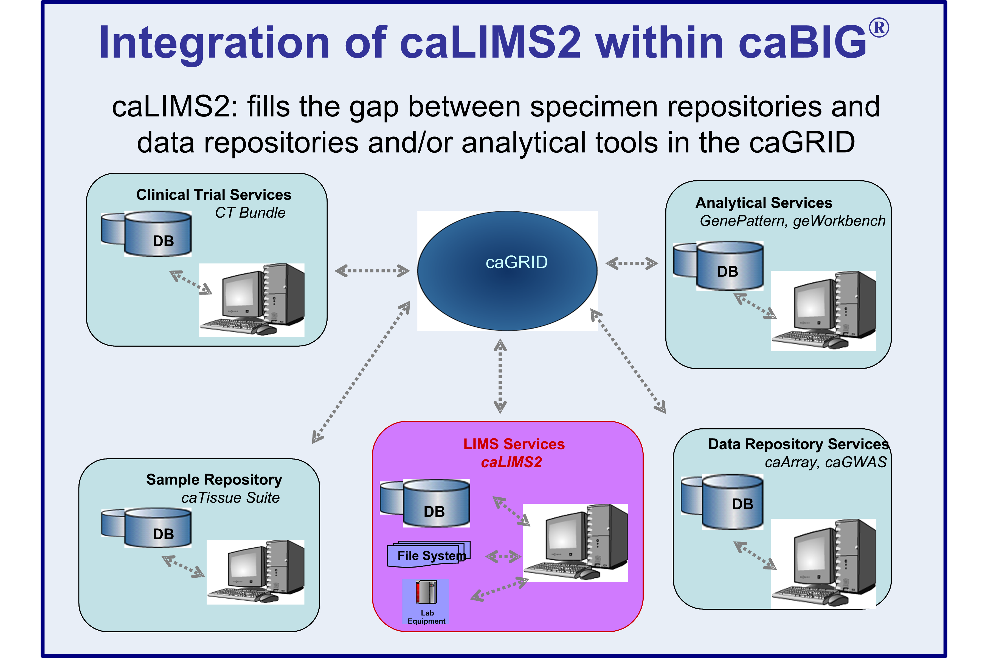
Figure 1: caLIMS2 fills the gap between tissue repositories and analytical tools in the caGRID.
Complex experimental designs are now becoming standard in biomedical research. Collaborations, the use of large core facilities, and the many new high throughput technologies – all support the need for a basic caBIG® LIMS that will serve the cancer research community and, ultimately, the cancer patient. Parallel advances in computing and technology provide opportunities for collaboration and discovery within the scientific community and across traditional boundaries to reach both clinicians and patients. The caBIG® insistence on open source development provides the community with the greatest opportunity to gain access to the tools they greatly need to execute their missions.
The caLMS2 will be initially developed with 4 main core modules: administration, inventory, workflow, and reports (see Fig. 2). There will also be compatibility with standards and guidelines as required by the stakeholder community (CLIA, HIPAA, 21CFR11, HL7v3, etc.). However, the ability to add new standards that are currently being developed to facilitate data exchange and analysis across domains is included in the caLIMS2 model.
The caLIMS2 v1.0 adaptive workflow engine will enable users to easily create new and/or modify existing laboratory ‘template’ workflows to fit the specific needs of their laboratories; these workflows can be shared with other caLIMS2 instances. The generic Experiment model for caLIMS2 will become a touch point of integration with many caBIG® applications. The initial core caLIMS2 application will support the generic molecular biology domain; the flexible design enables caLIMS2 to be customized for specific domains, such as nanoparticle characterizations, model organism research, or proteomics, by the integration with existing caBIG® applications or the addition of new modules.
Designed from the onset according to caBIG® principles, the initial version of caLIMS2 will integrate with caTissue and caArray. This integration will fulfill previously identified caBIG® Life Sciences use cases to link Specimens with Experiment results in caArray. From the caLIMS2 application, a user will be able to search caTissue for specimens of interest, import metadata about these samples into caLIMS2, and request the samples from a biobank. For specimens registered in caTissue that were processed in a lab using caLIMS2, caTissue users will be able to query caLIMS2 to obtain workflow information such as details of the method used for tissue preparation and fixation. A caLIMS2 user will be able to directly submit data files and associated metadata to the caArray data repository. Conversely, a caArray user will be able to query caLIMS2 for specific experimental details, such as microarray lot numbers or equipment settings and software parameters, related to an Experiment. See Figure 5 and more details under Product Perspective section 4.1.
A number of additional data management services and analytical tools or services that may be connected to caLIMS2 are already available - including caBIO, caGWAS, NCIA and multiple ICR analysis tools/services – geWorkbench, GenePattern, CGWB, VISDA, RProteomics, and Bioconductor - that provide a variety of storage, analysis, visualization and annotation functions for experimental data.
The primary goal of caLIMS2 is to further translational cancer research through the organization of laboratory workflow, tracking of specimens, acquisition of laboratory data and metadata, and the appropriate sharing and dissemination of the data to support subsequent multiple analyses. The core functions of the caLIMS2 will support both simple and complex laboratory methods, including those for genomics (expression, SNP, methylation, RNAi, CHip-chip) and proteomics (mass spec, 2D gels). The core functions identified by the user community for the caLIMS2 are included in Table 1.

Table 1. caLIMS2 Core Functions
caLIMS2 Core Functions | caLIMS2 Core Function Expanded
Primary Core LIMS Requirements | - Sample Management  - Adaptive Workflow  - Reporting  - Instrument Integration  - Software management  - Administration  - Fine-grained security (via NCI CBIIT Common Security Module)  - One point Configuration and easy Installation scripts/procedure  - Inventory Management  - Document Management  - Defined Meta Data Extensions
General System Requirements | - Web-based  - Operating system independent  - Programming language independent  - Data source independent
Additional LIMS Requirements | - configurable data file storage (file system/database)  - archiving  - mark as deleted

This need for secure, logical and expedient approaches to tracking, storing, querying, retrieving and reporting of experimental data has increased over the last several years. A significant challenge for this project is to prioritize the core caLIMS2 functionalities which will support meaningful analysis for current biomedical research. caLIMS2 will utilize the support of the user community and their ability to help design a core LIMS which will, in turn, help cancer and biomedical research communities (any disease research community) to minimize variables and maximize the likelihood of arriving at meaningful correlates of the traits of interest.
The desire to create an extensible LIMS that is non-platform-specific and potentially customizable is a central concept that will influence the design of caLIMS2. caLIMS2 will be built with an open architecture to allow for future enhancements, particularly with regard to interfacing with additional analysis tools, to query across platforms, and to exploit web services and/or databases from other components of caBIG® when available and appropriate.

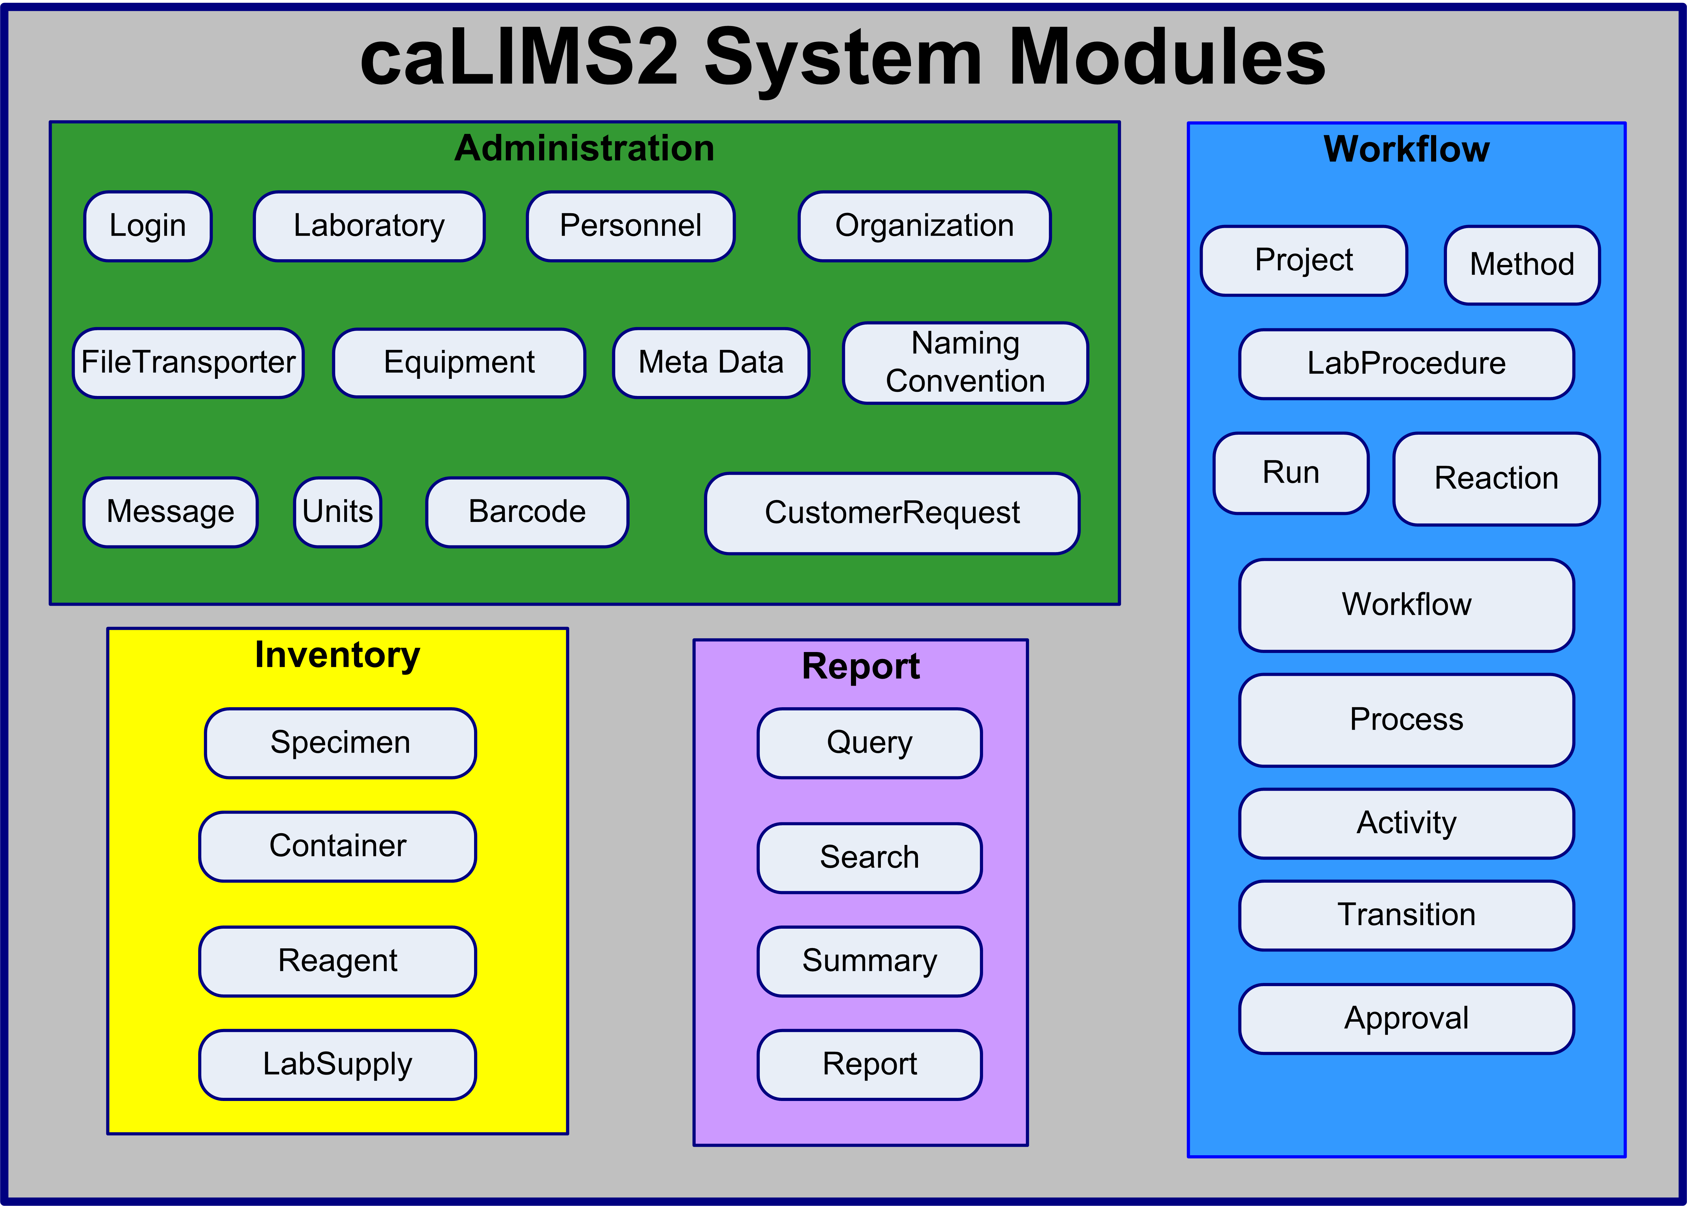
Figure 2: Basic caLIMS2 Design with the 4 main modules and key components.

Problem Statement
The problem of | - The need to securely track and report experimental data and metadata  - The lack of an appropriate basic LIMS that is interoperable with caBIG® tools  - The lack of an open source LIMS specific for biomedical research which can customized for specific domains  - The expense of purchasing, installing, customizing and supporting a commercial off–the-shelf (COT) LIMS
Affects | - The biomedical research community, the Life Science community as a whole, clinicians, and, ultimately their patient’s access to the highest quality care
The impact of which is | - A lack of continuity of data and metadata from clinical specimens to repositories to primary laboratory data to analyses of the data that limit the ability to share and benefit from others in the community who are generating useful clinical and experimental data and results,
A successful solution would be | - A caBIG® compliant LIMS that permits the biomedical research community to track, document, aggregate, and share laboratory and analytical data and metadata tied to meaningful sample annotations, regardless of the platform used to generate the data and metadata.

Product Position Statement
For | - The NCI and its affiliated institutions
Who | - Need to track, capture, generate, report, and securely share data as part of biomedical research and clinical trials in an integrative, interoperable manner
caLIMS2 | - Is an open-source, user-driven, role-based, web and programmatically accessible, service oriented, laboratory information management system that will guide the workflow and annotation of laboratory data and metadata in a manner compatible with caBIG® objectives and goals
That | - provides the data for caBIG® analytical services  - provides browser-based and programmatic access to the data stored locally;  - enables mechanisms for accessing all local installation data over the caGrid;  - provides interoperability with a wide set of data repositories and management systems available over the caGrid;  - supports follows caBIG® standards and guidelines;  - promotes compatibility with other established guidelines such as MAGE/MIAME, HL7v3, CLIA, HIPAA, 21 CFR part 11
Unlike | - caLIMS/lpgLIMS 1.3 (non-caBIG® compatible)  - caNanoLab (data portal)  - caProtLIMS (only supports 2D-gel proteomics)  - And a variety of commercial proprietary and open-source solutions from vendors and service providers
Our product | - Will be completely open source (web application server and database) and funded by the NCI with the intent to continue its open-source evolution  - Will support the natural workflow required by the Life Sciences community  - Will be caGrid-Enabled  - Will be caBIG® compliant

Stakeholder and User Descriptions

Market Demographics
The overall potential market for caLIMS2 is huge. Users of caBIG® products include more than 50 Cancer Centers and a significant number of collaborators worldwide. caLIMS2 can be implemented for both clinical and basic research laboratories and can accommodate any size laboratory – from the smallest lab to a core facility of considerable size. With today’s complex experimental designs and collaborations, more and more researchers are presently turning to a LIMS to manage workflow, ensure good data quality control (QC) and monitor day to day activities. Two methods for accessing caLIMS2 will be established. The first will be to download the application packaged with necessary external components to install locally. The second will be to use a centralized portal hosted by the NCI CBIIT.
The market for caLIMS2 will extend to centers, academic institutes and any clinical research laboratories actively using or considering the use of current caBIG® tools such as the caTissue Suite, caBIG® data repositories or management services (e.g. caArray, caGWAS, caNanoLab) and caBIG® data analysis tools or services (e.g. caWorkbench, GenePattern). In addition, caLIMS2 will be customizable to support public health laboratories, studies using model organisms, and projects for biomedical research on major diseases other than cancer.

Stakeholder Summary

External Stakeholders
These stakeholder types represent the breadth of the target audience that lie outside the core development team for the caLIMS2 application. At least one individual will be named as a representative for each Stakeholder type, though there is no restriction on the number of representatives or the ability for one individual to represent more than one stakeholder. In addition, not all stakeholders are end-users of the application.
Table 2. External Stakeholders
Type | Description | Responsibilities | Representative
NCI CBIIT Adopter | A user or group of users who will adopt the NCI CBIIT version of caLIMS2 but who don’t plan to use local installations of caLIMS2. | Requirements Specifier (excluding environment)  Contributes to feature prioritization  Potential Alpha Tester  Beta Tester | TMEN - Clint Malone (NCI/CBIIT)
NCI Early Adopter | A general term covering user groups who will install at least one version of caLIMS2 | Requirements Specifier (including environment)  Contributes to feature prioritization  Potential Alpha Tester  Beta Tester | NCI/LPG –  Robert Clifford  Jenny Kelley  Daoud Meerzaman
Early Adopter | A general term covering user groups who have will install at least one version of caLIMS2 | Requirements Specifier (including environment)  Contributes to feature prioritization  Potential Alpha Tester  Beta Tester | Arizona University – AZ Research Lab – Nirav Merchant  Dave Thompson
Early Adopter | A general term covering user groups who have will install at least one version of caLIMS2 | Requirements Specifier (including environment)  Contributes to feature prioritization  Potential Alpha Tester  Beta Tester | Dana-Farber Cancer Institute  Jomol Mathew  Erica Jones
Early Adopter | A general term covering user groups who have will install at least one version of caLIMS2 | Requirements Specifier (including environment)  Contributes to feature prioritization  Potential Alpha Tester  Beta Tester | IUPUI  Ganesh Shankar
Code Contributor | Anyone who has or plans to provide complete modules, enhancements or fixes to any of the underlying code of caLIMS2 | Requirements Specifier  API Reviewer  Follower of practices and procedures for code contribution | Abigail Ames (JAX)  Scott Hunike-Smith (UT Austin)  Erica Jones (DFCI)  Ganesh Shankar (IUPUI)  Dave Thompson (ARL)  Clint Malone (CBIIT)  Horatio Charro (CBIIT)
Desired Adopter | An individual or group of users who is targeted for adoption but for many reasons may not choose to adopt caLIMS2 at the present time. | Requirements Specifier  May contribute to feature prioritization  Alpha/beta tester? | - Anne Monks (STB/SAIC Fred)  - Additional Cancer Center Community (e.g., Duke, Purdue, UNC, Masters, APHL/MN PHL, MAYO/MSI, UPenn)  - The Jackson Laboratory  - Members of CBIIT LIMS Consortium
caGrid Team | The underlying service oriented infrastructure that supports caBIG® | Expose and maintain service definitions | TBD
caCORE Team | Cancer Common Ontologic Representation Environment; open-source software that helps to streamline informatics development throughout the cancer community | Validate Common Data Elements (caDSR)  Validate Controlled Vocabulary (EVS)  Validate UML supporting a Model Driven Approach | TBD
CBIIT Systems Support Team | The IT team that supports local installations of caLIMS2 for our end user community | Contribute to Environment Requirements  Support Installations and Updates | TBD

Internal Stakeholders
These stakeholders are, at a minimum, focused on the evolution of caLIMS2. For the purposes of this document and the caLIMS2 project, their perspective is squarely on caLIMS2 and its contribution to the success of caBIG®’s collective stakeholders.
Table 3. Internal Stakeholders
Name | Description | Responsibilities | Representative
caBIG® Program Leader | The visionary across the caBIG® enterprise. | Provide strategic input and validate the vision and scope of caLIMS2. | - Ken Buetow
CBIIT Chief Operations Officer | Head of operations for CBIIT. | Provide input into the position of caArray in the broader scope of all CBIIT products. | - George Komatsoulis
caLIMS2 Product Manager | Ensuring over time that caLIMS2 comfortably meets the needs of all stakeholders by continually monitoring and modifying the elements of how it is marketed and forecasting what caLIMS2 needs to provide to be successful. | Provide input into the direction for the evolution of the software leading the CCB.  Monitor development, marketing and outreach  Ensures that there will be a market demand for the product’s features | - Juli Klemm
caLIMS2 Engineering Manager | Responsible for the ultimate success of the application both as an independent service and under the umbrella of caBIG® | Monitors the project’s progress Ensures that the system will be maintainable  Monitors all facets of the project’s progress  Approves resources and funding | - Anand Basu
caLIMS2 Independent Quality Assurance (IQA) | Provides independent validation and verification that expected functional and non-functional requirements are met | Requirements Reviewer  Manages Test Plans, Test Cases, and provides Results  Validates and Promotes Deliveries across Tiers post Development | - Cliff Wong  - TBD
NCI CBIIT Systems Team | Provides system resources for development, test, stage and production | Contributes to Environment Requirements  Supports all Environment Setup and Maintenance  Provides Level 1 Help Desk Support | - TBD
NCI CBIIT Documentation | Provides end-user and system documentation | Requirements Reviewer  Creates User Help, Instructions and Installation Guides | - Jill Hadfield  - Rachel Shortt  - Jenny Kelley
caLIMS2 Development Team | Responsible for the delivery of the software meeting the requirements. | Elicits and Documents Requirements  Analyzes and Designs the Software  Implements the Software  Collaborates with all stakeholders to support the evolution of the software  Supports CCB  Responds to Level 2 and 3 Support Requests | LPG  - Bob Clifford  - Jenny Kelley  - Cu Nguyen  - Henry Zhang  Moxie Informatics  - Sashi Thangaraj  - Michael Visee  Michael Connolly
Table 4. User Depictions
Name | Description | Responsibilities | Stakeholder | Representative
Principal Investigator | Designers of laboratory experiments that will use caLIMS2 | Overall execution and quality of the science | NCI CBIIT Adopter, Local Installer, Desired Adopter | Ken Buetow
Research Scientist | A support position in the Principal Investigator’s department | Data entry and submission of projects for their PI | NCI CBIIT Adopter, Local Installer, Desired Adopter | TBD
Lab Manager | Responsible for coordination and often reporting of the lab’s day to day work. | Organizing and managing a lab’s production, sample storage, and meeting the needs of the lab’s researchers | NCI CBIIT Adopter, Local Installer, Desired Adopter | Daoud Meerzaman
Lab Researcher | Performs most of the lab’s day to day scientific work with regard to preparing of samples, running chips and checking quality. | Sample receipt and storage  Management of experiment runs  Raw Data Production  Quality Control | NCI CBIIT Adopter, Local Installer, Desired Adopter | TBD
Biostatistician | Performs analysis of the data derived from experiments | Quality Control of Data  Analysis of Raw Data  Creation and Management of Algorithms and Scripts  Reporting of Results | NCI CBIIT Adopter, Local Installer, Desired Adopter | Ying Hu  Henry Zhang
Quality Control Manager | Reviews their own or their labs data entry and may change and contribute data terms to increase quality of submissions | Annotation Quality Control | NCI CBIIT Adopter, Local Installer, Desired Adopter | Daoud Meerzaman  Bob Clifford  Jenny Kelley
User | Views the public projects on the NCI CBIIT instance of caLIMS2 | No responsibility | N/A – all stakeholders will dictate what is or isn’t available to an anonymous user | All
Collaborator | Member of a group working toward a common goal or Project | Enter, review, approve data per permissions | NCI CBIIT Adopter, Local Installer, Desired Adopter | Anne Monks
External System | Programmatically integrates with or interrogates the NCI CBIIT and/or a local instance of caLIMS2 | Use API to request and receive data | caBIG®  caTissue, caArray,  caBIO, caGWAS,  BRD  Analysis Tools | Juli Klemm  Ian Fore  Anand Basu  Andrew Breychak

User Summary
The laboratory community that caLIMS2 will serve has a variety of organizational approaches to laboratories and the scientists they serve. Our investigation into those structures has produced the following generic model that represents most of the institutional pattern for how people work within a laboratory setting. The model will be represented by the type of software roles we create, the allowances for collaboration within and across institutions, and the granularity of permissions when exposing data and experiments as public (see Table 5). A User can be authenticated against the caLIMS2 installation and can interact with the system. The User roles designated provide a basis for implementation in an academic, government research, public health, or core facility laboratory. The basic core version of caLIMS2 can be extended to accommodate additional user roles as needed for future versions or customized for Domain specific installations. The core set of Actors is listed below in Table 5.

Actor | Type | Description | Optional*
User | Generic caLIMS2 Actors | Base User from which all caLIMS2 actors are derived. User is a generic term used in the caLIMS2 documentation to denote an actor with appropriate privilege to perform the activity described in a Use Case. | required
SuperUser | Lab Actors | User who has access to all functions and can serve as the domain expert for caLIMS2 users. User who has access to all projects, all laboratory information, and all activities in the caLIMS2 system. This User may be assigned the SuperAdmin role in UPT. | required
GroupDirector | Lab Actors | User who is the Leader/supervisor of a set of labs; for example - an NCI Laboratory Chief, a university Department Head, a Scientific Director, or a Clinical Trials Program Manager. | optional
PI | Lab Actors | Principle Investigator/Head of a Laboratory - Individual who runs a single lab or core facility. A Principal Investigator is responsible for the design of scientific/technical conduct, administrative conduct, final approval and reporting of research projects | required
LabManager | Lab Actors | Lab Manager/Core Director responsible for organization, training, and running of Laboratory. Individual who is responsible for the overall development and implementation of laboratory policies and projects. The Lab Manager may perform experiments and/or supervise/approve others to run experiments. | required
Bioinformatician | Lab Actors | User who provides statistical and bioinformatics support for a laboratory. A Bioinformatician is generally supervised by a Staff Scientist or PI. | required
Researcher | Lab Actors | Individual who is responsible for sample preparation, running experiments/assays, recording results and observations. A Researcher is generally supervised by a Lab Manager, Staff Scientist, or PI. | required
StaffScientist | Lab Actors | Individual who designs and performs experiments. A Staff Scientist is generally supervised by a Principal Investigator. A Staff Scientist may supervise Researchers, Graduate Students, Postdocs, and Students. | optional
Postdoc | Lab Actors | Individual with a doctoral degree who designs and performs experiments. A Postdoc is generally supervised by a Principal Investigator. A Postdoc may supervise Graduate Students and Students. | optional
Student | Lab Actors | Undergraduate or High School student who performs experiments. A Student may be supervised by a Principal Investigator, LabManager, Staff Scientist, Postdoc or Graduate Student. | optional
GradStudent | Lab Actors | Individual working toward a doctoral degree who designs and performs experiments. A Graduate Student is usually supervised by a Principal Investigator and/or a Staff Scientist. | optional
Collaborator | External Lab Actors | Actor who participates in a Project and may have privileges in the System. This Individual may supply samples, perform specific experiments of relevance to a Project, record results, and/or draft reports. | required
Customer | External Lab Actors | Individual who places customer requests, provides samples, reviews data, and receives reports on a fee for service basis. | required
Administrator | External Lab Actors | caLIMS2 system administrator responsible for the System and database. | required
Guest | External Lab Actors | Actor given view only privileges within the System. | required
Safety Officer | Lab Support Actors | Person responsible for maintaining the Lab Safety regulations and documentation. | optional
InventoryManager | Lab Support Actors | Actor responsible for maintaining and ordering the Laboratory supplies and reagents; this person may also have privileges to maintain and aliquot samples. | optional
BusinessManager | Lab Support Actors | Individual who is responsible for managing interactions with customers (for example: accounts and billing). | optional
CSM/UPT | External SubSytem Actors | Common Security Module (CSM) and User Provisioning Tool (UPT): Application/utility to provide fine-grained security for the System. | required
AnalysisTool | External SubSytem Actors | Data analysis application that interacts with the System through an API or adapter module. | required
caBIG Application | External SubSytem Actors | An Application or Data source that is accessed through an API (e.g. EVS, caArray, caGWAS, CGWB, GenePattern, VISDA, RProteomics, caWorkbench) | required
Equipment | External SubSytem Actors | Laboratory equipment that interacts with the System through an API or adapter module. | required
CLM | External SubSytem Actors | NCI CBIIT Common Logging Module | required
*Optional actors that are not part of a default caLIMS2 installation may be added per customer need.

Key User Requirements
The following table describes high level needs elicited from the stakeholder and user representatives above and prioritized by the Development Team with their assistance. These requirements frame the context for deriving features.

Table 6. Stakeholder and User Requirements
Need | Priority | Details
General System Requirements | Critical | - Adherence to established caBIG® standards and guidelines  - Registered CDEs in the caDSR  - Use of common terminology from the EVS  - Well described information models and APIs  - Open Source and Open Architecture  - Web-Deployable Application  - Leverage NCI CBIIT usability standards  - Audit Trail (CLM)  - Record all authorized system events  - Data Archival/Retrieval  - Application Support  - Performance/Scalability  - Documentation/ Training
Configuration and Installation | Critical | - Allow one step configuration to install the LIMS application  - Provide user friendly install tool  - Provide platform independent Installation package of the application
Exception and Error handling | Critical | - Allow Generic and Custom error messages to the user depending on the scenario  - Generic message for an incomplete form  - Specific message if an instrument is offline
Logging | Critical | - Generic and specific logging module for the application that enables the administrator to trace and spot issues in the application  - Generic application log  - Specific module level log
Administration and Security | Critical | - Support for user authentication (user, password) and authorization (roles, privileges) via the NCI CBIIT Common Security Module (CSM)  - Support for user management via NCI CBIIT User Provisioning Tool (UPT)  - Create/manage users  - Create user skills  - Create user roles  - Assign user roles  - Assign user skills  - Support for laboratory management  - Assign users to laboratories  - Support for group management  - Create groups of laboratories and/or users  - Support ownership of LIMS objects (via CSM)  - Each object is owned by a user  - Objects can be shared/published to users or groups of users
Sample Management | Critical | - Allow authorized users to accession samples  - Allow authorized users to create sample containers (e.g. plates, tubes) and associate samples with containers  - Allow users to upload samples in batch via standard file format  - Allow authorized users to create aliquots of samples  - Allow authorized users to combine samples and/or sample containers  - Allow authorized users to bar code samples, aliquots, and sample containers  - Allow authorized users to create/obtain unique bar code IDs for labeling  - Allow authorized users to track samples and view sample histories  - Allow authorized users to specify additional sample meta data not included in the default set
Inventory Management | Critical | - Allow authorized users to check-in and check-out samples and laboratory supplies to/from storage devices  - Provide support for inventory receipt, validation, and distribution (shipping)  - Allow authorized users to manage storage devices (freezers)  - Allow authorized users to manage laboratory supplies (reagents, primers, test sets)  - Allow authorized users to track inventory via bar codes  - Allow authorized users to search for inventory  - Allow authorized users to monitor quantity of utilized samples and supplies  - Allow authorized users to monitor the capacity of storage devices
Adaptive Workflow Requirements | Critical | - Allow authorized users to visually define laboratory workflow(s) including workflow tasks (run assay, run instrument)  - Allow authorized users to visually define result entry screens  - Allow authorized users to assign workflow tasks  - Allow authorized users to execute assigned workflow tasks  - Allow authorized users to create multiple runs of assigned workflow tasks (assay processing), when applicable  - Allow authorized users to define read-only workflow templates that can be copied and modified for re-use  - Allow authorized users to link multiple workflows to create complex laboratory procedures
Reporting | Critical | - Allow authorized users to view standard reports and graphs  - Allow authorized users to create custom reports and graphs  - Allow authorized users to download reports in standard file formats such as spreadsheet (MS Excel format)  - Allow authorized users to print reports and graphs
Software Management | High | - Provide customizable adapter modules to support bi-directional laboratory instrument integration  - Support the generation of laboratory instrument input (e.g. sample lists, instrument configuration file)  - Support the capture of laboratory instrument binary output  - Support the usage of laboratory instruments within the laboratory workflow  - Support the analysis of laboratory instrument output  - Support data analysis via third-party analysis software  - Support statistical analysis based on multiple instrument outputs
Data File Management | High | - Allow authorized users to upload data files (files, images)  - Allow authorized users to associate data files with workflow components (experiments, assays)  - Allow authorized users to annotate uploaded data files via standard meta data tags  - Allow authorized users to search for data files based on associated meta data  - Provide automatic file version control  - Allow authorized users to export data files
Other LIMS Requirements | Medium | - Quality Assurance/Quality Control  - Bar code samples, aliquots, and sample containers; barcode equipment and supplies  - Equipment calibration, lot management (reagent expiration), User skills/certifications, CLIA forms/reports  - Analysis Tool Integration Module  - Electronic Signatures (FDA 21 CFR Part 11)  - Interfaces to Third Party Systems  - caArray (caBIG® gene expression repository)  - caTissue (caBIG® tissue bank system)  - caIntegrator (caBIG® informatics bridge between academic research labs, clinical trials labs, hospitals and other research centers)  - CLIA Compliance  - Waste disposal logging  - Material Safety Sheets  - Support for HL7 v3 Messaging (Laboratory Message)  - User/Laboratory Preferences  - Ordering Module  - Customer Request Processing  - Billing

Alternatives and Competition
In addition to commercial-off-the-shelf (COTS) LIMS products, there are several applications in CBIIT or caBIG® development that may serve a similar, if not the same, audience. Table 7 outlines how caLIMS2 will be positioned relative to its non-commercial alternate applications.
Table 7. Alternate LIMS-like Solutions
Alternative | Why caLIMS2 offers more | How we can benefit from that they do well
protLIMS - a Laboratory Information Management System dedicated to studies in the realm of proteomics. | protLIMS only provides support for proteomics 2D gel experiments  not caGrid Enabled  compatibility not determined | Leverage the proteomics OM to extend the caLIMS2 model
caELMIR - provide the pre-clinical scientist with a data management system to record experimental data. | caELMIR is only a data recording application with no workflow capabilities  not caGrid Enabled  compatibility not determined | Leverage caELMIR OM for integrating model organism data to caLIMS2.
lpgLIMS 1.3 - an enhanced version of the caLIMS 1.2 | Built on old technology  Does not have fine grained security with CSM  No plans to upgrade or extend  not caGrid Enabled  compatibility not determined | Leverage LIMS development team experience and expertise while updating resources and technology and use of OM design for caLIMS2.
caLIMS-LMT -extensions to provide custom functionality to the NCI LMT laboratory | Built on old caLIMS technology platforms  Extensions custom to the NCI LMT laboratory  Does not include workflow  Does not have fine grained security with CSM  not caGrid Enabled  compatibility not determined | Leverage experience with customer requests, billing information, and barcoding to incorporate into the basic core caLIMS2 design.
caNanoLab - cancer Nanotechnology Laboratory Analysis Bench (caNanoLab) | Design and development is dedicated to the needs of the nanotechnology laboratories.  Does not include workflow (is currently serving as a database/repository)  caGrid Enabled  compatibility not determined | Leverage the nano-OM, vocabulary, standards, and other components developed by the Nanotechnology community to extend the basic caLIMS2 for use with nanoparticle specimens and experiments.
Multiple COTS LIMS products (e.g. StarLIMS, LabVantage – Sapphire, SQL*LiMS, LabSoft, LabWare, CoreLIMS, etc.) | High purchase cost  High installation and maintenance/upgrade costs  High cost of customization  Loss of flexibility in customization  Do not fill requirement for Open Source | Leverage User Interface experience and presentation  Learn from examples what Users need and want for a UI  Learn how to model product packaging, information materials, and training information

Product Overview
The caLIMS2 application falls under the Integrative Cancer Research Workspace (ICR) in caBIG®. The caLIMS2 application will be designed with a core system which can be extended and customized. This product will be able to bridge the gap between specimen repositories or management services and data management systems. The main functions of the application are to manage laboratory workflow and data and to prepare laboratory generated data and metadata for submission to data repositories or management systems. The basic design will be adaptable to core facilities and both basic and clinical research laboratories. In addition, caLIMS2 will be able to support public health laboratory requirements with minor customizations.

Product Perspective
The conceptual positioning of the caLIMS2 project in the Integrative Cancer Research (ICR) workspace is shown in Fig.3. Specimens and their metadata will enter the caLIMS2 from a Specimen management system, e.g. (caTissue or similar sample sources) and data generated in the laboratory, along with the appropriate metadata, would be available for direct submission to various data management systems or repositories (e.g. caArray) or analyzed with available tools within the caLIMS2 and the results will be made available to data management and/or integration systems or through caLIMS2, as appropriate.
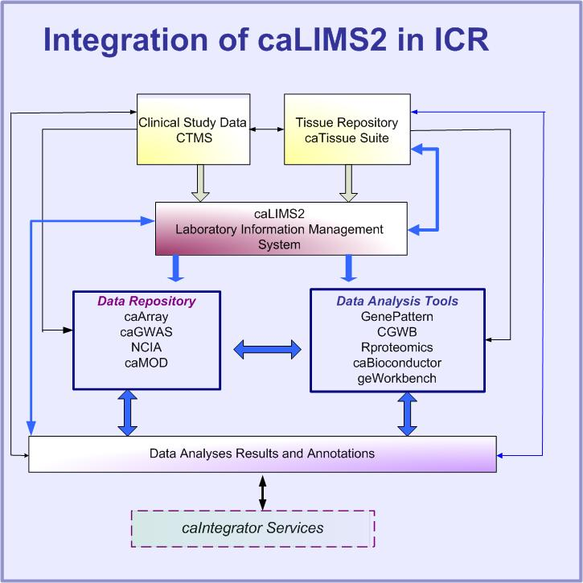
Figure 3: Conceptual positioning of caLIMS2 in integrative cancer research

A sample laboratory workflow which can be tracked in caLIMS2 is shown in Fig. 4. The rectangles represent experiment laboratory procedures that would be tracked by the caLIMS2. Permissions and approvals can be set for appropriate groups (LabManager, LabResearcher, PI) and workflows are indicated by arrows and decision points (diamonds).

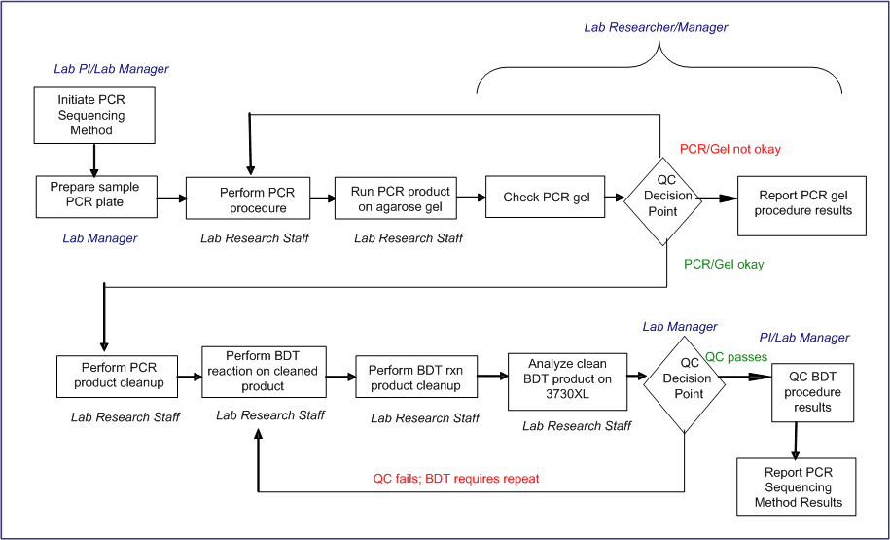
Figure 4: Sample laboratory workflow in caLIMS2

One important feature of caLIMS2 takes advantage of having the architectural design to be according to caBIG® principles from the project onset. The initial version of caLIMS2 will integrate with caTissue and caArray. This integration will fulfill previously identified caBIG® Life Sciences use cases to link Specimens with Experiment results in caArray. The specific use case for caLIMS2 integration with specimen management systems (caTissue) and array data management system (caArray) is illustrated below in Figure 5. Applications are shown along the left axis and the caLIMS2 Actors are shown across the top axis. The workflow (indicated by the lines and arrows) proceeds from left to right. From the caLIMS2 application, a user will be able to search caTissue for specimens of interest, import metadata about these samples into caLIMS2, and request the samples from the biobank. For specimens registered in caTissue that were processed in a laboratory using caLIMS2, caTissue users will be able to query caLIMS2 to obtain workflow information such as details of the method used for tissue preparation and fixation. A caLIMS2 user will be able to directly submit data files and associated metadata to a data management system (caArray). Conversely, a caArray user will be able to query caLIMS2 for specific experimental details, such as microarray lot numbers or equipment settings and software parameters, related to an Experiment in caArray that was captured in caLIMS2.
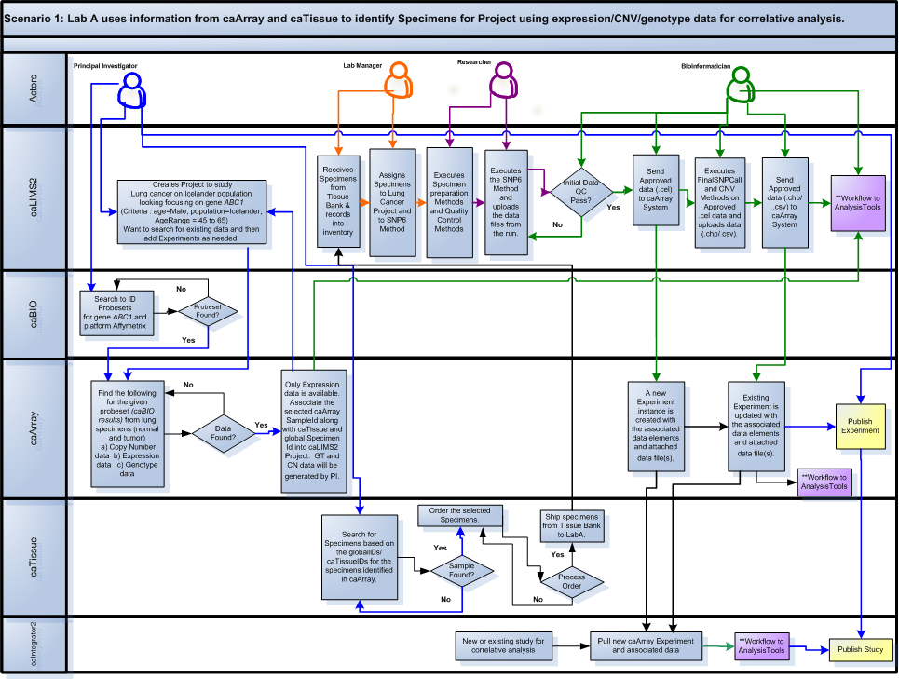
Figure 5: caLIMS2 integration scenario example diagram (details in text above).

Assumptions and Dependencies

Only terms from Managed Ontology systems will be available
Whenever a controlled vocabulary is appropriate for user-based entry, the system will allow for the use of terms from the NCI Enterprise Vocabulary Service. If terms are not found, then the data can be used but, in order to remain caBIG® compliant, the new data terms will need to be placed in the queue for submission to the EVS.

Cost and Pricing
There is no cost to the user community in terms of purchasing a license for caLIMS2. However, there is a cost in terms of time and energy spent in supporting the product and its evolution, the server(s) and potentially the use of commercial tools such as Oracle if an open source database –such as MySQL is not used. Barcode implementation would entail cost of the appropriate printers and commercial barcode label design products if an open source design product is not chosen. If an organization desires to enhance the model, an UML Model tool would need to be purchased.

Licensing and Installation
Following the principles of caBIG® of Federation, Open-Development, Open-Access, and Open Source, the source code for caLIMS2 is available to view, alter, and redistribute however a consumer chooses to do so.

NCI CBIIT/caBIG® license agreement
The license agreement is available from the NCI CBIIT download center (http://ncicb.nci.nih.gov/download/caarraylicenseagreement.jsp).

Individual licenses for associated downloaded applications and tools
User sites may need individual licenses for some associated applications and tools which will be distributed as downloads by users.

User sites responsibility if elect to deploy with additional licensed products
If User sites elect to deploy with additional licensed products specific to their installation, they will be responsible for any associated licenses and agreements.

Product Features
The goal of the caLIMS2 Consortium is to produce an open access, near commercial grade Laboratory Information Management System (LIMS) that is compliant with current established caBIG® standards and guidelines. The caLIMS2 will allow: a) management of laboratory personnel, equipment, inventory, samples and documents; b) adaptive workflow; c) management of laboratory equipment and software; and d) generation of standard and custom reports. The caBIG® Common Security Model (CSM) will be leveraged to provide fine-grained security and the Common Logging Model (CLM) will provide audit function. A single instance of caLIMS2 will be capable of hosting multiple laboratories, collaborations, and customers. The Use Cases are discussed in detail in the caLIMS2 project Use Case documents found on the project GForge site (http://gforge.nci.nih.gov/projects/calims2/).
caLIMS2 will be designed to allow easy customization and expansion. Users will be able to tailor this LIMS to their specific laboratory experiments, methods, assays, protocols and workflows. The application will possess well-defined APIs to facilitate the integration of new equipment, analytical tools and data sources.
The caLIMS2 application is divided into four modules:
- Administration
- Inventory
- Workflow
- Report

With priority set by the Development Team and input from NCI CBIIT LIMS Consortium members, the following features represent the functional aspects of the caLIMS2 (Table 8). All features are not of equal priority, particularly when having to deal with constraints such as time, budget and level of effort. Ranking requirements by their relative benefit to the end user opens a dialogue with customers, analysts and members of the development team (more details are included in Appendix I). This feature set and the relative priority will be used to manage scope and determining development priority.
In addition to the core system with the four modules, the caLIMS2 project will also create two Enterprise level services related to the caLIMS2 application that can be used by other applications and services in the caBIG® community. These will be an Experiment Method Service, which will maintain laboratory experiment workflow templates which can easily be exported to share with other instances of caLIMS2, and an Equipment Service, which will maintain laboratory equipment type templates which can be exported to any instance of caLIMS2 and used to define specific instances of equipment for the caLIMS2 application. Both services will allow easy programmatic sharing of templates for instances of caLIMS2 or other services in the caBIG® community, and, for both of these services, it is expected that there will be additions made from the caLIMS2 Development Working Group (DWG) and the caLIMS2 user community. Curation of the services content will be done by the caLIMS2 DWG subject matter experts (SMEs) and project leads.
The Experiment Service will include:
- Registration of Experiment (Method) caLIMS2 Workflow Templates
- Definition of Method and Procedure(s)
- Definition of expected Input(s), Parameter(s), and Output(s)
- Reference to associated Equipment service
- Contact person(s)
- Allow search (QBE)
The Equipment Service will include:
- Registration of equipment type template – manufacturer, model, associated software (operating, firmware, collection, data management/analysis)
- Definition of user defined input parameters
- Functional platforms supported and their expected Input(s), Output(s), and Parameters
- Available adapters/interfaces
- Contact person(s)
- Allow search (QBE)
More details of these services will become available on the caLIMS2 wiki site.

Table 8. caLIMS2 Features by Module
Module | Use Cases
Administration | - Laboratory Management  - Personnel Management  - Equipment/Software Management  - Units Management  - FileTransporter Management  - Message Management  - Status Management  - Naming Convention Management  - MetaData Management  - Customer Request Management  - Barcoding Management  - Laboratory Standards Management  - Billing Management
Inventory | - Container Management  - Sample Management  - Reagent Management  - Supply Management  - FillPattern Management  - Order Management
Workflow | - Workflow Management  - Process Management  - Activity Management  - Transition Management  - Project Management  - Method/Experiment (Assay) Management  - Procedure Management  - Run Management  - Reaction Management  - Approval Management
Reports | - Report Management  - Query Management  - Summary Management  - Search Management

Engineering Goals

Leverage caBIG® Architectural Components

caBIG® interoperability – Full compliance with caGrid technology stack.

Using caBIG® tools – Plan to use caCORE SDK, CSM, UPT and CLM.

Integration with caBIG® services – Plan to integrate with caBIG® services such as caTissue, caArray, etc.

Adaptive Workflow

Implementing Adaptive Workflow Components
caLIMS2 adaptive workflow module will provide the following capabilities:
- Definition of common specialized laboratory activities and the exposition of these activities as web services. (For example: Run a PCR experiment, Run an approval).
- Definition of dynamic processes using the common laboratory activities, other processes and/or external web-services. These dynamic processes must also be exposed as web-services.
- Execution of these dynamic processes with all the functional/non functional nice properties that a mature business process engine can provide like auditing, interoperability, portability, scalability, security.
- Extensibility: The collection of specialized activities available is open-ended. Each extension or new release of the product should easily provide new activities.
- Reuse: The workflow module will be preloaded with standard operating procedures so that users do not need to reinvent the wheel when they implement caLIMS2 in their lab.

Leverage Web2.0 Components

    - Implementing Spring Web Application Architecture
The Web Application will make use of Spring MVC (Model View Controller) Framework, Spring Security (formerly known as Acegi) and Spring JS. This will allow building a rich web application on top of the caBIG® recommended technology stack.
    - Implementing RIA (Rich Internet Application) Technology Components
caLIMS2 user interface will use RIA technology components provided by Spring JS. Spring JS is designed such that an implementation of its API can be built for any of the popular Javascript toolkits. The initial implementation of Spring.js builds on the Dojo toolkit. Dojo has made a commitment to creating a toolkit that allows the development of 508 compliant web applications. The core widget set of dojo, dijit, is fully accessible since the 1.0 release, making Dojo the only fully accessible open source toolkit for Web 2.0 development.

Constraints
Since caLIMS2 is one of several applications made under the caBIG® and CBIIT umbrella, all design constraints such as open source, J2EE, JBoss, etc. must be adhered to implicitly. Additionally, we feel it is important to note the following constraints.

Operating System and Browser Support

Server
caLIMS2 Server can be deployed on Linux/Unix/Mac OS X and Microsoft Windows XP/Vista/7.

Client
caLIMS2 is a web application that can be accessed via the following browsers.
IE version 7.x/8.x
Firefox version 3.x (Linux/Mac/Windows)
Chrome version 4.x (Linux/Mac/Windows)
Safari version 4

Open Source Database Support
In addition to Oracle, caLIMS2 will support open source databases such as MySQL and PostgreSQL.

Required caCORE Components
caLIMS2 will take advantage of the following caCORE components:
CSM – Common Security Module
UPT – User Provisioning Tool
CLM – Common Logging Module
caDSR – Cancer Data Standards Repository
caCORE SDK –Software Development Kit
caAdapter - provides model mapping services in support of caCORE components and facilitates data mapping and transformation among different kinds of data sources including HL7 v2 messages, HL7 v3 messages, and Regulatory Data Sets.

Quality Ranges
[Define the quality ranges for performance, robustness, fault tolerance, usability, and similar characteristics that are not captured in the Feature Set.]
The general caLIMS2 Architecture does not preclude clustering and failover. A detailed listing of non-functional characteristics will be defined at a later date.

Precedence and Priority
Appendix I has a detailed list of features and priorities. The caLIMS2 version 1.0 release plan includes the following mile stones:
Priority 1: Administration module
Priority 2: Inventory module
Priority 3: Workflow module
Priority 4: Report module

Other Product Requirements
[At a high level, list applicable standards, hardware or platform requirements, performance requirements, and environmental requirements.]

Applicable Standards

CLIA

Clinical Laboratory Improvement Amendments (CLIA) of 1988
The United States federal regulatory standards that apply to all clinical laboratory testing performed on humans in the United States, except clinical trials and basic research.

Congress passed the Clinical Laboratory Improvement Amendments (CLIA) in 1988
This established quality standards for all laboratory testing to ensure the accuracy, reliability and timeliness of patient test results regardless of where the test was performed. A laboratory is defined as any facility which performs laboratory testing on specimens derived from humans for the purpose of providing information for the diagnosis, prevention, treatment of disease, or impairment of, or assessment of health.

http://www.fda.gov/CDRH/clia/

HIPAA

National Standards to Protect the Privacy of Personal Health Information
The Health Insurance Portability and Accountability Act (HIPAA) was enacted by the U.S. Congress in 1996. According to the Centers for Medicare and Medicaid Services (CMS) website, Title I of HIPAA protects health insurance coverage for workers and their families when they change or lose their jobs. Title II of HIPAA, known as the Administrative Simplification (AS) provisions, requires the establishment of national standards for electronic health care transactions and national identifiers for providers, health insurance plans, and employers.

The Administration Simplification provisions address security and privacy of health data.
The Administration Simplification provisions also address the security and privacy of health data. The standards are meant to improve the efficiency and effectiveness of the nation's health care system by encouraging the widespread use of electronic data interchange in the US health care system.

http://www.hhs.gov/ocr/hipaa/

21 CFR 11

Title 21 Code of Federal Regulations (21 CFR Part 11) - Electronic Records; Electronic Signatures
Title 21 CFR Part 11of the Code of Federal Regulations deals with the FDA guidelines on electronic records and electronic signatures in the United States. Part 11, as it is commonly called, defines the criteria under which electronic records and electronic signatures are considered to be trustworthy, reliable and equivalent to paper records.

http://www.fda.gov/ora/compliance_ref/part11/

HL7v3

Health Level Seven (HL7), is an all-volunteer, not-for-profit organization involved in development of international healthcare standards.
“HL7” is also used to refer to some of the specific standards created by the organization (i.e. HL7 v2.x, v3.0, HL7 RIM etc.).

The HL7 version 3 standard has the aim to support any and all healthcare workflows.
Development of version 3 started around 1995, resulting in an initial standard publication in 2005. The v3 standard, as opposed to version 2, is based on a formal methodology (the HDF) and object oriented principles.
The HL7 version 3 Clinical Document Architecture allows for a common format for exchanging a patient's medical record between different hospital systems or even different hospitals. This HL7 standard has come to serve as a foundation for the universal electronic medical record.

http://www.hl7.org/

Barcode Standards

The mapping between messages and barcodes is called a symbology. A Barcode Symbology defines the technical details of a barcode.

International barcode quality specification: ISO/IEC 15416 (linear bar codes) and ISO/IEC 15415 (2D barcodes)

Barcode verifiers should comply with the ISO 15426-1 (linear barcode verifier compliance standard) or ISO 15426-2 (2d barcode verifier compliance standard)

http://en.wikipedia.org/wiki/Barcode; http://www.makebarcode.com/specs/speclist.html

caBIG® Compliancy and GUI Guidelines*

Current caBIG® and CBIIT UI guidelines will be implemented

*CBIIT UI guidelines include 508 compliancy

NCICB_UIstandards2004v3.pdf

UCUM - Uniform Code of Units Measurement

The Unified Code for Units of Measure is a code system intended to include all units of measures being contemporarily used in international science, engineering, and business.
The purpose is to facilitate unambiguous electronic communication of quantities together with their units. The focus is on electronic communication, as opposed to communication between humans. A typical application of The Unified Code for Units of Measure are electronic data interchange (EDI) protocols, but there is nothing that prevents it from being used in other types of machine communication.

http://www.regenstrief.org/medinformatics/ucum

Section 508 of the Rehabilitation Act of 1973*

Section 508 requires that when Federal agencies develop, procure, maintain, or use electronic and information technology, Federal employees with disabilities have access to and use of information and data that is comparable to the access and use by Federal employees who are not individuals with disabilities, unless an undue burden would be imposed on the agency.
Section 508 also requires that individuals with disabilities, who are members of the public seeking information or services from a Federal agency, have access to and use of information and data that is comparable to that provided to the public who are not individuals with disabilities, unless an undue burden would be imposed on the agency.

http://www.section508.gov/index.cfm?FuseAction=content&ID=12

Others TBD

System Requirements
[Define any system requirements necessary to support the application. These can include the supported host operating systems and network platforms, configurations, memory, peripherals, and companion software.]
Host Operating System: Microsoft Windows XP/Vista/7, Linux/Unix, Mac OS X.
JVM: Java Version 1.6 and higher.
Network platform: Standard TCP/IP network.
Hardware configuration: Typical configuration Intel Core 2 Duo with 4 Gigabytes RAM.
Hard disk: 250GB memory.
Peripherals: Standard peripherals.
Optional Peripherals: Includes barcode scanner and printer.

Performance Requirements
Non functional requirements will be defined at a later date. These requirements may include load factors, bandwidth or communication capacity, throughput, accuracy, and reliability or response times under a variety of loading conditions.
The design of caLIMS2 will allow deployment on server cluster, providing for high availability, scalability and failover. An example scenario will be provided at a later date.

Environmental Requirements
[Detail environmental requirements as needed. For hardware- based systems, environmental issues can include temperature, shock, humidity, radiation, and so forth. For software applications, environmental factors can include usage conditions, user environment, resource availability, maintenance issues, and error handling and recovery.]
The caLIMS2 user will need a standard terminal with the recommended browser to access the application. No other special condition applies.

Documentation Requirements

User Manuals

caLIMS2 User Manual
Purpose / Target Audience: End-Users/(Administrators)
The User’s Manual includes software authorizations, interface design, administrator’s guide, protocols, workflow, tools, data sources, database(s), data search, data management, integration with component software, internet access, glossary of terms, index, and using the software/data resource in local environments. The formatting and content of the manual will follow caBIG® guidelines and templates.

caLIMS2 Quick Start Guide
Purpose / Target Audience: End-Users/ (Administrators)
The Quick Start Guide includes the basic information required to set up the caLIMS2 and enter a project to begin using the system. There will be references to the complete User’s Manual and the Technical Manual as appropriate.

Installation Guides, Configuration, and Read Me File

caLIMS2 Quick Installation Guide
Purpose / Target Audience: Developer/Administrators
The Quick Installation Guide includes the basic information required to install and deploy the caLIMS2. There will be references to the complete caLIMS2 Technical Guide and the caLIMS2 User’s Guide as appropriate.

caLIMS2 Technical Guide
Purpose / Target Audience: Developers/Administrators
The Technical Guide describes the architecture, systems requirements, installation instructions and testing procedures for validating installation, administration logistics, APIs, and other tools that integrate with the software being developed and their implementation. Recommendations are included for customizing the technical guide for your needs.

caLIMS2 vx ReadMe File
Purpose / Target Audience: Developers/Administrators/End-Users
The ReadMe File lists new features and functionalities and address known issues such as bugs and their status. This file will also list appropriate documentation and websites / Programmers and points of contact.

Online Help

For the GUI Community
Purpose / Target Audience: End-Users/(Administrators)
The Online Help will have the same content as the User’s Manual (includes software authorizations, interface design, administrator’s guide, protocols, workflow, tools, data sources, database(s), data search, data management, integration with component software, internet access, glossary of terms, index, and using the software/data resource in local environments) and the Quick Start Guide( includes the basic information required to set up the caLIMS2 and enter a project to begin using the system. There will be references to the complete User’s Manual and the Technical Manual as appropriate). The formatting and content of the Online Help will follow established caBIG® guidelines and templates.

For the API Community
Purpose / Target Audience: Developers/Administrators
The Online Help for the API community will have the same content as the Technical Guide (describes the architecture, systems requirements, installation instructions and testing procedures for validating installation, administration logistics, APIs, and other tools that integrate with the software being developed and their implementation). Recommendations are included for customizing the technical guide for your needs. The formatting and content of the Online Help will follow established caBIG® guidelines and templates.

Labeling and Packaging
[Today's state-of-the-art applications provide a consistent look and feel that begins with product packaging and manifests through installation menus, splash screens, help systems, GUI dialogs, and so on. This section defines the needs and types of labeling to be incorporated into the code. Examples include copyright and patent notices, corporate logos, standardized icons and other graphic elements, and so forth.]

caLIMS2 Icon collection
The icon collection used in the caLIMS2 must be from the set of icons approved by the NCI CBIIT LIMS Consortium and the caLIMS2 Development team. Both communities will work closely with the development team to make sure that all established CBIIT standards and guidelines will be followed.

caLIMS2 screen templates
The screen template collection used in the caLIMS2 must be from the set of screen templates approved by the NCI CBIIT LIMS Consortium and the caLIMS2 Development team.

caLIMS2 splash screens/headers
The splash screen and header collection used in the caLIMS2 must be from the set of splash screen and header templates approved by the NCI CBIIT LIMS Consortium and the caLIMS2 Development team.

caLIMS2 required links, logos and footers
The required collection for links, logos, and footers used in the caLIMS2 must be from the set of screen templates approved by the NCI CBIIT, the NCI CBIIT LIMS Consortium and the caLIMS2 Development team. Current requirements for the links and display of copyright; license; logos for caBIG, CBIIT, NCI, NIH, HHS; disclaimer; contact us; application support; accessibility; privacy notice; and www.cancer.gov must be used. The project leads will work closely with the development team to make sure that all established CBIIT standards and guidelines will be followed.

APPENDIX I Details of caLIMS2 Modules
Details of the four caLIMS2 modules are presented below. Some of these use cases were used for the caLIMS2 build release 0.5M1.1, which is a conceptual model to show how caLIMS2 would work and does not include all the functions discussed in the 0.5 use cases. Preliminary prioritization of the functional use cases is indicated by the H, M, L (high, medium, low) and these priorities will be revisited periodically by the caLIMS2 leadership team and adopter community.

Administration Module
Overall Priority: High
The Administration module is a group of high-level functionalities. Access to administration module is provided to a restricted set of actors such as Lab Manager, Super User and Administrator. These Use Cases are discussed in detail in the caLIMS2 project Use Case documents found on the project GForge site. Use Cases involving security and permissions are assumed to be implemented using the Common Security Model/User Provisioning Tool (CSM/UPT). Audit trails and tracking will be implemented using the Common Logging Model (CLM).

Administration Function | Priorities  (High, Med, Low) | Description
Laboratory Management | H: beta release 0.5/1.0 *(use cases in italics will be in release 1.0) | Use Cases to manage: Laboratory, Personnel, Organization, Collaboration, and Contract. The Primary actor is any User with the privilege to access a particular use case and the Common Security Module (CSM) is a secondary actor.
Personnel Management | H: beta release 0.5/1.0 | Specific subset of Use Cases (Personnel, Role, and Contact Info Management) that allow Users to add, modify delete or assign Users to organizations and/or laboratories.
Equipment Management | H: beta release 0.5/1.0  *(use cases in italics will be in release 1.0) | A subset that includes: Equipment Management (Storage Space, Storage Device), Location Management, Adapter Management, Input Type Management, Output Type Management. The Primary actor is any User with the privilege to access a particular use case and the secondary actor includes Equipment and associated software.
Software Management | H: 0.5/1.0 beta release will have basics  M: 1.0 or later* will include use of external APIs by the system | Use Case allows users to manage the computer programs used by Entities in the system. Users can add, modify, delete or copy software. Software can include the operating system and/or controlling application of a piece of Equipment, analysis software or tool or an external data management system with an API.
Units Management | H: beta release 0.5/1.0 *(use cases in italics will be in release 1.0) | A subset that includes these use cases: Manage Unit, Manage Unit Type, Manage Base Unit, Manage Standard Unit, and Quantity and Worksheet (as Excel file). The Primary actor is any User with the privilege to access a particular use case and the secondary actor includes Enterprise Vocabulary Services (EVS) and GNU Unit (an Open Source Unit Engine).
FileTransporter Management | H: beta release 0.5/1.0  *(use cases in italics will be in release 1.0) | The File Transporter group of use cases is generic functions and may be used in different groups and modules of the system. They include: Manage File Transporter, Manage Adapter, Manage File Format Specification, Manage File Parser, and Manage Mapping  The Primary actor is any User or System with the privilege to access/perform a particular use case and the secondary actor includes parsing tool/library or file formatting tool/library.
Message Management | M: 1.0 or later* | The Manage Message Use Case allows users to Manage Messages, Compose Messages, Manage Conditions and Manage Tasks. Example: a Message may be an email regarding instrument maintenance reminder, reagent re-order or notification of unexpected equipment/system status  The Primary actor is any User or System with the privilege to access/perform a particular use case and the secondary actors include Scheduler and Messaging Service tools.
Naming Convention Management | H: beta release 0.5/1.0 | The Manage Naming Convention Use Case allows Users to specify the format of names for a Domain of entities such as Data Files, Equipment, Adapters, Samples, Aliquots, Plate Records, etc. The Manage Naming Convention allows Users to add, modify, delete or assign Naming Conventions. It also allows Users to suggest a Name or mandate a Naming Convention and Check Uniqueness. A Naming Convention is a regular expression.
MetaData Management | H: beta release 0.5/1.0 | MetaData is defined as data about data or information that describes another set of data. Examples include: 1) capture of an instrument’s run parameters for a particular data set; 2) analysis parameter settings used to generate an analysis data file; 3) a range of reference data used to interpret a new data set; or 4) a reviewer’s comments regarding a project’s results.  The Manage MetaData Use Case allows users to add, modify, delete, copy, view, import, export, or assign MetaData.
Laboratory Standards Management | H: beta release 0.5/1.0 for SOP  *External standards in later release | The Manage Laboratory Standard use case allows a User to enter information for a Standard Operation Procedure into the System. A Laboratory Standard may be an SOP for an Organization, Laboratory, Project or Personnel. A Laboratory Standard may be an external standard, such as CLIA. User adds, modifies, deletes, copies, or assigns a Laboratory Standard.
Barcoding Management | M: 1.0 | The Manage Barcode Use Case allows Users to assign a Barcode to an Entity’s attribute, assign the Barcode value to a barcode, or read and generate Barcodes. The Generate Barcode Use Case allows users to design a Barcode, as well as print and view Barcode information.
Customer Request Management | M: 1.0 | The Manage Customer Request Use Case allows Users to add, modify, delete, copy, place and validate customer requests.
Billing Management | M: 1.0 | The Manage Billing Information Use Case allows users to create, modify, view and delete billing information. The Manage Payment Use Case allows Users to add, modify and delete a Payment or select a Payment Method. The Manage Invoice Use Case allows Users to create, modify, delete, log or assign an Invoice in the system.
Status Management | H: beta release 0.5/1.0 | The Manage Status Use Case allows Users to add, modify, delete a Status or assign a Status to an entity. A Status is an Entity that describes state and may be assigned to another Entity (for example, the “Offline” Status could be associated with an item of Equipment). An Entity may have more than one Status (for example, an item of Equipment may be “CLIA-Certified” and “Online”).

Inventory Module
Overall Priority: High
The Inventory module is a group of high-level functionalities for activities related to sample and laboratory supply management. In addition, they include activities related to containers, aliquots, working stocks, and orders. Access to the Inventory module is provided to a select set of actors including Lab Manager, InventoryManager, Researcher, StaffScientist, Super User, and Administrator.

Inventory Function | Priorities  (High, Med, Low) | Description
Container Management | H: beta release 0.5/1.0 | The Manage Container Use Case allows users to create, modify, delete, copy or assign a Container. Containers can be created separately (as empty containers) and then assigned to a reagent, sample etc. A container may contain another container(s) (e.g., a plate container has wells; a rack can hold boxes; a box can hold tubes, etc.).  The Manage Container Type Use Case allows Users to define, modify or delete a Container Type. The Manage Layout Use Case allows Users to define, modify, delete, copy or assign a Layout. Layout refers to the arrangement of a container (for example: a single tube or a 96-well plate of PCR tubes arranged in 8 rows (A-H) by 12 columns (1-12)). (The Manage FillPattern use case is a separate function included below in Inventory).
Sample Management | H: beta release 0.5/1.0  L: 2.0 or later* for Artificial and Environmental Specimens | The Manage Sample use case allows Users to manage Specimens (samples) used in Lab Procedures. Samples may include: Molecular Specimens (DNA, RNA, protein, Ag, Ab, primers), Artificial Specimens (nanoparticles) or Environmental Specimens (water samples). A BioSpecimen can be derived from another Specimen (cell, tissue, molecular or biofluid). Samples derived from Specimens can be used in Lab Procedures and/or Reactions. Feature, Sequence, Characteristics, and Taxon are also included use cases.
Sample Aliquot Management | H: 1.0 | The Manage Sample Aliquot use case allows Users to manage Sample Aliquots in the System. Aliquots are not diluted - they are portions of a Sample, Reagent, etc.
Working Stock Management | H: 1.0 | The Manage Working Stock use case allows Users to manage Working Stocks in the System. A Working Stock is an aliquot of a Sample or Reagent that is ready for use in a Reaction or ready to add with other reagents to create another Working Stock (e.g. a forwardPCRPrimerWS1 (10 mM), a reversePCRPrimerWS1 (10 mM), and sterile water to create a PCRPrimerWS1 for PCR amplification). A Working Stock does not require dilution or concentration prior to use.
Supply Management | M: 1.0 | The Manage Lab Supplies use case allows Users to add, modify, delete or copy lab Supplies used in the System. A Lab Supply is a consumable that is not a component of a Reaction. Examples are: tubes, plates, pipette tips and columns. The Manage Lab Supply Type use case allows Users to manage a Lab Supply Type (e.g. tube, plate, capillary, or column).
Reagent Management | M: 1.0 | The Manage Reagent use case allows Users to manage Reagents used in the System. Users can add, modify, delete, and copy reagents.
Reagent Aliquot Management | M: 1.0 | The Manage Reagent Aliquot use case allows Users to manage Reagent Aliquots used in the System. Users can add, modify, or delete Reagent Aliquots.
Order Management | L: 2.0 or later* | The Manage Order Use Case allows Users to create, modify, delete, copy, or place an Order. An Order can be for supplies, samples, services, or instrument repairs.
FillPattern Management | H: beta release 0.5/1.0 | The Manage Fill Pattern Use Case allows Users to design, modify, delete, copy, or assign a Fill Pattern. Fill Patterns can be designed separately (as empty Fill Patterns) and can be then assigned to a Container or Storage Location.  An individual Fill Pattern will be captured as an atomic unit. In the case of a 96-well plate, each well is a separate simple Fill Pattern that is contained (in a fixed position) within the larger 96-well complex Fill Pattern. Under this arrangement, the simple Fill Patterns within a complex Fill Pattern do not need to be identical – a 10x10 box, for example, may contain 2 ml, 1 ml and 0.5 ml tubes.

Workflow Module
Overall Priority: High
The Workflow Management module is a group of high-level functionalities for activities related to the Workflow in a Laboratory; they include Project, Method (Experiment/LabOperation), Procedure and Run Management. These use cases allow tracking of activities in a wide variety of Laboratory types including small basic research laboratories, core facilities and high-throughput laboratories and clinical research laboratories. Workflow management allows authorized users to configure the workflow associated with multiple types of projects. The Workflow module is provided to an authorized set of actors including Lab Manager, Researcher, Staff Scientist and PIs.

Workflow Function | Priorities  (High, Med, Low) | Description
Workflow Management | M+: 1.0 | Use Case details are dependent on selection of open source Workflow Engine and will be entered into the Workflow Use Case Document after selection of WFE tool.
Process Management | M+: 1.0 | Use Case details are dependent on selection of open source Workflow Engine and will be entered into the Workflow Use Case Document after selection of WFE tool.
Activity Management | M+: 1.0 | Use Case details are dependent on selection of open source Workflow Engine and will be entered into the Workflow Use Case Document after selection of WFE tool.
Transition Management | M+: 1.0 | Use Case details are dependent on selection of open source Workflow Engine and will be entered into the Workflow Use Case Document after selection of WFE tool.
Project Management | M+: 1.0 | The Manage Project Use Case allows users to manage Projects. User designs, modifies, deletes, copies or executes a Project.
Method Management | M+: 1.0 | The Manage Method Use Case allows users to manage Methods (Experiment/LabOperation) that are utilized in the System. User adds, modifies, deletes or copies a Method.
Procedure Management | M+: 1.0 | The Manage Procedure Use Case allows users to manage Procedures of Methods that are utilized in the System. A Procedure is the smallest unit of work in a Laboratory Method or Experiment and may have multiple steps. User creates, modifies, deletes, or copies a Procedure.
Run Management | M+: 1.0 | The Manage Run Use Case allows users to manage Runs. A Run is the execution of an instance of a Procedure. User creates, cancels, invalidates, executes or terminates a Run, or assigns Procedure Input/Output and/or Procedure Result to a Run.
Reaction Management | M+: 1.0 | The Manage Reaction use case allows Users to manage ReactionMixes used in project Runs. User creates, modifies, deletes or copies a ReactionMix or assigns a sample aliquot to a ReactionMix.
Approval Management | M+: 1.0 | The Manage Approval Use Case manages a list of Approvals. It allows users to Set Approval status, Authenticate Approval or assign an Approval. Approvals are Entities that can be associated with other Entities such as Equipment, Samples, Run, Workflow, etc. A User or User Groups may grant Approval by changing the Approval Status. User adds, modifies, deletes, copies, assigns or sets Approval Status.
Project Document Management | M+: 1.0 | The Assign Project Document Use Case allows users to associate documents with a Project. Documents may be Reports generated within the System or Files imported into the System. (Manage Project Document uses the Manage Report and/or Manage FileTransporter use cases.)

Report Module
Overall Priority: High
The Report module is a group of high-level functionalities for Report, Query, Summary, and Search Management. Access to Report module is provided to a designated set of multiple actors. Some functionality for the ReportFormattingTool use cases will be implemented by third-party software – always including an option that is open source. In early versions of the caLIMS2, the report functions will be basic; later version will support the ability to format more complex reports.
One of the critical values that caLIMS2 must have is the ability to find and use the content of the LIMS data to serve many relevant functions, including, but not limited to, project documentation, sample and data annotation, data submission formatting, workflow monitoring and reporting and supply tracking.

Report Function | Priorities  (High, Med, Low) | Description
Report Management | H: beta release 0.5/1.0 | The Manage Report use case allows users and/or the System to generate Reports for Entities in the System. A Report is the formatted output of a Query. For example Monthly Report generated for Project. User adds, modifies, deletes, views, executes, copies to a new File Type, saves, prints, or assigns Report or manages Report Design.
Query Management | H: beta release 0.5/1.0 | The Manage Query use case allows users and/or the System to perform Queries against Entities in the system. User composes, modifies, deletes, copies, joins, validates, saves or executes a Query or User assigns a Query Type to a Query.
Summary Management | H: beta release 0.5/1.0 | The Manage Summary use case allows users to generate Summaries for Entities in the System. A Summary is the unformatted output of a Query and is displayed in the interface. User composes, modifies, deletes, copies, saves, prints, assigns or views the Summary.
Search Management | H: beta release 0.5/1.0 | The Manage Search use case allows users to execute standard or advanced searches against Entities in the System or manage Search Results. User executes Standard or Advanced searches or manages a Search Result. The Manage Result use case allows users and/or the System to filter, sort and print Query Results. A Hide Result Attribute Use Case allows users to hide the selected attributes of a Result.

