caTissue Suite
V 1.2

Technical Administration

Guide

caBIG® is an initiative of the National Cancer Institute, NIH, DHHS

Copyright and License page
Copyright Notice. Copyright 2010 Washington University in St. Louis (“caBIG® Participant”). caTissue was created with NCI funding and is part of the caBIG® initiative. The software subject to this notice and license includes both human readable source code form and machine readable, binary, object code form (the “caBIG® Software”).
This caBIG® Software License (the “License”) is between caBIG® Participant and You. “You (or “Your”) shall mean a person or an entity, and all other entities that control, are controlled by, or are under common control with the entity. “Control” for purposes of this definition means (i) the direct or indirect power to cause the direction or management of such entity, whether by contract or otherwise, or (ii) ownership of fifty percent (50%) or more of the outstanding shares, or (iii) beneficial ownership of such entity.
License. Provided that You agree to the conditions described below, caBIG® Participant grants You a non-exclusive, worldwide, perpetual, fully-paid-up, no-charge, irrevocable, transferable and royalty-free right and license in its rights in the caBIG® Software, including any copyright or patent rights therein, to (i) use, install, disclose, access, operate, execute, reproduce, copy, modify, translate, market, publicly display, publicly perform, and prepare derivative works of the caBIG® Software in any manner and for any purpose, and to have or permit others to do so; (ii) make, have made, use, practice, sell, and offer for sale, import, and/or otherwise dispose of caBIG® Software (or portions thereof); (iii) distribute and have distributed to and by third parties the caBIG® Software and any modifications and derivative works thereof; and (iv) sublicense the foregoing rights set out in (i), (ii) and (iii) to third parties, including the right to license such rights to further third parties. For sake of clarity, and not by way of limitation, caBIG® Participant shall have no right of accounting or right of payment from You or Your sublicensees for the rights granted under this License. This License is granted at no charge to You. Your downloading, copying, modifying, displaying, distributing or use of caBIG® Software constitutes acceptance of all of the terms and conditions of this Agreement. If you do not agree to such terms and conditions, you have no right to download, copy, modify, display, distribute or use the caBIG® Software.
- Your redistributions of the source code for the caBIG® Software must retain the above copyright notice, this list of conditions and the disclaimer and limitation of liability of Article 6 below. Your redistributions in object code form must reproduce the above copyright notice, this list of conditions and the disclaimer of Article 6 in the documentation and/or other materials provided with the distribution, if any.
- Your end-user documentation included with the redistribution, if any, must include the following acknowledgment: “This product includes software developed by Washington University in St. Louis.” If You do not include such end-user documentation, You shall include this acknowledgment in the caBIG® Software itself, wherever such third-party acknowledgments normally appear.
- You may not use the names ”Washington University in St. Louis”, “The National Cancer Institute”, “NCI”, “Cancer Bioinformatics Grid” or “caBIG®” to endorse or promote products derived from this caBIG® Software. This License does not authorize You to use any trademarks, service marks, trade names, logos or product names of either caBIG® Participant, NCI or caBIG®, except as required to comply with the terms of this License.
- For sake of clarity, and not by way of limitation, You may incorporate this caBIG® Software into Your proprietary programs and into any third party proprietary programs. However, if You incorporate the caBIG® Software into third party proprietary programs, You agree that You are solely responsible for obtaining any permission from such third parties required to incorporate the caBIG® Software into such third party proprietary programs and for informing Your sublicensees, including without limitation Your end-users, of their obligation to secure any required permissions from such third parties before incorporating the caBIG® Software into such third party proprietary software programs. In the event that You fail to obtain such permissions, You agree to indemnify caBIG® Participant for any claims against caBIG® Participant by such third parties, except to the extent prohibited by law, resulting from Your failure to obtain such permissions.
- For sake of clarity, and not by way of limitation, You may add Your own copyright statement to Your modifications and to the derivative works, and You may provide additional or different license terms and conditions in Your sublicenses of modifications of the caBIG® Software, or any derivative works of the caBIG® Software as a whole, provided Your use, reproduction, and distribution of the Work otherwise complies with the conditions stated in this License.
- THIS caBIG® SOFTWARE IS PROVIDED "AS IS" AND ANY EXPRESSED OR IMPLIED WARRANTIES (INCLUDING, BUT NOT LIMITED TO, THE IMPLIED WARRANTIES OF MERCHANTABILITY, NON-INFRINGEMENT AND FITNESS FOR A PARTICULAR PURPOSE) ARE DISCLAIMED. IN NO EVENT SHALL WASHINGTON UNIVERSITY IN ST. LOUIS OR ITS AFFILIATES BE LIABLE FOR ANY DIRECT, INDIRECT, INCIDENTAL, SPECIAL, EXEMPLARY, OR CONSEQUENTIAL DAMAGES (INCLUDING, BUT NOT LIMITED TO, PROCUREMENT OF SUBSTITUTE GOODS OR SERVICES; LOSS OF USE, DATA, OR PROFITS; OR BUSINESS INTERRUPTION) HOWEVER CAUSED AND ON ANY THEORY OF LIABILITY, WHETHER IN CONTRACT, STRICT LIABILITY, OR TORT (INCLUDING NEGLIGENCE OR OTHERWISE) ARISING IN ANY WAY OUT OF THE USE OF THIS caBIG® SOFTWARE, EVEN IF ADVISED OF THE POSSIBILITY OF SUCH DAMAGE.

Names of developers | Names of technical writers and reviewers | Names of program managers
Vishvesh Mulay | Vishvesh Mulay | Srikanth Adiga
Sagar Baldwa | Supriya Dankh | Bijoy George
Poornima Govindrao | Poornima Govindrao | Mark Watson
Deepti Shelar | Sagar Baldwa | Rakesh Nagarajan
Niharika Sharma | Niharika Sharma
Ketaki Pujari | Abhijeet Ranadive
Supriya Dankh
Nitesh Marwaha
Pooja Deshpande
Chitra Garg
Santosh Ganacharya
Ketaki Pujari
Prachi Sharma

Document Change History
Version Number | Date | Description | Contributor
1.0 | 3/18/2011 | Document Change History added | Dave Mulvihill
1.1 | 3/29/2011 | Section added for caCORE generation for DE | Kunal Kamble/Poornima Govindrao
1.2 | 3/31/2011 | Inserting data for annotations | Kunal Kamble

Contacts and Support
Knowledge Center Main Page | https://cabig-kc.nci.nih.gov/Biospecimen/KC/index.php/Main_Page
Knowledge Center Discussion Forum | https://cabig-kc.nci.nih.gov/Biospecimen/forums/
Knowledge Center Contact | tbpt_kc_support@mga.wustl.edu

Table of Contents

Chapter 1 Introduction 9
Organization of the Technical Guide 9
Chapter 2 Overview of the Software 10
Software Overview 10
Architecture 12
Chapter 3 Security Management 14
Software Authorization 14
Role requirements in caTissue Suite 15
Data Model Implementation of Fine Grained ROLE Requirements 17
Mapping of caTissue Roles with CSM data 23
Chapter 4 API Access 26
An application program interface (API) 26
Institution 31
Department 32
CancerResearchGroup 32
User 33
Site 36
StorageType 38
StorageContainer 40
CollectionProtocol 44
DistributionProtocol 47
Participant 49
SpecimenCollectionGroup 53
Specimen 56
Distribution 60
Ordering System 63
Dynamic Extensions API 67
Chapter 5 Loading Dynamic Extensions via XMI Import 70
Export XMI 113
Steps to Generate caCore APIs for Dynamic Extensions 115
Showing/Hiding forms for data entry 116
Known Issues in Dynamic Extensions 117
Chapter 6 Label & Barcode Print Service 121
Developing Customized PrintService Implementation 122
Implementation Details for caTissuePrintWebService 124
Chapter 7 Bulk operations 129
Bulk Operations CSV file and XML template 129
Steps to perform bulk operation 143
Chapter 8 Label and Barcode Generation 144
Chapter 9 IDP Integration 152
Chapter 10 Single Sign-On support 159
Appendix A–Longitudinal protocols 163
Appendix B: Auditing Functionality 166
Appendix C: Modifying permissible values 167
Appendix D: Model changes in v1.2 168

Introduction
This guide focuses on administrative tasks associated with the use of caTissue Suite and mainly focuses on using the application program interface in the caTissue Suite application for data entry and query operations.

Organization of the Technical Guide

Chapters | - Chapter Contents
Introduction | This chapter orients the first time user to the contents of this document.
Overview of the Software | This chapter gives an overview of the application and its architecture.
Security and Security management | This chapter outlines authorization rules of the application.
API Access | This chapter outlines how to use the API and also includes examples.
Label and Barcode Print Service | This chapter outlines how to customize the label and barcode printing
Label and Barcode Generation | This chapter outlines how to customize the format of the label and barcodes
- Overview of the Software

Software Overview
caTissue Suite is the next-generation tissue banking application which integrates the functionality of the existing caBIG® TBPT (Tissue bank and pathology Tools). The tool will make it easier for researchers to locate and analyze tissue specimens for use in cancer research that is based on tissue, clinical, and genomic characteristics. As part of the initial goal, the following three applications were developed in year 1 and year 2. These applications were subsequently rolled into caTissue Suite.
caTissue Core: This application is used to track multiple specimens from the same patient or participant, create and track refined materials (RNA, DNA) that are used for molecular analysis, and distribute specimens.
caTissue Clinical Annotations (CA): Stores and queries pathology annotations for breast, prostate, and melanoma cases. Future iterations would also cover other cancer types and information systems. For example: clinical pathology information systems, tumor registry, and so on.
caTIES: Automates the process of coding, storing, and retrieving data from free-text pathology reports.
caTissue Suite is an integrated system that can seamlessly perform tasks across the three applications mentioned above. All three applications have been independently developed and have their own UML (Unified modeling language) and data models. In addition, while caTissue Core and CAE are web based applications, caTIES is a Java thick client application. Thus, in the integrated solution, caTIES has been re-engineered to utilize the common object model and the existing caTIES user interface will be utilized for administrative functions. For example: QA or QC of de-identification and concept coding), and the essential functionality required for end user researchers will be provided through the integrated web interface.

Supported Software and Technology
Software Element Name | Version | Type
Windows | 2000 series/XP | Server and client
Linux | Red Hat 9 or Red Hat Enterprise ES/AS 2.1 or higher | Server
Ant | 1.7 | Build tool
JBoss | 4.2.2 GA | Application server
JDK | 1.5 | Java
Oracle | 10.2.0.2.0 | Database – Server and client  Note: Oracle client to be installed on the machine which is hosting JBoss server.
MySQL | 5.0.45 | Database
Internet Explorer | 7.0 | Web browser
Mozilla Firefox | 2.0.0.14 | Web browser
Safari (Mac) | 3.1 | Web browser
caCORE | 3.2 | Data management framework
CSM | 3.2 | Common Security Module
MMTx |  | Needed for caTIES. Download from  http://catissuecore.wustl.edu/caties_datafiles/
NCI Metathesaurus |  | Needed for caTIES. Download from  http://catissuecore.wustl.edu/caties_datafiles/
Table 1: System requirements

Architecture

The caTissue Suite comprises of an n-tiered architecture as illustrated in figure 1. The client layer contains applications on the client side that request operations on the server side. The Web browser and API are two client programs in caTissue Suite. The presentation layer provides a Web interface as well as support for the API. The object layer is the heart of the application and contains domain objects, model classes, and the data access layer. The object layer fulfills all tissue banking related business requirements. The backend of the application is a local database stores all the tissue banking information.
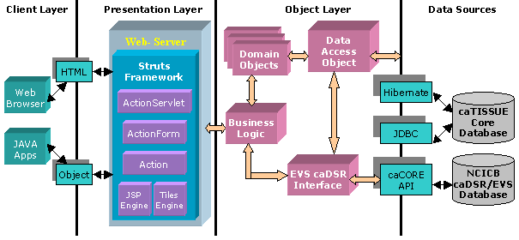
Figure 1 caTissue Suite Architecture
The main components of the application are as follows:
- Web interface: Web pages and APIs
- Business logic
- Data access object
- EVS/caDSR interface
The design follows the Model View Controller (MVC) design approach wherein the view, that is, the user interfaces, and the model, that is, the actual application logic, are completely insulated.
The Web interfaces communicate with external data sources such as caDSR, EVS, and caTissue Suite’s database through an intermediate interface. The purpose of these interfaces is to insulate the core application logic from any changes in the external data source. Interaction with the database is either through Hibernate or JDBC.

Prerequisites
Before reading this document, it is recommended that you are familiar with the software. Please refer to the following reference documents before moving to the next sections.
References:
- caTissue Requirements: This document captures the use cases and software requirements for caTissue.
- caTissue Design: This document describes the design of caTissue.

Security Management
caTissue uses Common Security Module (CSM) software to accomplish the security requirements. CSM is the part of the caBIG® infrastructure module chartered to provide a comprehensive solution to common security objectives. It provides solutions for Authentication and Authorization. This chapter describes authorization rules of the application.

Software Authorization
At the time of application deployment, the system provides default roles and privileges. These privileges can be edited using the application by a user having appropriate privileges.
The data entered in to caTissue Suite can be categorized into two different groups, Administrative and Biospecimen. Administrative data is the data required to set up the tissue bank. For example, Collection Protocols, Distribution Protocols, Biohazards, Sites, Storage containers, Users, Departments, Institutions, Cancer Research Groups, Storage Types, and Array Types. The Biospecimen data includes details on patient demographics, specimen quantity, storage locations, and samples distributed by the bank. The majority of the day-to-day operations of the tissue bank are centered on entering and updating the Biospecimen data.

Role requirements in caTissue Suite
In caTissue Suite 1.1 and newer versions, there is support for operation of multiple repositories within single instance of caTissue. When a single instance of caTissue manages multiple repository sites, it is crucial to control user access to operations and data across these repository sites. You can restrict user access to repository sites by associating collection protocols, users, and storage containers to the repository sites.
Below table summarizes different privileges available in caTissue and default privileges each role is associated with. It is possible to customize these through caTissue application.
CSM Privilege | Description | Default Role
User Provisioning | Privilege to add / edit users and their privileges. | Administrator
General Administration | Privilege to add / edit Institutions, Departments, Cancer Research Groups, Sites, Storage types, Specimen Array types, Bio-Hazards, Define Annotation | Super Administrator
Storage Administration | Privilege to add / edit Storage Containers | Administrator
Protocol Administration | Privilege to add / edit Collection and Distribution Protocols and assign privileges per protocol | Administrator
Registration | Privilege to PHI Access, add / edit Participants, Specimen Collection Group, Specimens | Administrator, Supervisor
Distribution | Privilege to  - place order under any Distribution Protocol  - distribute the specimens stored in the site user has access to  - process the orders placed based on Surgical Pathology Report belonging to Collection Protocol to which user has access to | Administrator, Supervisor, Technician
Specimen Processing | Privilege to add / edit Specimens, Specimen events, Specimen Array, Aliquot Specimens, Derive Specimens | Administrator, Supervisor, Technician
Read Denied | Privilege to deny READ on a Collection Protocol | Has to be explicitly given by selecting Role as Scientist – by default, all users have access to READ all non-PHI data
As seen above, new role super administrator is added, user with this role has all privileges within the application. Other roles are associated to each site. Also, customized role with required privileges can be created.
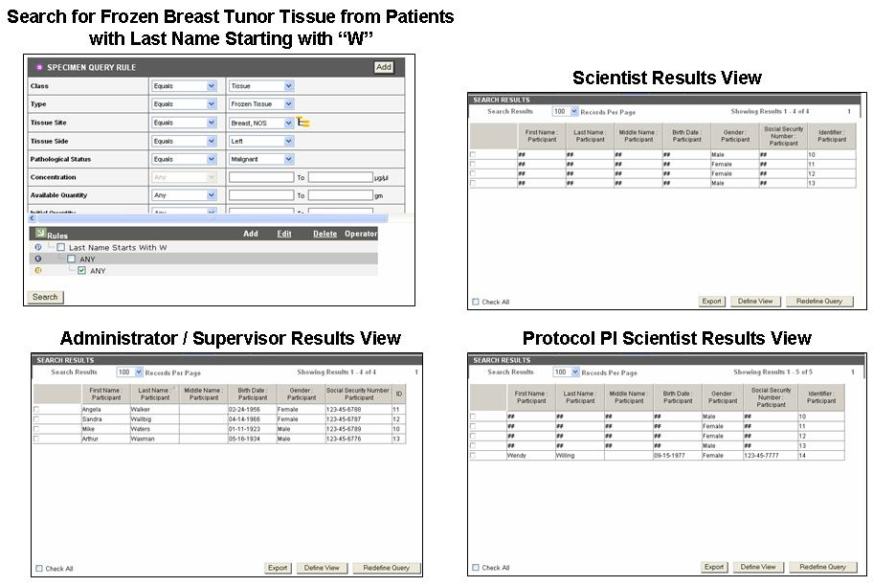
Figure 2:Role based PHI data view

Data Model Implementation of Fine Grained ROLE Requirements
caTissue Suite uses the CSM to protect against unauthorized actions and data access. The CSM database tables store all the security data required for caTissue Suite. This section explains the data model that is implemented to enable authorization in caTissue Suite.

User Groups
Roles in caTissue, as explained in the previous section, map to User Groups of CSM that is, each role is a CSM user group. For each role, a user group in caTissue Suite is created in the csm_group table as shown below:
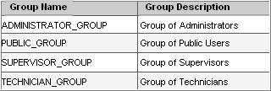
Table 2: User groups in caTissue
User provisioning is performed by the system at runtime in caTissue implementation. Once a user is created via caTissue Suite, a User object is created and inserted into the csm_user table. The user is then assigned to the appropriate user group by the application. The user is associated with the Administrator, Supervisor, Technician, or Public(Scientist) group based on the role that user is assigned.

Roles and Privileges
Following are the main roles and privileges based on the use cases defined for caTissue Suite. The system assigns privileges to each role to enable appropriate access for that type of user. The roles are then assigned to respective user groups mentioned in the previous section.
Note: These roles are not the roles defined in caTissue Suite. These are CSM roles. A role in CSM denotes a set of privileges. User groups, caTissue specific roles as explained in the previous section, have various CSM roles on different protection groups that is sets of data. Unless specified, subsequent references to role refer to those defined by the CSM.
The following table lists the role names and describes each role:
Role Name | Role Description
Administrator | Role for Administrator
Supervisor | Role for Supervisor
Technician | Role for Technician
PI | Role for Principal Investigator
READ_ONLY | Read Only Role
USE_ONLY | Use Only Role
Scientist | Role for Public
UPDATE_ONLY | Update Only Role
EXECUTE_ONLY | Execute Only Role
READ_DENIED | Read Denied Role
Coordinator | Role for Coordinator
CREATE_ONLY | Create only role
SUPERADMINISTRATOR | SUPER ADMINISTRATOR ROLE
Table 3: All CSM Roles
The following table lists the privilege names and describes each privilege:
ID | Privilege Name | Privilege Description
1 | USER_PROVISIONING | This privilege grants permission to a user for user creation and assigning privileges to that user
2 | STORAGE_ADMINISTRATION | This privilege grants permission to a user for add edit storage types and containers
3 | PROTOCOL_ADMINISTRATION | This privilege grants permission to a user for add edit collection as well as distribution protocols
4 | REGISTRATION | This privilege grants permission to a user for registering participant and consents
5 | SPECIMEN_ACCESSION | This privilege grants permission to a user for add edit specimen,specimen collection group and consents
6 | DISTRIBUTION | this privilege grants permission to a user for distribution
7 | SPECIMEN_PROCESSING | this privilege grants permission to a user for add edit aliquot, derivative, events
8 | GENERAL_ADMINISTRATION | this privilege grants permission to a user for add edit department,institution,cancer research group
9 | READ_DENIED | this privilege doesnt permit the user to read data for a particular protocol
Table 4: Privileges and descriptions

The following table lists the role and privilege:
Role Name | Privilege Name
Administrator | QUERY
Administrator | GENERAL_ADMINISTRATION
Administrator | DISTRIBUTION
Administrator | SPECIMEN_ANNOTATION
Administrator | REGISTRATION
Administrator | PROTOCOL_ADMINISTRATION
Administrator | PHI_ACCESS
Administrator | PARTICIPANT_SCG_ANNOTATION
Administrator | USER_PROVISIONING
Administrator | STORAGE_ADMINISTRATION
Administrator | SPECIMEN_PROCESSING
Coordinator | SPECIMEN_PROCESSING
Coordinator | DISTRIBUTION
Coordinator | SPECIMEN_ANNOTATION
Coordinator | REGISTRATION
Coordinator | PHI_ACCESS
Coordinator | PARTICIPANT_SCG_ANNOTATION
PI | PHI_ACCESS
PI | PARTICIPANT_SCG_ANNOTATION
PI | SPECIMEN_PROCESSING
PI | DISTRIBUTION
PI | SPECIMEN_ANNOTATION
PI | REGISTRATION
READ_DENIED | READ_DENIED
Scientist | QUERY
SUPERADMINISTRATOR | DISTRIBUTION
SUPERADMINISTRATOR | SPECIMEN_ANNOTATION
SUPERADMINISTRATOR | QUERY
SUPERADMINISTRATOR | PROTOCOL_ADMINISTRATION
SUPERADMINISTRATOR | USER_PROVISIONING
SUPERADMINISTRATOR | DEFINE_ANNOTATION
SUPERADMINISTRATOR | REGISTRATION
SUPERADMINISTRATOR | PHI_ACCESS
SUPERADMINISTRATOR | PARTICIPANT_SCG_ANNOTATION
SUPERADMINISTRATOR | STORAGE_ADMINISTRATION
SUPERADMINISTRATOR | GENERAL_ADMINISTRATION
SUPERADMINISTRATOR | SPECIMEN_PROCESSING
Supervisor | SPECIMEN_ANNOTATION
Supervisor | REGISTRATION
Supervisor | PHI_ACCESS
Supervisor | PARTICIPANT_SCG_ANNOTATION
Supervisor | SPECIMEN_PROCESSING
Supervisor | QUERY
Supervisor | DISTRIBUTION
Technician | SPECIMEN_PROCESSING
Technician | QUERY
Technician | DISTRIBUTION
Technician | SPECIMEN_ANNOTATION

Table 5: Roles and their mapping privileges

Protection Elements
A Protection Element is any entity that has controlled access. In caTissue Suite, the following categories of entities are identified that need controlled access:

Category | Description
Classes | All classes in the caTissue Suite form a protection element in CSM. Users/groups must have CREATE/UPDATE privilege on these to add or update the corresponding objects.
Objects | Protection elements are added for the new objects created, for which object level privileges are to be checked. Users are given appropriate rights to these objects.
Table 6: Protection elements in caTissue Suite

Protection groups
The use of protection groups is critical to the structure and foundation for implementation of the data model. caTissue Suite utilizes the protection groups to store collections of related protection elements.
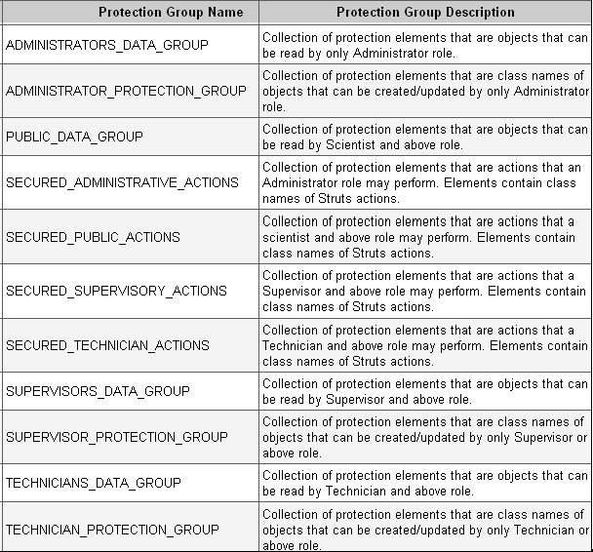
Table 7: Protection groups in caTissue Suite

Mapping of caTissue Roles with CSM data
This section describes the mapping between current caTissue Suite user groups and associated CSM roles.

Administrator
The Administrator group in caTissue Suite has privilege to view all data and perform all actions in caTissue Suite. The roles and groups associated with the Administrator user groups are listed below:
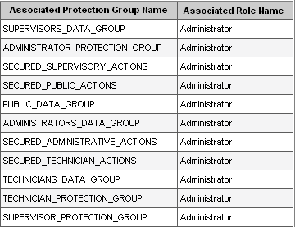
Table 8: Associated protection groups of Administrators

Supervisor
The Supervisor group in caTissue Suite has privilege to view PHI, add or edit biospecimen data, and view administrative data. Users in this group do not have privilege to add/edit administrative data. The protection groups associated with the Supervisor user group and roles are listed below:
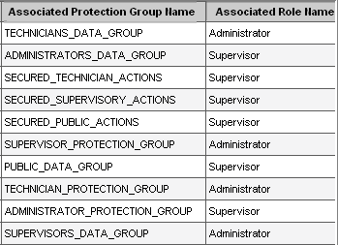
Table 9: Associated protection groups of Supervisors

Technician
Technicians in caTissue Suite does not have privilege to view PHI though they can add/edit biospecimen data and view administrative data. The protection groups associated to the Technician user group and roles are listed below:
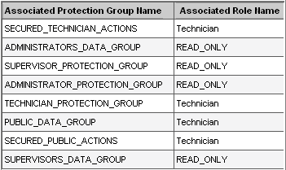
Table 10: Associated protection groups of Technicians

Scientist
The Scientist group in caTissue Suite has privilege to view all de-identified data. Users in this group do not have privileges to add/edit administrative data. The roles associated to the protection group are listed below:
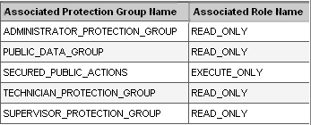
Table 11: Associated protection groups of Scientists
For more information on configuring user roles, please refer to the caTissue Suite user manual.

API Access
This chapter outlines how to use the API. It also includes examples of using the API.

An application program interface (API)
An application program interface (API) provides the ability to interface/interact with external systems. The caTissue Suite API is generated using the caBIG® caCORE SDK toolkit. You can use these APIs to add, edit, and query for data.
caCORE is an open-source enterprise architecture for NCI-supported research information systems. caCORE is built using formal techniques from the software engineering and computer science communities. The four characteristics of caCORE include:
- Model Driven Architecture (MDA)
- n-tier architecture with open APIs
- Use of controlled vocabularies, wherever possible
- Registered metadata
The use of MDA and n-tier architecture, both standard software engineering practices, allows easy access to data by other applications. The use of controlled vocabularies and registered metadata, less common in conventional software practices, requires specialized tools that are generally unavailable.
The documentation related to the caCORE can be found at the following location:
http://ncicb.nci.nih.gov/NCICB/infrastructure/cacoresdk
The following steps describe how to use APIs for data entry and query:
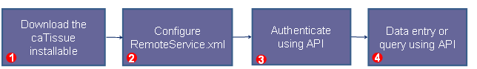

Step 1: Download the caTissue Suite installable from the location.

https://gforge.nci.nih.gov/frs/?group_id=689

Once you have downloaded the caTISSUE_SUITE_v12_Installable_Pack.zip, extract the contents of the file to any directory. This folder will contain two additional compressed files; caTissue_Suite_v1.2_Installable and caTissue_Suite_API_Client_v1.2_Installable.

Unzip the caTissue_Suite_v1.2_Installable.zip , extract the contents of the file to any directory. This folder will be referred to as CATISSUE_HOME in this document.
Unzip the caTissue_Suite_API_Client_v1.2_Installable.zip, extract the contents of the file to any directory. This folder will be referred to as CATISSUE_CLIENT_HOME in this document.

Step 2: Configure the following parameter in the remoteService.xml file present in CATISSUE_CLIENT_HOME /caTissueSuite_Client/conf:
<property name="serviceUrl">
<value>http://{host}:{port}/catissuecore/http/remoteService</value>
</property>

Parameter | Details
{host}:{port} | Host URL of the application to which caCORE client connects. Replace the host parameter with http host:port at which the server is configured. For example, to access the demo site of caTissue Suite you can configure this as ‘catissuecore.wustl.edu:80’.

Step 3: Authenticate: In order to connect to the caTissue database, provide the login credentials.
The following code snippet shows how to log in to the caTissue Suite application through API:
ApplicationServiceProvider asp = new ApplicationServiceProvider();
ApplicationService appService= ApplicationServiceProvider.getApplicationService();
//Start the session by giving proper credentials to startSession() method.
ClientSession cs = ClientSession.getInstance();
Provide the login name and password to the application
cs.startSession("<login-name>","<password>");

Configure Client for HTTPS
caTissue Suite contains patient identified information, so it is important to deploy it in a secure environment. For more information read http://en.wikipedia.org/wiki/Https. To deploy caTissue Suite as a HTTPS based secure Web application refer to the deployment guide.
Use API to authenticate to a caTissue Suite which is deployed as HTTPS:
- Generate the keystore file on the client machine. To generate the keystore file, perform the first step mentioned in the section “Configuring JBoss Server to deploy caTissue as HTTPS” of the deployment guide.
- Update the client API code in the authentication section to set the path of the keystore file to the system property javax.net.ssl.trustStore.
For example, if the keystore created is stored in
c://catissue/catissue.keystore, add the following code:
System.setproperty("javax.net.ssl.trustStore", “c://catissue/catissue.keystore”);
- In the remoteService.xml file, set the value for the property service URL to https://{host}:{port}/catissuecore/http/remoteService

Step 4a: Query using API
caTissue Suite API provides the following methods for querying any class present in the caTissue model:
- public List query(DetachedCriteria detachedcriteria, String targetClassName)
Specimen specimen = new Specimen();
DetachedCriteria criteria=DetachedCriteria.forClass(Specimen.class);
criteria.add(Restrictions.lt("id", new Long(4)));
List resultList = appService.query(criteria, Specimen.class.getName());
Detached criteria uses Hibernate detached criteria objects to provide a greater level of control over the results of a search, such as boolean operations, ranges of values, and so on.
Some applications need to create criteria queries in detached mode, where the Hibernate session is not available. This class can be instantiated anywhere, and then a Criteria can be obtained by passing a session to getExecutableCriteria().

Method signature description: Returns a List conforming to the criteria specified by detachedCriteria. The resulting objects of the list are of the type specified by targetClassName.

- public List query(HQLCriteria hqlcriteria, String targetClassName)
Participant participant = new Participant();
String hqlQuery="select elements(p.participantMedicalIdentifierCollection)"+" from edu.wustl.catissuecore.domain.Participant as p";
HQLCriteria hqlCriteria= new HQLCriteria(hqlQuery);
List medicalIdentifierCollection= appService.query(hqlCriteria, Participant.class.getName());

HQL searches: Provides the ability to use the Hibernate Query Language for the greatest flexibility in forming search criteria.
Method signature description: Returns a List of objects of the type specified by targetClassName that conform to the query in HQL syntax contained in hqlCriteria.

- public List search(Class targetClass, Object obj)
Biohazard biohazard = new Biohazard();
List resultList = appService. search(Biohazard.class,biohazard);

Simple searches: Take one or more objects from the domain models as inputs and return a collection of objects from the data repositories that meet the criteria specified by the input objects.
Method signature description: Returns a List containing objects of type targetClass that conform to the criteria defined by obj.

- public List search(String path, Object obj)
SpecimenArray specimenArray = new SpecimenArray();
String path = "edu.wustl.catissuecore.domain.Container,edu.wustl.catissuecore.domain.ContainerPosition,edu.wustl.catissuecore.domain.SpecimenArray";
Collection result=appService.search(path, specimenArray);

Nested searches: Take domain objects as inputs, but determine the type of objects in the result set by traversing a known path of associations from the domain model.
Method signature description: Returns a List containing objects conforming to the criteria defined by obj. The resulting objects of the list are of the type reached by traversing the node graph specified by path

In the caTissue Suite, the lazy initialization property of hibernate is set to true due to performance reasons. If this property is set to false, a query executed to retrieve a specimen object results in getting all the associated objects in a nested manner resulting in lot of data being loaded into memory. The impact of setting Hibernate lazy loading to true is that you cannot do resultsObj.getAssociatedObject() kind of queries that is fetching associated. In order to get the associated data, the API search must use the method search(String path, Object obj) where you mention what objects you want in the results.

Step 4b: Data entry operations through API:
caTissue Suite API uses createObject method of appService for adding domain object into database.
Consider the following example to insert a Participant object:
Participant participant = new Participant();
participant.setLastName("Duck");
participant.setFirstName("Donald");
participant.setGender("Male Gender");
participant.setVitalStatus("Alive");
participant.setEthnicity("Unknown");
participant.setSexGenotype("XX");

Collection raceCollection = new HashSet();
Race race = new Race();
race.setRaceName("Asian");
race.setParticipant(participant);
raceCollection.add(race);
participant.setRaceCollection(raceCollection);
participant.setActivityStatus("Active");
participant.setEthnicity("Hispanic or Latino");
participant = (Participant)
appService.createObject(participant);

Similarly for updating any class, caTissue API uses updateObject method of appService. Search for the data you want to update and set the values in this result that need to be updated.

Example code to update participant data:

participant.setVitalStatus("Alive");
participant.setGender("Male Gender");
participant.setSexGenotype("");

Collection raceCollection = new HashSet();
Race race = new Race();
race.setRaceName("Unknown");
race.setParticipant(participant);
raceCollection.add(race);
participant.setRaceCollection(raceCollection);
participant = (Participant)
appService.updateObject(participant);
Note: If you are looking for more examples of API code, please refer to section “Running the Test Case Suite (API)” in the deployment guide.
This section describes all the objects that can be added using API along with the information about mandatory fields and associated objects. An important consideration in using the API is handling of associated objects. There are two types of associated objects:
- Data association: Data association objects are those objects which are created and added along with the main object, for example, Address and Password are data associated objects of a User.
- Reference association: Reference association is when the associated object is expected to exist before adding the current object and would be referenced in the object being added. For example, Institution, Department and CancerResearchGroup are reference associations of User.

Institution

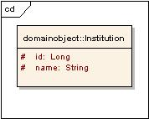
Figure 3:Institution
Institution
Attribute / Constituent Object | Datatype/Class | Mandatory
Id | Long | Yes
Name | String | Yes
Table 12:Institution attributes

Department

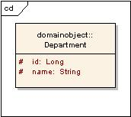
Figure 4:Department
Department
Attribute / Constituent Object | Datatype/Class | Mandatory
Id | Long | Yes
Name | String | Yes
Table 13:Department attributes

CancerResearchGroup

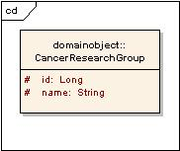
Figure 5:CancerResearchGroup

CancerResearchGroup
Attribute / Constituent Object | Datatype/Class | Mandatory
Id | Long | Yes
Name | String | Yes
Table 14:CancerResearchGroup attributes

User

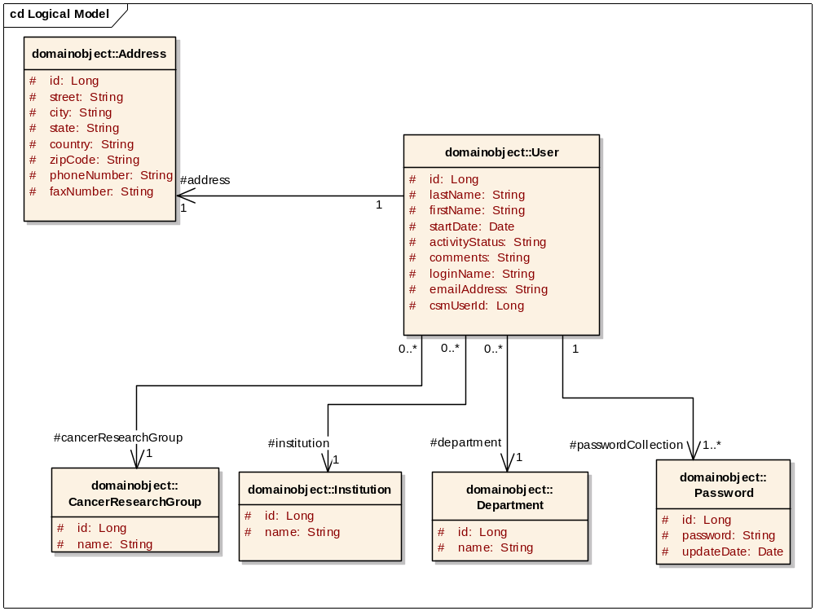
Figure 6:User

Associated object | Type
Address | Data
Password | Data
Institution | Reference
CancerResearchGroup | Reference
Department | Reference
Table 15: Associated objects of User

Address
Attribute/Constituent Object | Datatype/Class | Mandatory
Id | Long | Yes
Street | String | Yes
City | String | Yes
State | String | Yes
Country | String | Yes
Zipcode | String | Yes
phoneNumber | String | No
faxNumber | String | No
Table 16:Address attributes

User
Attribute / Constituent Object | Datatype/Class | Mandatory
Id | Long | Yes
emailAddress | String | Yes
lastName | String | Yes
firstName | String | Yes
activityStatus | String | Yes
Address | Address attributes | Yes
Institution | Institution attributes | Yes
Department | Department attributes | Yes
cancerResearchGroup | CancerResearchGroup attributes | Yes
Table 17:User attributes

Site

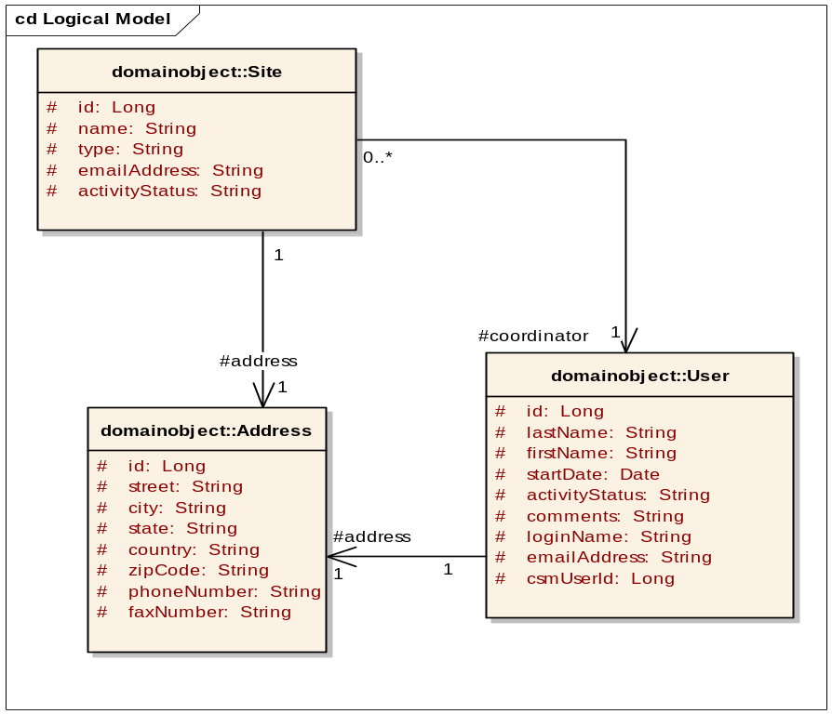
Figure 7:Site

Associated object | Type
Address | Data
User | Reference
Table 18: Associated objects of Site

Site
Attribute / Constituent Object | Datatype/Class | Mandatory
Id | Long | Yes
Name | String | Yes
Type | String | Yes
emailAddress | String | No
activityStatus | String | Yes
Address | Address attributes | Yes
Coordinator | User attributes | Yes
Table 19:Site attributes

StorageType
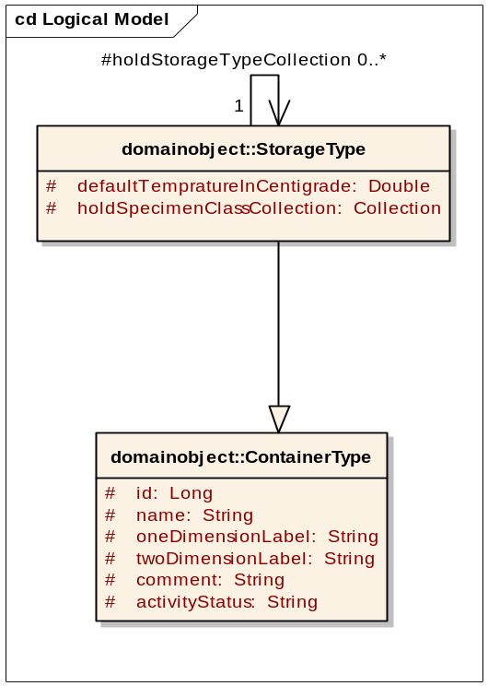
Figure 8:StorageType
StorageType is not associated to any other object. As indicated in the above diagram, StorageType is inherited from the parent class ContainerType.

ContainerType
Attribute/Constituent Object | Datatype/Class | Mandatory
Id | Long | Yes
Name | String | Yes
oneDimensionLabel | String | Yes
twoDimensionLabel | String | Yes
Comment | String | No
Capacity | Capacity attributes | Yes
Table 20:ContainerType attributes

StorageType
Attribute/Constituent Object | Datatype/Class | Mandatory
defaultTempratureInCentigrade | Double | No
holdsStorageTypeCollection | Collection | No
holdsSpecimenClassCollection | Collection | No
activityStatus | String | Yes
Table 21:Storage Type attributes

StorageContainer

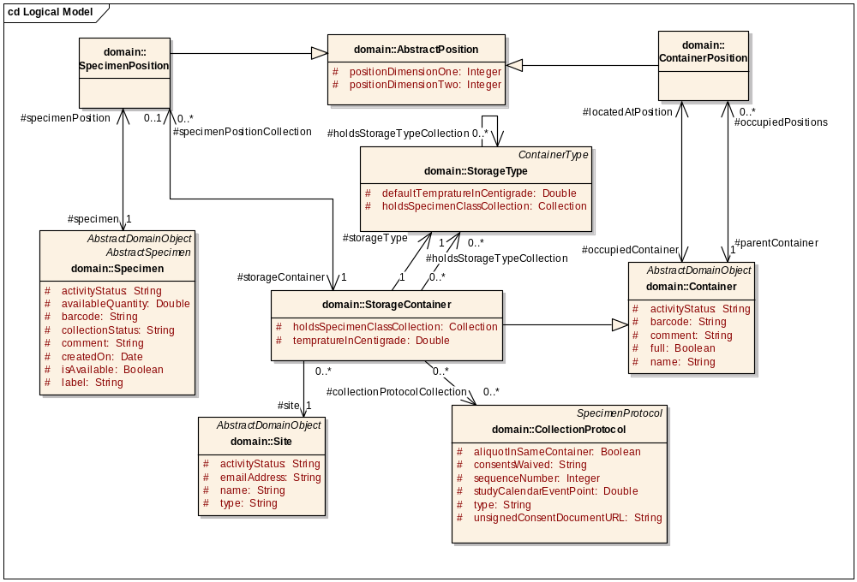
Figure 9:Storage Container
Associated object | Type
Container | Data
Site | Reference
CollectionProtocol | Reference
StorageType | Reference
AbstractPosition | Data
ContainerPosition | Data
SpecimenPosition | Data
Table 22: Associated objects of StorageContainer

Capacity
Attribute/Constituent Object | Datatype/Class | Mandatory
Id | Long | Yes
oneDimensionCapacity | Integer | No
twoDimensionCapacity | Integer | No
Table 23:Capacity attributes

Container
Attribute/Constituent Object | Datatype/Class | Mandatory
Id | Long | Yes
Full | Boolean | Yes
Name | String | Yes
barcode | String | No
activityStatus | String | Yes
comment | String | No
capacity | Capacity attributes | Yes
occupiedPositions | Collection | No
locatedAtPosition | ContainerPosition attributes | No
Table 24:Container attributes

StorageContainer
Attribute/Constituent Object | Datatype/Class | Mandatory
tempratureInCentigrade | Double | No
storageType | Storage Type attributes | Yes
site | Site attributes | No
collectionProtocolCollection | Collection | No
holdsStorageTypeCollection | Collection | No
holdsSpecimenClassCollection | Collection | No
Table 25:StorageContainer attributes

AbstractPosition
Attribute/Constituent Object | Datatype/Class | Mandatory
Id | Long | Yes
positionDimensionOne | Integer | Yes
positionDimensionTwo | Integer | Yes
Table 26:AbstractPosition attributes

ContainerPosition
Attribute/Constituent Object | Datatype/Class | Mandatory
occupiedContainer | Container attributes | Yes
parentContainer | Container attributes | Yes
Table 27:ContainerPosition attributes

SpecimenPosition
Attribute/Constituent Object | Datatype/Class | Mandatory
specimen | Specimen attributes | Yes
storageContainer | StorageContainer attributes | Yes
Table 28:SpecimenPosition attributes

CollectionProtocol
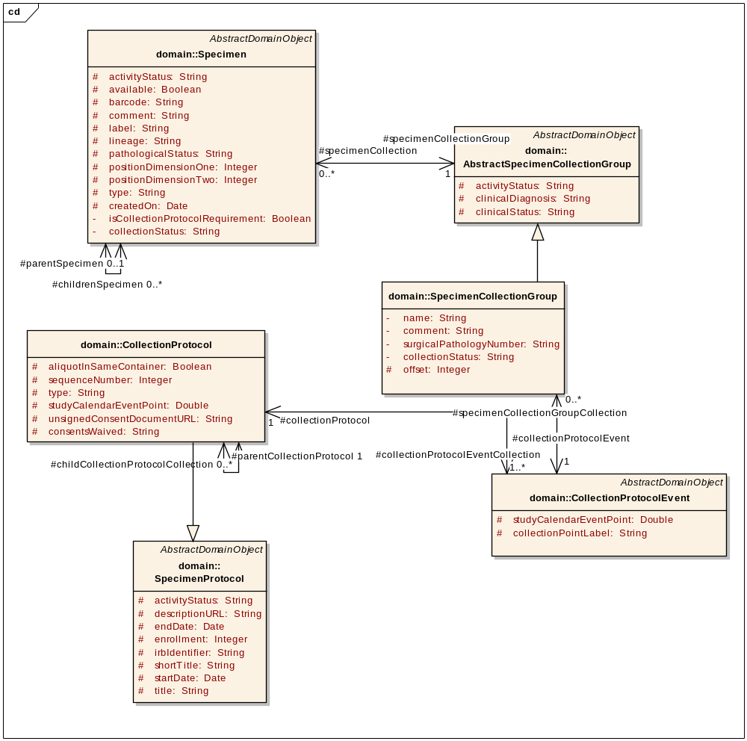
Figure 10:CollectionProtocol
Associated object | Type
SpecimenProtocol | Derived
User | Reference
CollectionProtocolEvent | Data
SpecimenCollectionRequirementGroup | Data
CollectionProtocolRegistration | Data
Specimen | Data
ConsentTier | Data
Table 29: Associated objects of CollectionProtocol

SpecimenProtocol
Attribute/Constituent Object | Datatype/Class | Mandatory
id | Long | Yes
title | String | Yes
shortTitle | String | Yes
irbIdentifier | String | Yes
startDate | Date | Yes
endDate | Date | No
enrollment | Integer | Yes
descriptionURL | String | Yes
principalInvestigator | User attributes | Yes
Table 30:SpecimenProtocol attributes

CollectionProtocol
Attribute / Constituent Object | Datatype / Class | Mandatory?
distributionProtocolCollection | Collection | No
userCollection | Collection | No
collectionProtocolEventCollection | Collection | Yes
consetTierCollection | Collection | No
Table 31:Collection Protocol attributes

CollectionProtocolEvent
Attribute/Constituent Object | Datatype/Class | Mandatory
id | Long | Yes
clinicalStatus | String | Yes
studyCalendarEventPoint | Double | Yes
specimenRequirementCollection | Collection | Yes
collectionProtocol | Collection Protocol attributes | Yes
Table 32:CollectionProtocolEvent attributes

ConsentTier
Attribute/Constituent Object | Datatype/Class | Mandatory
Id | Long | Yes
Statement | String | Yes
Table 33 ConsentTier attributes

DistributionProtocol

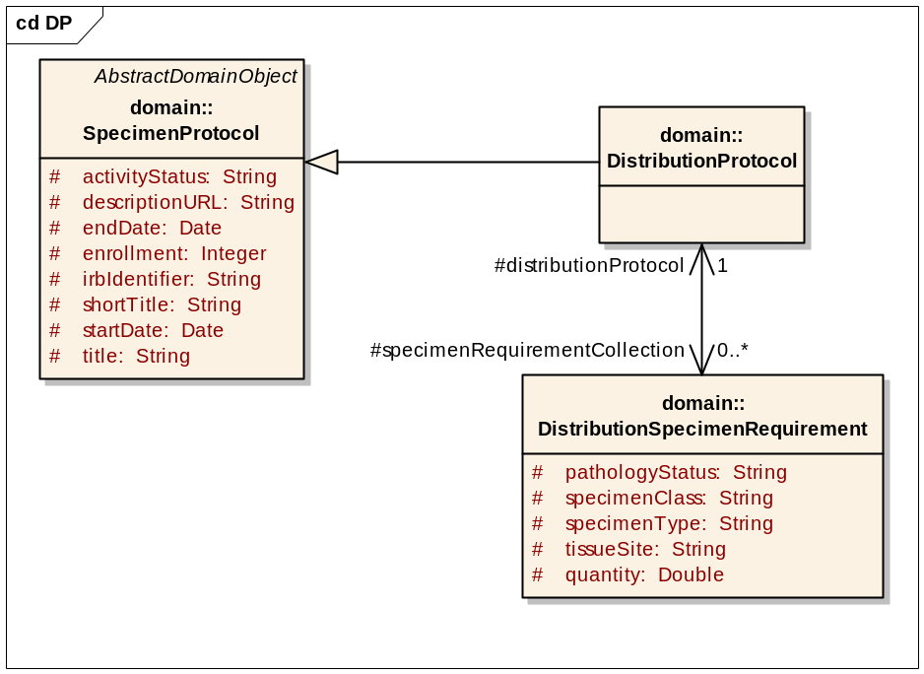
Figure 11:DistributionProtocol

Associated object | Type
SpecimenProtocol | Derived
DistributionSpecimenRequirement | Data
Table 34: Associated objects of DistributionProtocol
SpecimenProtocol
Attribute / Constituent Object | Datatype / Class | Mandatory?
id | Long | Yes
title | String | Yes
shortTitle | String | Yes
irbIdentifier | String | Yes
startDate | Date | Yes
endDate | Date | No
enrollment | Integer | Yes
descriptionURL | String | Yes
principalInvestigator | User attributes | Yes
Table 35:SpecimenProtocol attributes

DistributionProtocol
Attribute/Constituent Object | Datatype/Class | Mandatory
distributionSpecimenRequirementCollection | Collection | No
collectionProtocolCollection | Collection | No
Table 36:DistributionProtocol attributes

Participant

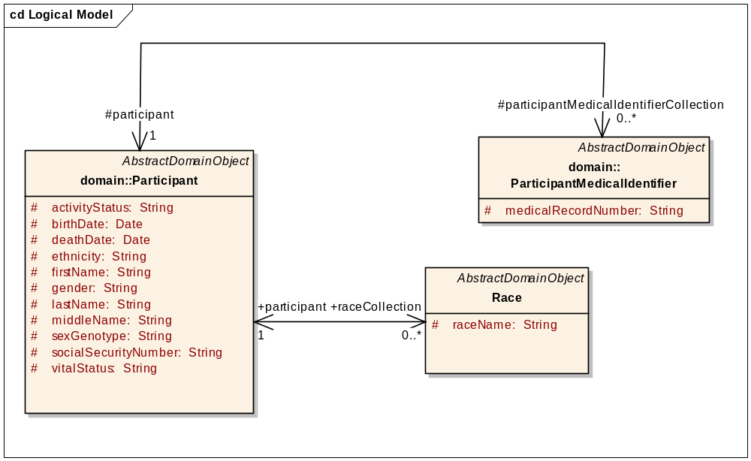
Figure 12:Participant
Associated object | Type
ParticipantMedicalIdentifier | Data
Race | Data
Table 37: Associated objects of Participant
Participant
Attribute/Constituent Object | Datatype/Class | Mandatory
Id | Long | Yes
LastName | String | No
FirstName | String | No
MiddleName | String | No
BirthDate | Date | No
DeathDate | Date | No
SexGenotype | String | No
ethnicity | String | No
socialSecurityNumber | String | No
vitalStatus | String | No
gender | String | No
participantMedicalIdentifierCollection | Collection | No
collectionProtocolRegistrationCollection | Collection | No
raceCollection | Collection | No
Table 38:Participant attributes

ParticipantMedicalIdentifier
Attribute / Constituent Object | Datatype / Class | Mandatory?
Id | Long | Yes
medicalRecordNumber | String | Yes
Site | Site attributes | Yes
Table 39:ParticipantMedicalIdentifier attributes

Race
Attribute / Constituent Object | Datatype / Class | Mandatory?
Id | Long | Yes
raceName | String | Yes
Table 40: Race attributes
CollectionProtocolRegistration

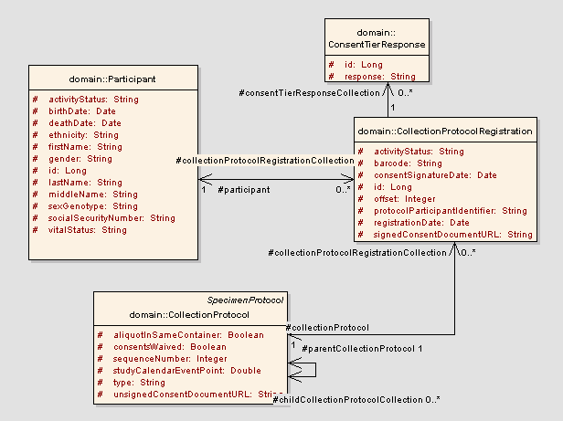
Figure 13:CollectionProtocolRegistration
Associated object | Type
Participant | Reference
CollectionProtocol | Reference
ConsentTierResponse | Data
Table 41: Associated objects of CollectionProtocolRegistration

CollectionProtocolRegistration
Attribute/Constituent Object | Datatype/Class | Mandatory
Id | Long | Yes
protocolParticipantIdentifier | String | No
registrationDate | Date | Yes
activityStatus | String | Yes
participant | Participant attributes | No
collectionProtocol | Collection Protocol attributes | Yes
consentTierResponseCollection | Collection | No
collectionPointLabel | String | Yes
barcode | String | No
Table 42:CollectionProtocolRegistration attributes

ConsentTierStatus
Attribute / Constituent Object | Datatype / Class | Mandatory?
Id | Long | Yes
status | String | Yes
Table 43 ConsentTierStatus attributes

SpecimenCollectionGroup

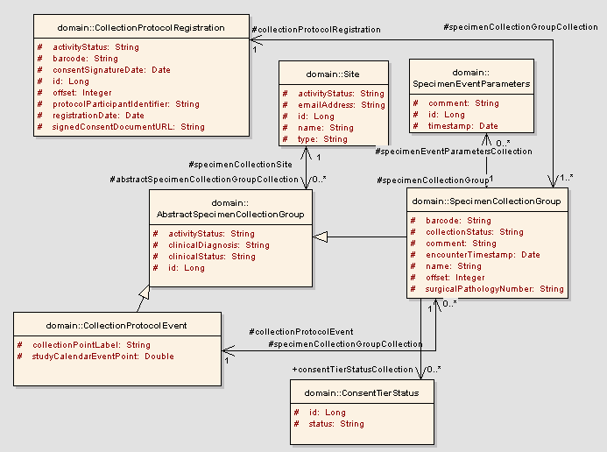
Figure 14:SpecimenCollectionGroup
Associated object | Type
CollectionProtocolEvent | Reference
CollectionProtocolRegistration | Reference
Site | Reference
SpecimenEventParameters | Reference
AbstractSpecimenCollectionGroup | Derived
ConsentTierStatus | Data
Table 44: Associated objects of SpecimenCollectionGroup

AbstractSpecimenCollectionGroup
Attribute / Constituent Object | Datatype / Class | Mandatory?
id | Long | Yes
clinicalStatus | String | Yes
site | Site attributes | Yes
clinicalDiagnosis | String | Yes
activityStatus | String | Yes
Table 45: AbstractSpecimenCollectionGroup attributes

SpecimenCollectionGroup
Attribute / Constituent Object | Datatype / Class | Mandatory?
Id | Long | Yes
barcode | String | No
name | String | Yes
Offset | Integer | No
encounterTimestamp | Date | No
collectionProtocolEvent | CollectionProtocolEvent attributes | Yes
surgicalPathologyNumber | String | No
specimenCollection | Collection | No
collectionProtocolRegistration | CollectionProtocolRegistration attributes | Yes
specimenEventParametersCollection | Collection | Yes
comment | String | No
consentTierStatusCollection | Collection | No
Table 46:SpecimenCollectionGroup attributes

Specimen
Specimens can be one of the four different classes: Molecular, Fluid, Tissue, and Cell. Each specimen class is represented by a different UML Class in the model.
There are three categories of specimens:
- New specimen
- Derivative
- Aliquot
The lineage attribute must be set to New, Aliquot, or Derived. In order to create aliquot or derivative specimen, you must set an existing specimen as the parent specimen. You must populate the Parent specimen object. The parent specimen object must exist in the database. Aliquot and derived specimen objects contain this parent specimen object.
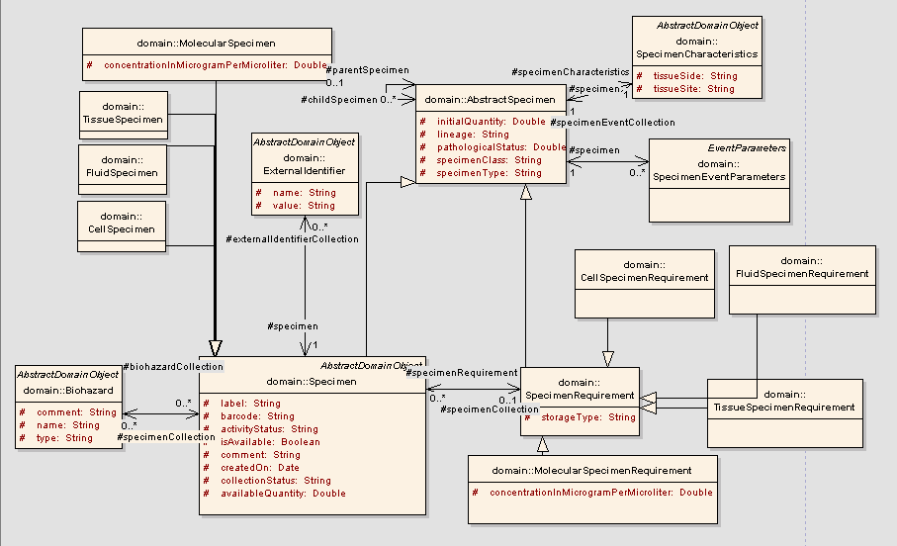
Figure 15:Specimen
Associated object | Type
ExternalIdentifier | Data
Biohazard | Reference
SpecimenCharacterstics | Reference
SpecimenEventParameter | Data
SpecimenCollectionGroup | Reference
SpecimenPosition | Data
ConsentTierStatus | Data
Table 47:Associated objects of Specimen

AbstractSpecimen
Attribute/Constituent Object | Datatype/Class | Mandatory
Id | Long | Yes
specimenClass | String | Yes
specimenType | String | Yes
pathologicalStatus | String | Yes
initialQuantity | Double | Yes
childrenSpecimen | Collection | No
parentSpecimen | Specimen attributes | No
specimenEventCollection | Collection | No
specimenCharacteristics | SpecimenCharacteristics attributes | Yes
Lineage | String | No
Table 48:AbstractSpecimen attributes

SpecimenRequirement
Attribute/Constituent Object | Datatype/Class | Mandatory
Id | Long | Yes
specimenCollection | Collection | Yes
CollectionProtocolEvent | CollectionProtocolEvent attributes | Yes
storageType | String | Yes
Table 49:SpecimenRequirement attributes

Specimen
Attribute/Constituent Object | Datatype/Class | Mandatory
Id | Long | Yes
Available | Boolean | Yes
Barcode | String | No
Comments | String | No
ActivityStatus | String | Yes
availableQuantity | Double | Yes
specimenPosition | SpecimenPosition attributes | Yes
specimenCollectionGroup | SpecimenCollectionGroup attributes | No
biohazardCollection | Collection | No
externalIdentifierCollection | Collection | No
createdOn | Date | No
consentTierStatusCollection | Collection | No
collectionStatus | String | Yes
Table 50: Specimen attributes

SpecimenCharacteristics
Attribute/Constituent Object | Datatype/Class | Mandatory
id | Long | Yes
tissueSite | String | Yes
tissueSide | String | Yes
Table 51:SpecimenCharacteristics attributes

Biohazard
Attribute/Constituent Object | Datatype/Class | Mandatory
Id | Long | Yes
Name | String | Yes
Type | String | Yes
Comments | String | No
Table 52:Biohazard attributes

Distribution
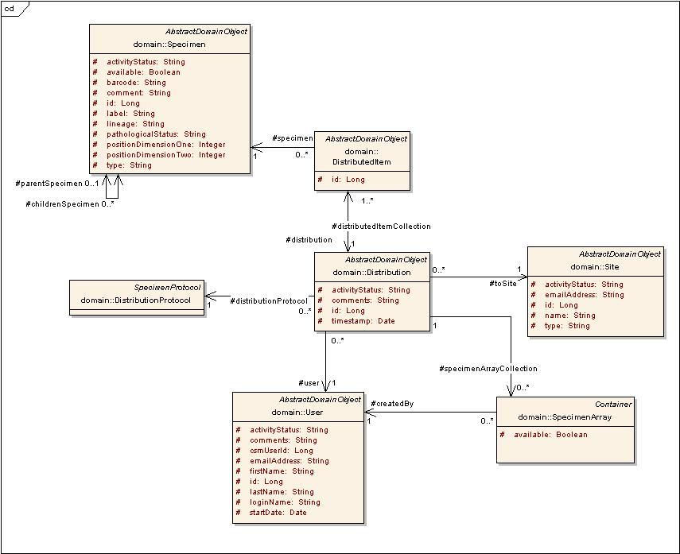
Figure 16:Distribution

Associated object | Type
Site | Reference
DistributedItem | Data
DistributionProtocol | Reference
User | Reference
Specimen | Reference
SpecimenArray | Reference
Table 53: Associated objects of Distribution
Distribution
Attribute/Constituent Object | Datatype/Class | Mandatory
activityStatus | String | Yes
toSite | Site attributes | Yes
distributionProtocol | DistributionProtocol attributes | Yes
distributedItemCollection | Collection | Yes
specimenArrayCollection | Collection | No
Table 54:Distribution attributes

DistributedItem
Attribute/Constituent Object | Datatype/Class | Mandatory
id | Long | Yes
quantity | Double | Yes
specimen | Specimen attributes | Yes
distribution | Distribution attributes | Yes
Table 55:DistributedItem attributes
ConsentTierResponse
Associated object | Type
ConsentTier | Reference
CollectionProtocolRegistration | Data
Table 56 Associated objects of ConsentTierResponse
ConsentTierStatus
Associated object | Type
ConsentTier | Reference
SpecimenCollectionGroup | Reference
Specimen | Reference
Table 57 Associated objects of ConsentTierStatus

Ordering System
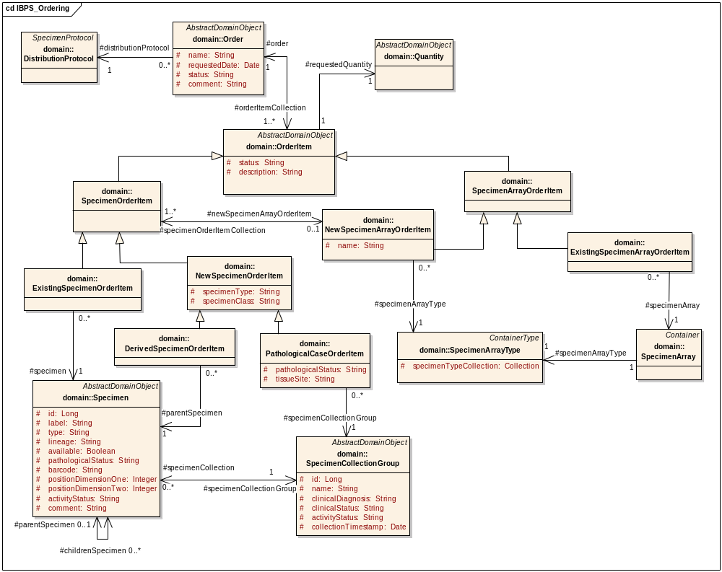
Figure 17 Ordering System
Ordering System module includes following classes:
Order
Associated object | Type
OrderItem | Data
Distribution | Reference
DistributionProtocol | Reference
Table 58 Associated objects of Order

Order
Attribute/Constituent Object | Datatype/Class | Mandatory
Id | Long | Yes
Name | String | Yes
requestedDate | Date | Yes
Status | String | Yes
Comment | String | Yes
Table 59 Order attributes
OrderItem
OrderItem can be of two types SpecimenOrderItem, SpecimenArrayOrderItem
Associated object | Type
Order | Reference
Quantity | Reference
DistributedItem | Reference
Table 60 Associated objects of OrderItem
OrderItem
Attribute/Constituent Object | Datatype/Class | Mandatory
Id | Long | Yes
Status | String | Yes
Description | String | Yes
Table 61 OrderItem attributes

SpecimenOrderItem
SpecimenOrderItem has a generalization link from class NewSpecimenOrderItem and ExistingSpecimenOrderItem.
Associated object | Type
NewSpecimenArrayOrderItem | Data
Table 62 Associated objects of SpecimenOrderItem
SpecimenOrderItem
Attribute/Constituent Object | Datatype/Class | Mandatory
Id | Long | Yes
Name | String | Yes
requestedDate | Date | Yes
status | String | Yes
comment | String | Yes
Table 63 SpecimenOrderItem attributes

NewSpecimenOrderItem
NewSpecimenOrderItem has a generalization link from class DerivedSpecimenOrderItem and PathologicalCaseOrderItem.

DerivedSpecimenOrderItem
Associated object | Type
Specimen | Reference
Table 64 Associated objects of DerivedSpecimenOrderItem

PathologicalCaseOrderItem
Associated object | Type
SpecimenCollectionGroup | Reference
Table 65 Associated objects of PathologicalCaseOrderItem

PathologicalCaseOrderItem
Attribute/Constituent Object | Datatype/Class | Mandatory
pathologicalStatus | String | Yes
tissueSite | Date | Yes
Table 66 PathologicalCaseOrderItem attributes

ExistingSpecimenOrderItem
Associated object | Type
Specimen | Reference
Table 67 Associated objects of ExistingSpecimenOrderItem
SpecimenArrayOrderItem
SpecimenArrayOrderItem has a generalization link from class NewSpecimenArrayOrderItem and ExistingSpecimenArrayOrderItem.
Associated object | Type
SpecimenOrderItem | Reference
SpecimenArrayType | Reference
SpecimenArray | Reference
Table 68 Associated objects of SpecimenArrayOrderItem

Dynamic Extensions API
The caCORE APIs generated from dynamic extensions and the static model are not integrated. For this reason, the data entry and query involves some extra steps that are described in the following sections.

Query
To query the dynamic extensions through API, two queries have to be executed by the user. The first query is executed for the static data to which the annotations are associated.The second query is executed on the other desired annotations after setting the resultant static object in it.
Consider the query to look for all the participants born before 1974, and who also have a smoking history of five years.
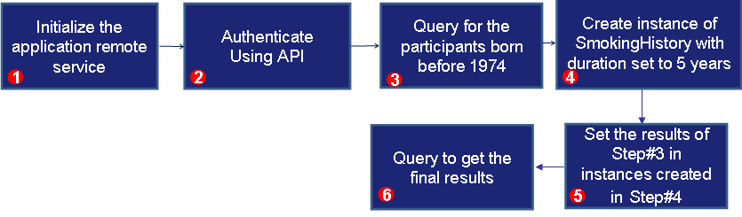
Note: The issue of different APIs will be solved in the next iteration of caTissue Suite, thus using API for dynamic extensions will become seamless.
- Initialize the Application Remote Services.
appServiceCatissue = ApplicationServiceProvider.getRemoteInstance("http://localhost:8080/catissuecore/http/remoteService");
appServiceDEEntity = ApplicationServiceProvider.getRemoteInstance("http://localhost:8080/CA/http/remoteService");
- Authenticate using API
ClientSession cs = ClientSession.getInstance();
cs.startSession("admin@admin.com", "Login123");
- Query for caTissue static objects
String hql1 = "from edu.wustl.catissuecore.domain.Participant as participant where participant.birthDate < 1974";
HQLCriteria criteria1 = new HQLCriteria(hql1);
List participantList = (List)appServicecaTissue.query(criteria1, Participant.class.getName());
- Create instance of Annotations
SmokingHistory smokingHistory = new SmokingHistory();
smokingHistory.setDuration(5);
smokingHistory.setParticipant(participant);
- Query for Annotations
appServiceDEEntity.search(SmokingHistory.class,smokingHistory);

Inserting data for Annotations
To insert data for the dynamically created Annotations, following steps have to be followed:
Note: Program referred in the example is present in catissue_v1.2_ build/caTissue_Suite_API_Client_v1.2_Installable/catissue_de_integration_client/src/client/ClientDemo_CA.java
- Query for the static hook object for which the annotation has been created.
Static hook objects: Participant, Specimen, SepcimenCollectionGroup
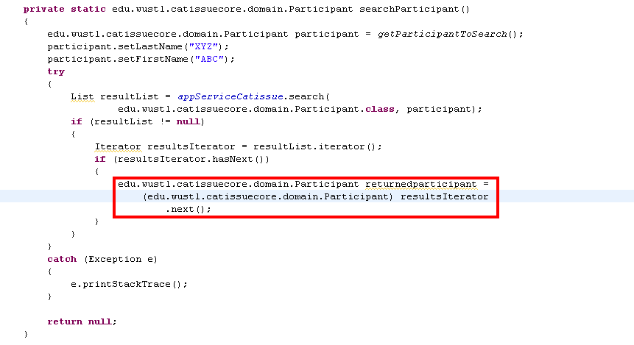
- Create integration record entry object from package edu.wustl.catissuecore.domain.deintegration.
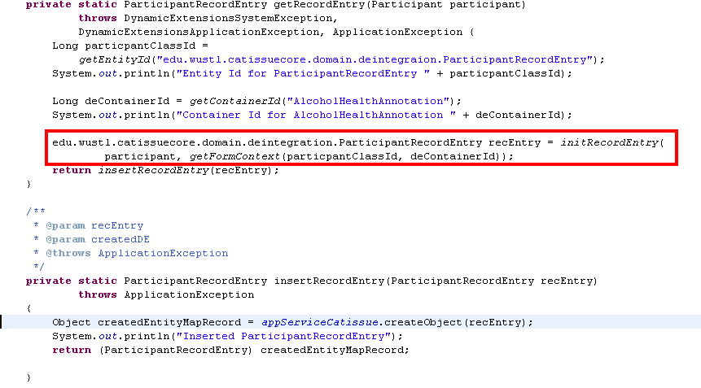
Note: ParticipantRecordEntry Object created in this steps belong to package “edu.wustl.catissuecore.domain.deintegration”
- Create annotation record entry object from package to which annotation belong and set the id from the record entry object created in the step 2 and set it in the new instance of the annotation
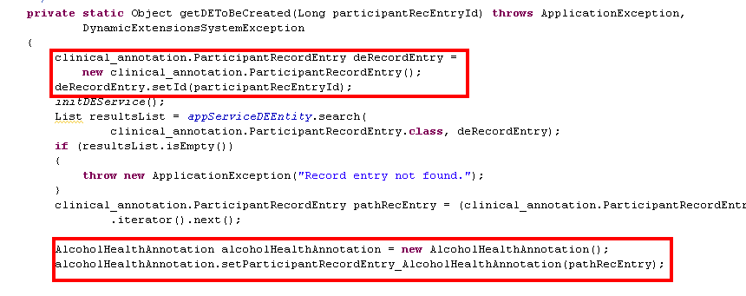
- Populate annotation object attributes and insert it using application service object.
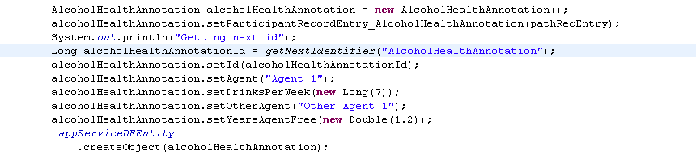

Updating data for Annotations:
To update data for the dynamically created Annotations, following steps have to be followed:
- Query for the desired annotation to be updated.
- Modify the data for the annotation and update it
Consider the example to update the smoking history of five years for all participants born before 1974 to smoking history of 10 years.
- Query for all participants who were born before 1974. This is described above in step 3 under Query.
- Query for Smoking History for five years for all these participants as described in steps 4, 5, and 6 under Query.
- Modify the annotation as desired.
smokingHistory.setDuration(10);
- Update the annotation.
appServiceDEEntity.updateObject(smokingHistory);

Loading Dynamic Extensions via XMI Import
Dynamic extensions are created by XMI import (XML metadata interchange import) mechanism, into the application. There are four main steps to accomplish the above goal:
- Create UML model
- Import XMI of the UML model
- Import permissible values
- Import form definition file

a. Create UML model
You can define the required classes and attributes in a UML model using a UML modeling tool, such as Enterprise Architect (also called EA, and is presently supported for UML modeling for caTissue). You can specify within the UML model the class(s) (Or entity), attribute(s), attribute data type, attribute/class concept code(s), attribute validation(s), attribute PHI feature. While creating a new UML model, first compare the Data Dictionary for the Study you are modeling and find out the entities from the unified model that you can re-use. Create a template accordingly and then proceed with the model.
b. Import XMI of the UML model
Once the above components are defined in the model, you can export the model to an XMI file with appropriate version and export parameters from EA. You can then import this XMI into the caTissue application by running an ANT command.
c. Import permissible values
Once the UML model is imported, you can upload permissible values into the system for all the enumerated attributes of the model. This can be done in two ways-
- Create a CSV file in which all the permissible values are explicitly specified for each enumerated attribute, or
- Create a CSV file in which absolute path of text files is specified. These are text files that contain the permissible values separated by line

d. Import form definition file
Next you can define the custom view of the form that is how you want your form to look like on the UI. This can be done by creating a form definition file that contains description about the display of data fields required on the form at the time of data entry. The form generated so, is based on the entity and attribute information imported from the model into the system through XMI.
Within the form definition you can use attribute(s) from one entity or from a number of different entities that essentially belong to the same entity group.

You can define default values and display properties for these attributes as well as and restrict the initially uploaded permissible values to a subset of those values. You can also override the validations defined earlier in the UML model by defining the modified validations in the form definition. While overriding the validations in form definition, these can be made more restricted than the ones specified in the UML model.

You can as well mark one or more attributes as related attributes (that is an attribute for which a predefined default value, as specified in form definition file, will be inserted while data entry). You can make these related attributes either visible or invisible on the form as per requirement. The visible related attribute’s default value is displayed in a ‘Read only’ mode while the invisible related attributes are not displayed on the UI at all.

You can logically group attributes and define a sub form within the main form. Multiple instances of an entity can be used in different sub-forms within a main form. Sub forms can be created up to any depth within the main form, for example a main form contains a sub form which further contains a sub form and so on.
You can make the label of a form/sub-form visible or invisible as per requirement. For example, the display-label only for the first instance of a sub form must be displayed and none for the remaining instances.

2. Importing Classes from XMI:
To import an XMI, perform the following steps:
- Create UML model for the desired extensions using Enterprise Architect (v6.1) (UML modeling tool). For example, consider the following UML model created in EA:
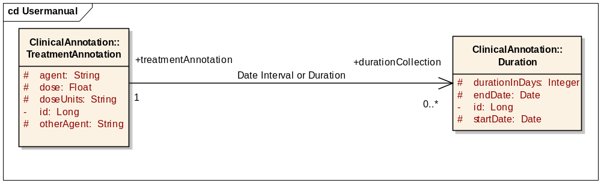
Figure 1: UML Model Created in EA
- Define the concept code(s) and definition for class(s) and attribute(s) as tagged value (standard tags used/supported by SIW) if required. (To add a tag press Ctrl+Shift+6 or click View in the Menu bar and select Tagged Values)See Table 70:Tagged Values allowed in UML model
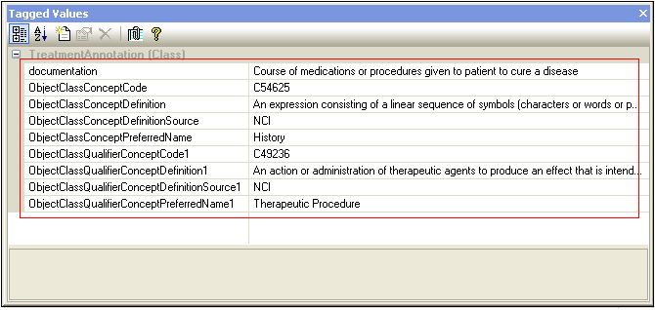
Figure 2: Concept Code Tagged Values for a Class
- Define the validations on attribute as tagged values, if required. See Table 70:Tagged Values allowed in UML model.
- Define PHI attribute feature as tagged value, if required. See Table 70:Tagged Values allowed in UML model..
- Define attribute display properties as tagged values. See Table 70:Tagged Values allowed in UML model.
The prerequisites to create UML model are:
- Create a template by including al the entities, attributes, associations from the unified UML model that you can re-use in the study.
- The names of the entities, attributes, associations should not contain spaces in it.
- Association should have directionality. Both source and target class must have multiplicity.
- Associations should have link names without any spaces embedded in it. This name will be the name given to the association on the UI.
- To specify containment of one entity under another entity, containment type for the association must be selected as Reference and Value in the source and target roles respectively. For containment type selected as Not Specified, the target entity gets generated as a look-up association to the source entity. See the following figure - Association Properties Dialog Box.

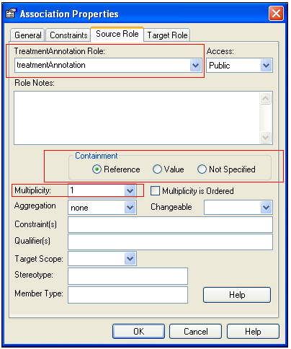
Figure 3: Association Properties Dialog Box
- Delete the association and add a new association while changing the containment type, in EA.
- The name of the XMI file generated will be the name of the Entity Group.
- EA version 6.1 is supported. No other UML modeling tools are supported in caTissue.

 | - Concept Codes, Concept Definitions, Preferred Names, and Definition Source cannot have following special characters in their values: <, >, ~, #, :, and comma.  - Order of concept code, definition, source and preferred name can be interchanged.  - If there is a need to specify, then only Concept Code is mandatory while the remaining tags are not.  - Entity/Class names should start with an Upper case letter and should be in Camel Case (no spaces allowed). Ex: For a class capturing pathological annotations, the class name should be PathologicalAnnotations.  - Attribute names, association names, source role names and target role names should start with lower case, at least first two letters should be in lower case. Ex: kResult is invalid, but kresult is valid. These should also be in camel case (no spaces allowed).  - None of these names can begin with a digit.  - Class names, association names, attribute names, source role names or target role names in any model can only have any of the alphabet/digit (but not at the beginning)/underscore (_). No other characters are allowed.  - A source/target role name of an association should not match with the association name, or the name of any attribute in the main class.
- Under Project View window of EA, right-click Logical Model and select Export. Export the XMI format of the UML model created in Step1 using Enterprise Architect by selecting options:
  - Select the Format XMI Output and Use DTD check box under General Options,
  - Select UML 1.4 (XMI v1.2) from the XMI Type drop-down list under For Export to Other Tools.
  - Click Export.
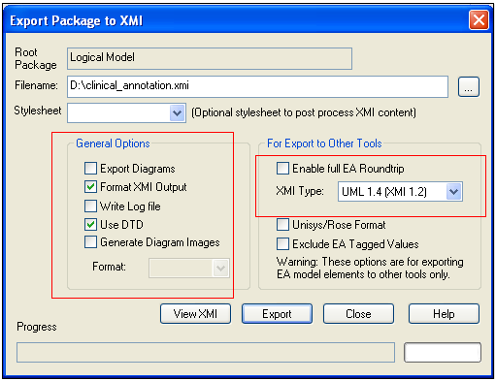
Figure 418: Exporting UML Model from Enterprise Architecture

- Create the Main Container List CSV file as follows:
  - Open an excel spreadsheet.
  - Enter the name of the class which is to be hooked to a static suite-entity and also to be used to define the main form in first column of the first row. Similarly, enter the name of all such classes in the spreadsheet, one in each column of first row.
  - Save the file as a .csv file.

The csv file (say container.csv) for the UML model example given above would contain the name of the class TreatmentAnnotation that has to be hooked to the static suite-entity Participant and also be used for defining the main form Treatment Annotation. The file will not contain the other class Duration (sub class) because it will not be hooked directly to any static entity nor be used to define any main form. Rather it will be used to define the sub form within the main form Treatment Annotation.

- Run the ant task to import the XMI of the model into caTissue Suite as follows:
  - Unzip the caTissue Suite installable zip at an appropriate location.
  - Go to the command prompt and change the directory to the unzipped folder.
  - From this directory, run the following ant target:
ant import_xmi -Dfilename=”<FILENAME>” -Dhookentity=”<HOOKENTITYNAME>” -DmainContainerList=
”<MainContainerCSVFileName>” -Dpackage=”<Package>” -Dgenerate.cacore=<caCORE Generation flag>
Table 69: ANT Command Field Description
Parameter | Description | Mandatory
<FILENAME> | Absolute path and name of XMI file exported from EA in the previous step. For example: D:\clinical_annotation.xmi | Yes
<HOOKENTITYNAME> | Full qualified name of the hook entity for e.g. Participant, Specimen, SpecimenCollectionGroup in caTissue.
<MainContainerCSVFileName> | Path and name of CSV file that must contain the name of class(s) that would be linked directly to the static caTissue Suite hook objects and will be used to define the main form(s). For example: in the file D:\container.csv you specify class TreatmentAnnotation as the class to be hooked to a static class and used to create the main form. | Yes
<Package> | Package name in the UML model under which all the classes that have to be imported into the application, are present. For example: you have a UML model which has classes defined under two different packages, and you want to import only the classes under one of the package. In this case you can specify the name package to be imported. | Yes
<caCORE Generation flag> | This is true by default and generates caCORE. But when set to false, it imports model without caCORE generation. | No (takes value true when not specified)
Example:
ant import_xmi -Dfilename=" D:\clinical_annotation.xmi" Dhookentity=edu.wustl.catissuecore.domain.Participant -DmainContainerList="D:\container.csv" -Dpackage=ClinicalAnnotation

The order of parameters in the ant task should be the same as specified in the above example.
- On successful completion of the task, a message is displayed.
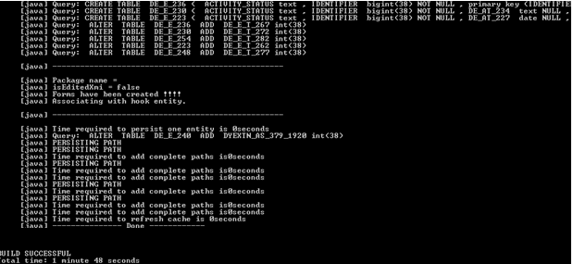
Figure 5: Success Message on Completion of XMI Import

Table 70:Tagged Values allowed in UML model
UI Property | UML Tag Name | Tag used for | UML Tag Value
Concept Codes for Classes | ObjectClassConceptCode  ObjectClassConceptPreferredName  ObjectClassConceptDefinitionSource  ObjectClassQualifierConceptCodeN  ObjectClassQualifierConceptPreferredNameN  ObjectClassQualifierConceptDefinitionSourceN | Class | alphanumeric
Concept Codes for Attributes | PropertyConceptCode  PropertyConceptPreferredName  PropertyConceptDefinitionSource  PropertyQualifierConceptCodeN  PropertyQualifierConceptPreferredNameN  PropertyQualifierConceptDefinitionSourceN | Attribute | alphanumeric
Concept Definitions for Classes | ObjectClassConceptDefinition  ObjectClassQualifierConceptDefinition | Class | alphanumeric
Concept Definitions for Attributes | PropertyConceptDefinition  PropertyQualifierConceptDefinition | Attribute | alphanumeric
Mandatory | Rule_required | Attribute
Unique values | Rule_unique | Attribute
Range | Rule_range_min, Rule_range_max | Attribute | number
Max length | MaxLength | Attribute | number
Precision | Precision | Attribute | number
Date format | Format | Attribute | DateOnly,  DateAndTime,  MonthAndYear,  YearOnly
Display as URL | URL | Attribute | true/false
Single line / Multi line | Multiline | Attribute | number (No. of lines)
Text box as password | Password | Attribute | true/false
Default value | DefaultValue | Attribute | text, number
PHI attribute | PHI | Attribute | true/false
Display width | DisplayWidth | Attribute | number
Date Range | Rule_dateRange_min, Rule_dateRange_max | Attribute | date ‘–‘ separated
Specifying List Box or MultiselectCheckbox | Multiselect | Attribute | number of lines
Specifying List Box or Combo Box or MultiselectCheckbox for Look-up Association | Multiselect | Association | number of lines
Separator for Look-up Association | Separator | Association | comma, colon, dot, space
Specifying attributes to be displayed in drop down for Look-up Association | DisplayInAssociationDropDown | Association | Comma-separated attribute names

3. Importing Permissible Values:
To import Permissible Values for enumerated attributes, perform the following steps:
- Create a CSV file for permissible values of all the enumerated attributes based on any of the two templates mentioned below:
  - When the number of permissible values of attribute(s) is small they can be defined in the main CSV itself. Concept code, concept definition and other concept information can also be associated with each permissible value within the main CSV file, though optional.
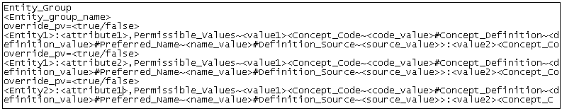
Figure 6: Permissible Value CSV File Template a
  - When the number of permissible values of an attribute is large, they can first be defined in a text file separated by line. Concept code, concept definition and other concept information can also be associated with each permissible value within the text file, though optional. The name and path of this text file can then be specified in the main CSV file.

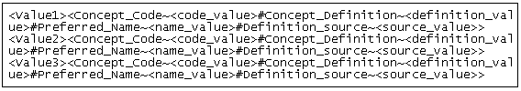
Figure 19: Permissible Value Text File Template
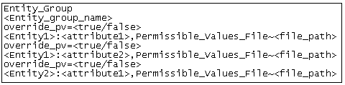
Figure 20: Permissible Value CSV File Template b
Table 71: Permissible Value CSV File Field Description
Keyword/Data field | Meaning/Action | Mandatory
Entity_Group | This is a keyword used to mark the beginning of an entity group. | Yes
<Entity_Group_Name> | Enter the Entity group name which is the name of XMI that you imported previously | Yes
override_pv=<true/false> | override_pv keyword is used to specify whether the old set of permissible values is to be over-ridden by a new set for an attribute. Set the value equals true if importing the permissible values for an attribute for the first time.  Set the value equals false if editing an existing set of permissible values imported earlier for an attribute. This needs to specified for every attribute in the csv file. | No
<Entity> | Enter the name of the entity whose attribute you want to enumerate. | Yes
<Attribute> | Enter the name of the attribute of the above mentioned entity for which you want to import permissible values. | Yes
Permissible_Values~<value1><Concept_Code~<co  de_value>#Concept_Definition~<definition_value>  #Preferred_Name~<name_value>#Definition_Sourc  e~<source_value>>  :<value2> | The keyword Permissible_Values before the tilde (~) marks the beginning of the permissible values. Enumerate the permissible value(s) after the tilde (~) character, and separate them by colon.  (Optional) <Concept_Code~ is a keyword to mark the begining of concept code information for a permissible value. You may enter the code_value, definition_value, name_value and source value for that PV. | Either one of the two tags, viz., Permissible_Values or Permissible_Values_File can be used. One of them is mandatory, but specifying concept codes for Permissible Values is optional
Permissible_Values_File~<file_path> | The keyword Permissible_Values_File before the tilde (~) marks the beginning of the permissible value file name. If number of permissible values is large then define them in a text file and separate each value with a new line. Enter the path and name of this file after the tilde (~) character. | Either one of the two tags, viz., Permissible_Values or Permissible_Values_File can be used. One of them is mandatory. Specifying the Concept Codes in the line separated PV file for each attribute is optional

Ex: Consider the following permissible value CSV files based on both the templates given above:
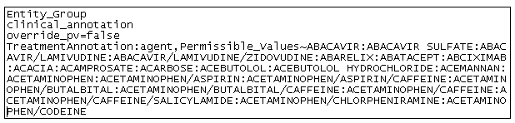
Figure 9: Permissible Value CSV File (template a) - D:\pv.csv
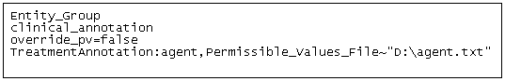
Figure 10: Permissible Value CSV File (template b) - pv.csv
Permissible Values are contained in file “agent.txt” as follows:
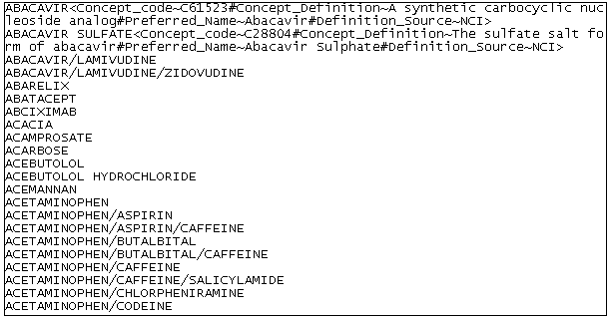
Figure 11: Text file containing line separated PVs - agent.txt
- Permissible Values cannot contain colon or any keywords.
- For all the cases of first-time upload of permissible values, “override_pv = false”
- “override_pv = true” holds good in case where one needs to edit permissible values already uploaded for an attribute through process mentioned above. This should be specified separately for each attribute in the csv file for which you want to override the old PVs.
- By default, “override_pv=false”.
- PVs cannot be overridden once data entry has been done for an attribute.

- Run the ant task to import the permissible value CSV into caTissue Suite as follows:
  - Go to the command prompt and change the directory to the unzipped folder of CaTissue Installable zip.
  - From this directory, run the following ant target:
ant import_permissible_values -Dpv.dir=<Path of the directory that has all the PV text files and the main PV.csv files> -DpermissibleValuesFile=<Path of the PV.csv file>

Table 72: ANT Command Field Description
Parameter | Description | Mandatory
-Dpv.dir | Relative or absolute path and name of the directory where the PV text files and CSV files are present. | Yes
-DpermissibleValuesFile | Relative path and name of the PV.csv files. If this is not specified PVs from all the main CSV files will be imported. If this is specified PVs from only the specified file will be imported. The paths specified within this file MUST be relative to the –Dpv.dir path. NOTE: Only relative paths are allowed here. | No
Example:
ant import_permissible_values -Dpv.dir=D:\CPUML -DpermissibleValuesFile=CPUML\PermissibleValues.csv

- On successful completion of the task, a message is displayed.
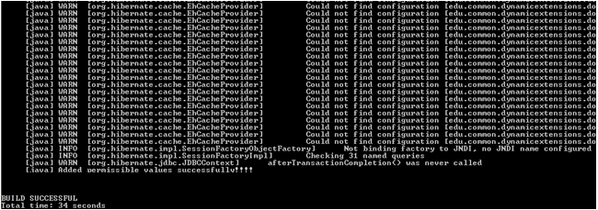
Figure 12: Success Message on Completion of PV Upload

4. Importing Form Definition:
To import Form Definition, perform the following steps:
- Create a CSV with form definition as per the template mentioned below. The template below tells how to define a custom view for a form based on the UML model which is imported into the system using an XMI.
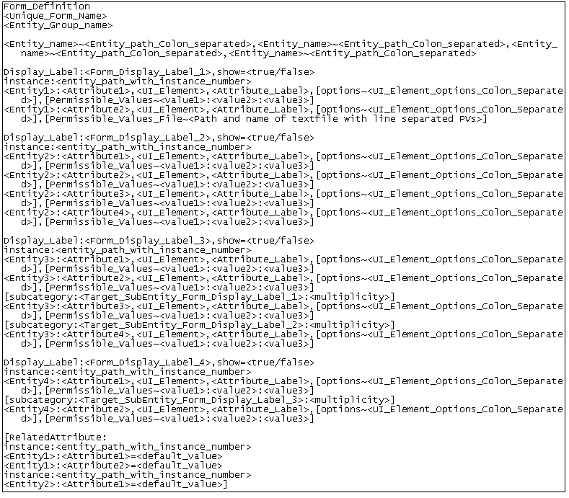
Figure 13: Form Definition CSV File Template
Note: In the template defined above, parameters enclosed within square brackets [] represent the optional parameters.
Table 73: Form Definition CSV File Field Description
Keyword/Data field | Meaning/Action | Mandatory
Form_Definition | This is a keyword used to mark the starting of a form definition. | Yes
<Unique_Form_Name> | Enter the name of the form. This is not shown on UI though. | Yes
<Entity_Group_Name> | Enter the Entity group name which is the name of XMI imported previously based on which you define your form. | Yes
<Entity_name>~<Entity_Path_Colon_Separated> | Enter the Entity name and its path in original entity model specified as colon-separated entities.  This helps in specifying the entity chosen in a form hierarchy. The left side of ~ denotes the entity name and right side denotes the path. | Yes
Display_Label:<Form_Display_Label>,show=<true/false> | Enter the display label for the form that you may want to display on the UI. If you wish to display this label on the UI, set show=true. If you do not wish to display the label on the UI, set show=false. | Yes
instance:<entity_path_with_instance_number> | Enter the actual path of the entity while creating form. The path must start from the root entity in the model. | Yes
<Entity>:<Attribute> | This marks the starting point for specifying the UI control property associated with an attribute in a particular entity. Enter the entity name and attribute name separated by colon. | Yes
<UI_Element> | Enter the UI control type for the attribute specified above. See Table 7 for control types. | Yes
<Attribute_Label> | Enter the label for the attribute specified above to be displayed on the UI. | Yes
options~<UI_Element_Options_Colon_Separated> | Enter the properties of UI control for attribute specified above. See Table 8 for UI control properties. | Optional
defaultValue=<default value> | Specify the Default Value that should be displayed/selected for the attribute. This keyword is added comma separated after “options”. | Optional
PermVal_Options~IsOrdered=<true/false> | This option enables us to specify whether the PVs should be displayed in the order specified in the PV file or should be alphabetically sorted. Default value is ‘true’ and by default the PVs are sorted alphabetically. To make the PVs appear in the same order as specified in PV file, set this to ‘false’. This option should be set for each attribute where PV sorting is not required. | Optional
Permissible_Values~<Value1>:<Value2>… | Enumerate the permissible values, in case you wish to display only a subset of the previously imported list of permissible values and the subset PV list is small. | Optional
Permissible_Values_File~<Path and name of text file with line separated PVs> | Enter the path and name of the text file containing line separated PVs in case you wish to display only a subset of the previously imported list of permissible values and the subset PV list is large. | Optional
subcategory:<Target_Sub_Form_Display_Label>:  <Multiplicity> | Enter the subcategory target_sub_form name and its multiplicity.On UI Subcategory appears as a sub form within its parent form. Set Multiplicity as single if only one instance of subcategory form is required within the parent.  Set Multiplicity as multiline if more than one instance of subcategory form is required within the parent. | Optional
RelatedAttribute: | This is a keyword to mark the beginning of all invisible related attribute(s) definition. Related attributes are those for which a default value is inserted automatically whenever data entry for the form is done. | Optional
SkipLogicAttribute: | This is a keyword to mark the beginning of all skip logic attribute(s) definition. Skip logic attributes are for enumerated controls where selection of permissible value enable/disable dependent controls. | Optional
instance:<entity_path_with_instance_number> | Enter the actual path of the entity whose attribute(s) is to be defined as related attribute. The path must start from the root entity in the model. | Yes, if Related Attribute is specified
<Entity>:<Attribute>=<default_value> | This marks the starting point for specifying the related attribute’s default value. Enter the entity name and attribute name separated by colon. Enter the default value that must get inserted whenever data entry for the form is done. | Yes, if Related Attribute is specified
Rules~required:range-min=<minimum value>&max=<maximum value> | This Rule enables user to specify a range to numeric attributes (Integer, Long, Float, Double) and date attributes. The specified range should be a sub-set of the one specified in the UML model. Also, the min and max value specified for date should match the date format specified in the UML model. | Optional
Rules~allowfuturedate | This rule enables user to allow future date for a date attribute. | Optional
HEADING~<Heading> | This enables the user to add a heading/title to the form/sub-form before any attribute irrespective of the form structure. Only one heading can be added before one attribute. So, on using this, the UI will look like a sub-form title while actually it won’t be a separate sub-form. Note: Commas or colons are not allowed in the Heading. | Optional
NOTE~<Note/Instruction> | A note or an instruction can be added before attribute in a form using this syntax. Multiple instructions can be added before an attribute. The added note/instruction appears in bold characters. The added instruction should not contain commas or colons. NOTES can be added after a HEADING or without a HEADING. | Optional

- To use property [Permissible_Values~< Value1>:<Value2>] OR [Permissible_Values_File~< Path and name of text file with line separated PVs >], you must ensure that the original list of permissible values has been imported for that attribute in the system (Refer to section describing procedure for importing permissible values).
- To define a subform, you must ensure that the target subform has been defined in the CSV prior to the form expected to contain the subcategory definition.
- Different instances of the same entity-attribute can have different default values, in case of invisible related attribute.
Example: Consider the following form definition CSV file based on example of model above:
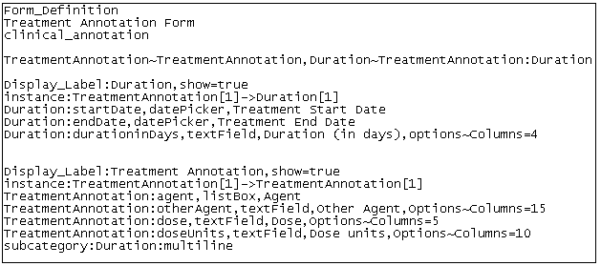
Figure 14: Form Definition CSV File - D:\annotation.csv
- More than one form definition can be specified in the same category CSV.
- Keywords cannot be used as permissible values, form names, other definitions. See keywords enumerated in Table 70:Tagged Values allowed in UML model.
- Definition for form(s) and its attributes must be based on available entities and their attributes within the same entity group. All entities within that entity group must be associated to same hook entity.

- Run the ant task to import the form definition CSV into caTissue Suite as follows:
  - Go to the command prompt and change the directory to the unzipped folder of caTissue Suite Installable zip.
  - From this directory, run the following ant target:
ant create_category -DcategoryFileDir="<Path of the category file directory>" -DcategoryFormNamesFile=<path of the file which contains the list of categories to be imported from the -DcategoryFileDir> -DisPersistMetadataOnly=<true/false>

Table 74:ANT Command Field Description
Parameter | Description | Mandatory
-DcategoryFileDir | Path and name of folder which has all the category files. For example: D:/CPUML | Yes
-DcategoryFormNamesFile | Relative path and name of the file that consists of the names of the categories to be imported. This is an optional argument. In absence of this all the categories in –DcategoryFileDir directory will be imported.. Ex: CPUML/Renal/… | No
-DisPersistMetadataOnly | This value when set to true, saves only the category metadata and not the DE tables. This is set to false by default. This property is not required for usual form development | No

Example:
ant create_category -DcategoryFileDir ="D:\CPUML\Renal" -DcategoryFormNamesFile="D:\CPUML\Renal\CatNames.txt" -DisPersistMetadataOnly=false
- On successful completion of the task, a message is displayed.

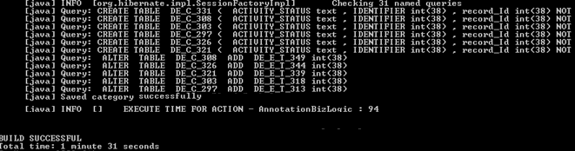

The JBoss server has to be restarted once the form creation ant target has been executed.
Table 75:Valid UI Control Types
UI Control Type | Description
textField | This is a single line edit box control.
listBox | This is a single or multi-select list box control.
datePicker | This is a date picker control with default date format “DateOnly”.
fileUpload | This is a file upload/browser control.
radioButton | This is an option button control.
textArea | This is a multiline edit box control.
checkbox | This is a check box control with default display as unchecked.
comboBox | This is a single select drop-down control.
multiselectCheckBox | This is a single or multi-select checkbox controls.

‘listBox’ & ‘multiselectCheckBox’ can be used in form if the corresponding attribute is tagged ‘Multiselect’ in the XMI import.

Table 76:Valid UI Control Properties
UI Control Type | UI Control Properties | Description
textField | Columns | Width of text field.
 | IsPassword | Text field of type password (value = true/false).
 | IsUrl | Text field displayed as URL (value = true/false).
textArea | Columns | Number of columns in a text area.
 | Rows | Number of rows in a text area.
 | IsPassword | Text field of type password (value=true/false).
listBox | IsMultiSelect | Multiple selection of values (value = true/false). For specifying this property, ‘Multiselect’ tag should have been added for that attribute in the UML model. (Refer to table 2)
 | NoOfRows | Number of rows to be displayed on the UI of list box.
All Control Types | IsReadOnly | IsReadOnly=true makes the attribute a visible related attribute with a read only default value.
 | defaultValue | Value to be displayed by default for a normal attribute (either enumerated or non-enumerated) or value to be inserted by default for a visible related attribute. For enumerated normal attribute, default value has to be one of the previously imported permissible values.

Table 77:Keywords
Keyword | CSV File type
Entity_Group | Permissible Value CSV
override_pv | Permissible Value CSV
Permissible_Values | Permissible Value CSV/Form Definition CSV
Permissible_Values_File | Permissible Value CSV/Form Definition CSV
Form_Definition | Form Definition CSV
Display_Label | Form Definition CSV
instance | Form Definition CSV
options | Form Definition CSV
subcategory | Form Definition CSV
RelatedAttribute | Form Definition CSV
defaultValue | Form Definition CSV
PermVal_Options | Form Definition CSV

NOTE: In a Form Definition File or a Permissible Value csv file, comments can be added by using ## at the start of the line. So any line starting with ‘##’ will not be read while importing the PVs or Form and will be considered as a comment.
Log on to the CaTissue application using the UI and perform the following checks:
- Click the Administrative Data tab.
- Select Define under Local Extension. Under Existing annotations, check the entity group that must get created upon importing the XMI.
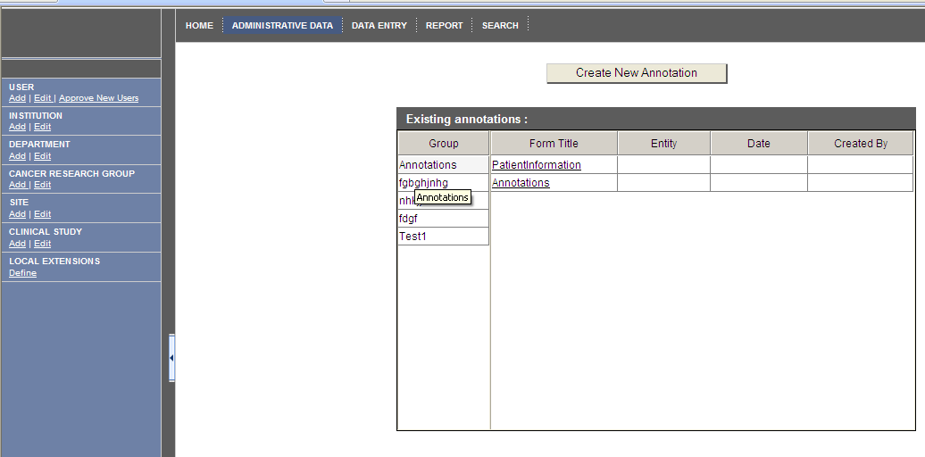
Figure 15: Importing XMI: Groups Created

- Click the Biospecimen Data tab and check the data entry forms as follows:
  - Select the CP Based View under the Biospecimen Data tab.
  - Select a collection protocol under which form is available.
  - Navigate to the edit page of the hook entity object.
  - Click the View Annotations tab.
  - Select the annotation and click the Go button.

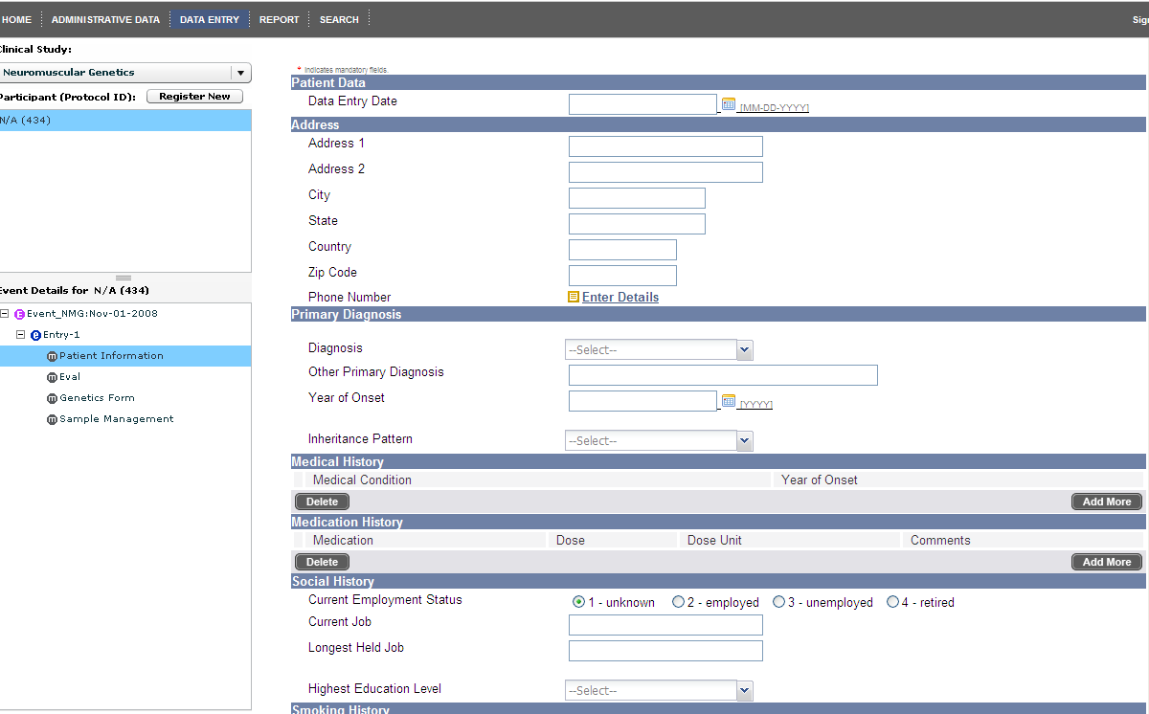
Figure 16: Importing XMI - Data Entry Form
Note: The data entry form fields are created based on the UI control type, UI control type properties and other definitions as specified in the form definition CSV.

5. Importing Form Definition for a UML Model with Inheritance:
Many UML models contain classes that have inheritance-relationship between them. The inheritance relationship implies that all the attributes/associations of the parent class get inherited in the derived class. The feature of form-with-inheritance allows the user to specify form definition for any of the attribute(s) and/or association that gets inherited in a derived class.

The csv form definition process is similar for using entities having inheritance relationship. The syntax for defining form name, attribute name, path definition, and related attributes remains exactly the same.

For example, consider the following entity diagram (Figure 89). It contains inheritance up to one level. The parent class is SpecimenBaseSolidTissuePathologyAnnotation which has associations with classes SpecimenHistologicType, AdditionalPathologicFinding, SpecimenInvasion, SpecimenHistologicGrade. The derived class ProstateSpecimenPathologyAnnotation inherits attributes and associations from the parent class SpecimenBaseSolidTissuePathologyAnnotation.

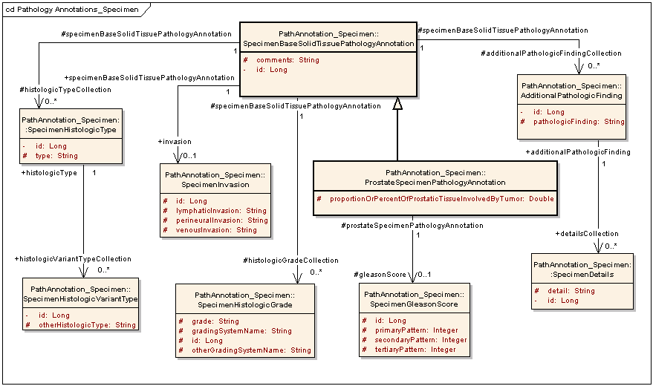
Figure 17: UML Model with Inheritance
The import procedure for an XMI of this model remains the same as mentioned earlier in the user manual. The entity used in the main form should be present in the main container list. After you import the XMI, you may import permissible values for all enumerated type attributes through the previously defined process. Once you upload the permissible values, you must import the form definition.

In the form definition CSV file, you can define the inherited attributes as well as associations directly within the derived class definition. You do not need to define the parent class in the path definitions for derived class. The Form definition file for the model (with inheritance relationship) given above is as follows:

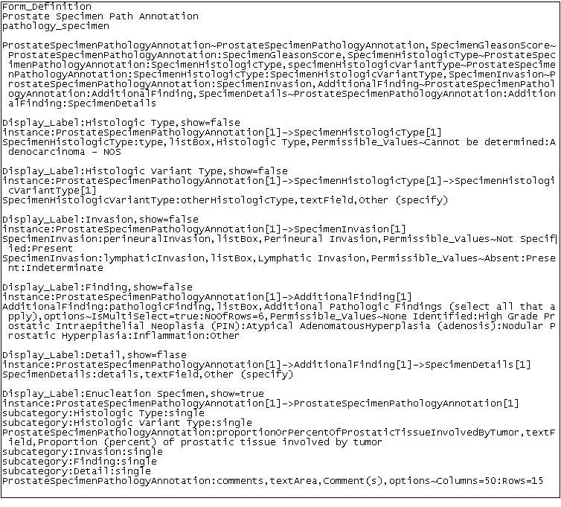
Figure 21: Form Definition CSV File with Inheritance
The UI display for the form definition specified above is as follows:
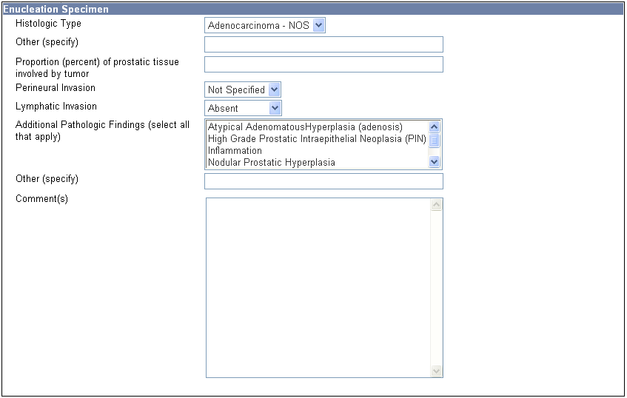
Figure 19: UI Display for Form Definition with Inheritance

6. Single Line Display

With this feature, two or more attributes in a form may now be shown in a single horizontal line. This helps in increasing the readability of the form and reduces vertical scrolling. All attributes logically related can be grouped on a single line (e.g. vitals below). The attributes on a single line can be separated by a separator (like ‘/’ or ‘:’ or any string) and unnecessary attribute labels (e.g. ‘systolic’ and ‘diastolic’ below) may be hidden.
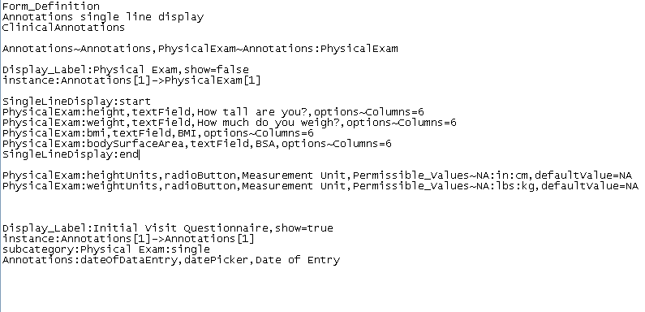
Figure20: Form definition file for single line display
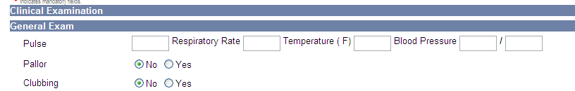

Figure21: Example of single line display of attributes.

7. Calculated Attributes
Frequently, data coordinators and clinical researchers require clinical variables to be calculated based on the values of previously entered variables. This feature allows users to define any attribute from any class in the UML model as a calculated attribute within the form definition.

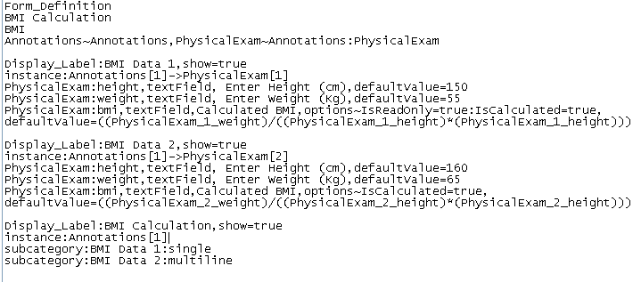
Figure 22: Form definition file for calculated attributes.
The format for defining Calculated-Attributes (ones with default value displayed as either editable or read only) is as follows:
[Class1]:[Attribute1],[UI_Control_Attribute1],[Attribute1_Label],options~[IsCalculated=true:Columns=n:Rows=m:isReadOnly=true/false etc], defaultValue=(([Class1]_[InstanceNumber]_[Attribute2])+([Class1]_[InstanceNumber]_[Attribute3]))

EXAMPLE-
******************************************************************************
PhysicalExam:bmi,textField,Calculated BMI,options~IsReadOnly=true:IsCalculated=true,defaultValue=((PhysicalExam_1_weight)/((PhysicalExam_1_height)*(PhysicalExam_1_height)))
******************************************************************************

The format for defining Calculated-Attributes (ones as invisible related attributes) is as follows:
RelatedAttribute:

[Class1]:[Attribute1]=(([Class1]_[InstanceNumber]_[Attribute2])+([Class1]_[InstanceNumber]_[Attribute3])),options~[IsCalculated=true]
EXAMPLE-
******************************************************************************RelatedAttribute:

instance:Annotations[1]->PhysicalExam[2]
PhysicalExam:bmi=((PhysicalExam_2_weight)/((PhysicalExam_2_height)*(PhysicalExam_2_height))),options~IsCalculated=true
******************************************************************************

Example: In the example below, height and weight have been specified in the formula for calculating BMI. So, when the user enters height and weight and clicks the calculate button, the value for BMI gets populated as per its formula (e.g. BMI = wt (kg)/height (m)^2).

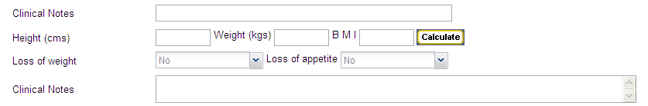
Figure 223: Example of calculated attribute in DE form

8. Skip Logic
This feature is supported in Dynamic Extensions 1.3.0 & later releases.

Attributes or fields captured in a form are sometimes logically related to each other. The value entered for one field decides the choice or availability of subsequent field(s) or section(s) in the form.
With this new feature, users can
- Specify the dependency of an attribute on another attribute.
- On selection of permissible value for an enumerated control or checkbox.
- Change dependent controls permissible values as well as the default values.
- Enable/disable dependent controls.
- Show/Hide dependent controls.
- Show/Hide dependent sub forms in a form.
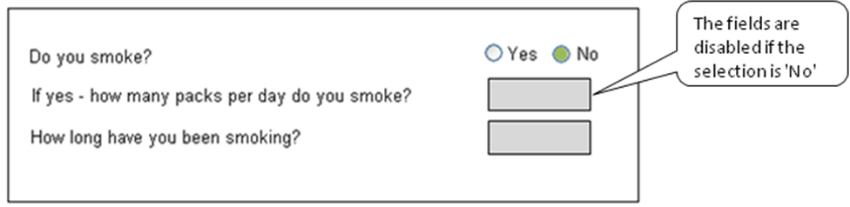

Figure 24: Example of skip logic in DE form
The format for defining Skip Logic Attributes is as follows:

SkipLogicAttribute:
instance:[instance path for source attribute], [instance path for target attribute]
[Class1][instanceNumber]:[Attribute1]:[PermissibleValue1],[dependent_attribute]~ [Class2][instanceNumber]:[Attribute2/all][,options~[IsSelectiveReadOnly=true/false:IsShowHide=true/false:etc][,Permissible_Values_File~filepath][,defaultValue=value]

EXAMPLE-
******************************************************************************
SkipLogicAttribute:
instance:PathologicalAnnotations[1]->History[1]->Hazards[1],PathologicalAnnotations[1]->PhysicianInformation[1]->PhyContactInfo[2]
Hazards[1]:hazardType:Tobacco,dependentAttribute~PhyContactInfo[2]:phoneType,Permissible_Values_File~D:/template/template/bug_import/bug_import/PVs/PhoneType1.txt,options~IsSelectiveReadOnly=true

instance:PathologicalAnnotations[1]->History[1]->Hazards[1],PathologicalAnnotations[1]->PhysicianInformation[1]->PhyContactInfo[1]
Hazards[1]:hazardType:Tobacco,dependentAttribute~PhyContactInfo[1]:all,options~IsShowHide=true

******************************************************************************

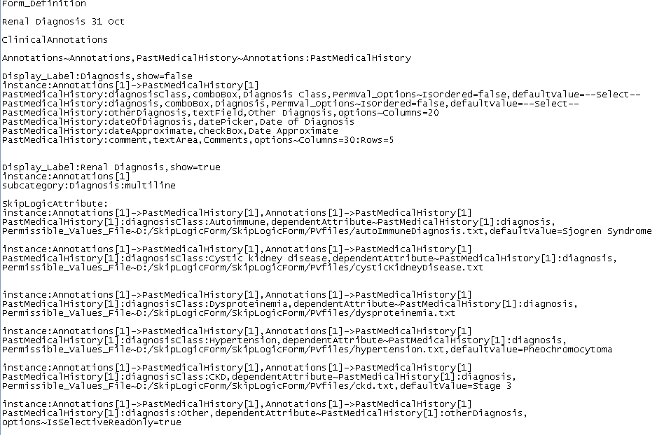
Figure 25: Form definition file for skip logic for attributes.

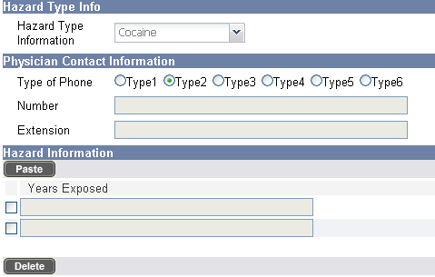
Figure 26: On selecting permissible value ‘Cocaine’ & ‘Type3’ controls -Number, Extensions & Years exposed are disabled.

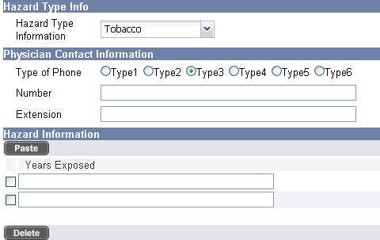

Figure 27: On selecting permissible value Tobacco’ & ‘Type3’ controls -Number, Extensions & Years exposed are enabled.

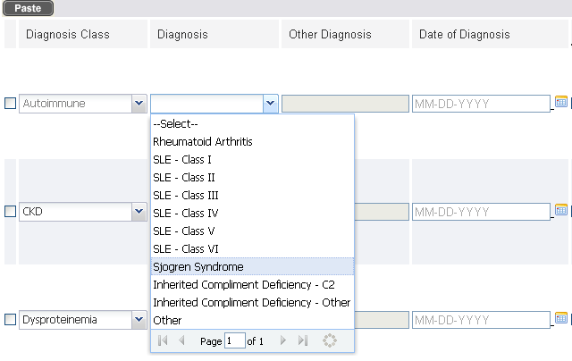
Figure 28: On selecting permissible value ‘Autoimmune’ for Diagnosis Class control, permissible values set is changed for Diagnosis control.

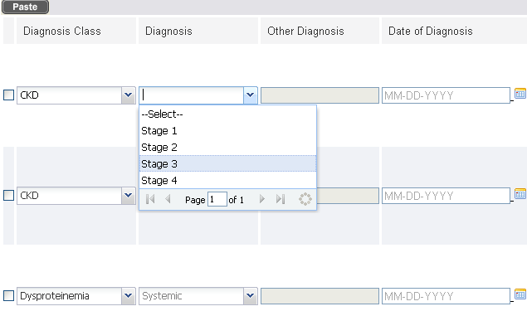
Figure 29: On selecting permissible value ‘CKD for Diagnosis Class control, permissible values set is changed for Diagnosis control.

Export XMI
The XMI export feature in caTissue Suite helps institutions to share their extensions and to maintain caBIG® compatibility. The extensions defined in the application can be exported as an XMI file. This can be imported in EA and edited for any local customizations or sharing it with another institution. The procedures mentioned in XMI import can be used to add the updated model to the application.
To export extensions from caTissue Suite application as an XMI file:

Only one entity group can be exported to a XMI file.
- Unzip the caTissue Suite installable zip and perform the configuration for the following properties in caTissueInstall.properties.

Table 78: caTissue Install Properties
Parameter | Description
database.type | Oracle or MySQL
database.host | Hostname or IP address of the machine on which the database server is running.
database.port | Port number to connect with the database server  #Default port for MySQL : 3306  #Default Port for Oracle: 1521
oracle.tns.name | Oracle TNS name, applicable only when database.type=oracle
database.name | Database name
database.username | Database user name
database.password | Database password
Go to the command prompt and change the directory to the unzipped folder.
- Run the following ant target:
ant export_xmi -Dgroupname <groupname> -Dfilename <export filename> -Dversion <version>

Table 79: ANT File Field Description
Parameter | Description | Mandatory
<group name> | The group name in which the forms are created in the application. | Yes
<export filename> | Name of the file to which the model will be exported.  If this file exists, it will be overwritten. If it does not exist, a new file will be created. | Yes
<version> | Version of the XMI being exported:  XMI Version should be 1.1 for caCore generation.  XMI Version should be 1.2 to import the XMI in DE or in EA.  Default value is 1.2. | No

Example:
ant export_xmi -Dgroupname="IPBS" -Dfilename=" D:\build\DE Import-
Export\export_demo.xmi" -Dversion="1.1"
On successful completion of the export XMI task, XMI Successfully Exported message is displayed at the command prompt.

Known issue: XMI is created in the root directory of the installable and the file name is "${relative.filename}" and not what user specifies in the command.

Steps to Generate caCore APIs for Dynamic Extensions
Data entry for dynamic extensions can also be done using caCore APIs (Application Program Interface). In order to do this, these APIs needs to be generated first. The caCore like API for Dynamic Extensions is used to insert, update, or query data through a client program. This section outlines the steps to be taken to run the client program

- Copy caCore sdk 3.2 from the following location:
http://gforge.nci.nih.gov/projects/cacoresdk/
- Copy the XMI file generated under cacoretoolkit\models\xmi folder.
- Change deploy.properties under conf folder in cacoretoolkit folder hierarchy.
Perform following changes in the deploy.properties file
  - System Properties
  - Project Properties
  - Model Properties (The GroupName used for exporting XMI is the Package Name)
  - Database Properties
  - J2SE CONTAINER PROPERTIES, Set “start_container=no”
  - Set “disable_writable_api_generation=no”.
For more information on caCore, refer to the caCore User Guide.
- Run build-system target in build.xml
- Copy <caCORE_SDK_HOME>\output\example\package\<project_name>.war file to <JBOSS_HOME>\server\default\deploy folder
- Restart Jboss
- Copy <project_name>-client.jar from
cacoretoolkit\output\<project_name>\package\client\lib to
catissue_de_integration_client\lib
- Choose appropriate demo client depending on the annotation hooked with
  - ClientDemo_CA.java for annotations associated with Participant
  - ClientDemo_SCG.java for annotations associated with SpecimenCollectionGroup
  - ClientDemo_Specimen.java for annotations associated with Specimen.
- Change application service URL in ClientDemo.java for DE Service.
The DE service context Name should be the same as the project_name in the deploy.properties file in cacore sdk project.
- To populate the annotation data do the appropriate changes in the “getDEToBeCreated” of the demo class.
- Depending on the class modified run matching target. E.g if ClientDemo_CA.java is modified run target “ant runDemo_CAModel”

Go to the caTissue Suite application. Select the Biospecimen Data tab and select an appropriate hook entity like Participant, SCG, or Specimen. All the records added from ca-core Client are visible under the View Annotation tab.

Showing/Hiding forms for data entry

By default caTissue loads CA model (refer to Error: Reference source not found) forms, which are purely based on the CAP checklist models. These are hidden by default as users might want to create more user friendly data entry forms using the DE feature of form definition upload through CSV. This feature allows the user to create data entry forms from different classes of the mode by not restricting to tightly couple with the model.The forms can be associated per collection protocols using Show_Hide_Forms.xml present in the installable.

For more details on how to configure the forms to be hidden, refer to the deployment guide.

Known Issues in Dynamic Extensions
The following list mentions the known issues in DE, XMI Import, XMI export, and caCore like API generation:
- DE does not support bi-directional association specified in the UML model. For example:

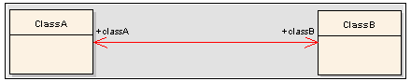

- DE does not support importing many to one OR many to many association specified in the UML model. For example:
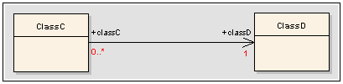
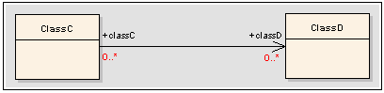

- XMI Import does not support the functionality of specifying the permissible values for enumerated attributes (for example: drop down, list box, or option button) within the UML model and then importing them into caTissue Suite.

- Few unique cases of association between classes are not supported in XMI Import. They are:
  - Class A contains Class B, Class B contains Class C, and Class C contains Class A.

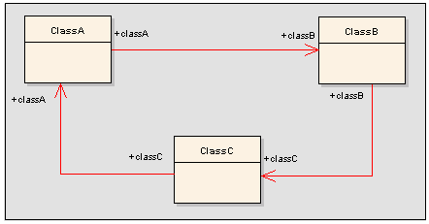

- Multiple-Inheritance (a derived class which inherits from more than one parent class) is not supported in form-with-inheritance feature. For example, import mechanism for the model below is not supported.
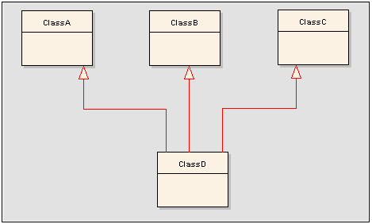

- You cannot define derived child entity as an association to its parent entity in form definition. In the example below, it is not possible to define an association between Class A and Class B, since Class A and Class B share inheritance relationship between them.

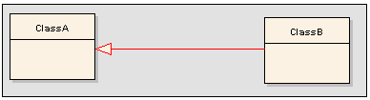

- You cannot define a derived entity’s association as the association of its parent entity. In the example below, Class C which is an association to Class B cannot be defined as an association to Class A because there exists no direct association between the two classes C and A.

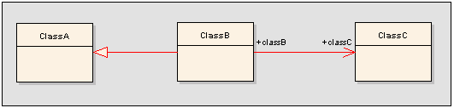

- Collection data type for an attribute is not recognized in XMI Import.

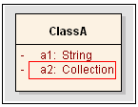

Note: You may however achieve a similar effect by following the steps below:
- Pull the attribute out from the main class as a new class (i.e. create a new class with that attribute).
- Assign the data type of the attribute as String/Integer/Double/Float/etc (except Collection, Boolean).
- Create a containment association between the original class and the new class.
- Mark the multiplicity of the target new class as many.

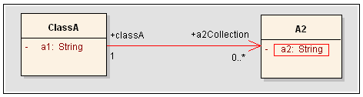

- Colon and comma are not supported currently in Permissible Value names.
- Metadata (also referred to as template) generated upon import of XMI is also shown under biospecimen data tab, though it is not meant to act as a data entry form.
- There is no provision of editing or viewing data-entry forms under the Administartive Data Tab on the User Interface.
- DE does not support models exported from ArgoUML. But if user wants to use an XMI of the model created in ArgoUML, below are the steps for workaround:
- Take the XMI of the model created in ArgoUML
- Import that XMI file to Enterprise Architecture using the ‘templae.eap’ file.
- Check all association properties :
    - For association of main form and sub form containment value for source (main form) should be “by reference”.
    - For association of main form and sub form containment value for target (sub form) should be “by reference” /“by value”.
- Save the changes, if any.
- Export the model as XMI file as explained in Error: Reference source not found
- Use the XMI file for import tasks.

Label & Barcode Print Service

The caTissue Suite provides a framework in which institution can plug-in label or barcode printer interface without making any change to the main the caTissue codebase. This section describes the framework.
The following flowchart describes the workflow of Print Service:
Web Client
(caTissueSuite)
Web Service
(caTissuePrintWebService)
Invoke PrintService
Receive status response
PrintService Module
Invoke Web service
Return status
Configuration File
Figure 23: Print Service Work Flow

Description of the Print Service workflow:
The Print Service workflow takes place between caTissue Suite and caTissue PrintWebservice with the Print Service module as an intermediate.
- The caTissue Suite sends a request to print a label. For example, when a user selects the print option from the specimen page.
The print request goes to PrintService class with all the data.
- The concerned institution customizes the PrintService code to process the data and sends it to the PrintWebService in the desired format.
- PrintWebservice then forwards the formatted data to the printer.
Note: PrintWebService is not mandatory in the PrintService workflow. It is required when the printer is not accessible to the application on the server machine.

Developing Customized PrintService Implementation
Currently, the PrintService module has the framework to support printing of labels using Specimen, SpecimenCollectionGroup, and StorageContainer. The following figure describes the implementation of PrintService:
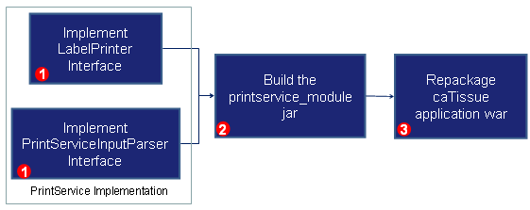
Figure 24: PrintService Implementation
To implement PrintService, perform the following procedure:
- To customize the PrintService implementation, write a class that implements LabelPrinter and another class that implements PrintServiceInputParserInterface.
The following example describes how to implement LabelPrinter:
- Implement LabelPrinter Interface: Write a code to generate data that you want to print, when a print label from the UI is invoked.
public class SpecimenLabelPrinterImplforXYZ implements LabelPrinter {
public boolean printLabel(AbstractDomainObject abstractDomainObject, String ipAddress, User userObj)
{
//Write implementation here regarding Specimen object
//Call to customized PrintServiceInputParserInterface implementation
}
public boolean printLabel(List<AbstractDomainObject> abstractDomainObjectList, String ipAddress, User userObj)
{
//Write implementation here regarding Specimen object
//Call to customized PrintServiceInputParserInterface implementation
}

- Implement PrintServiceInputParserInterface – Write the following code to process the data obtained from the LabelPrinter. The data is processed into a particular format, such as XML format, and is sent to the PrintWebservice.
public class PrintServiceInputXYZParser implements PrintServiceInputParserInterface
{
public boolean callPrintService(Object listData) throws Exception
{
//write implementation regarding how to print Object's data
//how to generate dynamic XML of object data
//Make condition whether to call caTissueprintwebservice
}
}
Note: : By default, the current implementation supports the XML format, but the application is customized to any format.
If implementation requires making a call to PrintWebService, then mention its endpointURL as shown in the sample properties file.
- Modify the value of the key specimen with a fully qualified class name. The property file is located at catissue core-properties or PrintServiceImplementor.properties
- Modify the values in the property file. You need to restart server for this modification to be implemented. If there is another implementation then rebuild the application to include your class. In this case, remove the default jar named printservice_module.jar from WEB-INF/lib in caTissuecore.war and repackage catissurecore.war by adding your custom jar in the WEB-INF/lib directory.
- Run the build_war target of caTissueSuite’s build.xml file and deploy the caTissue application again.

Note: The PrintServiceImplementor.properties is important for the PrintService module for providing information about the LabelPrinter Implementation class. Ensure that the JBOSS_HOME/server/default/catissuecore-properties folder contains the properties file and its key names are the same as those mentioned in the above steps.

Implementation Details for caTissuePrintWebService
The main tasks in building a JAS-WS style caTissuePrintWebService are:
- Designing and coding the caTissuePrintWebService endpoint interface.
- Implementing the caTissuePrintWebService endpoint interface.
- Writing the configuration file.
- Using the deploy tool or ant, to package the service in a WAR file.

Design and Coding the PrintWebService Endpoint Interface
The endpoint interface contains the declaration of methods that a Web service remote client can invoke on the service. PrintService is a default class. This class has print() method and jax-ws annotations implementation.
The following figure displays the folder structure of caTissuePrintWebService:

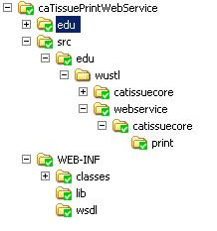

Implement the Service Endpoint Interface
Depending on the configuration PrintWebServiceFactory returns the PrintServiceClient instance and calls the print() method. The PrintServiceClient interface is specific to a University specific PrintService Client implementation. The fully qualified class name of the client implementation needs to be specified in the PrintWebServiceFactory class. For example, WashUPrintServiceClient is specific to the Washington University.

Writing a Configuration File
The next step is to generate portable JAX-WS artifacts using the wsprovide tool. This tool is used to generate the abstract contract (WSDL file) for service. The wsprovide Ant target is provided in caTissuePrintWebService/build.xml. To use this ant script, change the value of property jboss.home.dir and java.home.dir to the JBOSS_HOME and JAVA_HOME path respectively.
The wsprovide target generates the following artifacts at caTissuePrintWebService or output folder:
- Print.java
- PrintResponse.java
- PrintWebService.wsdl

Packaging the Service
A JAX-WS Web service is a Servlet or a Web component in J2EE terminology, and hence it is deployed on the Web Server. The Ant is also used for creating the necessary files and deploys the caTissuePrintWebService to Jboss server.
The steps to packaging the service areas follows:
- Create the caTissuePrintWebService war file.
<target name="copyFiles">
<copy file="./output/PrintWebService.wsdl" todir="./WEB- INF/wsdl"/>
<copy todir="./WEB-INF/classes">
<fileset dir="./output">
<include name="edu/**" />
<exclude name="**/*.java"/>
</fileset>
</copy>
</target>
<target name="build_war" depends="copyFiles">
<war destfile="caTissuePrintWebService.war" webxml="./WEB-INF/web.xml">
<fileset dir="${base.dir}">
<include name="WEB-INF/**" />
<include name="edu/**" />
</fileset>
</war>
</target>
- Copy the caTissuePrintWebService war file in the caTissueSuite. The copy of the WebserviceTocaTissue ant target is provided in caTissuePrintWebService/build.xml.

Creating Client for the caTissuePrintWebService
JAX-WS uses the abstract contract for the service that includes:
- The WSDL file
- Zero or more schema files
The wsconsume tool is then used to consume the contract file. The wsconsume tool also produces annotated Java classes (optionally sources) that define the file. The wsconsume ant target is provided in caTissuePrintWebService/build.xml. To use this ant script, change the value of property java.home.dir to the JAVA_HOME path.
The wsprovide target generates the following artifacts in the caTissuePrintWebService/outputclient folder:
- ObjectFactory.java
- Print.java
- PrintResponse.java
- PrintService.java
- PrintWebService.java
- package-info.java

File | Purpose
Print.java | Service Endpoint Interface
PrintResponse.java | Wrapper bean for response message
ObjectFactory.java | JAXB XML Registry
package-info.java | Holder for JAXB package annotations
PrintService.java | Used only by JAX-WS clients
The next step is to create jar of all these files and copy that jar in caTissue. The Build_PrintCatissueCore_Client ant target is provided in caTissuePrintWebService/build.xml. To use this ant script, change the value of property lib.dir to the WEB-INF/lib of caTissue.
<target name="Build_PrintCatissueCore_Client" description="Created jar of all classes generated from wsconsume">
<jar destfile="PrintCatissueCore_Client.jar">
<fileset dir="${base.dir}/outputclient" >
<include name="**/*.java" />
<include name="**/*.class"/>
</fileset>
</jar>
<copy file="PrintCatissueCore_Client.jar" todir="${lib.dir}"/>
</target>
The caTissuePrintWebservice client makes an RPC call, to specify the service endpoint interface address, operation name, parameter names, types, modes, and port type at the client side. Using the call object, the client invokes the methods of the Web service. The PrintService module acts as a Webservice client, the implementation of client is available in it.
For example, at Washington University the data input for PrintService is in XML format. So, the PrintServiceInputXMLParser class that implements PrintServiceInputParserInterface, has the functionality to generate an XML input message, call caTissuePrintWebservice, and return the result message.
The dynamic generation of input XML data is different for various types of objects. For example, for the Specimen type of the object the implementation is provided by SpecimenLabelPrinterImpl:
<?xml version="1.0" encoding="UTF-8"?>
<Properties>
<!--This is a simple File that contain specimens object data-->
<object class="Tissue" id="215">
<property>
<name>label</name>
<value>167</value>
</property>
<property>
<name>barcode</name>
<value>167</value>
</property>
<property>
<name>printerType</name>
<value>Box</value>
</property>
<property>
<name>printerLocation</name>
<value>printer1</value>
</property>
</object>
</Properties>
These implementation classes are available in the PrintService module. The PrintService module invokes the caTissuePrintWebService with XML data input and ireceives the status.

Class Diagram
The following figure displays the class diagram for caTissuePrintWebService. The diagram outlines the classes related to WebService:

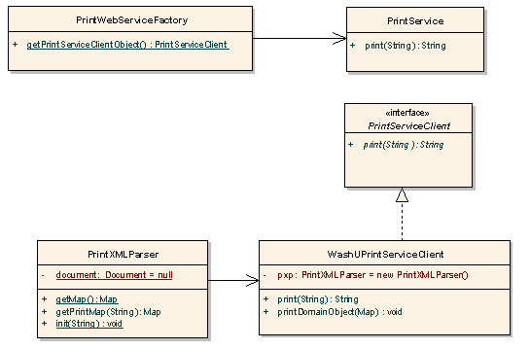
Figure 25: Class diagram related to caTissuePrintWebService

# | Class Name | Description
1 | PrintService | Class having the method print(String.
2 | PrintServiceClient | This interface provides a method, which is implemented by every PrintService Client.
3 | PrintXMLParser | This class parses input XML string and returns collection of DomainObjects to PrintServiceClient.

Bulk operations
Bulk operations are a time saving feature that helps you to add or update bulk data in caTissue at one time. In this version of caTissue, Bulk operations feature supports only objects of caTissue static model. The Bulk Operations is a command line feature which takes two inputs.
- A data file in CSV format – This will contain the caTissue data which has to be added or updated.
- An XML template file: This is an Extended Mark-up File (XML) also called as the Bulk Operation XML template. This is used to represent the object model in a form of tree-structure format for which the user is adding or editing data in caTissue.

Bulk Operations CSV file and XML template
The bulk operation XML template has to be prepared by the user according to his needs. The XML template design is self configurable with some basic tree tag structure and naming conventions. The user is required to have a complete understanding of caTissue Suite data model.
The XML template data is a representation of the caTissue Suite data model in an XML file. The user can create XML templates for each caTissue static object as well as combine two or more objects together in an XML depending on the caTissue Suite data model and the use case.
The Bulk Operation XML template has the meta-data defined in it for the desired bulk operation by the user with respect to the caTissue Suite static objects. Bulk Operations run in the background. User can run multiple Bulk Operations simultaneously.
The BulkOperations.xsd is the XSD used defined for the XML template. It explains various tags and elements used in the XML template. This can be found in the caTissue installable zip at location {CATISSUE_HOME}/modules/bulk_operations/conf.

Following table describes the tag of the bulk operation XML template.

Table 80: Bulk Operation Tags
Bulk Operation XML tag | Description
BulkOperationMetadata | Identifies the start of Bulk Operation meta-data XML file.
BulkOperationClass | Identifies the beginning of a Bulk Operation defined in the bulk Operation meta-data XML file.
attributeCollection | Identifies the data members of the caTissue Suite domain object.
containmentAssociationCollection | Identifies the containment association of a caTissue Suite domain object within another one.
referenceAssociationCollection | Identifies the reference association of a caTissue Suite domain object to another one.
discriminatorCollection | Identifies the exact type of caTissue instance to be created. The XML can be created for a generic type of caTissue instance which can be separated out with the actual class type depending upon the data using the discriminator tag.

Following table describes the attributes of the bulk operation XML tag template

Table 81: Bulk Operations XML tag template attributes
Bulk Operation XML attributes | Description | XML tag it belongs to
className | Its value should have fully qualified class name of caTissue Suite domain object. | BulkOperationClass  containmentAssociationCollection  referenceAssociationCollection
relationShipType | It is the relationship type between one domain object to another object in caTissue Suite. | BulkOperationClass  containmentAssociationCollection  referenceAssociationCollection
templateName | It is unique name for each Bulk Operation. | BulkOperationClass  containmentAssociationCollection  referenceAssociationCollection
parentRoleName | It is used to identify the re-use and add reference of the main Bulk Operation domain object to other objects of the BulkOperationClass defined in the XML. It is the actual attribute name defined in the caTissue Suite data model. | BulkOperationClass  containmentAssociationCollection  referenceAssociationCollection
Cardinality | It is used to identify the mapping of one domain object to another one. | BulkOperationClass  containmentAssociationCollection  referenceAssociationCollection
roleName | It is the actual attribute name defined in the caTissue Suite data model. | BulkOperationClass  containmentAssociationCollection  referenceAssociationCollection
maxNoOfRecords | It is used to specify the maximum number of objects that can be added as a containment or reference association to the main Bulk Operation class. | BulkOperationClass  containmentAssociationCollection  referenceAssociationCollection
batchSize | It is used to specify to create a output report zip file after every specified batch size value. | BulkOperationClass  containmentAssociationCollection  referenceAssociationCollection
Name | It is the actual data member name defined in the java class in caTissue Suite data model. | attributeCollection
csvColumnName | It is the column name mentioned in the CSV template which has the data corresponding to the attributes. | attributeCollection
updateBasedOn | It is used to identify in the bulk operation is for updating the data and on what unique attribute parameter user wants to identify and the update the respective object. | attributeCollection
dataType | It is the java data type used in to define the attribute in caTissue Suite data model. | attributeCollection
belongsTo | It has the caTissue Suite domain object to which the attributeCollection belongs to. | attributeCollection
name (for discriminator tag) | It has the value that will be specified in the CSV data file. | Discriminator
value (for discriminator tag) | It should have the corresponding caTissue Suite object name for the name mentioned in the discriminator tag. | Discriminator

Following is the table for the Bulk Operation XML Template permissible values.

Table 82: Bulk Operations XML Template PV's
XML parameters | Permissible values
relationshipType | main  association  containment
Cardinality | 1  *
parentRoleName | The parentRoleName value has to be identified by referring the caTissue Suite data model.
updateBasedOn | true  false  Note: If any other value other than the ones above are used, then the value defaults to “false”
dataType | java.lang.Boolean  java.lang.Byte  java.lang.Character  java.lang.Double  java.lang.Float  java.lang.Integer  java.lang.Long  java.lang.String  java.lang.Short  java.lang.Number  java.util.Date  Note: New Attribute data-types permissible values can add if new data-types added in the caTissue Suite data model.
roleName | The role value has to be identified by referring to the caTissue Suite data model.
Name | The Attribute name has to be identified by referring tothe caTissue Suite data model.
maxNoOfRecords | The value should be an Integer value. The value should be ‘1’ if the cardinality is mentioned to ‘1’.
batchSize | The value should be an Integer value. If specified value a ‘0’ or kept as empty then the default value is set to 100.
belongsTo | It accepts a string value. The value can be kept as empty. It should have the complete object name which can be referred from caTissue data model.
Name (for discriminator) | It accepts string value.
value (for discriminator) | It accepts string value. It should have the complete object name which can be referred from caTissue data model.

Below are the sample Bulk Operation XML templates for Adding Cell Specimen Review Event Parameters and insert specimen operation.
XML Sample 1: Bulk Operation XML template for Cell Specimen Review Parameters

<?xml version="1.0" encoding="UTF-8"?>
<BulkOperationMetadata>
<BulkOperationClass className="edu.wustl.catissuecore.domain.CellSpecimenReviewParameters"
relationShipType="main" templateName="createCellSpecimenReviewParameters"
parentRoleName="" maxNoOfRecords="" batchSize="5" cardinality="" roleName="specimenEventParameters">
<referenceAssociationCollection
className="edu.wustl.catissuecore.domain.User"
relationShipType="association" templateName="createCellSpecimenReviewParameters"
parentRoleName="" maxNoOfRecords="" batchSize="5" cardinality="1" roleName="user">
<attributeCollection name="loginName" csvColumnName="User Login Name" updateBasedOn="false" dataType="java.lang.String" belongsTo=""/>
</referenceAssociationCollection>
<containmentAssociationCollection
className="edu.wustl.catissuecore.domain.Specimen"
relationShipType="containment" templateName="createCellSpecimenReviewParameters"
parentRoleName="" maxNoOfRecords="" batchSize="5" cardinality="1" roleName="specimen">
<attributeCollection name="label" csvColumnName="Specimen label" updateBasedOn="false" dataType="java.lang.String" belongsTo=""/>
</containmentAssociationCollection>
<attributeCollection name="timestamp" csvColumnName="Date (MM-DD-YYYY HH:MM)" updateBasedOn="false" dataType="java.util.Date" belongsTo=""/>
<attributeCollection name="neoplasticCellularityPercentage" csvColumnName="Neo Plastic Cellularity Percentage" updateBasedOn="false" dataType="java.lang.Double" belongsTo=""/>
<attributeCollection name="viableCellPercentage" csvColumnName="Viable Cell Percentage" updateBasedOn="false" dataType="java.lang.Double" belongsTo=""/>
<attributeCollection name="comment" csvColumnName="Comments" updateBasedOn="false" dataType="java.lang.String" belongsTo=""/>
</BulkOperationClass>
</BulkOperationMetadata>

XML Sample 2: Bulk Operation Template for Create Specimen

<?xml version="1.0" encoding="UTF-8"?>
<BulkOperationMetadata>
<BulkOperationClass className="edu.wustl.catissuecore.domain.Specimen"
relationShipType="main" templateName="createSpecimen" maxNoOfRecords="1" parentRoleName="" batchSize="5"
cardinality="1" roleName="specimen">
<referenceAssociationCollection
className="edu.wustl.catissuecore.domain.SpecimenCollectionGroup"
relationShipType="association" templateName="createSpecimen" maxNoOfRecords="1" parentRoleName="" batchSize="5" cardinality="1" roleName="specimenCollectionGroup" >
<attributeCollection name="name" csvColumnName="SCG name" updateBasedOn="false" dataType="java.lang.String" belongsTo=""/>
</referenceAssociationCollection>
<containmentAssociationCollection
className="edu.wustl.catissuecore.domain.SpecimenCharacteristics"
relationShipType="containment" templateName="createSpecimen" maxNoOfRecords="1" parentRoleName="" batchSize="5" cardinality="1" roleName="specimenCharacteristics">
<attributeCollection name="tissueSite" csvColumnName="Tissue Site" updateBasedOn="false" dataType="java.lang.String" belongsTo=""/>
<attributeCollection name="tissueSide" csvColumnName="Tissue Side" updateBasedOn="false" dataType="java.lang.String" belongsTo=""/>
</containmentAssociationCollection>
<containmentAssociationCollection
className="edu.wustl.catissuecore.domain.CollectionEventParameters"
relationShipType="containment" templateName="createSpecimen" maxNoOfRecords="2" parentRoleName="specimen" batchSize="5" cardinality="*" roleName="specimenEventCollection">
<referenceAssociationCollection
className="edu.wustl.catissuecore.domain.User"
relationShipType="association" templateName="createSpecimen" maxNoOfRecords="1" parentRoleName="" batchSize="5" cardinality="1" roleName="user">
<attributeCollection name="loginName" csvColumnName="Collected User Login Name" updateBasedOn="false" dataType="java.lang.String" belongsTo=""/>
</referenceAssociationCollection>
<attributeCollection name="comment" csvColumnName="Collected Comments" updateBasedOn="false" dataType="java.lang.String" belongsTo="" />
<attributeCollection name="collectionProcedure" csvColumnName="Procedure" updateBasedOn="false" dataType="java.lang.String" belongsTo=""/>
<attributeCollection name="container" csvColumnName="Container" updateBasedOn="false" dataType="java.lang.String" belongsTo=""/>
<attributeCollection name="timestamp" csvColumnName="Collected Date (MM-DD-YYYY HH:MM)"
updateBasedOn="false" dataType="java.util.Date" belongsTo=""/>
</containmentAssociationCollection>
<containmentAssociationCollection
className="edu.wustl.catissuecore.domain.ReceivedEventParameters"
relationShipType="containment" templateName="createSpecimen" maxNoOfRecords="2" parentRoleName="specimen" batchSize="5" cardinality="*" roleName="specimenEventCollection">
<referenceAssociationCollection
className="edu.wustl.catissuecore.domain.User"
relationShipType="association" templateName="createSpecimen" maxNoOfRecords="1" parentRoleName="" batchSize="5" cardinality="1" roleName="user">
<attributeCollection name="loginName" csvColumnName="Received User Login Name" updateBasedOn="false" dataType="java.lang.String" belongsTo=""/>
</referenceAssociationCollection>
<attributeCollection name="comment" csvColumnName="Received Comments" updateBasedOn="false" dataType="java.lang.String" belongsTo=""/>
<attributeCollection name="receivedQuality" csvColumnName="Quality" updateBasedOn="false" dataType="java.lang.String" belongsTo=""/>
<attributeCollection name="timestamp" csvColumnName="Received Date (MM-DD-YYYY HH:MM)" updateBasedOn="false" dataType="java.util.Date" belongsTo=""/>
</containmentAssociationCollection>
<attributeCollection name="label" csvColumnName="Label" updateBasedOn="false" dataType="java.lang.String" belongsTo=""/>
<attributeCollection name="barcode" csvColumnName="Barcode" updateBasedOn="false" dataType="java.lang.String" belongsTo=""/>
<attributeCollection name="createdOn" csvColumnName="Created On" updateBasedOn="false" dataType="java.util.Date" belongsTo=""/>
<attributeCollection name="activityStatus" csvColumnName="Activity Status" updateBasedOn="false" dataType="java.lang.String" belongsTo=""/>
<attributeCollection name="comment" csvColumnName="Comment" updateBasedOn="false" dataType="java.lang.String" belongsTo=""/>
<attributeCollection name="isAvailable" csvColumnName="Is Available" updateBasedOn="false" dataType="java.lang.Boolean" belongsTo=""/>
<attributeCollection name="collectionStatus" csvColumnName="Collection Status" updateBasedOn="false" dataType="java.lang.String" belongsTo=""/>
<attributeCollection name="specimenClass" csvColumnName="Specimen Class" updateBasedOn="false" dataType="java.lang.String" belongsTo="">
<discriminatorCollection name="Tissue" value="edu.wustl.catissuecore.domain.TissueSpecimen"/>
<discriminatorCollection name="Fluid" value="edu.wustl.catissuecore.domain.FluidSpecimen"/>
<discriminatorCollection name="Molecular" value="edu.wustl.catissuecore.domain.MolecularSpecimen"/>
<discriminatorCollection name="Cell" value="edu.wustl.catissuecore.domain.CellSpecimen"/>
</attributeCollection>
<attributeCollection name="specimenType" csvColumnName="Type" updateBasedOn="false" dataType="java.lang.String" belongsTo=""/>
<attributeCollection name="initialQuantity" csvColumnName="Initial Quantity" updateBasedOn="false" dataType="java.lang.Double" belongsTo=""/>
<attributeCollection name="availableQuantity" csvColumnName="Available Quantity" updateBasedOn="false" dataType="java.lang.Double" belongsTo=""/>
<attributeCollection name="lineage" csvColumnName="Lineage" updateBasedOn="false" dataType="java.lang.String" belongsTo=""/>
<attributeCollection name="pathologicalStatus" csvColumnName="Pathological Status" updateBasedOn="false" dataType="java.lang.String" belongsTo=""/>
<attributeCollection name="concentrationInMicrogramPerMicroliter" csvColumnName="Concentration" updateBasedOn="false" dataType="java.lang.Double" belongsTo="edu.wustl.catissuecore.domain.MolecularSpecimen"/>
</BulkOperationClass>
</BulkOperationMetadata>

Table 83: CSV Sample 1: Bulk Operation CSV template for Cell Specimen Review Events.
Specimen label | User Login Name | Date (MM-DD-YYYY HH:MM) | Comments | Neo Plastic Cellularity Percentage | Viable Cell Percentage
Label_1 | admin@admin.com | 11-12-2009 11:13 | Mycomments1 | 14.89 | 45.71
Label_1 | admin@admin.com | 11-12-2009 11:13 | Mycomments2 | 14.89 | 45.71

The Bulk Operation XML template starts with the <BulkOperationMetaData> tag and ends with </BulkOperationMetaData> tag. Inside the tags, <BulkOperationClass> tag is placed. This tag determines a Bulk Operation task which is to be carried out on specifically for the Cell Specimen Review Events Parameters domain object in Sample 1. In the <BulkOperationClass> tag, there are attributes defined such as className, templateName, relationshipType, parentRoleName, batchSize, maxNoOfRecords, cardinality and roleName.
The descendent tags in the above sample XML template are <attributeCollection>, <containmentAssociationCollection> and <referenceAssociationCollection>.
The CSV column name specified in the XML which is placed under containmentAssociation or referenceAssociation tag and has the cardinality mentioned as “*”,there respective CSV column names are created in special format.

Example 1:
In Sample 1 XML, there is containment of CollectedEventParameters object which has cardinality mentined as ‘*’ and maxNoOfRecords = 1. So, in such case, the CSV column names for this caTissue domain object attributes will have the same columnName specified in the XML appended with ‘#1’ value to all the columns in the CSV template which belong to CollectedEventParameters” object.

Table 84: Example 1 template
Collected User Login Name#1 | Collected Comments#1 | ,Procedure#1 | Container#1 | Collected Date (MM-DD-YYYY HH:MM)#1

Example 2:
Add participant in caTissue Suite with more than one Race.
The XML tag for the race object will be as below:

<containmentAssociationCollection
className="edu.wustl.catissuecore.domain.Race" relationShipType="association"
templateName="createParticipantRegistration" maxNoOfRecords="1" parentRoleName="participant" batchSize="10000"
cardinality="*" roleName="raceCollection">

<attributeCollection name="raceName" csvColumnName="Race" updateBasedOn="false" belongsTo="" dataType="java.lang.String"/>

</containmentAssociationCollection>

Here, the maxNoOfRecords value = “3” and cardinality=”*”. It means that, in CSV there should be 3 columns which will have column name as Race#1, Race#2, and Race#3. The column name starts with ‘Race’ because in XML template the column name is specified as ‘Race’.

Table 85: Example 2 template
Race#1 | Race#2 | Race#3

It is not necessary for the user to enter all 3 values for the Race while adding a participant. User can add a maximum of 3 race types to a Participant.

Note: ‘’#’ value with a number appended to it depends on the maxNoOfRecords value. If the maxNoOfRecords = “5” , then the CSV should have the all respective column names appended will #1, #2, #3, #4 and #5 for the respective caTissueSuite object. The special column names with ‘#’ are required to create only when we have cardinality = ‘*’. For cardinality = ‘1’, normal column names are required in CSV template as specified in the XML template.

About <attributeCollection> tag
In Sample 1 Cell Specimen Review Parameters class, the data members for the class are neoplasticCellularityPercentage, viableCellPercentage, timestamp and comment. These can be identified by referring the caTissue Suite data model. We define a <attributeCollection> tag for each these data members in the XML template as descendent to the main object Cell Specimen Review Parameters. Specify their data-type in the dataType attribute which is written with the <attributeCollection>. For example the data member “neoplasticCellularityPercentage” is of data type double which is to be written with the complete java package name “java.lang.Double”. For each of the data member, there is some value to be inserted or updated in the caTissue database. All the data has to be present in the CSV format file which will have data separated in different columns with a unique column name to each. The corresponding column name for data member has to be mentioned in “csvColumnName”.

About <containmentAssociationCollection> tag
This tag represents the containment relation between the two objects of caTissue Suite. It is representation of one objects’ existence depends over another object’s existence. It is like one object life comes into existence only if other object has a life.
E.g.: A Cell Specimen Event Parameter object wont exists if the Specimen object does not exists.
An Address object wont exists if there is no User object exist.
There are many such examples in caTissue Suite data model. The user should have a good understanding of the caTissue Suite data model before using the Bulk Operations.
Thus, objects which contain other objects within them and are created only when the main object is created classify in the <containmentAssociationCollection> tag. In the above Sample 2 of Bulk Operation XML template, Specimen object has containment of Specimen Position object.

About <referenceAssociationCollection> tag

The semantic of the tag is that other objects which are already in to existence are referred by the main object or its descendent objects.

E.g.: A Site object refers a User object as its Site-coordinator. The User object is already in existence irrespective of whether the Site object is in existence or not.
A Storage Container object is referred a Specimen object for assigning it a Specimen Position. If the Specimen object does not object, the Storage Container can exist. Thus, the objects which are referred by other others classify in the <referenceAssociationCollection> tag. In the above Sample 2 of Bulk Operation XML, the Specimen has Specimen Position object as containment, whereas the Specimen Position has the Storage Container object as reference object. From this, it implies that, is a Specimen has its storage position as virtual, and then he may not have the Specimen Position as its containment object and still the Storage container object has exist. But if the Specimen Position object exists, then Storage Container is referred by the Specimen Position.

About <discriminatorCollection> tag
The semantic of the tag is that you can explicitly specify the caTissue object name to be created instead of creating the main class object name which could be a generic class name.
E.g.: A Specimen can be of 4 types; Cell, Fluid, Molecular and Tissue. In the sample2 XML, the main Bulk Operation class name is “edu.wustl.catissuecore.domain.Specimen”. But the Specimen objects accepted by caTissue application are of type “edu.wustl.catissuecore.domain.CellSpecimen”, “edu.wustl.catissuecore.domain.FluidSpecimen”, “edu.wustl.catissuecore.domain.MolecularSpecimen”, and “edu.wustl.catissuecore.domain.TissueSpecimen”. So we use the discrminator tag which helps us to add all different types of specimens with 1 XML and CSV file only. The attributes of discriminator tag are “name” and “value”. The name is the value which should be equal to the specimen class name and the “value” will be the complete caTissue data object name.

Other Bulk Operation XML attributes tag
The className is “edu.wustl.catissuecore.domain.CellSpecimenReviewParameters” which is the absolute class name of Cell Specimen Review Parameters object in caTissue Suite. The className should be the object name on which we the BulkOperation have to be carried out.
The relationShipType attribute value should be “main” only when it is written in <BulkOperationClass> tag. The value “main” identifies the main bulk operation class object on which the bulk operation task is to perform. The value for relationShipType will change to “containment” or “association” in inner/descendent tags depending upon its main object relationship type corresponding with the other inner/descendent objects.

The templateName attribute is the unique operation name given each to the Bulk Operation Class XML template.

The parentRoleName attribute has a String value to it. If in a Bulk Operation task, you require the main object details to be mapped to the descendent objects, which are also of the same object type defined in the <BulkOperationClass> tag, then the value of parentRoleName should be specified. The value can be referred from caTissue data model.
The cardinality attribute value in the main tag in XML i.e. in the <BulkOperationClass> tag should be set to “1”. The value could change for descendent objects in the XML to “*” depending the objects association to other objects. Eg: An object has a Collection of other objects. In that case, the cardinality for Collection type will be “*”.
The roleName attribute value has to be looked into the caTissue Suite Data Model.
The maxNoOfRecords attribute value has to be an integer value. It is the count of objects that a caTissue Suite object’s containment or reference associations will have. Eg: Particpant can have more than one Race. So the maxNoOfRecords value can be set accordingly which could be greater than 1.
The batchSize attribute value has an Integer value. The batch size value specified is used to create the output report zip file which is stored in database after every records processed from the CSV file.
The belongsTo value has the caTissue Suite model object name with respect to the attribute.
The name attribute (for discriminator) accepts String value.
The value attribute (for discriminator) accepts String value. The value for this attribute has to be looked into the caTissue Suite Data Model.

Steps to perform bulk operation
- Try to find whether the XML template for your specific bulk operation is already added or not. This can be done by observing the contents of “CATISSUE_BULK_OPERATION” table
- If the XML template is not present then it needs to be created as per the XSD. Please refer to the sections above to see how XML template needs to be created.
- Once the XML template is created, upload this template into caTissue application by using “add_bulk_operation_template”
- After the XML template is created and uploaded, there are two ways user can perform bulk operation. First way is to log into the application and upload the CSV using the bulk operation page. Second way is to provide the CSV data and XML template to an ANT command viz “run_Bulk_Operation”

Label and Barcode Generation
caTissue Suite provides a framework wherein an institution can plug-in a label or barcode generation interface without making any code change to the caTissue Suite codebase. Currently, automatic label generation is implemented for Specimen, SpecimenCollectionGroup, and StorageContainer type of objects.
If automatic label generation is specified, then you will not be able to manually enter the label at the time of adding the object through UI or API. The label of object will be auto-generated at the time of object creation.
If automatic label generation is not specified, then you can provide value for the label at the time of adding the object through UI or API.
Custom label generation is also supported in caTissue. If any institution wants to have their own format for label generated for specimens then some interfaces are provided to support this functionality. By implementing those interfaces any institution can have their own label generated with their own formats.

In order disable label generator, follow the below steps:
- Change the properties file LabelGenerator.Properties present in JBOSS-HOME/server/default/catissuecore-properties folder. Remove the below entry in case you do not need auto label generation:
specimenLabelGeneratorClass=edu.wustl.caTissuecore.namegenerator.DefaultSpecimenLabelGenerator
By default, it is set to the default label generator. In similar way, you can change for all objects like storage container and specimen collection group to either use the default label generator, institution specific label generator or no label generator.
- Restart the JBoss server and the changes will be reflected.

Sample entries in LabelGenerator.Properties related to Label Generation are as follows:
specimenLabelGeneratorClass=edu.wustl.caTissuecore.namegenerator.DefaultSpecimenLabelGenerator
storageContainerLabelGeneratorClass=edu.wustl.caTissuecore.namegenerator.DefaultStorageContainerLabelGenerator
speicmenCollectionGroupLabelGeneratorClass=edu.wustl.caTissuecore.namegenerator.DefaultSCGLabelGenerator
Following table shows the key name of corresponding label generator classes for Specimen, SpecimenCollectionGroup, and StorageContainer.
Object type | Key Name | Value
Specimen | specimenLabelGeneratorClass | classname
SpecimenCollectionGroup | speicmenCollectionGroupLabelGeneratorClass | classname
StorageContainer | storageContainerLabelGeneratorClass | classname
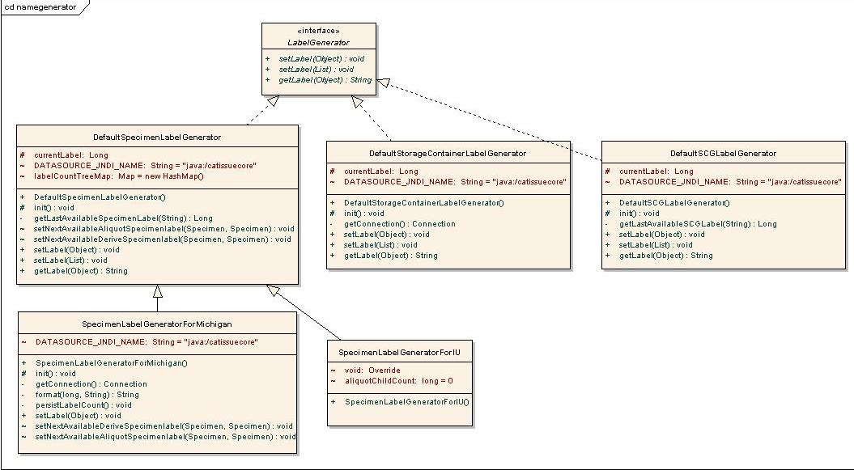
Figure 26:Label generator model
# | Class Name | Description
1 | LabelGenerator | This interface has the method setLabel (Object), setLabel (List<Object>) and getLabel (Object), which will be implemented by Label Generator Classes.
2 | DefaultSpecimenLabelGenerator | This class provides default implementation related to the Specimen type of object.
3 | DefaultStorageContainerLabelGenerator | This class provides default implementation related to the StorageContainer type of object.
4 | DefaultSCGLabelGenerator | This class provides default implementation related to the SpecimenCollectiongGroup type of object.
Table 86:Label generator classes

Folder Structure and Deployment Details
The source folder of all generator classes is caTissueSuite/WEB-INF/src. The package edu.wustl.caTissuecore.namegenerator contains all the class files.
The label and barcode generation related classes are available in two JAR files:
- label_barcode_gen_client.jar: This JAR file contains interface and factory classes for label and barcode generation. It contains the following:
  - LabelGenerator
  - LabelGeneratorFactory
  - BarcodeGenerator
  - BarcodeGeneratorFactory
  - LabelTokens
  - TokenFactory
- Default_label_barcode_gen.jar: This JAR file contains default implementation of label and barcode generator for different type of objects. It contains the following:
  - LabelGenerator.Properties
  - DefaultSCGLabelGenerator
  - DefaultSpecimenLabelGenerator
  - DefaultStorageContainerLabelGenerator
  - DefaultStorageContainerBarcodeGenerator
  - DefaultSpecimenBarcodeGenerator
For deployment, the ant tasks provided in build.xml file of caTissue Suite are: Default_Label_BarCode_Generator and Label_BarCode_Generator_Client
This task is included in build_war target, so every time the build_war target is run these jars are created and added into build path of caTissue Suite during deployment.

Barcode Generation
The barcode generation also follows the same logic as label generator design. The automatic barcode generation is specified in LabelGenerator.Properties. Currently, automatic barcode generation is implemented for Specimen and StorageContainer type of objects.
If automatic barcode generation is specified, then you cannot enter the barcode at the time of adding the object through UI screen. The barcode is auto-generated at the time of creation.
If automatic barcode generation is not specified, then you are able to enter it manually.
Sample entries in LabelGenerator.Properties related to barcode generation are as follows:
specimenBarcodeGeneratorClass=edu.wustl.caTissuecore.namegenerator.DefaultSpecimenBarcodeGenerator
storageContainerBarcodeGeneratorClass=edu.wustl.caTissuecore.namegenerator.DefaultStorageContainerBarcodeGenerator
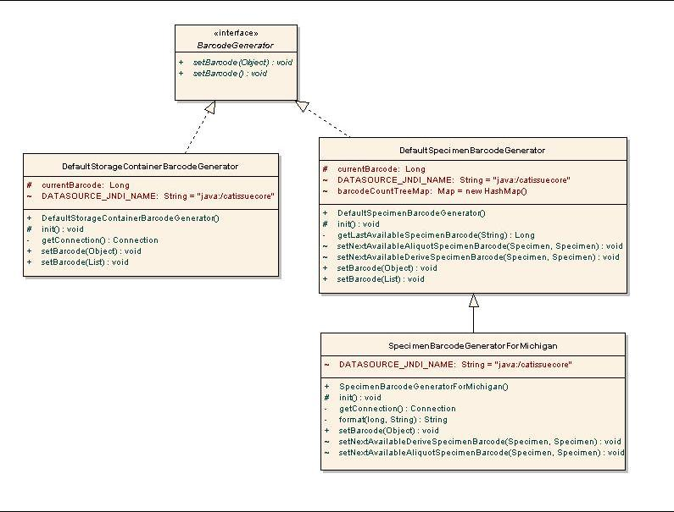
Figure 27: Barcode Generation Model

# | Class name | Description
1 | BarcodeGenerator | This interface has the method setBarcode (Object) and setBarcode (List<Object>), which will be implemented by Barcode Generator Classes.
2 | DefaultSpecimenBarcodeGenerator | This class provides default implementation related to Specimen type of Object.
3 | DefaultStorageContainerBarcodeGenerator | This class provides default implementation related to StorageContainer type of Object.
Table 87:Barcode generator classes

Developing Customized Label and Barcode Generator
You can customize the label and barcode generation process according to your requirements.
The LabelGenerator and BarcodeGenerator are main Interfaces. The customized class requires to implement the appropriate interface.
For example, if an university named XYZ wants to run its own algorithm for label generation or barcode generation, then it is possible by just writing their own class which implements the necessary interface that is, LabelGenerator / BarcodeGenerator.
Following are the steps to write and configure custom label/barcode generators:
Following is the Client jar which contains all required interfaces is present at
File: label_barcode_gen_client.jar
Location: caTissue_home/custom_impl_lib folder
- Write custom label/barcode generators by using label_barcode_gen_client.jar.

Assume XYZ University has written customized label generator named, SpecimenLabelGeneratorforXYZ as follows:
public class SpecimenLabelGeneratorForXYZ implements LabelGenerator
{ public SpecimenLabelGeneratorForXYZ() {
}
public void setLabel(Object obj) {
//Implementation specific to University
Specimen objSpecimen = (Specimen)obj; objSpecimen.setLabel("xyz_"+UniqueNumber) ;
}
public void setLabel(List objList)
{ for (int index=0;index <objList.size();index++) {
Specimen objSpecimen = (Specimen)objList.get(index); setLabel(objSpecimen);
}
}
public String getLabel(Object object){
Specimen objSpecimen = (Specimen)obj;
return objSpecimen.getLabel();
}
}
- Include this class in Default_label_barcode_gen.jar
- Edit configuration file LabelGenerator.Properties.Provide fully qualified class name to modify the value of key specimenLabelGeneratorClass. Present in catissuecore-properties folder.
- Add modified jar to caTissueIncaTissue_homestallableZip/custom_impl_lib folder.
- Run deploy_app target from deploy.xml.
- Start the server.

Note: The LabelGenerator.Properties is important for initializing label generator and barcode generator. Therefore make sure your new jar file contains this file at the root of the jar and its key names are same as mentioned above.

Custom Label Generation
In V1.2, along with custom label generation caTissue supports different formats for a specific label for specimens. This means that any institution can have their own logic to generate labels for specimen along with multiple formats which user can user while creating specimens
The overall design of the custom label generator is based on the tokens that a user can use to create different formats of labels for the specimens.
Here token is nothing but a key defined in a properties file for which a class is there which will return value of key.
For e.g. PPI=edu.wustl.catissuecore.namegenerator.LabelTokenForPPI
here PPI is a token and LabelTokenForPPI.java is a class that will return value related to PPI token.

DefaultTemplateBasedLabelGenerator is the implementation class that reads the user defined format and parses the different tokens used, and based on these tokens, generates the actual label.
All the predefined labels are present in the following properties file:
File name: LabelTokens.Properties
Location: JBOSS_HOME/server/default/catissuecore-properties/
For every token a token processor class is specified along with the token in the properties file. This class will return value related to token specified in file.

For detailed design of this module, please refer to the caTissue v1.2 design document.

Label Token Interfaces/classes:
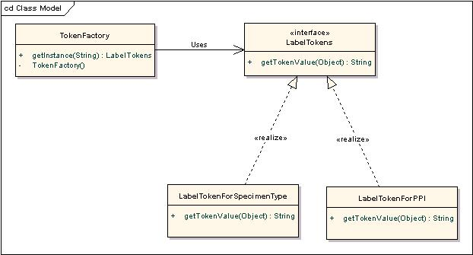

# | Class Name | Description
1 | TokenFactory | It is the factory class that returns the class associated with a given token.
2 | LabelTokens | It is the interface that defines the methods to be implemented by each class that calculates the value of the token.

Adding new token and related processor class in caTissue to generate custom label:
Any new token for generating custom label should be added in LabelToken.properties file. A user will have to write a token processor for every newly added token. This new class should implement LabelTokens interface.
Code E.g.:
public class LableTokenForXyz implements LabelTokens
{
public String getTokenValue(Object object)
{
This method will contain logic to return the value for particular token for which this class is implemented.
}
}

Deployment and folder structure details are same as mentioned in sub section “Folder Structure and Deployment Details” for Label generator. Just the change is:
If user has written a custom label generator for specimen then only he/she can use different tokens to generate custom label in specific format.
For that following file needs to be changed:
Whenever any new token is added entry of that token should be added in LabelToken.properties file and run deploy_app target.

IDP Integration
This section will describe how caTissue can be configured with one or more IDPs (Identity Providers). Along with this, if any institution wants to add a new IDP, how it could be done is described briefly in the following session.

IDP Configuration
Before deploying the application, the following file should be configured properly for IDP integration.
File Name: IDPAuthentication.xml
Location: JBOSS_HOME/server/default/catissuecore-properties

<?xml version="1.0" encoding="UTF-8"?>
<IDPS>
<IDP name="IDP_NAME">
<class name="AUTH_MANAGER_CLASS_NAME" />
<idpdetails>
<defaultidp>DEFAULT_IDP_VALUE</defaultidp>
<displayname>DISPLAY_NAME</displayname>
</idpdetails>
<idp-configuration>
If IDP points to LDAP, then specify all the LDAP details in this section; else
keep it empty.
</idp-configuration>
<user-attributes>
If required, any user attributes such as ‘first name’, ‘last name’ could be specified
here.
</user-attributes>
<migration-details>
<migrator>
<rule-class>RULE_CLASS_NAME</rule-class>
<migrator-class>MIGRATOR_CLASS_NAME</migrator-class>
<target-idp-name>TARGET_IDP_NAME</ target-idp-name >
</migrator>
<migrator>
<rule-class>RULE_CLASS_NAME</rule-class>
<migrator-class>MIGRATOR_CLASS_NAME</migrator-class>
<target-idp-name>TARGET_IDP_NAME</ target-idp-name >
</migrator>
</migration-details>
</IDP>
</IDPS>
Tag Name | Description
IDP_NAME | Description: Name of IDP.  Default Value: N/A  Permissible Values: NA  Validation: Spaces are not allowed.
AUTH_MANAGER_CLASS_NAME | Description: Fully qualified name of authentication manger java class for any particular IDP.  Default Value: NA  Permissible Values: NA
DEFAULT_IDP_VALUE | Description: ‘true’ if any particular IDP is default one.  Default Value: false  Permissible Values: true/false
DISPLAY_NAME | Description: Display name of IDP.  Default Value: None  Permissible Values: N/A  Validation: NA
RULE_CLASS_NAME | Description: Fully qualified class name of rule java class defined for any IDP. Rule for migration will be specified in this particular class. The users who will satisfy this rule will be eligible for migration.  Default Value: None  Permissible Values: N/A
TARGET_IDP_NAME | Description: Name of a Target idp for which migration rule and migrator classes are provided.  Default Value: It can take value of only IDP_NAME tag of target IDP specified in this file.  Permissible Values: It can take value of only IDP_NAME tag of target IDP specified for this particular IDP.
MIGRATOR_CLASS_NAME | Description: Fully qualified class name of migrator java class. This is used only for migration. Whenever user will satisfy rules specified in Rule class those users are eligible for migration. For migration of those users migratory class will be used.  Default Value: None  Permissible Values: N/A

Implementation classes required to configure new IDP
AuthenticationManager classes/Interfaces:
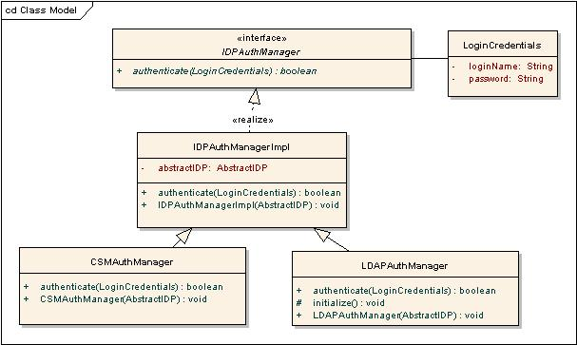

# | Class name | Description
1 | IDPAuthmanager.java/IDPAuthmanagerImpl.java | Authentication manager is a class which is used to authenticate an IDP user. Currently auth manager for default IDP i.e. CSM is provided. LDAP authentication is also possible by using LDAP authentication manager. All new auth managers will have to extend IDPAuthmanagerImpl.java.
2 | CSMAuthManager.java | Implementation class for CSM authentication.
3 | LDAPAuthMAnager.java | Implementation class for LDAP authentication. Any new IDP which wants to authenticate user across any LDAP and want some other implementation of LDAP authentication can write a new class by extending this class.

Migrator classes/Interfaces:
Migration is the process of migrating a caTissue user form default IDP to any other IDP. To support migration in caTissue “<migration-details>” section of auth file should be updated properly. Following are the required classes which need to be extended by any new IDP implementation classes.

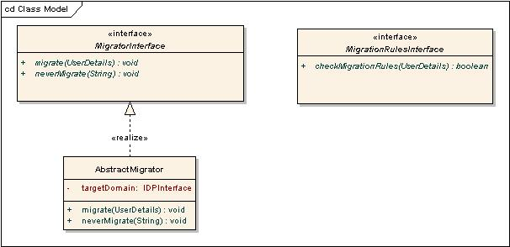

# | Class name | Description
1 | MigrationRuleInterface.java | This interface will represent rule for migration of a IDP .Any user who will satisfy this rule is eligible for migration.  E.g. If a caTissue user login id ends with “wustl.edu” such users are eligible for migration and should get option for migrating to WUSTL IDP.
2 | MigratorInterface.java | This interface provides methods for migrating a user from default IDP to any other IDP.
3 | AbstractMigrator.java | AbstractMigrator is an abstract java class which implements Migrator Interface. For new IDP a migrator is required which will migrate caTissue user from default IDP to new IDP. This migrator class must be a subclass of AbstractMigrator.

E.g. code:
Example IDPAuthentication.xml

<IDPS>

<IDP name="CSM">
<class name="edu.wustl.authmanager.CSMAuthManager " />
<idpdetails>
<defaultidp>true</defaultidp>
<displayname>CSM</displayname>
</idpdetails>

<idp-configuration>
</idp-configuration>
<user-attributes>
</user-attributes>

<migration-details>
<migrator>
<rule-class>
edu.wustl.migration.rules.NewIDPMigrationRule</rule-class>
<migrator-class>
edu.wustl.migrator.NewIDPMigrator</migrator-class>
<target-idp-name>NEW_IDP</target-idp-name>
</migrator>

</migration-details>
</IDP>
<IDP name=NEW_IDP/>
<class name="edu.wustl.authmanager. NewIDPAuthManager" />

<idpdetails>
<defaultidp>false</defaultidp>
<displayname>New Idp</displayname>
</idpdetails>

<idp-configuration>
<initContextFactory> </initContextFactory>
<securityAuthetication> </securityAuthetication>
<securityProtocol></securityProtocol>
<directory> /</directory>
<searchbase> </searchbase>
<searchfilter> </searchfilter>
<stringToReplace> </stringToReplace>
<bindUser> </bindUser>
<bindPassword></bindPassword>
</idp-configuration>

<user-attributes>
<firstName>givenname</firstName>
<lastName>sn</lastName>

</user-attributes>

<migration-details>
</migration-details>
</IDP>

</IDPS>

E.g. code for authentication manager:
Public class NewIDPAuthManager extends IDPAuthManagerImpl
{
Public Boolean authenticate (LoginCredentials loginCredentials)
{
This method will contain the logic for user authentication.
}
}

E.g. code for migration rule implementation:
Public class NewMigartionRule implements MigrationRulesInterface
{
Public Boolean checkRulesForMigration(LoginCredentials loginCredentials)
{
This method will contain the actual migration rule and code to check if user satisfies migration rule or not.
}
}

E.g. code for Migrator:
Public class NewIDPMigrator extends AbstractMigrator
{
Public void migrate (UserDetails userDetails)throws MigrationException
{
This method will contain logic to migrate user from default IDP to new IDP.
}

Public void neverMigrate (String loginName)throws MigrationException
{
This method will contain logic for not to migrate user from default IDP to new IDP.
}

}

New IDP Deployment Details:
Any institution can have their own IDP across which logged in user will be authenticated and that user can be migrated from one IDP to other. To have a new IDP, migrators, authentication managers and migration rules have to be defined properly.
Steps to write and configure new IDP classes:
Following is the Client jar which contains all required interfaces
File: IDPAUthengticationManager0_0.jar
Location: CATISSUE_HOME/modules/custom_impl_lib folder
- Write required authentication managers, migrator and migration rules required for new IDP all the interfaces are present in IDPAUthengticationManager0_0.jar.
- Prepare jar of all the implementation classes required for new IDP.
- Copy that jar in to CATISSUE_HOME/modules/custom_impl_lib folder.
- Update IDPAuthentication.xml present in caTissuecore-properties folder properly.
- Run deploy_app any target.
- Start jboss server.

Single Sign-On support

caTissue uses JASIG CAS (Common Authentication Service) for providing Single Sign-On support with other applications. This section explains the different integration aspects of caTissue with CAS. It also explains the procedure to implement and use an authentication mechanism other than the default.

Installation parameters

caTissue-CAS integration requires the following parameters to be specified in “caTissueInstall.properties” file which is used to deploy the caTissue application.

The table below provides a brief description of these properties.

Property | Description
cas.deploy | Description: This property specifies if the CAS server needs to be deployed on the same server as caTissue application.  Default Value: true  Permissible Values: true/false
cas.jboss.server.host | Description: This property specifies the host name of the CAS server. This property is required to be specified, if “cas.deploy“ is set to “false” and will be ignored if it is set to true.  Default Value: None  Permissible Values: N/A
cas.jboss.port | Description: This property specifies the port on which the CAS server is available. This property is required to be specified, if “cas.deploy“ is set to “false” and will be ignored if it is set to true.  Default Value: None  Permissible Values: N/A
cas.jboss.container.secure | Description: This property specifies whether CAS server is available on a secure server. This property is required to be specified, if “cas.deploy“ is set to “false” and will be ignored if it is set to true.  Default Value: no  Permissible Values: yes/no
cas.server.keystore.path | Description: This property specifies path to the keystore for the CAS server if it is accessible on an HTTPS secure link. This property is required to be specified, if “cas.deploy“ is set to “false” and will be ignored if it is set to true.  Default Value: no  Permissible Values: yes/no

The caTissue application uses the HTTP request filter provided by CAS to intercept all requests and redirect the user to the login page in case the user in not already logged- in. caTissue application’s web.xml contains the following filter mapping.
<filter>
<filter-name>CASFilter</filter-name>
<filter-class>edu.yale.its.tp.cas.client.filter.CASFilter</filter-class>
<init-param>
<param-name>edu.yale.its.tp.cas.client.filter.loginUrl</param-name>
<param-value>@@cas-server-url-login@@/cas/login</param-value>
</init-param>
<init-param>
<param-name>edu.yale.its.tp.cas.client.filter.validateUrl</param-name>
<param-value>@@cas-server-url-validateUrl@@/cas/serviceValidate</param-value>
</init-param>
<init-param>
<param-name>edu.yale.its.tp.cas.client.filter.serverName</param-name>
<param-value>@@catissue-cas-login-serverName@@</param-value>
</init-param>
</filter>
<filter-mapping>
<filter-name>CASFilter</filter-name>
<url-pattern>*.do</url-pattern>
</filter-mapping>

Authentication in CAS is achieved using the IdpAuthenticationHandler.java which extends the AbstractUsernamePasswordAuthenticationHandler.java provided by CAS. It provides implementation to the abstract method
boolean authenticateUsernamePasswordInternal(UsernamePasswordCredentials)
this authenticates users using the IDPs configured with the caTissue application. This class is provided in the classpath of the CAS server as a jar.
CAS is a Spring based application and uses the file deployerConfigContext.xml present in the WEB-INF directory of CAS war, for configuring the class used for authentication as a Spring bean. The property “authenticationHandlers” of the bean “authenticationManager” defined in this configuration file, lists IdpAuthenticationHandler as the class to be used for authentication. Following is the bean definition mentioned in this file.
<bean id="authenticationManager" class="org.jasig.cas.authentication.AuthenticationManagerImpl">
<property name="credentialsToPrincipalResolvers">
<list>
<bean class="org.jasig.cas.authentication.principal.UsernamePasswordCredentialsToPrincipalResolver" />
<bean class="org.jasig.cas.authentication.principal.HttpBasedServiceCredentialsToPrincipalResolver" />
</list>
</property>
<property name="authenticationHandlers">
<list>
<bean class="edu.wustl.cas.idp.authentication.handler.IdpAuthenticationHandler" />
</list>
</property>
</bean>

For detailed design of this module, please refer to the caTissue v1.2 design document.

Customizing Authentication mechanism with CAS
For implementing a custom authentication mechanism within CAS, it is required to write a class extending from AbstractUsernamePasswordAuthenticationHandler.java which provides implementation of the method authenticateUsernamePasswordInternal(). This class needs to be put in the class path of the CAS server and authenticationHandlers property of authenticationManager bean needs to be updated to use this class as the authentication handler. The CAS server will now use this new class for authentication instead of IdpAuthenticationHandler.java

Using Single Sign-On mechanisms other than CAS
If caTissue application needs to use some other mechanism to support Single Sign-On, IdpAuthenticationHandler.java can be used as a reference to do so. This class contains the appropriate calls to authenticate users using the appropriate IDPs configured with the application. IdpAuthenticationHandler.java needs to be modified to implement or extend the interface or class required by the new mechanism. For example, if some X Single Sign-On mechanism requires the authentication class extends from class Y, then IdpAuthenticationHandler.java can be modified to extend from Y and implement the authentication logic in the same way as has been done with the current implementation.

Appendix A–Longitudinal protocols
Longitudinal collection protocols are complex protocols that can contain sub-protocols as well as time points. Sub-protocol can contain any other sub-protocol and time points. caTissue Suite allows you to define longitudinal collection protocols using the API, but you cannot define longitudinal collection protocols through UI. The following sections describe how this can be achieved:
Term | Definition
Sub-Protocol | A part of a protocol that represents phases, arms, and cycles.
Phase | Study phases are successive pathways which may or may not apply in the cause of a treatment for one participant. Some phases may apply to all participants and some phases are used for unplanned course of disease progression or relapse.
Arm | Study arms are alternative pathways, with alternative visit timelines and participants assigned to one of these alternative arms by inclusion criteria and/or randomization. Collection time points are often different on different arms.
Cycle | Cycles are successive steps of treatment that belong to a particular phase.
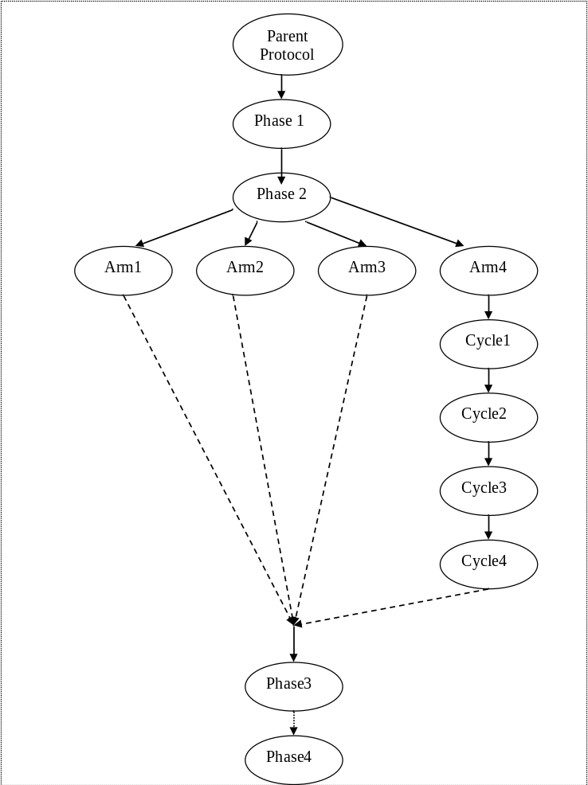
The following image depicts one such collection protocol: Osteosarcoma CP

Under parent protocol, 4 phases are present.
Under Phase2, 4 arms are present
And under Arm4, there are 4 cycles.

Collection Protocol model changes:
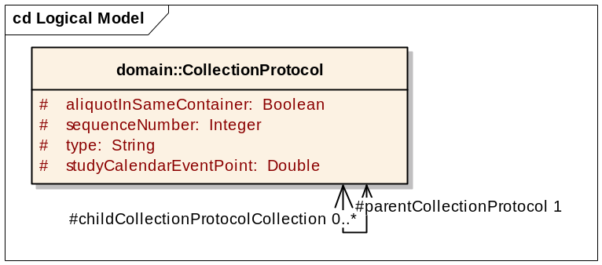
The following changes are made to the model to accommodate this requirement:
- childCollectionProtocolCollection added to hold child collectionProtocol.
- parentCollectionProtocol holds the parent of the collectionProtocol.
- Type is a type of the collection protocol that is Phase, Arm, Cycle, or Parent.

For adding complex collectionProtocol following attributes must to be set:
CollectionProtocol collectionProtocol = new CollectionProtocol();
//for setting type
collectionProtocol.setType(“Phase”);

//for setting child childCollectionProtocol collection.
collectionProtocol.setChildCollectionProtocolCollection(childCpCollection)
//for setting parent collectionProtocol.
collectionProtocol.setParentCollectionProtocol(parentProtocol)

Appendix B: Auditing Functionality
Every add, edit, and query operation in caTissue Suite application is audited in the AuditEvent tables in the database.
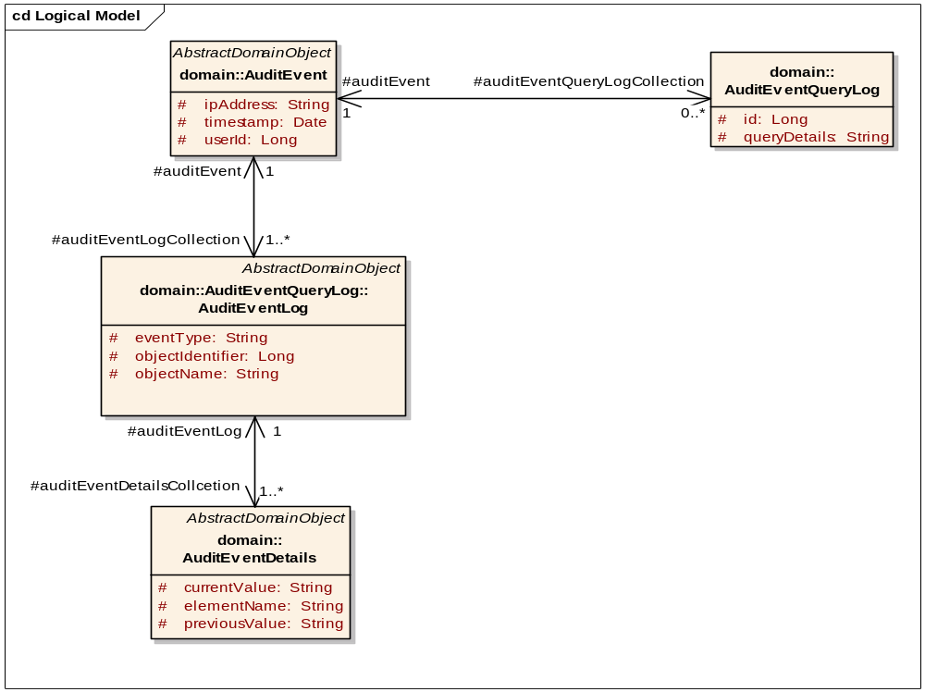
Figure 28: Auditing model
As seen in the above model, all the details about the activities of the logged in user are audited in the database. To know the audit details, you can query against the audit table to get the desired information. Audit table descriptions are given below:
- catissue_audit_event: Details about the user like user id and ipaddress of the machine. It also has the details about when the event was carried out by the user.
- catissue_audit_event_log: Details about the which data was added/changed.
- catissue_audit_event_details: Details about the old and new values of the data that was added/modified.
- catissue_audit_event_query_log: SQL queries that were executed by the user. This also contains the queries executed though API. For API queries in catissue_audit_event table the value of comment field is ‘APIQueryLog’

Appendix C: Modifying permissible values
In the caTissue Suite application, there are many attributes or fields for which the permissible values are pre-defined. Such attributes are known as enumerated attributes. For example, the specimen class has predefined set of permissible values including Fluid, Cell, Molecular, and Tissue. Any adopting institution can change these default values according to local requirements. However, the caTissue Suite cautions that adding values may make the application not caBIG® compatible. For all enumerated fields, all the required values identified by the system adopters during the course of development will be included. Before adding any new value, you must double check whether the existing values satisfy the requirement. If an available value for some attribute is irrelevant and is of no use for the institution, the value can be removed.
Database tables related to permissible values:
- catissue_cde:All the attributes that are enumerated are listed in this table. Each attribute is given a unique identifier called PUBLIC_ID.
- catissue_permissible_value: Permissible values for all the enumerated fields are listed in this table. These are associated with the catissue_cde table by the PUBLIC_ID field.
In order to modify any value in the permissible value list, you have to get the PUBLIC_ID corresponding to that attribute from catissue_cde and query against that in catissue_permissible_value. The new values for the same PUBLIC_ID can be added or existing values can be removed. The Value field is the column which stores the actual permissible value in catissue_permissible_value table. Another field in catissue_permissible_value is the PARENT_IDENTIFIER. The parent identifier field is used for attributesthat have hierarchical data such as clinical diagnosis and tissue site. In such cases, appropriate parent_id should also be set.
For example:
If you need to add a specimen type under a particular specimen class:
- Find public id for specimen class. Select public_id from catissue_cde where <search based on definition or long name’.
- Using the above public id. Select identifier from catissue_permissible_value where public_id=<public_id>.
- Find the max identifier in table catissue_permissible_value.
- Add a new entry for the new specimen type under fluid as: Insert into catissue_permissible_value values (<max_identifier, null, null, <identifier found in step 2>, <new type>, null.

Appendix D: Model changes in v1.2
In the caTissue Suite v1.2 release there is a slight change in model as shown in below image.
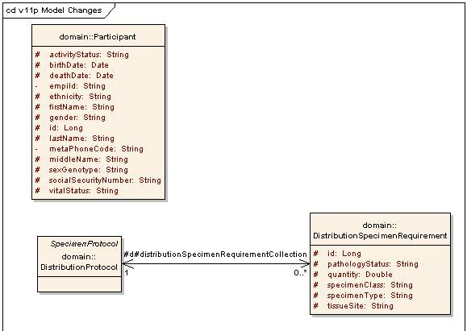

    - In Participant class the two new attributes are added empiId and metaPhoneCode. The addition of attributes does not affect any UI functionality as it is not displayed on UI as well as there is no specific bizlogic for this.
    - The cardinality between DistributionProtocol and DistributionSpecimenRequirement is changed to 0..*. So now the creating Distribution protocol the DistributionSpecimenRequirement is not mandatory.

