Specification of Full Mailing Address
Version 2
January 25, 2007

Objective: To develop a common agreement on the expression of the Full Mailing Address.

Purpose: To establish standards that are agreements on meaning, format, and permissible values to reduce the ambiguity between the same data elements residing in different information tools, to enable the efficient and integrated flow of data, and to aid in common understanding of the semantic meaning of data. When all partners consistently use the same terminology and format, data exchange and analysis is improved.

Standard Description: The address standard consists of data elements used by the United States Postal Service (USPS) and the Universal Postal Union (UPU) International, for specification of mail address. The address components provide for Full United States and International Mailing Addresses based on USPS/UPU formatting conventions, map to the HL7v3 Address data type, and offer guidance for the development of data elements to support the representation of additional countries. 7 data elements (2 derived and 5 non-derived) describe the components of the USPS Address. 35 additional data elements describe the Address components necessary to meet the requirements of 44 UPU countries (42 CDEs in total). The 44 UPU Countries used as references were provided from epidemiological use cases

Change History: The Vocabularies and Common Data Elements Work Space (VCDE WS) received a request from the caDSR Software Team to change the Data Element Concept (DEC) in the Common Data Element (CDE) Address Postal Code in order to facilitate metadata reuse. The proposal included changing the DEC Object Class from Postal Code (C25621) to Address (C25407) and changing the Property term from Code (C25162) to Postal Code (C25521). When the VCDE Small Group carried out its technical review of the CDE, other administered items were recommended for modification, including the addition of a representation term of Identifier (C25364) in the Value Domain (VD). These changes required versioning of the DEC, VD and the CDE, according to established business rules. The governance process for data standards maintenance was initiated and resulted in adoption of the proposed changes by the VCDE on January 25, 2007.

Definitions of Key Standard Terms:

- State - A politically organized body of people usually occupying a definite territory. (Dictionary.com)
- Province -Territory governed as an administrative or political unit of a country or empire. A region, district or division of a country; a tract; a portion a state, especially one remote from the capital. (NCI)
- Locality - A particular neighborhood, place, or district: “Localities, even individual villages, developed their own languages” (Wall Street Journal).
- District - A division of an area, as for administrative purposes. A region or locality marked by a distinguishing feature: went to the Lake District for their vacation. A territorial division (as of a nation, state, county, or city) for administrative, judicial, electoral, or other purposes: as a: an administrative unit esp. of a town or city established for the performance of a special governmental function <the water district> <park district> b: CONGRESSIONAL DISTRICT c : one of the divisions of the United States or of the individual states served by a particular federal or state court —see also the JUDICIAL SYSTEM in the back matter a region marked off for administrative or other purposes [syn: territory, territorial dominion, dominion] v : regulate housing in; of certain areas of towns [syn: zone]. (Dictionary.com)
- City - A large and densely populated urban area; a city specified in an address. A large or important municipality of a country, usually a major metropolitan center. (NCI)
- Town - A population center that is larger than a village and smaller than a city. A territorial and political unit governed by a town meeting, especially in New England. Informal. A city: New York is a big town. Chiefly British. A rural village that has a market or fair periodically.
- Village - A small group of dwellings in a rural area, usually ranking in size between a hamlet and a town. In some U.S. states, an incorporated community smaller in population than a town. (Dictionary.com)
- Farm - A tract of land cultivated for the purpose of agricultural production. A tract of land devoted to the raising and breeding of domestic animals. (Dictionary.com)
Definitions of Key Reference Terms:

- Qualifier
A term added to the name of a CDE to provide additional semantic meaning.

- Generic CDE
A generic CDE is one that can be used without additional qualifiers. An example of a generic CDE is Person Full Formatted Name.

- Descriptive CDE
A descriptive CDE is one that has qualifier terms to provide semantic specificity. An example of a descriptive CDE is Principal Investigator Person Full Formatted Name.

- Template CDE
A Template CDE is instructional in nature and defines best practices for the creation of descriptive CDEs. An example of a template CDE is TEMPLATE Person [Name Type] Full Formatted Name that provides business rules for creating a descriptive CDE such as Person Married Full Formatted Name.

- Derived CDE
A derived CDE is formed based on a business rule provided in a derivation rule. The rule may be a mathematical calculation, a concatenation, a format, or other specification. A derived CDE has input CDE(s) upon which a rule is applied.
caBIG/NCI Standard Data Elements for Address:
The caBIG/NCI Standard Data Elements for Address meets the requirements for creation of addresses used in 44 UPU Countries, and the United States. The complete list of component data elements is provided in Tables 1 through 4. Examples on the usage of the component data elements to form mailing addresses based on UPU formatting guidance can be found in Tables 5 through 7 for three example countries, Canada, China, and Mexico.
Table 1 - Full List of Address Components: the CDEs that could be used to create addresses for the 44 UPU Countries.
Table 2 – United States (USPS) Address Standard: the CDEs that the USPS uses for mailing addresses in the United States. This table includes the Derived Street/Thoroughfare Address 1 and Derived Supplemental (Street/Thoroughfare Address 2).
Table 3 – Derived Street/Thoroughfare Address 1: the component CDEs that compose this derived data element.
Table 4 – Derived Supplemental (Street/Thoroughfare Address 2): the component CDEs that compose this derived data element.
Table 5 – Canada Address - Example: a formatted Canadian Address constructed from data element components in the full list.
Table 6 – China Address - Example: a formatted Chinese Address constructed from data element components in the full list.
Table 7 – Mexico Address - Example: a formatted Mexican Address constructed from the data element components in the full list.
Attachment A provides graphical representations illustrating the construction of the United States, Canada, China, and Mexico full addresses, from derived and component CDEs.
Attachment B provides screen shots that illustrate the location of the data elements and examples included in this data standard in the caDSR Browser tree.
Attachment C provides graphical representations illustrating the Change History of the Data Standard.

Additional information about the components in this data standard may be found by querying the caDSR Public ID provided in the caDSR Browser (http://cdebrowser.nci.nih.gov/CDEBrowser/). The data standards may be found by selecting caBIG in the left browser tree, then selecting Classification, and then Data Standards.

Table 1 provides the compiled list of data elements that could potentially be used to create addresses for the 44 (Pilot) UPU countries.
Table 1. Full List of Address Components
 | Data Element Name and Public ID | Definition | Datatype/  # of Characters) | Permissible Values
1 | Derived Address Street/Thoroughfare Line 1 Text  2341940v1 | A component of an address that specifies a location by formatted concatenation of street/thoroughfare address components as described by a derivation rule. | Character/200 | Address Street/Thoroughfare Text  2341935v1
2 | Derived Address Street/Thoroughfare Supplemental Text  2341946v1 | A component of an address that specifies a location by formatted concatenation of supplemental address components as described by a derivation rule. | Character/200 | Address Street/Thoroughfare Supplemental Text  2341941v1
3 | Address Secondary Unit Indicator/Designator Type  2341954v1 | A component of an address that specifies a location by identification of an additional subdivision of the primary address by type. | Character/10 | Address Street/Thoroughfare Supplemental Text  2341941v1
4 | Address Village Identifier  2405434v1 | A component of an address that specifies a location by identification of a small group of dwellings in a rural area. | Character/30 | Address Division Identifier  2405191v1
5 | Address Door Text Identifier  2405161v1 | A component of an address that specifies a location by identification of an entrance way into a building. | Character/355 | Entity Text Identifier  2405142v1
6 | Address Street/Thoroughfare Name  2341883v1 | A component of an address that specifies a location by identification of a related road or public highway. | Charater/200 | Street Address Name  2017348v1
7 | Address Double Dependent Locality Name  2405444v1 | A component of address that specifies a locality or minor thoroughfare the address for which must be specified in relationship to a more major one. | Character/30 | Address Locality Name  2345360v1
8 | Address Entity Name Text  2341926v1 | A component of an address that specifies a location by identification of a specific person, corporation, organization, building or similar unit. | Character/355 | Entity Name Text  2341901v1
9 | Address Additional Identifier Text  2405182v1 | A component of address where additional attributes of an address are represented through the use of text. The additional attributes may include: name, service, or geographical place. [Explanatory Comment: geographical elements are more precisely addressed in the locational data elements.] | Character/200 | Address Identifier Text  2192759v1
10 | Address Department/Division Name Text  2341930v1 | A component of an address that specifies a location by identification of a specialized division of a large organization. | Character/255 | Division/Department Name Text  2341903v1
11 | Address Tower Text Identifier  2405187v1 | A component of an address that specifies a location by identification of a vertical building, often in a complex of buildings. | Character/355 | Entity Text Identifier  2405142v1
12 | Address Street/Thoroughfare Extension Name  2405176v1 | A component of an address that specifies a location by identification of an expanded part of road or public highway. | Character/200 | Street Address Name  2017348v1
13 | Address County/Parish Name  2345409v1 | A component of an address that specifies a location by identification of a governmental administrative subdivision. | Alphanumeric/30 | Address County/Parish Name  2345356v1
14 | Address Sector Text Identifier  2405428v1 | A component of an address that specifies a location by identification of a part or division. | Character/30 | Address Division Identifier  2405191v1
15 | Address Dependent Street/Thoroughfare Name  2405166v1 | A component of an address that specifies a location by identification of a related road or public highway. | Character/200 | Street Address Name  2017348v1
16 | Address Street/Thoroughfare Section Name  2405174v1 | A component of an address that specifies a location by identification of a distinct area of road or public highway. | Character/200 | Street Address Name  2017348v1
17 | Address Island Name  2405446v1 | A component of an address that specifies a location by identification of a land mass surrounded by water. | Character/35 | Address Island Name  2405247v1
18 | Address County/Parish Sub Division Name  2405442v1 | A component of an address that specifies a location by identification of a sub-part of a governmental administrative subdivision. | Alphanumeric/30 | Address County/Parish Name  2345356v1
19 | Address Region Identifier  2405440v1 | A component of an address that specifies a location by identification of a specified district, territory, or extended spatial location. | Character/30 | Address Division Identifier  2405191v1
20 | Address Secondary Unit Indicator/Designator Number  2341957v1 | A component of an address that specifies a location by identification of an additional subdivision of the primary address by number. | Character/6 | Address Secondary Unit Indicator/Designator Number  2341955v1
21 | Address Canton Identifier  2405438v1 | A component of an address that specifies a location by identification of a small territorial division of a country. | Character/30 | Address Division Identifier  2405191v1
22 | Address Prefecture Identifier  2405436v1 | A component of an address that specifies a location by identification of a district administered or governed by a prefect. | Character/30 | Address Division Identifier  2405191v1
23 | Address Industrial Zone Identifier  2405430v1 | A component of an address that specifies a location by identification of an area where products are manufactured. | Character/30 | Address Division Identifier  2405191v1
24 | Address Street Post Directional Type  2341900v1 | A component of an address that specifies a location by identification of directional text occurring after the street/thoroughfare name. | Character/2 | Address Post Directional Type  (Enumerated) – NE, SE, etc.  2340678v1
25 | Address Block Text Identifier  2405421v1 | A component of an address that specifies a location by identification of a city area that is commonly rectangular and surrounded by streets. | Character/30 | Address Division Identifier  2405191v1
26 | Address Street/Thoroughfare Type  2341948v1 | A component of an address that specifies a location by identification of a street/thoroughfare by type. | Character/20 | Address Street/Thoroughfare Type  (Enumerated) – Street, Alley, Way, etc.  2330415v1
27 | Address Entity Number  2341928v1 | A component of an address that specifies a location by identification of a specific person, corporation, organization, building or similar unit. | Character/20 | Entity Number  2341902v1
28 | Address Mail Stop Code  2341932v1 | A component of an address that specifies a location by identification of an internal delivery code assigned by the addressee. | Character/255 | Mailstop Code  2341904v1
29 | Address Post Office Box Number  2341934v1 | A component of an address that specifies a location by identification of a delivery box at a postal facility. | Character/20 | Post Office Box Number  2341905v1
30 | Address Farm Identifier  2405432v1 | A component of an address that specifies a location by identification of an area of agricultural activities. | Character/30 | Address Division Identifier  2405191v1
31 | Address Floor/Premises Text Identifier  2405150v1 | A component of an address that specifies a location by identification of the story or level of a building. | Character/355 | Entity Text Identifier  2405142v1
32 | Address Street Pre Directional Type  2341893v1 | A component of an address that specifies a location by identification of directional text occurring before the street/thoroughfare name. | Character/1 | Address Pre Directional Type  (Enumerated) – N, S, etc.  2340677v1
33 | Address Street/Thoroughfare Number  2341863v1 | A component of an address that specifies a location by identification of an assigned numeral or string of numerals on a street/thoroughfare. | Character/10 | Address Street/Thoroughfare Number  2329283v1
34 | Address State/Province Name  2179603v2 | The name that represents a principal administrative subdivision of the United States, Canada, and Mexico. | Alphanumeric/30 | Address State Name (Enumerated) - Virginia, Quebec, and Guanajuato etc. Name/2179442v1
35 | Address City Name  2179601v1 | A component of an address that specifies a location by identification of a city, town, or village. | Alphanumeric/30 | Address City Name/ 2179440v1
36 | Address Postal Code  2179606v1  Version 1.0 retired 2/21/2007 | The combination of the five-digit Zone Improvement Plan (ZIP) code and the four-digit extension code (if available) that represents the geographic segment that is a subunit of the ZIP code, assigned by the U.S. Postal Service to a geographic location to facilitate mail delivery; or the postal zone specific to the country, other than the U.S., where the mail is delivered. | Alphanumeric/15 | Address Postal Code/ 2179524v1
 | Address Postal Code Identifier  2179606v2.0  Versioned to facilitate reuse in UML models | The string of characters used to identify the five-digit Zone Improvement Plan (ZIP) code and the four-digit extension code (if available) that represents the geographic segment that is a subunit of the ZIP code, assigned by the U.S. Postal Service to a geographic location to facilitate mail delivery; or the postal zone specific to the country, other than the U.S., where the mail is delivered. | Character/15 | Address Postal Code Identifier  2179524v2.0
37 | Address Country Name  2179604v1 | A component of an address that specifies a location by identification of a country. | Alphanumeric/35 | Address Country Name (Enumerated) - United States of America Canada Mexico/2179443v1
38 | Address China State/Province Name  2345466v1 | A component of an address that specifies a location by identification of a political subdivision in the People's Republic of China. | Alphanumeric/30 | Address China State/Province Name/ 2345460v1
39 | Address District Name  2345413v1 | A component of an address that specifies a location by identification of an administrative division and/or a locality marked off by a distinguishing feature. | Alphanumeric/30 | Address District Name/2345361v1
40 | Address Locality Name  2345411v1 | A component of an address that specifies a location by identification of a local name for a particular neighborhood, place, or district. | Alphanumeric/30 | Address Locality Name/2345360v1
41 | Address Quarter Name  2345415v1 | A component of an address that specifies a location by identification of a place of residence, especially the buildings or barracks. | Alphanumeric/30 | Address Quarter Name/2345392v1
42 | Address Staircase Text Identifier  2405159v1 | A component of an address that specifies a location by identification the way of a flight or series of flights of steps. | Character/355 | Entity Text Identifer/2405142

Table 2 provides the full representation of USPS United States Mailing Address. The Full United States Address is composed of the 2 Derived Data Elements described in tables 3 and 4, along with additional components, as illustrated in table 2.
Table 2. United States (USPS) Address Standard
 | Data Element Name and Public ID | Definition | Datatype/  # of Characters) | Permissible Values
1 | Derived Address Street/Thoroughfare 1 Text  2341940v1 | A component of an address that specifies a location by formatted concatenation of street/thoroughfare address components as described by a derivation rule. | Character/200 | Address Street/Thoroughfare Text  2341935v1
2 | Derived Address Street/Thoroughfare Supplemental Text  2341946v1 | A component of an address that specifies a location by formatted concatenation of supplemental address components as described by a derivation rule. | Character/200 | Address Street/Thoroughfare Supplemental Text  2341941v1
3 | Address County/Parish Name  2345409v1 | A component of an address that specifies a location by identification of a governmental administrative subdivision. | Alphanumeruc/30 | Address County/Parish Name  2345356v1
4 | Address State/Province Name  2179603v2 | The name that represents a principal administrative subdivision of the United States, Canada, and Mexico. | Alphanumeric/30 | Address State Name (Enumerated) - Virginia, Quebec, and Guanajuato etc. Name/2179442v1
5 | Address City Name  2179601v1 | A component of an address that specifies a location by identification of a city, town, or village. | Alphanumeric/30 | Address City Name/ 2179440v1
6 | Address Postal Code  2179606v1  Version 1.0 retired 2/21/2007 | The combination of the five-digit Zone Improvement Plan (ZIP) code and the four-digit extension code (if available) that represents the geographic segment that is a subunit of the ZIP code, assigned by the U.S. Postal Service to a geographic location to facilitate mail delivery; or the postal zone specific to the country, other than the U.S., where the mail is delivered. | Alphanumeric/15 | Address Postal Code/ 2179524v1
 | Address Postal Code Identifier  2179606v2.0  Versioned to facilitate reuse in UML models | The string of characters used to identify the five-digit Zone Improvement Plan (ZIP) code and the four-digit extension code (if available) that represents the geographic segment that is a subunit of the ZIP code, assigned by the U.S. Postal Service to a geographic location to facilitate mail delivery; or the postal zone specific to the country, other than the U.S., where the mail is delivered. | Character/15 | Address Postal Code Identifier  2179524v2.0
7 | Address Country Name  2179604v1 | A component of an address that specifies a location by identification of a country. | Alphanumeric/35 | Address Country Name (Enumerated) - United States of America, Canada, Mexico/2179443v1

Table 3 provides data elements for the derived Street Address 1 CDE, as specifically described by the USPS. These building blocks can also be used in the creation of UPU Countries.
Table 3. Derived Street/Thoroughfare Address 1
 | Data Element Name and Public ID | Definition | Datatype/  # of Characters) | Permissible Values
1 | Address Post Office Box Number  2341934v1 | A component of an address that specifies a location by identification of a delivery box at a postal facility. | Character/20 | Post Office Box Number  2341905v1
2 | Address Street/Thoroughfare Number  2341863v1 | A component of an address that specifies a location by identification of an assigned numeral or string of numerals on a street/thoroughfare. | Character/10 | Address Street/Thoroughfare Number  2329283v1
3 | Address Street Pre Directional Type  2341893v1 | A component of an address that specifies a location by identification of directional text occurring before the street/thoroughfare name. | Character/1 | Address Pre Directional Type  (Enumerated) – N, S, etc.  2340677v1
4 | Address Street/Thoroughfare Name  2341883v1 | A component of an address that specifies a location by identification of a related road or public highway. | Charater/200 | Street Address Name  2017348v1
5 | Address Street Post Directional Type  2341900v1 | A directional occurring after the street name. A component of an address that specifies a location by identification of directional text occurring after the street/thoroughfare name. | Character/2 | Address Post Directional Type  (Enumerated) – NE, SE, etc.  2340678v1
6 | Address Street/Thoroughfare Type  2341948v1 | A component of an address that specifies a location by identification of a street/thoroughfare by type. | Character/20 | Address Street/Thoroughfare Type  (Enumerated) – Street, Alley, Way, etc.  2330415v1
7 | Address Secondary Unit Indicator/Designator Type  2341954v1 | A component of an address that specifies a location by identification of an additional subdivision of the primary address by type. | Character/10 | Address Street/Thoroughfare Supplemental Text  2341941v1
8 | Address Secondary Unit Indicator/Designator  2341957v1 | A component of an address that specifies a location by identification of an additional subdivision of the primary address by type. | Character/6 | Address Secondary Unit Indicator/Designator Number  2341955v1

Table 4 provides data elements for the derived Supplemental (Street Address 2) CDE, as specifically described by the USPS. These building blocks can also be used in the creation of UPU Countries.

Table 4. Derived Supplemental (Street/Thoroughfare Address 2)
 | Data Element Name and Public ID | Definition | Datatype/  # of Characters) | Permissible Values
1 | Address Entity Name Text  2341926v1 | A component of an address that specifies a location by identification of a specific person, corporation, organization, building or similar unit. | Character/355 | Entity Name Text  2341901v1
2 | Address Entity Number  2341928v1 | A component of an address that specifies a location by identification of a number for a specific person, corporation, organization, building or similar unit. | Character/20 | Entity Number  2341902v1
3 | Address Department/Division Name Text  2341930v1 | A component of an address that specifies a location by identification of a specialized division of a large organization. | Character/255 | Division/Department Name Text  2341903v1
4 | Address Mail Stop Code  2341932v1 | A component of an address that specifies a location by identification of an internal delivery code assigned by the addressee. | Character/255 | Mailstop Code  2341904v1

Table 5 provides the full representation of Canada (as specified by the UPU) Address as an example of reuse of component address data elements. The Full Canada Address is composed of data elements from table 1, table 2, and table 3.

Table 5. Canada Address - Example
 | Data Element Name and Public ID | Definition | Datatype/  # of Characters) | Permissible Values
1 | Derived Address Street/Thoroughfare Line 1 Text  2341940v1 | T A component of an address that specifies a location by formatted concatenation of street/thoroughfare address components as described by a derivation rule. | Character/200 | Address Street/Thoroughfare Text  2341935v1
2 | Derived Address Street/Thoroughfare Supplemental Text  2341946v1 | A component of an address that specifies a location by formatted concatenation of supplemental address components as described by a derivation rule. | Character/200 | Address Street/Thoroughfare Supplemental Text  2341941v1
3 | Address State/Province Name  2179603v2 | The name that represents a principal administrative subdivision of the United States, Canada, and Mexico. | Alphanumeric/30 | Address State Name (Enumerated) - Virginia, Quebec, and Guanajuato etc. Name/2179442v1
4 | Address City Name  2179601v1 | A component of an address that specifies a location by identification of a city, town, or village. | Alphanumeric/30 | Address City Name/ 2179440v1
5 | Address Postal Code  2179606v1  Version 1.0 retired 2/21/2007 | The combination of the five-digit Zone Improvement Plan (ZIP) code and the four-digit extension code (if available) that represents the geographic segment that is a subunit of the ZIP code, assigned by the U.S. Postal Service to a geographic location to facilitate mail delivery; or the postal zone specific to the country, other than the U.S., where the mail is delivered. | Alphanumeric/15 | Address Postal Code/ 2179524v1
 | Address Postal Code Identifier  2179606v2.0  Versioned to facilitate reuse in UML models | The string of characters used to identify the five-digit Zone Improvement Plan (ZIP) code and the four-digit extension code (if available) that represents the geographic segment that is a subunit of the ZIP code, assigned by the U.S. Postal Service to a geographic location to facilitate mail delivery; or the postal zone specific to the country, other than the U.S., where the mail is delivered. | Character/15 | Address Postal Code Identifier  2179524v2.0
6 | Address Country Name  2179604v1 | A component of an address that specifies a location by identification of a country. | Alphanumeric/35 | Address Country Name (Enumerated) - United States of America, Canada, Mexico/2179443v1

Table 6 provides the full representation of China (as specified by the UPU) Address as an example of reuse of component address data elements. The Full China Address is composed of data elements from table 1, table 2, and additional address components as listed below.

Table 6. China Address - Example
 | Data Element Name and Public ID | Definition | Datatype/  # of Characters) | Permissible Values
1 | Address China State/Province Name  2345466v1 | A component of an address that specifies a location by identification of a political subdivision in the People's Republic of China. | Alphanumeric/30 | Address China State/Province Name/ 2345460v1
2 | Address County/Parish Name  2345409v1 | A component of an address that specifies a location by identification of a governmental administrative subdivision. | Alphanumeric/30 | Address County/Parish Name  2345356 v1
3 | Address District Name  2345413v1 | A component of an address that specifies a location by identification of an administrative division and/or a locality marked off by a distinguishing feature. | Alphanumeric/30 | Address District Name/2345361v1
4 | Address Locality Name  2345411v1 | A component of an address that specifies a location by identification of a local name for a particular neighborhood, place, or district. | Alphanumeric/30 | Address Locality Name/2345360v1
5 | Address Street/Thoroughfare Name  2341883v1 | A component of an address that specifies a location by identification of a related road or public highway. | Charater/200 | Street Address Name  2017348v1
6 | Address Street/Thoroughfare Number  2341863v1 | A component of an address that specifies a location by identification of an assigned numeral or string of numerals on a street/thoroughfare. | Character/10 | Address Street/Thoroughfare Number  2329283v1
7 | Address City Name  2179601v1 | A component of an address that specifies a location by identification of a city, town, or village. | Alphanumeric/30 | Address City Name/ 2179440v1
8 | Address Country Name  2179604v1 | A component of an address that specifies a location by identification of a country. | Alphanumeric/35 | Address Country Name (Enumerated) - United States of America, Canada, Mexico/2179443v1
9 | Address Postal Code  2179606v1  Version 1.0 retired 2/21/2007 | The combination of the five-digit Zone Improvement Plan (ZIP) code and the four-digit extension code (if available) that represents the geographic segment that is a subunit of the ZIP code, assigned by the U.S. Postal Service to a geographic location to facilitate mail delivery; or the postal zone specific to the country, other than the U.S., where the mail is delivered. | Alphanumeric/15 | Address Postal Code/ 2179524v1
 | Address Postal Code Identifier  2179606v2.0  Versioned to facilitate reuse in UML models | The string of characters used to identify the five-digit Zone Improvement Plan (ZIP) code and the four-digit extension code (if available) that represents the geographic segment that is a subunit of the ZIP code, assigned by the U.S. Postal Service to a geographic location to facilitate mail delivery; or the postal zone specific to the country, other than the U.S., where the mail is delivered. | Character/15 | Address Postal Code Identifier  2179524v2.0

Table 7 provides the full representation of Mexico (as specified by the UPU) Address as an example of reuse of component address data elements. The Full Mexico Address is composed of data elements from table 1, table 2, and additional address components as listed below.
Table 7. Mexico Address - Example
 | Data Element Name and Public ID | Definition | Datatype/  # of Characters) | Permissible Values
1 | Address State/Province Name  2179603v2 | The name that represents a principal administrative subdivision of the United States, Canada, and Mexico. | Alphanumeric/30 | Address State Name (Enumerated) - Virginia, Quebec, and Guanajuato etc. Name/2179442v1
2 | Address County/Parish Name  2345409v1 | A component of an address that specifies a location by identification of a governmental administrative subdivision. | Alphanumeric/30 | Address County/Parish Name  2345360v1
3 | Address Quarter Name  2345415v1 | A component of an address that specifies a location by identification of a place of residence, especially the buildings or barracks. | Alphanumeric/30 | Address Quarter Name/2345392v1
4 | Address Locality Name  2345411v1 | A component of an address that specifies a location by identification of a local name for a particular neighborhood, place, or district. | Alphanumeric/30 | Address Locality Name/2345360v1
5 | Address Street/Thoroughfare Name  2341883v1 | A component of an address that specifies a location by identification of a name assigned to a street/thoroughfare. | Character/200 | Street Address Name/2017348v4
6 | Address Street/Thoroughfare Number  2341863v1 | A component of an address that specifies a location by identification of an assigned numeral or string of numerals on a street/thoroughfare. | Character/10 | Address Street/Thoroughfare Number  2329283v1
7 | Address City Name  2179601v1 | A component of an address that specifies a location by identification of a city, town, or village. | Alphanumeric/30 | Address City Name/ 2179440v1
8 | Address Country Name  2179604v1 | A component of an address that specifies a location by identification of a country. | Alphanumeric/35 | Address Country Name (Enumerated) - United States of America Canada Mexico/2179443v1

Issues Not Addressed in This Standard:

1. The identification of geographical locations, including: census tract, longitude, latitude, etc.
2. For HL7v3 conformance reasons, the CDE Census Tract and Care of will exist in
the caDSR, however; it will not be part of the Full Mailing Address Standard.

References:

- Cancer Therapy Evaluation Program (CTEP), http://ctep.cancer.gov/forms/Organization_Codes.txt

- Clinical Data Exchange Standards Consortium (CDISC), http://www.cdisc.org/models/sds/v3.1/index.html

- Federal Information Processing Standards Publications (FIPS) PUB 10-4, http://www.itl.nist.gov/fipspubs/fip10-4.htm

- Federal Information Processing Standards Publications (FIPS) PUB 5-2, http://www.itl.nist.gov/fipspubs/fip5-2.htm

- Health Level Seven (HL7), http://www.medclinic.net/HL7Specs/HL7 Control Query.htm

- HR-XML Consortium, http://ns.hr-xml.org/2_3/HR-XML-2_3/CPO/PostalAddress.html.

- International Organization of Standards (ISO), ISO 3166-1 Code List, http://www.iso.org/iso/en/prods-services/iso3166ma/02iso-3166-code-lists/index.html

- National Center for Health Statistics (NCHS), http://www.cdc.gov/nchs/

- National Committee on Vital and Health Statistics (NCVHS), http://www.ncvhs.hhs.gov/

- Universal Postal Union (UPU), http://www.upu.int/post_code/en/postal_addressing_systems_member_countries.shtml UPU Addressing, http://www.upu.int/post_code/en/addressing.shtml

- United States Postal Service (USPS), http://pe.usps.gov/cpim/ftp/pubs/Pub28/pub28.pdf

- X12 American National Standards Institute (ANSI), http://www.ansi.org/

Attachment A
Provides graphical representations, illustrating the construction of the United States, Canada, China, and Mexico full addresses, from derived and component CDEs.
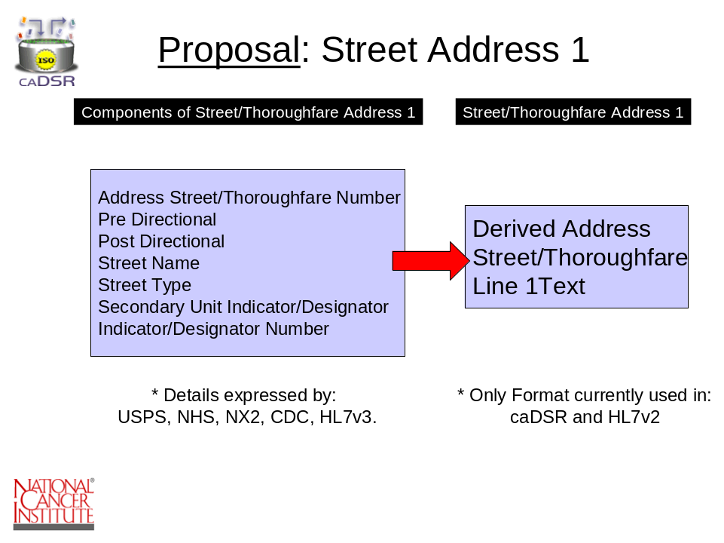
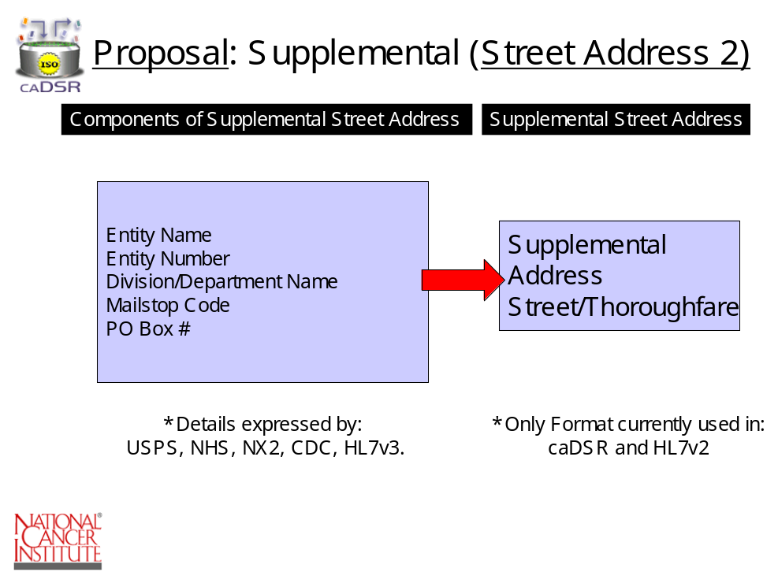

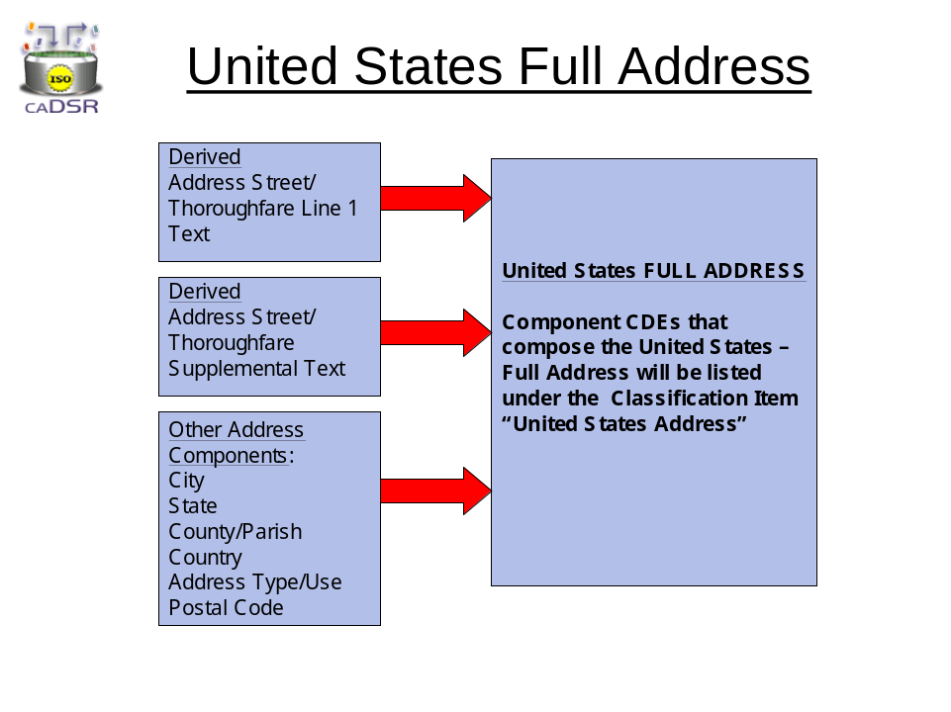
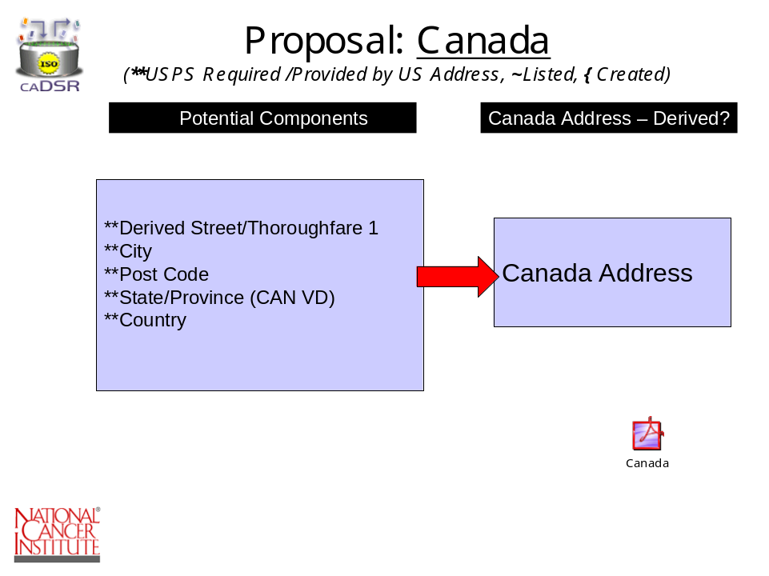

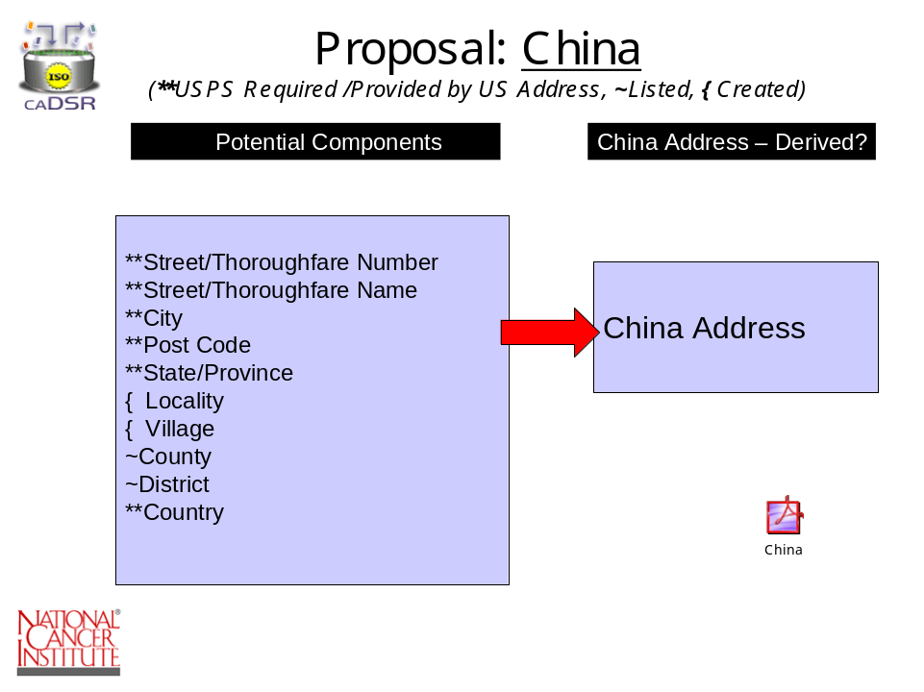

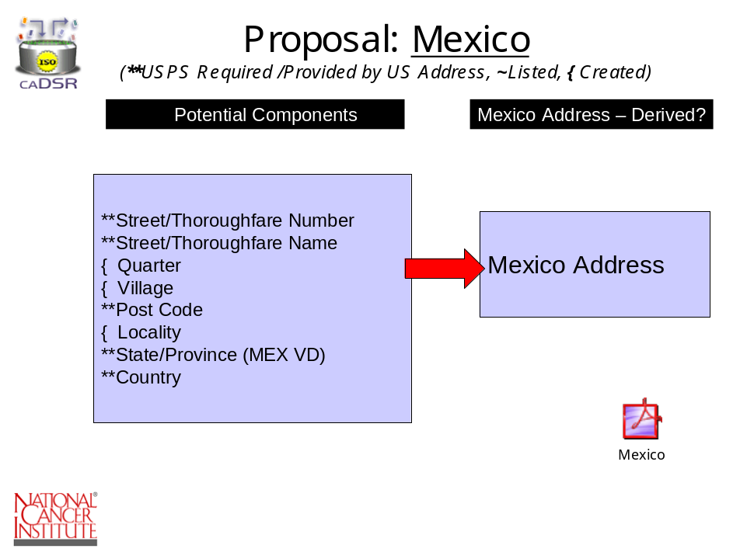

Attachment B
Provides screen shot that illustrates the placement of the data standard CDEs within the caDSR Browser hierarchy.
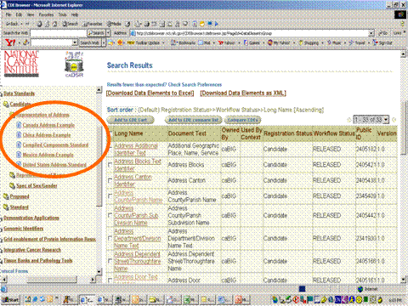
Attachment C

Attachment C provides graphical representations illustrating the Change History of the Data Standard (changes are represented in red).
