Specification of Organization
Version 2
January 25, 2007

Objective: To develop a common agreement on the representation of Organization.

Purpose: To establish standards that agree on meaning, format, and permissible values to reduce the ambiguity between the same data elements residing in different information tools, to enable the efficient and integrated flow of data, and to aid in common understanding of the semantic meaning of data. When all partners consistently use the same terminology and format, data exchange and analysis is improved.

Standard Description: The standard consists of six data elements that describe the organization components, provides for full organization identification referencing the HL7v3 organization data type convention, and documents guidance for development of data elements that include an Affiliation/Role related to an Organization. The data elements included in this data standard are listed in the two tables below.

Change History: The Vocabularies and Common Data Elements Work Space (VCDE WS) received a request from the Division of Cancer Prevention (DCP) to change the Value Domain (VD) of the Common Data Element (CDE) to include two additional Permissible Values (PV) of Lead Organization (C63409) and Participating Organization (C63411) to accommodate the DCP Enterprise System Knowledgebase (DESK) application. When the VCDE Small Group carried out its technical review of the CDE, other administered items were recommended for modification, including the Data Element Concept (DEC). It was recommended that the DEC be modified to remove the property qualifier of Affiliation (C25412). It was proposed that the definition be modified to provide semantic clarity based on the metadata concepts. It was also recommended that the VD representation term be changed to Type (C25284), with qualifiers of Affiliation (C25412) and Text (C25704), to be consistent with other data standards and to comply with current best practices. These changes required versioning of the DEC, VD and the CDE, according to established business rules. The governance process for data standards maintenance was initiated and resulted in adoption of the proposed changes by the VCDE WS on January 25, 2007.

Definitions of Key Standard Terms:
- Legal entity
A legal construct through which the law allows a group of natural persons to act as if it were an individual for certain purposes. The most common purposes are lawsuits, property ownership, and contracts. This allows for easy conduct of business by having ownership, lawsuits, and agreements under the name of the legal entity instead of the several names of the people making up the entity. (Wikipedia)
- Organization
The persons (or committees or departments etc.) who make up a body for the purpose of administering something; "he claims that the present administration is corrupt"; "the governance of an association is responsible to its members"; "he quickly became recognized as a member of the establishment" [syn: administration, governance, governing body, establishment, brass, organization]. (WordNet ® 2.0, © 2003 Princeton University)
- Organizational Unit
Organizational unit like a laboratory, institute or consortium. (NCI)

- Role
The actions and activities assigned to, required, or expected of a person or group.

- Role Entity

A non-hierarchical, named relationship between concepts. They are binary relationships pointing from one concept to another concept. Roles are unidirectional and each role has a Domain and a Range; the role points from one kind, the Domain, to another (or same) kind, the Range. The specific concept pointed to is considered the Role Value. (NCI)

Definitions of Key Reference Terms:

- Qualifier
A term added to the name of a Common Data Element (CDE) to provide additional semantic meaning.

- Generic CDE
A generic CDE is one that can be used without additional qualifiers. An example of a generic CDE is Person Full Formatted Name.

- Descriptive CDE
A descriptive CDE is one that has qualifier terms to provide semantic specificity. An example of a descriptive CDE is Principal Investigator Person Full Formatted Name.

- Template CDE
A Template CDE is instructional in nature and defines best practices for the creation of descriptive CDEs. An example of a template CDE is TEMPLATE Person [Name Type] Full Formatted Name that provides business rules for creating a descriptive CDE such as Person Married Full Formatted Name.

- Derived CDE
A derived CDE is formed based on a business rule provided in a derivation rule. The rule may be a mathematical calculation, a concatenation, a format, or other specification. A derived CDE has input CDE(s) upon which a rule is applied.
Candidate caBIG/NCI Data Elements:
The five Candidate caBIG/NCI Data Elements for Organization are provided in the following two tables:

Table 1 – Data Elements for Organization Components: lists the CDEs that describe organization components.

Table 2 - CDEs with Affiliation/Role or Type of Name: provides templates for creation of Organization(s) with affiliation/role qualifiers.

At the end of table 2, an example is provided to illustrate the use of the template.

Attachment A provides graphical representations illustrating the construction of Derived and Template CDEs from Organization CDEs and components.
Additional information about the candidate CDEs in this data standard may be found by querying the caDSR Public ID provided in the caDSR Browser (http://cdebrowser.nci.nih.gov/CDEBrowser/). The data standards may be found by selecting caBIG in the left browser tree, then selecting Classification, and then Data Standards.

Attachment B provides graphical representations illustrating the Change History of the Data Standard.

Table 1 provides data elements for Organization. These building blocks can be used to represent an organization. In order to conform to HL7v3 the organization components include a CDE for Organization Name, as well as a separate CDE for Organization Legal Category Type to identify the category of the organization entity, such as Corporation, Incorporated, LLC, LLP, etc.

Table 1. Data Elements for Organization Components

 | Data Element Name and Public ID | Definition | Datatype/  Enumerated/  Non-Enumerated (Character Count) | Permissible Values
1 | Organization Name  2152v 2.31 | The name of the Organization or an institution. | Character/Non-Enumerated/200 | Organization Name  2192751v1
2 | Organization Legal Category Type  2413148v 1.0 | A particular thing (organization, group, etc.) and its associated legal type. | Character/Enumerated/200 | Legal Category Type  2413142v1  (Corp, LLP, Inc., etc.)
3 | Affiliation Organization Role Text Type  2413117v1.0  Version 1.0 retired 1/26/2007 | The type of role/affiliation of an organization. | Character/Enumerated/200 | Organization Role Association Text Type  2413103v1  (Institute, Lead, HMO, etc.)  Version 1.0 retired 1/26/2007
 | Organization Role Affiliation Text Type  2413117v2.0 | The text that describes the distinguishable characteristics of a formal association between entities. | Character/Enumerated/200 | Affiliation Text Type  2413103v2.0  (Institute, Lead, HMO, etc.)
4 | Tax Organization Identifier Number  2413168v 1.0 | The number representing the information related to the unique tax identifier of an organization. | Character/Non-Enumerated/25 | Tax Identifier Number  2413160v1  *De-identification will be completed by the GRID architecture
5 | Organization Identifier Number 2407007v1.0 | The unique CTEP-assigned ID number of an organization. | Character/Non-Enumerated/25 | Organization Identifier Number  2183519v1

Table 2 provides templates for the development of data elements to create an organization with an affiliation/role. An organization may be defined by the addition of qualifier terms that specify the affiliation/role (using the current version of permissible values in the Affiliation Text Type Value Domain, Public ID: 2413117) with/of the organization names (Public IDs: 2152, 2413148) allowing for the creation of a data element i.e. (Lead Organization Name). Rather than creating standard data elements for a multitude of examples (such as Lead) for qualified organizations, this data standard includes template for construction of organization names with instructions or business rules for use of the template to create CDEs. Lists of standard values for affiliations/roles are included in the data standard. The term in brackets as noted in the templates would be replaced with a qualifier from the list of standard values to create a specific descriptive CDE.
An example is Lead Organization Name. In this example the permissible value of Lead is referenced from the current version of the Affiliation Text Type Value Domain (Public ID 2413117).
Table 2. CDEs Representing Affiliation Organization Role Name
 | Data Element Name and Public ID | Definition | Datatype/  # of Characters) | Permissible Values
1 | TEMPLATE [Organization Role Affiliation Text Type] Full Organization Name  2414564v1.0 | When there is the need to associate an Affiliation or Role with an organization name, this template can be used to create Descriptive Derived Data Elements. [Explanatory comment: When creating a descriptive CDE using this template the term in brackets ([]) would come from the current version of the Value Domain, Affiliation Text Type (Public ID 2413117) permissible value list. Please see Descriptive CDE Public ID 2414566 for an example on how the template is used.] | Character/Non-Enumerated/ 363 | Affiliation Text Type  (Public ID 2413117 current version)

The following example provides an illustration of how the templates are to be used and is not part of the data standard.

Derived Lead Full Organization Name  2414566v1.0 | When there is the need for an Affiliation/Role, the Affiliation/Role = Lead and the Full Organization Name are combined. [Explanatory comment: Please reference the TEMPLATE CDE Public ID 2414564 for specific instructions on how descriptive name affiliation/role CDEs are created.] | Character/Non-Enumerated/ 200 | Lead Full Organization Name  2414562v1

Issues Not Addressed in This Standard:

- A person or patient’s relationship to an organization.
- Specific contact information as it relates to an organization.

References:

- CDC Proposed Health Data Standards, Common Data Elements Implementation Guide, http://www.cdc.gov/data

- Health Level Seven, Version 2.x and Version 3, Ballot Document, August 2004, http://www.hl7.org/

- HR-XML Consortium, Person Name 1.2 SingleSpace Edition
http://www.hr-xml.org/hr-xml/wms/hr-xml-1-org/index.php?id={1385974ED5904A438616FF7BDB3F7439|140|2}

- ISO/IEC 5218:2004 Information Exchange, http://www.iso.ch/iso/en/CombinedQueryResult.CombinedQueryResult?queryString=11179
Attachment A
Attachment A provides graphical representations illustrating the construction of Derived and Template CDEs from name CDEs and components.
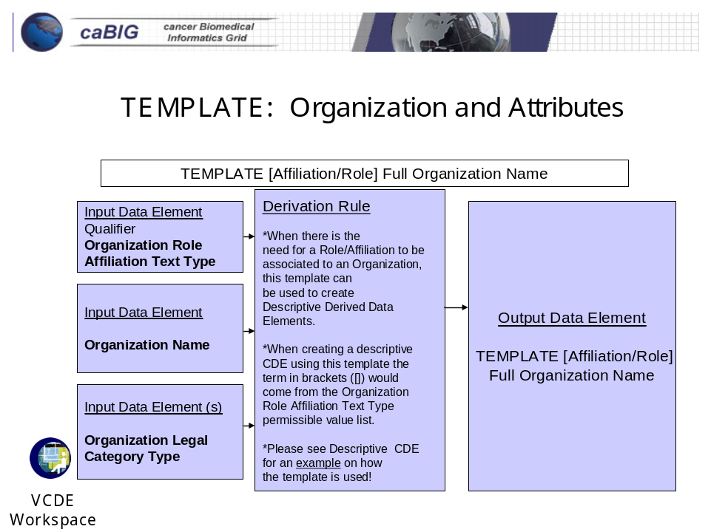

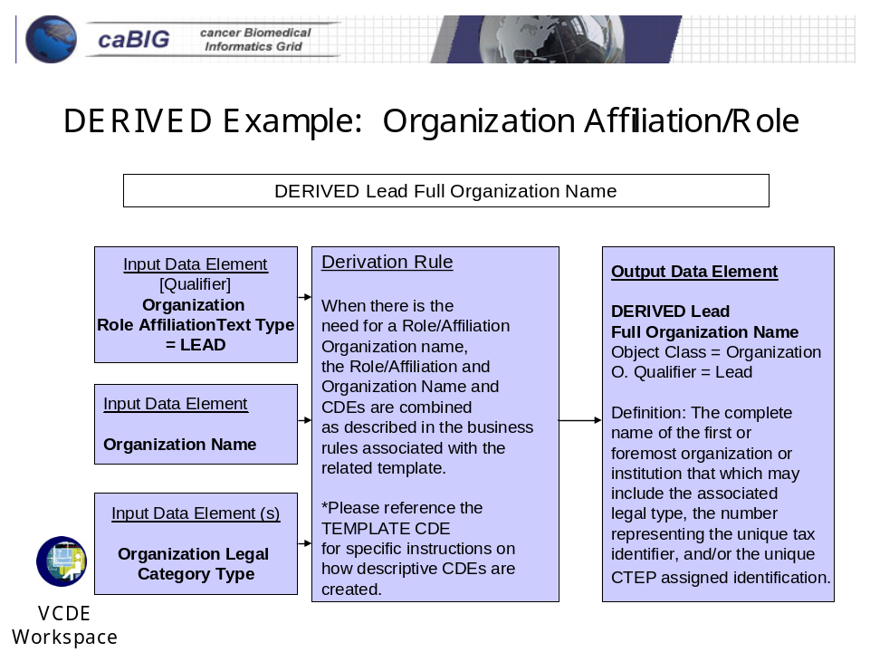

In this example, the permissible value, Lead, can be found in the current version of the Value Domain, Affiliation Text Type (Public ID 2413117). This and other values in the list can be used with the Template Data Element to create new descriptive data elements.
Attachment B
Attachment B provides graphical representations illustrating the Change History of the Data Standard (changes are represented in red).
