Specification of Person Age
Version 2
January 25, 2007

Objective: To develop a common agreement on the representation of Person Age.

Purpose: To establish standards that agree on meaning, format, and permissible values to reduce the ambiguity between the same data elements residing in different information tools, to enable the efficient and integrated flow of data, and to aid in common understanding of the semantic meaning of data. When all partners consistently use the same terminology and format, data exchange and analysis is improved.

Background: The majority of external standards and relevant usages do not represent, transmit, or store the concept of Age. HL7v2/3, ANSIX12, EDI, and CDUS are concerned with the components that could be used in an age calculation, which is specific to the server, application, and/or database. These groups focus on Date of Birth and Date of Event. The calculation of age is based on the equation of: Date of Event – Date of Birth. Because years are not uniform in the number of days included, a simple calculation of the number of days divided by 365 will not lead to the correct age in completed years. The specifics of the calculation differ in syntax between servers, applications, and databases. An algorithm is included to provide guidance for the computation of age value and Microsoft provides instructions on the most common calculations (go to http://www.microsoft.com/ and enter ‘calculating age’ in the Search box.) These instructions are referenced within the age data elements that compose the standard.

To minimize data errors, the recommended best practice is to exchange dates, rather than calculated age values. However, because of confidentiality rules, this may not always be possible. In these cases, the Derived Person Age Value CDE is the proper exchange format. Using the algorithm referenced in the CDE, the transfer format for Years, Months and Days is expressed as YYY.MM.DD that includes values for year between 0 and 999, for month between 0 and 11, and for day between 0 and 30.

Standard Description: The standard consists of 8 data elements. The first two data elements describe the basic components of an age calculation, Patient Birth Date and Event DateTime. The third data element is a derived data element, which illustrates how age is calculated using Event DateTime minus Patient Birth Date to obtain a person’s age at the time of an event. The fourth data element describes a person’s age when self-reported. The fifth data element is an Event Description Type that may be used to qualify the Event DateTime and the Person Reported Age Value. The sixth data element is a template data element that provides guidance for creating an Event Description Type which is associated with an Event Date. The seventh and eighth data elements are templates which add an Event Description Type to the Derived Person Age Value and the Person Reported Age Value. Examples of how the templates are used to create qualified descriptive data elements follow the tables with the Templates.

Change History: The Vocabularies and Common Data Elements Work Space (VCDE WS) received a request by the NCI Context Administrators to change Person Self Report Age Value in order to facilitate the reuse of the data element. The proposal included changing the Data Element Concept (DEC) to remove the property qualifier, Self, from the name of the DEC. This change required versioning of the DEC and the data element, according to established business rules. The governance process for data standards maintenance was initiated and resulted in adoption of the proposed changes by the VCDE on January 25, 2007.

Definitions of Key Standard Terms:

- Calculated Age – The completed years, months, and days from the person’s date of birth and the date of event.

- Date of Birth - The calendar date on which a person was born (NCI).

- Birth - The emergence and separation of offspring from the body of the mother.

- Event - Something that happens at a given place and time (NCI).

- DateTime - The value that represents the time or period to which any event belongs and the measured or measurable period during which an action, process, or condition exists or continues. The preferred exchange format for DateTime is the Point in Time (TS) exchange format of YYYYMMDDhhmmss.uuuu[+|-ZZzz] that has been specified by Health Level 7 (HL7) version 3 for use in message sets that exchange Date and Time information (NCI and HL7).

- Exchange Format - The way characters are presented or arranged in an electronic file used to transfer between applications.

- Display Format - The way characters are presented or arranged in a report or on a computer screen.

Definitions of Key Reference Terms:

- Qualifier - A term added to the name of a CDE to provide additional semantic meaning.

- Generic CDE - A generic CDE is one that can be used without additional qualifiers. An example of a generic CDE is Person Full Formatted Name.

- Descriptive CDE - A descriptive CDE is one that has qualifier terms to provide semantic specificity. An example of a descriptive CDE is Principal Investigator Person Full Formatted Name.

- Template CDE - A Template CDE is instructional in nature and defines best practices for the creation of descriptive CDEs. An example of a template CDE is TEMPLATE Person [Name Type] Full Formatted Name that provides business rules for creating a descriptive CDE such as Person Married Full Formatted Name.

- Derived CDE - A derived CDE is formed based on a business rule provided in a derivation rule. The rule may be a mathematical calculation, a concatenation, a format, or other specification. A derived CDE has input CDE(s) upon which a rule is applied. An example of a derived CDE is Derived Person Full Formatted Name.
Standard caBIG/NCI Data Elements:
The eight standard Data Elements for Age are provided in the following tables:

Table 1 – Data Elements for Calculation and Representation of Person Age: lists the CDEs that describe the components that calculate age, the derived calculation data element, and the reported age.

Table 2 - CDEs for Event Description Type and TEMPLATE [Event Description Type] Event DateTime: provides a template for creation of Event DateTime with Event Type Name qualifiers.

At the end of table 2, an example is provided to illustrate the use of the template.

Table 3 – TEMPLATE for Calculation or Representation of Person Age at a Specific Event: provides templates for creation of a qualified Age data element calculated by subtraction of Patient Birth Date from a qualified Event DateTime, and the reported age of a person at the time of an event type.

At the end of table 3, examples are provided to illustrate the use of the templates.

Attachment A provides graphical representations illustrating the construction of Derived and Template CDEs from Age CDEs and components.

Attachment B provides an algorithm for the computation of age value.

Attachment C provides graphical representations illustrating the Change History of the Data Standard.

Additional information about the candidate CDEs in this data standard may be found by querying the caDSR Public ID provided in the caDSR Browser (http://cdebrowser.nci.nih.gov/CDEBrowser/). The data standards may be found by selecting caBIG in the left browser tree, then selecting Classification, and then Data Standards.

Table 1 provides data elements for components needed to calculate and represent age. The components of Patient Birth Date and Event DateTime comply with HL7v2/3, ANSIX12, EDI, and CDUS usages. The Derived Person Age Value data element is based on the calculation of Event DateTime minus the Patient Birth Date. The derived data element demonstrates the basic calculation of age and complies with CDC, Census Bureau, and CTESS usage. A data element for Person Reported Age Value is also included.

Table 1. Data Elements for Calculation and Representation of Person Age

 | Data Element Name (Public ID and Version) | Definition | Datatype  (Max Character) | Comments
1 | Patient Birth Date  (793v4.0) | The month, day and year on which the patient/participant was born. | Date (8) | The birth date Display format is defined in the CDE as MM/DD/YYYY.
2 | Event DateTime  (2423385v1.0) | The particular year, month, day and/or time of a significant occurrence or happening. An expression of both date and time that the event has happened or will happened. [Explanatory comment: The preferred exchange format for DateTime is YYYYMMDDhhmmss.uuuu[+|-]ZZzz where YYYY is a Year of the Gregorian Calendar and may contain the integers 1 or 2 in the first position and the integers 0 to 9 in the remaining three positions, mm is a Month of the Gregorian Calendar represented by the values 00 to 12 beginning with January as 01, DD is a Day represented by the values 00 to 31, hh is a Hour with numbers between 00 and 23 (00 being midnight and 12 being noon), mm is a Minute with numbers between 00 and 59, ss is Seconds with numbers between 00 and 59, uuuu is optional Fractional Seconds with integers (0 to 9) in any position, and [+|-]ZZzz=optional difference in hours (ZZ - integers +14 to -13) and minutes (zz-values 00 to 59) from Coordinated Universal Time (UTC). A Full DateTime would contain all the elements, YYYYMMDDhhmmss. Partial DateTime may be filled from the left, e.g., YYYY, YYYYMM, YYYYMMDD, YYYYMMDDhh, YYYYMMDDhhmm, YYYYMMDDhhmmss, etc. This business rule for reporting Partial DateTime is in agreement with the HL7 guidelines for exchange of DateTime information. The display format for DateTime information is determined by programmatic requirements.] | DateTime (24) | The DateTime format for dates is an approved standard for caBIG. The time component is not used in the age computation.
3 | Derived Person Age Value  (2423393v1.0) | The length of time that one has existed in completed years, months and days at the time of the event. [Explanatory Comment 1: Age is calculated as the Event Date - Person Birth Date. The transfer format of Years, Months and Days (YYY.MM.DD) includes values for year between 0 and 999, for month between 0 and 11, and for day between 0 and 30. Explanatory Comment 2: The majority of external standards does not represent, transmit, or store the concept of Age. Microsoft provides instructions on the most common calculations and an algorithm is included to provide guidance for the computation of age value.] | Character (9) | Value Domain:  Person Age Value  Public ID: 2423391v1.0  An algorithm is also included to provide guidance for applications. https://cabig.nci.nih.gov/workspaces/VCDE/Data_Standards/Age.zip
4 | Person Self Report Age Value  (2433964v1)  Version 1 retired 1/26/2007 | An individual's description in completed years of their elapsed time since birth. | Number (3) | Value Domain:  Age Value  Public ID: 2488598
 | Person Reported Age Value  (2433964v2.0)  Versioned to facilitate reuse. | An individual's description in completed years of their elapsed time since birth. | Number (3) | Value Domain:  Age Value  Public ID: 2488598  Data Element Concept (DEC) modified to remove the property qualifier, Self, creating a new version of the DEC and Data Element
Table 2 provides a template for the curation of data elements to create Event DateTime CDEs by qualification with an Event Description Type. A data element for Event Description Type is provided to identify the type or category of an event, such as Registration, Remission, etc. The term in brackets in the template would be replaced with a qualifier from the Event Description Type list of permissible values to create a specific descriptive CDE. An initial list of permissible values, which may be expanded as needed, is provided. The use of a template with a qualifier list allows for the creation of qualified data elements as needed rather than creating standard data elements for a multitude of examples, such as the Registration example that follows the table.
Table 2. CDEs for Event Description Type and TEMPLATE [Event Description Type] Event DateTime
 | Data Element Name (Public ID and Version) | Definition | Datatype  (Max Characters) | Permissible Values
5 | Event Description Type  (2423305v1) | The terms that describe a significant occurrence or happening. | Character (50) | Observation  Procedure  Admission  Discharge  Registration  Diagnosis  Randomization  Questionnaire Completed  Birth, etc.
6 | TEMPLATE [Event Description Type] Event DateTime  (2423390v1) | When there is the need for an Event Description Type to be associated with an Event Date, this template can be used to create Descriptive Data Elements. [EXPLANATORY COMMENT: When creating a descriptive CDE using this template the term in brackets ([]) would come from the Event Description Type permissible value list.] | DateTime (24)

The following example provides an illustration of how the template is to be used and is not part of the data standard.

Registration Event DateTime  (2423400v1) | The particular year, month, day, and/or time on which the person is enrolled in an activity. | DateTime (24)

Table 3 provides templates for the curation of data elements to represent a person’s age at a specific event. The first uses the calculation of [Event Description Type] Event DateTime (i.e., the date of a specific event) – (Patient Birth Date) to obtain a value for age. An Event DateTime may be defined by the addition of qualifier terms from the Event Description Type value list as illustrated in Table 2. The second template in the table provides guidance for the creation of data elements where a person would report their current age at a given event, such as Registration.
Table 3. TEMPLATE for Calculation or Representation of Person Age at a Specific Event
 | Data Element Name (Public ID and Version) | Definition | Datatype  (Max Characters) | Comments
7 | TEMPLATE Derived Person [Event Description Type] Age Value  (2423403v1) | When there is a need to capture a calculated age at the time of a certain event, this template can be used to create descriptive data elements. [Explanatory Comment 1: When creating a descriptive CDE using this template the term in brackets ([]) would come from the Event Description Type permissible value list. Explanatory Comment 2: Derived Age is calculated as the Event Date - Person Birth Date. The transfer format of Year, Month and Day (YYY.MM.DD) includes values for year between 0 and 999, for month between 0 and 11, and for day between 0 and 30.] | Character (9) | When creating descriptive CDEs  Use Value Domain:  Person Age Value  Public ID: 2423391v1.0
8 | TEMPLATE Person Reported [Event Description Type] Age Value  (2438656v2.0) | When there is a need to capture an age reported by a person at the time of a certain event, this template can be used to create descriptive data elements. [Explanatory Comment: When creating a descriptive CDE using this template the term in brackets ([]) would come from the Event Description Type permissible value list.] | Number (3) | When creating descriptive CDEs  Use Value Domain:  Age Value  Public ID: 2488589v1.0

The following examples provide an illustration of how the templates are to be used and are not part of the data standard.

Derived Person Registration Age Value  (2423408v1) | The calculated age of a person at the time of enrollment in an activity. | Character (9)
Person Reported Registration Age Value  (2611882v1) | An individual's description at the time of enrollment of their elapsed time since birth in years. | Number (3)

Issues Not Addressed in This Standard:

Determination of Age outside of Birth = 0 years :
Examples such as Korea and other countries where the birthday is not recognized as the year, month and day on which the person was born.

Pre-birth Age such as:
Gestational age in weeks

Descriptive Age Terms such as:
Gestational
In-utero
Preterm Newborn
Neonate
Infant and Toddler
Child
Adolescent
Adult
Elderly/Geriatric

Age Range Categories such as:
0 - 11 Months
0 - 52 Weeks
0 - 28 Days
0 = <1 Year
1 - 4 Years
5 - 9 Years
10 - 14 Years
15 - 19 Years
Etc.

References:

- CDC Proposed Health Data Standards, Common Data Elements Implementation Guide, http://www.cdc.gov/data

- Health Level Seven, Version 2.x and Version 3, Ballot Document, August 2004, http://www.hl7.org/

- Clinical Data Interchange Standards Consortium (CDISC), Study Tabulation Model Implementation Guide: Human Clinical Trials, July 2004, http://www.cdisc.org/

- American National Standards Institute (ANSI),

- ISO/IEC 5218:2004 Information Exchange, http://www.iso.ch/iso/en/CombinedQueryResult.CombinedQueryResult?queryString=11179

- ISO 8601: Numeric Representation of Date and Time, http://www.iso.ch/

- Health Level 7: Version 2, http://www.hl7.org/

- Health Level 7: Version 3, http://www.hl7.org/ ; HL7, XML Implementation Technology Specification – Data Types, Section 2.34, http://www.hl7.org/v3ballot8/html/infrastructure/itsxml/datatypes-its-xml.htm ; HL7 Data Types - Abstract Specification, Section 2.36, http://www.hl7.org/v3ballot8/html/foundationdocuments/helpfiles/datatypes.htm

- Clinical Data Interchange Standards Consortium (CDISC), http://www.cdisc.org/models/sds/v3.1/index.html

- Consolidated Health Informatics, http://www.whitehouse.gov/omb/egov/c-3-6-chi.html

- Public Health Information Network, http://www.cdc.gov/phin/

Attachment A
Attachment A provides graphical representations illustrating the construction of Derived and Template CDEs from Age CDEs and components.
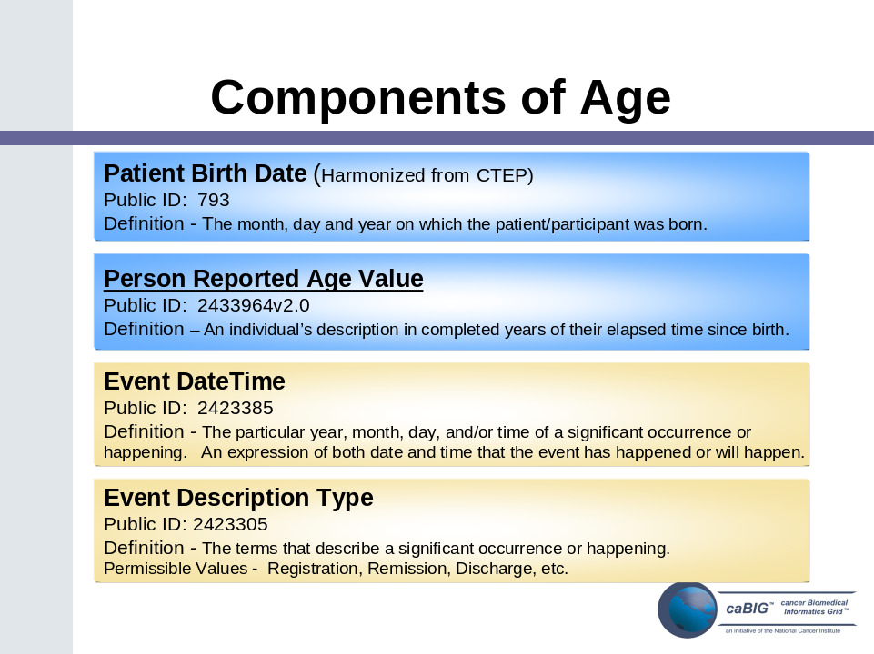
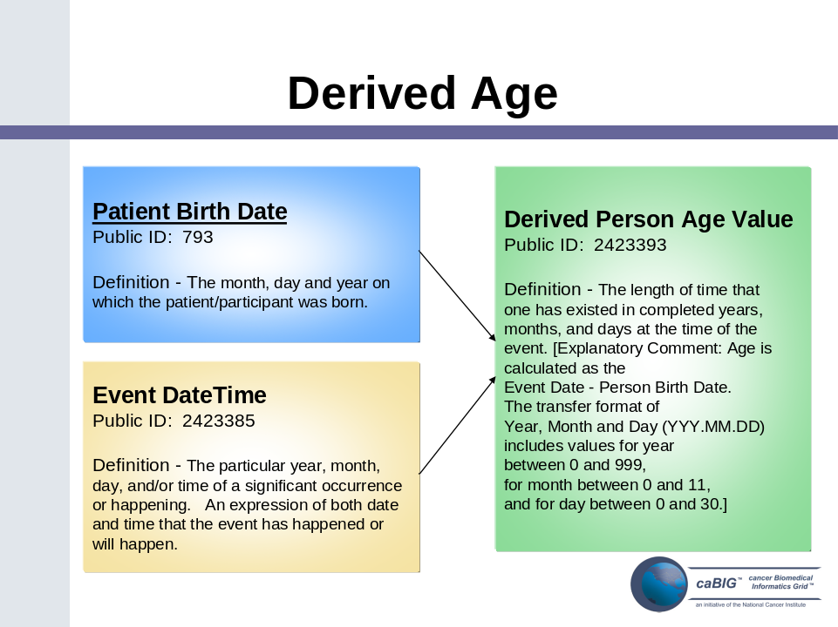
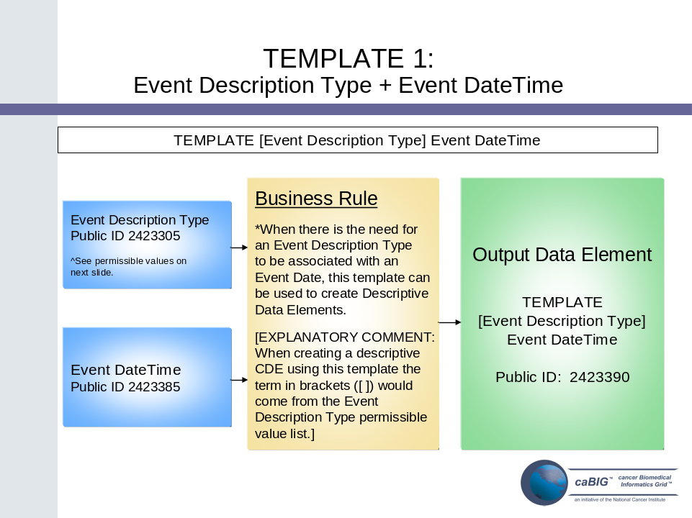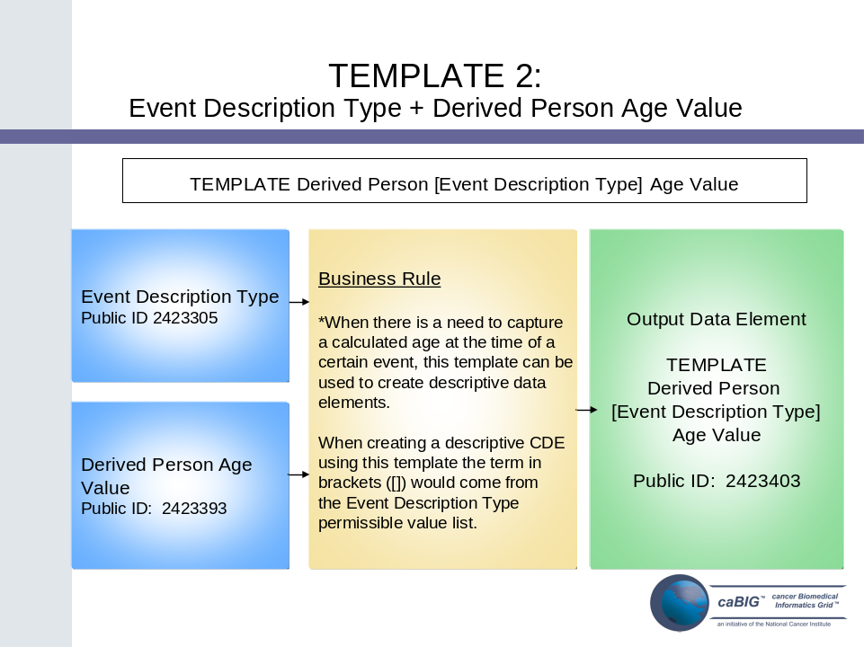

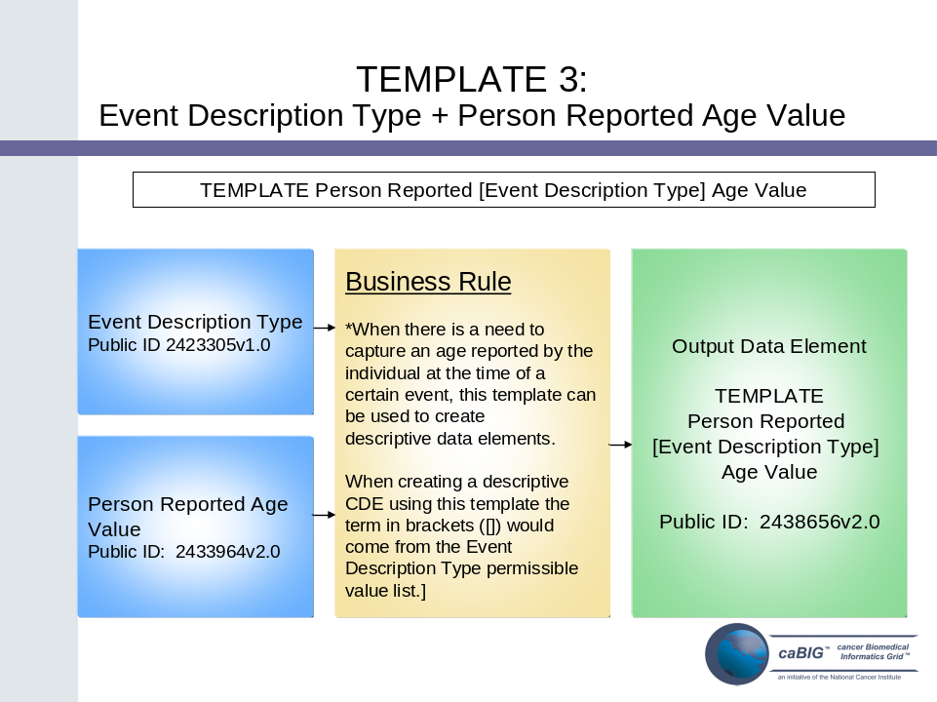

Attachment B

Attachment B provides an algorithm for the calculation of age based on birth date and event date.

Algorithm for Age Computation Based on Dates

A person's age is the amount of time that has passed since he or she was born. The age is computed in completed units of time, such as years. Computer programs generally store dates in terms of days from a set date, such as January 1, 1900. If you subtract a stored event date from a stored birth date, the result is the number of elapsed days. The number of completed years cannot easily be computed from the number of elapsed days, as the number of days per year is not constant at 365.

An algorithm is given below to compute age in completed years, months and days. The algorithm to compute age in completed years counts the number of times the anniversary date has occurred. The algorithm to compute age in completed months counts the number of times the anniversary day has occurred from the last anniversary date. The algorithm computes age in completed days by counting the days between the last occurrence of the anniversary day and the event day. For example, if the birth date is 1/1/2000 and the event date is 6/15/2004, then the number of completed years is 4, as the date 1/1 occurred 4 times between the birth date and the event date. The number of completed months is 5, as the day 1 occurred 5 times between 1/1/2004, the last anniversary date, and the event date. The number of completed days is 14, the days between 6/1/2004, the last occurrence of the anniversary day, and the event date. The age is stored as 004.05.14.

Note that if the day does not exist in all months, the number of months is incremented once the next day is reached. Suppose that the birth date is 1/31/2000 and the event date is 3/1/2004. The number of completed years is 4, as the date 1/31 occurred 4 times. The number of completed months is 1. The day 31 does not occur in February. However, once 3/1/2004 is reached, the 31st day of the month is assumed to have occurred. The age is stored as 004.01.01.

There are a number of ways age can be computed when elements of dates are missing or invalid. A common approach is to create an estimated age by imputing 15 when day is missing and imputing 7/1 when month and day are missing. However, our algorithm does not estimate ages and only computes as much of the age that is possible for the given age components. For instance, suppose day is missing for event date. Only completed years and months will be computed. The event month is assumed not to have been completed. If only year is available, only completed years will be computed. The event year is assumed not to have been completed. The decision to not impute date components simplifies the interpretation of the exchanged age, as it will never represent estimated age.

Age components (years, months and days) should always be >0. A zero should be used if a negative value results.

Children’s ages are often given in completed months. Completed months can easily be computed from our age as (completed years × 12 + completed months).

I. Algorithm when both birth and event dates have valid year, month and day present, and event date is after birth date.

/* Event month after birth month */
IF month of birth is less than month of event THEN
Years of age = event year – birth year
/* Event day on or after birth day */
IF day of birth is less than or equal to day of event THEN
Months of age = event month – birth month
Days of age = event day – birth day
/* Event day before birth day */
ELSE IF day of birth is greater than day of event THEN
Months of age = event month – birth month – 1
Days of age = max(0, number of days in month prior to event – birth day) + event day

/* Event month before birth month */
ELSE IF month of birth is greater than month of event THEN
Years of age = event year – birth year – 1
/* Event day on or after birth day */
IF day of birth is less than or equal to day of event THEN
Months of age = 12 – birth month + event month
Days of age = event day – birth day
/* Event day before birth day */
ELSE IF day of birth is greater than day of event THEN
Months of age = 12 – birth month + event month – 1
Days of age = max(0, number of days in month prior to event – birth day) + event day

/* Event month equal to birth month */
ELSE IF month of birth is equal to month of event THEN
/* Birth day on or before event day */
IF day of birth is less than or equal to day of event THEN
Years of age = event year – birth year
Months of age = 0
Days of age = event day – birth day
/* Birth day after event day */
ELSE IF day of birth is greater than day of event THEN
Years of age = event year – birth year – 1
Months of age = 11
Days of age = max(0, number of days in month prior to event – birth day) + event day

EXAMPLES
BIRTH: January 29, 1960
EVENT: April 30, 2004
Years = 44
Months = 3
Days = 1
Exchange format = 044.03.01

BIRTH: January 29, 1960
EVENT: April 29, 2004
Years = 44
Months = 3
Days = 0
Exchange format = 044.03.00

BIRTH: January 29, 1960
EVENT: April 3, 2004
Years = 44
Months = 2
Days = 5
Exchange format = 044.02.05

BIRTH: January 31, 1960
EVENT: March 3, 2004
Years = 44
Months = 1
Days = 3
Exchange format = 044.01.03

BIRTH: October 19, 1960
EVENT: February 28, 2004
Years = 43
Months = 4
Days = 9
Exchange format = 043.04.09

BIRTH: October 19, 1960
EVENT: February 19, 2004
Years = 43
Months = 4
Days = 0
Exchange format = 043.04.00

BIRTH: October 19, 1960
EVENT: February 3, 2004
Years = 43
Months = 3
Days = 15
Exchange format = 043.03.15

BIRTH: October 31, 1960
EVENT: March 3, 2004
Years = 43
Months = 4
Days = 3
Exchange format = 043.04.03

BIRTH: October 19, 1960
EVENT: October 28, 2004
Years = 44
Months = 0
Days = 9
Exchange format = 044.00.09

BIRTH: October 19, 1960
EVENT: October 19, 2004
Years = 44
Months = 0
Days = 0
Exchange format = 044.00.00

BIRTH: October 19, 1960
EVENT: October 3, 2004
Years = 43
Months = 11
Days = 14
Exchange format = 043.11.14

BIRTH: January 29, 2004
EVENT: April 30, 2004
Years = 0
Months = 3
Days = 1
Exchange format = 000.03.01

BIRTH: October 19, 2004
EVENT: April 30, 2005
Years = 0
Months = 6
Days = 11
Exchange format = 000.06.11

BIRTH: October 19, 2004
EVENT: October 30, 2005
Years = 1
Months = 0
Days = 11
Exchange format = 001.00.11

BIRTH: October 19, 2004
EVENT: October 10, 2005
Years = 0
Months = 11
Days = 21
Exchange format = 000.11.21

II. Algorithm when both birth and event date have valid years and months but not days, and event date (mm/yyyy) is after birth date.
Day may be missing for birth date and/or event date. Alternatively, a day value may be invalid. That is, the date of 4/31/2004 may be given, although April does not have a 31st day.

/* Event month after birth month */
IF month of birth is less than month of event THEN
Years of age = event year – birth year
/* Event month is assumed not to have been completed */
Months of age = event month – birth month – 1

/* Event month before birth month */
ELSE IF month of birth is greater than month of event THEN
Years of age = event year – birth year – 1
/* Event month is assumed not to have been completed */
Months of age = 12 – birth month + event month – 1

/* Event month equal to birth month */
/* Event month is assumed not to have been completed */
ELSE IF (year of birth is not equal to year of event) and
(month of birth is equal to month of event) THEN
Years of age = event year – birth year – 1
Months of age = 11

/* If death occurred in same month and year as event, set to 0 */
ELSE IF (year of birth is equal to year of event) and
(month of birth is equal to month of event) THEN
Years of age = 0
Months of age = 0

EXAMPLES
BIRTH: January 29, 1960
EVENT: April 2004
Years = 44
Months = 2
Exchange format = 044.02.

BIRTH: October 19, 1960
EVENT: February 2004
Years = 43
Months = 3
Exchange format = 043.03.

BIRTH: October 12, 1960
EVENT: October 2004
Years = 43
Months = 11
Exchange format = 043.11.

BIRTH: January 29, 2004
EVENT: April 2004
Years = 0
Months = 2
Exchange format = 000.02.

BIRTH: October 19, 2004
EVENT: February 2005
Years = 0
Months = 3
Exchange format = 000.03.

BIRTH: October 12, 2004
EVENT: October 2004
Years = 0
Months = 0
Exchange format = 000.00.

III. Algorithm when both birth and event date have valid years but not months and/or days, and event year is ≥ birth year.
Month and/or day may be missing for birth date and/or event date. Alternatively, a month or day value may be invalid (e.g., 13/01/2004 or 4/31/2004).

/* Event year is assumed not to have been completed */
Years of age = max(0, event year – birth year – 1)

EXAMPLES
BIRTH: January 29, 1960
EVENT: 2004
Years = 43
Exchange format = 043. .

BIRTH: October 19, 1960
EVENT: 2004
Years = 43
Exchange format = 043. .

BIRTH: January 29, 2004
EVENT: 2004
Years = 0
Exchange format = 000. .

BIRTH: October 19, 2004
EVENT: 2005
Years = 0
Exchange format = 000. .

IV. Algorithm when event year is missing.

/* No event year */
IF year of event is missing THEN stop

V. Algorithm when event date is prior to birth date

/* Event date prior to birth date */
IF year of event < year of birth THEN stop
ELSE IF year of event = year of birth and month of event < month of birth THEN stop
ELSE IF year of event = year of birth and month of event = month of birth
and day of event < day of birth THEN stop

Attachment C

Attachment C provides graphical representations illustrating the Change History of the Data Standard (changes are represented in red).

