Specification of Person Name
Version 2
January 25, 2007

Objective: To develop a common agreement on the expression of Person Name.

Purpose: To establish standards that are agreements on meaning, format, and permissible values to reduce the ambiguity between the same data elements residing in different information tools, to enable the efficient and integrated flow of data, and to aid in common understanding of the semantic meaning of data. When all partners consistently use the same terminology and format, data exchange and analysis is improved.

Standard Description: The Person Name standard consists of nine data elements that describe the components of Person Name, provides for a Person Full Formatted Name using the HL7 v2/v3 name formatting conventions, and documents guidance for development of data elements that include a Name Type or Affiliation/Role related to a Person Full Formatted Name. The data elements included in this data standard are listed in the three tables below.

Change History: The Vocabularies and Common Data Elements Work Space (VCDE WS) received a request from the Division of Cancer Prevention (DCP) to change the Value Domain (VD) of the Common Data Element (CDE) to include one additional Permissible Value (PV) of Funded Principal Investigator and change the Value Meaning Descriptions for three existing Value Meanings, Investigator, Principal Investigator and Site Coordinator to accommodate the DCP Enterprise System Knowledgebase (DESK) application. When the VCDE Small Group carried out its technical review of the CDE, other administered items were recommended for modification, including the Data Element Concept (DEC). It was recommended that the DEC Object Class be changed to Person (C25190), Property be changed to Role (C25199) with a property qualifier of Affiliation (C25412). It was proposed that the definition be changed to provide semantic clarity based on these concepts. It was also recommended that the VD representation term be changed to Type (C25284), with qualifiers of Role (C25199) and Text (C25704), to be consistent with other data standards and to comply with current best practices. In addition, it was recommended that the VD maximum length be changed to 100. These changes required versioning of the DEC, VD and the CDE, according to established business rules. The governance process for data standards maintenance was initiated and resulted in adoption of the proposed changes by the VCDE WS on January 25, 2007.

Definitions of Key Standard Terms:

- First Name, Given Name
A word or group of words indicating a person's first (personal or given) name; the name that precedes the surname. Synonym = Given Name. (NCI Thesaurus)

- Middle Name
A means of identifying an individual by using a word or group of words indicating a person's middle name. (NCI Thesaurus)

- Last Name, Family Name
A means of identifying an individual by using a word or group of words indicating a person's last (family) name. Synonym = Surname, Family Name. (NCI Thesaurus)

- Suffix/Genealogy Identifier
An affix occurring at the end of a word, base, or phrase which represents an individual's position in a family lineage or pedigree. (NCI Thesaurus)

- Person Name
The element is meant to apply a format to a full name so that it can be understood between applications/interfaces. (Derived from HL7)

Definitions of Key Reference Terms:

- Qualifier
A term added to the name of a CDE to provide additional semantic meaning.

- Generic CDE
A generic CDE is one that can be used without additional qualifiers. An example of a generic CDE is Person Full Formatted Name.

- Descriptive CDE
A descriptive CDE is one that has qualifier terms to provide semantic specificity. An example of a descriptive CDE is Principal Investigator Person Full Formatted Name.

- Template CDE
A Template CDE is instructional in nature and defines best practices for the creation of descriptive CDEs. An example of a template CDE is TEMPLATE Person [Name Type] Full Formatted Name that provides business rules for creating a descriptive CDE such as Person Married Full Formatted Name.

- Derived CDE
A derived CDE is formed based on a business rule provided in a derivation rule. The rule may be a mathematical calculation, a concatenation, a format, or other specification. A derived CDE has input CDE(s) upon which a rule is applied.

Candidate caBIG/NCI Data Elements:
The nine Candidate caBIG/NCI Data Elements for Person Name are provided in the following three tables:
Table 1 – Data Elements for Name Components: lists the CDEs that describe individual person name components.

Table 2 - Full Person Name in HL7v2/v3 Format: describes the full person name in HL7 format to be used for exchange.
Table 3 - CDEs with Affiliation/Role or Type of Name: provides templates for creation of person names with affiliation/role or name type qualifiers. Two examples are provided to illustrate use of the templates.
Attachment A provides graphical representations illustrating the construction of Derived and Template CDEs from name CDEs and components.
Attachment B provides graphical representations illustrating the Change History of the Data Standard.

Additional information about the candidate CDEs in this data standard may be found by querying the caDSR Public ID provided in the caDSR Browser (http://cdebrowser.nci.nih.gov/CDEBrowser/). The data standards may be found by selecting caBIG in the left browser tree, then selecting Classification, and then Data Standards.

Table 1 provides data elements for person name components. These building blocks can be used to create the formatted person name illustrated in Table 2 and in the templates described in Table 3.
Table 1. Data Elements for Name Components
 | Data Element Name and Public ID | Definition | Datatype/  # of Characters) | Permissible Values
1 | Person Given/First Name  2179589 v2.0 | A word or group of words indicating a person's first (personal or given) name; the name that precedes the surname. Synonym = Given Name. | Character (100) | Non Enumerated  (Using Value Domain 2018284 v1.0)
2 | Person Middle Name  2179590 v2.0 | A means of identifying an individual by using a word or group of words indicating a person's middle name | Character (100) | Non Enumerated  (Using Value Domain 2018284 v1.0)
3 | Person Family/lLast Name  2179591 v2.0 | A means of identifying an individual by using a word or group of words indicating a person's last (family) name. Synonym = Surname, Family Name. | Character (100) | Non Enumerated  (Using Value Domain 2018284 v1.0)
4 | Individual Genealogy Suffix Code  2006475 v2.0 | Text term to represent an individual's position in a family lineage or pedigree. | Character (4) | Enumerated  (Using Value Domain 2018689v2.0) Jr., Sr., II, III, IV.

As shown in Table 2, the Table 1 components are used to form the derived Person Full Formatted Name CDE. By concatenating the name components, a CDE can be derived that conforms to HL7 specifications for exchange on full formatted Person Name information:

Person Family/Last Name,Person Given/First Name Person Middle Name Individual Genealogy Text Name

An example of a person name in this format is: Smith,John Michael Junior.
Table 2. Full Person Name in HL7v2/v3 Format

 | Data Element Name and Public ID | Definition | Datatype/  # of Characters) | Permissible Values
5 | Derived Person Full Formatted Name  2222323 v1.0 | A formatted means of identifying an individual derived from multiple naming elements. | Character (313) | Non Enumerated  (Using Value Domain 2224527 v1.0)

Table 3 provides templates for the development of data elements to create a person name with an affiliation, role, or type of name specification. A Person Name may be defined by the addition of qualifier terms that specify their affiliation or role with a project or organization (e.g., Principal Investigator) or define the type of name being recorded (e.g., Married). Rather than creating standard data elements for a multitude of examples for qualified person names, this data standard includes templates for construction of qualified person names with instructions or business rules for use of the template to create CDEs. Lists of standard values for affiliations or roles and types of name are included in the data standard. The term in brackets as noted in the templates would be replaced with a qualifier from the list of standard values to create a specific descriptive CDE.

Examples are Person Birth Full Formatted Name and Principal Investigator Person Full Formatted Name.
Table 3. CDEs with Affiliation/Role or Type of Name
 | Data Element Name and Public ID | Definition | Datatype/  # of Characters) | Permissible Values
6 | Template Person [Name Type] Full Formatted Name  2262139 v1.0 | When there is a need to qualify a type of Name, this template can be used to create Descriptive Derived Data Elements. | Character (328) | Non Enumerated  (Using Value Domain 2262137 v1.0)
7 | Person Name Type  2262142 v1.0 | The name type that describes a non-current person name. | Enumerated (12) | Enumerated  (Using Value Domain 2262140v1.0)  Birth  Married  Alternate  Culture  Publications
8 | Template [Affiliation/Role] Person Full Formatted Name  2262127 v1.0 | When there is the need for an Affiliation or Role associated with a person name, this template can be used to create Descriptive Derived Data Elements. | Character (363) | Non Enumerated  (Using Value Domain 2201711v2.0)
9 | Affiliation Role Association Type  2201713 v1.0  Version 1.0 retired 1/26/2007 | The actions and activities assigned to, required, or expected of a person or group. | Character (33) | Enumerated  (Using Value Domain 2201711v1.0)  Examples include: Agent Expert, Clinical Coordinator, Healthcare Provider, Principal Investigator, etc.
 | Person Affiliation Role Text Type  2201713 v2.0 | The text that describes the distinguishable characteristics of the action or activity assigned to or required or expected of a person in a formal association with a group or organization. | Character (100) | Enumerated  (Using Value Domain Role Text Type 2201711v2.0)  Examples include: Agent Expert, Clinical Coordinator, Healthcare Provider, Principal Investigator, etc.

These example CDEs are provided as illustrations of how the templates are to be used and are not part of the data standard.

Derived Person Birth Full Formatted Name  2262145 v1.0 | The full formatted name given to a person at birth. | Character (318) | Non Enumerated  (Using Value Domain 2262143 v1.0)
Derived Principal Investigator Person Full Formatted Name  2262131 v1.0 | The full formatted name of a person assigned the role of Principal Investigator for a project. | Character (336) | Non Enumerated  (Using Value Domain 2262128v1.0)

Issues Not Addressed in This Standard:

1. Basis for assignment of “Last Name”, “First Name”, “Middle Name”. Assignments which have a cultural component are not included in the current Standard.

A brief discussion of some of the cultural issues may be found at:
- Wikipedia - http://en.wikipedia.org/wiki/Middle_name
- HR-XML Consortium - http://ns.hr-xml.org/2_3/HR-XML-2_3/CPO/PersonName.html

- Additional components of a Person Name such as Salutation, Title, and Education Indicator are not included in the current standard.

References:

- CDC Proposed Health Data Standards, Common Data Elements Implementation Guide, http://www.cdc.gov/data

- Clinical Data Interchange Standards Consortium (CDISC), Version 1.2 Source File: ODM-1.2.5, Dec 19, 2003, http://www.cdisc.org/models/odm/v1.2/

- Clinical Data Update System (CDUS), Version 3.0, Release 2, June 10, 2003, http://ctep.cancer.gov/reporting/cdus.html

- Health Level Seven, Version 2.x and Version 3, Ballot Document, August 2004, http://www.hl7.org/

- HR-XML Consortium, Person Name 1.2 SingleSpace Edition
http://www.hr-xml.org/hr-xml/wms/hr-xml-1-org/index.php?id={1385974ED5904A438616FF7BDB3F7439|140|2}

- ISO/IEC 5218:2004 Information Exchange, http://www.iso.ch/iso/en/CombinedQueryResult.CombinedQueryResult?queryString=11179

- United States Citizen and Immigration Service http://uscis.gov/graphics/formsfee/forms/index.htm

Attachment A

Attachment A provides graphical representations illustrating the construction of Derived and Template CDEs from name CDEs and components.
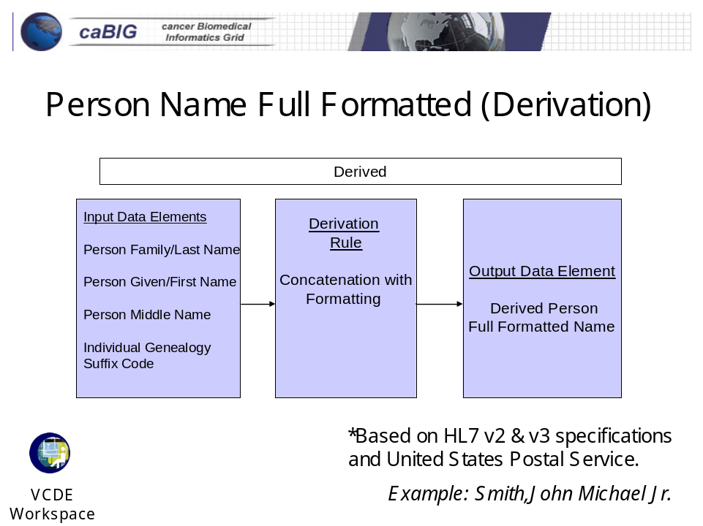

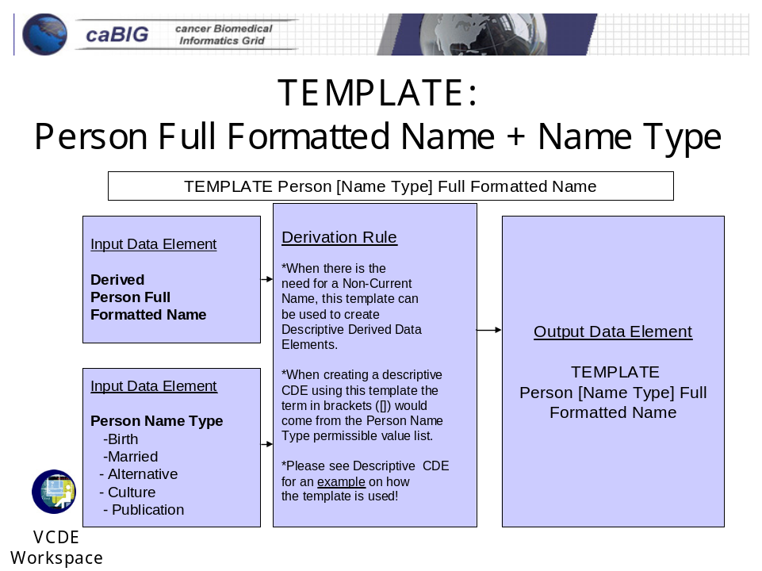

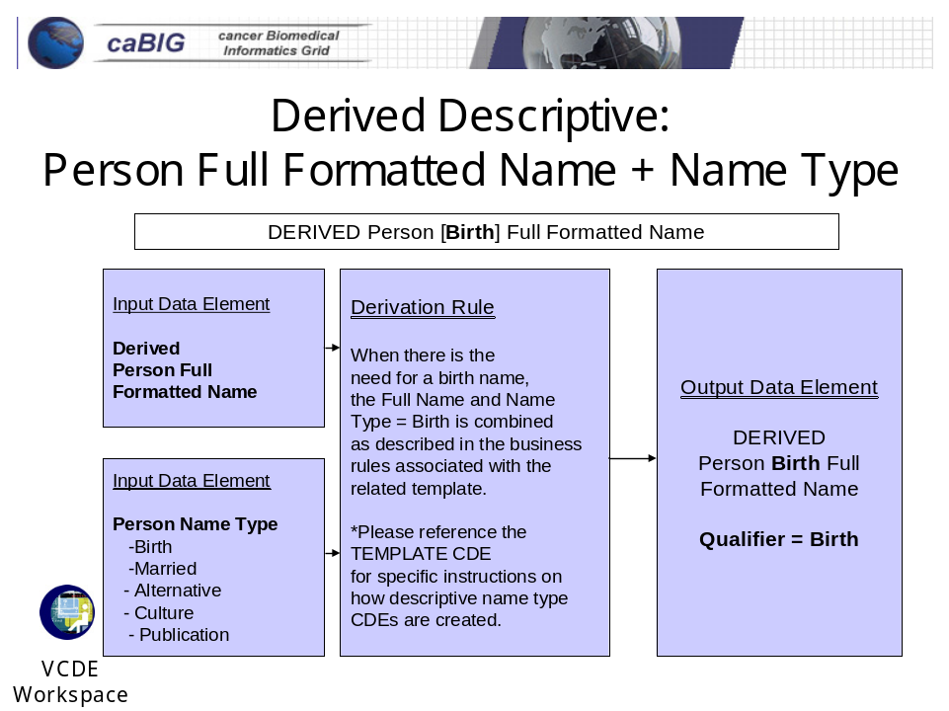

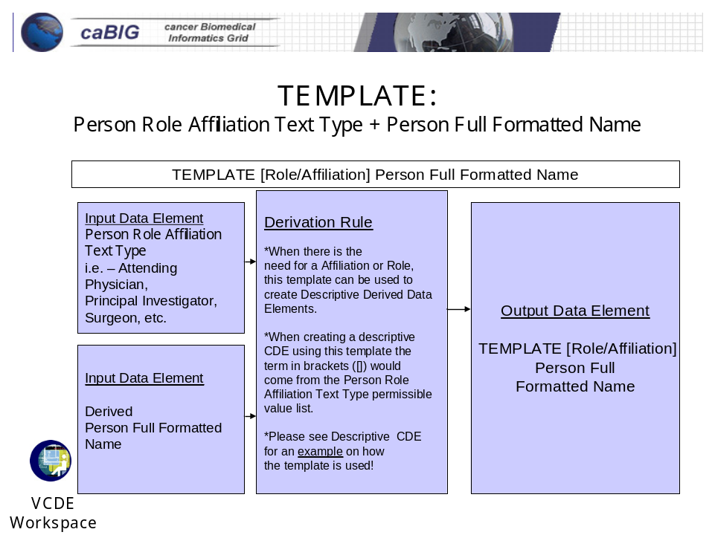

In this example, the permissible value, Principal Investigator, can be found in the current version of the Value Domain, Role Text Type (Public ID 2201711). This and other values in the list can be used with the Template Data Element to create new descriptive data elements.

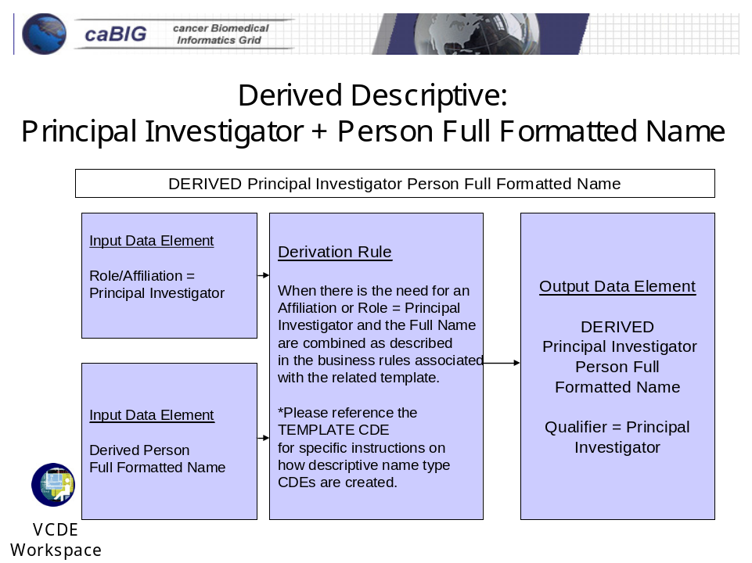

In this example, the permissible value, Principal Investigator, can be found in the current version of the Value Domain, Role Text Type (Public ID 2201711). This and other values in the list can be used with the Template Data Element to create new descriptive data elements.

Attachment B

Attachment B provides graphical representations illustrating the Change History of the Data Standard (changes are represented in red).

