Online Risk Calculator
Tutorials
RadRAT 3.7

Table of Contents
Example Case 1 – Excess Lifetime Risk from a Single Exposure of a Single Organ 1
Step-by-Step Solution 1
Results 2
Example Case 2 – Excess Lifetime Risk from a Single Exposure of Multiple Organs 3
Step-by-Step Solution 3
Preparing the Excel file 4
Results 5
Example Case 3 – Excess Lifetime Risk from Multiple Exposures of a Single Organ 6
Step-by-Step Solution 6
Results 7
Changing the Sample Size 7
Example Case 4 – Excess Lifetime Risk from Multiple Exposures of Multiple Organs 9
Step-by-Step Solution: 9
Results 11
Example Case 5 – Excess Lifetime Risk from Long-Term Exposure of All Organs 12
Step-by Step Solution 13
Prepare an Excel file 13
Results 14
Example Case 6 – Excess Future Risk from Multiple Exposures of a Single Organ 15
Step-by-Step Solution: 15
Results 16
Setting Assumptions, Settings and Report Options 17

Example Case 1 – Excess Lifetime Risk from a Single Exposure of a Single Organ

Estimate the excess lifetime risk (chances in 100,000) of developing colon cancer as a result of a single exposure to radiation at age 10.

Gender – Male or Female
Birth year – 1970
Exposure year – 1980
Age at time of exposure – 10 yrs
Exposure scenario – Single exposure to high-energy gamma radiation
Exposure Rate – acute (i.e., dose was delivered in a matter of seconds)
Organ exposed – Colon
Organ dose – 10 mGy

Step-by-Step Solution
- On the calculator home page, click Get Started.
- On the main input page, set Gender to Male and Birth Year to 1970 and set Organ Dose to mGy.
Enter exposure information
- Key 1 into the Exposure Event field, to indicate that this case has a single exposure
- Key 1980 into the Exposure Year field.
- Select Colon from the Organ drop-down menu.
- Select acute from the Exposure Rate drop-down menu.
- Select Fixed Value from the Distribution Type drop-down menu.
- Key 10 into the Parameter 1 field to indicate that the radiation dose received by the colon is equal to 10 mGy.
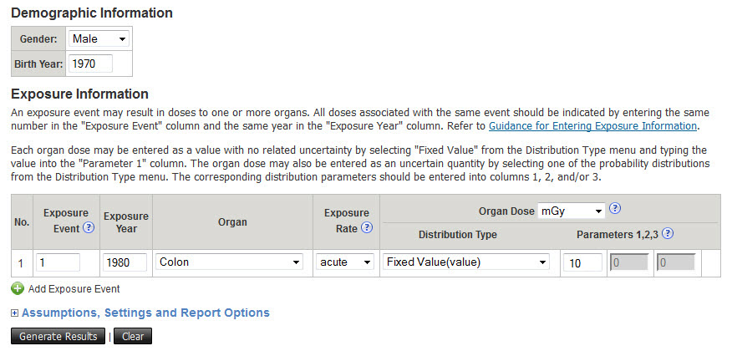

Click Generate Results.

Results
The estimated excess lifetime risk for males is displayed in the Summary Report page.

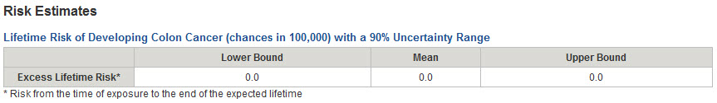

To estimate the excess lifetime risk for females
- Click the Back button of the browser or the Information link in the top left of the Summary Report page to return to the main data input page.
- Change Gender to Female.

Click Generate Results.

The Summary Report page displays the excess lifetime risk for females.
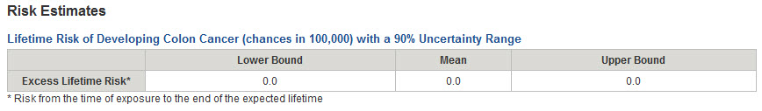

Example Case 2 – Excess Lifetime Risk from a Single Exposure of Multiple Organs

Estimate the excess lifetime risk of developing cancer (summed across cancer sites) as a result of a single exposure at age 10 to radiation affecting multiple organs.

Gender – Female
Birth year – 1990
Exposure year – 2000
Age at time of exposure – 10 yrs
Exposure scenario – single exposure of multiple organs to high-energy gamma radiation
Exposure Rate – acute (i.e., dose was delivered in a matter of seconds)
Organ exposed – multiple organs (see table below)
Organ dose – See table below

Example doses (mGy) to multiple organs from a single exposure

Organ | Organ Dose (mGy)
Oral Cavity and Pharynx | 0.0238
Esophagus | 0.353
Stomach | 13.4
Colon | 10.0
Rectum | 6.21
Liver | 13.0
Gallbladder | 11.0
Pancreas | 11.0
Lung | 2.11
Breast | 0.904
Ovary | 9.72
Uterus | 9.72
Bladder | 3.07
Kidney | 14.1
Thyroid | 0.0476
Leukemia | 4.62

Step-by-Step Solution
The input data can be entered by keying the information directly into the main input page. However, in this example, we will use an Excel template file to store the input data for future use. The Excel file can be uploaded to populate the input fields on the main input page. To accomplish this, follow these steps:

- From the calculator home page, click Get Started.
- On the main input page, click Upload an input file. link in the upper left corner. The page for downloading the template and uploading the file will open.
- Click Download a template version of the Excel input file and save the template Excel file on your computer. If you already have an Excel template file on your computer, skip this step.

- Prepare the Excel file (see the directions below).
- From the upload page of the calculator, click Browse, select the saved Excel file and upload it. The data in the upload file will populate all the fields in the main input screen.
- Click Generate Results. The Results page will open.

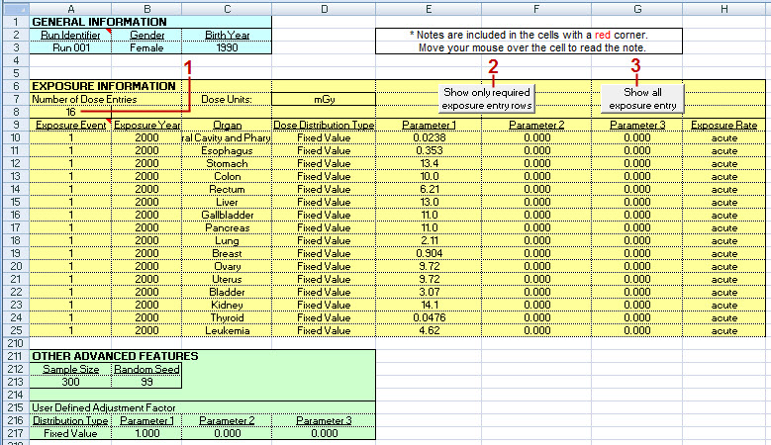

Preparing the Excel file
- In the General Information section, set Gender to Female using the drop-down list, and key 1990 in the Birth Year field.
- At the top of the Exposure Information section, key in the Number of Dose Entries (1) as 16, because there are 16 doses measured, each to a different organ. Note: The number on this line will be the number of lines that are uploaded.
- The Show only required exposure entry rows (2) and Show all exposure entry (3) buttons can be used to hide or show the lines that don’t have data. This feature only works if you have macros enabled. If you don’t have macros enabled, you can use the Hide/Unhide function of Excel or delete the extra rows. However, only the number of rows indicated in Number of Dose Entries are uploaded into the application, so it is not necessary to delete or hide them.
- Leave Dose Units at the default setting (mGy). There is a drop-down menu for other settings.
- In the Exposure Event column, key 1 in as the exposure number in all 16 rows of the table, to indicate that there was only one event that irradiated all 16 organs.
- Enter 2000 in the Exposure year column for all 16 rows.
- Select the exposed organ from the drop-down menus in the Organ column for each of the 16 rows.
- Leave the Dose Distribution Type set to the default, Fixed Value in all 16 rows.
- Key in the respective dose values in the Parameter 1 column for each selected organ, and leave the values set to zero, the default settings, in the Parameter 2 and Parameter 3 columns.
- Leave the Exposure Rate column set to the default, acute for all 16 rows of dose entries.
- Save the Excel file with any desired name.

Results
The total excess lifetime risk (summed across cancer sites) is displayed in the Summary Report page.

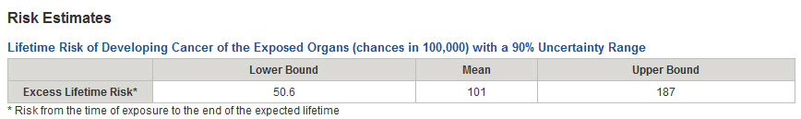

To inspect the risks estimated for each cancer site, click on the link labeled:
+ Excess Lifetime Risk per Cancer Site with a 90% Uncertainty Range
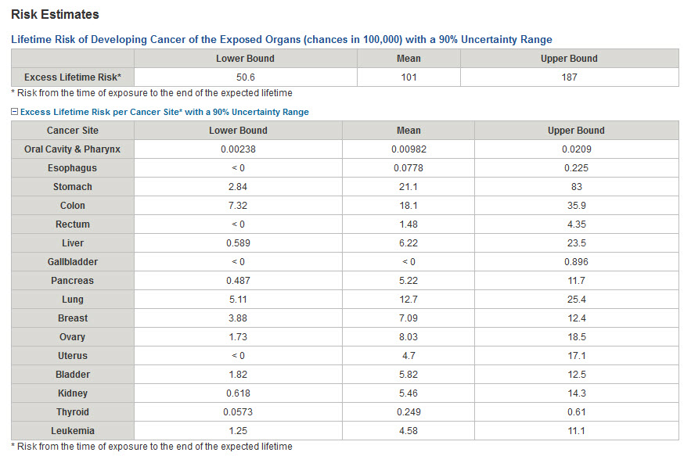

Example Case 3 – Excess Lifetime Risk from Multiple Exposures of a Single Organ

Estimate the total excess lifetime risk of developing breast cancer as a result of annual exposures between ages 40 and 49.

Gender – Female
Birth year – 1950
Exposure years – 1990-1999
Age at time of exposure – 40-49 yrs
Exposure scenario – single dose each year for 10 years
Exposure Rate – acute (i.e., dose was delivered in a matter of seconds)
Organ exposed – Breast
Each organ dose – Lognormal probability distribution with a geometric mean (GM) of 1.73 mGy and a geometric standard deviation (GSD) of 1.15

Step-by-Step Solution
- From the calculator home page, click Get Started.
- On the main input page, set Gender to Female and Birth Year to 1950 and set Organ Dose to mGy.

For the first exposure event in 1990
- Key 1 into the Exposure Event field, because this is the first exposure.
- Key 1990 into the Exposure Year field.
- Select Breast from the Organ drop-down menu.
- Select acute from the Exposure Rate drop-down menu.
- Select Lognormal from the Distribution Type drop-down menu.
- Key 1.73 in the Parameter 1 field to indicate that the lognormal distribution describing the uncertain dose has a geometric mean equal to 1.73 mGy.
- Key 1.15 in the Parameter 2 field to indicate that the lognormal distribution describing the uncertain dose has a geometric standard deviation equal to 1.15 mGy.

For the second exposure event in 1991
- Click Add to insert another line of input information.
- Key 2 into the Exposure Event field, because this is the second exposure received by the breast tissue.
- Populate the fields labeled Exposure Year, Organ, Exposure Rate, Distribution Key, Parameters 1, 2, 3 with the same values as above.

Repeat this process by adding eight additional lines of exposures (events 3 to 10), representing exposures in years 1992 to 1999, and enter the same dose information for each of them, as described above.

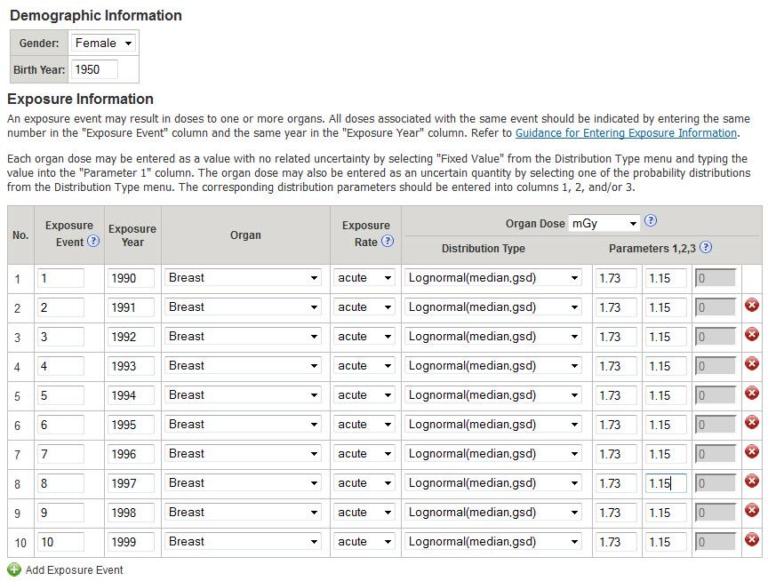

Click Generate Results.

Results
The estimated excess lifetime risk is displayed in the Summary Report page.
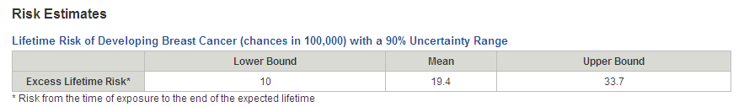
The calculation above was performed using a simulation sample size of 300 Monte-Carlo iterations and a random number seed equal to 99 (default settings). In some situations, it may be necessary to estimate risk with a different Monte-Carlo sample size and/or a different Monte-Carlo random seed.

Changing the Sample Size
To change the simulation sample size to 1,000 and the random seed to 123
- Click the Back button of the browser or the Information link in the top left of the Summary Report page to return to the main data input page.
- Click on the link labeled:
+ Assumption, Settings and Report Options.
- Key 1000 the Simulation Sample Size field.
- Key 123 in the Random Seed field.
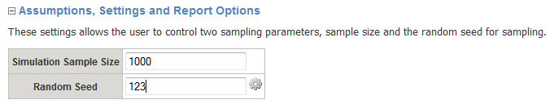

Click Generate Results.

The Summary Report page displays the estimated excess lifetime risk obtained using a Monte-Carlo simulation sample size of 1,000 iterations and a random number seed equal to 123.
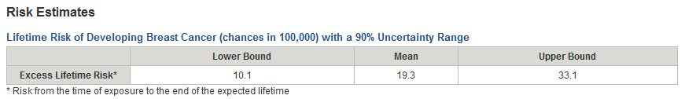

Example Case 4 – Excess Lifetime Risk from Multiple Exposures of Multiple Organs

Estimate the excess lifetime risk of developing cancer (summed across cancer sites) as a result of exposure to radiation at ages 30, 31 and 35.

Gender – Male
Birth year – 1960
Exposure years – 1990, 1991, 1995
Age at time of exposure – 30, 31, and 35 years of age
Exposure scenario –
Exposure Event 1 in 1990 – single acute doses to colon, bladder and kidneys
Exposure Event 2 in 1991 – single acute doses to oral cavity, esophagus and thyroid
Exposure Event 3 in 1995 – single chronic dose to the thyroid gland
Organ dose – Listed in table below

Example doses (mGy) to multiple organs from multiple exposures

Exposure No. | Exposure Year | Organ | Organ Dose (mGy)
1 | 1990 | Colon | Normal (Mean=4.0, Standard Deviation=0.35)
1 | 1990 | Bladder | Triangular (Min=2.5, Mode=3.5, Max=4.0)
1 | 1990 | Kidneys | Lognormal (GM=5.0, GSD=1.5)
2 | 1991 | Oral Cavity and Pharynx | Uniform (Min=0.3, Max=0.8)
2 | 1991 | Esophagus | Log-Triangular (Min=0.2, Mode=0.7, Max=1.4)
2 | 1991 | Thyroid | Log-Uniform (Min=0.1, Max=1.0)
3 | 1995 | Thyroid | Fixed Value=10.0

Step-by-Step Solution:
- On the calculator home page, click Get Started.
- On the main input page, set Gender to Male and Birth Year to 1960 and set Organ Dose to mGy.

For the first exposure event
- Click Add Exposure Event to generate a total of three lines in the Dose Exposure Information table.
- In each of the three lines, key 1 into the Exposure Event column to indicate that this is the first event that resulted in an exposure.
- In each of the three lines, key 1990 into the Exposure Year column
- In each of the three lines, select acute from the drop-down menus in the Exposure Rate column.
- In the Organ column, use the drop-down menus to select Colon in the first line, Bladder in the second line and Kidney in the third line.
- In the Organ Dose (mGy) fields enter the doses listed in the table above.
  - In the first line, the dose to colon is set by selecting Normal from the drop-down menu in the Distribution Type field, keying 4.0 into the Parameter 1 field as the mean of the distribution, and 0.35 in the Parameter 2 field as the standard deviation.
  - Doses provided in the table above for bladder (second line) and for kidneys (third line) can be entered in a similar way.

For the second exposure event
- Click Add Exposure Event to generate a total of three lines in the Dose Exposure Information table.
- In each of the three lines, key 2 into the Exposure Event column to indicate that this is the second event that resulted in an exposure.
- In each of the three lines, key 1991 into the Exposure Year column.
- In each of the three lines, select acute from the drop-down menus in the Exposure Rate column.
- In the Organ column, the drop-down menus to select Oral Cavity and Pharynx in the first of the newly added lines, Esophagus in the second added line and Thyroid in the third added line.
- In the Organ Dose fields, enter the doses listed in the table above by selecting the desired type of probability distribution (i.e., Uniform, Logtriangular, and Loguniform) from the Distribution Type drop-down menus, and by setting parameters 1, 2, and 3 to the listed values..

For the third exposure event
- Click Add Exposure Event to generate one more line in the Dose Exposure Information table.
- Key 3 into the Exposure Event column to indicate that this is the third event that resulted in an exposure.
- Key 1995 into the Exposure Year column.
- Select chronic from the drop-down menus in the Exposure Rate column.
- Select Thyroid in the Organ column drop-down menu.
- In the Organ Dose field, enter the dose listed in the table above for the thyroid gland by selecting Fixed Value from the Distribution Type drop-down menu, and keying 10 into the Parameter 1 field.

Click Generate Results.

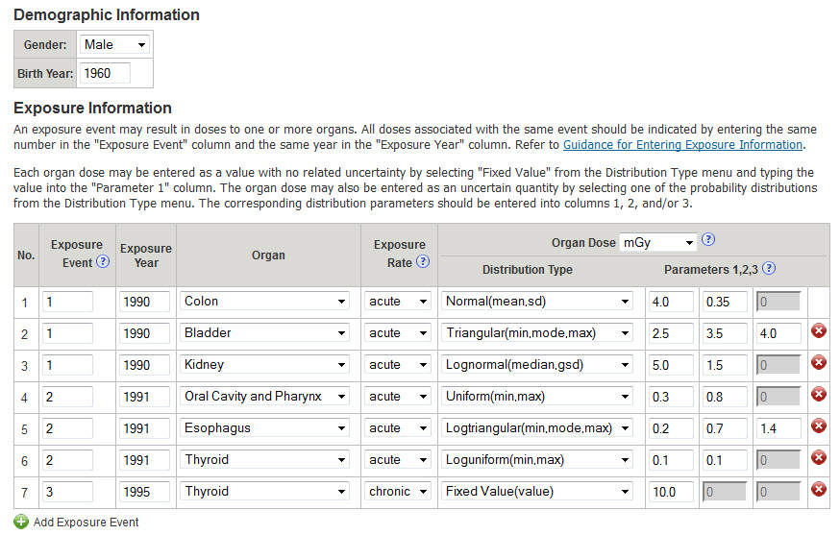

Results
The estimated excess lifetime risk is displayed in the Summary Report page.
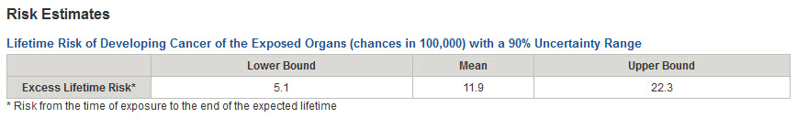

To inspect the risks estimated for each cancer site, click on the link labeled:
+ Excess Lifetime Risk per Cancer Site* with a 90% Uncertainty Range.
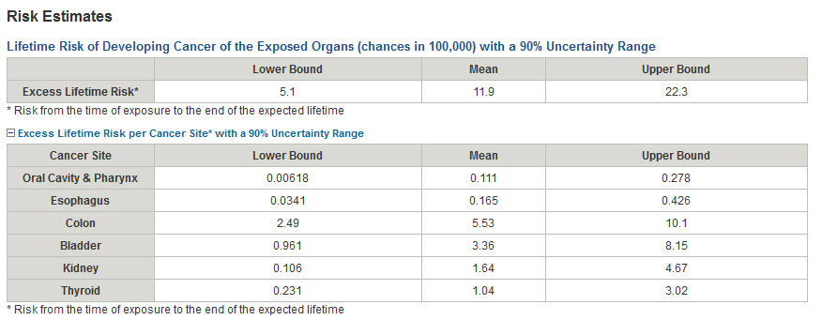

Example Case 5 – Excess Lifetime Risk from Long-Term Exposure of All Organs

Calculate the excess lifetime risk from external exposure to high-energy gamma radiation in areas contaminated with radionuclides.

Gender – Male
Birth year – 1991
Years of exposure: 2011 – 2040
Age at time of exposure: 20 – 50 years of age
Organ exposed – All organs
Organ dose – Each organ receives a dose ranging from 1 to 5 mGy in the first year, after which annual doses are assumed to decrease with an effective half-life of 1100 days (approximately 3 years). To account for uncertainty, doses are expressed as uniform probability distributions between the minimum and the maximum values listed in the table below.
Exposure Rate – chronic (i.e., annual doses are delivered chronically over the entire year)

Example external exposure doses (mGy)
Year | Possible range of doses-  Minimum | Possible range of doses-  Maximum |  | Year | Possible range of doses-  Minimum | Possible range of doses-  Maximum
2011 | 1.0000 | 5.000 |  | 2026 | 0.0317 | 0.159
2012 | 0.7945 | 3.973 |  | 2027 | 0.0252 | 0.126
2013 | 0.6313 | 3.156 |  | 2028 | 0.0200 | 0.100
2014 | 0.5016 | 2.508 |  | 2029 | 0.0159 | 0.080
2015 | 0.3985 | 1.993 |  | 2030 | 0.0127 | 0.063
2016 | 0.3166 | 1.583 |  | 2031 | 0.0101 | 0.050
2017 | 0.2516 | 1.258 |  | 2032 | 0.0080 | 0.040
2018 | 0.1999 | 0.999 |  | 2033 | 0.0063 | 0.032
2019 | 0.1588 | 0.794 |  | 2034 | 0.0050 | 0.025
2020 | 0.1262 | 0.631 |  | 2035 | 0.0040 | 0.020
2021 | 0.1003 | 0.501 |  | 2036 | 0.0032 | 0.016
2022 | 0.0797 | 0.398 |  | 2037 | 0.0025 | 0.013
2023 | 0.0633 | 0.316 |  | 2038 | 0.0020 | 0.010
2024 | 0.0503 | 0.251 |  | 2039 | 0.0016 | 0.0080
2025 | 0.0400 | 0.200 |  | 2040 | 0.0013 | 0.0063

Step-by Step Solution
The input data can be entered by keying the information directly into the main input page. However, in this example, we will use an Excel template file to store the input data for future use. The Excel file can be uploaded to populate the input fields on the main input page. To accomplish this, follow these steps:

- From the calculator home page, click Get Started.
- On the main input page, click Upload an input file. link in the upper left corner. The page for downloading the template and uploading the file will open.
- Click Download a template version of the Excel input file and save the template Excel file on your computer. If you already have an Excel template file on your computer, skip this step.
- Prepare the Excel file (see the directions below).
- From the upload page of the calculator, click Browse, select the saved Excel file and upload it. The data in the upload file will populate all the fields in the main input screen.
- Click Generate Results. The Results page will open

Prepare an Excel file
- Edit the Excel template file.
- Set Gender to Male and key 1991 in as the Birth Year.
- Set the Number of Dose Entries at the top left side of the template to 30, the number of rows of data. In this example there are 30 doses, each to be applied to all organs of the body. Note: The number you key into this field will be the number of lines that are uploaded from your file.
- In the Exposure Event column, enter the exposure numbers in increasing order from 1 to 30, since there are 30 years of exposure.
- In the Exposure Year column, key in the consecutive years of exposure starting with 2011 and ending with 2040.
- In the Organ column, use the drop-down menus to select All organs for each of the 30 years of exposure.
- For the dose received in any given year, select Uniform from the Distribution Type drop-down menu, and key the minimum and the maximum doses from the table above into the Parameter 1 and Parameter 2 fields, respectively.
- Leave the default value of 0 in Parameter 3 field for all years of exposure.
- Select chronic from the drop-down menus in the Exposure Rate column, for all years of exposure.
- The Show only required exposure entry rows (2) and Show all exposure entry (3) buttons can be used to hide or show the lines that don’t have data. This feature only works if you have macros enabled. If you don’t have macros enabled, you can use the Hide/Unhide function of Excel or delete the extra rows. However, only the number of rows indicated in Number of Dose Entries are uploaded into the application, so it is not necessary to delete or hide them.
- Save the template Excel file with a desired name.
- The Show only required exposure entry rows (2) and Show all exposure entry (3) buttons can be used to hide or show the lines that don’t have data. This feature only works if you have macros enabled. If you don’t have macros enabled, you can use the Hide/Unhide function of Excel or delete the extra rows. However, only the number of rows indicated in Number of Dose Entries are uploaded into the application, so it is not necessary to delete or hide them.

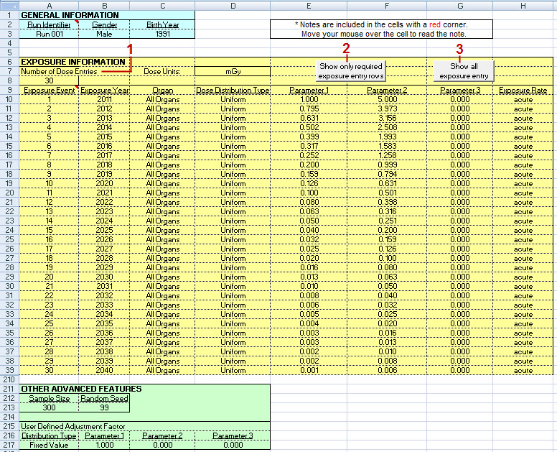

Results
The estimated excess lifetime risk is displayed in the Summary Report page.
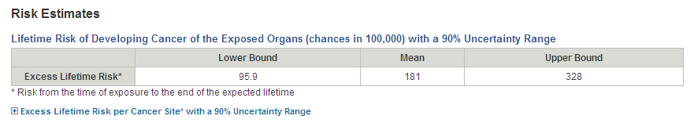

Example Case 6 – Excess Future Risk from Multiple Exposures of a Single Organ

Estimate the excess future risk of developing thyroid cancer as a result of childhood exposure to radiation.

Gender – Female
Birth year – 1950
Exposure year – 1951, 1952, 1953, 1955, and 1957
Age at time of exposure – 1, 2, 3, 5, and 7 yrs
Exposure scenario – ingestion and inhalation of ¹³¹I
Exposure Rate – chronic (i.e., dose was delivered in a matter of seconds)
Organ exposed – thyroid gland
Organ dose – See table below

Example doses (mGy) to the thyroid gland

Year of exposure (age) | Organ Dose (mGy)
1951 (age 1) | 0.047
1952 (age 2) | 12.0
1953 (age 3) | 3.3
1955 (age 5) | 4.9
1957 (age 7) | 42.0

Step-by-Step Solution:
- On the calculator home page, click Get Started.
- On the main input page, set Gender to Female and Birth Year to 1950 and set Organ Dose to mGy.
For the exposure in 1951
- Set Exposure Event to 1, because this is the first exposure.
- Key 1951 into the Exposure Year field.
- Select Thyroid from the Organ drop-down menu.
- Select chronic from the Exposure Rate drop-down menu.
- Select Fixed Value from the Distribution Type drop-down menu.
- Key 0.047 into the Parameter 1 field to represent a dose of 0.047 mGy.
For the second exposure in 1952
- Click Add Exposure Event to insert another line of input information.
- Set Exposure Event to 2, because this is the second exposure.
- Key 1952 into the Exposure Year field.
- Select Thyroid from the Organ drop-down menu.
- Select chronic from the Exposure Rate drop-down menu.
- Select Fixed Value from the Distribution Type drop-down menu.
- Key 12.0 into the Parameter 1 field to represent a dose of 12.0 mGy.

Repeat the steps above by adding three additional lines of exposures (events 3, 4 and 5)
- Enter doses equal to 3.3, 4.9, and 42 mGy, for exposures in years 1953, 1955, and 1957, respectively.

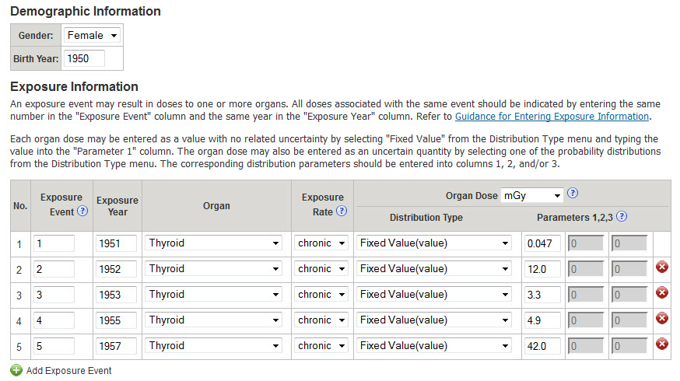

Click Generate Results.

Results
The Summary Report page provides the excess lifetime risk, excess future risk, baseline future risk and total future risk (excess + baseline).
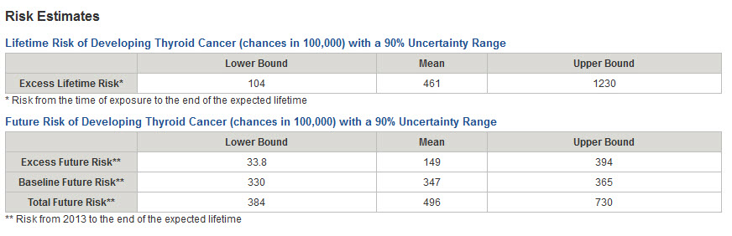

The excess lifetime risk is a representation of the chances of developing cancer from the time of exposure until the end of life. The future risk represents the chance of developing cancer from the present time until the end of the life, assuming no cancer has manifested to date. The baseline future risk is the risk expected in the absence of exposure to radiation. The excess future risk is the risk attributable to the exposure to radiation.

Setting Assumptions, Settings and Report Options
This example case has been prepared in 2013, and the online calculator, by default, uses the current year as the present time for the purpose of estimating the future risk. Thus, the future risks displayed above represent the risk from year 2013 until the end of life.

In many risk assessment situations, it is of interest to calculate risk from moments in time different that the present year. For example, one may be interested in calculating risk for workers from the time their plant has closed, several years ago, or the risk for a patient from the year of the last medical examination. To accommodate such situations, the calculator allows the user to change the setting of the current year.

To change the current year setting to 2000, use the following steps:
- From the Summary Report page, click the Back button of the browser or the Information link in the top left to return to the main data input page.
- Click on the link labeled:
+ Assumptions, Settings and Report Options
- Key 2000 into the Current Year Setting field.
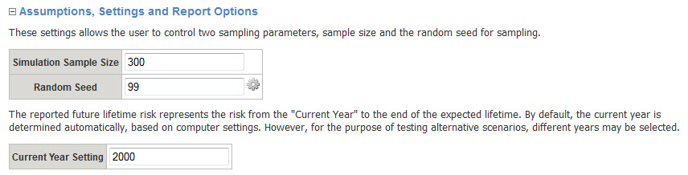
Click Generate Results.
The Summary Report page now provides the future risk from year 2000 until the end of life.
