Introduction
eGrants application use was initiated by NCI in 1996 as a replacement for a microfiche system which at that time served as the backup for the Grant Application paper files. The primary function of eGrants is to convert Grant Application documents to indexed electronic images and provide authorized users online access to those documents. Over the years, with enhancements to eGrants and the implementation of other new systems, NCI’s Office of Grants Administration (OGA) has become able to perform its functions with little or no access to paper Grant Application documents.

Purpose
The eGrants application was developed and extended in its functionality to provide support for tracking the paper Grant Application folders and the transfer of those folders after close-out to the Federal Records Center.

Scope
eGrants use is not limited to NCI. Over the years many other NIH institutes have elected to utilize eGrants. Only minor adjustments are needed to make eGrants meet the needs of an institute. This tailoring is primarily in the areas of document Category sets, Authorization, document sources and linkages; access to options including what document imagery and index data can be changed.

Accessing eGrants
A user can access to eGrants using NIH log in credentials.

Access Levels
There are two levels of access for eGrants users.
- Read only
Read only permission for funded and unfunded grants.
- Modify
Read, upload/replace and add document permissions.

How to get Access
eGrants authenticates user’s access to application through Active directory and keeps control and record of the access level through Access Control functionality. OGA Management determines a level of access for a user and controls it through eGrants Admin Tab. This tab is available only to OGA Admin Roles. To add new user click on Admin tab and get a menu option list.
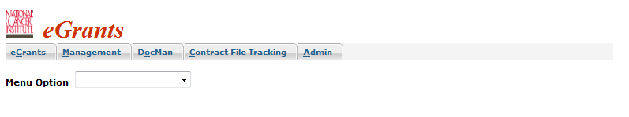Select eGrants Access Control option from the drop down box
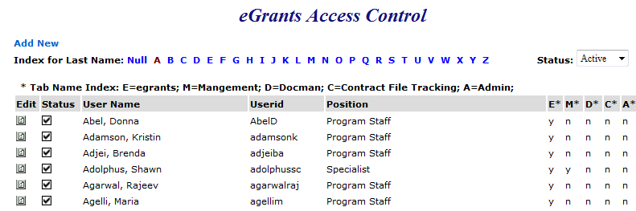
To add new user click on this will open a new window to enter user information.
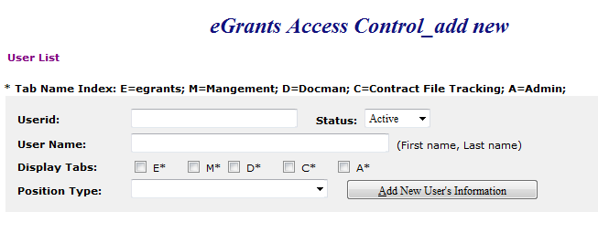
Fill in the boxes for User id and User Name select status Active from the drop down menu and check the box for specific permission from Display Tabs option E is for eGrants, M for Management, D for Docman, C for Contract file tracking, A for Admin. Select position type from dropdown list;
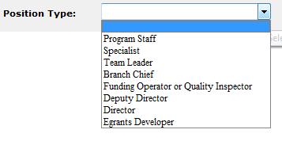
Select an option according to user’s role and click on
To check a newly added user or already existing one click on it will display a list of users and an index list for user last name that makes easy to get information for a specific user by clicking on the last name initial.

Tab Name Index is a description of E, M, D, C and A tabs which is required to be granted to a user based upon need.
Status:
There are three options to check a specific status Active, Inactive or all select an option from the Status drop down box. If A is selected from the Index for last name and 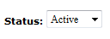 it will display the information about all users having last names with an initial of A for Active Status as following;

This information displays a status of access to a specific resource, in this case user has active status for E (eGrants). Y is for Yes and n for No.

 If the Status is selected Inactive it will display the information like following
This user does not have access to any of the resource that’s why there is n under E, M, D, C, A.
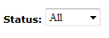

Status All displays information about both Active and Inactive.
To update user access level click on Edit icon and a new window will pop up with user’s information.
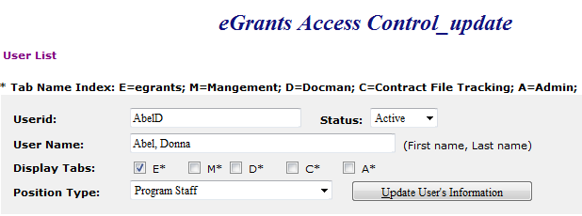
Select a check box for required access from the Display Tabs option and change status if it needs to be changed then click on button the access level will be updated.

Links to Access eGrants
https://i2e.nci.nih.gov/egrants/
https://egrants.nci.nih.gov/
https://i2e.nci.nih.gov/egrants/egrants.asp
https://i2e.nci.nih.gov/workbench/WorkbenchView
From Workbench under Links Heading choose eGrants for Web Applications and click on Go it will open the eGrants Application.
https://ccrod.cancer.gov/confluence/pages/viewpage.action?pageId=63996798
Only OGA staff can access through confluence page by clicking on eGrants heading from the left side Menu list.
GPMATS also has a link for eGrants if you click on the little icon in front of the grant number in GPMATS it will open the eGrants application where you can check the saved documents for that grant.

eGrants Interface

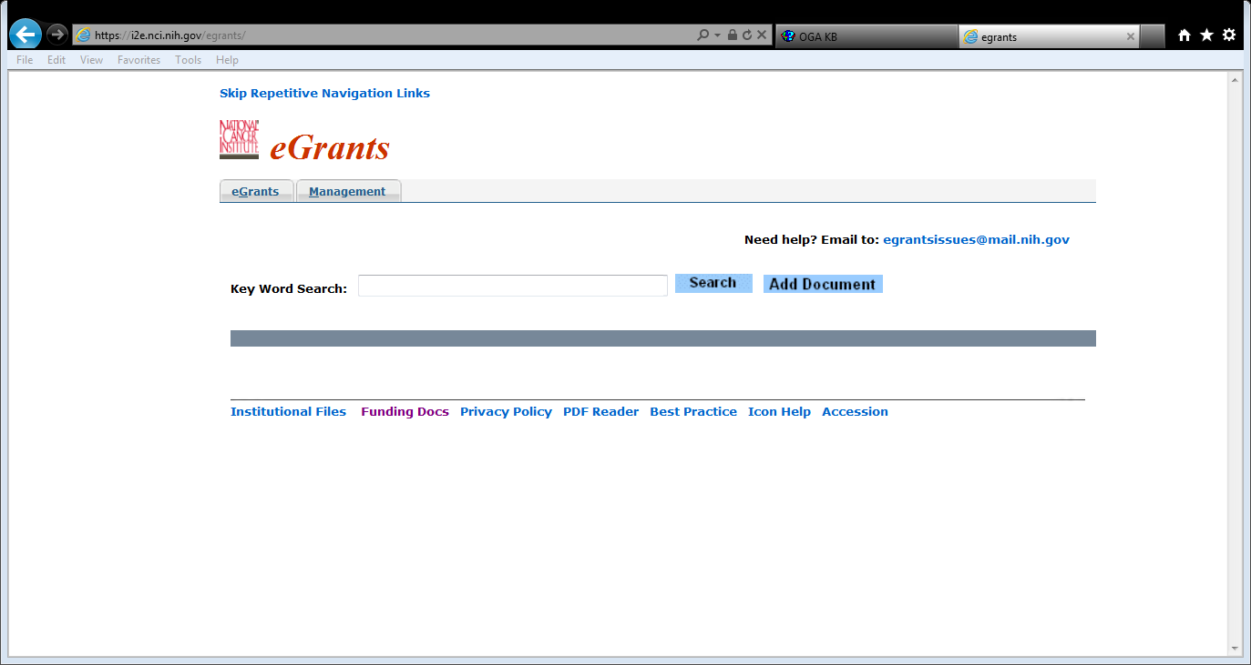

Skip Repetitive Navigation Links
This is just a message to show the main content and skip the navigation links eGrants users please do not pay attention to it.

Logo
National Cancer Institute and eGrants logo.

eGrants Tab
Users having access to read and upload to eGrants will have only this Tab. Below this tab is a main page of eGrants.

Search Request
This is a most common used part of the application where user can perform a search for grant’s related documents.

Search Options
There are three options to perform a search for specific grant by Full Grant Number, only Serial Number and Serial Number with IC.
By Full Grant Number
Search by full grant number like this sample number 0R01CA123456-00W0 will display the results for that grant. The more specific entry for the grant number would return the more restrictive results for that grant.

By Serial Number with IC
CA123456 Searching grant number with institution name would return the results for that specific institute.

By Only Serial Number
123456 search by only serial number will result the information including other IC’s.

Grant Information Display

Specific Grant Folder
Grant Folder icon with specific grant number as a result of search criteria will be displayed.

Signs
In front of that grant number if there is any sign please read the information about that sign
Read Stop Notice
- Locate Physical File
Tobacco related Grant
Replace Document
- Indicating Recovery Act Grant
Report Problem with Document
This File is available in electronic form only
© Competing years are identified with this sign

Project Title
Name of the project for that specific grant will be displayed here.

PI Name
Program investigator’s name for that grant shows here.

Program Code
Program Code like 4DAT

By Package
Documents will be displayed about that grant number by package heading or if you want to see all documents just click on

By Year
If you want to see documents for specific grant year click on that number and it will display the saved documents for that year with document name, saved date and count of pages.

Report Error
If you notice any error with that document like wrong Grant, bad Image or incorrect Identification click on Report Error and type the error message. This document will be routed to quality control team to check the error.

Upload/Replace Document
If you want to replace selected document click on upload icon and replace the document with existing one.

Upload/Replace via email
If you want to replace a document by email click on the envelope icon in front of that document you will get an outlook new email window with pre populated subject line as shown below
Attach file that is already saved on your desktop and click on send.

Add Document
There are three options to add documents, adding from eGrants main page, adding through selected grant number and adding by email.
Add Document from eGrants main page
To add document click on and get a new screen as following;
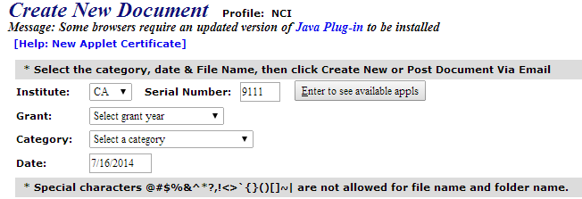 On this screen you will also get a message “Java needs your permission to run” select Run.
If the grant number is described on the previous page this will auto generate the specific serial number here. You can click on tab to refresh the list of available Grant years and select year from The Grant drop down list or if you want to create a New Year select that option. Select Category of that document from the Category drop down list. Select a document that is already saved on your machine or network and click on Create New.
Create Grant Year
This option is available under Grant drop down list by selecting this option a new window pop ups like the following;
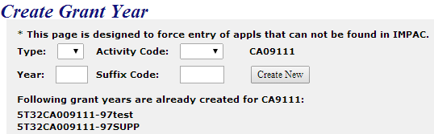
Select Type and Activity Code from the drop down lists fill the boxes of Year and Suffix Code as desired and click on. New Year for that specific grant number will be created. At the bottom of this screen you can see already created grant years.
Add Document from selected grant number
By clicking on you will find the same window as mentioned above the only difference is not to enter grant serial number because it’s already selected but you still have to select category and select or create new grant year from the Grant drop down list.
Add document via email
By clicking on tab Create New Document window pops up and displays an option to just click on this option, read the instructions “ How to upload via email” given on that page as following;
Do not change email To, Subject and message fields just attach a document that is already saved on your desktop and send it. You can go back to previous page by clicking on . Email function has a time lag of 5 to 15 minutes so wait for this time before checking the new added document.

Switch to Update Mode
Search for any grant number returns the values with switch to update mode except for those having read only permission. When you click on this option you will have more options for that document like these and also there would be a name of resource that has saved the document.
Store
If you click on store the document will be stored.
Store Selected
This option is also to save the document but you have to select first.
Modify/Route
By selecting this option you can change Grant year, Category and Route it to QC or any of the specialist
To update document index make changes to any field and click on Index will be modified and if routed to someone it will be displayed under his queue.
Delete
Be careful to choose this option it will delete the document.

Restore
Only quality control management team has option to restore a deleted document.

Switch to Read Only Mode
Having permission for read only you can search for any grant number and read the documents related to that grant but cannot upload or add documents. With modify permission you will have an option to after making the required changes.

eGrants Footer Notes
Institutional Files
This is a link for Institutional files database. Files are saved with institution name in alphabetical order by clicking on the name you can read file about that institution. This database link is available to only NCI.
Funding Docs
This link is for master funding plan files and only document control management team has access to it. This is also available only for NCI.
Privacy Policy
This link is for eGrants privacy policy notice available to all institutes.
PDF Reader
This is a link for Adobe website from where you can install adobe reader in order to read PDF files.
Best Practice
This link is for a saved document with instructions to use adobe acrobat with eGrants. It is available to all institutes.
Icon Help
This link shows the icons with their definitions used in eGrants and it is also available to all institutes.
Accession
This is a link for inventory of paper files available to all institutes.

Management
Tab is available to quality control management team to upload, replace, add, modify, store, restore and rout documents.

