## Introduction

eGrants application use was initiated by NCI in 1996 as a replacement for a microfiche system which at that time served as the backup for the Grant Application paper files. The primary function of eGrants is to convert Grant Application documents to indexed electronic images and provide authorized users online access to those documents. Over the years, with enhancements to eGrants and the implementation of other new systems, NCI’s Office of Grants Administration (OGA) has become able to perform its functions with little or no access to paper Grant Application documents.

## Purpose

The eGrants application was developed and extended in its functionality to provide support for tracking the paper Grant Application folders and the transfer of those folders after close-out to the Federal Records Center.

## Scope

eGrants use is not limited to NCI. Over the years many other NIH institutes have elected to utilize eGrants. Only minor adjustments are needed to make eGrants meet the needs of an institute. This tailoring is primarily in the areas of document Category sets, Authorization, document sources and linkages; access to options including what document imagery and index data can be changed.

## Accessing eGrants

A user can access to eGrants using NIH log in credentials.

## Access Levels

There are two levels of access for eGrants users.

1. **Read only**

Read only permission for funded and unfunded grants.

1. **Modify**

Read, upload/replace and add document permissions.

## How to get Access

eGrants authenticates user’s access to application through Active directory and keeps control and record of the access level through Access Control functionality. OGA Management determines a level of access for a user and controls it through eGrants Admin Tab. This  tab is available only to OGA Admin Roles. To add new user click on Admin tab and get a menu option list.

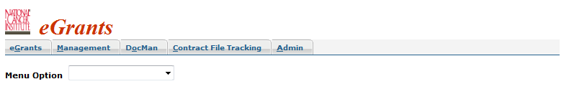Select eGrants Access Control option from the drop down box

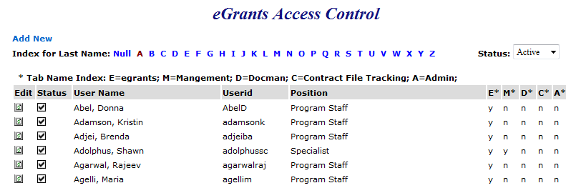

To add new user click on  this will open a new window to enter user information.

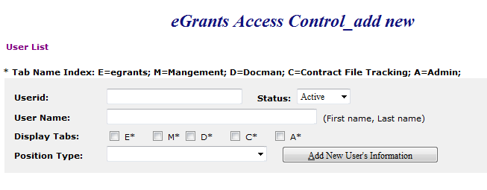

Fill in the boxes for **User id** and **User Name** select **status** Active from the drop down menu and check the box for specific permission from **Display Tabs** option E is for eGrants, M for Management, D for Docman, C for Contract file tracking, A for Admin. Select **position type** from dropdown list;

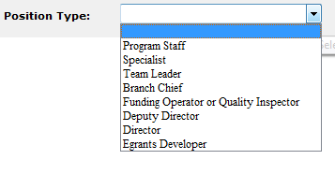

Select an option according to user’s role and click on 

To check a newly added user or already existing one click on it will display a list of users and an index list for user last name that makes easy to get information for a specific user by clicking on the last name initial.





Tab Name Index is a description of E, M, D, C and A tabs which is required to be granted to a user based upon need.

**Status:**

There are three options to check a specific status Active, Inactive or all select an option from the Status drop down box. If A is selected from the Index for last name and  it will display the information about all users having last names with an initial of A for Active Status as following;



This information displays a status of access to a specific resource, in this case user has active status for E (eGrants). Y is for Yes and n for No.

 If the Status is selected Inactive it will display the information like following



This user does not have access to any of the resource that’s why there is n under E, M, D, C, A.





Status All displays information about both Active and Inactive.

To update user access level click on Edit  icon and a new window will pop up with user’s information.

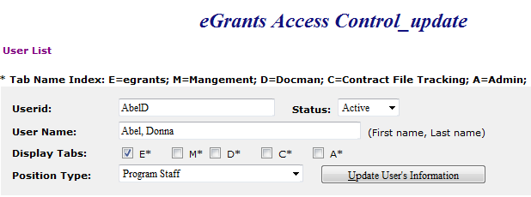

Select a check box for required access from the Display Tabs option and change status if it needs to be changed then click on  button the access level will be updated.

## Links to Access eGrants

<https://i2e.nci.nih.gov/egrants/>

<https://egrants.nci.nih.gov/>

<https://i2e.nci.nih.gov/egrants/egrants.asp>

<https://i2e.nci.nih.gov/workbench/WorkbenchView>

From Workbench under Links Heading choose eGrants for Web Applications and click on Go it will open the eGrants Application.

<https://ccrod.cancer.gov/confluence/pages/viewpage.action?pageId=63996798>

Only OGA staff can access through confluence page by clicking on eGrants heading from the left side Menu list.

GPMATS also has a link for eGrants if you click on the little icon  in front of the grant number in GPMATS it will open the eGrants application where you can check the saved documents for that grant.

## eGrants Interface

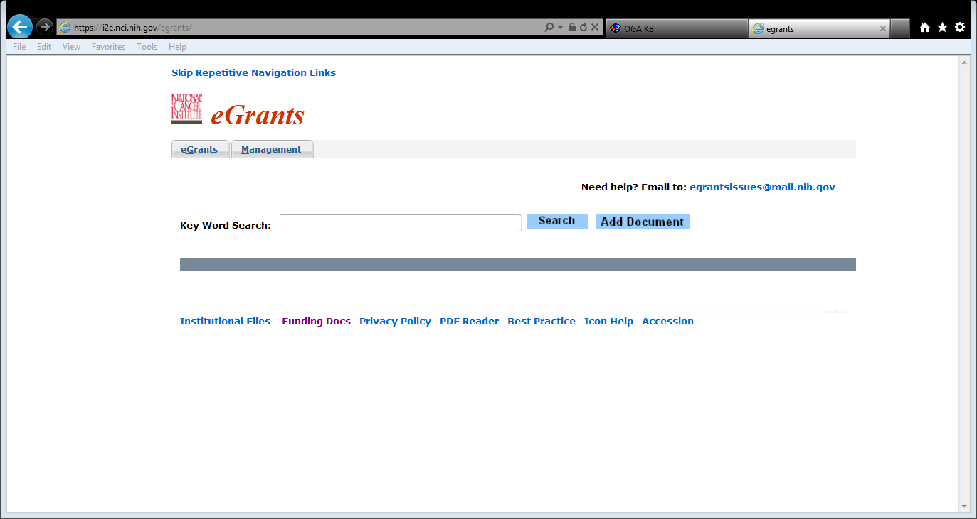

## Skip Repetitive Navigation Links

This is just a message to show the main content and skip the navigation links eGrants users please do not pay attention to it.

## Logo

## 

National Cancer Institute and eGrants logo.

## eGrants Tab

Users having access to read and upload to eGrants will have only this Tab. Below this tab is a main page of eGrants.

## Search Request



This is a most common used part of the application where user can perform a search for grant’s related documents.

## Search Options

There are three options to perform a search for specific grant by Full Grant Number, only Serial Number and Serial Number with IC.

**By** **Full Grant Number**

Search by full grant number like this sample number 0R01CA123456-00W0 will display the results for that grant. The more specific entry for the grant number would return the more restrictive results for that grant.

**By Serial Number with IC**

CA123456 Searching grant number with institution name would return the results for that specific institute.

**By Only Serial Number**

123456 search by only serial number will result the information including other IC’s.

## Grant Information Display



## Specific Grant Folder

 Grant Folder icon with specific grant number as a result of search criteria will be displayed.

## Signs

In front of that grant number if there is any sign please read the information about that sign

 Read Stop Notice

* Locate Physical File

 Tobacco related Grant

 Replace Document

* Indicating Recovery Act Grant

 Report Problem with Document

 This File is available in electronic form only

**©** Competing years are identified with this sign

## Project Title

Name of the project for that specific grant will be displayed here.



## PI Name

Program investigator’s name for that grant shows here.



## Program Code

Program Code like **4DAT**

## By Package



Documents will be displayed about that grant number by package heading or if you want to see all documents just click on 

## By Year



If you want to see documents for specific grant year click on that number and it will display the saved documents for that year with document name, saved date and count of pages.

## Report Error



If you notice any error with that document like wrong Grant, bad Image or incorrect Identification click on Report Error and type the error message. This document will be routed to quality control team to check the error.

## Upload/Replace Document



If you want to replace selected document click on upload icon  and replace the document with existing one.

## Upload/Replace via email



If you want to replace a document by email click on the envelope icon  in front of that document you will get an outlook new email window with pre populated subject line as shown below



Attach file that is already saved on your desktop and click on send.

## Add Document

There are three options to add documents, adding from eGrants main page, adding through selected grant number and adding by email.

**Add Document from eGrants main page**

To add document click on  and get a new screen as following;

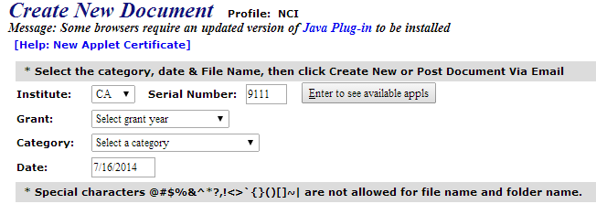 On this screen you will also get a message “Java needs your permission to run” select Run.

If the grant number is described on the previous page this will auto generate the specific serial number here. You can click on  tab to refresh the list of available Grant years and select year from The **Grant** drop down list or if you want to create a New Year select that option. Select Category of that document from the **Category** drop down list. Select a document that is already saved on your machine or network and click on **Create New**.

**Create Grant Year**

This option is available under **Grant** drop down list by selecting this option a new window pop ups like the following;

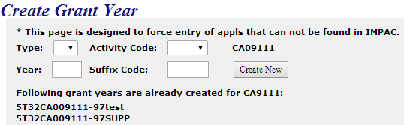

Select **Type** and **Activity Code** from the drop down lists fill the boxes of **Year** and **Suffix Code** as desired and click on. **New Year** for that specific grant number will be created. At the bottom of this screen you can see already created grant years.

**Add Document from selected grant number**



By clicking on  you will find the same window as mentioned above the only difference is not to enter grant serial number because it’s already selected but you still have to select **category** and select or create new grant year from the **Grant** drop down list.

**Add document via email**

By clicking on  tab Create New Document window pops up and displays an option to just click on this option, read the instructions “ How to upload via email” given on that page as following;

## 

Do not change email To, Subject and message fields just attach a document that is already saved on your desktop and send it. You can go back to previous page by clicking on  . Email function has a time lag of 5 to 15 minutes so wait for this time before checking the new added document.

## Switch to Update Mode



Search for any grant number returns the values with switch to update mode except for those having read only permission. When you click on this option you will have more options for that document like these and also there would be a name of resource that has saved the document.

**Store**

If you click on store the document will be stored.

**Store Selected**

This option is also to save the document but you have to select first.

**Modify/Route**

By selecting this option you can change Grant year, Category and Route it to QC or any of the specialist



To update document index make changes to any field and click on Index will be modified and if routed to someone it will be displayed under his queue.

**Delete**

Be careful to choose this option it will delete the document.

**Restore**

Only quality control management team has option to restore a deleted document.

## Switch to Read Only Mode

Having permission for read only you can search for any grant number and read the documents related to that grant but cannot upload or add documents. With modify permission you will have an option to after making the required changes.

## eGrants Footer Notes

**Institutional Files**

This is a link for Institutional files database. Files are saved with institution name in alphabetical order by clicking on the name you can read file about that institution. This database link is available to only NCI.

**Funding Docs**

This link is for master funding plan files and only document control management team has access to it. This is also available only for NCI.

**Privacy Policy**

This link is for eGrants privacy policy notice available to all institutes.

**PDF Reader**

This is a link for Adobe website from where you can install adobe reader in order to read PDF files.

**Best Practice**

This link is for a saved document with instructions to use adobe acrobat with eGrants. It is available to all institutes.

**Icon Help**

This link shows the icons with their definitions used in eGrants and it is also available to all institutes.

**Accession**

This is a link for inventory of paper files available to all institutes.

## Management



 Tab is available to quality control management team to upload, replace, add, modify, store, restore and rout documents.