DocManUser’s Guide

National Cancer Institute

National Institutes of Health

### Table of Contents

Table of Contents 1

1 Introduction 2

2 Document Identification and User Access Level 2

2.1 Document Index 2

*2.1.1* *Document Categories* 2

*2.1.2* *Document ID* 3

*2.1.3* *Document Date* 3

2.2 DocMan Levels of Access 3

3 Using DocMan 4

3.1 Accessing DocMan 4

*3.1.1* *Document Deleted Report* 5

*3.1.2* *User’s Guide* 5

*3.1.3* *Help Request* 5

3.2 Accessing a Contract 5

*3.2.1* *Select from Authorized Access Listing* 5

*3.2.2* *Search* 5

3.3 Document Posting 7

3.3.1 Select Document Category 9

3.3.2 *Enter Document ID* 9

*3.3.3* *Enter Document Date* 9

*3.3.4* *Upload Document File* 9

*3.3.5* *Upload Via email* 9

3.4 Document Viewing 11

3.5 Document Modification 11

*3.5.1* *Edit Document Index* 11

*3.5.2* *Replace Document* 12

*3.5.3* *Delete Document* 13

3.6 Documents Deleted From System Report 14

*3.6.1* *Select a Deleted Document* 16

*3.6.2* *Select a Contract* 16

*3.6.3* *Exit Report* 16

# Introduction

DocMan provides authorized NCI Office of Acquisition (OA) personnel with a means for easily storing and retrieving selected contract documents in PDF or Excel format.

Section 2 of this guide provides the basics of the document identification and user access level for Docman.

Section 3 of this guide steps through the screens and actions needed to store, view and modify documents in DocMan. It also contains procedures for authorized personnel to access and use the Deleted Document History report.

Section 4 of this guide provides a summary of error messages that may be encountered when using DocMan.

# Document Identification and User Access Level

## Document Index

All documents in DocMan are indexed with contract identification, a document date and a document category.

### *Document Categories*

There are eleven types of categories and each category has multiple sub categories that can be selected from the drop down list.

Following table shows all Main Categories with their Sub Categories.

|  |  |
| --- | --- |
| **Main Category** | **Sub Category** |
| Award & Post Award | Contract, Modifications, Mod Support, Invoices, Invoice Approvals, Invoice Other, Technical reports and Deliverables, Deliverable Approvals, Task Orders, COAs, MTAs, CRADA, Subcontract and Past Performance reports, Clearances or assurances, Other-Unsolicited proposal docs, RFIs |
| Presolicitation | Concept Clearance, Acquisition Plan(AP), JOFOC, HHS-653 and/or 8(a) supporting docs, Sources sought notice or other Market Research, Presolicitation Notice, Other |
| Solicitation | RFP or RFQ, Amendments, Questions or correspondence, List of proposals received, Record of late proposal(s) and notification letter(s) (FAR 15.208), Excluded Parties List System, Other – Pre proposal conference docs, Potential offer or intent to respond, etc. |
| Technical Evaluation | Peer review, technical evaluation, panel agenda, roster & COI/Confidentiality, Technical evaluation report, Technical report from the Source Selection meeting, Other – Withdrawal of proposals, Conflict of Interest/Confidentiality forms. |
| Competitive Range/Source Selection | Competitive range determination, Notice of exclusion from competitive range, Negotiation questions and responses, Request for final proposal revision, Signed final technical evaluation score sheets, Past performance evaluation, Small disadvantaged business evaluation, Source selection determination, Other - SBA cert of competency, exchanges w/offer or, pre award survey or site visit, etc. |
| Successful Proposal | Original proposals (cost/price), SAM verification of reps and certs, Final proposal revisions, Other (Negotiation questions and responses, etc.), COR review of contractor’s business proposal, Cost/price analysis, Indirect cost rate agreement, Structured fee/weighted fee analysis, Cost realism analysis [FAR 15.404-1(d)], Other – related cost or pricing data |
| Negotiations | Pre negotiation objectives, Summary of negotiations with cost/price spreadsheet, Other |
| Pre-award Documentation, Funding, and Clearances | Requisition, Small business subcontracting plan with SADBUS approval, Internal/BOA/other file review, EEO compliance clearance (FAR 22.805), Foreign acquisition clearance, Human subjects assurance and/or Animal Welfare Assurance, FPDS/DCIS sheet/eContracts printout, Other. |
| Notices, Reports, Debriefings, and Protests | FedBizOpps award synopsis, Award Notifications and letters, HHS congressional liaison notification, Debriefing documentation (pre award & post award), COR certification of training, COTR designation memorandum, Protest documentation, Other (Contract Transmittal letter, etc.). |
| Determinations and Pre-solicitation Clearances | Use of Government Furnished Property, Project Officer (PO) Certification of Training, IT Clearances, Wage rate determinations, Other (Determinations for use of letter contracts or other types, etc.) |
| Pre-award Documentation, Funding, and Clearances | System for Award Management (SAM)verification <http://www.SAM.gov> , Subcontract and Past Performance reports,  Clearances or assurances (animal, humans, exceptions, etc.) |

### *Document ID*

A Document Modification or Document Sequence Number will be entered in association with all document categories as Document ID.

### *Document Date*

The Document Date will be entered for all documents. This is the date of the document, not the date the document is entered into DocMan.

## DocMan Levels of Access

Personnel authorized access to DocMan will be able to view selected documents, and depending on their authorized level of access, able to post new documents and make changes to existing documents.

* Level 1: Access to view all documents for contracts for which permission has been granted by a Level 2 or 3 system user. This is a View-Only level of access.
* Level 2: Access to view, create (Post), modify and delete documents for those contracts for which the person (usually Specialist) has been assigned. Users with Level 2 access may be authorized to view documents from contracts that are not assigned to them.
* Level 3: Access to view, create (Post), modify and delete all documents, and to access a Document Deleted From System report. Persons at this level include the Director, Deputy Director, the Branch Chiefs, and Team Leaders and members of the Policy group.

# Using DocMan

## Accessing DocMan

DocMan can be accessed from CSS-NG, by selecting the **DocMan tab** in the right portion of the CSS-NG header OR

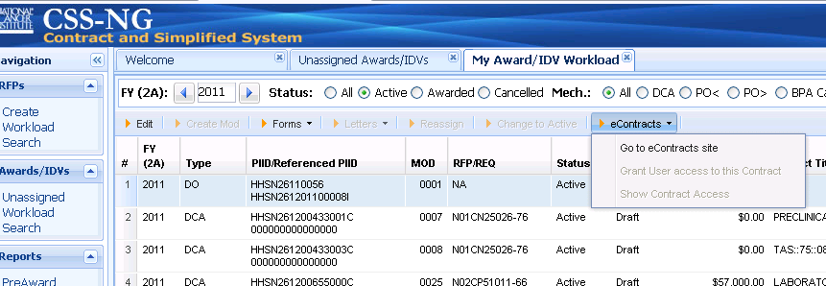

DocMan can be accessed using the address:

<https://egrants.nci.nih.gov/docman/docman_search.asp>

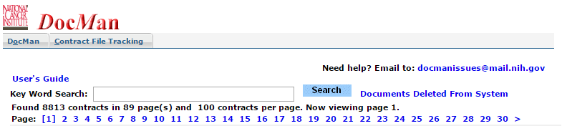

However accessed, DocMan will provide authorized users with the option to view post and make changes to documents. The specific functions that can be performed will depend on the user’s authorized level of access.

### *Document Deleted Report*

Users with Level 3 Access will have a **Document Deleted from System** option located to the right of the **Search** button. This option provides access a report on documents that have been deleted from DocMan. The nature and functioning of this report are described in Section 3.6

### *User’s Guide*

The **User’s Guide** located above the search entry field, provides access to the *DocMan User’s Guide.*

### *Help Request*

The [**NCIdocmanIssues@mail.nih.gov**](mailto:NCIdocmanIssues@mail.nih.gov)button, located in the upper right hand portion of the DocMan screen, opens an email message for requesting help. If the DocMan screen is not available, help messages should be sent to [NCIdocmanIssues@mail.nih.gov](mailto:NCIdocmanIssues@mail.nih.gov)

## Accessing a Contract

There are two ways of accessing a contract to view or to perform other document related actions: selecting from a list of all contracts that the user is authorized to access, and selecting from a list based on a **Search** action.

### *Select from Authorized Access Listing*

All of the contracts that a user is authorized to access will be listed on the screen. In the event that the user is authorized access to more than sixty contracts, the contracts will be “bundled” into sets (pages) of up to sixty contracts each in alpha numeric order. (Due to variations in AOs contract identification schema, the alpha numeric order may have inconsistencies). The bundles/pages will be listed below the **Search** entry line on the screen. The contracts from the first page (the displayed page number is bracketed) will be listed below the listing/line of pages. In the event that the desired contract is not listed, another page can be selected, but it often will be easier to perform a **Search** action.

### *Search*

To access a contract using the **Search** function, a request/entry must be made in the search field and the **Search** button selected. The search can be made by entry of a “key word”. The “key word” search is performed by DocMan on all, or any portion of the following contract header information fields:

NCI Control#

PIID

RFP

Specialist

Team Leader

Branch Chief

Vendor Name

Based on the user’s **Search** entry, level of access and/or assigned responsibility, a list of all relevant authorized contracts will be displayed. In the event that there are more than sixty contracts that satisfy the criteria, the contracts will be bundled into sets of sixty contracts and each bundle/page can be selected for searching.

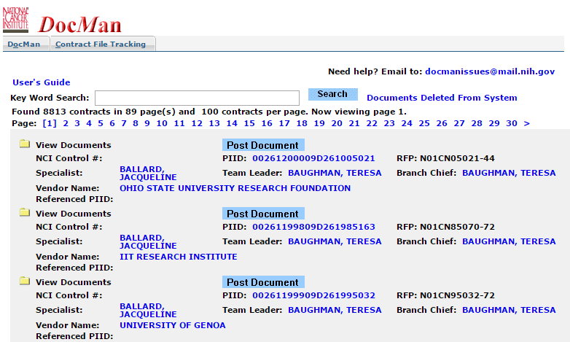

In the event that the desired contract is not on the page of contracts that is on the screen, a more specific **Search** can be performed or another page (in the example below, Page 3) can be selected.

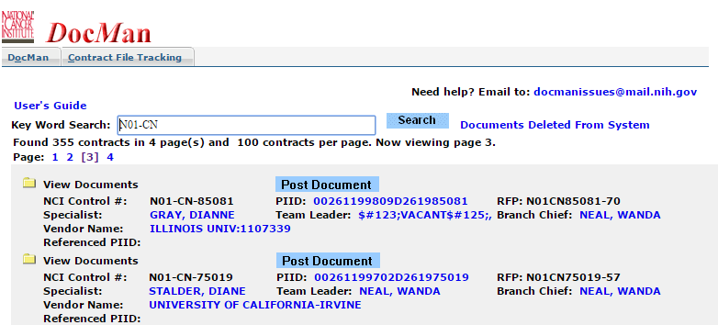

The contract header fields that are in color are hyperlinks. The selection of any of these hyperlinked fields, except the NCI Control Numbers, will act as a new **Search** request.

The selection of a specific NCI Control Number that has any DocMan documents (contracts with documents have an open folder icon to the left of the NCI Control Number, and the NCI Control Number is colored) will result in the listing of all of the contract’s documents.

Five types of document actions can be performed, depending on the user’s authorization:

* Create new document – Select **Post Document**
* View Document – Select a document
* Edit document index – Select **Edit Index** for a document
* Replace the document imagery – Select **Replace Document** for a document
* Delete Document – Select **Delete Document** for a document

As the various actions are performed, in most instances the message/button Back **to the current contract** will appear at the bottom of the screen. Selection of this button will result in the return to the previous screen. If the action has been completed, return to the previous screen will not negate the completed action.

## Document Posting

Selection of the highlighted **Post Document** button on the first line of a contract’s header data will result in the display of *DocMan: Post New Document* screen. The interface for *DocMan: Post New Document* minimizes data entry requirements through the automatic inclusion of the selected contract’s Identification data and the use of drop-down list. Documents can be posted for any of the contracts listed on the screen.

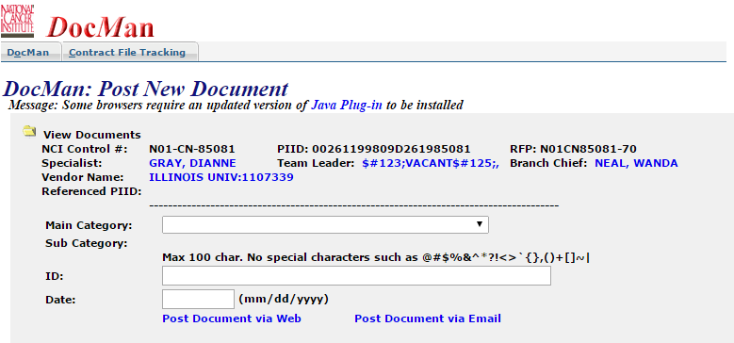

The first Document Posting action in a session may require Java authentication by the user. When this occurs, the User Name and Password must be entered.

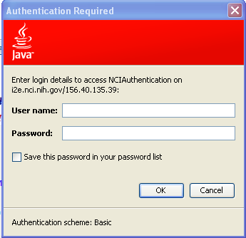

### Select Document Category

Select document category from **Main** **Category** drop-down list. After selecting the main category sub category list will pop up, select **Sub Category** in accordance to the Main Category from the drop down list.

### *Enter Document ID*

Enter document identification number in **ID** field.

### *Enter Document Date*

The document **Date** must be entered. The system will check to insure that it is valid (e.g., not February 30) and not beyond the current date.

### *Upload Document File*

Click on the **Post Document Via web** buttonand select an already saved file to upload, by clicking on the **Post Document** button will display of the message, “Uploading...” When the upload has been completed, the message “Done!” will be displayed.

### *Upload Via email*

Post document via email option will display the following screen with instructions how to upload via email. 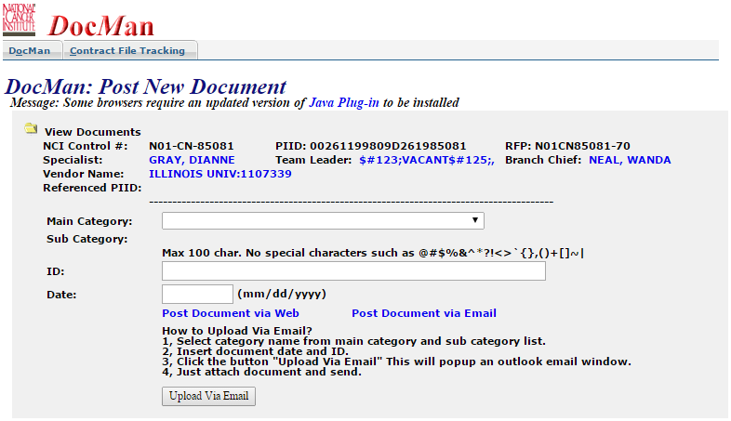

The process to upload via email is similar to upload via web except attaching the file to email. After selecting document Category, Sub category, ID and Date click on Upload via Email option this will generate an outlook email window with instructions to upload the document.

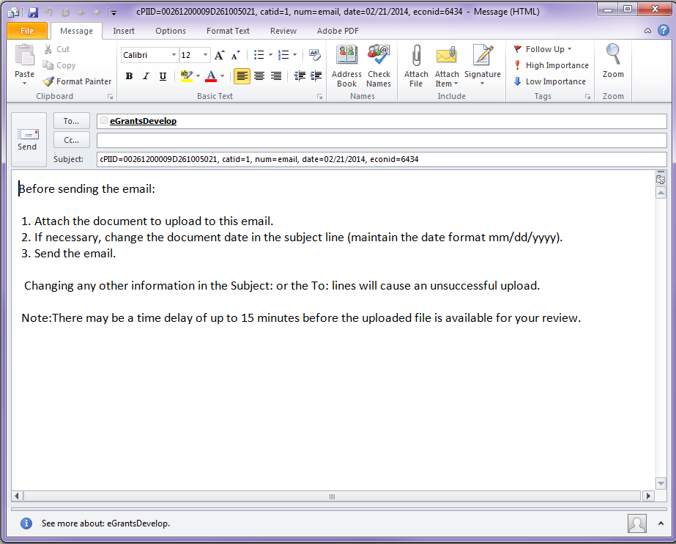



Attach an already saved document from attach file option and send email. Make sure to open your outlook before selecting post document via email option.

Selection of the **Return** button will result in the return to the previous screen. If the previous screen was a listing of the contract’s documents, the newly posted document(s) will be present in the list. If the previous screen was not a listing of the contract’s documents select the contract number to cause the listing of all posted documents. Subsequent **Back to the current contract** actions will return to the screen with all documents, including the new one being displayed.

## Document Viewing

The selection of a specific contract from the list created by DocMan search will result in the listing of documents that can be viewed.

The selection of a document (e.g., Basic Contract, Mod 2, etc,) will bring up the document imagery for viewing.

## Document Modification

Document modification, i.e., edit document index, replace document images, and delete document functions will be accessed by selecting one of the three buttons to the right of a listed document.

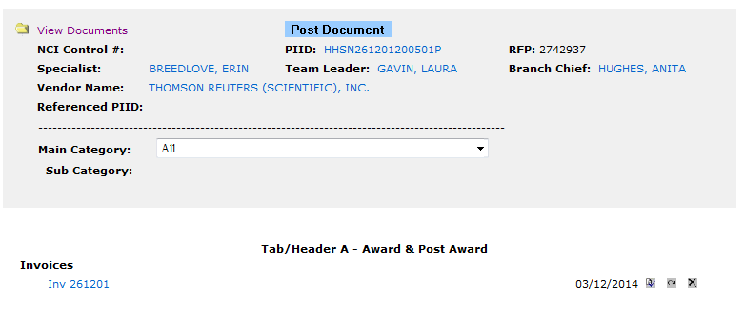 

### *Edit Document Index*

Changes can be made to the index data (Category, ID Number, and Date).

Select the **Edit Index** button: 

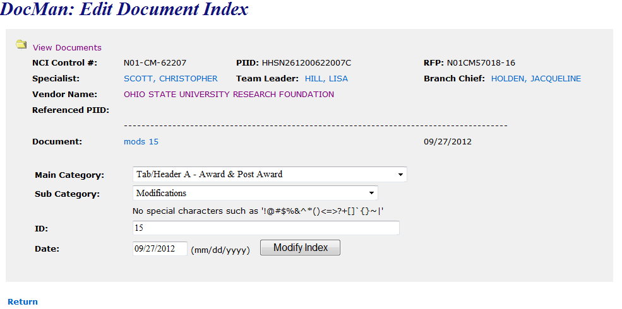

Enter changes that are to be made to the index data:

* **Category** (Do not enter, unless a change to Category or Category number)
* **Sub Category** Do not enter, unless a change to Category or Category number
* **ID** enter document id number
* **Date** (There must always be an entry in the Date field even if not a change)

After entering the changes, select the **Modify Index** button and the changes will be made to the document index.

After selection of the **Return** button, the document list for the contract will be displayed with the modifications reflected.

### *Replace Document*

To replace document select the **Replace Document** button. 

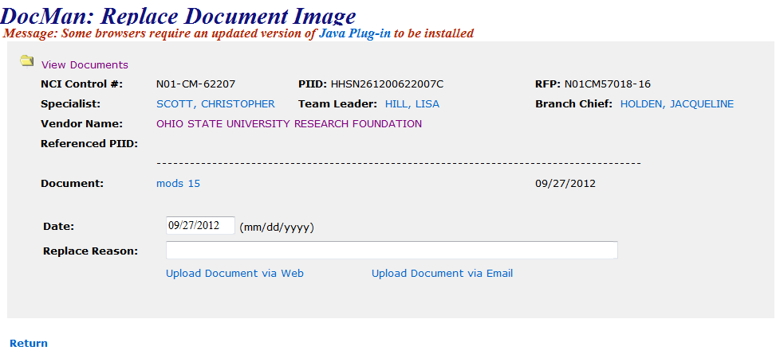

When the *DocMan: Replace Document Image* screen is displayed enter the document *Date* (if it is to be changed) and the *Reason to replace this document*? The file navigator displayed on the screen will be used to locate and select the desired PDF or Excel file that is to be loaded into DocMan. The screen and process is similar to that for Document posting.

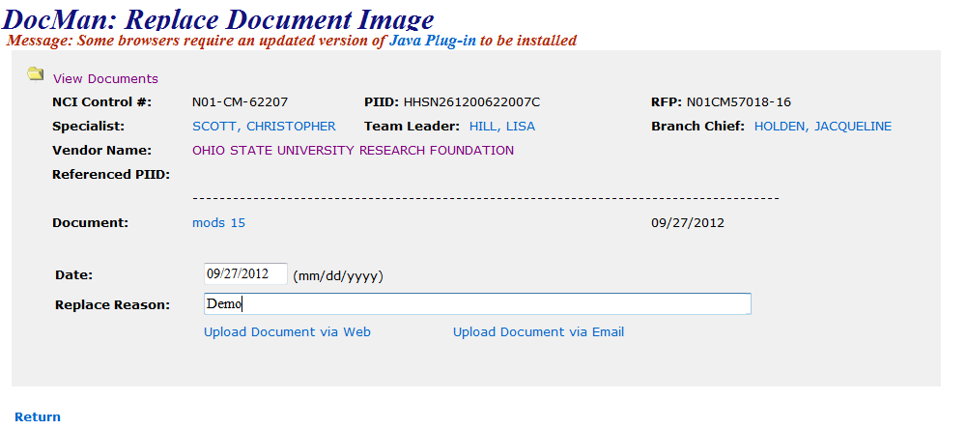

After the document has been chosen, select the **Upload Document via Web** button to initiate the uploading of that document to replace the current document imagery in DocMan. The message “Uploading…” will be displayed or Upload Document via email can also be selected.

The completion of uploading is signaled by the display of the message, “Done!” After “Done!” is displayed, select the **Return** button to return to the DocMan screen with the list of contract documents.

The list of the documents will remain unchanged unless the **Date** for the Replaced Document has been changed.

### *Delete Document*

Document imagery and the associated index data can be deleted from DocMan. Selection of **Delete Document** will bring up the *DocMan: Delete Document* screen.

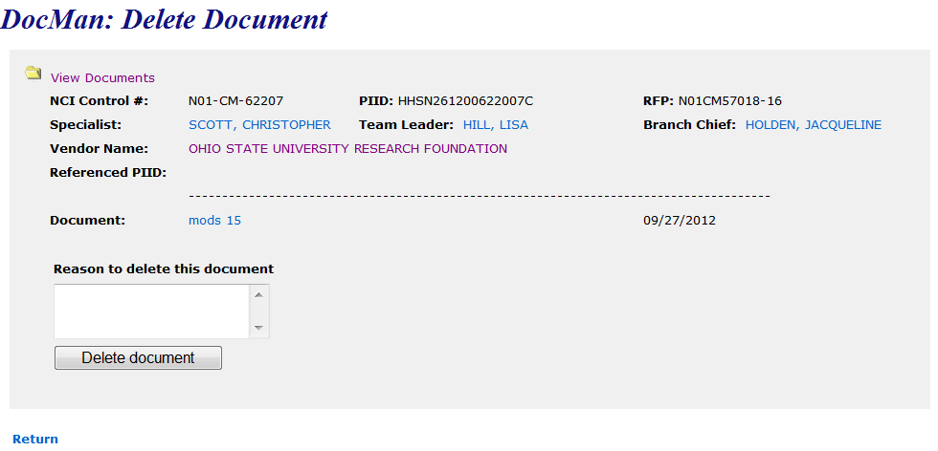

A **Reason to delete this document** must be entered and then the **Delete Document** button selected. The completion of the deletion action will be indicated by the display of the document identification (e.g., Invoice_Inv 1) followed by **has been deleted**.

Selection of the **Return** button will return the list of contract documents. The deleted document will have been removed from the list.

## Documents Deleted From System Report

As changes are made to a document in DocMan, the preceding version of the document will be removed from the DocMan. Those documents that have been deleted (*Delete Document* action); can be listed in the *Documents Deleted From System* report. This report is accessible only by persons with Level 3 access: the Director, Deputy Director, Branch Chief, and all Team leaders and members of the Policy group. This report will list deletions that had been made during a specified time period. The report contains:

Date

Contract Number

Category Name

Deleted By

Reason Deleted

A deleted document will no longer be available to retrieve directly through DocMan. However a hyperlink from this report will enable the user to retrieve a copy of the deleted document imagery for viewing. If necessary the viewed document can be saved locally and then re-Posted to DocMan. It should be noted that a document with the same index identification as the deleted document may have been added to DocMan after the document was deleted.

The DocMan screen for a person with Level 3 access will contain a button for producing a *Documents Deleted From System* report***.***

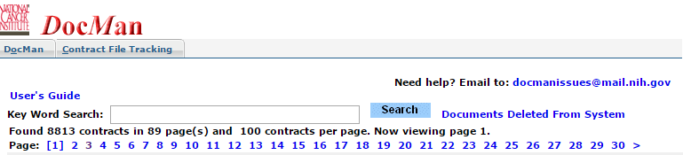

Selection of the **Documents Deleted From System** button will generate the *Documents Deleted from System* report. The report will show the results for the current month (***This******Month*** is the default period).

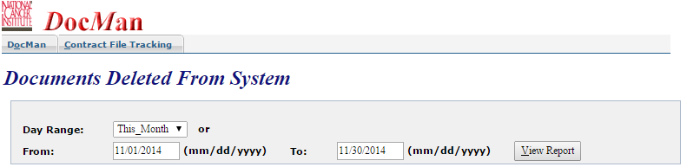

Options exist to modify the report period or sort the document contents based on one of the five column headers. The options *Day Range* that can be selected from a drop-down list are; *Today, This Week, Last Week, This Month* and *Last Month*. In addition *from* and *To* dates can be entered to select a specific date range. When from and *to* date option is used the **View Report** button must be selected to reflect the changes.

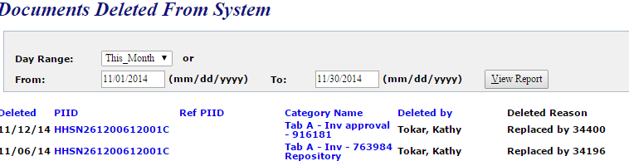

### *Select a Deleted Document*

Selection of a document listed in the report will result in the retrieval of a copy of that document. The retrieved document can be saved locally and then at any time using **Post Document** or **Replace Document** added back into DocMan. It is important to note that a document with the same index identification as the deleted document may have been added to DocMan after the document was deleted.

### *Select a Contract*

Selection of a specific *Contract Number*in the report will result in the accessing of DocMan screen for that contract (the report screen is not closed by this action). All DocMan activities for the contract will be available including accessing a different contract.

When the DocMan screen accessed by the selection of ***a*** *Contract Number* in the report is exited the *Documents Deleted from System* report will be present on the user’s terminal.

### *Exit Report*

To exit *Documents Deleted from System* and return to normal Docman functions select DocMantab at the top of the screen.

**DocMan Error Messages**

|  |  |
| --- | --- |
| **Error Condition** | **Error Message** |
|  |  |
| Non-numeric Month entry or outside range of 1 - 12 | Enter Valid Month |
| Non-numeric Day entry or outside range for month | Enter Valid Day |
| Non-numeric Year Entry or not from 1900 to current date | Enter Valid Year |
|  |  |
| Invalid Documents Deleted From System report dates | Enter Valid Dates |
|  |  |
| Search action without valid available response | No Valid Response for this Search |
| Search action without entry in search field | Insert a search string |
|  |  |
| Failure to enter an Integer Sequence Number | Enter Integer Sequence Number |
| Failure to enter an Integer Mod Number | Enter Integer Mod Number |
|  |  |
| Failure to enter reason to Replace Document Image | Enter Reason for Replace Document Image |
|  |  |
| Failure to enter reason for Delete Document | Enter Reason for Delete Document |
|  |  |
| Create duplicate document | (document ID) Already Exists |
|  |  |
| Initiate file upload action before selecting a file | Select a File |