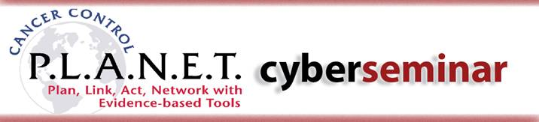

Developing, Maintaining, and Sustaining Partnerships
Abstract Submission

We invite you to submit an abstract describing a partnership that was successful in identifying, adapting, and/or implementing an evidence-based cancer control program or policy.

The abstracts will be reviewed by a panel and three will be selected for presentation during the May cyberseminar. If you are interested in submitting, please complete this form and send it to NCICCPLANETStep2@mail.nih.gov by Friday, March 12, 2010.

General Information

Your Name:
Title:
Organization:
Email:
Phone Number:

Abstract

In 250 words or less, please describe a partnership that was successful in identifying, adapting and/or implementing an evidence-based cancer control program or policy.

Please include at least one element presented in the February cyber-seminar: how the need for the partnership was determined; partnership challenges and successes; and how the partnership was evaluated and/or sustained.

Presentation Title:
Partner Organizations:
Presenter (if different than person submitting the abstract):
Presenter’s Email:
Learning Objectives:
1.
2.
3.

Abstract (250 words):

Next Steps

You will be notified of the status of your submission no later than April 9th, 2010.

If you are selected, you must be willing to:

- Participate in a live cyberseminar broadcast scheduled for May 25, 2010 from 1:30 p.m. to 3:00 p.m. ET.
- Participate in a “dry run” approximately one week before the live event.
- Prepare a 15-20 minute presentation, and submit slides by May 3, 2010.
- Prepare to engage participants in a 15 minute Q&A session/discussion immediately following the presentation.
- Share additional supplemental materials as needed.

Thank you for your consideration.

