caIntegrator-CGOM API

Software Design Description

Version 2.0

[Insert approval date of document]

Document Change Record
Version Number | Date | Description
1.0 | 7/24/06 | Initial document
1.0 | 7/28/06 | Incorporated Team comments
1.0 | 8/25/06 | Added Ram’s DTO design

TABLE OF CONTENTS
1. Introduction 1
1.1 Project Background 1
1.2 IdentifIcation 2
1.3 System Overview 2
1.4 Document Overview 2
2. System Architecture 4
2.1 System Architecture Overview 4
2.1.1 Clinical Genomic Object Model (CG-OM) 5
2.1.2 CG-OM API Service Layer 6
2.1.3 CG Database Schema 6
2.1.4 WebGenome Integration 6
2.1.5 Security 7
3. Components 8
3.1 Clinical GeNOMIC Object MODEL (CG-OM) 8
3.2 CG-OM MetaDATA REGISTRATION 8
3.3 Controlled Vocabularies and Terminologies 9
3.4 Object Query Service 9
3.5 Study Query Service 10
3.6 Analytical Query Service 19
3.7 webGenome Integration 22
3.7.1 BioAssayService 24
3.7.2 ApplicationStateService 24
3.8 Error Handling 25
3.8.1 caIntegrator Findings Specification Errors 25
Appendix A – acronym List 27
[Appendix B – Forms and Templates] 28
[APPENDIX C – DATABASE] 29
[Appendix D – Other Appendix] 34

Introduction
The Software Design Description (SDD) describes the design decisions, architectural design, and the detailed design needed to implement the caIntegator’s Clinical Genomic Object Model (CG-OM) Application Programming Interface (API). The SDD is used as the basis for implementing the software. It provides the acquirer visibility into the design and provides information needed for software support.
This document will provide instruction and strategy for documenting the design of requirements. The SDD is used as the basis for implementing the software.
This document must include or reference requirements traceability.
Requirements Traceability
- Design to Requirements Traceability – Refer to the project's RTM or insert traceability from each design element identified in this plan to the requirements and, if applicable, software system requirements it addresses.

Project Background
In 2004, NCICB along with NCI’s Neuro-Oncology Branch (NOB) initiated development of a publicly accessible database known as REMBRANDT, a Glioma Molecular Diagnostic Initiative (GMDI) which is being jointly led by NCI and the National Institute of Neurological Disorders and Stroke (NINDS).
GMDI includes a retrospective study of about 300 glioma tumor specimens and a 1,000- to 1,500-patient prospective study involving two NCI-funded brain tumor consortia and other NCI-funded institutions. Patients in the prospective study have samples of their surgically-removed tumors sent to NCI for genetic and molecular analyses; findings are then correlated with each patient's clinical course. REMBRANDT houses both molecular and genetic data on all brain tumor types.
Similar to REMBRANDT, NCICB is involved in the development of I-SPY Trail Data Analysis Portal. I-SPY TRIAL is short for Investigation of Serial Studies to Predict Your Therapeutic Response with Imaging and Molecular Analysis.
It is an ambitious nationwide breast cancer research. The goal is to find a way to identify the best breast cancer chemotherapy for each individual patient. Standard chemotherapy treatments for breast cancer may be given for months prior to surgery to remove the tumor, or else for months afterward. Women with especially aggressive cancer might receive chemotherapy both before and after surgery. These standard treatments have proved generally effective in treating the disease and lessening the likelihood of cancer returning.
But individual cancer cases differ in how they resist or succumb to chemotherapy. I-SPY researchers and physicians want to help each patient choose the most promising chemotherapy – one that will offer the best likelihood of long-term, cancer-free survival. The project is coordinated through a UCSF group led by Laura Esserman, breast cancer surgeon and
the clinical leader of the UCSF Comprehensive Cancer Center’s Breast Oncology Program, and by Nola Hylton, a physicist who developed the MR imaging techniques used in the study. The program is designated as a Specialized Program of Research Excellence (SPORE) and funded by the National Cancer Institute (NCI). All NCI’s breast cancer SPORE sites are participating in I-SPY, which also is supported by two national clinical research groups, CALGB and ACRIN.
Cancer Genetic Markers of Susceptibility (CGEMS) is a three-year initiative that will identify genetic alterations that make people susceptible to prostate and breast cancer. Scientists involved will use DNA available from five large studies of prostate cancer and five large studies of breast cancer to “scan” the genome for common genetic variations between patients who have these cancers and controls that do not have cancer. NCICB in collaboration with Division of Cancer Epidemiology and Genetics (DCEG), the NCI Core Genotyping Facility (CGF), and the NCI Office of Cancer Genomics (OCG) is helping develop the CGEMS data repository.
The caIntegrator version 1.0 addressed Rembrandt 1.0 and I-SPY portal version 0.5 use cases and was release in Jan 2006. The caIntegrator version 2.0 expands and updates the CG-OM to address Rembrandt version 1.5, I-SPY version 1.0 and CGEMS use cases as well as provides a caBIG compatible API.

IdentifIcation
The release version of caIntegrator-CGOM API that this document applies is version 2.0.

System Overview

Document Overview
This Software Design Description defines the strategies necessary to accomplish the design activities associated with caIntegrator-CGOM API. Design related procedural instructions are included in the Standard Operating Procedures (SOPs). The remaining Software Design Description sections are organized as follows:
- Section 2. System Architecture: Describes and overview of the API, the conceptual and architectural design, interfaces and the various environments that will be used throughout the development lifecycle.
- Section 3. Components: Identifies and describes each component broken down into its parts that are described in detail.
- [Section 4. Notes: Contains general information that aids in the understanding of this document.]
- Appendix A. Acronym List: Defines the acronyms to be used on the project.
- [Appendix B. Forms and Templates: Contains the forms and templates that will be used on the project.]
- Appendix C. Database: Describes database-wide design decisions about the database's behavioral design and other decisions affecting further design of the database broken down into its parts that are described in detail.
- [Appendix D. Other appendices: Provides any additional information published separately for convenience in document maintenance.}
[Reference documents - Refer to the HST Software Engineering Handbook for additional information. For additional project specific information, refer to the following documents:
- [Project Name]'s Software Development Plan (SDP)
- [Project Name]'s Configuration Management (SCM) Plan
- Add any additional relationships, if any, of the Software Design Description to related project management plans.
The following Standard Operating Procedures for design will be used on this project and are referenced in this document.
- List any project specific SOPs]

System Architecture

System Architecture Overview
The overall goal of caIntegrator project is to provide a framework with the infrastructural components needed to develop enterprise level translational applications such as Rembrandt, I-SPY, CGEMS and EAGLE. Some of the core guiding principles that will be used to develop this framework include:
- Driven by user requirements.
- User-friendly for a wide range of audience (physician scientists, programmers, statisticians)
- Standards-based and pattern-driven.
- Extensible and scalable.
- Reuse/extend existing open-source technologies.
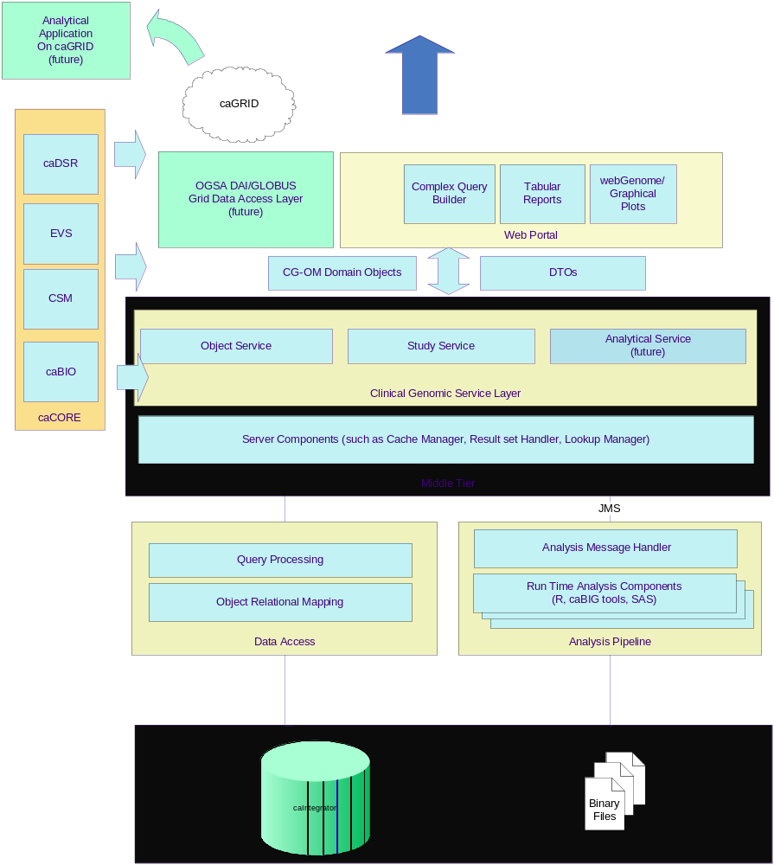
The framework leverages Java 2 Enterprise Edition, a hybrid star schema, caCORE SDK and various open source technologies. Following are some of the high level features of the caIntegrator framework:

Clinical Genomic Object Model (CG-OM)
Clinical Genomic Object Model (CG-OM) is a domain model based on a common set of use cases that were derived from various translational studies such as Rembrandt, I-SPY and CGEMS. The purpose of the CG-OM is to model the translation space that high lights the integration of clinical domain with genomic domain within a context of a clinical study. The CG-OM is further discussed in detail in Section 3.1, 3.2 and 3.3

CG-OM API Service Layer
The purpose of the CG-OM API Service Layer to allow programmatic and logical access to the underlying Data Mart via the clinical genomic domain objects. The API is organized by three separate services; each compliments the other to provide a full suit of tools that allows researchers and bioinformatics developers to analyze, search and retrieve clinical genomic data.

Object Query Service
The Object Query Service allows the API users to initiate search from any object within the CG-OM and retrieve the query results in the form of a domain object graph. caIntegator leverages the caCORE SDK tool kit to implement the Object Query Service. The service further described in detail in section 3.4

Study Query Service
The Study Query Service allows the API users to initiate search from a Criteria Data Transfer Object (DTO) and retrieve the query results in the form of a CG domain object graph or a Report DTO. This services provides a domain specific aggregation of query criteria and results and is further described in detail in section 3.5

Analytical Query Service
The Analytical Query Service allows the API users to perform run time analysis of clinical genomic data that currently supports class comparison analysis, principle component analysis and hieratical analysis. It is designed to easily incorporate other types of analysis in the future and scale to provide performance. This services is further described in detail in section 3.6

CG Database Schema
The caIntegrator hybrid data system consists of the star schema database which contains the clinical and annotation data as dimensions, pre-calculated gene expression copy number data as facts and CSM tables for user provisioning data. For performance reasons, normalized gene expression data used by the real time analysis module is stored as R-binary files.

WebGenome Integration
A generic interface to allow visualization of both genomic and gene expression data via the WebGenome application.

Security
In version 1.0, caIntegrator only needed to support data access control based on study group/institution level. It uses CSM version 3.0.1 for LDAP authentication and user registration. Due to performance considerations, it does not utilize CSM’s authorization API or schema.
For Authorization use cases, caIntegrator will perform as follows:
1. Use the User – Protection Group Relationship in CSM’s UserProvisioningManager.
2. During the run time it will obtain the User object by passing the user name and calling the getUser method of the UserProvisioningManager.
3. Using the user id of the user obtained, call the getGroups method of the UserProvisioningManager. This returns a Set of the Group objects to which the user belongs.
4. Retrieve the group name by iterating through them.
5. Constrain the caIntegrator query with the retrieved group name.

Components
The domain that each of studies involve may be different or even highly specific to the study, but the most important use case that each of these studies is trying to accomplish is to allow clinical scientists and bioinformatician to analyze, query and search translational findings in a simple and user friendly manner.

Clinical GeNOMIC Object MODEL (CG-OM)
[This paragraph shall identify a requirement by a project-unique identifier and shall describe the unit. The description shall include the following information, as applicable. Alternatively, this paragraph may designate a group of requirements and identify and describe the requirements in subparagraphs. Requirements that contain other requirements may reference the descriptions of those requirements rather than repeating information.
Requirement: Built an Object-oriented domain information model which is expressed in UML as class diagram and as an XMI file, and is reviewed and validated by the VCDE Workspace. Ensure that the information model is harmonized across the caBIG Domain Workspace. (caBIG Compatibility Guidelines Revision 2)
Design of the CG-OM is driven by use cases from three critical NCI-sponsored studies, a brain tumor trail called GMDI and a breast cancer study called I-SPY TRIAL and CGEMS. The model represents data from clinical trials, micro array-based gene expression, SNP genotyping and copy number experiments, Fluorescent IN SITU Hybridization (FISH), Somatic Mutation, Cell Lycate and Immunohistochemistry-based protein assays.
Study domain objects in CGOM allow access to the Study, treatment arms, patient information and specimen histology and information on the biospecimen. The “Finding objects” model the in-silico transformation and analyses performed on the raw experimental datasets. The clinical findings domain objects provide clinical observations and assessments. Annotation objects such as GeneBiomarker, ProteinBiomarker and SNPAnnotation help provide context to the various Findings.
CGOM_v2_1.EAP.

Clinical Genomic Package Structure
The goal of translational research is to accelerate the adoption of therapies and findings that are gathered from genomics and clinical research during a clinical trial study.
The caIntegrator project provides bio-medical software developers with a universal framework and a clinical genomic domain model that allows them to easily traverse from study related domain to clinical and genomic domains to related genomic annotation domain.
The challenge is that not every type of clinical or genomic domain may apply to every study that wants to build upon the caIntegrator framework. Therefore, we want to package these domains in a way similar to aisles in a supermarket where related products are located close to each other so that shoppers can gather them efficiently, although each product is actually unrelated or independent of each other, but they all come together at the check out line, where they may be bagged together.
Similarly the Clinical Genomic Object Model is packaged into several domain related packages such as gov.nih.nci.caIntegrator.study, gov.nih.nci.caIntegrator.findings and gov.nih.nci.caIntegrator.annonations.
The gov.nih.nci.caintegrator.findings package is further sub packaged based on the domain such as gov.nih.nci.caintegrator.findings.clinical, gov.nih.nci.caintegrator.findings.geneExpression, gov.nih.nci.caintegrator.findings.copyNumber, gov.nih.nci.caintegrator.findings.FISH etc.
The gov.nih.nci.caintegrator.annotation package is grouped in sub packages such as gov.nih.nci.caintegrator.annotation.gene, gov.nih.nci.caintegrator.annotation.protein and gov.nih.nci.caintegrator.annotation.snp.
Universal study related objects such as StudyParticipant, Study, TimeCourse, Histology, Specimen and other related objects are grouped under the gov.nih.nci.caintegrator.study package.
Even though products on supermarket shelves are independent of each other, they do in fact have dependencies regarding where they can be located in the supermarket because they may be perishable or non-perishable item (interfaces). Therefore supermarkets display items on selves, refrigerators, freezers and chillers (implementations) based on if the item’s behavior whether the item is perishable or non-perishable.
Similarly objects in the CGOM that have dependencies across packages will be abstracted behind interfaces. In particular, the association from study package objects such as SubjectParticipant, Study and Specimen to their related findings will be abstracted behind a common interface called FindingInterface that has a method getFindings(FindingType) and is implemented by the Speciemen and StudyParticipant objects and will return any type of Finding rather than getGEFinding() or getCopyNumberFinding() which might not applicable to every study.
Similar to the check out clerk at a supermarket that interfaces with both the customers and products, each study’s implementation of the caIntegrator service layer will allow end users to perform queries that go across the different findings and annotations that are relevant to that particular study.

gov.nih.nci.caIntegrator.study
findings.geneExpression
findings.copyNumber
findings.clinical
annotation.gene
annotation.protien
annotation.snp
FindingInterface

CG-OM MetaDATA REGISTRATION
Requirement: Common Data Elements (CDEs) built from controlled terminologies and according to practices validated by the VCDE workspace are used throughout the CG-OM and caIntegratorbased application. CDEs are registered as ISO/IEC 11179 metadata components in the caBIG Context of the cancer Data Standards Repository (caDSR). (From caBIG Compatibility Guidelines Revision 2)
The CG-OM will be completely annotated and processed thru the caCORE’s Semantic Integration Workbench (SIW) and uploaded to caDSR via the UML loader tool.

Controlled Vocabularies and Terminologies
Requirement: All terminologies and term definitions used for all appropriate data collection fields and attributes of data objects are reviewed and validated by the caBIG VCDE Workspace. (From caBIG Compatibility Guidelines Revision 2)
The caIntegrator team will work with the EVS Curation Team to fully curate the domain model and its associated Value Domains. Value Domains will be searched in EVS and new ones created where applicable. Domain Standards such as HUGO gene symbols, GO terms, BioCarta Pathway Names, GeneBank Accession Numbers, Entrez Gene Identifier, DB SNP Identifier and Uniprot Identifiers will be utilized by caIntegrator.

Object Query Service
Requirement: Create well-described API’s approved by the caBIG Architecture workspace that provide access to data in the form of data objects that are instances of classes represented by a domain model. Electronic data formats reviewed and approved by the caBIG Architecture Workspace are supported for both input to and output from the system. Messaging protocols approved by the caBIG Architecture Workspace are supported wherever messaging is indicated by the use cases.
The Object Query Service allows the API users to initiate search from any object within the CG-OM and retrieve the query results in the form of a domain object graph. caIntegator project is planning to accomplish this requirement by leveraging the caCORE SDK tool kit to implement the Object Query Service as a “caCORE-like” API.
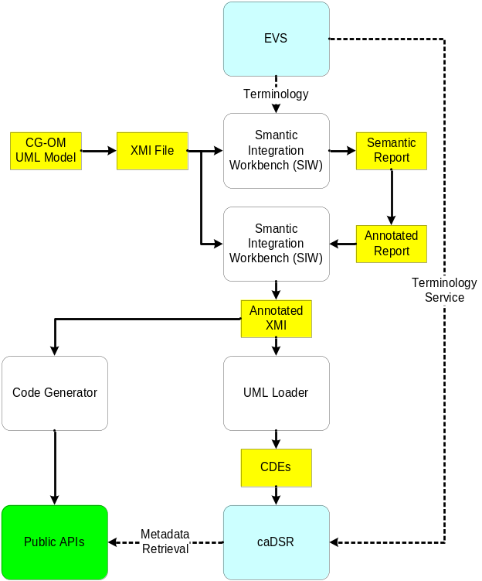
❶
❷
❸
❹
- The above diagram describes caCORE SDK work flow to generated a caBIG compatible API. The CG-OM UML will be designed using a caBIG approved UML tool.
- Model will be annotated via the Semantic Integrator Workbench (SIW).
- Next the model’s metadata will be registered using the UML Loader.
- Using the caCORE Code Generator, the Object Query Service will be generated as a caCORE-like API and deploy.

Study Query Service
Requirement: Create a well-described API that provides ability to perform arithmetic operations such as less than, greater than less than equal to, greater than equal to and set range values on date and numeric attributes. The API should provide a well defined coarse grain as well as a fine interface to perform translational queries. The API should be able to handle collections of objects as inputs. The API should provide ability to return a particular set of Findings based on another Finding.(see CGEMS_use_case.doc)

Typically when an application's presentation tier is defined, it is not necessary that the presentation layer will map directly with the underlying domain model objects in a one-to-one mapping. Also from the domain model prospective, how the overlying applications transfers the data or how the presentation layer's work flow is defined is not a domain models’ core concerns. The task of mapping domain objects to the presentation data elements can be cumbersome task and hard to maintain, especially as the domain keeps evolving over time.
In addition, a complex object model such as CG-OM has many bi-directional associations which can lead to conical queries. Even thought these queries might eventually return the correct results, they may not be the most efficient way of retrieving them.
Based on the study use cases and presentation needs caIntegrator's Study Query Service will provide the ability query based on Data Transfer Objects (DTOs) that map to the underlying Domain Object model.
Martin Fowler coined the phrase Data Transfer Objects or DTOs. The basic idea is that a DTO helps encapsulate the business data. A single method call is used to send and retrieve the Transfer Object. The middle tier is then responsible for deconstructing the DTO back into domain objects, assembling the results and returning the desired results as another DTO (if required) or simply as Domain Objects.
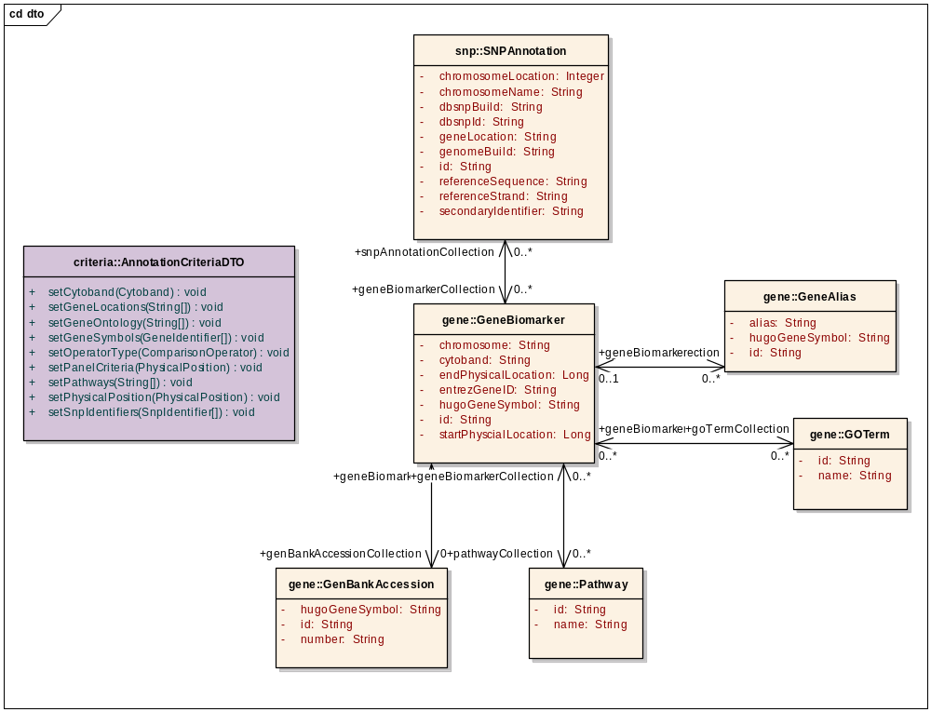
For example, if the presentation layer wants to allow users to search for a Finding based on a HUGO gene symbol, gene alias, SNP identifier, a chromosome location or study participants control status then the middle tier should provide the presentation tier with an AnnotationCriteriaDTO object that takes Gene Symbol, Gene Alias, SNP Identifier, etc as attributes and maps these attributes to the underlying Domain objects. If required, similar type of DTOs can be created for the returned result sets that allow selected attributes from one or more objects, otherwise the domain object graph will be returned.
For the Study Query Service to be scalable for all caIntegrator based studies, the HQL used to perform these queries has to be dynamically assembled. Additionally, caIntegrator will utilize NCIA team's hibernate performance bench mark and tips as the starting point for this effort.
The Study Query Service will also provide methods to address the “Findings to Findings” use case, so that the presentation layer is abstracted from the low level mappings involved in resolving such Findings.
For illustrating this approach, CGEMS Criteria DTOs is used as an example to describe the details of the Study Query Service API. Please refer to the below diagram:
- There is a FindingCriteriaDTO that corresponds to each type of Finding (such as GetotypeFindingCriteriaDTO corresponds to GenotypeFinding). All attributes within the GetotypeFindingCriteriaDTO will be ANDed together.
- Each of these FindingCriteriaDTO objects will allow user to specify a set of well defined criteria such as “Within” clause for range attributes like Physical Position and Date, “GreaterThan/LessThan” for numeric attributes, along with the ability to specify multiple values for any given attribute such as Gene Symbol list.
- The AnnotationCriteriaDTO allows searches on genomic annotations and provides a simple way to nest annotation lists provided by the user such as Gene symbols, GOTerms, Pathways, Cytoband etc. All attributes within the AnnotationCriteriaDTO will be ORed together.
- The AnnotationCriteriaDTO may be nested with the above GetotypeFindingCriteriaDTO with an AND operator.
- Similarly there is a StudyParticipantCriteriaDTO class that encapsulates study domain objects such as Study, TimeCourse, Specimen, StudyParticipant, etc. The StudyParticipantCriteriaDTO can be nested with the above GetotypeFindingCriteriaDTO with an AND operator.
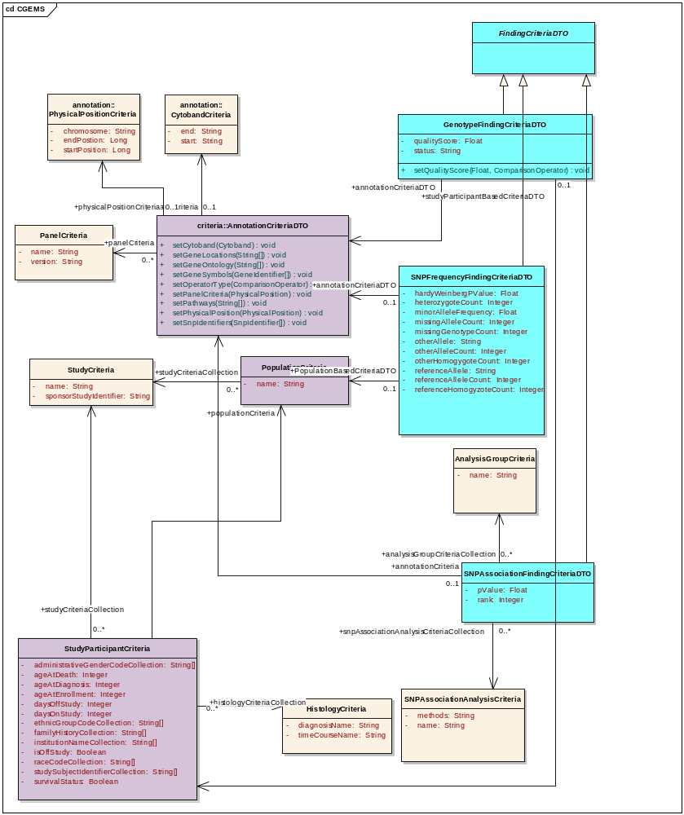
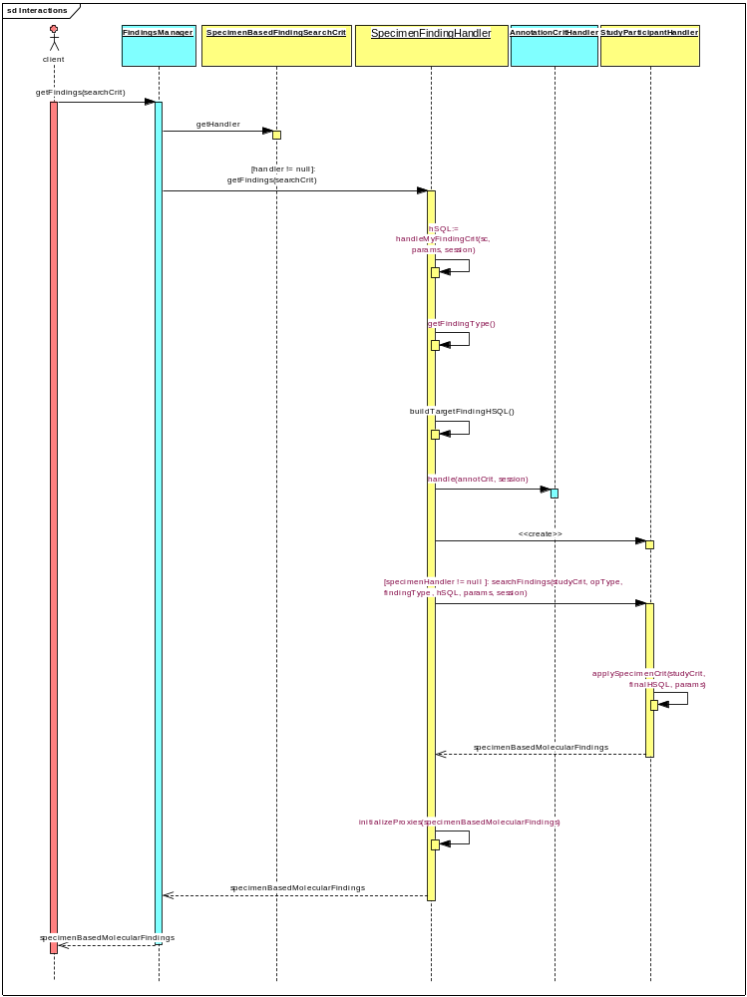
The following describes the above sequence diagram:
- Client will call the static method getFindings() method on FindingsManager class. This class acts as a controller between client and persistent layer. This method returns SpecimenBasedMolecularFinding type objects. It does this by simply delegating to corresponding SpecimenFindingHandler (based on SpecimenBasedFindingSearchCriteria)
- SpecimenFindingHandler is the super class for all types of FindingHandlers. This class uses Template pattern in combination with Strategy pattern. It mainly requires the sub classes to implement 3 methods out of which handle() method is the main method that is implemented by all concrete finding handlers (such as GetotypeFindingHandler). This method is responsible for handling the corresponding SearchCriteria and returns HSQL (hibernate query language) that will primarily take care of all criteria specified for the Finding itself. This handle() method also uses AnnotationCriteriaHandler to handle AnnotationCriteriaDTO that was nested and generates combined HSQL. So sequence of execution is as follows:
  - FindingsManager first calls the inherited method getFindings() (from the super class SpecimenFindingHandler) on the corresponding handler.
  - This getFindings() method calls handle() method on the corresponding Specimen FindingHandler to get the above mentioned HSQL to handle the criteria for the Finding itself.
  - It then instantiates corresponding type of StudyParticipantHandler based on StudyParticipantCriteriaDTO specified in the SpecimenBasedFindingSearchCriteria passed in. This StudyParticipantHandler generates HSQL to handle any sub type of StudyParticipantCriteriaDTO. It then adds this HSQL to the above HSQL (required to handle Finding itself) and then executes this entire HSQL as a single query to retrieve all Findings of the corresponding type.

API Usage
Here is an example of study query service methods for a germ line study such as CGEMS that clients may call:

- public static Collection<? extends Finding> FindingsManager.getFindings (
FindingCriteriaDTO findingCritDTO, int fromIndex, int toIndex );

- public static Collection<SNPAnnotation> FindingsManager.
getSNPAnnotations(AnnotationCriteria annotationCrit);

- public static Collection<Study> FindingsManager. getStudies(StudyCriteria
studyCrit);

getFindings method
For example in the case of CGEMS study, the Study Query Service allows the users to get the foloowing types of findings:
- GenotypeFinding
- SNPAssociationFinding
- SNPFrequencyFinding.

The following method supports the searching of all three types of findings mentioned above:
public static Collection<? extends Finding> FindingsManager.getFindings (
FindingCriteriaDTO findingCritDTO, int fromIndex, int toIndex );
All these findings extend abstract Finding class (refer to the CG-OM). In addition the domain objects, the DTO model facilitates the clients to nest object queries in the form of Criteria objects. (See the germ line DTO model diagram).
The FindingCriteriaDTO corresponding to each of the above 3 types of findings are as follows:
- GenotypeFindingCriteriaDTO
- SNPAssociationFindingCriteriaDTO
- SNPFrequencyFindingCriteriaDTO

All these 3 DTO’s extend from abstract FindingCriteriaDTO similar to Findings. Each of these DTO consists of a set of Criteria objects. Each of these FindingCriteriaDTO objects will allow user to specify a set of rich criteria for the corresponding Finding object attributes (such as within clause, GreaterThan/LessThan, Within clause etc along with the ability to specify multiple values for any given attribute). All this attribute criteria within the FindingCriteriaDTO will be ANDed together.

The AnnotationCriteria class encapsulates all Annotation criteria and provides a simple way to nest multiple lists of Annotations (such as geneSymbols, SNPIdentifiers etc). Also the user can specify annotations such as PhysicalPosition, PanelCriteria etc in this AnnotationCriteria. AnnotationCriteria is different than other criteria the attributes within the AnnotationCriteria object are ORed when the Findings are retrieved.

In other words, all the annotation criteria will be ORed while the Finding object attributes themselves will be ANDed. And what comes out of this nested query is entire the Object Graph of corresponding Finding objects which includes that is shown in the domain model.

As described above, Each of these FindingCriteriaDTO implements getHandler() method that returns corresponding FindingHandler (through polymorphism). This handler is responsible for handling the nested query (by parsing and creating Hibernate Queries using HQL & Hibernate Criteria API and eventually generating required SQL which is tuned to give best performance).
Example of a code snippet that demonstrates the usage of FindingCriteriaDTO.
public class GenotypeFindingTest {
protected AnnotationCriteria annotCrit;
private GenotypeFindingCriteriaDTO gfDTO;
private StudyParticipantCriteria spCrit;
private void setUp() throws Exception {
gfDTO = new GenotypeFindingCriteriaDTO();
annotCrit = new AnnotationCriteria();
gfDTO.setAnnotationCriteria(annotCrit);
spCrit = new StudyParticipantCriteria();
gfDTO.setStudyParticipantCriteria(spCrit);
}
protected void setUpSNPPhysicalPositionCrit() {
PhysicalPositionCriteria ppc = new PhysicalPositionCriteria();
ppc.setChromosome("8");
ppc.setStartPosition(new Integer(76065000));
ppc.setEndPosition(new Integer(76075000));
annotCrit.setPhysicalPositionCriteria(ppc);
}
private void setUpGenotypeCrit() {
gfDTO.setQualityScore(new Float(0.50), ArithematicOperator.LT);
}
protected void setUpPanelCrit() {
PanelCriteria p = new PanelCriteria();
p.setName("HumanHap300");
p.setVersion("1.1");
annotCrit.setPanelCriteria(p);
}
public void testGenotypeFindingCriteriaDTO() {
setU p();
setUpSNPPhysicalPositionCrit();
setUpGenotypeCrit ();
setUpPanelCrit ();
Collection<? extends Finding> findings =
FindingsManager.getFindings( gfDTO,startIndex, endIndex);
for (Iterator<? extends Finding> iter = findings.iterator();
iter.hasNext();) {
GenotypeFinding finding = (GenotypeFinding)iterator.next();
System.out.println("QualityScore: " + finding.getQualityScore());
System.out.println("Allel1: " + finding.getAllele1());
System.out.println("Allel2: " + finding.getAllele2());
//….. so on ….
}
}

Other methods
Besides getFindings method, for convenience the study query service provides other service methods to retrieve domain objects. As an example:
public static Collection<Study> getStudies(StudyCriteria studyCrit);
The user can simply instantiate a StudyCriteria object and set attributes on this (such as name, sponsorStudyIdentifier) and call the above service method. This will return Study objects (domain objects) that satisfies the criteria specified. If no attributes were specified, then it will return all Study Objects.
Code Snippet:
private StudyCriteria studyCrit ;
studyCrit = new StudyCriteria();
studyCrit.setName("A");
Collection<Study> studyObjs = FindingsManager.getStudies(studyCrit);
for (Iterator<Study> iterator = studyObjs.iterator(); iterator.hasNext();) {
Study study = iterator.next();
System.out.println("Study Name: " + study.getName());
// ….. so on ….
}

Analytical Query Service
Requirement: Create a well-described API that provides ability to perform on-the-fly computational analysis capability for applications built on the caIntegrator application framework (i.e., Rembrandt and I-SPY) (see Rembrandt/I-SPY use cases documents)

The Analytical Server provides an on-the-fly computational analysis capability for applications built on the caIntegrator application framework (i.e., Rembrandt and I-SPY). The Analytical Server communicates with the application middle-tier via the Java Messaging Service (JMS).
JMS allows the Analytical Server to communicate asynchronously with the application via the AnalysisServerClientManager object located in the application middle-tier. The middle-tier makes analysis requests via AnalysisRequest objects. The Analytical Server performs computations and sends AnalysisResult objects back to the middle-tier.

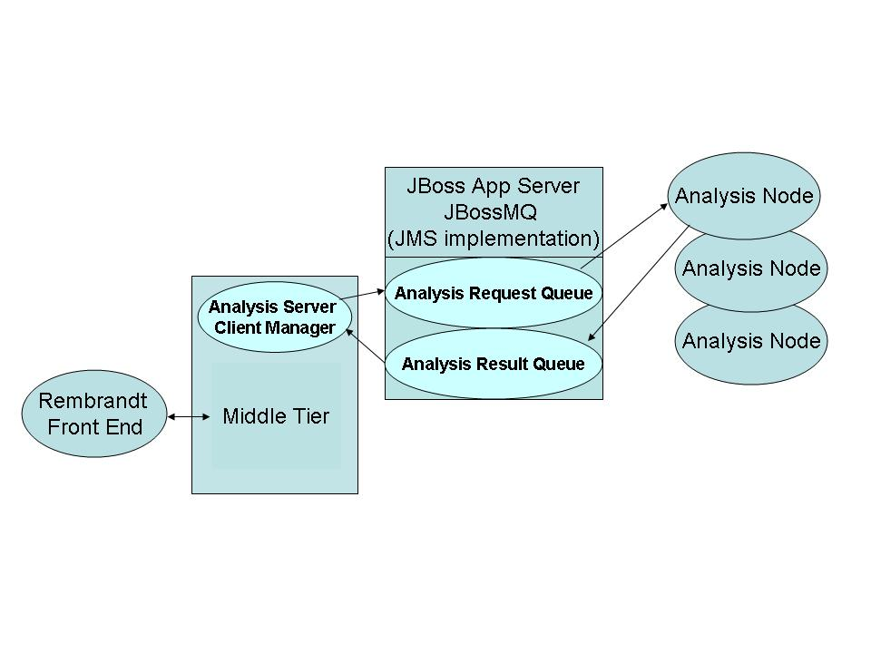

The analytical server consists of one or more analysis nodes. Each analysis node is intended to be located on a separate computer. The analysis nodes communicate with the middle-tier via the JMS Analysis Request and Analysis Result queues. These queues are located on the JBoss server hosting the application middle-tier. AnalysisRequest and AnalysisResult objects are passed between the middle tier and the analytical server using JMS object messages. JMS object messages allow serializable Java objects to be imbedded in JMS messages.
The AnalysisServerClientManager is a class that resides in the middle-tier that handles all of the messaging between the middle tier and the analytical server. It places AnalysisRequest objects on the Analysis Request Queue and listens for AnalysisResponse objects on the Analysis Result Queue.
The JMS Message Handler component of each analysis node listens for AnalysisRequest objects on the Analysis Request Queue and places AnalysisResult objects on the Analysis Result Queue.
The JMS infrastructure insures that only one and only one analysis node will receive a given analysis request. JMS also distributes the request across the analysis nodes so that each node will receive approximately the same number of requests.
An analysis node determines the type of analysis to perform based on the type of the received AnalysisRequest object. For example, if a ClassComparisonAnalysisRequest object is received, the analysis node will perform a class comparison computation using the parameters contained in the request and then send a response of type ClassComparisonAnalysisResult. The ClassComparisonAnalysisResult contains the results of the class comparison computation.
Each specific computational method has a corresponding AnalysisRequest and AnalysisResult object. The three computational methods that are currently being implemented are: class comparison, principal component analysis, and hierarchal clustering. The corresponding message types are: ClassComparisonAnalysisRequest, ClassComparisonAnalysisResult, PrincipalComponentAnalysisRequest, PrincipalComponentAnalysisResult, HierarchicalClusteringAnalysisRequest, and HierarchicalClusteringAnalysisResult. Each request object is a subclass of the abstract AnalysisRequest object and each response object is a subclass of the abstract AnalsyisResponse object.
To add a new type of analysis, the developer would create new request and response objects corresponding to the new statistical method.

Each analysis node consists of a JMS message handler, a thread pool executor, and one or more compute threads as illustrated in the diagram below.

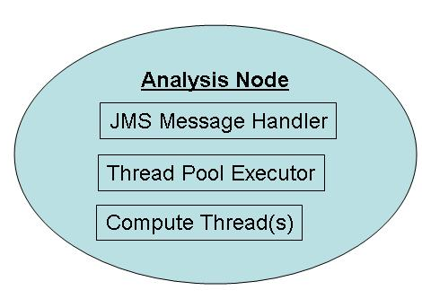

On a multi-processor computer the number of compute threads would usually be set to equal or exceed the number of available processors. The thread pool executor is derived from the Java 1.5 ThreadPoolExecutor. It is responsible for distributing compute tasks to the compute threads and for queuing tasks that can not be immediately assigned to a compute thread.
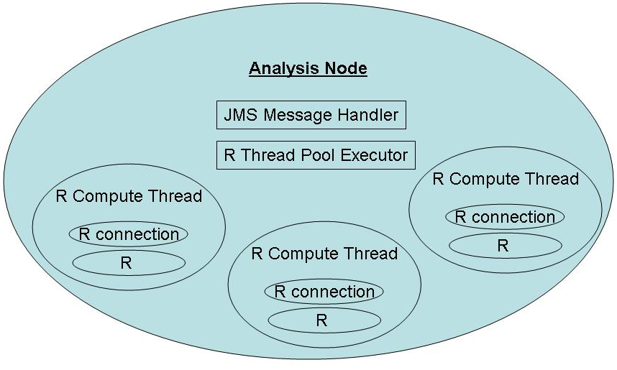

Each compute thread is derived from the Java Thread class. In the diagram above the compute threads are called R Compute Threads because they contain all of the code and data needed to perform a given statistical computation using the R statistical package. The Rserve package (see: http://stats.math.uni-augsburg.de/Rserve/) is used to call the R system from the R compute thread. Rserve provides Java classes to execute R commands and to retrieve results as Java objects. Each R compute thread contains one R connection (a line of communication to an R process).
The code snippet below illustrates how R commands can be called from Java:

double varianceFilterValue = 0.9;
c.voidEval("pcaResult <- computePCA(dataMatrix," + varianceFilterValue + " )");
double[] pca1 = c.eval("pcaMatrixX <- pcaResult$x[,1]").asDoubleArray();
double[] pca2 = c.eval("pcaMatrixY <- pcaResult$x[,2]").asDoubleArray();double[] double[] pca3 = c.eval("pcaMatrixZ <- pcaResult$x[,3]").asDoubleArray();
c is a previously instantiated Rconnection object. The code above will call the R function computePCA and place the results into the Java double arrays pca1, pca2, and pca3.
The analysis node design allows for calling other types of statistical packages. The diagram below illustrates using SAS instead of R. The SAS ComputeThread and the SAS ThreadPoolExecutor classes would contain all of the SAS specific code necessary to execute SAS within the analysis node.
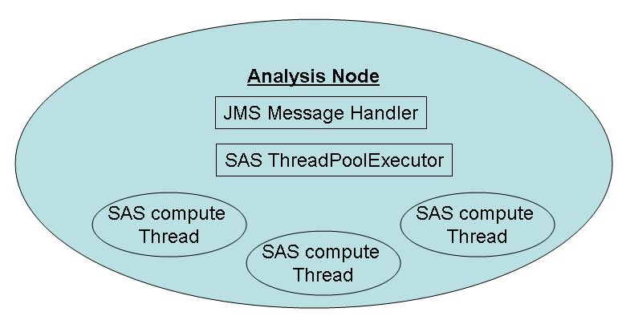

webGenome Integration
Requirement: One of requirements of caIntegrator is to help researchers better analyze and visualize the results in a user friendlier manner by creating an interface between caIntegrator and webGenome and extend webGenome’s capabilities with new plots and functionality.
(see Rembrandt 1.0 use cases documents)

WebGenome is a plotting application. The goal is to show the data from the Rembrandt report in genomic plots of WebGenome. Then WebGenome can further query Rembrandt application for more data (for selected samples in Rembrandt report). To achieve this integration, an EJB architecture was proposed. The proposed architecture is that WebGenome come up with set of Interfaces to represent their data sources. So that any client (such as Rembrandt) that wants to integrate with WebGenome, will implement these interfaces and will make these interface type objects available to WebGenome application (using some type of remote protocol). Rembrandt uses EJB to achieve this remote capability. And make these objects available through JNDI. Please see below for the architecture diagram.
The main interface that needs to be implemented is org.rti.webgenome.client.BioAssayMgr. (This is of type Remote). Rest is set of Data Transfer Objects (DTO) interfaces. Please refer below the attached DTO interfaces (model)

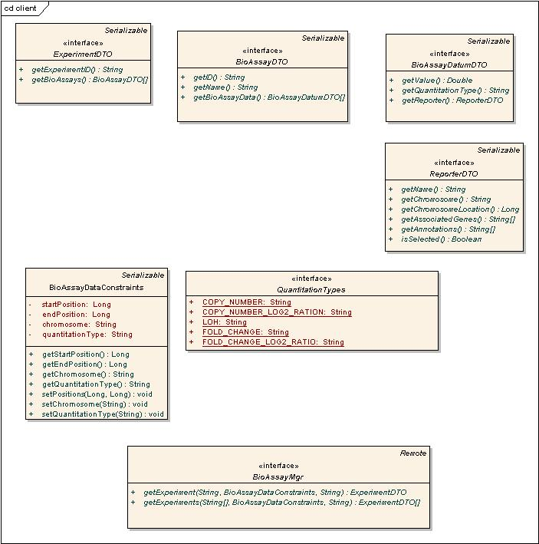
DTOs;
- org.rti.webgenome.client.ExperimentDTO
- org.rti.webgenome.client. BioAssayDTO
- org.rti.webgenome.client. BioAssayDatumDTO
- org.rti.webgenome.client. ReporterDTO
And a constraints object org.rti.webgenome.client.BioAssayDataConstraints to specify the query criteria.

BioAssayService
This is implemented as EJB Stateless Session Bean. The class that implements this is gov.nih.nci.caIntegrator.services.bioAssay.ejb. BioAssayServiceBean. The two main methods that are implemented are
ExperimentDTO[] getExperiments(String[] experimentIDs, BioAssayDataConstraints bioAssayDataConstraints, String clientID)
&
public ExperimentDTO getExperiment(String experimentID, BioAssayDataConstraints assayDataConstraints, String clientID)
From ExperimentDTO all other DTO can be accessed. This BioAssayServiceBean class uses strategies pattern to serve different types of data. It contains BioAssayService type that actually does the job. Currently Copy number data, Gene Expression Data and LOH data are supported. There are three classes (CopyNumberDataService, GeneExprDataService and LOHDataService) that implement the above mentioned BioAssayService interface. This design will leave the flexibility to support more data types in future. At that time, that class simply need to implement BioAssayService. All these classes uses current Rembrandt code base (multi-threaded query model) to retrieve the data.

ApplicationStateService
There is also another generic service implemented to support this integration effort. It is gov.nih.nci.caIntegrator.services.appState.ApplicationStateService. The main purpose of this is to provide services to publish and retrieve application states between the calls. That is any application which is interested in saving its state (to be queried later by other apps) can implement an interface (TrackableAppState) and utilize the services of this class to publish and retrieve its state. These services are exposed utilizing EJB Session bean. The two main methods in this are service are:
public Integer publishReportState(TrackableAppState stateDTO) &
public TrackableAppState getReportState(Integer stateDTOID)
The former method publishes the application state (passed as TrackableAppState type) and returns the auto-generated ID under which it was saved. The client can use this ID to retrieve this application state (as TrackableAppState) at later point of time before the predefined time expires.
The later method returns application state as TrackableAppState object for the stateDTOID passed in.

Rembrandt application utilizes the ApplcationState service. It will publish the Rembrandt report state to this service before it launches the WebGenome application (in a separate window) Then the above mentioned BioAssayMgrService utilizes this ApplicationState service to retrieve the report state It then uses this state data in querying / filtering the data before it send it to WebGenome for display. Below is the Sequence diagram that describes all of this.
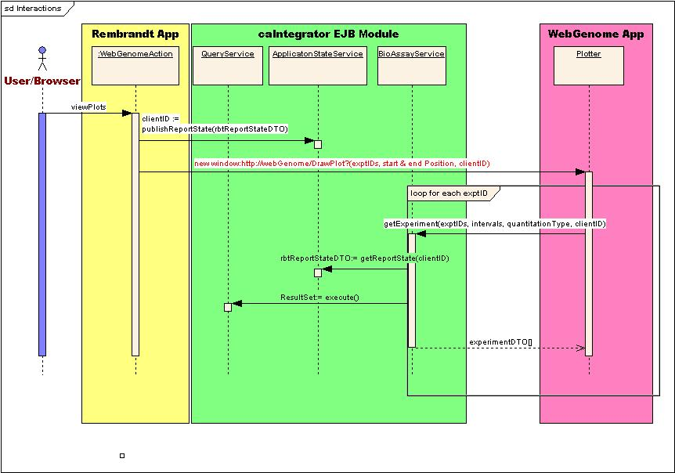

Error Handling

caIntegrator Findings Specification Errors
An effort has been made to create a simple error checking/handling mechanism for the findings framework. In other locations of the application, other than the UI, exceptions when they can not be handled are to be thrown up to the calling class, and never to be caught and left unhandled. All exceptions will use the application logging mechanism to log the date/time, exception type and if available, a stack trace.
All middle-tier to persistent tier exception thrown exceptions are to be wrapped in one of the following four classes shown in FIGURE and then sent back through the Findings API to the calling classes. In most circumstances this will be the UI or web interface which will then wrap or handle the exception into it’s handling mechanism.
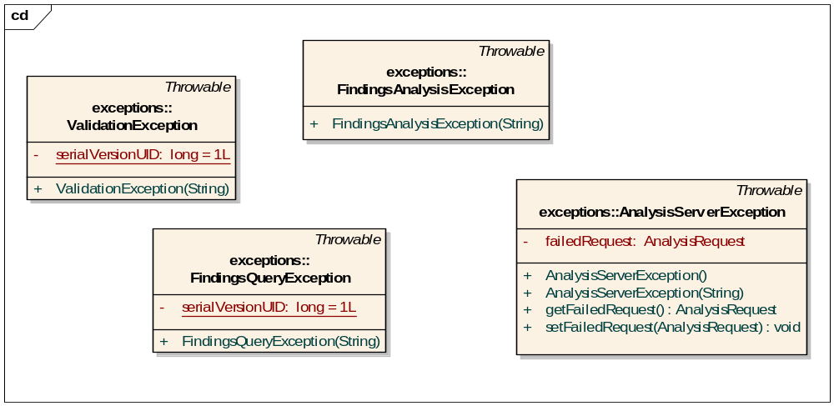
Figure 1 - Findings/Analysis Wrapping Exceptions

Appendix A – acronym List
[Insert an alphabetical listing of all acronyms, abbreviations, and their meanings as used in this document.]
Acronym | Description
[????] | [Insert Project Name acronym]
[????] | [Insert Project all other project Software Design Description specific acronyms and resort the table]
CI | Configuration Item
DBA | Database Administrator
MS | Microsoft
PM | Project Manager
RM | Requirements Manager
RTM | Requirements Traceability Matrix
SCM | Software Configuration Management
SDD | Software Design Description
SDLC | Software Development Lifecycle
SDP | Software Development Plan
SE | Software Engineering
SEPG | Software Engineering Process Group
SPE | Software Product Engineering
SM | Software Manager
SOP | Standard Operating Procedure
SPI | Software Process Improvement
SQA | Software Quality Assurance
SRS | Software Requirement Specification
SW | Software
TM | Test Manager

[Appendix B – Forms and Templates]
[Attach any design forms or templates used on the project. Use dynamic links; do not paste the forms and template in this file/document.]

[APPENDIX C – DATABASE]
Overview – This section shall describe any changes made to the database/back end. All changes should be maintained in CCR/Release folders in PVCS. The entity changes will be updated in ER tool (Erwin/Oracle Designer etc) at the implementation time. The database changes will be updated in PVCS at the time of implementation. Examples of database changes include:
- Table
  - New Table
    - Purpose:
    - Schema:
    - Create Script including indexes, constraints and grants, sequences, snapshots:
    - Type of Table: normal, index organized, materialized view etc.
    - Data expected in 1 year:
    - Data Retention Period: Will data be archived from time to time?
    - Are there data that need to be loaded into the table at the creation time? What and where are the scripts to load the data?
    - Location of scripts, data etc.
  - Modifications to Old Table
    - Purpose:
    - Schema:
    - Modification Script (include changes to the storage clause, indexes, sequences and grants as well):
    - Procedure to Modify: Describe the process to modify the old table; for example if adding a column, simply provide the script to add the column; if modifying the data type of a column, provide the necessary steps like export, drop recreate and import clearly
    - Data Modifications: Will the modified table require modifications to data or require insertions of additional data? Provide scripts as required.
    - Location of scripts, data etc.
  - Obsolete Tables:
    - Reason the object has become obsolete?
    - Schema:
    - Should the data be retained for any reason and for how long? This will help decide whether to store an export file on server or tape. Regardless of the retention period, the data should be retained online until the Release has been implemented and approved.
    - Script to delete table, views build upon the table, synonyms for the table and any referential integrity
    - Location of Script:
- Data Modifications
  - Purpose:
  - Schema:
  - Script to add/modify data (include changes to storage clause, indexes and grants as well as necessary statements to disable and enable constraints and triggers before and after the data modifications):
  - Step by step process to modify the data:
- Stored Objects (Trigger, Procedure, Package, Function, View)
  - Purpose:
  - Obsolete/New/Modification Description:
  - Will the stored objects change the data retention/growth of any table? If so, describe the change.
  - Location of Scripts:
- Database Links
  - Purpose:
  - New/Modification/Obsolete:
    - If new or modification: is the database link private/public? If the database link is public, state the justification. If a public database link is created, ensure the schema used in the link will not compromise security.
  - For modified or obsolete database links, are there any outside users of the link that need to be notified?
  - Location of Scripts:
- Init.ora
  - Purpose:
  - Addition/Modification
  - Temporary? If the addition/modification is temporary, what is the time period?
  - Expected Results: For example, will this addition/modification change the performance?
  - Location of new Init.ora file & distribution:
  - Comments:
- Listener.ora
  - Purpose:
  - Modification:
  - Temporary: for example, is the change required to troubleshoot an issue by placing a trace level?
  - If adding more listeners or changing ports, are there any users that need to be notified to reference the new ports?
  - Location of new Listener.ora file & distribution:
- Tnsnames.ora
  - Purpose:
  - Addition/Modification/Deletion:
  - Location of new tnsnames.ora file:
- Server Batch jobs:
  - New
    - Purpose:
    - Command File:
    - Owner:
    - Privileges required to execute batch job:
    - Schedule:
    - Expected length of execution? Will the new length interfere with other command files/backups?
    - Maintenance of log files generated by command file: will the command file maintain its own log files or is there another command file that maintains all log files on the server?
    - Location of command file:
  - Modification
    - Purpose:
    - Modified Command File:
    - Schedule change?
    - Change in length of execution? If the execution time increases, will there be any interference to other command files/backups?
    - Location of command file:
  - Obsolete
    - Purpose:
    - Name of Command file and any other scripts called by command file:
- Oracle jobs:
  - New
    - Purpose:
    - Name of sql package/procedure or external script:
    - Owner:
    - Privileges required to execute job:
    - Schedule:
    - Expected length of execution? Will the new length interfere with other jobs backups?
    - Maintenance of log files/tables generated by job: will the job maintain its own log files/tables or is there another job that maintains all log files/log tables in the database?
  - Modification
    - Purpose:
    - Modified sql code:
    - Schedule change?
    - Change in length of execution? If the execution time increases, will there be any interference to other jobs/backups?
  - Obsolete
    - Purpose:
    - Name of job and any other scripts called by the job:

- Arvhive Log File Maintenance:
  - Purpose:
  - Change in the maintenance schedule or retention period?
  - Is there sufficient space on disk to support the change?
- Storage Maintenance:
  - Of all the data modifications, new tables and retention changes for this CCR/Release, consider the availability of resources in the following areas:
    - Tablespace: Does the tablespace have enough space to capture the new data?
    - If datafiles need to be added/resized, are there enough space on the disks?
    - Will the generation of redo log files change thus changing the amount of archive log files that are kept on line? If yes, then is there enough disk space on the server?

[Appendix D – Other Appendix]
[Appendixes may be used to provide information published separately for convenience in document maintenance (e.g., charts, classified data). As applicable, each appendix shall be referenced in the main body of the document where the data would normally have been provided. Appendixes may be bound as separate documents for ease in handling. Appendixes shall be lettered alphabetically (A, B, etc.).]

