**G50c dataset**

550 data points, 50 features, 2 classes

~ 10% labeled (50 datapoints)

~5% increase accuracy (0.82% -> 0.87%)

C:\Users\llonini\Google Drive\Activity Recognition\SSRF\Figures\g50c\AccTests.eps

**Fisheriris**

150 data points, 4 features, 3 classes

10% labeled (15 datapoints)

~9% increase accuracy (0.86% -> 0.95%)

C:\Users\llonini\Google Drive\Activity Recognition\SSRF\Figures\FisherIris\Acc_fixSeed.eps

**UCI- Activity recognition dataset**

Recordings of 30 subjects performing activities of daily living (ADL) while carrying a waist-mounted smartphone with embedded inertial sensors.

3-axial linear acceleration and 3-axial angular velocity at a constant rate of 50Hz

Total time 2.86h of recording

7352 data points, 561 features (accelerometer and gyroscope), 7 classes

3 subjects labeled (990 datapoints)

3 subjects unlabeled (914 datapoints)

~3% increase accuracy (0.88% -> 0.91%)

C:\Users\llonini\Google Drive\Activity Recognition\SSRF\Figures\UCI\acc-tr3-te3_10trees.epsC:\Users\llonini\Google Drive\Activity Recognition\SSRF\Figures\UCI\tau50-tr13vste13.eps

4 subjects labeled (1315 datapoints)

4 subjects unlabeled (1228 datapoints)

~6% increase accuracy (0.82% -> 0.88%)

**C:\Users\llonini\Google Drive\Activity Recognition\SSRF\Figures\UCI\acc-tr4-te4_10trees.eps**

3 subjects labeled (990 datapoints)

3 subjects unlabeled (914 datapoints)

Alpha = 2

**C:\Users\llonini\Google Drive\Activity Recognition\SSRF\Figures\UCI\acc-tr3-te3_10trees_alpha2.eps**

3 subjects labeled (990 datapoints)

3 subjects unlabeled (914 datapoints)

Alpha = 0.5C:\Users\llonini\Google Drive\Activity Recognition\SSRF\Figures\UCI\acc-tr3-te3_10trees_alpha05.eps

**Using different values of T0**

**3 labeled, 3 unlabeled, 10 trees**

**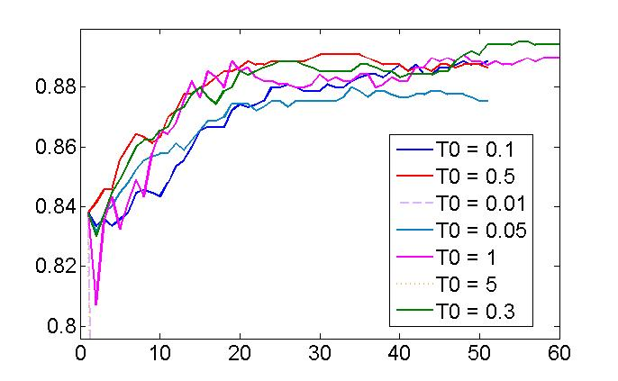**

**1-7 labeled, 9 unlabeled, T0 = 1, 10 trees**

**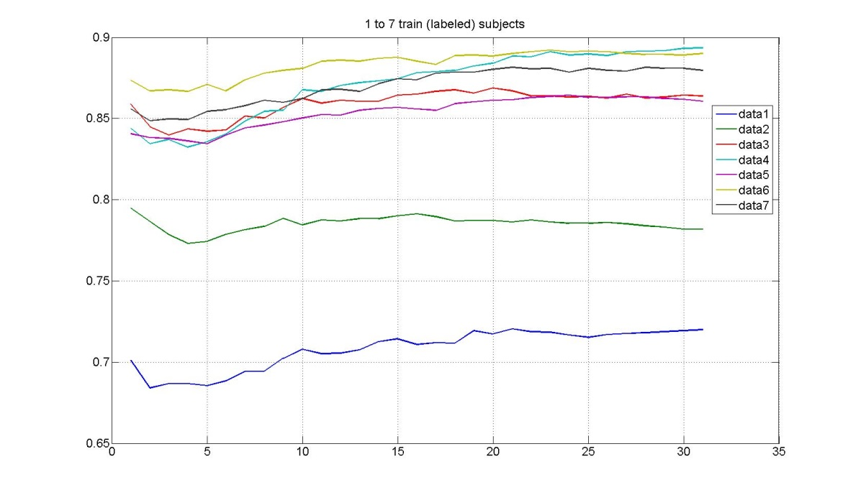**

**8-14 labeled, 9 unlabeled, T0 = 1, 10 trees**

**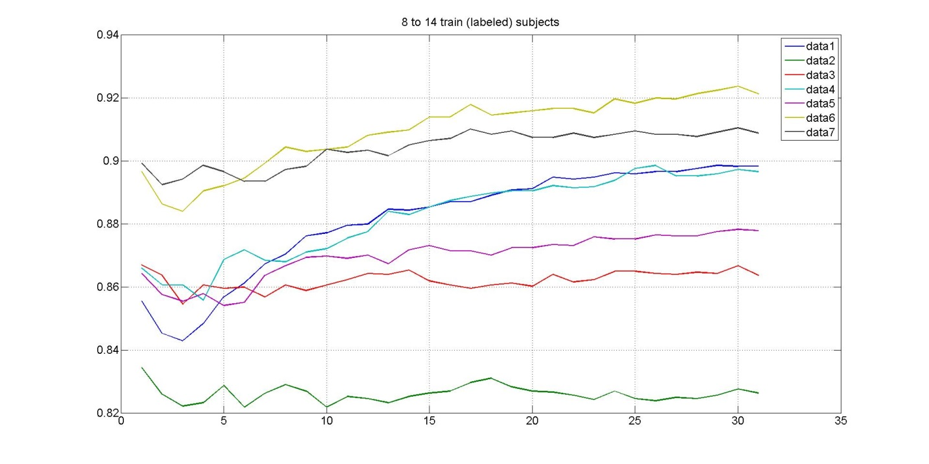**

**15-21 labeled, 9 unlabeled, T0 = 1, 10 trees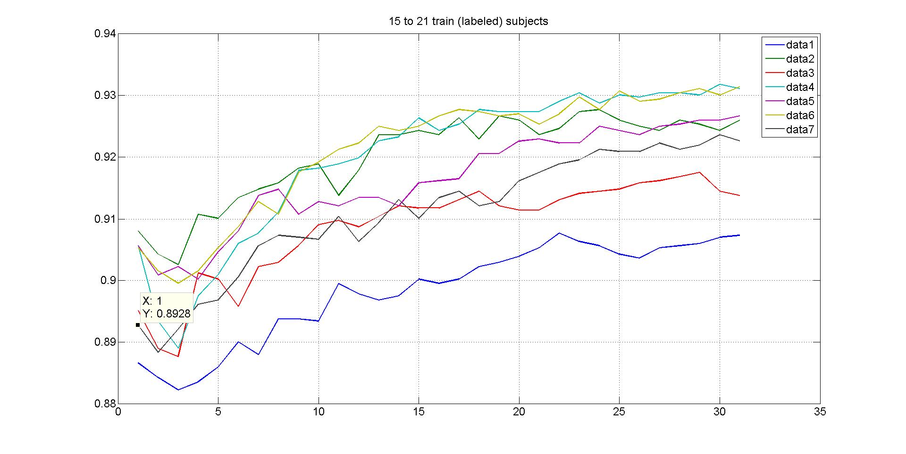**

**Initial seed and number of trees matter**

**3 labeled, 3 unlabeled, T0 = 1, 30 trees, tau = 320, 3 runs**

**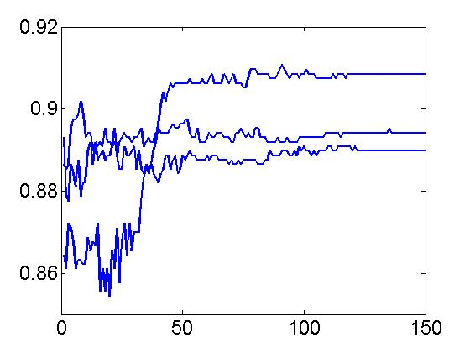**

**Effect of tau**

**3 labeled, 9 unlabeled, T0 = 1, 10 trees**

**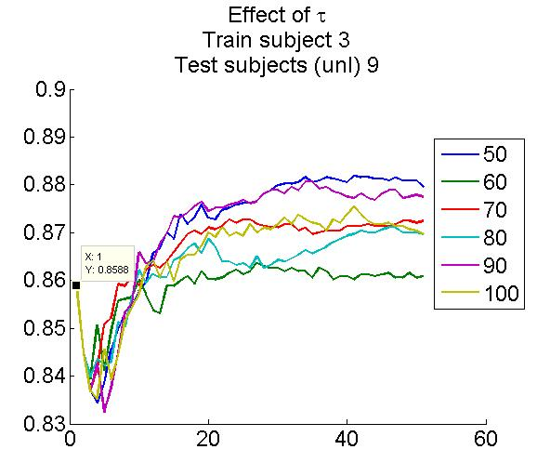**

**Labeled/unlabeled ratio**

**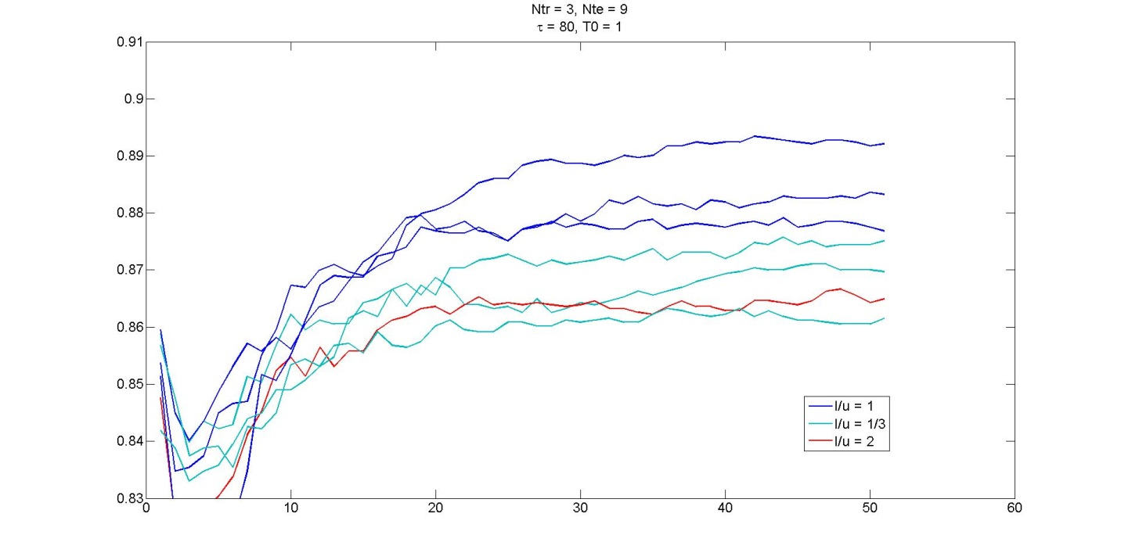**

**Single subject tests – few labeled samples**

**347 data points; 2 labeled; 10 runs (blue: init accuracy; red: final accuracy)**

**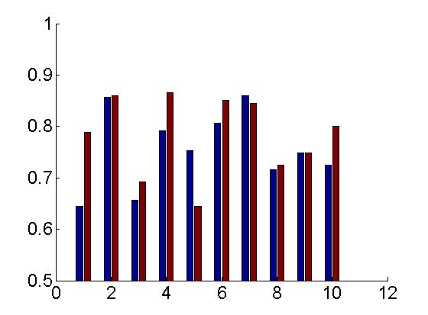**

**4 labeled**

**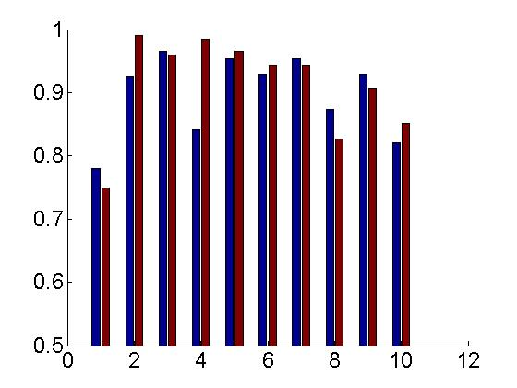**

**8 labeled**

**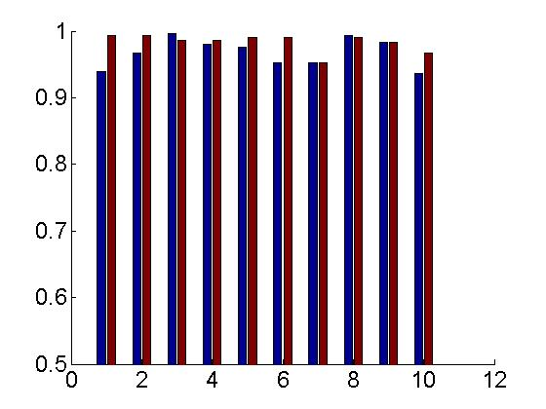**

**Improvement vs # labeled samples**

**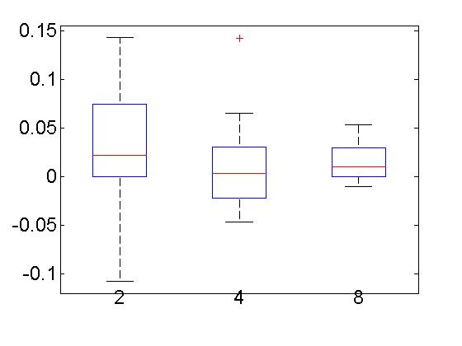**

**2 labeled, mid samples (lucky ones?)**

**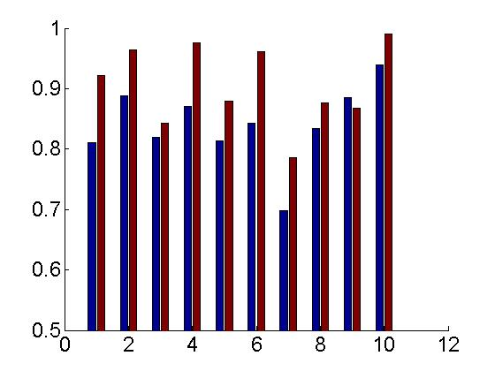**

**+/- 10% around mid sample**

**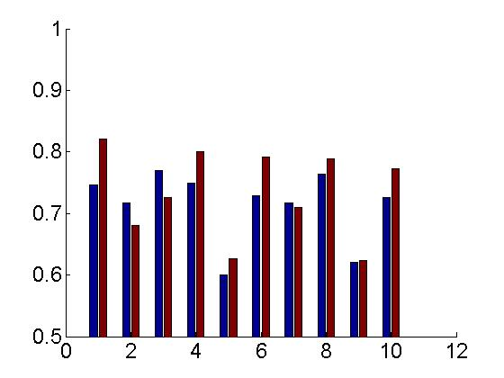**

**+/- 25% around mid sample**

**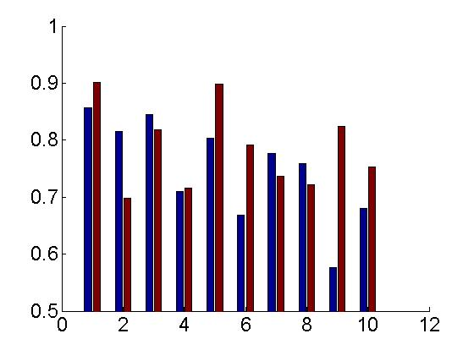**

**Self-training SSRF**

3 subjects labeled (990 datapoints)

3 subjects unlabeled (914 datapoints)

Increase # of labeled datapoints at each epoch (10 to 80)

50 trees

C:\Users\llonini\Google Drive\Activity Recognition\SSRF\Figures\UCI\iSSRF_3tr_3te.eps

3 subjects labeled (990 datapoints)

15 subjects unlabeled (5253 datapoints)

Increase # of labeled datapoints at each epoch (10 to 80)

50 trees

C:\Users\llonini\Google Drive\Activity Recognition\SSRF\Figures\UCI\iSSRF_3tr_15te.eps