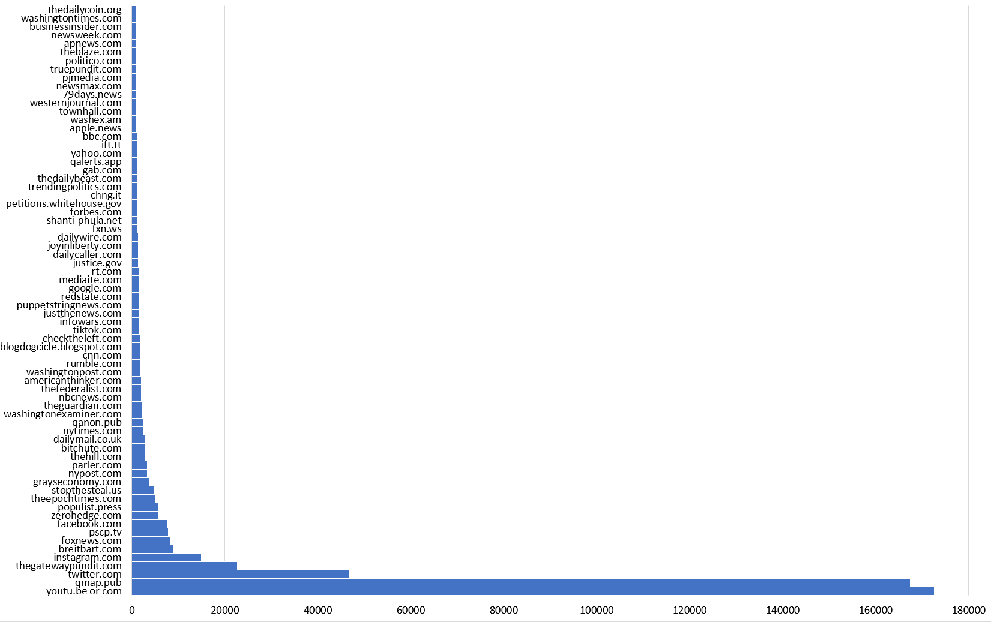
FIGURE 11.4 Sites referenced across ten right-wing Twitter datasets, top seventy shown, 2020.
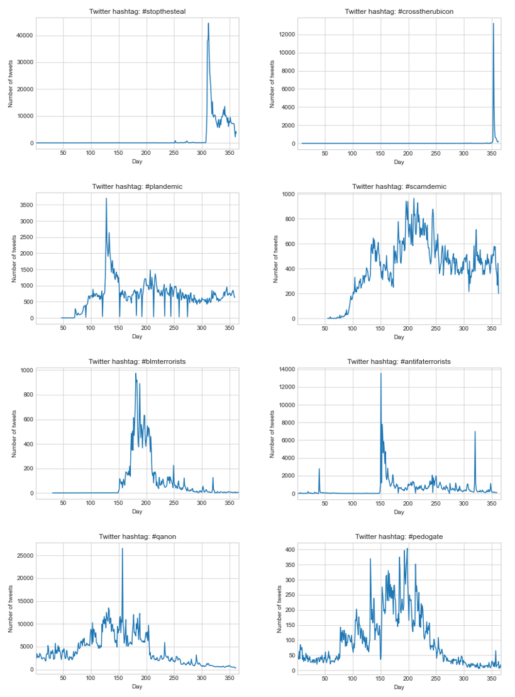
FIGURE 11.6 Twitter tweet frequencies, 2020, for #antifaterrorists and #whitegenocide (row 1), #stopthesteal and #crosstherubicon (row 2), #plandemic and #scamdemic (row 3). Frequencies related to #qanon and #pedogate are included for comparison (row 4)

