Science Fair
Project Report
Project Title
Literature-Anchored Prediction of Chronic Disease Recurrence
A Longitudinal Study Combined With 3,200 Virtual Patients
Category:
Division:
Keywords: chronic disease recurrence, longitudinal study, literature synthesis, virtual patients, prediction model
Entry number:

Abstract
People living with chronic disease often worry about one thing: getting better for a while and then relapsing. This study keeps the aim of our previous study, which asked whether long-term records can predict recurrence and roughly when it will happen. This time, no individual-level data from public databases were used for training or back-fitting. Instead, we extracted population-level numbers from 46 PubMed abstracts: one-year recurrence rates for 13 diseases, effect sizes for two groups of risk factors, and five cumulative recurrence curves. We combined these with the 3,200 virtual patients created earlier (16 chronic diseases, 200 patients each).
In the literature, past or recent disease activity was associated with later recurrence (pooled relative risk 3.27, 95% CI 2.24–4.78). Missing or stopping medication was associated with more recurrence (2.43, 1.03–5.76). In 4 of 5 curves the Weibull shape parameter was below 1, meaning risk was highest early. None of the 13 comparable diseases in the original virtual cohort had a one-year recurrence rate inside the published range. After calibrating a single threshold per disease, the year-3 rates, which were not used in calibration, differed from the literature targets by 3.0 percentage points on average, and 9 diseases fell inside the published range.
In the calibrated new data, a model using two years of records predicted recurrence within 90 days with an AUROC of 0.738 (95% CI 0.709–0.768), slightly higher than 0.726 for age, sex and disease alone. The Cox model's one-year timeline was close to what was observed. The virtual patients reproduced the direction of "more past recurrences, more later recurrences," but the effect was smaller than in the literature, and the effect of missed doses did not appear. Simulated data are useful for checking methods; real patient records are still needed before any clinical use.
Keywords: chronic disease recurrence, longitudinal study, literature synthesis, virtual patients, prediction model

Introduction

Motivation
Chronic conditions such as systemic lupus erythematosus (SLE), rheumatoid arthritis (RA), inflammatory bowel disease (IBD) and multiple sclerosis (MS) tend to go up and down. After a stable period the disease can suddenly get worse; doctors call this a flare or relapse. From an immunologist's point of view, these diseases share an immune system that stays easy to ignite: an infection, a stressful month, or cutting down on medicine can all be followed by a rise in inflammation. Flares are not only unpleasant. They are also linked to organ damage. In Behçet's syndrome, for example, people who had a relapse were more likely to accrue damage later (Floris et al., 2022).
MD. Piece is a phone app in which patients record symptoms, medicines and daily life. Our previous study used the NHANES I Epidemiologic Follow-up Study (NHEFS) and the Framingham teaching dataset. It found that adding long-term records gave an AUROC of about 0.71 for recurrence hospitalisation, and about 0.77 in a digital twin simulation (MD. Piece Research Team, 2026a). This time the rules are different: individual-level public data may not be used to train or back-fit a model. So we asked whether published numbers alone are enough to build and check a recurrence model. We also wanted to see whether the virtual patients we made earlier behave like the real patients described in the literature.

Aims
1. Summarise one-year recurrence rates for 13 chronic diseases from the literature, and check three mechanism hypotheses across longitudinal studies: H1, past or recent disease activity is associated with later recurrence; H2, missing or stopping medication is associated with later recurrence; H3, risk is highest soon after a stable period and then falls.
2. Compare the 3,200 virtual patients with the literature, and calibrate them to the published numbers to produce new data.
3. With the same aim as the previous study, train models on the new data to see whether long-term records predict recurrence within 90 days and the timing of recurrence within a year, and estimate early-warning performance.
4. Cross-compare the new data, the original virtual patients and the literature, and finally compare model performance with published models.

Literature Review
Many longitudinal studies point to past history as an important clue. The ECLIPSE study followed 2,138 people with chronic obstructive pulmonary disease (COPD) for three years. A history of exacerbations was the single best predictor of later exacerbations, and the frequent-exacerbation tendency was fairly stable over three years (Hurst et al., 2010). In severe asthma, a recent severe exacerbation was associated with future exacerbation, with an adjusted odds ratio of 3.77 (Miller et al., 2007). In placebo arms of MS trials, more relapses in the two years before a trial went with a higher relapse rate during the trial (Held et al., 2005).
Medication adherence is another clue. Patients with quiescent ulcerative colitis who refilled less than 80% of their medicine had about 5.5 times the risk of relapse (Kane et al., 2003). Stopping hydroxychloroquine in SLE was followed by more major flares, although the difference was not statistically significant (Tsakonas et al., 1998), and stopping low-dose glucocorticoids by slightly more flares (Ji et al., 2021). As for timing, after stopping biologics in RA the cumulative flare proportions were 45%, 64% and 80% at 1, 3 and 5 years (Mori et al., 2022). Newly diagnosed IBD also showed most recurrences in the first year (Vester-Andersen et al., 2014). Both curves rise quickly at first and slowly later.
For prediction models, COPD alone has more than 400 prognostic models, most with a high risk of bias (Bellou et al., 2019). AI models for COPD exacerbations have a pooled AUC of about 0.77, with large differences between studies (Niraula et al., 2025). In SLE, persistently active disease could be predicted, while models for single flares performed poorly (Nikpour et al., 2009). Recurrence prediction is hard, and results depend on what a model is compared with.

Materials
1. Hardware: a cloud Linux computer (4 CPU cores, 16 GB memory).
2. Software: Python 3.13 with NumPy, pandas, SciPy, scikit-learn (Pedregosa et al., 2011) and Matplotlib (Hunter, 2007). The Cox proportional hazards model was written with Newton–Raphson and matched statsmodels to four decimal places.
3. Literature: PubMed, searched and downloaded through NCBI E-utilities.
4. Virtual patients: the md_piece simulator and its 16 disease files from the MD. Piece project (MD. Piece Research Team, 2026b), used without changes.
5. Code: experiments/literature_recurrence_model/ in the repository. Running simulate_cohort.py, run.py, figures.py, references.py and build_report.py reproduces all numbers, figures and this report.

Method

Design and Workflow
Figure 1 shows the design and Figure 2 the workflow. There were only two data sources: population-level numbers in published abstracts, and the virtual patients created earlier. Individual-level public data (such as NHEFS or Framingham) were not used at all, neither for training nor for back-fitting. The analysis plan was written at the top of run.py before running, and thresholds and weights were not changed afterwards. Two coding problems found and fixed during the work are described at the end of this section.
Figure 1
Study Design
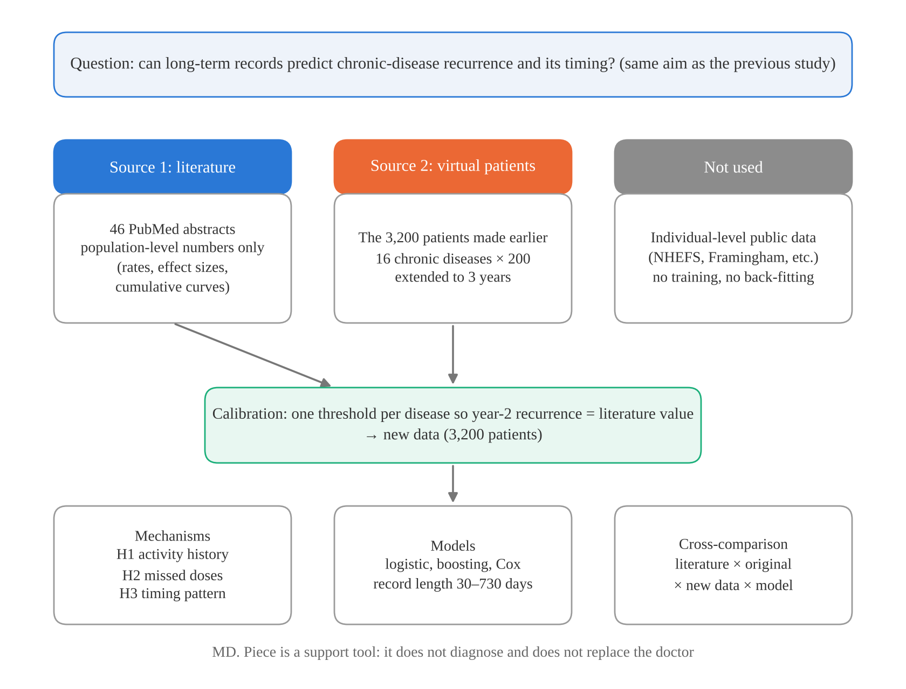
Note. MD. Piece is a support tool only. It does not diagnose and does not replace the doctor.
Figure 2
Study Workflow
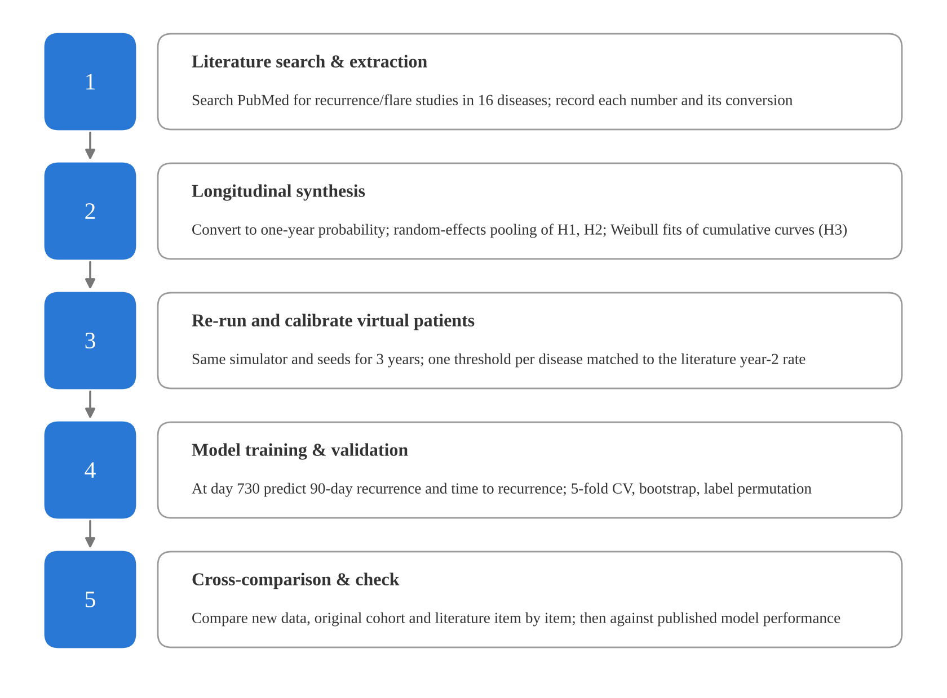

Literature Search and Extraction
We searched PubMed with disease names plus flare, relapse, exacerbation, recurrence, cohort and adherence, and read each abstract. Only longitudinal studies, trials or meta-analyses that stated numbers in the abstract were used. Numbers not stated in the abstract (for example some confidence intervals) were not filled in from elsewhere. In the end we used 46 research papers and 3 statistical methods papers. All are listed in Appendix Table A1 with the reason for use and the part used.
Studies report recurrence in different ways, so every number was converted to one scale: the proportion with at least one recurrence within a year. An event rate λ per person-year became 1 − e^(−λ); a cumulative proportion p at t years became 1 − (1 − p)^(1/t); one-year proportions were used directly. For each disease, the median of the converted values was the calibration target, and the minimum to maximum was the published range. For osteoarthritis, systemic sclerosis and Sjögren's disease we found no comparable yearly rate. The latter two are mostly described in terms of progression or fluctuating activity (Elhai et al., 2022; Fernández-Castro et al., 2025). These three were not calibrated and are marked in the results.

Pooling the Mechanism Hypotheses
For H1 and H2 we collected effect sizes with 95% confidence intervals (odds ratio, hazard ratio or relative risk). They were pooled on the log scale with a DerSimonian–Laird random-effects model (DerSimonian & Laird, 1986), and heterogeneity was summarised with I². The three measures are close when events are not common; treating them as one scale is a limitation. For H3, each cumulative curve was fitted to a Weibull distribution, log(−log S(t)) = k·log t − k·log λ. A shape k below 1 means risk is highest early; k = 1 means constant risk.

Virtual Patients
The virtual patients come from the md_piece simulator. Each patient has a daily latent disease activity that responds to treatment, missed doses, triggers such as infection or stress, life events, subtype and individual differences. When activity is above a threshold the patient is in a flare. The simulator also produces a self-reported symptom score and clinic lab values. Earlier work used the same simulator and random seeds (base_seed = 2024) to make 200 patients for each of 16 diseases, 3,200 in total, over 180 days. We kept the same seeds and extended the simulation to 1,095 days (three years) so that changes from year 1 to year 3 could be seen.
A new recurrence was defined as a change from no flare to flare, at least 7 days after the end of the previous flare (or the disease's refractory period, if longer). Shorter gaps were counted as the same flare.

Literature Calibration: Making the New Data
Only one parameter was changed per disease: a shift δ in the flare threshold. Starting at δ = 0, δ moved in steps of 0.05 in the direction that brought the year-2 one-year recurrence rate toward the literature target, followed by 12 bisection steps after the target was crossed. The reason for searching in one direction is given below. Only the year-2 rate was used. H1, H2, H3, the year-3 rate and flare length were kept out of calibration as independent checks. The calibrated 3,200 patients are the new data of this study; the original 3,200 serve as the comparison.

App Record Layer and Predictors
Real app records are never perfect, so a record layer was placed between latent activity and the model. Symptom diaries were filled on 70% of days with an error of 0.3 SD. Lab values came every 30 days. Missed doses and triggers were visible only on diary days, and flare history was fully visible. Looking back over 30, 90, 180, 365 or 730 days, we computed symptom mean, maximum, variability, the last 14-day mean and slope, the missed-dose fraction, the fraction of days with triggers, the latest and mean lab values, the number of flares in the window and days since the last flare, plus age, sex and disease.

Models and Evaluation
The prediction point was day 730, equivalent to two years of app use. Patients in a flare on that day were excluded. The main outcome was a new recurrence within 90 days; the secondary outcome was the time to the next recurrence, followed for up to 365 days. Models were: age, sex and disease only; literature only, untrained, using each disease's published yearly rate multiplied by the pooled H1 and H2 factors; literature score plus records; logistic regression with five record lengths; gradient boosting; and a Cox model for timing.
All models used stratified five-fold cross-validation and were scored only on the held-out fold. Discrimination was measured with AUROC, with 95% confidence intervals from 1,000 bootstrap samples. Calibration was measured with the calibration slope and the Brier score. For the Cox model we used the C-index (Harrell et al., 1982) and time-dependent AUCs at 90, 180 and 365 days. To check that no answer leaked into training, outcome labels were shuffled 50 times; AUROC should then stay near 0.5. For early warning, the top 20% of predicted risk was flagged, and we computed sensitivity, positive predictive value (PPV), lift (PPV divided by the mean recurrence rate) and lead time. A sensitivity analysis compared four record-quality settings: recall-style records (30% of days, 0.8 SD error), this study's setting, complete records, and an upper bound with direct access to latent activity.

Cross-Comparison
Cross-comparison had three layers: (a) one-year recurrence by disease in the literature, the original cohort, the new data (year 3) and the model; (b) the three mechanisms, comparing pooled literature values with stratified Mantel–Haenszel relative risks in the virtual cohorts (Greenland & Robins, 1985), dose–response and Weibull k; and (c) model performance in this study, the previous study and published models.

Problems Found and Fixed
First, the initial calibration searched the whole δ axis for the closest value. It pushed RA, psoriatic arthritis and IgG4-related disease to very low thresholds, where patients were in flare almost all year and "new" flares became rare. The rates matched the literature on paper but made no sense: only 17 RA patients were out of flare at the prediction point. After switching to a one-direction search, the share of days in flare was below 1.5% for every disease. Second, the first Cox model diverged on the new data, because a few diseases had very few events and their coefficients grew without limit. A small L2 penalty (λ = 0.01) fixed this; without the penalty our code matched statsmodels. Both fixes were made before model performance was examined.

Results

Literature Synthesis
We extracted 29 yearly recurrence estimates from 20 studies covering 13 diseases. Converted one-year rates ranged from 0.08 in idiopathic pulmonary fibrosis (IPF) to 0.41 in Behçet's disease. Values also differed within a disease. In chronic urticaria, for instance, they ranged from 0.06 to 0.36, largely depending on whether patients had just stopped treatment or had been stable for years (blue dots in Figure 3).
Figure 3
One-Year Recurrence by Disease: Literature, Original Virtual Cohort, New Data and Model
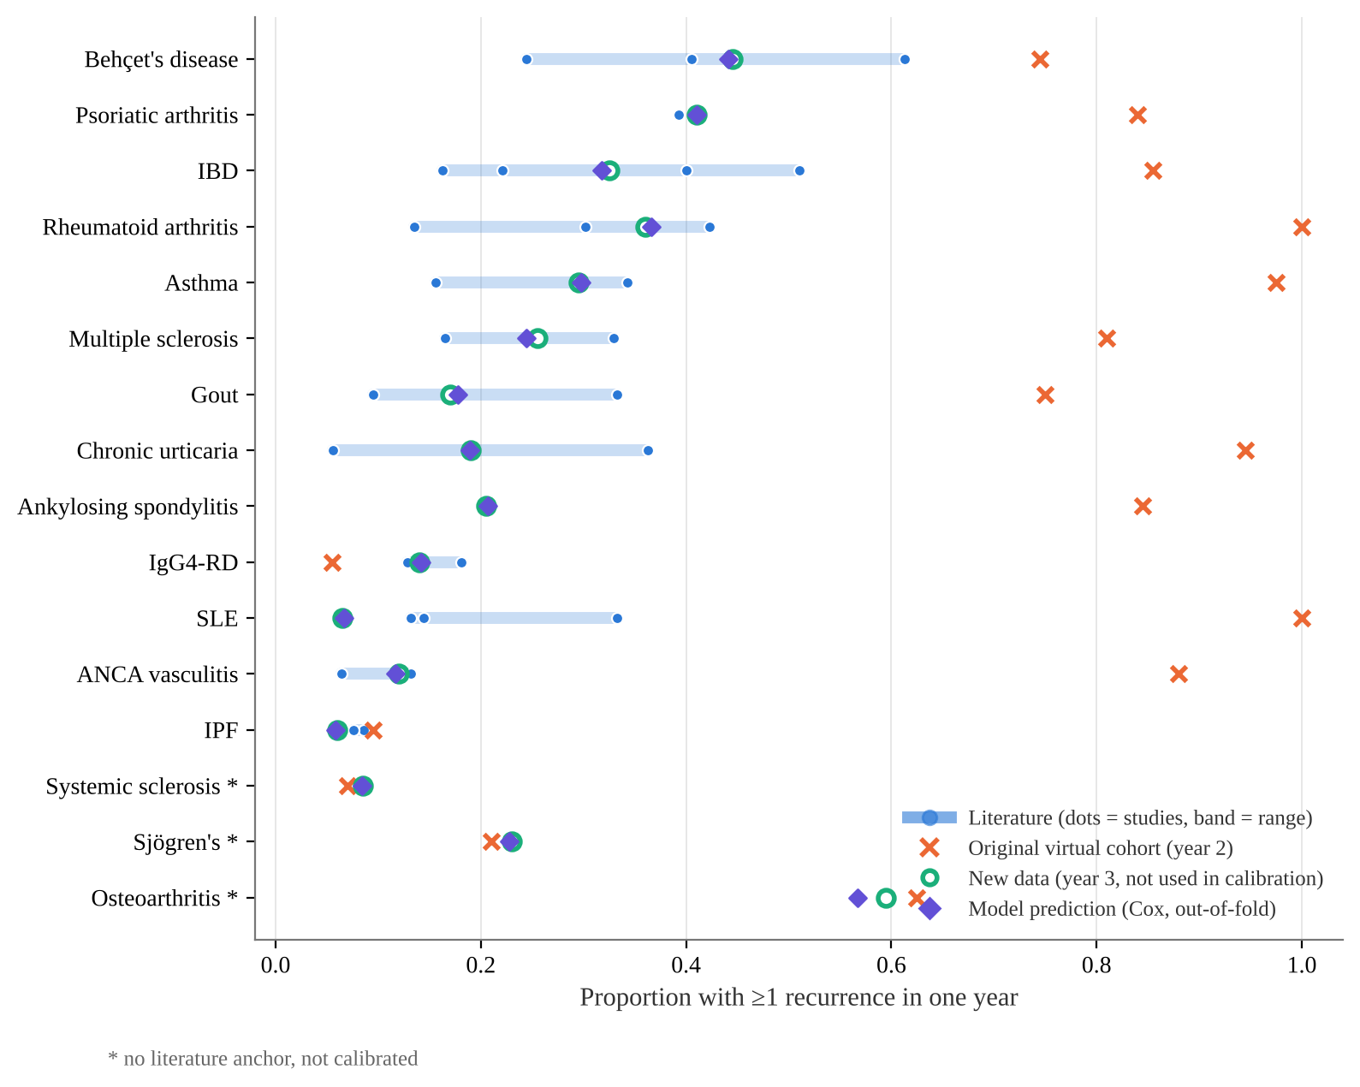
Note. Blue dots are converted one-year rates from individual studies; the light band is the published range. New data are shown for year 3, which was not used in calibration. The model value is the mean one-year risk predicted by the Cox model at day 730 (out-of-fold).
H1 had 5 studies, with a pooled relative risk of 3.27 (95% CI 2.24–4.78) and I² = 32%; all pointed the same way. H2 had 3 studies, pooled at 2.43 (1.03–5.76) with I² = 78%: the same direction, but very different sizes (Figure 4). The NOR-Gout study gave no confidence interval and was not pooled, but flares in the lowest versus highest adherence quartile were 33.3% versus 9.5% (Uhlig et al., 2025a), again in the same direction. For H3, k was below 1 for RA after stopping biologics (0.60), Crohn's disease (0.39) and ulcerative colitis (0.41), and close to 1 for IgG4-related disease (1.09) and IPF (0.97) (Figure 5a). The early-risk pattern was clearest after stopping treatment or soon after diagnosis.
Figure 4
Mechanisms H1 and H2: Individual Studies, Pooled Literature Values and the Two Virtual Cohorts
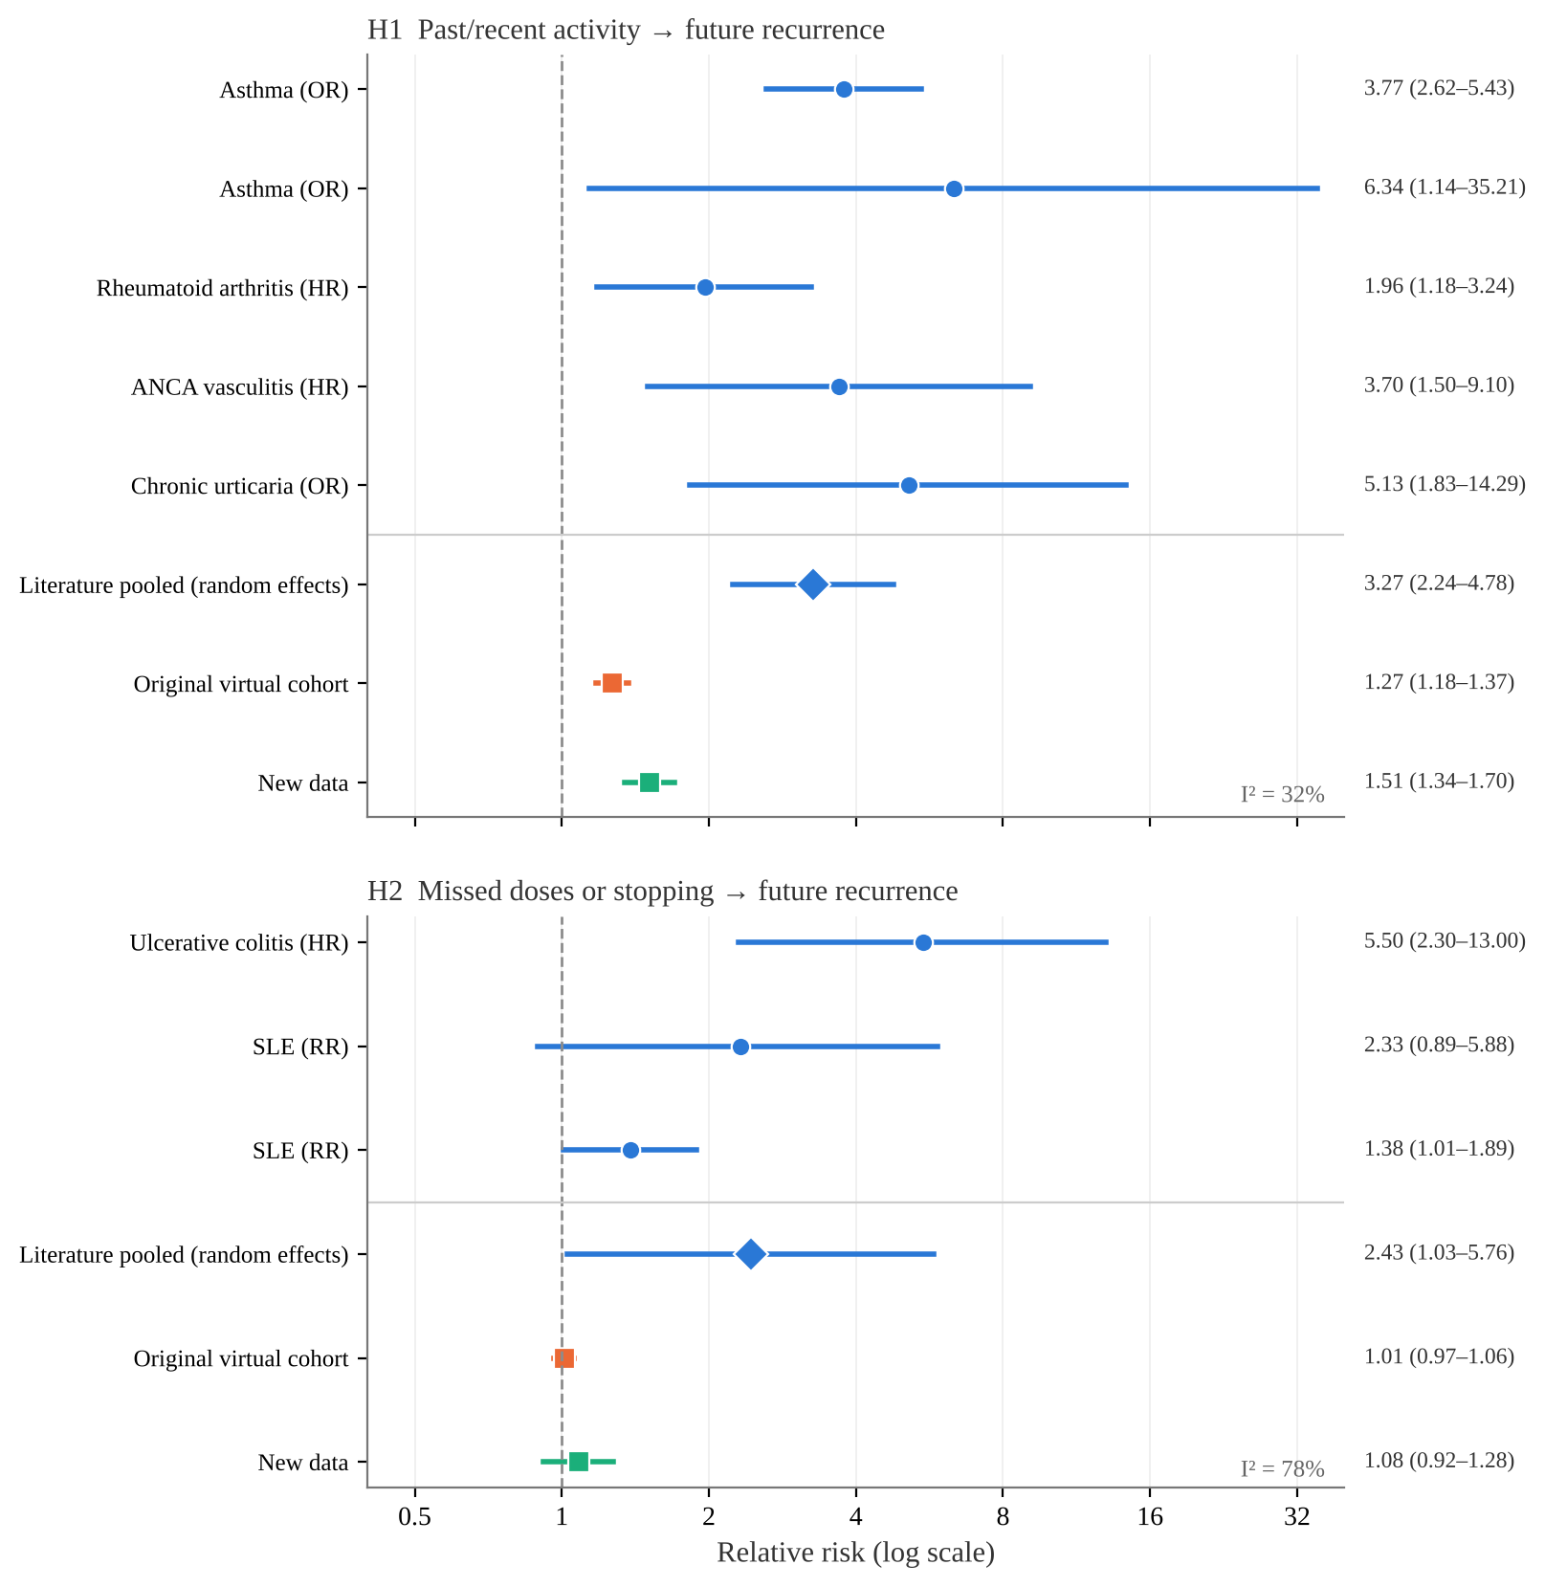
Note. H1 includes recent severe exacerbation, poor control, higher activity, recurrent ANCA and short remission. In the virtual cohorts, H1 is the relative risk of a year-2 flare for patients with versus without a year-1 flare. H2 compares the highest and lowest quartiles of the year-1 missed-dose fraction. All are stratified by disease.
Figure 5
Mechanism H3: Timing Pattern of Cumulative Recurrence
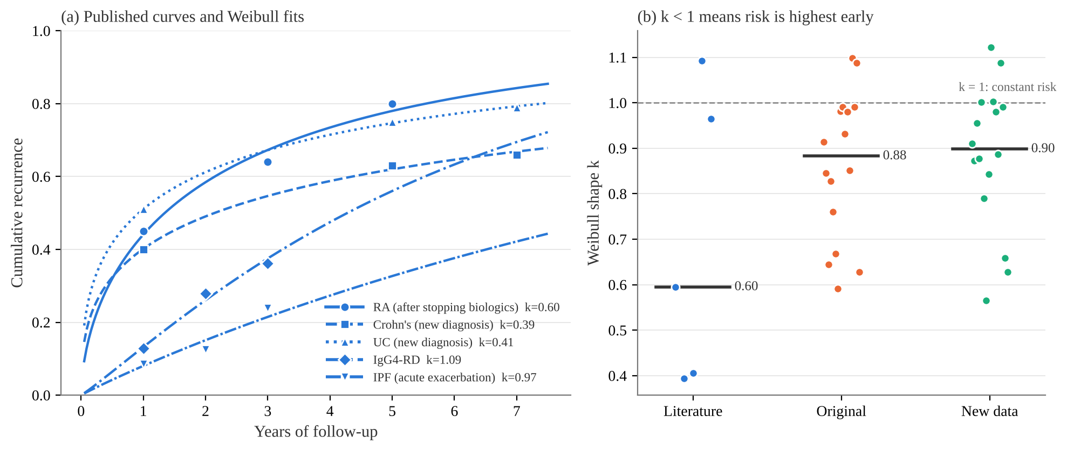
Note. (a) Dots are published values; lines are Weibull fits. (b) Each virtual dot is one disease, followed for two years from day 365; bars show medians.

Original Virtual Patients Versus the Literature
Recurrence in the original virtual cohort was far too frequent. Across the 13 comparable diseases, one-year rates ranged from 0.06 to 1.00. None fell inside the published range, the mean gap from the targets was 54 percentage points, and the ranking of diseases was almost unrelated to the literature (Spearman ρ = 0.06). Under the original settings, nearly every SLE and RA patient flared every year, while studies report about 14% to 30% per year (Nikpour et al., 2009; Peng et al., 2017; Mori et al., 2022). Only IPF (0.10 vs 0.08) and IgG4-related disease (0.06 vs 0.16) were close.
For the mechanisms, the original cohort's H1 relative risk was 1.27 (1.18–1.37): the same direction as the literature but much smaller. H2 was 1.01 (0.97–1.06), with no visible effect of missed doses. The median Weibull k was 0.88, closer to constant risk than the literature's 0.60.

The Calibrated New Data
After calibration, the year-2 rates of all 13 diseases matched their targets (RA stopped at 0.33 against a target of 0.30 because of small-sample steps). The more informative check is year 3, which was not used in calibration. There the mean gap was 3.0 percentage points, 9 of 13 diseases fell inside the published range, and the rank correlation was ρ = 0.97 (Figure 3, Table 1). The main miss was SLE: 0.14 in year 2 but 0.07 in year 3, below the published minimum of 0.13.
In the new data, the H1 relative risk rose to 1.51 (1.34–1.70). For the most versus least symptomatic third it was 1.23 (1.06–1.41). Both point the same way as the literature but stay below the pooled 3.27. H2 was 1.08 (0.92–1.28) and was still not reproduced. For dose–response, patients with 0, 1, 2 and ≥3 past flares had later flare rates of 1, 2.2, 3.7 and 4.3 times the reference. This is similar in shape to the MS values of 1, 1.8, 2.5 and 4.3 (Figure 6; Held et al., 2005). The median Weibull k was 0.90, still above the literature.
Figure 6
Dose–Response Between Past Recurrences and Later Recurrence Rate
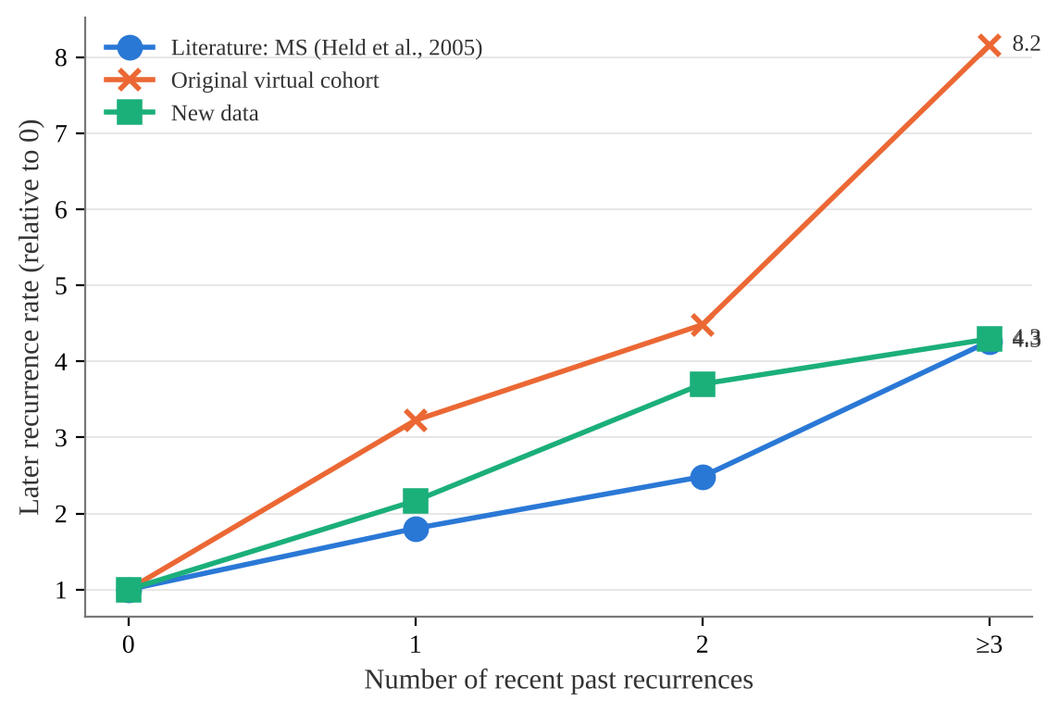
Note. Literature values are pre-trial relapses over 24 months in MS placebo arms. Virtual values are year-1 flares versus year-2 flares.
Flare length was another independent check. In the new data most diseases had flares lasting 2 to 7 days on average; for example 4.5 days in ankylosing spondylitis and 4.5 days in SLE. That is close to weekly self-reports in which most flares lasted 3 days or less (Jacquemin et al., 2017). It is shorter than the 2.4 weeks reported for major flares in ankylosing spondylitis (Cooksey et al., 2010). In other words, flares in the new data look more like short symptom worsening than like flares that lead to admission or a change in treatment.
Table 1
Cross-Comparison of One-Year Recurrence by Disease
Disease | k | Literature target (range) | Original, year 2 | New data, year 3 | Model
Behçet's disease | 3 | 0.41 (0.24–0.61) | 0.74 | 0.45 | 0.44
Psoriatic arthritis | 1 | 0.39 (0.39–0.39) | 0.84 | 0.41 | 0.41
IBD | 4 | 0.31 (0.16–0.51) | 0.85 | 0.33 | 0.32
Rheumatoid arthritis | 3 | 0.30 (0.14–0.42) | 1.00 | 0.36 | 0.37
Asthma | 2 | 0.25 (0.16–0.34) | 0.97 | 0.29 | 0.30
Multiple sclerosis | 2 | 0.25 (0.16–0.33) | 0.81 | 0.26 | 0.24
Gout | 2 | 0.21 (0.10–0.33) | 0.75 | 0.17 | 0.18
Chronic urticaria | 2 | 0.21 (0.06–0.36) | 0.94 | 0.19 | 0.19
Ankylosing spondylitis | 1 | 0.20 (0.20–0.20) | 0.84 | 0.20 | 0.21
IgG4-RD | 2 | 0.15 (0.13–0.18) | 0.06 | 0.14 | 0.14
SLE | 3 | 0.14 (0.13–0.33) | 1.00 | 0.07 | 0.07
ANCA vasculitis | 2 | 0.10 (0.06–0.13) | 0.88 | 0.12 | 0.12
IPF | 2 | 0.08 (0.08–0.09) | 0.10 | 0.06 | 0.06
Osteoarthritis | None | — | 0.62 | 0.59 | 0.57
Sjögren's | None | — | 0.21 | 0.23 | 0.23
Systemic sclerosis | None | — | 0.07 | 0.09 | 0.08
Note. Values are the proportion with at least one recurrence in a year. k is the number of convertible published values. None means no comparable published rate, so the disease was not calibrated. New data are year 3; the model value is the mean out-of-fold one-year Cox prediction.

Predicting Recurrence Within 90 Days
In the new data, 3177 patients could be scored at day 730 (23 were in a flare and excluded). Of these, 8.0% had a recurrence within 90 days and 24.4% within a year. Age, sex and disease alone gave an AUROC of 0.726 (95% CI 0.697–0.757). Adding 730 days of records gave 0.738 (95% CI 0.709–0.768), an increase of 0.012. Lengthening the record window from 30 to 365 days raised AUROC from 0.723 to 0.738, with no further gain at 730 days (Figure 7). The untrained literature-only model reached 0.656 (95% CI 0.623–0.691). Adding the literature score to the record model (0.736) did not help. Gradient boosting reached 0.706, but its calibration slope of 0.52 suggests overfitting. With shuffled labels, the mean AUROC over 50 runs was 0.497 (0.439–0.545), so no answer leaked into training.
Because diseases differ a lot in their rates, disease type alone separates risk well. Within a disease, using an event-weighted average, AUROC was 0.648 for the record model, 0.609 for age and sex, and 0.597 for literature only. Records helped within diseases, but only modestly.
Figure 7
Length of Records Used and AUROC
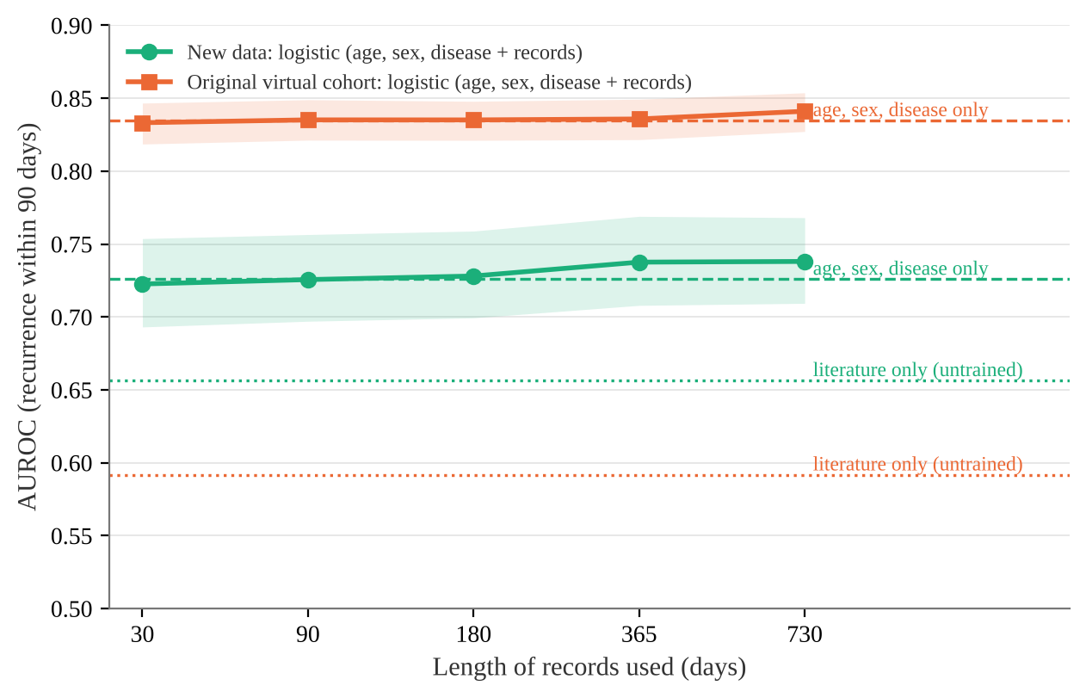
Note. Bands are bootstrap 95% confidence intervals. Dashed lines show age, sex and disease only; dotted lines show literature only (untrained).
Table 2
Performance of Each Model for Recurrence Within 90 Days
Model | New data AUROC (95% CI) | Calibration slope | Brier | Original cohort AUROC
Age, sex and disease only | 0.726 (0.697–0.757) | 0.89 | 0.069 | 0.835 (0.821–0.848)
Literature only (untrained) | 0.656 (0.623–0.691) | 0.63 | 0.073 | 0.592 (0.570–0.613)
Records, 30 days | 0.723 (0.693–0.754) | 0.82 | 0.070 | 0.833 (0.819–0.847)
Records, 365 days | 0.738 (0.708–0.769) | 0.85 | 0.069 | 0.836 (0.822–0.849)
Records, 730 days | 0.738 (0.709–0.768) | 0.86 | 0.069 | 0.841 (0.827–0.854)
Literature score + records, 730 days | 0.736 (0.706–0.766) | 0.85 | 0.069 | 0.841 (0.827–0.854)
Gradient boosting, 730 days | 0.706 (0.676–0.737) | 0.52 | 0.073 | 0.824 (0.809–0.838)
Note. A calibration slope near 1 is best; below 1 means predictions are too spread out. Lower Brier scores are better.
Figure 8
ROC Curves
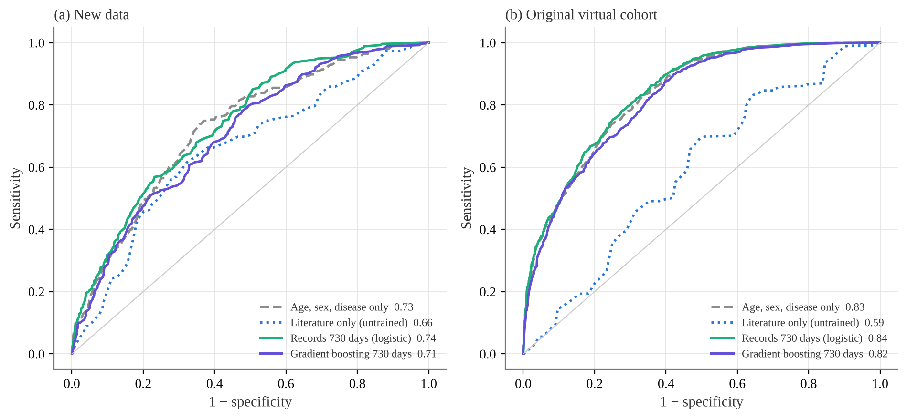
Note. Numbers in the legend are AUROCs.
Figure 9
Calibration of the 730-Day Record Model
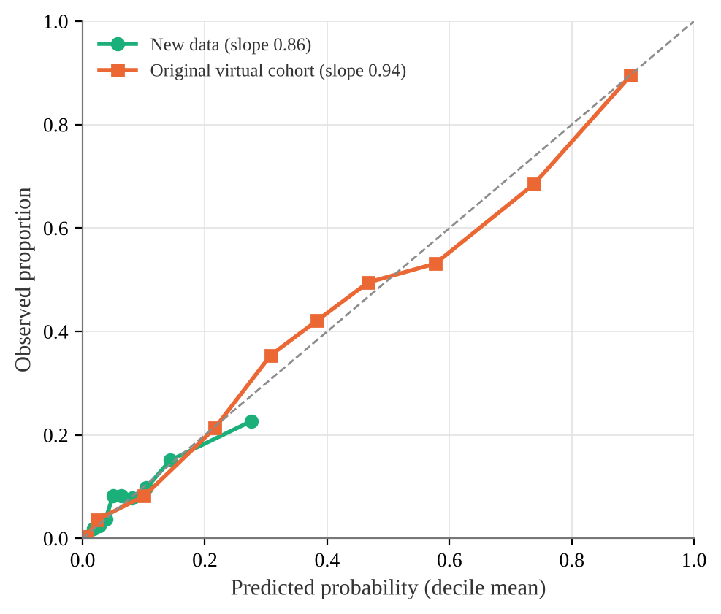
Note. Predictions were split into tenths; each point compares the mean prediction with the observed proportion. The dashed line is perfect agreement.

Recurrence Timeline
The Cox model had a C-index of 0.731 (0.728 with age, sex and disease only). Time-dependent AUCs at 90, 180 and 365 days were 0.737, 0.762 and 0.761. When patients were split into three risk groups, the observed one-year proportions were 7.4%, 20.6% and 44.7%, against predictions of 7.0%, 19.3% and 45.8%; the two lines stayed close throughout the year (Figure 10). Predicted one-year rates by disease differed from the literature targets by 2.9 percentage points on average, and 9 diseases fell inside the published range (Table 1).
Figure 10
Recurrence Timeline by Predicted Risk Group: Observed and Predicted
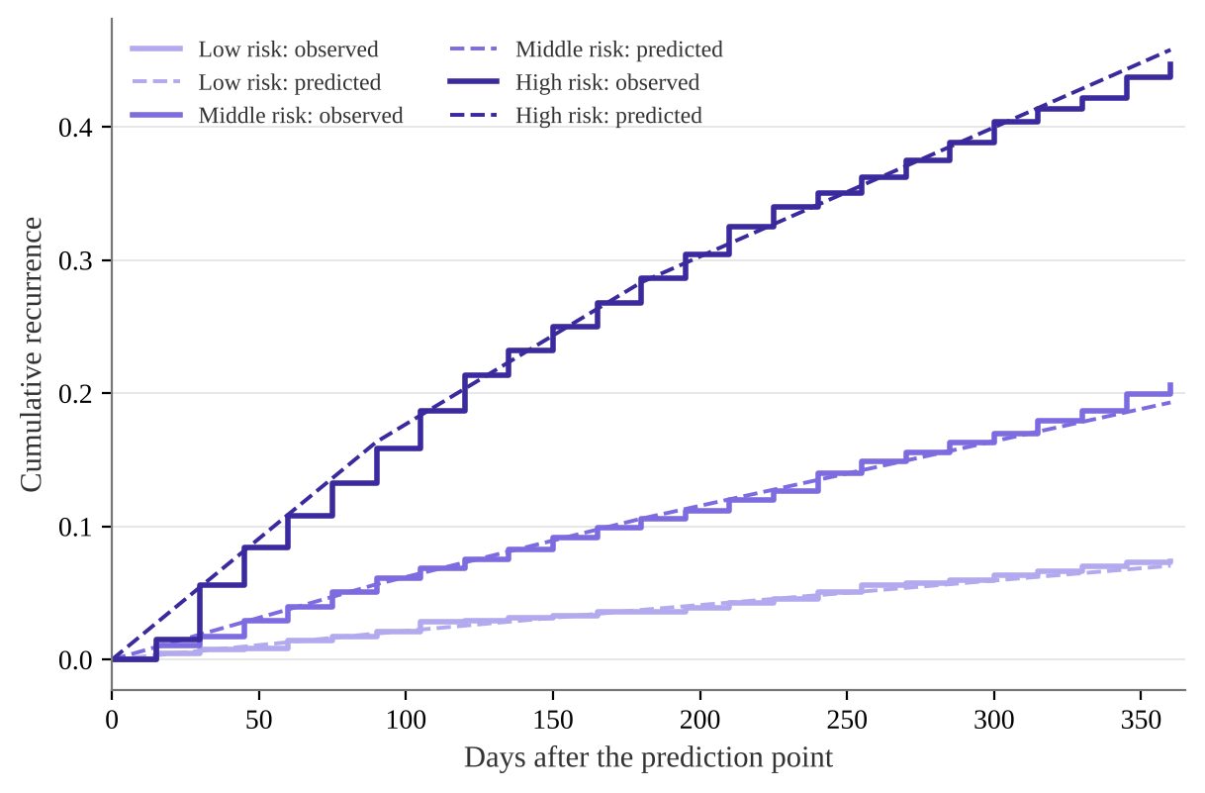
Note. Solid lines are observed cumulative recurrence; dashed lines are out-of-fold Cox predictions.

Record Quality, Early Warning and Predictors
Record quality made almost no difference. Recall-style, standard and complete records gave AUROCs of 0.740, 0.738 and 0.738. Even with direct access to latent activity, the ceiling was only 0.767, or 0.706 within diseases (Figure 11). In this simulator, much of the 90-day recurrence comes from triggers that appear at random and are hard to see in advance.
Figure 11
Record Quality and the Theoretical Ceiling
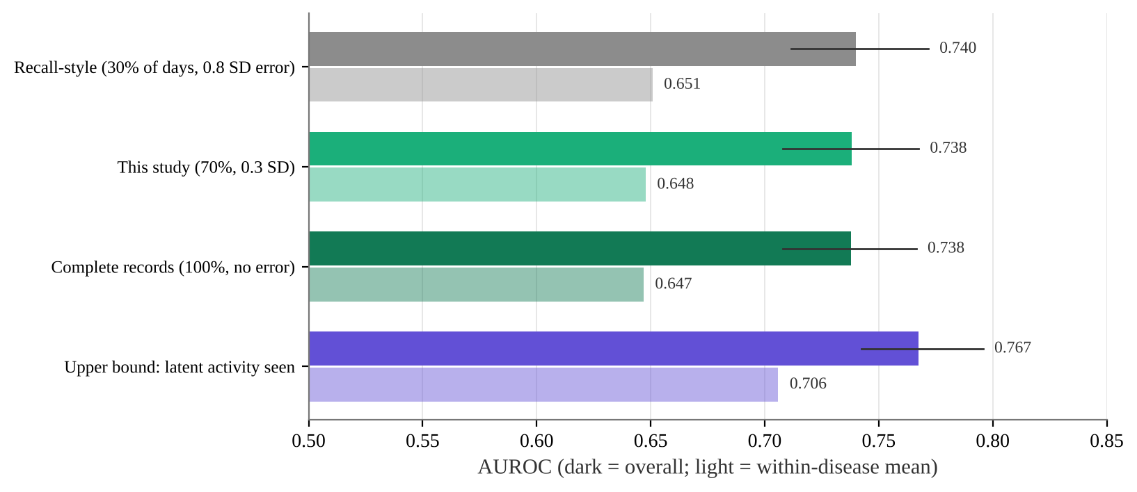
Note. Dark bars are overall AUROC (lines are 95% CIs); light bars are event-weighted within-disease AUROC.
For early warning, flagging the top 20% of risk caught 47% of recurrences with the record model. Among flagged patients, 19% did recur, 2.35 times the average rate. The median time from prediction to recurrence was 44 days (IQR 25–70). The literature-only model caught 43%, and age, sex and disease 44% (Figure 12). The largest weight in the model was the number of flares in the past two years, followed by days with triggers, the missed-dose fraction and symptoms in the last 14 days (Figure 13). This matches the published finding that history is the best predictor (Hurst et al., 2010). The negative weight on mean symptoms reflects its strong correlation with maximum and recent symptoms; its sign means little on its own.
Figure 12
Early-Warning Performance When the Top 20% of Risk Is Flagged
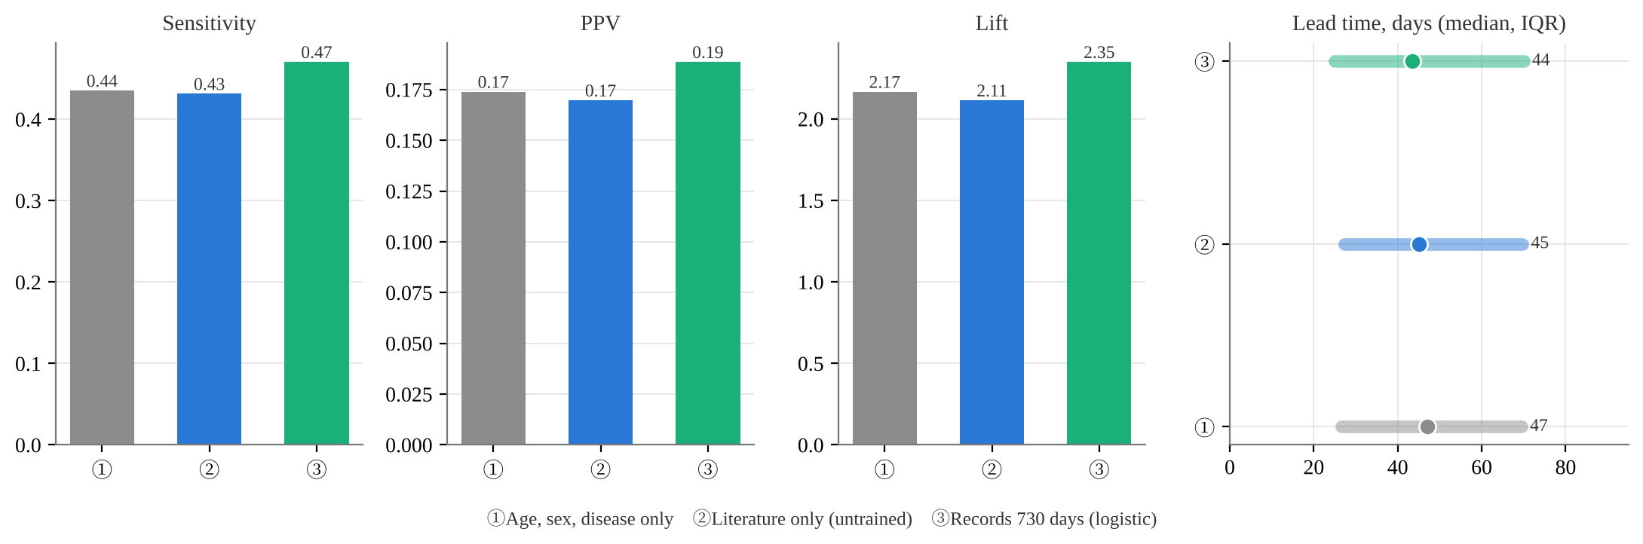
Note. Lift = PPV ÷ mean recurrence rate. Lead time is counted only for flagged patients who did recur.
Figure 13
Standardised Coefficients of the 730-Day Record Model
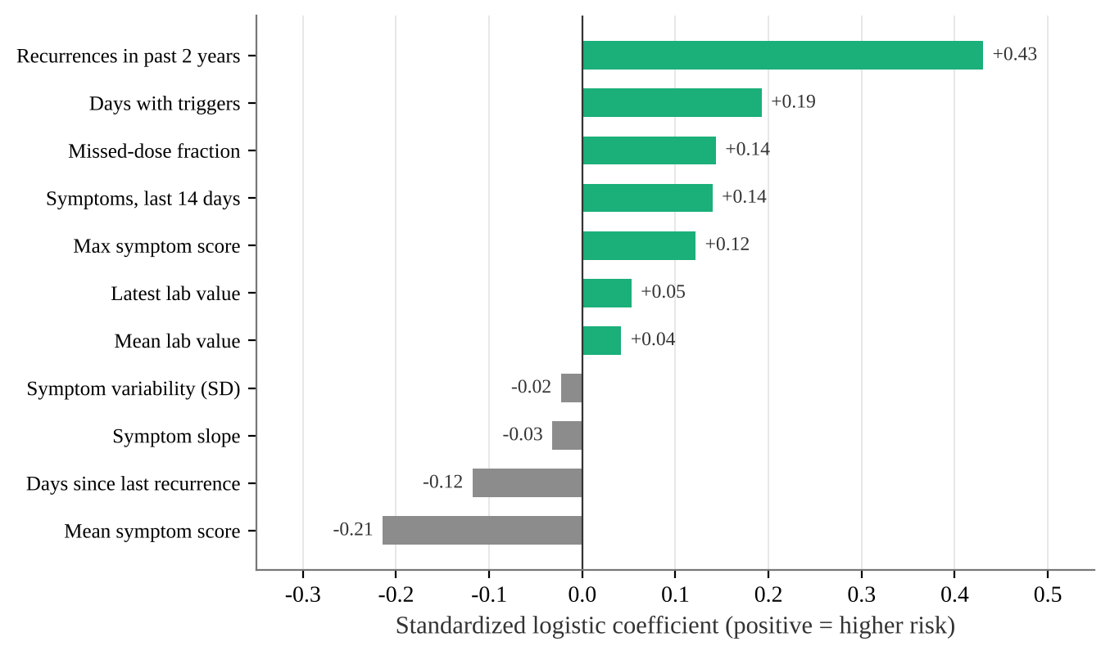
Note. Coefficients come from a fit on all data and are for explanation only, not evaluation.

Comparison With the Previous Study and Published Models
Table 3 places this study next to the previous study and published models. Populations, outcomes and time spans differ, so the table shows rough ranges rather than a ranking.
Table 3
Model Performance in Context
Source and model | AUROC / C | Notes
This study: new data, records 730 days (logistic) | 0.738 | 3,177 virtual patients, 90 days
This study: new data, Cox timeline | C = 0.731 | Time to recurrence within a year
This study: literature only (untrained) | 0.656 | Same
Previous study: NHEFS long-term records | 0.71 | Real public data, readmission in 12 months
Previous study: digital twin | 0.77 | 3,200 virtual patients
Literature: pooled AI models for COPD exacerbation | 0.77 | 13 studies, I² = 99.5% (Niraula et al., 2025)
Literature: Asthma Control Questionnaire | 0.68 | Exacerbation within 3 years (He et al., 2022)
Literature: progression-free survival in SSc | 0.70–0.71 | EUSTAR (Elhai et al., 2022)

Discussion

Do the Three Mechanisms Hold in the Literature?
H1 pointed the same way in 5 studies across 4 diseases with moderate heterogeneity. Together with long-term follow-up in COPD and MS (Hurst et al., 2010; Held et al., 2005), the link between past or recent activity and later recurrence looks consistent. Immunology offers more than one explanation. Some people's immune systems may simply be easier to ignite, and the tissue damage left by each episode may make the next one more likely. Observational studies show association only and cannot tell these apart. H2 also pointed one way, but rests on 3 studies of very different size, with a lower confidence limit close to 1, so the evidence is weaker than for H1. People who miss doses may also be sicker or living more disrupted lives, so the whole gap cannot be credited to the medicine itself. H3 was clear only after stopping treatment or soon after diagnosis. Long-stable groups such as IgG4-related disease and IPF were closer to constant risk.

Where the Virtual Patients Fit and Where They Do Not
The original virtual patients flared far too often. This is one of the most direct findings of the study. One reason is that the simulator counts every brief crossing of the threshold as a flare, whereas most studies require a doctor's judgement or a change in treatment. With one threshold adjusted per disease, the year-3 rates matched the literature. This suggests that the shape of the ups and downs in the simulator is broadly reasonable, and that the main problem was the scale used to call a flare.
Three things did not fit: H1 was weaker than in the literature, H2 barely appeared, and Weibull k was higher. In the simulator a missed dose only lowers the drug effect slightly for a short time, while real non-adherence can mean weeks off treatment, often with other life changes. Flares in the simulator are mostly set off by random triggers and are fairly independent of each other, which may be why both the early-risk pattern and the frequent-flarer tendency are weak. These gaps should be handled in the simulator design, not forced into line by tuning parameters.

Why Long-Term Records Helped Less This Time
In the previous study's NHEFS data, adding long-term records raised AUROC from 0.53 to 0.71. Here they added about 0.01 overall, and 0.61 to 0.65 within diseases. The record-quality analysis gives a clue: even complete records, or direct access to latent activity, reached only 0.77. The predictable part of this simulated data is small to begin with, so better data cannot add much. This fits the SLE finding that single flares are hard to predict (Nikpour et al., 2009), and the observation in spondyloarthritis that disease activity rises after sudden stressful events (Luo et al., 2019), which are hard to foresee. On the other hand, the model leaned most on flare history, which a real app can record fairly completely. That is useful for designing reminders.

A Clinical Reading
Flagging 20% of patients caught about half of recurrences, about 44 days ahead, but only about one in five flagged patients actually flared. In practice this suits an earlier check-in or a few extra questions, not a decision to add or change medicine. That is the intended role of MD. Piece: organise records and prompt patients and doctors to pay attention, with the doctor making the final call.

Limitations
1. Only numbers in abstracts were used. Some populations were special (just stopped treatment, newly diagnosed or severe), and the conversion to yearly rates assumed equal risk each year.
2. OR, HR and RR were treated as roughly one scale, and H2 rests on three studies.
3. Three diseases had no literature anchor; their results reflect the simulator's original settings only.
4. The new data are still simulated, and their flares are mostly short symptom worsening rather than clinically defined flares. Performance cannot be carried over to real patients.
5. Each disease had only 200 patients, and some had single-digit numbers of events within 90 days, so within-disease results are unstable.

Future Work
Next, the published H1, H2 and timing patterns could be built into the simulator itself, for example by letting non-adherence last for a period and adding a personal tendency to flare, and then checked the same way. After ethics approval, a prospective check with records from real app users is needed.

Conclusions
1. The literature supports a link between past or recent disease activity and later recurrence (pooled 3.27). Missed or stopped medication points the same way with weaker evidence (2.43). Early-high risk appears mainly after stopping treatment or soon after diagnosis.
2. The original virtual cohort was far from the literature. After adjusting one threshold per disease, year-3 rates, not used in calibration, differed from the literature by 3.0 percentage points on average.
3. The new data reproduced the direction and dose–response of "more past recurrences, more later recurrences," but the effect was smaller than published, and the effect of missed doses did not appear.
4. In the new data, two years of records predicted recurrence within 90 days with an AUROC of 0.738, slightly above age, sex and disease alone. The Cox timeline was close to what was observed. Record quality mattered little, and the ceiling was 0.767.
5. Published numbers alone can support a recurrence model that points the right way with moderate performance, and they show where the simulator needs work. Real records are still needed before use with real patients.

References
Alvarado-de la Barrera, C., López-López, C. O., Álvarez-Hernández, E., Peláez-Ballestas, I., Gómez-Ruiz, C., Burgos-Vargas, R., & Vázquez-Mellado, J. (2020). Are Target Urate and Remission Possible in Severe Gout? A Five-year Cohort Study. The Journal of Rheumatology, 47(1), 132–139. https://doi.org/10.3899/jrheum.181214
Bechman, K., Sin, F. E., Ibrahim, F., Norton, S., Matcham, F., Scott, D. L., Cope, A., & Galloway, J. (2018). Mental health, fatigue and function are associated with increased risk of disease flare following TNF inhibitor tapering in patients with rheumatoid arthritis: an exploratory analysis of data from the Optimizing TNF Tapering in RA (OPTTIRA) trial. RMD Open, 4(1), e000676. https://doi.org/10.1136/rmdopen-2018-000676
Bellou, V., Belbasis, L., Konstantinidis, A. K., Tzoulaki, I., & Evangelou, E. (2019). Prognostic models for outcome prediction in patients with chronic obstructive pulmonary disease: systematic review and critical appraisal. BMJ, 367, l5358. https://doi.org/10.1136/bmj.l5358
Chen, R., Wei, L., Dai, Y., Wang, Z., Yang, D., Jin, M., Xiong, C., Li, T., Hu, S., Song, J., Chan, R., Kumar, S., Abdelkarim, A., & Zhong, N. (2024). Efficacy and safety of mepolizumab in a Chinese population with severe asthma: a phase III, randomised, double-blind, placebo-controlled trial. ERJ Open Research, 10(3). https://doi.org/10.1183/23120541.00750-2023
Cooksey, R., Brophy, S., Gravenor, M. B., Brooks, C. J., Burrows, C. L., & Siebert, S. (2010). Frequency and characteristics of disease flares in ankylosing spondylitis. Rheumatology, 49(5), 929–932. https://doi.org/10.1093/rheumatology/kep435
DerSimonian, R., & Laird, N. (1986). Meta-analysis in clinical trials. Controlled Clinical Trials, 7(3), 177–188. https://doi.org/10.1016/0197-2456(86)90046-2
Edwards, N. L., Sundy, J. S., Forsythe, A., Blume, S., Pan, F., & Becker, M. A. (2011). Work productivity loss due to flares in patients with chronic gout refractory to conventional therapy. Journal of Medical Economics, 14(1), 10–15. https://doi.org/10.3111/13696998.2010.540874
Elhai, M., Sritharan, N., Boubaya, M., Balbir-Gurman, A., Siegert, E., Hachulla, E., de Vries-Bouwstra, J., Riemekasten, G., Distler, J. H. W., Rosato, E., Del Galdo, F., Mendoza, F. A., Furst, D. E., de la Puente, C., Hoffmann-Vold, A. M., Gabrielli, A., Distler, O., Bloch-Queyrat, C., Allanore, Y., & EUSTAR collaborators. (2022). Stratification in systemic sclerosis according to autoantibody status versus skin involvement: a study of the prospective EUSTAR cohort. The Lancet Rheumatology, 4(11), e785–e794. https://doi.org/10.1016/S2665-9913(22)00217-X
Eudy, A. M., Siega-Riz, A. M., Engel, S. M., Franceschini, N., Howard, A. G., Clowse, M. E. B., & Petri, M. (2018). Effect of pregnancy on disease flares in patients with systemic lupus erythematosus. Annals of the Rheumatic Diseases, 77(6), 855–860. https://doi.org/10.1136/annrheumdis-2017-212535
Fasano, S., Messiniti, V., Iudici, M., Coscia, M. A., & Ciccia, F. (2023). Hydroxychloroquine daily dose, hydroxychloroquine blood levels and the risk of flares in patients with systemic lupus erythematosus. Lupus Science & Medicine, 10(1). https://doi.org/10.1136/lupus-2022-000841
Fernández-Castro, M., Plaza-Almuedo, Z., Rosas, J., Martínez-Taboada, V., Olivé, A., Menor-Almagro, R., Serrano-Benavente, B., Font-Urgelles, J., García-Aparicio, A., Manrique-Arija, S., García-Vadillo, J. A., López-González, R., Narváez, J., Rodriguez-Lozano, B., Galisteo, C., González-Martín, J., Vela-Casasempere, P., Bohórquez, C., Erausquin, C., ... Systemic Autoimmune Diseases Group of the Spanish Society of Rheumatology (EAS-SER). (2025). Long-term changes in Sjögren's disease: a 9-year prospective follow-up study from the SJOGRENSER Registry. Rheumatology International, 45(7), 156. https://doi.org/10.1007/s00296-025-05909-0
Floris, A., Piga, M., Laconi, R., Espinosa, G., Lopalco, G., Serpa Pinto, L., Kougkas, N., Sota, J., Lo Monaco, A., Govoni, M., Cantarini, L., Bertsias, G., Correia, J., Iannone, F., Cervera, R., Vasconcelos, C., Mathieu, A., & Cauli, A. (2022). Accrual of organ damage in Behçet's syndrome: trajectory, associated factors, and impact on patients' quality of life over a 2-year prospective follow-up study. Arthritis Research & Therapy, 24(1), 253. https://doi.org/10.1186/s13075-022-02947-y
Fornaro, M., Righetti, G., Abbruzzese, A., Lopalco, G., Cacciapaglia, F., Anelli, M. G., Venerito, V., & Iannone, F. (2021). High disease relapse after bDMARD spacing in psoriatic arthritis compared to rheumatoid arthritis and axial spondyloarthritis patients: real-life data from BIOPURE registry. Clinical Rheumatology, 40(9), 3659–3665. https://doi.org/10.1007/s10067-021-05728-1
Foti, C., Romita, P., Ambrogio, F., Fanelli, M., Panebianco, R., Vena, G. A., Cassano, N., Ragusa, M., Giuffrida, R., Papaianni, V., Borgia, F., Cannavò, S. P., & Guarneri, F. (2022). Analysis of clinical factors as possible predictors of response to omalizumab and relapse after treatment discontinuation in chronic spontaneous urticaria. Dermatologic Therapy, 35(2), e15248. https://doi.org/10.1111/dth.15248
Greenland, S., & Robins, J. M. (1985). Estimation of a common effect parameter from sparse follow-up data. Biometrics, 41(1), 55–68.
Harrell, F. E., Califf, R. M., Pryor, D. B., Lee, K. L., & Rosati, R. A. (1982). Evaluating the yield of medical tests. JAMA, 247(18), 2543–2546.
He, S., Lin, W., Zhong, J., Zheng, X., Jin, Y., & Cao, C. (2022). Independent risk factors of asthma exacerbations: 3-year follow-up in a single-center prospective cohort study. Annals of Translational Medicine, 10(24), 1353. https://doi.org/10.21037/atm-22-5918
Held, U., Heigenhauser, L., Shang, C., Kappos, L., Polman, C., & Sylvia Lawry Centre for MS Research. (2005). Predictors of relapse rate in MS clinical trials. Neurology, 65(11), 1769–1773. https://doi.org/10.1212/01.wnl.0000187122.71735.1f
Hunter, J. D. (2007). Matplotlib: A 2D graphics environment. Computing in Science & Engineering, 9(3), 90–95. https://doi.org/10.1109/MCSE.2007.55
Hurst, J. R., Vestbo, J., Anzueto, A., Locantore, N., Müllerova, H., Tal-Singer, R., Miller, B., Lomas, D. A., Agusti, A., Macnee, W., Calverley, P., Rennard, S., Wouters, E. F., Wedzicha, J. A., & Evaluation of COPD Longitudinally to Identify Predictive Surrogate Endpoints (ECLIPSE) Investigators. (2010). Susceptibility to exacerbation in chronic obstructive pulmonary disease. The New England Journal of Medicine, 363(12), 1128–1138. https://doi.org/10.1056/NEJMoa0909883
Jacquemin, C., Molto, A., Servy, H., Sellam, J., Foltz, V., Gandjbakhch, F., Hudry, C., Mitrovic, S., Granger, B., Fautrel, B., & Gossec, L. (2017). Flares assessed weekly in patients with rheumatoid arthritis or axial spondyloarthritis and relationship with physical activity measured using a connected activity tracker: a 3-month study. RMD Open, 3(1), e000434. https://doi.org/10.1136/rmdopen-2017-000434
Ji, L., Xie, W., & Zhang, Z. (2021). Low-dose glucocorticoids should be withdrawn or continued in systemic lupus erythematosus? A systematic review and meta-analysis on risk of flare and damage accrual. Rheumatology, 60(12), 5517–5526. https://doi.org/10.1093/rheumatology/keab149
Kane, S., Huo, D., Aikens, J., & Hanauer, S. (2003). Medication nonadherence and the outcomes of patients with quiescent ulcerative colitis. The American Journal of Medicine, 114(1), 39–43. https://doi.org/10.1016/s0002-9343(02)01383-9
Kappos, L., Radue, E. W., O'Connor, P., Polman, C., Hohlfeld, R., Calabresi, P., Selmaj, K., Agoropoulou, C., Leyk, M., Zhang-Auberson, L., Burtin, P., & FREEDOMS Study Group. (2010). A placebo-controlled trial of oral fingolimod in relapsing multiple sclerosis. The New England Journal of Medicine, 362(5), 387–401. https://doi.org/10.1056/NEJMoa0909494
Kishaba, T., Hozumi, H., Fujisawa, T., Nei, Y., Enomoto, N., Sugiura, H., Kitani, M., & Suda, T. (2020). Predictors of acute exacerbation in biopsy-proven idiopathic pulmonary fibrosis. Respiratory Investigation, 58(3), 177–184. https://doi.org/10.1016/j.resinv.2020.02.004
Kondoh, Y., Taniguchi, H., Katsuta, T., Kataoka, K., Kimura, T., Nishiyama, O., Sakamoto, K., Johkoh, T., Nishimura, M., Ono, K., & Kitaichi, M. (2010). Risk factors of acute exacerbation of idiopathic pulmonary fibrosis. Sarcoidosis, Vasculitis, and Diffuse Lung Diseases, 27(2), 103–110.
Limphoka, P., Jiamton, S., Chularojanamontri, L., Kulthanan, K., & Tuchinda, P. (2025). Recurrent chronic spontaneous urticaria in a tropical country: Clinical characteristics and associated factors. Asian Pacific Journal of Allergy and Immunology, 43(3), 513–520. https://doi.org/10.12932/AP-261124-1984
Liu, Y., Zeng, Q., Zhu, L., Gao, J., Wang, Z., Wang, Z., Yang, F., Wang, K., Chen, D., Xia, C., Zhang, S., Wang, Y., Shen, D., Yu, G., & Li, Z. G. (2020). Relapse predictors and serologically unstable condition of IgG4-related disease: a large Chinese cohort. Rheumatology, 59(8), 2115–2123. https://doi.org/10.1093/rheumatology/kez669
Luo, G., Boelle, P. Y., Turbelin, C., Costantino, F., Kerneis, S., Said Nahal, R., Breban, M., & Hanslik, T. (2019). Abrupt and unexpected stressful life events are followed with increased disease activity in spondyloarthritis: A two years web-based cohort study. Joint Bone Spine, 86(2), 203–209. https://doi.org/10.1016/j.jbspin.2018.05.009
MD. Piece Research Team. (2026a). Longitudinal prediction of chronic disease recurrence: MD. Piece recurrence engine with real longitudinal data and a digital twin [Unpublished raw data]. GitHub repository cbl-aicm/md.piece, branch claude/chronic-disease-recurrence-prediction-212dbc.
MD. Piece Research Team. (2026b). md_piece virtual patient simulator and 16 disease settings [Computer software]. GitHub repository cbl-aicm/md.piece, branch claude/train-ai-model-0NYvq.
Miller, M. K., Lee, J. H., Miller, D. P., Wenzel, S. E., & TENOR Study Group. (2007). Recent asthma exacerbations: a key predictor of future exacerbations. Respiratory Medicine, 101(3), 481–489. https://doi.org/10.1016/j.rmed.2006.07.005
Mok, T. C., & Mok, C. C. (2025). Glucocorticoid in systemic lupus erythematosus: the art beyond science. Expert Review of Clinical Immunology, 21(5), 543–553. https://doi.org/10.1080/1744666X.2025.2494654
Monstad, I. L., Solberg, I. C., Cvancarova, M., Hovde, O., Henriksen, M., Huppertz-Hauss, G., Gunther, E., Moum, B. A., Stray, N., Vatn, M., Hoie, O., & Jahnsen, J. (2021). Outcome of Ulcerative Colitis 20 Years after Diagnosis in a Prospective Population-based Inception Cohort from South-Eastern Norway, the IBSEN Study. Journal of Crohn's and Colitis, 15(6), 969–979. https://doi.org/10.1093/ecco-jcc/jjaa232
Mori, S., Okada, A., Koga, T., & Ueki, Y. (2022). Long-term outcomes after discontinuing biological drugs and tofacitinib in patients with rheumatoid arthritis: A prospective cohort study. PLOS ONE, 17(6), e0270391. https://doi.org/10.1371/journal.pone.0270391
Nikpour, M., Urowitz, M. B., Ibañez, D., & Gladman, D. D. (2009). Frequency and determinants of flare and persistently active disease in systemic lupus erythematosus. Arthritis & Rheumatism, 61(9), 1152–1158. https://doi.org/10.1002/art.24741
Niraula, P., Upreti, M., Kadariya, S., Poudel, B., Kadariya, S., & Kunwar, S. (2025). AI/ML driven prediction of COPD exacerbations and readmissions: a systematic review and meta-analysis. Frontiers in Digital Health, 7, 1641356. https://doi.org/10.3389/fdgth.2025.1641356
Oristrell, J., Loureiro-Amigo, J., Solans, R., Valenzuela, M. P., Monsálvez, V., Segarra, A., Amengual, M. J., Marín, A., Feijoo, C., & Tolosa, C. (2021). Relapse rate and renal prognosis in ANCA-associated vasculitis according to long-term ANCA patterns. Clinical and Experimental Immunology, 203(2), 209–218. https://doi.org/10.1111/cei.13530
Park, H. J., Lee, C. H., Lee, J. K., Kim, D. K., & Lee, H. W. (2025). Clinical remission at two years post-diagnosis of asthma and its association with clinical outcomes: A retrospective cohort study in asthma patients with maintenance inhaler therapy. Pulmonary Pharmacology & Therapeutics, 90, 102381. https://doi.org/10.1016/j.pupt.2025.102381
Pascart, T., Norberciak, L., Ea, H. K., Graf, S., Guggenbuhl, P., & Lioté, F. (2019). Difficult-to-treat gout flares: eligibility for interleukin-1 inhibition in private practice is uncommon according to current EMA approval. Rheumatology, 58(12), 2181–2187. https://doi.org/10.1093/rheumatology/kez203
Pedregosa, F., Varoquaux, G., Gramfort, A., Michel, V., Thirion, B., Grisel, O., Blondel, M., Prettenhofer, P., Weiss, R., Dubourg, V., Vanderplas, J., Passos, A., Cournapeau, D., Brucher, M., Perrot, M., & Duchesnay, É. (2011). Scikit-learn: Machine learning in Python. Journal of Machine Learning Research, 12, 2825–2830.
Peng, L., Wang, Z., Li, M., Wang, Y., Xu, D., Wang, Q., Zhang, S., Zhao, J., Tian, X., & Zeng, X. (2017). Flares in Chinese systemic lupus erythematosus patients: a 6-year follow-up study. Clinical Rheumatology, 36(12), 2727–2732. https://doi.org/10.1007/s10067-017-3842-z
Polman, C. H., O'Connor, P. W., Havrdova, E., Hutchinson, M., Kappos, L., Miller, D. H., Phillips, J. T., Lublin, F. D., Giovannoni, G., Wajgt, A., Toal, M., Lynn, F., Panzara, M. A., Sandrock, A. W., & AFFIRM Investigators. (2006). A randomized, placebo-controlled trial of natalizumab for relapsing multiple sclerosis. The New England Journal of Medicine, 354(9), 899–910. https://doi.org/10.1056/NEJMoa044397
Snoeck Henkemans, S. V. J., Vis, M., Koc, G. H., Luime, J. J., Kok, M. R., Tchetverikov, I., Visser, K., Korswagen, L. A., Bijsterbosch, J., van Oosterhout, M., Baudoin, P., van der Kaap, J. H., Helm-van Mil, A. H. M. V., & de Jong, P. H. P. (2025). Disease-modifying antirheumatic drug-free remission in psoriatic arthritis: is it attainable and sustainable? A large longitudinal study. Annals of the Rheumatic Diseases, 84(7), 1130–1139. https://doi.org/10.1016/j.ard.2025.04.022
Solberg, I. C., Lygren, I., Jahnsen, J., Aadland, E., Høie, O., Cvancarova, M., Bernklev, T., Henriksen, M., Sauar, J., Vatn, M. H., Moum, B., & IBSEN Study Group. (2009). Clinical course during the first 10 years of ulcerative colitis: results from a population-based inception cohort (IBSEN Study). Scandinavian Journal of Gastroenterology, 44(4), 431–440. https://doi.org/10.1080/00365520802600961
Terrier, B., Pagnoux, C., Perrodeau, É., Karras, A., Khouatra, C., Aumaître, O., Cohen, P., Decaux, O., Desmurs-Clavel, H., Maurier, F., Gobert, P., Quémeneur, T., Blanchard-Delaunay, C., Bonnotte, B., Carron, P. L., Daugas, E., Ducret, M., Godmer, P., Hamidou, M., ... French Vasculitis Study Group. (2018). Long-term efficacy of remission-maintenance regimens for ANCA-associated vasculitides. Annals of the Rheumatic Diseases, 77(8), 1150–1156. https://doi.org/10.1136/annrheumdis-2017-212768
Tsakonas, E., Joseph, L., Esdaile, J. M., Choquette, D., Senécal, J. L., Cividino, A., Danoff, D., Osterland, C. K., Yeadon, C., & Smith, C. D. (1998). A long-term study of hydroxychloroquine withdrawal on exacerbations in systemic lupus erythematosus. The Canadian Hydroxychloroquine Study Group. Lupus, 7(2), 80–85. https://doi.org/10.1191/096120398678919778
Uhlig, T., Karoliussen, L. F., Sexton, J., Provan, S. A., Haavardsholm, E. A., Dalbeth, N., & Hammer, H. B. (2025a). Non-adherence to urate lowering therapy in gout after 5 years is related to poor outcomes: results from the NOR-Gout study. Rheumatology, 64(4), 1799–1806. https://doi.org/10.1093/rheumatology/keae514
Uhlig, T., Stjärne, J., Karoliussen, L. F., Sexton, J., Eskild, T., Provan, S. A., Haavardsholm, E. A., & Hammer, H. B. (2025b). Remission in gout is possible: 5-year follow-up in the NOR-Gout study. Seminars in Arthritis and Rheumatism, 72, 152698. https://doi.org/10.1016/j.semarthrit.2025.152698
Vester-Andersen, M. K., Vind, I., Prosberg, M. V., Bengtsson, B. G., Blixt, T., Munkholm, P., Andersson, M., Jess, T., & Bendtsen, F. (2014). Hospitalisation, surgical and medical recurrence rates in inflammatory bowel disease 2003-2011—a Danish population-based cohort study. Journal of Crohn's and Colitis, 8(12), 1675–1683. https://doi.org/10.1016/j.crohns.2014.07.010
Weinshenker, B. G. (1994). Natural history of multiple sclerosis. Annals of Neurology, 36 Suppl, S6–S11. https://doi.org/10.1002/ana.410360704
Zhong, Z., Wang, J., Xia, L., Jing, S., Lai, Y., Cai, T., & Yang, P. (2026). Comparative Real-World Effectiveness of Immunomodulatory Therapies for Prevention of Uveitis Relapse in Behçet Disease. Arthritis & Rheumatology, 78(2), 438–448. https://doi.org/10.1002/art.43382
Zongfei, J., Lingying, M., Lijuan, Z., Ying, S., Rongyi, C., Dongmei, L., Xiufang, K., Xiaomin, D., Lili, M., Huiyong, C., & Lindi, J. (2021). Prognostic factors in IgG4-related disease: a long-term monocentric Chinese cohort study. Clinical Rheumatology, 40(6), 2293–2300. https://doi.org/10.1007/s10067-020-05484-8

Appendix
Table A1
How Each Source Was Used
Source | Category | Use
Alvarado-de la Barrera et al. (2020) | Background and plausibility check | Poor adherence as obstacle to gout remission (H2 background)
Bechman et al. (2018) | Annual recurrence rate (calibration target); Mechanism effect size (H1/H2) | RA tapering 41/97 flares in 12 mo; DAS28 HR 1.96 (H1)
Bellou et al. (2019) | Benchmark for model performance | Most COPD prognostic models at high risk of bias
Chen et al. (2024) | Background and plausibility check | Severe asthma placebo 1.31/y: severity range
Cooksey et al. (2010) | Background and plausibility check | AS self-reported flares frequent and short; flare length check
DerSimonian & Laird (1986) | Statistical method | Random-effects pooling method
Edwards et al. (2011) | Background and plausibility check | Refractory gout 8.8 flares/y: subgroup, not used as target
Elhai et al. (2022) | Benchmark for model performance; Background and plausibility check | SSc progression-free AUC 0.70; SSc is progressive, no flare rate
Eudy et al. (2018) | Background and plausibility check | SLE pregnancy flare HR 1.59, reduced with HCQ: triggers × treatment
Fasano et al. (2023) | Annual recurrence rate (calibration target) | SLE 16% flares in 14.8 months, converted to annual
Fernández-Castro et al. (2025) | Background and plausibility check | Sjögren's 9.5-y follow-up without flare rate → not calibrated
Floris et al. (2022) | Background and plausibility check | Behçet relapse linked to damage accrual
Fornaro et al. (2021) | Annual recurrence rate (calibration target) | 12-month persistence of bDMARD spacing in RA, PsA, axSpA
Foti et al. (2022) | Annual recurrence rate (calibration target) | CSU relapse after omalizumab: 45/124
Greenland & Robins (1985) | Statistical method | Variance of stratified Mantel–Haenszel RR
Harrell et al. (1982) | Statistical method | C-index method
He et al. (2022) | Mechanism effect size (H1/H2); Benchmark for model performance | Uncontrolled asthma OR 6.34 (H1); ACQ AUC 0.68 as benchmark
Held et al. (2005) | Mechanism effect size (H1/H2) | MS dose–response by prior relapses 0/1/2/≥3 (Figure 6)
Hunter (2007) | Statistical method | Plotting software
Hurst et al. (2010) | Benchmark for model performance | COPD exacerbation history best predictor; phenotype stable 3 y (H1 background)
Jacquemin et al. (2017) | Background and plausibility check | Weekly self-reported flares 28%, most ≤3 days; flare length check
Ji et al. (2021) | Mechanism effect size (H1/H2) | Glucocorticoid withdrawal RR 1.38 (H2); 17-study meta-analysis
Kane et al. (2003) | Annual recurrence rate (calibration target); Mechanism effect size (H1/H2) | UC 19/86 relapses in 12 mo; nonadherence HR 5.5 (H2)
Kappos et al. (2010) | Annual recurrence rate (calibration target) | MS annualized relapse rate 0.40 (placebo) and 0.18
Kishaba et al. (2020) | Annual recurrence rate (calibration target) | IPF acute exacerbation 7.6% at 1 y
Kondoh et al. (2010) | Annual recurrence rate (calibration target); Cumulative curve (H3) | IPF acute exacerbation 8.6/12.6/23.9% at 1/2/3 y (Weibull)
Limphoka et al. (2025) | Annual recurrence rate (calibration target); Mechanism effect size (H1/H2) | CSU recurrence 10.6%; remission < 3 y OR 5.13 (H1)
Liu et al. (2020) | Annual recurrence rate (calibration target); Cumulative curve (H3) | IgG4-RD cumulative relapse at 12/24/36 mo (Weibull)
Luo et al. (2019) | Background and plausibility check | Stressful events precede SpA activity rise: supports trigger design
MD. Piece Research Team (2026a) | Earlier project material | Previous study: same aim and metrics; results compared
MD. Piece Research Team (2026b) | Earlier project material | Source of the 3,200 virtual patients (used unchanged)
Miller et al. (2007) | Mechanism effect size (H1/H2) | Asthma recent severe exacerbation OR 3.77 (H1)
Mok & Mok (2025) | Background and plausibility check | Review of flare risk after withdrawal in SLE (H2 background)
Monstad et al. (2021) | Background and plausibility check | UC mucosal healing at 1 y, later relapse HR 0.5
Mori et al. (2022) | Annual recurrence rate (calibration target); Cumulative curve (H3) | RA 0.36 flares/person-year; cumulative 45/64/80% at 1/3/5 y (Weibull)
Nikpour et al. (2009) | Annual recurrence rate (calibration target); Benchmark for model performance | SLE annual flare proportion (~1/3 per year); discussion of poor flare prediction
Niraula et al. (2025) | Benchmark for model performance | COPD AI pooled AUC 0.77 as benchmark
Oristrell et al. (2021) | Mechanism effect size (H1/H2) | Recurrent ANCA pattern relapse HR 3.7 (H1)
Park et al. (2025) | Annual recurrence rate (calibration target) | Asthma annual exacerbation rates 0.17 and 0.42
Pascart et al. (2019) | Background and plausibility check | Few gout patients have ≥3 flares/y
Pedregosa et al. (2011) | Statistical method | Logistic regression, boosting, cross-validation
Peng et al. (2017) | Annual recurrence rate (calibration target) | SLE yearly flare proportion 13.0–15.7%
Polman et al. (2006) | Background and plausibility check | Natalizumab −68% relapse: treatment changes rates
Snoeck Henkemans et al. (2025) | Background and plausibility check | PsA early vs late flares after DMARD stop
Solberg et al. (2009) | Annual recurrence rate (calibration target) | UC: 83% relapsing course over 10 y
Terrier et al. (2018) | Annual recurrence rate (calibration target) | AAV 60-month major relapse-free survival 49.4%/71.9%
Tsakonas et al. (1998) | Mechanism effect size (H1/H2) | HCQ withdrawal RR (inverse of 0.43) (H2)
Uhlig et al. (2025a) | Annual recurrence rate (calibration target); Mechanism effect size (H1/H2) | Gout flare 9.5% vs 33.3% by adherence quartile (H2 check)
Uhlig et al. (2025b) | Background and plausibility check | Gout remission rises over years (timing background)
Vester-Andersen et al. (2014) | Annual recurrence rate (calibration target); Cumulative curve (H3) | IBD year-1 recurrence; CD and UC 1/5/7-y curves (Weibull)
Weinshenker (1994) | Background and plausibility check | MS natural history: few early attacks, better course
Zhong et al. (2026) | Annual recurrence rate (calibration target) | Behçet uveitis annualized relapse 0.28–0.95
Zongfei et al. (2021) | Annual recurrence rate (calibration target) | IgG4-RD 29.5% refractory/relapsed in 21 mo; more after withdrawal
Note. Categories: annual recurrence rate = calibration target; mechanism effect size = H1/H2 forest plot and pooling; cumulative curve = H3; benchmark = discussion; background and plausibility check; statistical method; earlier project material. Study-level conversions are in outputs/plot_data/文獻_各研究一年復發機率.csv.

