Library

Information

System



Designed By:

We Wear Crocs with Socks

•     Stephanie Parrish ([sap0034@auburn.edu-](mailto:sap0034@auburn.edu-)) - Project Leader

•     Will Coughlin ([wfc0003@auburn.edu](https://cas.auburn.edu/owa/redir.aspx?REF=lnmD-oGqBQ1GesUIb8B7IWJGEKLdSTH2mWx2oQ7UCbbkRJPgbIfVCAFtYWlsdG86d2ZjMDAwM0BhdWJ1cm4uZWR1)) - Analyst

•     Cole McKiever ([cmb0022@auburn.edu](https://cas.auburn.edu/owa/redir.aspx?REF=nTY9PynORRQpg9kzXO8yPwx8nmamt__-mSZr-6bnjD7kRJPgbIfVCAFtYWlsdG86Y21iMDAyMkBhdWJ1cm4uZWR1)) - Programmer

•     Cera Harrell ([cdh0022@auburn.edu](https://cas.auburn.edu/owa/redir.aspx?REF=eW_M1EYgSZ9rDpMCxTWA55B-lVM3jddW1ifZdg-ltILkRJPgbIfVCAFtYWlsdG86Y2RoMDAyMkBhdWJ1cm4uZWR1)) -Architect

•     Thaddeus Hatcher ([trh0020@auburn.edu](https://cas.auburn.edu/owa/redir.aspx?REF=GguhytTxaYGXCkebhoGJWPDncqovMFzpq2kJM-h2AQnkRJPgbIfVCAFtYWlsdG86dHJoMDAyMEBhdWJ1cm4uZWR1)) – Designer

Table of Contents

1. Domain Analysis 3

a. Concept Statement 3

b. Conceptual Domain Model 5

c. Domain State Model 5

2. Application Analysis 7

a. Application Interaction Model 7

i. Scenarios 7

ii. Essential Use Cases 15

iii. Sequence System Diagrams: 21

iv. Concrete Use Cases: 31

v. Detailed SSD 41

b. Application Class Model 55

i. OCL Constraints 56

c. Application State Model 57

3. Consolidated Class Model 62

4. Model Review 63

# 1. Domain Analysis

## a. Concept Statement

This project requests for software to be build for a computerized web-based library system. This application will serve as a book checkout and information management system for the library. Librarians may use the system for management and cataloging tasks, while the primary use for patrons will be to search the library’s catalog and for viewing rental statuses. This will enable the library to conduct smoother business with their patrons. The system may be accessed on on-premise library computers, as well as on librarians and patrons’ personal computers. This system interfaces with an advanced database, which stores all of the information about catalog items and information pertaining to patron and librarian accounts. Catalog items include books and audiobooks that are entered into the library system manually by the librarian.

At the library, a librarian may log in to manage the catalog of books and audiobooks. The librarian may add, edit, and remove catalog items, or mark the catalog items as lost. Any library user--a librarian, a patron, or an anonymous user--may search the catalog at an on-premise computer or on their personal computer using the library website. When a librarian or a patron is logged in their library account will be customized to that user. Pertinent information about a catalog item may be available as well, such as, the catalog items rental status or due date. Any catalog item currently available for checkout will be shown as available. An item that is currently checked-out will be shown as such. Finally, any book or audiobook that is missing or has been removed from the catalog will not be displayed in search results. Items can be reported as missing when a patron notifies a librarian, or if a librarian discovers an item is missing. The librarian will manually remove the catalog items that the library will no longer offer. If an item is missing then the librarian will change the status of the catalog item to “lost” so it does not appear in searches. If the item is later found then the status of the item would be changed to available.

A patron may also reserve an item after searching for it in the catalog search interface. Any of the search result items that are currently available may be reserved, granted the user has an account. If the patron is not logged in to the system, he or she will be asked to log in to the library system with their account number and password before confirming the reservation. Upon reservation, the system will display a notice for all librarians to see when logged in. A librarian may retrieve the item from the shelf to be stored in a special reservations section for easy retrieval by the patron. The library will only hold a catalog item for a certain period of time for pickup by the patron before the item is replaced on a shelf and available to other patrons. When a patron arrives to pick up the reserved item, the librarian will fetch it from the reservations section, or direct the patron to its location on the shelves, if a librarian has not yet retrieved it. From here, the patron and the librarian will follow the standard checkout procedure. If a patron brings an item to a librarian for checkout, which has been reserved by another patron, then the checkout will not occur and the item will be placed with the other reservations. From the time a patron makes a reservation, they have 48 hours to retrieve the item before the reservation expires.

To check out an item, a user must bring it to a librarian’s desk. The librarian is responsible for transacting the item rental while logged into the library information system on his or her desktop computer. To begin the process, the librarian will first request the patron’s membership information. The patron may provide an account number or library card to identify themselves and continue the checkout process. In the case that a user is not registered with the library, the librarian must first register the patron before creating the checkout record. Registration includes a patrons name, address, phone number, etc. Upon registration, the patron will be issued an account number and temporary password by the system. The librarian will relay this information to the patron. At this point, the librarian may begin recording the checkout information for the now registered patron. After inputting all relevant data to the system, the system will update the item’s status as unavailable and then issue a due date for the item. The librarian then gives to the patron their item and lets the patron know when the item is due, and the checkout is complete.

Using the temporary password given to the patron by the librarian, the user may log in to the library information system, but will be prompted immediately to set a new account password. After setting a password, the user will be able to view the status of current rentals to see when an item is due. The patron may also view his or her rental history and find a previously rented item in the catalog if not deleted or missing. If a patron has forgotten his or her password, he or she must visit a librarian and ask for a password reset. The librarian will ask for an account number and verify the user’s identity before resetting the password. After the patron is verified, the system will generate a new temporary password, which will be given to the patron by the librarian.

When a due date is passed before the item is returned, the system updates the item as overdue and flags the user account for attention. A user will be prompted to visit the library to return the item and pay any applicable fines the next time he or she logs in. Upon viewing rental statuses, the patron will also be shown that the item is overdue, along with the total fine to be paid. To pay his or her fine, the patron must visit a librarian and provide account information and a payment method. Upon reception of the payment, the librarian can use the system to clear the patron’s account balance and disable the hold on the account.

A librarian may, according to his or her discretion, suspend a patron’s account due to failure to pay a fine. The system will produce a message to be sent via email and the post (if the user provided a physical address) that indicates the total balance owed, explaining that the account has been suspended until it is paid. By the request of the patron, a librarian may also suspend an account for non-punitive reasons.

The library system provides provisions for a librarian to generate detailed reports. A report may include information about all items in the library catalog, including title, author, location, genre, and current status. If an item is checked out, the report should show who the book is checked out to. Reporting could be used to show the status of items according to certain filters, such as author, genre, and other parameters.

Patrons have the ability to generate reports about their own checkout history. In these reports, a patron will be shown all titles previously checked out under their account. They may filter by genre, author, and other parameters similar to the functionality provided to librarians for their report generation. Reports will include links to items in the catalog so that a patron interested in checking an item out again may easily access it within the library.

## b. Conceptual Domain Model

OCL Constraints

context Library

inv: Account.allInstances().isUnique(accountNumber)

context Item

inv: this.Authors.notEmpty()

context PatronAccount

inv: this.balanceDue >= 0.0

context Library

inv: LibrarianAccount.allInstances().notEmpty()

context Author

inv: Item.allInstances().exists(author == this)

## c. Domain State Model

State Models

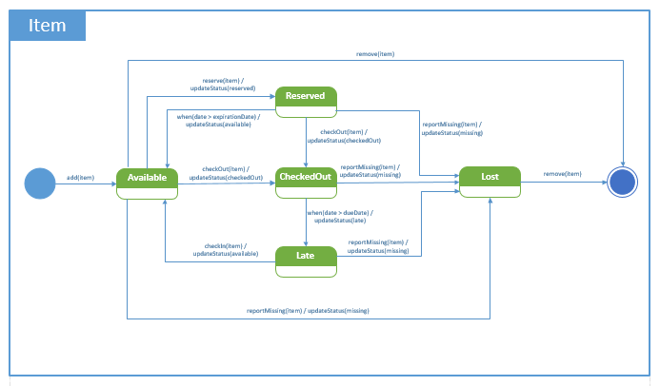Item State Model

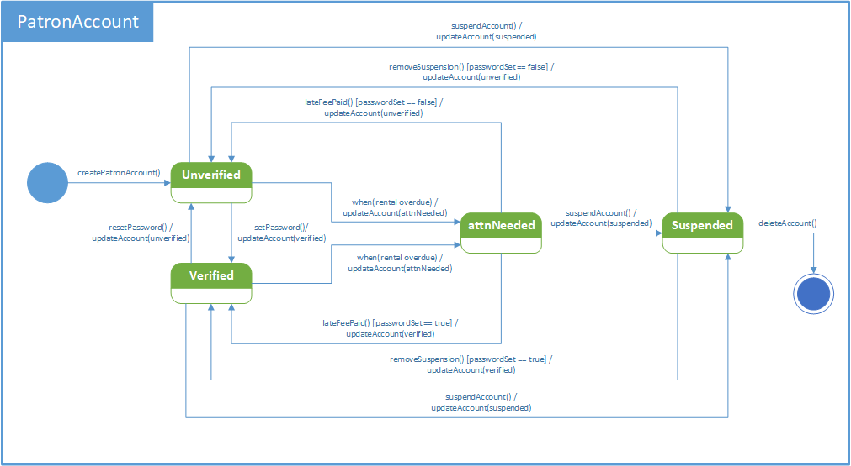Patron Account State Model

# 2. Application Analysis

## a. Application Interaction Model

### i. Scenarios

1.  Search

|  |
| --- |
| John Doe logs into Library Information System  System displays Patron portal  John Doe presses a button, requests a search  System displays search bar  John Doe types Author/Title/ISBN/Item ID  System matches search query to an item(s) in the catalog  System displays the search results in a window  John Doe exits window  John Doe logs out  System displays goodbye message |

2. Search - No Results Exception

|  |
| --- |
| John Doe logs into Library Information System  System displays Patron portal  John Doe presses a button, requests a search  System displays search bar  John Doe types Author/Title/ISBN/Item ID  System matches search query to an item(s) in the catalog  System doesn’t find match  System displays message in window “No Results Match Your Query”  John Doe exits window  John Doe logs out  System displays goodbye message |

3. Login

|  |
| --- |
| System displays login portal  John Doe enters username and password  System confirms password matches with user  System allows user access to Library Information System  System displays user portal  John Doe logs out  System displays goodbye message |

4. Login - Login Failed Exception

|  |
| --- |
| System displays login portal  John Doe enters username and password  System confirms password does not match with user  System does not allow user access to Library Information System  System displays message in window to user “Login Failed: Invalid Username or Password”  System displays goodbye message |

5. Set Password

|  |
| --- |
| System displays login portal  John Doe enters username and *temporary password*  System Confirms username and password match  System confirms password has not been set up  System displays window for user  John Doe enters a new password  System changes user password to selected password  System displays a window confirming the password change  System allows access to Library Information System |

6. Set Password - Invalid Password Exception

|  |
| --- |
| System displays login portal  John Doe enters username and *temporary password*  System Confirms username and password match  System confirms password has not been set up  System displays window for user  John Doe enters a new password  System matches the new password to the password requirements  System displays a window alerting user that password does not meet requirements |

7. Reset Password

|  |
| --- |
| John Doe requests a password reset to the librarian  Librarian allows a password reset  Librarian assigns *temporary password*  John Doe logs into Library Information System  System recognizes a temporary password  System displays a window for user  John Doe enters a new password  System changes user password to selected password  System displays a window confirming the password change  System allows access to Library Information System |

8. Reset Password Exception - Invalid Password

|  |
| --- |
| John Doe requests a password reset to the librarian  Librarian allows a password reset  Librarian assigns *temporary password*  John Doe logs into Library Information System  System recognizes a temporary password  System displays a window for user  John Doe enters a new password  System matches the new password to the password requirements  System displays a window alerting user that password does not meet requirements |

9. Request Personal Status Report

|  |
| --- |
| John Doe logs into Library Information System  System displays Patron portal  John Doe requests to display patron report  System checks user ID, gathers all checked out items  System displays all items checked out to John Doe  John Doe exits patron report window  John Doe logs out of Library Information System |

10. Request Personal Status Report Exception - Empty Report

|  |
| --- |
| John Doe logs into Library Information System  System displays Patron portal  John Doe requests to display patron report  System checks user ID, gathers all checked out items  System recognizes no items are checked out  System displays a message saying “No Items Checked Out”  John Doe exits patron report window  John Doe logs out of Library Information System |

11. Request Report (Librarian)

|  |
| --- |
| Librarian logs into Library Information System  System Displays Employee portal  Librarian requests a full report  System gathers a collection of all items currently checked out  System displays a window with a list of all items checked out in the employee portal  Librarian exits the report window  Librarian logs out of information system  System Displays goodbye message |

12. Request Report (Librarian) Exception - Empty Report

|  |
| --- |
| Librarian logs into Library Information System  System Displays Employee portal  Librarian requests a full report  System recognizes no items are checked out  System displays a message saying “No Items Checked Out”  Librarian exits the report window  Librarian logs out of information system  System Displays goodbye message |

13. Add Item

|  |
| --- |
| Librarian logs into Library Information System  System displays employee portal  Librarian requests to add an item  System displays a screen with inputs for Author/Title/Item ID/ISBN  Librarian enters Author/Title/Item ID/ISBN  System records new item  System displays window with message confirming the item was added  Librarian logs out of Library Information System  System displays a goodbye message |

14. Add Item Exception - Not Enough Information

|  |
| --- |
| Librarian logs into Library Information System  System displays employee portal  Librarian requests to add an item  System displays a screen with inputs for Author/Title/Item ID/ISBN  Librarian doesn’t enter enough information  System displays window with message saying “Not enough information to add item”  System displays a screen with inputs for Author/Title/Item ID/ISBN |

15. Remove Item

|  |
| --- |
| Librarian logs into Library Information System  System displays employee portal  Librarian requests to remove an item  System displays a window with input for Item ID  Librarian enters the Item ID  System removes item from catalog with matching ID  System send a window with message confirming item has been deleted |

16. Remove Item Exception - No Match

|  |
| --- |
| Librarian logs into Library Information System  System displays employee portal  Librarian requests to remove an item  System displays a window with input for Item ID  Librarian enters the Item ID  System fails to find item with matching ID  System send a window with message “No Match for item” |

17. Register New User (Patron)

|  |
| --- |
| Patron checks out with Librarian for first time  Librarian logs into Library Information System  Librarian requests to register new user  System displays a window with inputs for Name/ID/temp password  Librarian enters information in window  Librarian submits form to system  System registers the new user  System returns confirmation of added user to Librarian  Librarian logs out of Library information system  System displays goodbye message |

18. Register New User (Patron) Exception - Already Registered

|  |
| --- |
| Patron checks out with Librarian for first time  Librarian logs into Library Information System  Librarian requests to register new user  System displays a window with inputs for Name/ID/temp password  Librarian enters information in window  Librarian submits form to system  System matches User ID with an existing ID  System displays a window with a message saying “User Already Registered”  Librarian logs out of Library information system  System displays goodbye message |

19. Terminate Account

|  |
| --- |
| John Doe logs into Library Information System  System displays user portal  John Doe requests to terminate account  System displays a message asking for confirmation  John Doe confirms termination of account  John Doe exits termination window  John Doe logs out of library information system  System displays a goodbye message  Librarian Logs into Library Information System  System displays employee portal  System alerts Librarian of new termination request  Librarian confirms termination request  System matches User ID for termination  System terminates account with matching ID  System displays confirmation of termination  Librarian exits termination window  Librarian logs out of Library Information System  System displays goodbye message |

20. Terminate Account Exception - No Match

|  |
| --- |
| John Doe logs into Library Information System  System displays user portal  John Doe requests to terminate account  System displays a message asking for confirmation  John Doe confirms termination of account  John Doe exits termination window  John Doe logs out of library information system  System displays a goodbye message  Librarian Logs into Library Information System  System displays employee portal  System alerts Librarian of new termination request  Librarian confirms termination request  System matches User ID for termination  System doesn’t find match for User ID  System displays message saying “No Match. User Not Found.”  Librarian exits termination window  Librarian logs out of Library Information System  System displays goodbye message |

21. Update Item Status

|  |
| --- |
| Librarian logs into Library Information System  System displays Employee Portal  Librarian requests to change an items status  System displays a window with an input for Item ID/New Status  Librarian enters Item ID  System matches Item ID with an item in the catalog  System changes the status of the item to the New Status  System sends confirmation of Item Status Change to Librarian  Librarian logs out of Library Information System  System displays goodbye message |

22. Update Item Status Exception - No Match

|  |
| --- |
| Librarian logs into Library Information System  System displays Employee Portal  Librarian requests to change an items status  System displays a window with an input for Item ID/New Status  Librarian enters Item ID  System matches Item ID with an item in the catalog  System does not find match for item in the catalog  System displays window with message saying “No Match. Item not found.”  Librarian logs out of Library Information System  System displays goodbye message |

23. Register New User (Librarian)

|  |
| --- |
| Librarian logs into Library Information System  System displays employee portal  Librarian requests to register a new employee  System displays a window with inputs for Name/ID  Librarian fills out form and submits it to system  System registers a new employee under the inputted ID  System sends confirmation of new registration to Librarian  Librarian logs out of Library Information System |

24. Register New User (Librarian) Exception - Already Registered

|  |
| --- |
| Librarian logs into Library Information System  System displays employee portal  Librarian requests to register a new employee  System displays a window with inputs for Name/ID  Librarian fills out form and submits it to system  System finds match of Employee ID with an existing account  System displays window with message saying “User Already Registered”  Librarian logs out of Library Information System  System displays goodbye message |

25. Report Missing Item

|  |
| --- |
| John Doe logs into Library Information System  System displays patron portal  John Doe requests to report a missing item  System displays a screen with inputs for Author and Title  John Doe enters author and title  System matches author and title to a book checked out by John Doe  System confirms request  John Doe logs out of Library Information System  System sends alert to librarian  Librarian logs into Library information system  System displays Employee portal  Librarian Requests to confirm missing item  System displays a screen with inputs for confirmation  Librarian enters confirmation  System changes item status to missing  Librarian logs out of Library Information System  System displays goodbye message |

26. Report Missing Item Exception - No Match

|  |
| --- |
| John Doe logs into Library Information System  System displays patron portal  John Doe requests to report a missing item  System displays a screen with inputs for Author and Title  John Doe enters author and title  System matches author and title to a book checked out by John Doe  System doesn’t find matching item  System displays window with message saying “No Match. Item Not Found.”  John Doe logs out of Library Information System  System Displays goodbye message |

27. Place Hold on Account

|  |
| --- |
| Librarian logs into Library Information System  System displays employee portal  Librarian requests to place hold on an account  System displays a window with an input for User ID  Librarian enters User ID, submits form back to System  System places the hold on the account with matching User ID  System sends an alert to patron with matching User ID  System sends confirmation back to Librarian  Librarian logs out of Library Information System  System displays goodbye message |

28. Place Hold on Account Exception - No Match

|  |
| --- |
| Librarian logs into Library Information System  System displays employee portal  Librarian requests to place hold on an account  System displays a window with an input for User ID  Librarian enters User ID, submits form back to System  System does not find user with matching User ID  System displays a window with message saying “No Match. User Not Found.”  Librarian logs out of Library Information System  System displays goodbye message |

29. Suspend Account

|  |
| --- |
| Librarian logs into Library Information System  System displays employee portal  Librarian requests to suspend account  System displays a window with an input for User ID  Librarian enters User ID, submits form back to System  System suspends account with matching User ID  System sends an alert to patron with matching User ID  System sends confirmation of account suspended to Librarian  Librarian logs out of Library Information System  System displays goodbye message |

30. Suspend Account Exception - No Match

|  |
| --- |
| Librarian logs into Library Information System  System displays employee portal  Librarian requests to suspend account  System displays a window with an input for User ID  Librarian enters User ID, submits form back to System  System does not find a matching User ID  System displays a window with message saying “No Match. User Not Found.”  Librarian logs out of Library Information System  System displays goodbye message |

31. Patron Reserves Item

|  |
| --- |
| Patron logs into Library Information System  System displays patron portal  Patron searches for item in the system catalog  System catalog displays search results  Patron selects the item that he wishes to reserve  System changes the item status to reserve  System notifies patron item has been reserved for him  Patron logs out of system |

32. Patron check-out item

|  |
| --- |
| Patron logs into Library Information System  System displays patron portal  Patron searches for item in the system catalog  System catalog displays search results  Patron selects the item that he wishes to checkout and sees the location in library  Patron logs out of the system  Patron fetches the item  Patron hands item to librarian for checkout  Librarian looks up the patron account  Librarian looks up the item  Librarian changes item status to checked out and gives patron due date  System changes the item status to checked out  System notifies librarian item has checked out  Librarian logs out of system |

### ii. Essential Use Cases

1. Search

Summary: The system returns an item or list of items based on a search query made by the user.

Actors: User, System

Preconditions: The system is waiting for a search query from the user.

Description:

|  |  |
| --- | --- |
| Actor Intentions | System Responsibility |
| 1.  Request search |  |
| 2. Give search terms | 3. Provide Search Results |

1. Login

Summary: The system grants access to a user after a valid user ID and password are entered.

Actors: User, System

Preconditions: The system is waiting for a user ID and Password from the user.

Description:

|  |  |
| --- | --- |
| Actor Intentions | System Responsibility |
|  | 1. Asks for login credentials |
| 2. Provides login credentials. | 3. Authenticates user |
|  | 4. Takes user to desired destination. |

1. Set Password

Summary: The system changes the password to a user selected password when given a valid user ID and valid temporary password.

Actors: Librarian, Patron, System

Preconditions: The Librarian has assigned a temporary password, and the Patron is registered.

|  |  |
| --- | --- |
| Actor Intentions | System Responsibility |
| 1. Librarian assigns temporary password |  |
| 2. User signs in with temporary password | 3. System asks user to change password. |
| 4. User sets new password. | 5. System saves new password. |

1. Reset Password

Summary: The system grants a password reset with validation from librarian, then gives the user a new temporary password, allowing the user to set a new password.

Actors: Librarian, Patron, System

Preconditions: The Librarian has authorized a password reset, and given a temporary password.

Description:

|  |  |
| --- | --- |
| Actor Intentions | System Responsibility |
| 1. Librarian resets a user password |  |
| 2. Librarian assigns user a new temporary password |  |
| 3. Patron signs in with temporary password | 4. System asks user to change password. |
| 5. Patron sets new password. | 6. System saves new password. |

1. Request Personal Status Report

Summary: A patron requests a personal status report, the system generates a list of items checked out to the user and their statuses.

Actors: Patron, System

Preconditions: The Patron is logged into their patron account.

Description:

|  |  |
| --- | --- |
| Actor Intentions | System Responsibility |
| 1. Patron requests Patron Report | 2. System provides report |

1. Request Report (Librarian)

Summary: A librarian requests a report, the system generates a list of all items checked out, their statuses, and which patrons they are checked out to.

Actors: Librarian, System

Preconditions: The Librarian is logged into their employee account.

Description:

|  |  |
| --- | --- |
| Actor Intentions | System Responsibility |
| 1. Librarian requests full Librarian Report | 2 System provides report. |

1. Add Item

Summary: The librarian requests to add an item, the system requests any pertinent information for the item to add (Author, ISBN, etc.) and adds that item to the catalogue.

Actors: Librarian, System

Preconditions: The librarian has an item to add.

Description:

|  |  |
| --- | --- |
| Actor Intentions | System Responsibility |
| 1. Librarian Initiates Action | 2. System Asks Librarian for details |
| 3. Librarian provides details to system | 4. System adds new item |

1. Remove Item

Summary: The Librarian requests to remove an item, the system requests an Item ID, and the system removes the item.

Actors: Librarian, System

Preconditions: The librarian needs to remove an item.

Description:

|  |  |
| --- | --- |
| Actor Intentions | System Responsibility |
| 1. Librarian initiates removal action | 2. System asks for which item to remove |
| 3. Librarian provides item information | 3. System removes matching item |

1. Register New User (Patron)

Summary: When checking out for the first time, a patron is registered for the Library Information System.

Actors: Librarian, System, Patron

Preconditions: The Patron doesn't have an existing account.

Description:

|  |  |
| --- | --- |
| Actor Intentions | System Responsibility |
| 1. Patron brings item to check out |  |
| 2. Librarian initiates registration action | 3. System asks librarian for patron details. |
| 4. Librarian asks patron for his or her details. |  |
| 5. Patron provides information to librarian. |  |
| 6. Librarian provides system with patron details. | 7. System registers user and provides an account number |
| 8. Patron provides patron account number and temporary password. |  |

1. Terminate account

Summary: When an account is no longer needed, a librarian may use the system at the patron’s request to terminate an account.

Actors: Librarian, Patron, System

Preconditions: An account needs deleted, with patron's request.

Description:

|  |  |
| --- | --- |
| Actor Intentions | System Responsibility |
| 1. Patron requests account to be terminated |  |
| 2. Librarian initiates action | 3. Asks Librarian for account details |
| 4. Librarian provides system with patron’s information. | 5. Terminates the matching account. |

1. Update Item Status

Summary: When an Item’s status is changed, the Librarian and the system update the item’s status.

Actors: Librarian, System

Preconditions: An Item’s status changes, and a status update is waiting to be completed.

Description:

|  |  |
| --- | --- |
| Actor Intentions | System Responsibility |
| 1. Librarian initiates status change action | 2. System asks for which item the status is being changed and what the new status is. |
| 3. Librarian provides details about item and new status. | 4. System updates item record with new status. |

1. Register New User (Librarian)

Summary: When an Item’s status is changed, the Librarian and the system update the item’s status.

Actors: Librarian, System

Preconditions: An Item’s status changes, and a status update is waiting to be completed.

Description:

|  |  |
| --- | --- |
| Actor Intentions | System Responsibility |
| 1. Librarian initiates register librarian action | 2. System requests pertinent employee information |
| 3. Librarian provides the system the new librarian details. | 4. The System registers the new librarian account. |

1. Report Missing item

Summary: A Patron uses the system to request a missing item report, the system asks for pertinent information on the missing item (Item ID) and updates the status of the item to missing.

Actors: Patron, System

Preconditions: An Item has been lost.

Description:

|  |  |
| --- | --- |
| Actor Intentions | System Responsibility |
| 1. Patron initiates Missing Item Report | 2. System requests details about missing item |
| 3. Patron provides details about missing item | 4. System requests confirmation of missing item from Librarian. |
| 5. Librarian confirms or denies missing item. | 6. System updates item status accordingly. |

1. Place Hold on account

Summary: The librarian places a hold on a patron account for overdue books/outstanding balances.

Actors: Librarian, System

Preconditions: The patron has overdue books/outstanding balance, and account has been flagged.

Description:

|  |  |
| --- | --- |
| Actor Intentions | System Responsibility |
| 1. Librarian initiates action | 2. System asks which account to place the hold on |
| 3. The librarian provides account details | 4. The system places the hold and confirms to the librarian |

1. Suspend Account

Summary: The librarian suspends a patron account for overdue books/outstanding balances.

Actors: Librarian, System

Preconditions: The patron has overdue books/outstanding balance.

Description:

|  |  |
| --- | --- |
| Actor Intentions | System Responsibility |
| 1. Librarian initiates action | 2. System asks which account to suspend |
| 3. The librarian provides account details | 4. The system suspends the given account. |

1. Reserve Item

Summary: Patron reserves an item

Actors: Patron, System

Preconditions: The patron is logged into the system and has searched for an item to reserve.

Description:

|  |  |
| --- | --- |
| Actor Intentions | System Responsibility |
| 1. Patron initiates action | 2. System finds item that patron wants to reserve |
|  | 3. System reserves item and confirms to the patron |

1. Check-out item

Summary: The patron checks out an item from library.

Actors: Librarian, System, Patron

Preconditions: The patron has found an item to checkout and already has an account at the library.

Description:

|  |  |
| --- | --- |
| Actor Intentions | System Responsibility |
| 1. Librarian initiates action | 2. System asks which account the item is checked out to |
| 3. Patron provides account information | 4. System finds account and asks which item is being checked out |
| 4. Librarian provides item info | 5. System finds item and updates status to “check-out” and notifies librarian of due date |
| 6. Librarian hands patron the item and notifies patron of due date |  |

### iii. Sequence System Diagrams:

1. Search:

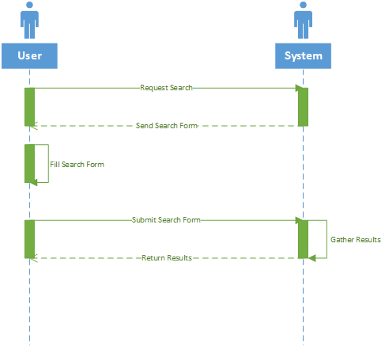

2.  Login:

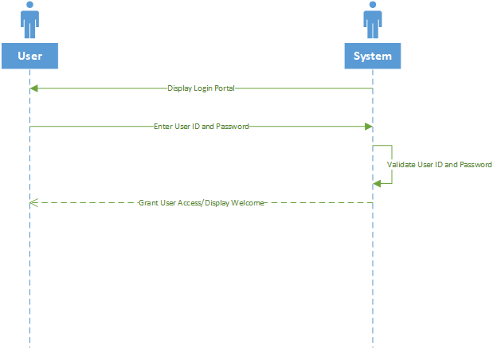

3. Set Password:

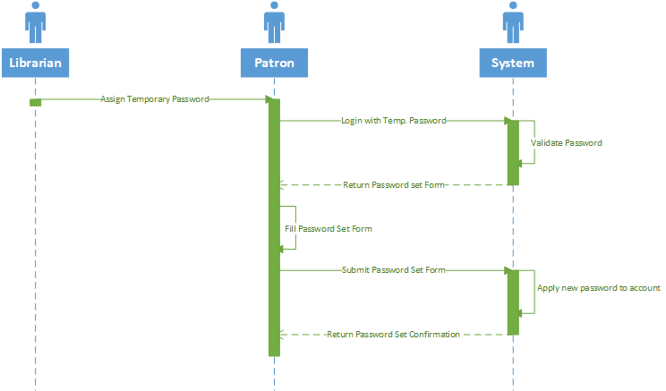

4. Reset Password:

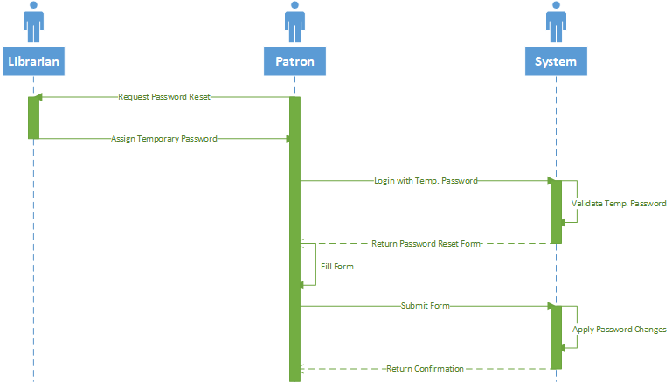

5. Request Personal Status Report:

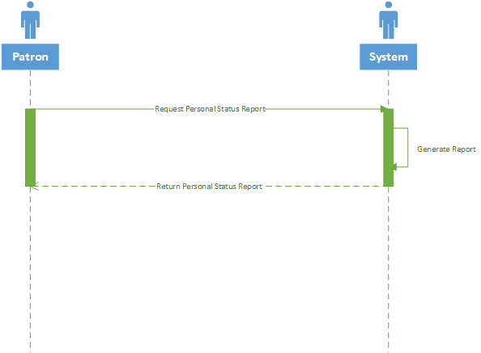

6. Request Report:

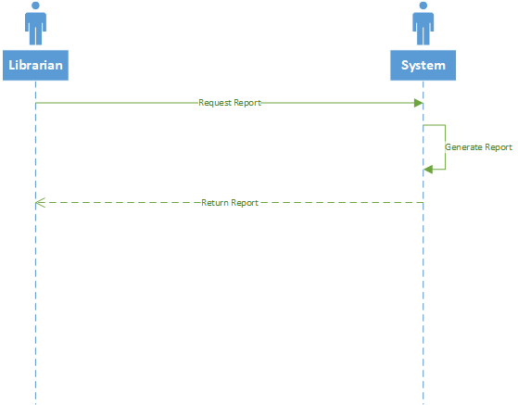

7. Add Item:

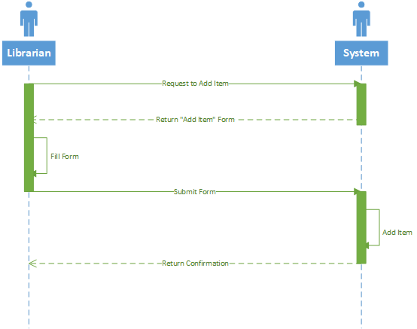

8. Remove Item:

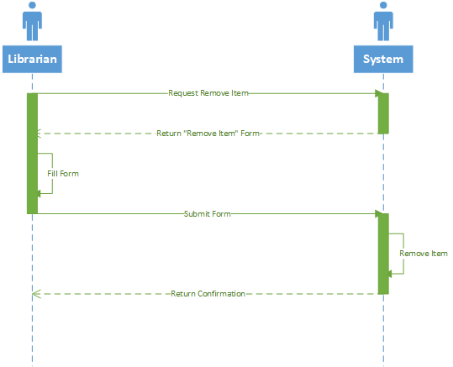

9. Register New User (Patron):

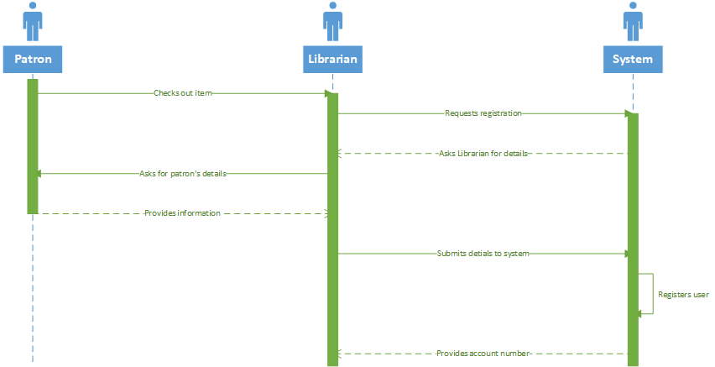

10. Terminate Account

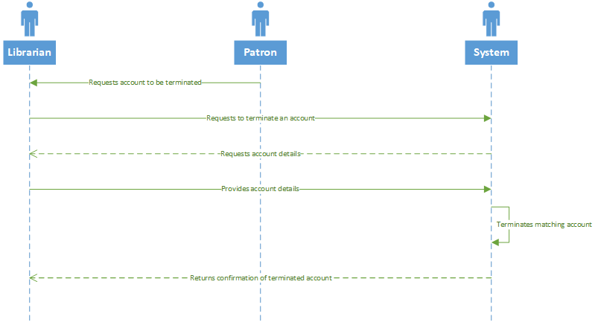

11. Update Item Status:

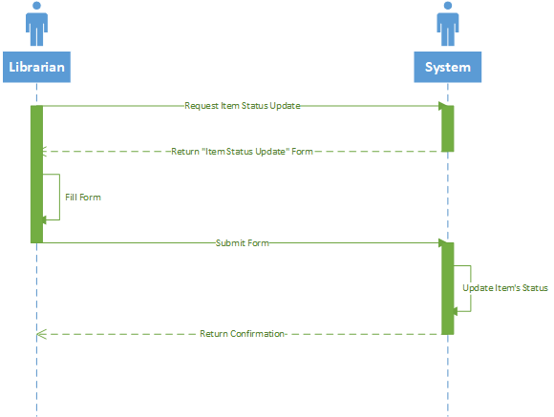

12. Register New User (Librarian)

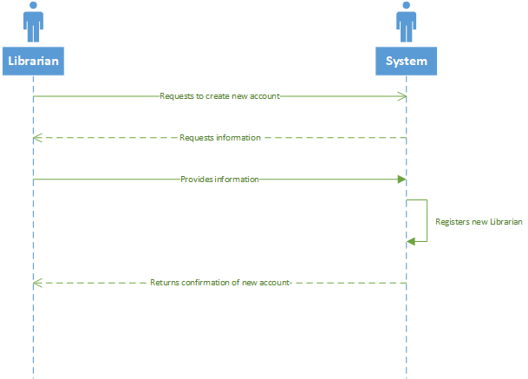

13. Report Missing Item

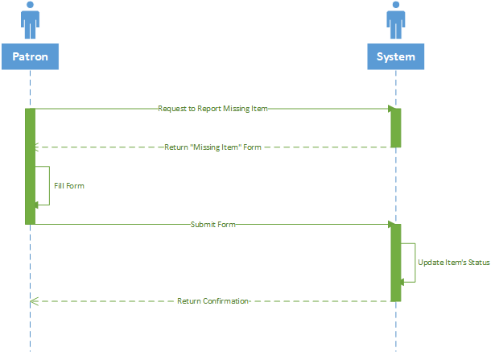

14. Place Hold on Account:

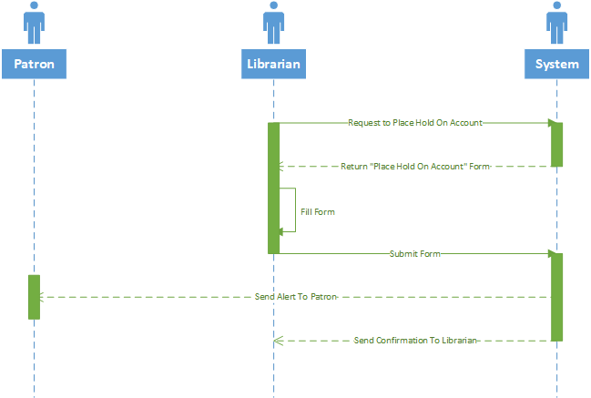

15. Suspend Account:

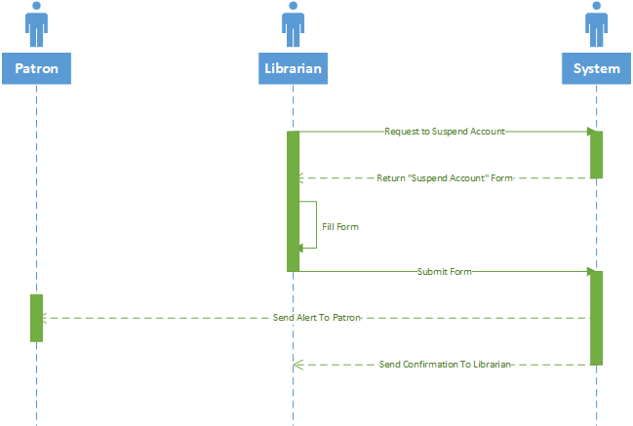

1. Patron reserves an item:

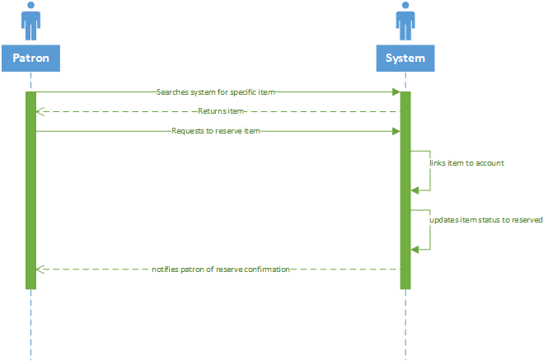

1. 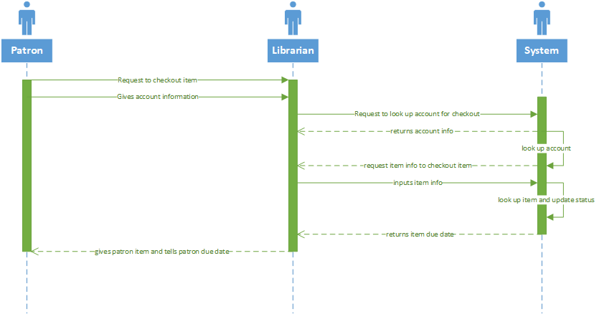Patron check-out an item:

### iv. Concrete Use Cases:

1. Search
   1. Summary: The system returns an item or list of items based on a search query made by the user.
   2. Actors: User, System
   3. Preconditions: The system is waiting for a search query from the user.
   4. Description:

|  |  |
| --- | --- |
| Actor Intentions | System Responsibility |
| 1. User requests a search from system. | 2. Displays search query with message “Search by Author/ISBN/Item ID”. |
| 3. Enters pertinent information for search, submits to system. | 4. Returns list of results based on search query. |

* 1. Exceptions:

*i: No Results:* If the query by the user has no matches, the system returns a message displaying “No Results”

1. Login
2. Summary: The system grants access to a user after a valid user ID and password are entered.
3. Actors: User, System
4. Preconditions: The system is waiting for a user ID and Password from the user.
5. Description:

|  |  |
| --- | --- |
| Actor Intentions | System Responsibility |
|  | 1. Displays login portal, requests information from user. |
| 2. Enters User ID and Password, presses login button. | 3. System checks for correct ID/password combination. |
|  | 4. Sends confirmation to user, and grants access to Library Information System. |

* 1. Exceptions:
     1. *Login Failed:* If the user logs in with a wrong username or password, the system returns a message displaying “Login Failed: Invalid Username or Password”.

1. Set Password
2. Summary: The system changes the password to a user selected password when given a valid user ID and valid temporary password.
3. Actors: Librarian, Patron, System
4. Preconditions: The Librarian has assigned a temporary password, and the Patron is registered.
5. Description:

|  |  |
| --- | --- |
| Actor Intentions | System Responsibility |
| 1. Librarian assigns temporary password to patron. |  |
| 2. Patron logs in to library system using temporary password. | 3. Displays form to patron asking for new password. |
| 4. Patron fills form with new password, submits form back to system. | 5. System sends confirmation to patron, allows access to library information system. |

* 1. Exceptions:
     + 1. *Invalid Password:* If the entered password does not meet the requirements, the system will display a message “Password does not meet requirements, please enter a different password.”

1. Reset Password
2. Summary: The system grants a password reset with validation from librarian, then gives the user a new temporary password, allowing the user to set a new password.
3. Actors: Librarian, Patron, System
4. Preconditions: The Librarian has authorized a password reset, and given a temporary password.

|  |  |
| --- | --- |
| Actor Intentions | System Responsibility |
| 1. Librarian has authorized password reset. |  |
| 2. Librarian Assigns temporary password for patron. |  |
| 3. Patron logs in to system using ID and temporary password. | 4. Sends form to user requesting new password. |
| 5. Patron fills form with new password |  |
| 6. Patron submits form | 7. Resets user’s password, allows access to system. |
|  | 8. Sends confirmation of changed password to user. |

* 1. Exceptions:
     + 1. *Invalid Password:* If the entered password does not meet the requirements, the system will display a message “Password does not meet requirements, please enter a different password.”

1. Request Personal Status Report
2. Summary: A patron requests a personal status report, the system generates a list of items checked out to the user and their statuses.
3. Actors: Patron, System
4. Preconditions: The Patron is logged into their patron account.
5. Description:

|  |  |
| --- | --- |
| Actor Intentions | System Responsibility |
| 1. Patron presses button requesting personal status report. | 2. Displays a list of all items current patron has checked out and their statuses. |

* 1. Exceptions:
     1. *Empty Report*: if the Patron does not have any items currently checked out, then the system returns an empty report. A message will be displayed saying the Patron has no items currently checked out.

1. Request Report
2. Summary: A librarian requests a report, the system generates a list of all items checked out, their statuses, and which patrons they are checked out to.
3. Actors: Librarian, System
4. Preconditions: The Librarian is logged into their employee account.
5. Description:

|  |  |
| --- | --- |
| Actor Intentions | System Responsibility |
| 1. Librarian logs into system, presses a button requesting a full report. | 2. Generates a list of all items that have been checked out from the library, along with their statuses. |
|  | 3. Displays list to librarian. |

* 1. Exceptions:
     + 1. *Empty Report:* If the library has no items currently checked out, the system returns an empty report. A message will be displayed to the librarian saying there are no items checked out.

1. Add Item
2. Summary: The librarian requests to add an item, the system requests any pertinent information for the item to add (Author, ISBN, etc.) and adds that item to the catalogue.
3. Actors: Librarian, System
4. Preconditions: The librarian has an item to add.
5. Description:

|  |  |
| --- | --- |
| Actor Intentions | System Responsibility |
| 1. Librarian presses button requesting to add an item. | 2. Generates form for librarian to fill. |
| 3. Librarian fills form with pertinent attributes (Authors, ISBN, Title, Item ID, etc.). |  |
| 4. Submits form to system. | 5. Records new item. |

* 1. Exceptions:
     + 1. *Not Enough Information:* if the user does not include enough information when filling out the report (no ID, No title, etc.), the system returns a message asking for more information.
       2. *Duplicate Item:* if the item ID of the item to add matches an item currently in the catalog, then the item is not added, and the system returns a message to alert the user of the duplicate.

1. Remove Item
2. Summary: The Librarian requests to remove an item, the system requests an Item ID, and the system removes the item.
3. Actors: Librarian, System
4. Preconditions: The librarian needs to remove an item.
5. Description:

|  |  |
| --- | --- |
| Actor Intentions | System Responsibility |
| 1. Librarian presses button requesting to the system to remove an item. | 2. Returns form for librarian to fill out. |
| 3. Fills form with Item ID |  |
| 4. Submits form back to system. | 5. Removes item with matching Item ID. |

* 1. Exceptions:
     + 1. *No Match:*  If the item ID entered by the librarian does not match any item ID in the catalog, the system will return a message saying “No Match”.

1. Register New User (Patron)
   1. Summary: When checking out for the first time, a patron is registered for the Library Information System.
   2. Actors: Librarian, System, Patron
   3. Preconditions: The Patron doesn't have an existing account.
   4. Description:

|  |  |
| --- | --- |
| Actor Intentions | System Responsibility |
| 1. Patron checks out for first time |  |
| 2. Librarian presses a button, requesting to the system to add a User. | 3. Returns form for librarian to fill out. |
| 4. Librarian fills form with all pertinent information (Name, ID, temp password, etc.) |  |
| 5. Submits form back to system by pressing a button. | 6. Registers user. |
|  | 7. Returns confirmation message to user. |
| 8. Librarian assigns temporary ID to patron. |  |

* 1. Exceptions:
     + 1. *Already Registered:* If when the Librarian enters the form, the system finds that a patron with that name is currently registered, the system will return a message saying “User already Registered.”.

1. Terminate Account
   1. Summary: When an account is no longer needed, a librarian may use the system at the patron’s request to terminate an account.
   2. Actors: Librarian, Patron, System
   3. Preconditions: An account needs deleted, with patron's request.
   4. Description:

|  |  |
| --- | --- |
| Actor Intentions | System Responsibility |
| 1. Patron requests to librarian to terminate account. |  |
| 2. Librarian requests to system to terminate an account by pressing a button. | 3. Returns a form to librarian to fill out. |
| 4. Librarian fills form with pertinent information (User ID). |  |
| 5. Librarian submits form to system by pressing a button. | 6. Removes the User with a matching User ID. |
|  | 7. Returns confirmation message to user. |

* 1. Exceptions:
     + 1. If when the Librarian requests to terminate an account of a certain User ID, and the system finds no match, the system will return a message saying “No Match. User Not Found.”

1. Update Item Status
   1. Summary: When an Item’s status is changed, the Librarian and the system update the item’s status.
   2. Actors: Librarian, System
   3. Preconditions: An Item’s status changes, and a status update is waiting to be completed.
   4. Description:

|  |  |
| --- | --- |
| Actor Intentions | System Responsibility |
| 1. Librarian requests to change the status of a book | 2. Returns form for librarian to fill. |
| 3. Librarian fills form with pertinent information about item (Item ID, new status). |  |
| 4. Librarian submits form back to system by pressing a button. | 5. Changes items status according to Librarians request. |
|  | 6. Sends confirmation back to user. |

* 1. Exceptions:
     + 1. *No Match:*  If the item ID entered by the librarian does not match any item ID in the catalog, the system will return a message saying “No Match”.

1. Register New User (Librarian)
   1. Summary: When a new employee (librarian) is brought on, a new account must be created.
   2. Actors: Librarian, System
   3. Preconditions: A new account must be created.
   4. Description:

|  |  |
| --- | --- |
| Actor Intentions | System Responsibility |
| 1. Librarian presses a button requesting to register a new employee. | 2. Returns form to librarian requesting information on the new user. |
| 3. Librarian fills form with pertinent information (Name, Employee ID. etc.) |  |
| 4. Librarian submits form back to system by pressing a button. | 5. Registers the new user. |
|  | 6. Returns confirmation to Librarian |

* 1. Exceptions:
     + 1. *Already Registered:*  If when the Librarian enters the form, the system finds that an Employee with that name is currently registered, the system will return a message saying “User already Registered.”.
       2. *Need More Information:* If when the Librarian enters the form, the system finds that some critical information is missing from the form. The system will send a message saying “More information needed” and send out another form for the User to fill.

1. Report Missing Item
   1. Summary: A Patron uses the system to request a missing item report, the system asks for pertinent information on the missing item (Item ID) and updates the status of the item to missing.
   2. Actors: Patron, System, Librarian
   3. Preconditions: An Item has been lost.
   4. Description: An item has been lost. The patron, logged into the Library Information System, requests to report a missing item. The system delivers a form to the user to fill out. The user enters the Author and Title of the missing item, and submits the form. The system records this form, and changes the status of the item to lost.

|  |  |
| --- | --- |
| Actor Intentions | System Responsibility |
| 1. Patron requests to the system to report missing Item by pressing a button. | 2. Returns a form for patron to fill out. |
| 3. Patron fills form out with pertinent information on the missing book. (Author and Title) |  |
| 4. Patron presses a button to submit the form back to the system. | 5. Alerts Librarian of missing item |
| 6. Librarian sees alert, changes status of the item. | 7. Returns confirmation of item change. |

* 1. Exceptions:
     + 1. *No Match:*  If the item entered by the patron does not match any item he/she has checked out, the system will return a message saying “No Match”.

1. Place Hold on Account
   1. Summary: The librarian places a hold on a patron account for overdue books/outstanding balances.
   2. Actors: Librarian, System, Patron
   3. Preconditions: The patron has overdue books/outstanding balance, and account has been flagged.
   4. Description: The patron has overdue books or an outstanding balances, and account has been flagged. The librarian presses a button on the library information system to request a hold on the users account. The system delivers a form to the librarian for them to fill out. The Librarian enters the User ID to place a hold on and presses a button. The User ID is submitted to the system. The system places a hold on the account and alerts the Patron

|  |  |
| --- | --- |
| Actor Intentions | System Responsibility |
| 1. Librarian presses a button requesting to place a hold on a patron account. | 2. Returns form for librarian to fill |
| 3. Librarian fills form with pertinent information (User ID) |  |
| 4. Librarian submits form back to system by pressing a button. | 5. Returns confirmation of placing hold on account to librarian. |
|  | 6. Sends alert to Patron alerting them of hold on account. |

* 1. Exceptions:
     + 1. *No Match:*  If the User ID entered by the librarian does not match any User ID in the registry, the system will return a message saying “No Match”.

1. Suspend Account
   1. Summary: The librarian suspends a patron account for overdue books/outstanding balances.
   2. Actors: Librarian, System
   3. Preconditions: The patron has overdue books/outstanding balance.
   4. Description: The patron has overdue books or an outstanding balances, and account has a hold placed on it. The librarian presses a button on the library information system to request to suspend the users account. The system delivers a form to the librarian for them to fill out. The Librarian enters the User ID to suspend and presses a button. The User ID is submitted to the system. The system suspends the account and alerts the Patron.

|  |  |
| --- | --- |
| Actor Intentions | System Responsibility |
| 1. Librarian presses button requesting to suspend an account. | 2. System returns a form to the librarian to fill out. |
| 3. Librarian fills out form with pertinent information (User ID). |  |
| 4. Librarian presses a button to submit the form back to the system. | 5. System suspends the account with matching User ID. |
|  | 6. System sends confirmation of suspended account to Librarian. |
|  | 7. System sends alert to user that their account has been suspended. |

* 1. Exceptions:
     + 1. *No Match:*  If the User ID entered by the librarian does not match any User ID in the registry, the system will return a message saying “No Match”.

1. Patron Reserves an Item
   1. Summary: The patron finds and item in the system and reserves it for pick-up
   2. Actors: System, Patron
   3. Preconditions: The patron is logged into their account and has found an item that he would like to reserve.
   4. Description: The patron is logged into the system and wishes to reserve an item so he may pick it up at the library without searching for it. The patron searches through the online catalog and selects the item he wishes to reserve. The item is available so the patron clicks reserve on the item. The system then finds the patrons account information and the items information and updates the patrons account to reserve the item and sets the items status as reserved. The patron can then go to the library and present his account information or library card and pick up the reserved item.

|  |  |
| --- | --- |
| Actor Intentions | System Responsibility |
| 1. Patron presses button to reserve an item after searching for it | 2. Finds the patrons account |
|  | 3. Finds the items information |
|  | 4. Links the item to the patrons account |
|  | 5. Updates the items status as reserved |
|  | 6. returns notification letting patron know item has been reserved for him |
| 7. Views notification and heads to library to pick up item. |  |

* 1. Exceptions:
     + 1. *Not Available:*  If the patron searches for an item that has already been checked-out then it will not be available to be reserved.

1. Patron Check-out Item
   1. Summary: Patron finds an item and checks it out of the library.
   2. Actors: Librarian, System, Patron
   3. Preconditions: Patron already has an account at the library in good standing.
   4. Description: The patron finds an item in the library to check-out. The patron gives the item to the librarian. The librarian also gets the patrons library card. The librarian looks up the patron in the system to verify the patron is in good standing. The library finds the item in the system that the patron wishes to checkout and links it to the patrons account. The librarian updates the items status to “checked-out” and gives the patron the item with a date that the item must be returned by.

|  |  |
| --- | --- |
| Actor Intentions | System Responsibility |
| 1. Patron gives librarian item and library card |  |
| 2. Librarian looks up patrons account | 3. Returns the patrons account information |
| 4. Librarian looks up the items information the patron wishes to check-out | 5. Returns the items information for the librarian to view |
| 6. Librarian links the item to the patrons account | 7. System links the item to the patrons account |
| 8. Librarian updates the items status to “checked-out” | 9. System updates the item status to “checked-out” |
|  | 10. System returns a date that the item is due |
| 11. Librarian views the due date and tells the patron |  |
| 12. Librarian hands the patron the item |  |
| 13. Librarian goes back to homepage and out of patrons account information | 14. Displays librarians home page |

* 1. Exceptions:
     + 1. *No Match:*  If the User ID entered by the librarian does not match any User ID in the registry, the system will return a message saying “No Match”.

### v. Detailed SSD

* + 1. 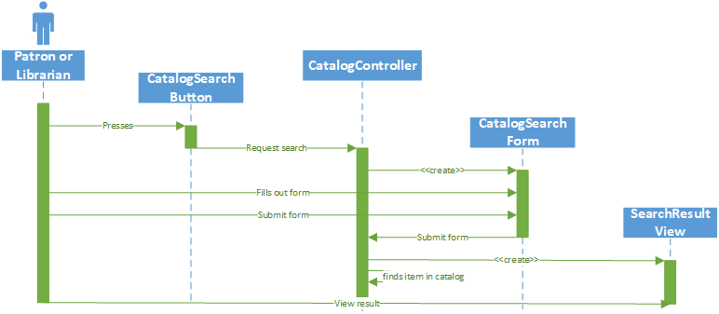Search:
    2. 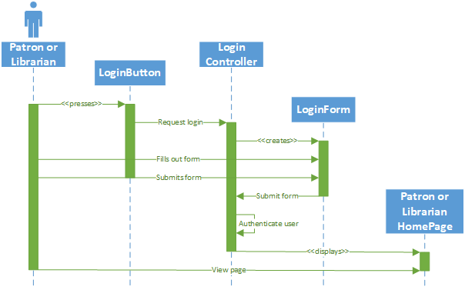Login:
    3. 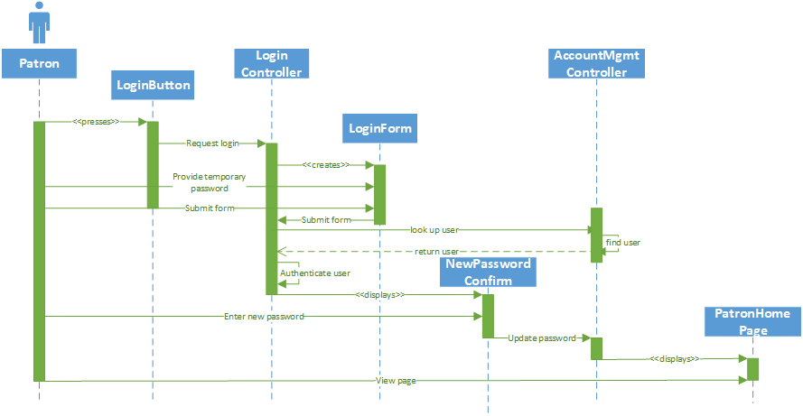Set Password:
    4. 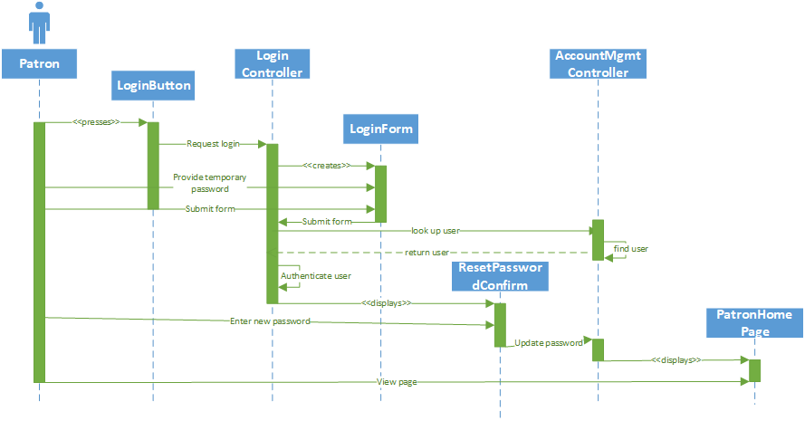Reset Password:
    5. 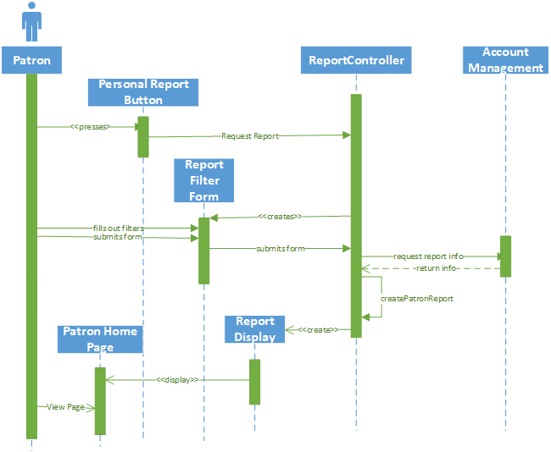Request Personal Status Report:

1. 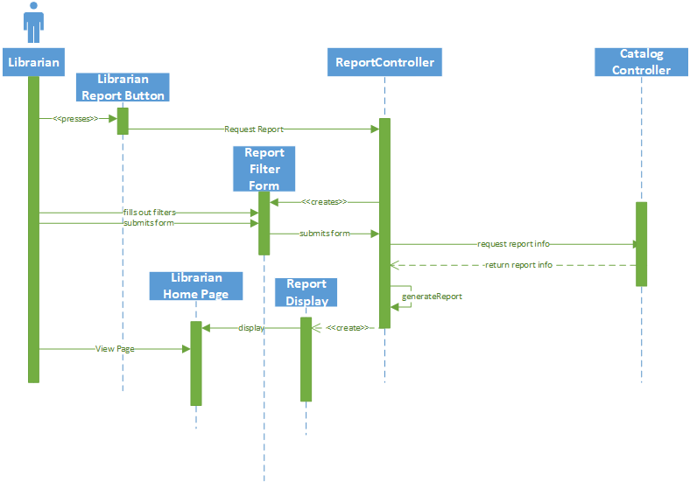Request Report (Librarian):
2. 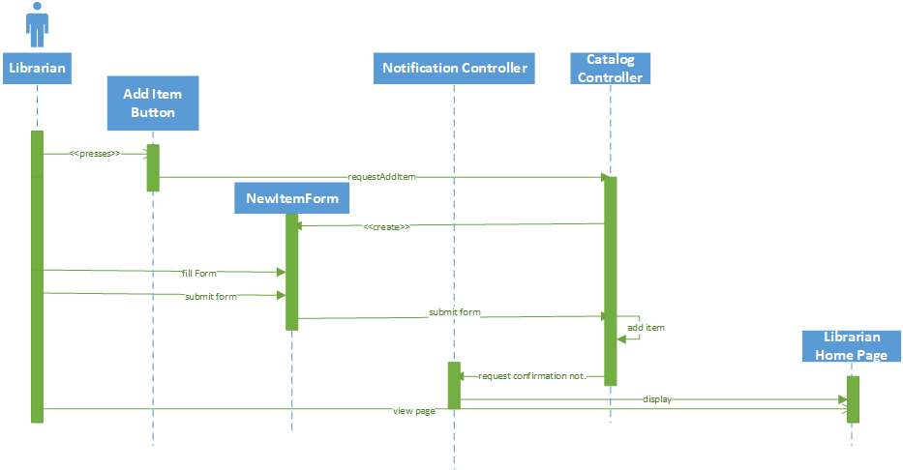Add Item:
3. 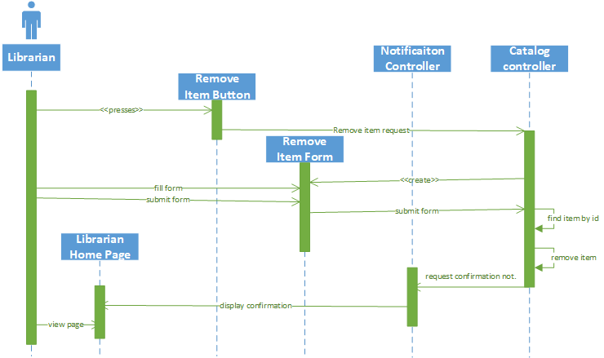Remove Item:
4. 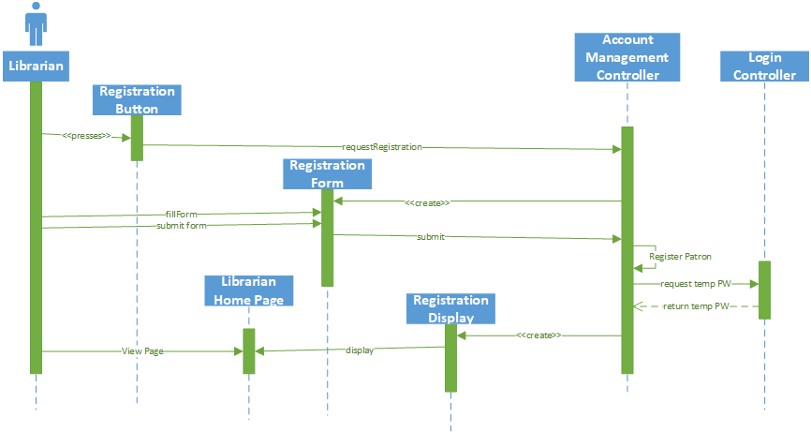Register New User (Patron):
5. 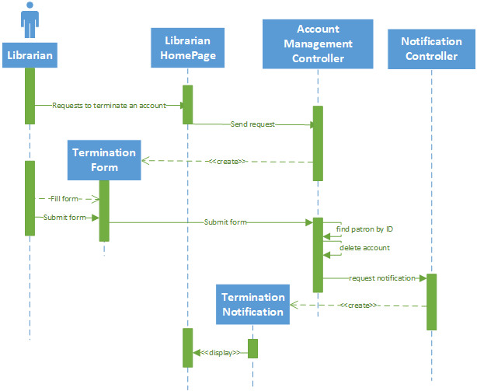Terminate Account:
6. 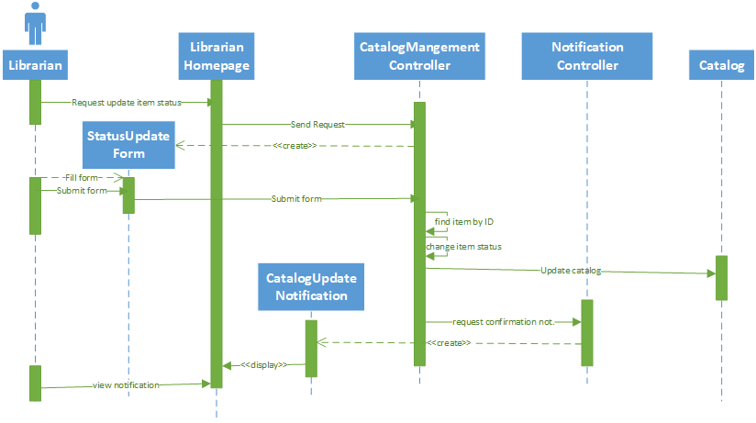Update Item Status:
7. 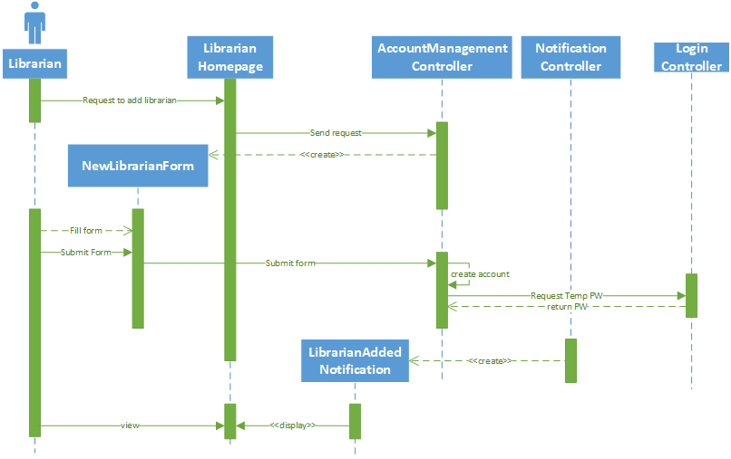Register New User (Librarian):
8. 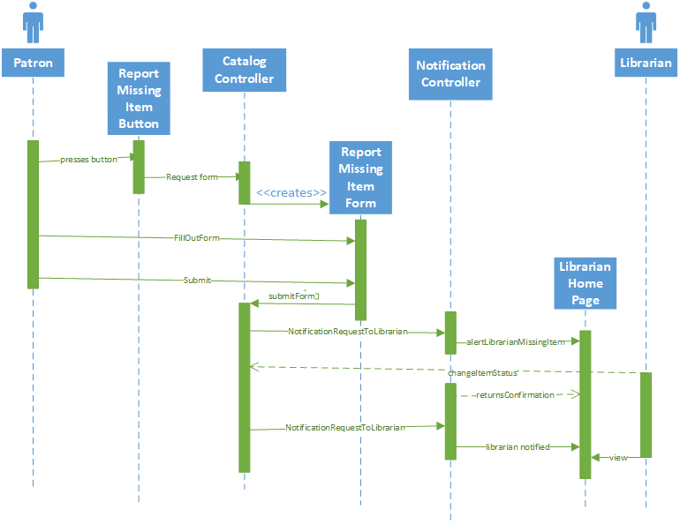Report Missing Item:
9. 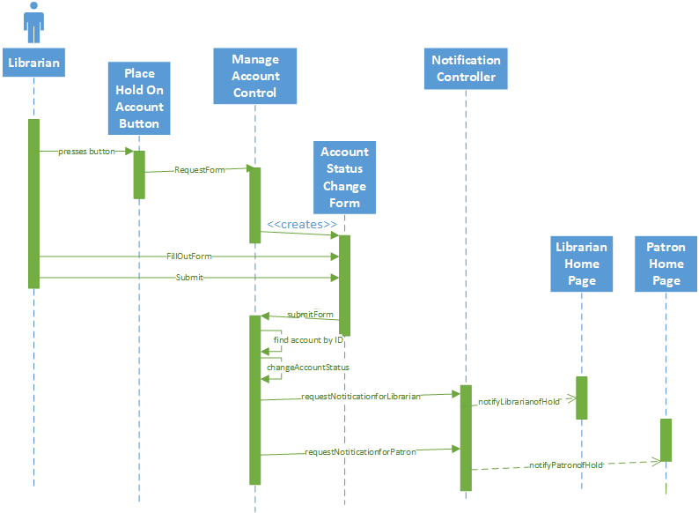Place Hold on Account:
10. 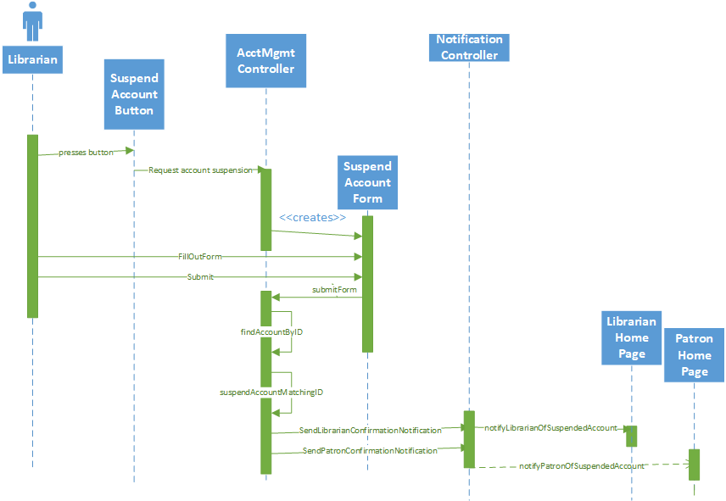Suspend Account:
11. 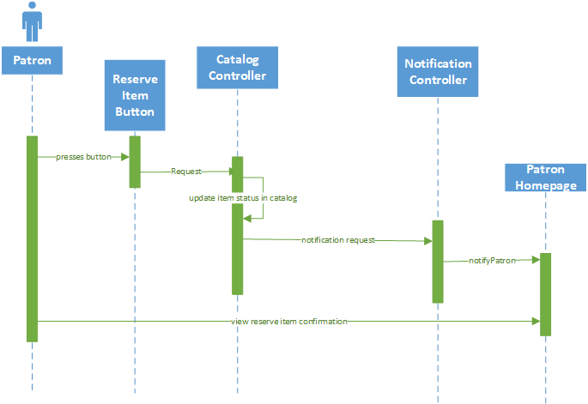Reserve Item
12. 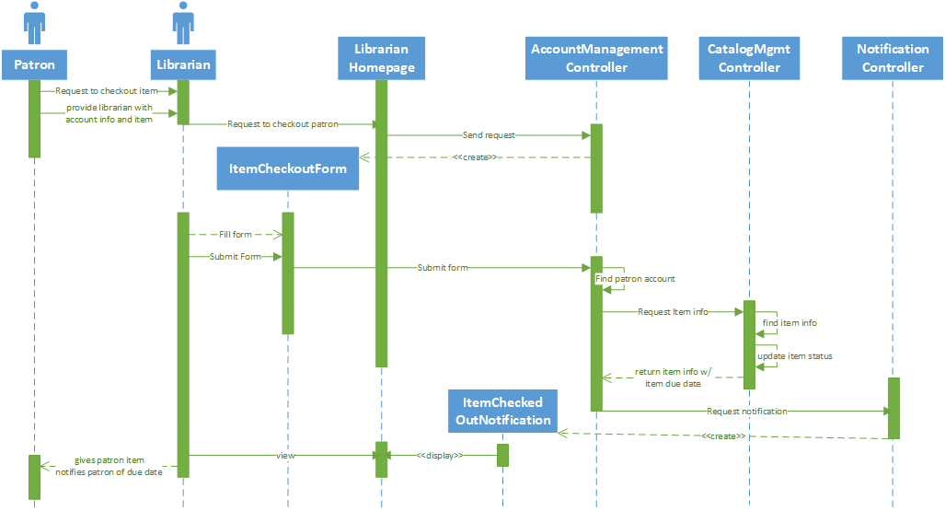Checkout Item

## b. Application Class Model

### i. OCL Constraints

context Item

inv: this.Authors.notEmpty()

context PatronAccount

inv: this.balanceDue >= 0.0

context AccountManagementController

inv: Item.allInstances().contains(this.itemId) &&         Patron.allInstances().contains(this.patronId)

context CatalogManagementController

inv: Items.count >= 0

context AccountManagementController

inv: Accounts.where(account.oclType() == Librarian)

.notEmpty() &&

Accounts.where(account.oclType() == Patron)

.count() >= 0

## c. Application State Model

* + - 1. 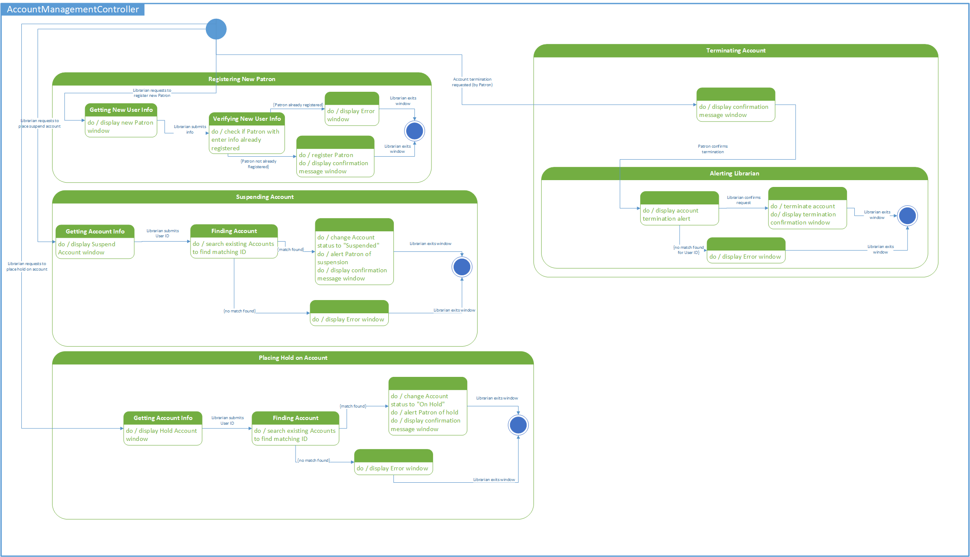**Account Management Controller Application State Model**
    1. 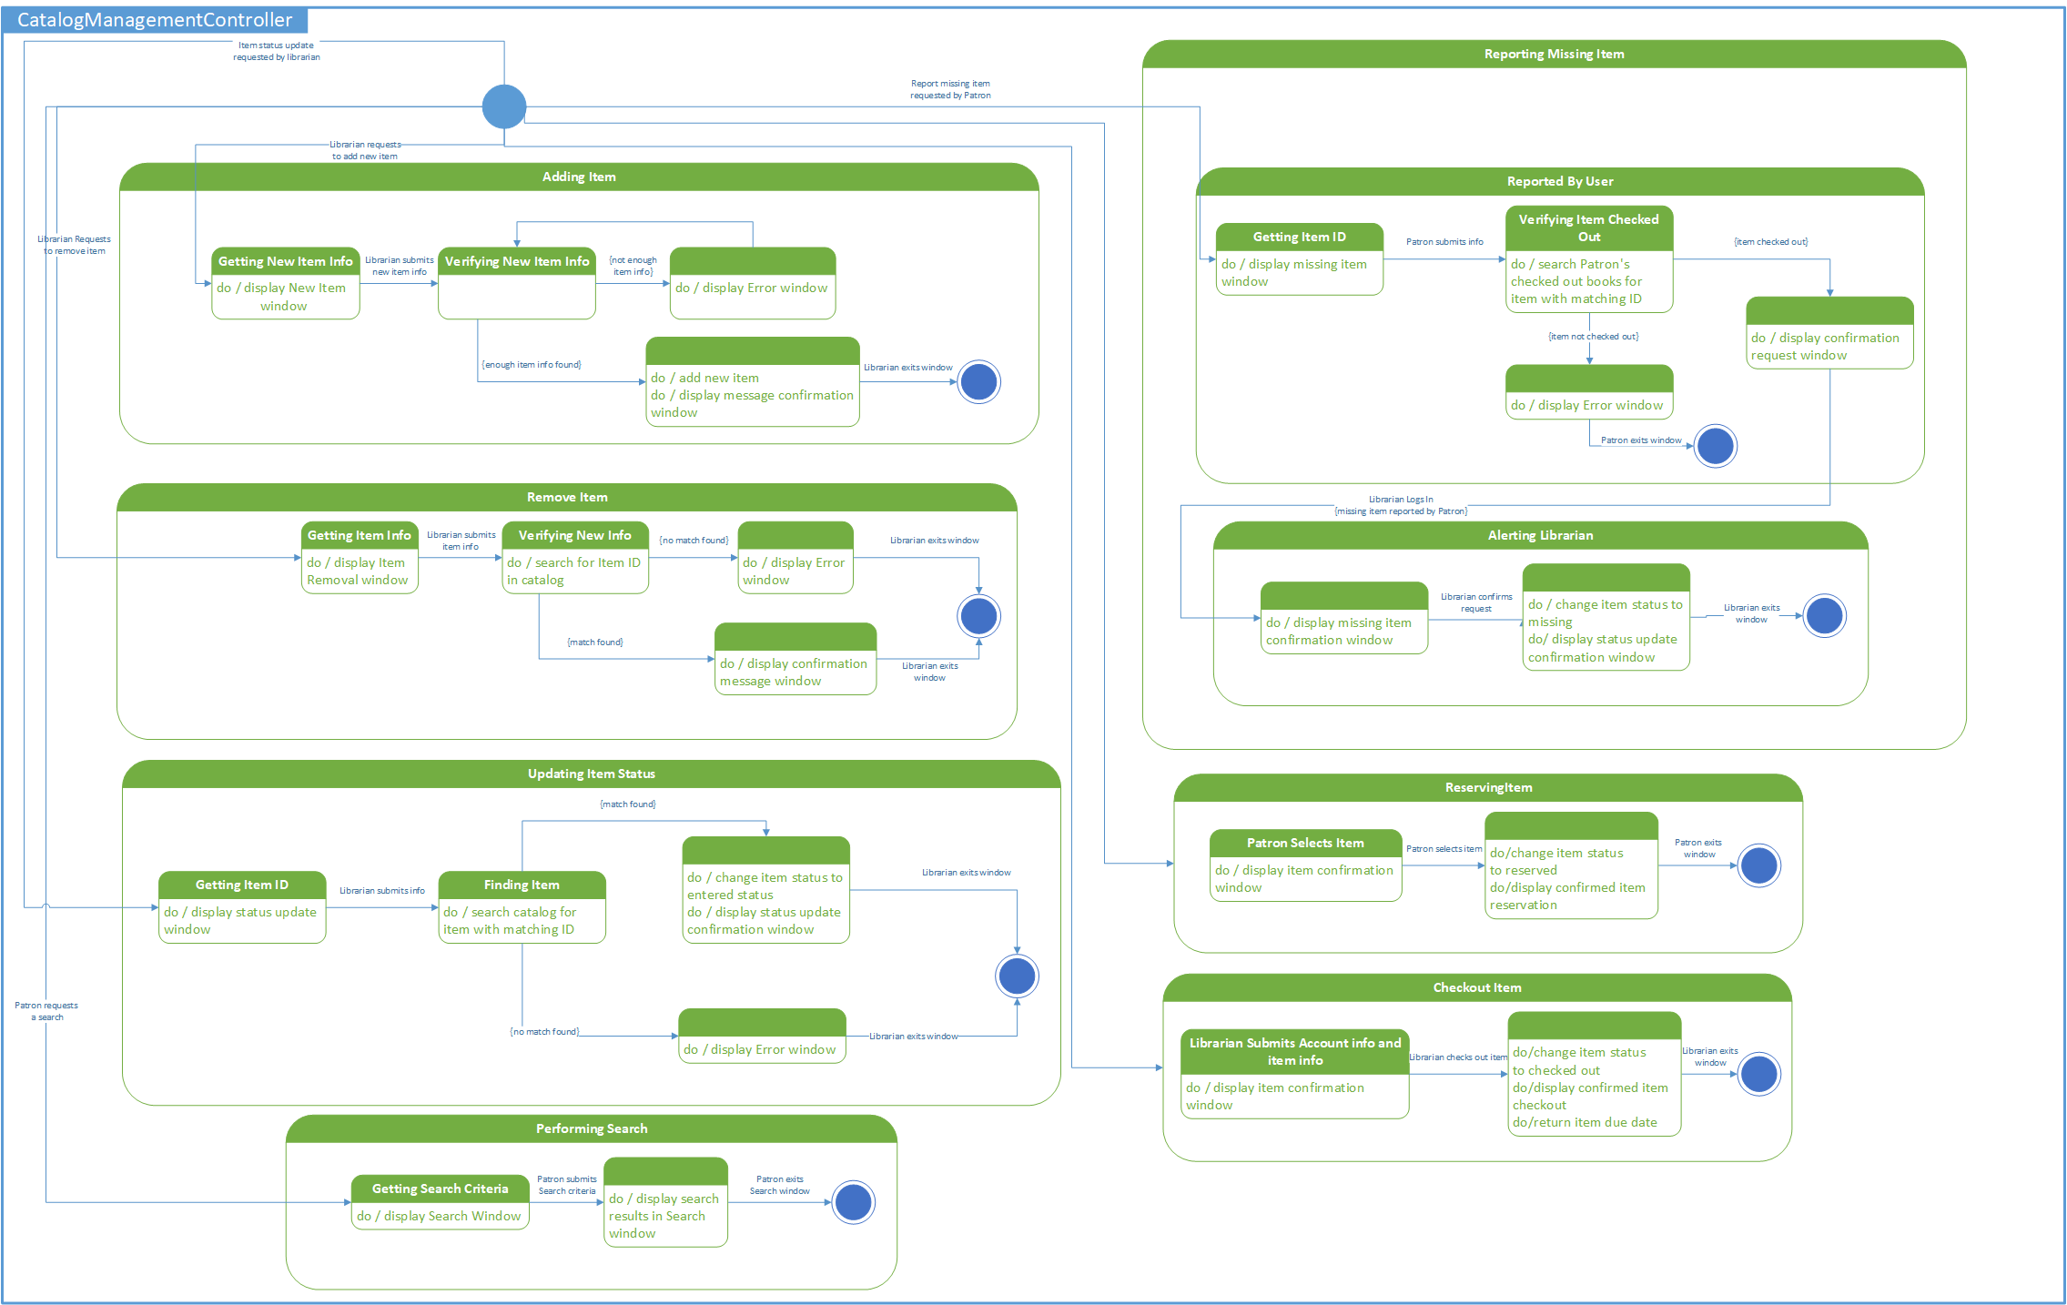**Catalog Management Controller Application State Model**
    2. 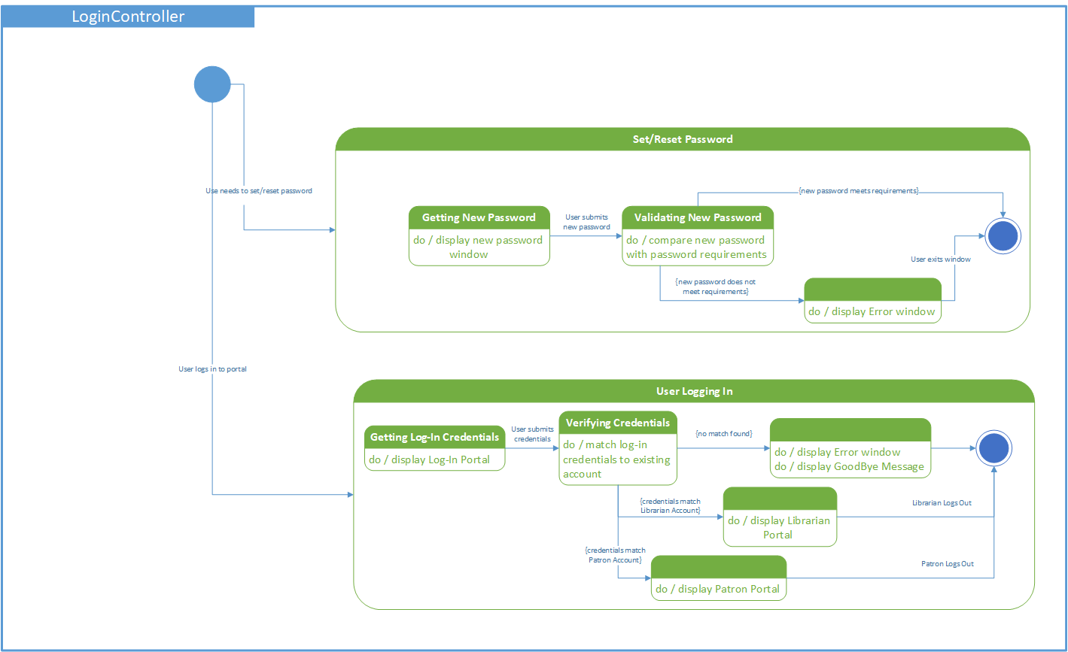Login Controller Application State Model
    3. 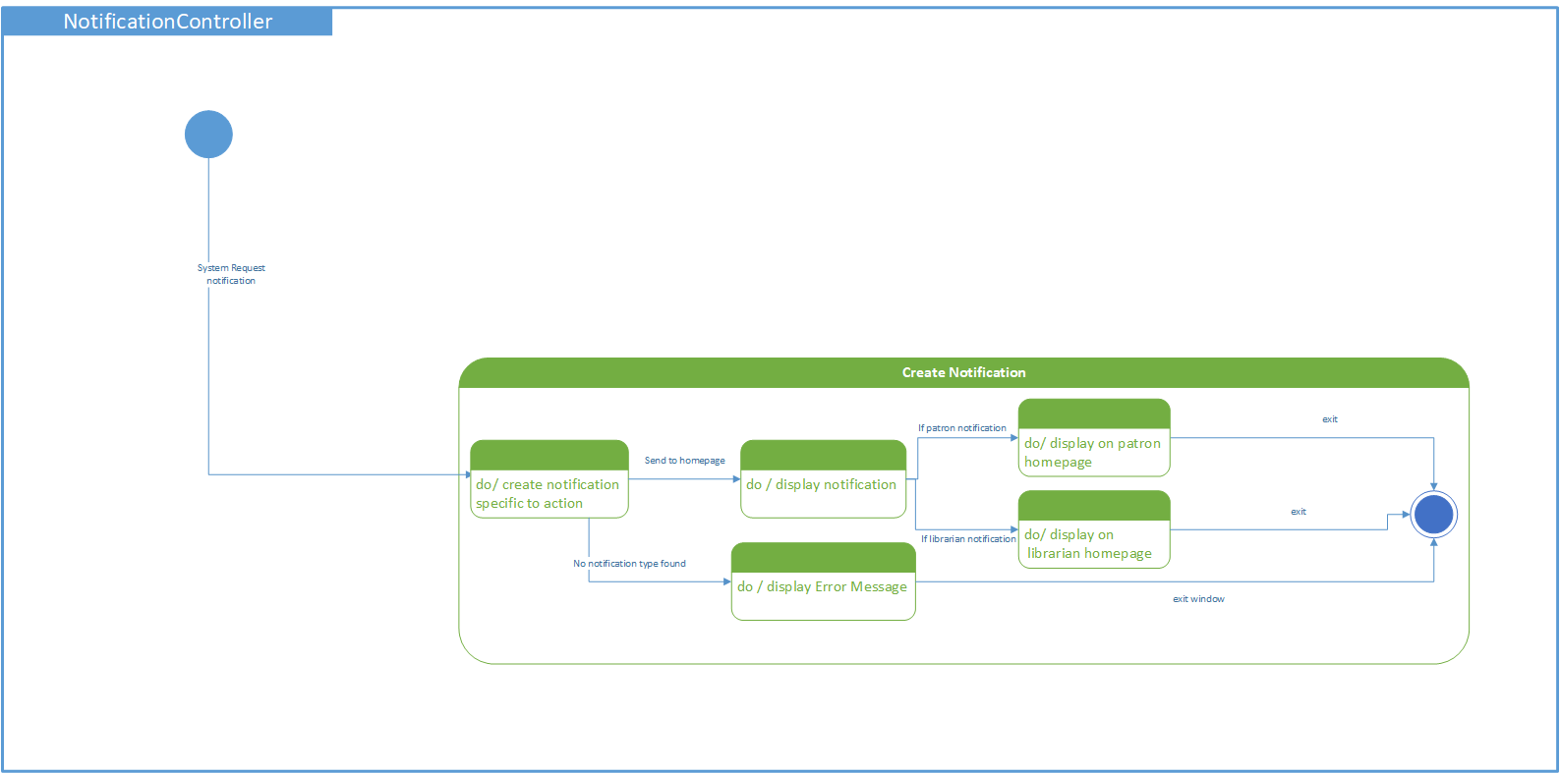Notification Controller Application State Model
    4. 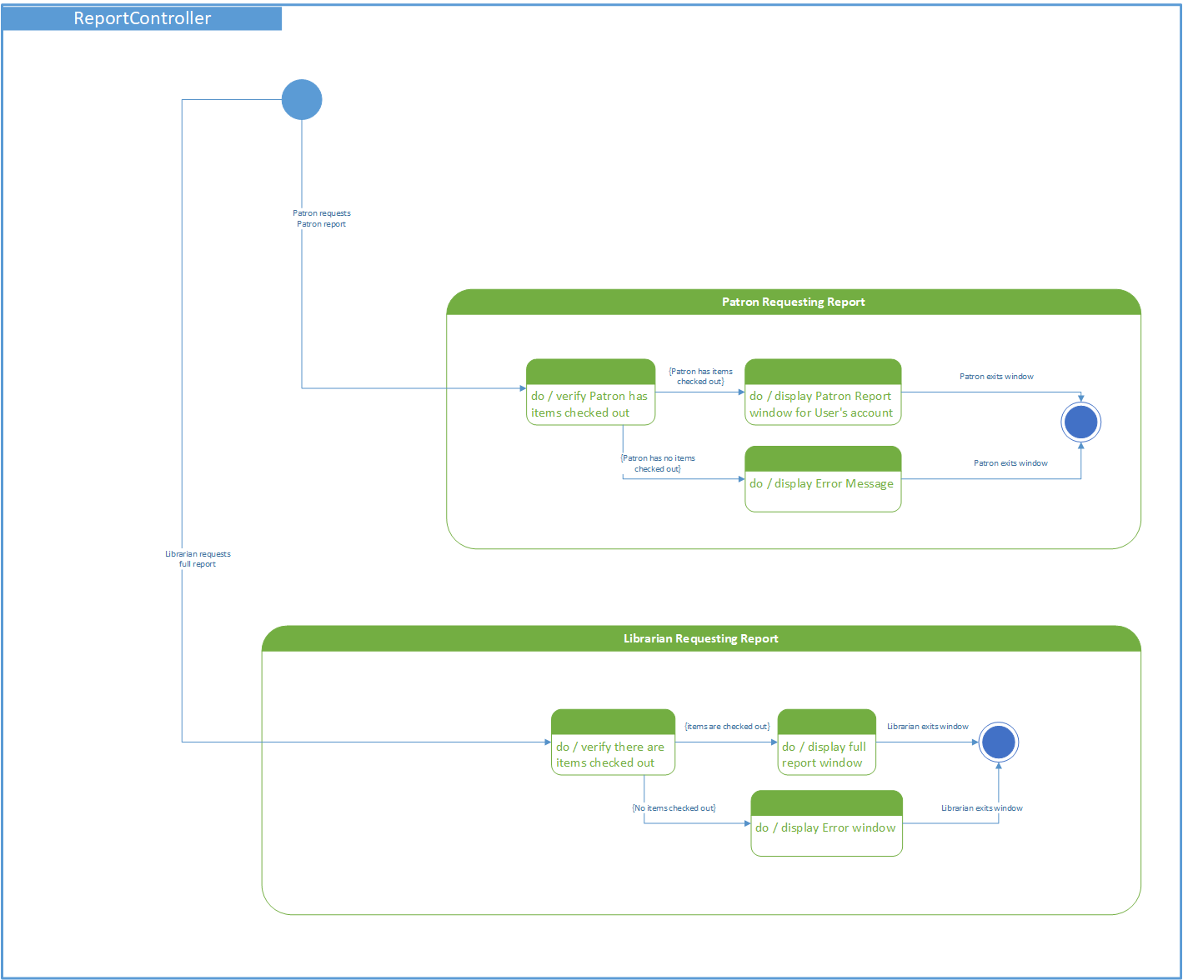Report Controller Application State Model

# 3. Consolidated Class Model

# 4. Model Review

The analysis models for this Library Information System use the United Modeling Language (UML) design process in order to provide a standard way to visualize the layout of the library system. The analysis phase is broken down into two main parts: domain analysis and application analysis. Each part of the analysis phase is broken down further into different UML models such as state diagrams, class diagrams, use case diagrams, concept statements, and OCL constraints.

The first part of the analysis phase is the “Domain Analysis”. This part contains a concept statement, conceptual domain model with OCL constraints, and a domain state model. The domain analysis is concerned with devising a precise, concise, understandable, and correct model of the real world. Domain analysis helps the client and programmer better understand the system that is being built by only looking at the system on a very general level. The concept statement for this project gives a thorough explanation on what the purpose of the Library Information System is, and it describes what the system should do, who can use the system, what each user of the system has the ability to do, and how the system should respond to certain requests. The concept statement’s detailed coverage of the requirements of the system made it easier to construct the models for the domain analysis. The first model constructed is the Conceptual Domain Model. This model was implemented by incorporating the behavior and data of objects (classes) and using UML notation to show the relationships between the objects. Some relationships show inheritance between one object and another object. An example of this would be that once an account has been created for a patron or a librarian, then the patron or librarian inherits the account information. Other relationships include aggregation, composition, and association, all of which also show multiplicity. From the Conceptual Domain Model multiple constraints were stated using Object Constraint Language, OCL. Some constraints include: all library accounts must have an account number that is unique, the authors information for an item must not be empty, and a patron’s balance due most be greater than or equal to zero. Using the Conceptual Domain Model state models were configured for Items and Patron Accounts. A domain state model shows the behavior of an object in response to a series of events in the library system. The domain state model for Item shows that when an item is entered into the system it can then be reserved or checked out by a user. If an item is reserved, then it can be checked out or lost by a user. If an item is checked out then it can be late, lost, or returned to the library in which case it will be marked available again. The state model for Patron Accounts show that once a patron account is created then it will enter an unverified state. From this state the account can go to a suspended state or to a verified state. Once an account has been verified then it can go into an attention needed state if the patron has a late item on the account or the account needs to be updated, or it can go to a suspended state. From the attention needed state an account can go into the unverified state, verified state, or suspended state which means the account is deleted.

The second part of the analysis phase is the “Application Analysis”. This part contains an application interaction model, application class model, and application state model. The application analysis goes into a more in-depth application specific detail level, which shows how an application will function and go into greater details on the features and internal components. The application analysis is broken down into three different parts. The first part is the Application Interaction Model. This model consists of scenarios that could occur within the system. There are thirty different scenarios outlined and a detailed analysis of what happens with each one. From the scenarios essential and concrete use cases were developed, fifteen of the use cases are essential and fifteen are concrete. Essential use cases show how a user interacts with the system on a high-level. Concrete use cases show a user interacts with the system on a lower-level without going into too much specific UI detail. The use cases outline everything from searching for an item in the Library System to adding a user to the system. With each use case presented there is a problem and a solution. The use cases show how the system will handle exceptions with step by step interactions. For each use case, essential and concrete, a System Sequence Diagram was developed. These diagrams show how over time an issue is resolved, and an exception is handled. This is very helpful to give a visual of how the system is interacting with the user. The essential use cases provide the basis to create High-Level System Sequence Diagrams (HSSD) and concrete use cases provide information to create Detailed System Sequence Diagrams (DSSD). The next model created was the Application Class Model. This model shows the user interface, boundary classes, controllers, and entities. A boundary class is the class between a system and a user. This class will protect the system from the external world. A controller is an active object that manages control within an application. The Application Class Model created shows how a user logs into the library system (boundary) and is then sent to the user account (controller) which has information transferred to it from an account entity, patron entity, and librarian entity. There are OCL constraints defined for this class model that go into more depth than the previous domain OCL constraints. The Application Analysis also contains a state diagram for each controller that was defined in the class model diagram. The state diagrams show what state the system is in and its behavior as multiple actions are performed. There are state diagrams for account management, catalog management, and library reporting.

Lastly, the Consolidated Class model was created to combine the Conceptual Domain Model with the more detailed Application Class Model. This model shows how the application interacts with higher-level aspects of the system. Because the Application Class Model is a much more detailed version of the Conceptual Domain Model, a lot of the concepts are combined to simplify the system. Some of the concepts are elaborated on more with the Consolidated Class Model to highlight the significance of them.