How to Change the Beeper Volume on Scanner Models LS1902, LS2208, LS4004, LS4006, LS4008, LS6004, M2004, M2005 or M2007

CRM CATEGORY:
Article Id | : ADC-00048
Last Review | : 02-15-05
Revision | : 0.1
- [Click here to enter the case Type]
- [Click here to enter Case Sub Type]
- [Click here to enter Sub Sub Type]

On this Page:
Symptoms
Cause
Resolution
Action Steps
Applies To

SYMPTOMS:

- Scanner beeper volume is too loud.

CAUSE:

- The beeper volume is defaulted for the highest volume setting.

RESOLUTION:

Beeper volume can be changed to low, medium or high by scanning the appropriate bar code.

ACTION STEPS:

- Scan the bar code that corresponds to the desired beeper volume:

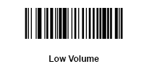

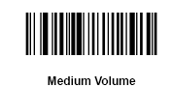

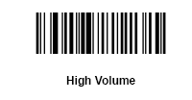

REFERENCES:
Document Name/Location | Description
- [Enter references to other documents] | [Enter reference description]

APPLIES TO:
LS1902, LS2208, LS4004, LS4006, LS4008, LS6004, M2004, M2005, M2007

