Dispatch User Manual
Prepared by Alberta Ingenuity Centre for Machine Learning
October 9, 2010
Document History

Document Date | Author | Description
Sept. 27, 2010 | N. Loyola | Initial version.
Oct. 9, 2010 | N. Loyola | Changes after software changes resulting from user feedback.

Table of Contents
Document History 2
1 Introduction 5
2 Configure Site for Sending Dispatches 6
3 Sending a Dispatch 8
4 Receiving a Dispatch 12
5 Dispatches with Missing Aliquots 16
6 Dispatch with Extra Aliquots 17

Illustration Index

Introduction
The Dispatch feature is used to record the shipping of a set of patient sample aliquots between two repository sites where all the patients and aliquots belong to a single study. Aliquots from multiple patients may be included in a dispatch.
To use the dispatch feature in BioBank2 the two sites and the study involved must first be configured. See section 2 for instructions.
Prior to sending the dispatch, the administrator of the sending site must create a Dispatch entry that records the aliquots that are part of the shipment. After the entry is created and the shipment is ready to be sent, the administrator must mark the entry as Sent. At this point BioBank2 displays the shipment entry as In Transit. See section 4 for instructions.
Sites that wish to send dispatches can only send aliquots that have been scan assigned to container positions. Aliquots without a position are not allowed in a dispatch.
When receiving a dispatch, a technician with the appropriate role must Receive and Process the dispatch entry in BioBank2. Only entries marked as In Transit can be received and processed. A technician has the option of only marking an entry as received and then process it at a later time. Processing of a dispatch entry involves confirming that the aliquots recorded as sent are actually received. See section 5 for instructions.
The following errors can happen when sending a dispatch:
- The shipment never arrives at the destination site.
- One or more aliquots marked as sent are not actually received at the receiving site,
- One or more aliquots never marked as sent are received at the receiving site.
Please see sections 6, 7 and 8 for instructions on how to deal with these cases.
If a repository site no longer sends dispatches, the instructions to remove the dispatche information is given in section 3.

Configure Site for Sending Dispatches
- Log into the BioBank2 Java Client as a user in the Website Administrator group.
- From the Administration view, edit the site that is to send dispatches.
- Click on Add Dispatch Relation.
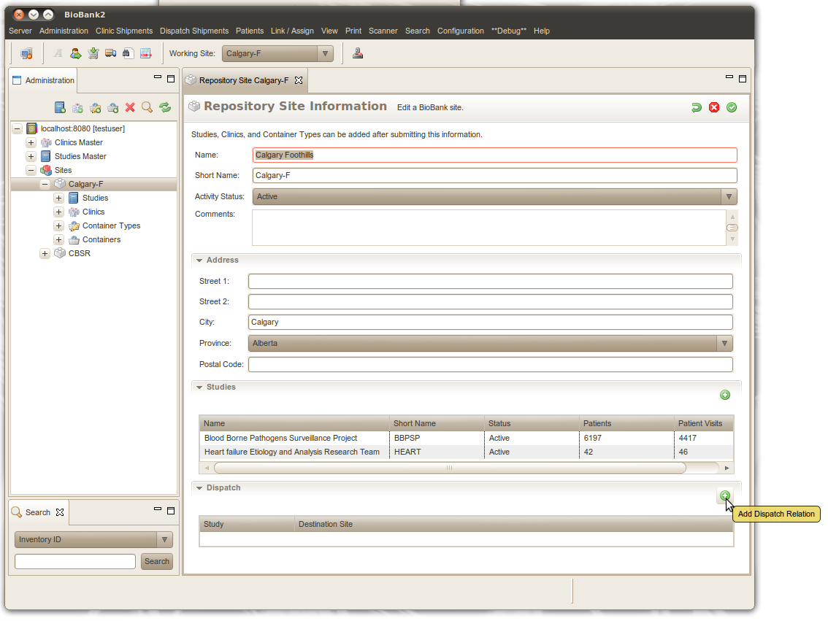
- From the dialog box the pops up, select the study associated with the site and the destination site for the shipments.
- Press OK.
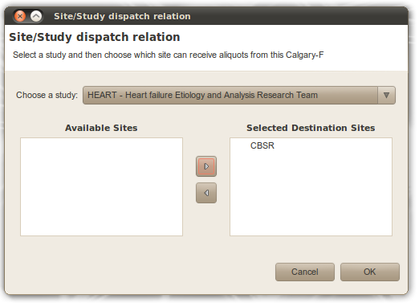
- If there are more studies that dispatch from this site go to step 3.

Configure a Site to No Longer Send Dispatches
*** To be completed ***

Sending a Dispatch
- Log into BioBank2 Java Client as a user in the Website Administrator group (which user groups should be allowed to create dispatch?).
- In the Working Site pull down, select the site that is to send the dispatch.
- Using the main menu or the toolbar icon select Dispatch view.
- Select Add Dispatch from the Dispatch Shipments sub menu or from the toolbar icon.
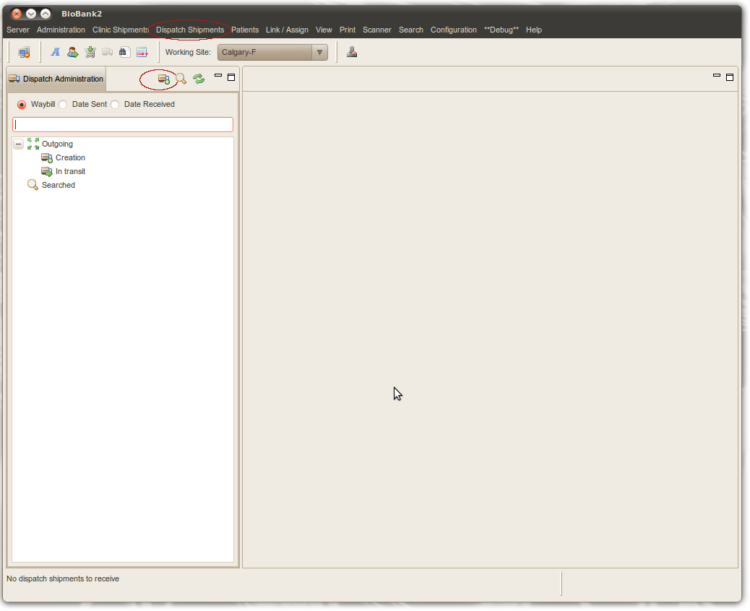

- Select the study and receiver site the dispatch aliquots are for. If there is a single study and / or a single receiver site they will be already selected.
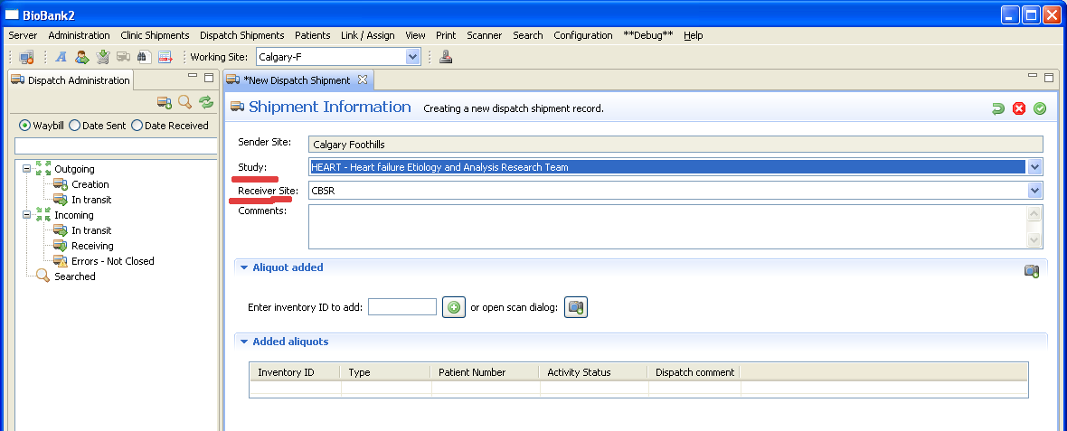

- In the form click on the open scan dialog button to scan assign aliquots into the dispatch.
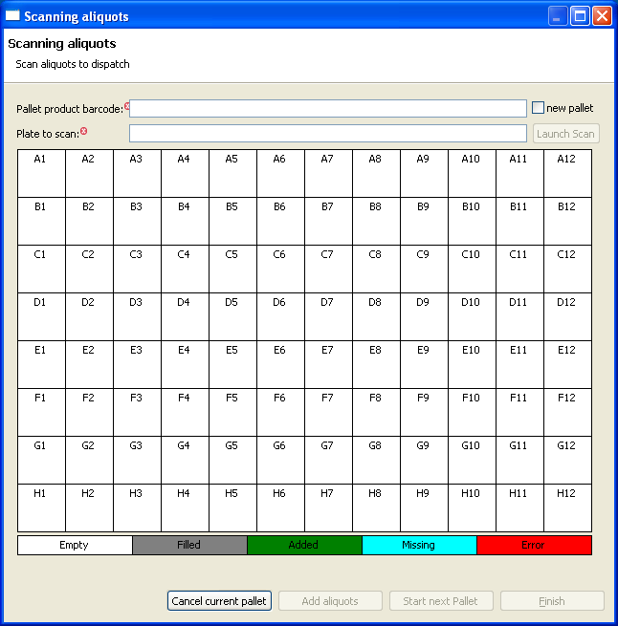

- Enter the pallet's product barcode or “new pallet”, then the plate number for where the pallet has been placed on the flatbed scanner and then press the Launch Scan button.
- If some of the tubes were not decoded by the scanner, press “Retry scan” to attempt to decode another time.
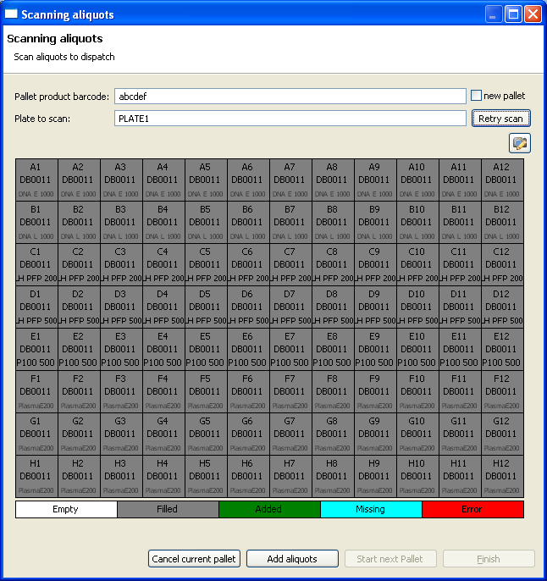
- If a pallet product barcode was entered and an aliquot reported as missing after the scanning is complete, then **** give explanation here of what to do ***
- After the scan is complete press the Add aliquots button.
- If more pallets are to be added, press Start next Pallet.
- Once all pallets have been added press Finish to close the dialog box.
- Press confirm on the Shipment Information entry form to finish entering the dispatch.
- If more aliquots should be added to the shipment press the Edit button and go to step 4.
- If the dispatch is ready to ship, press the Send button to have the dispatch enter the In Transit state.
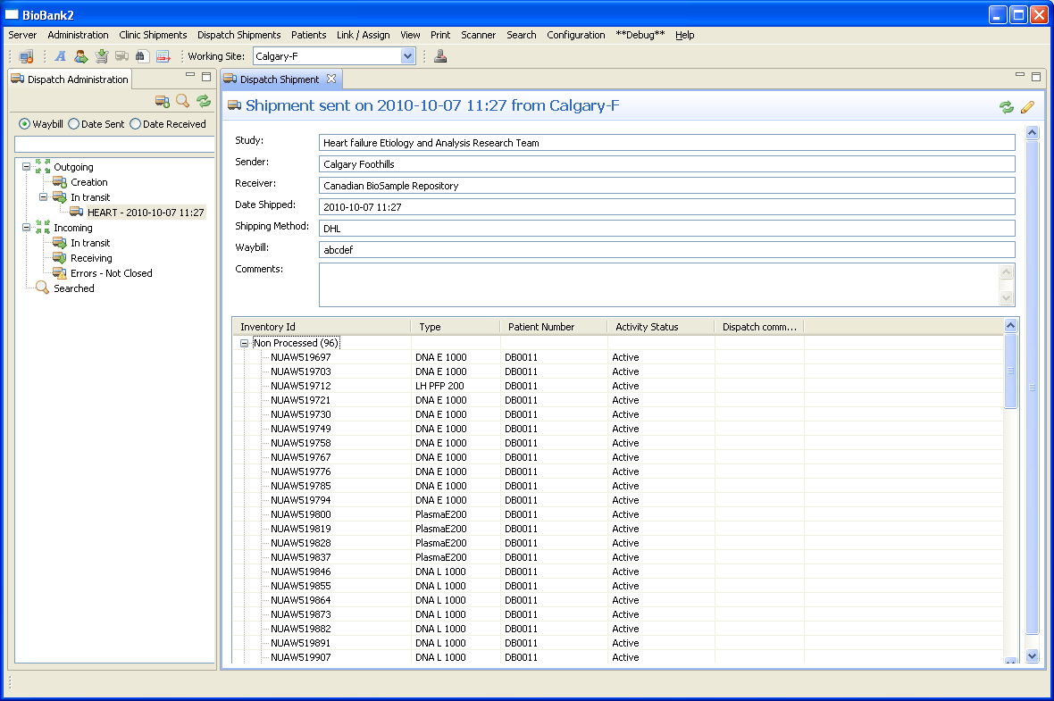

- In the dialog box that pops up, enter the shipping method, the waybill number if applicable, and the date shipped if different from the default value.
- Now the shipment is ready to be received by the receiving site.
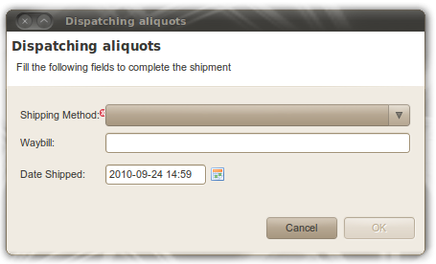

Receiving a Dispatch
This section discusses how to process a dispatch that does not have errors. If the dispatch has errors see sections 6, 7 and 8.
- Log into BioBank2 Java Client as a user in the Website Administrator group (which user groups should be allowed to create dispatches?).
- In the Working Site pull down, select the site that is to receive the dispatch.
- Select Dispatch view from the View sub menu in the main menu or with the toolbar icon.
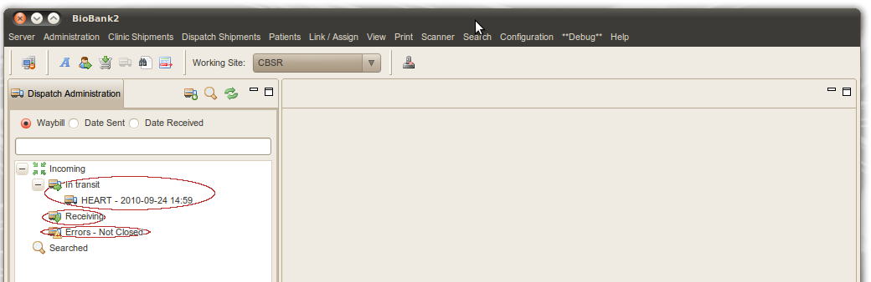
- In the tree view the user is presented with:
  - The dispatch shipments that are in transit to the selected working site.
  - The dispatches that are in Received state, which means the ones that are currently being processed.
  - The dispatches that have errors associated with them.
- A dispatch can have the following actions applied to it: Receive or Receive and Process. Received means that the shipment will be removed from the In Transit list and moved to the Receiving list. Receive and Process means that in addition to Receive the user will also scan assign the dispatch.
- To Receive a shipment that is in transit, the user has two options:
  - Right click on it and select Receive.
  - double click on it and from the form that is displayed press the Receive button.
- To Receive and Process a shipment that is in transit the user can:
  - Right click on it and select Receive and Process.
  - double click on it and from the new form that is displayed press the Receive and Process button.
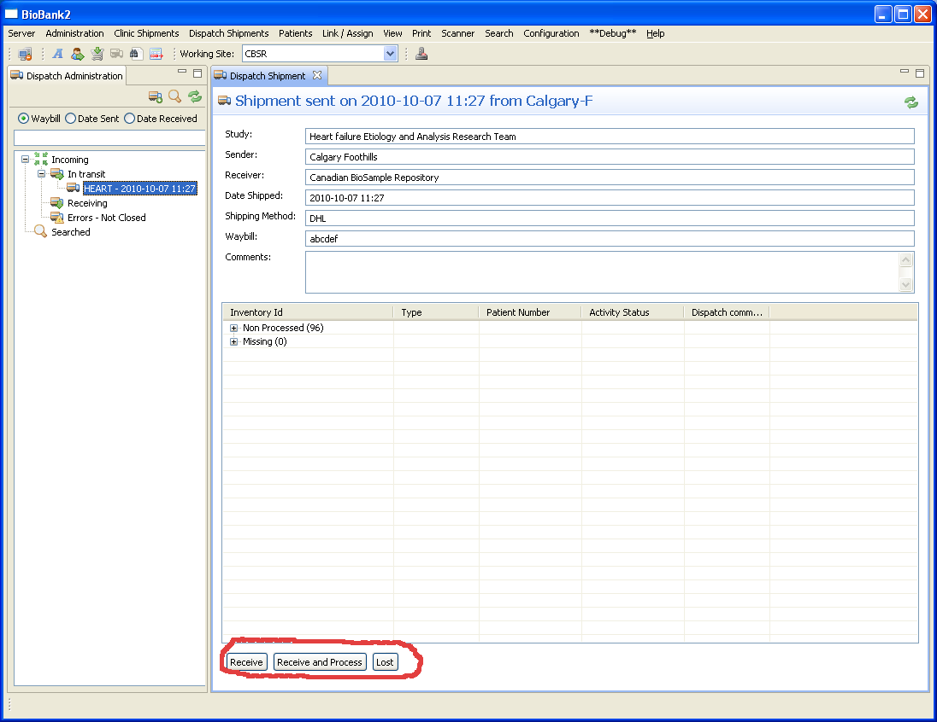

- Once a dispatch has been received, it's aliquots can be accepted. Two options are available: the flatbed scanner can be used to accept multiple aliquots at the same time, or individual aliquots can be entered using the hand held 2D bar code scanner.
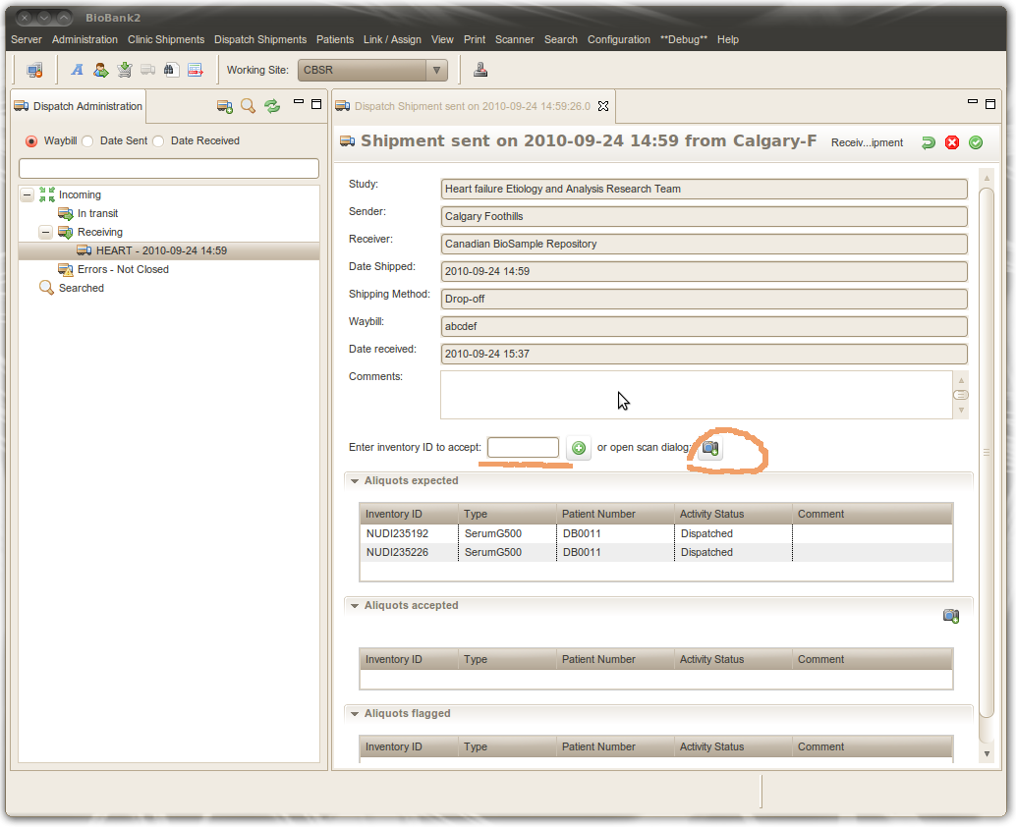

- If using the flatbed scanner, the press the scan dialog button.
- Enter the plate number for where the pallet has been placed on the flatbed scanner and then press the Launch Scan button.
- If, after the scan is complete, some of the tubes did not scan, the hand held 2D barcode scanner can be used to scan the missed tubes (similar to the way done in Scan Link and Scan Assign).
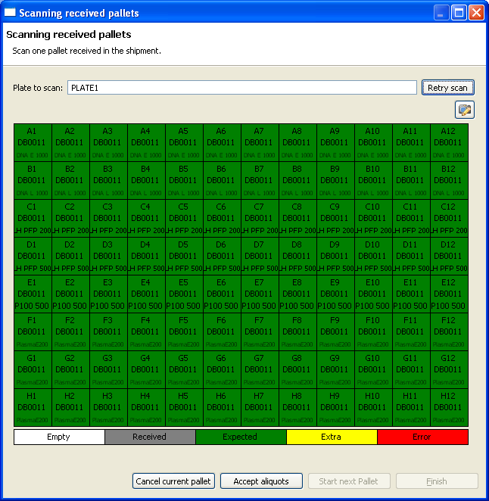
- Once the scan is complete, press the Accept aliquots button.
- Press “Finish” when all the pallets have been scanned.
- To use the hand held scanner, first click on the “Inventory ID” text box and then scan the aliquot.
- If there are no errors and all aliquots have been scanned, press the Confirm button. Once the button is pressed the dispatch view form is displayed.

- To close the dispatch press the Close button. The dispatch is no longer displayed in the tree. However, closed dispatches can be searched for by using the waybill number, date sent or date received.
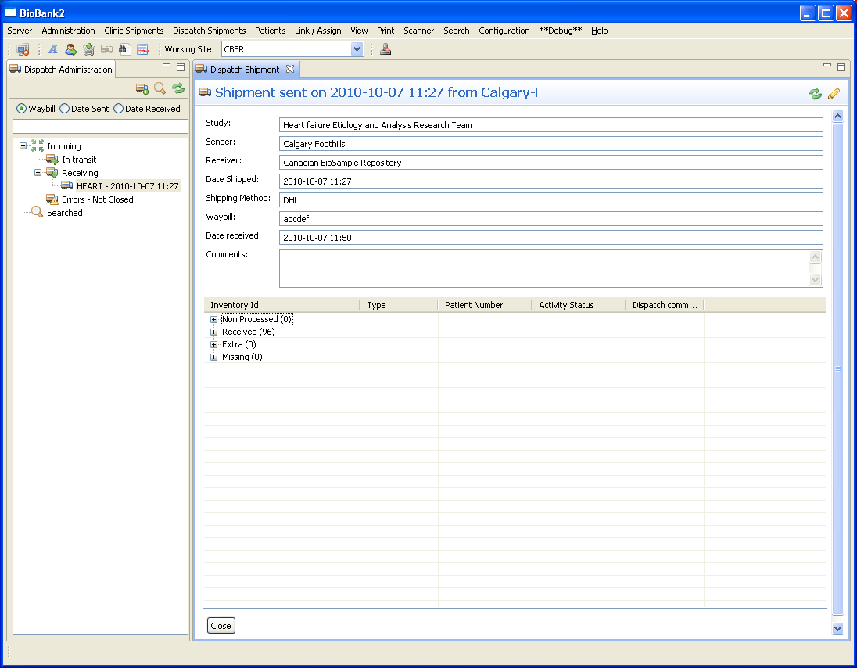

Dispatch Never Arrives at Destination Site
- Repeat steps 1 to 3 in Section 5.
- In the tree view, double click or the dispatch that was lost. You can also right click on the lost shipment and select View Dispatch Shipment.
- From the dispatch entry form that opens up click on the Lost button to mark the shipment as lost.
- The aliquots that were attached to the dispatch will now have their activity status set to Closed and will no longer have a position. Note that the aliquots still belong to the sending site.
You can expand the aliquots in the Non Processed node and double click on an aliquot to display the aliquot view form.

Dispatches with Missing Aliquots
- Perform steps 1 through 13 in section 5.
- In the table showing the aliquots, expand the “Non Processed” node in the aliquot table.
- Right click on the aliquot that is missing and select “Set as missing”.
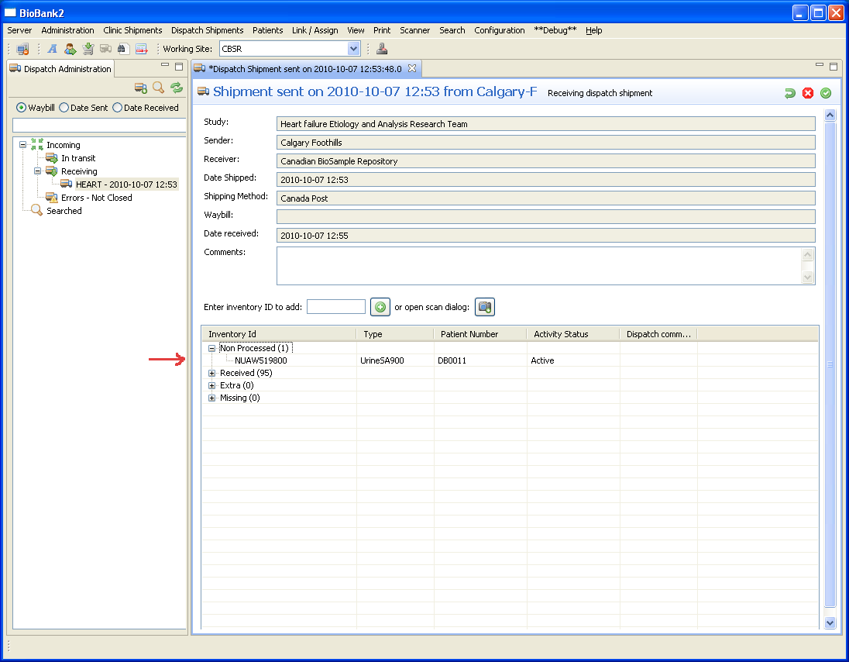
- In the dialog box that pops up enter an appropriate comment as to why the aliquot is being marked as missing. For example, “Never Received”, “Still at sending site”.

- The aliquot is now displayed in the “Missing” node of the table.
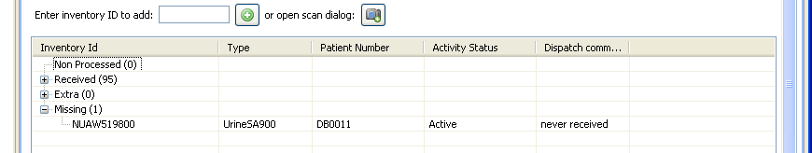
- If there are more aliquots to mark as missing got to step 2.
- Press the Confirm button to save the state of the dispatch.

Dispatch with Extra Aliquots
*** Needs to be completed ***
- Perform steps 1 through 10 in section 4 Receiving a Dispatch Shipment.
- If an aliquot is found that is not part of the dispatch entry, the following dialog box will be displayed:
- Press OK to have the aliquot's Activity Status set to Flagged.
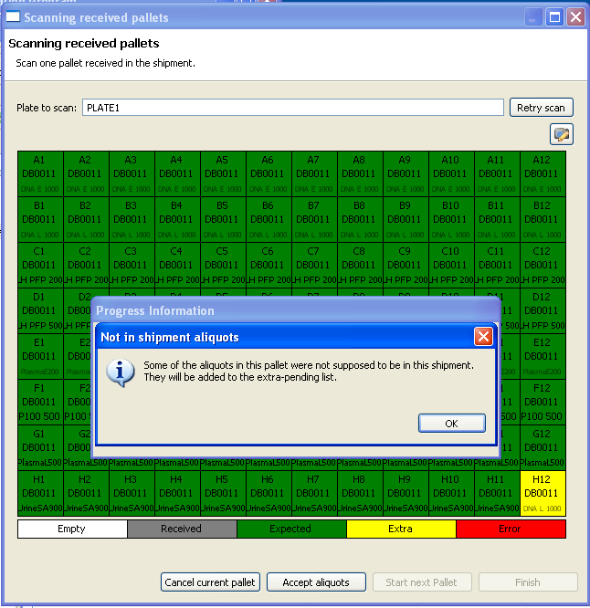
- The aliquot will now be shown in the Aliquots Flagged table in the dispatch entry form.
