BioBank 2

Architecture Guide
Prepared by Alberta Ingenuity Centre for Machine Learning
January 12, 2009
Document History
Document Date | Author | Description
January 11, 2009 | N. Loyola | Initial version.

Table of Contents
Document History 2
1 Introduction 5
2 Software Requirements 5
3 Software Packages 5
4 User Roles 5
5 Architecture 6
5.1 N-Tier System 6
5.1.1 Persistence Tier 7
5.1.2 Application Service Tier 7
5.1.3 Security Interception Tier 7
5.1.4 Client Interface Tier 7
5.1.5 Security Filters 7
5.2 Logging / Audit Trail Management 7
6 Domain Object Model 8
6.1 Site 8
6.2 Study 9
6.3 Clinic 10
6.4 Patient 11
6.5 Sample 12
6.6 StorageType 13
6.7 StorageContainer 14
6.8 User 15
7 Java Client 16
Appendix A – References 17
Appendix B – Software Repository Information 18
Appendix C - Instructions for Running caCORE SDK 19

Illustration Index
Illustration 1: Site Class Diagram 8
Illustration 2: Study Class Diagram 9
Illustration 3: Clinic Class Diagram 10
Illustration 4: Patient Class Diagram 11
Illustration 5: Sample Class Diagram 12
Illustration 6: StorageType Class Diagram 13
Illustration 7: StorageContainer Class Diagram 14
Illustration 8: User Class Diagram 15

Introduction
The BioBank 2 software package allows for tracking the receipt, processing and storage of biological samples. The samples belong to patients participating in a study associated with the Canadian Biosample Repository at the Faculty of Medicine at the University of Alberta.
BioBank 2 is is designed to participate in the National Cancer Institute's (NCI) caBIG (cancer Biomedical Informatics Grid) information network. The network allows researchers, clinitians and patients to share data and knowledge to accelerate the discovery of new diagnostics and theraputics, and improve patient outcomes.

Software Requirements
BioBank 2 requires the following software:
Software Package | Version | Notes
Windows | XP / Vista | Operating System
Linux | Ubuntu 8.10 or higher | Operating System
JBoss | 4.0.5 | Application Server
JDK | 1.5 | Java
MySQL | 5.0.67 | Database Server
Mozilla Firefox | 3.0 | Web Browser

Software Packages
The application is made up the following software packages:
- Database running on dedicated or shared server.
- Web application running on a JBoss Application Server (web server and database server can run on same machine)
- Java Client that accesses the web application.

User Roles
The application supports the following user roles:
- Scientist: searches for biospecimens
- Technician: Manipulates biospecimens in the bank
- Supervisor: Accessions new participants / biospecimens
- Administrator: Defines protocols and storage containers

Architecture
The BioBank 2 sofware package is comprised of an n-tiered architeture with client interfaces, server components, backend objects, data sources and additional backend systems.
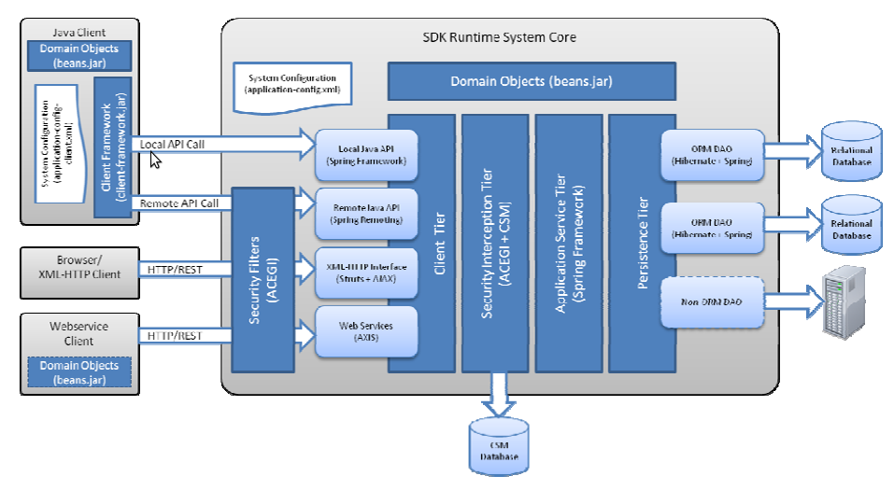
This n-tiered system divides tasks or requests among different servers and data stores. This isolates the client from the details of how or from where data is retrieved. The system also provides security, logging and auditing capabilities.
There are two applications on the client side that can be used to perform operations on the server side: the Java client and a web browser.

N-Tier System
The system can be viewed as a typical n-tier architecture where each tier in the system is responsible for a set of defined activities. The layers, starting from the lowest layer, are as follows:
- Persistence Tier
- Application Service Tier
- Security Interception Tier
- Client Interface Tier
- Security Filters

Persistence Tier
This tier is responsible for understanding the query that has been requested and fetching the results from the data store. The tier is implemented as an object-relational mapping (ORM) based persistence tier that uses Hibernate (www.hibernate.org). With the aid of caCORE SDK, objects are mapped to the relational database with the aid of Hibernate. Hibernate maps these objects to the database with the use of ORM files which are generated by caCORE SDK from the data model.

Application Service Tier
This tier consolidates incoming requests from the various interfaces and forwards them to the appropriate persistence tier implementation. The Application Service tier is the main tier that facilitates the operations within the system and the Java client.

Security Interception Tier
This tier ensures that only authorized users are allowed acces to the system. This tier is implemented with Acegi (www.acegisecurity.org) and the Common Security Module (CSM) developed by NCI CBIIT.

Client Interface Tier
The two distinct client interface methods to access the Application Service tier are:
- XML-HTTP Interface (web browse)
- Remote Java API Client
Ech of these methods of retrieving data involves preparing the query in the format that the interface understands, sending the request to the corresponding interface, and retrieving the results from the interface to which the query was submitted. The following sections provide details about system usage for each method.

Security Filters
The security filters are HTTP servlet filters configured through Acegi (www.acegisecurity.org).

Logging / Audit Trail Management
CaCORE provides the capability to configure the generation of logging and audit trail records to a database (see Chapter 7 in [2]). The BioBank 2 application uses this feature to log user activity.

Domain Object Model
This section describes the objects that make up the BioBank 2 application. These objects reside on the server and can be accessed with the Java client or a web browser.

Site
The Site object stores infomation about a BioBank site. A site represents the collection of samples and containters at an individual location.
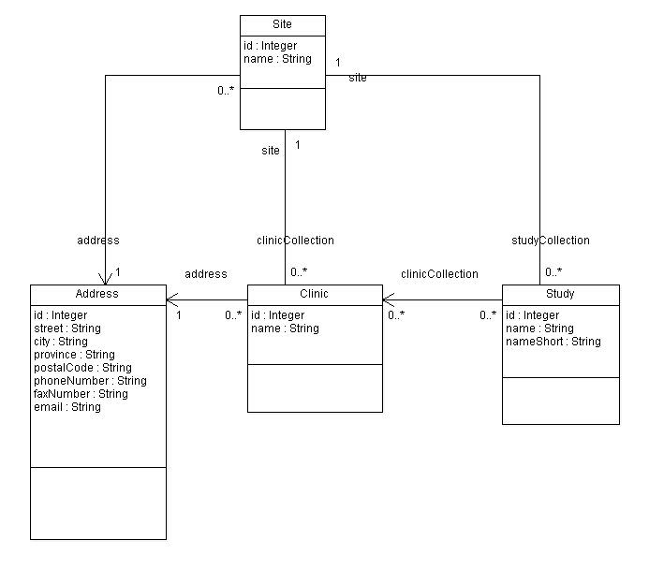Illustration 1: Site Class Diagram
The figure shows that the studyCollection attribute contains the studies that have been defined for the site. Likewise, the clinicCollection attribute contains the clinics associated with the site. The site also has an address (with telephone number and email address).
The BioBank application can store information for one or more sites.

Study
The Study object is used to store information about a specific study. The name attribute stores the study's full name. The short name stores the string used in tabular reports.
The class diagram shows that a study object is associated with every patient that has been added to the study. A workflow worksheet, in PDF or another document format, can be attached to a study. The sdataCollection association allows the administrator to define the information that is collected with a particular study. For example: when a patient visit is recorded, the information stored as part of the patient visit is the selection of associated clinic, and the selection of the associated aliquot volumes, etc.
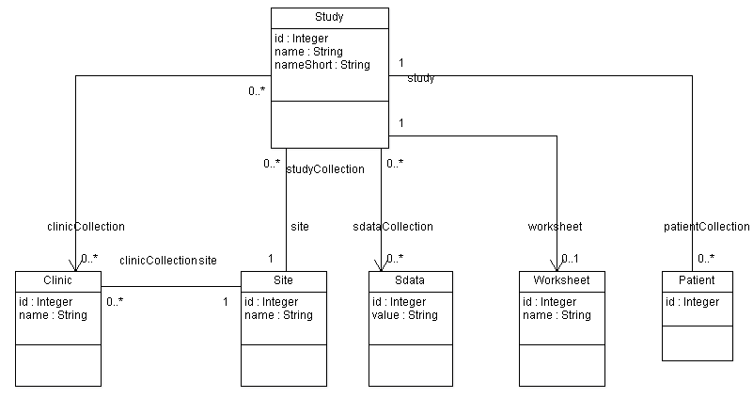Illustration 2: Study Class Diagram

Clinic
The Clinic object stores relevant information for a clinic.
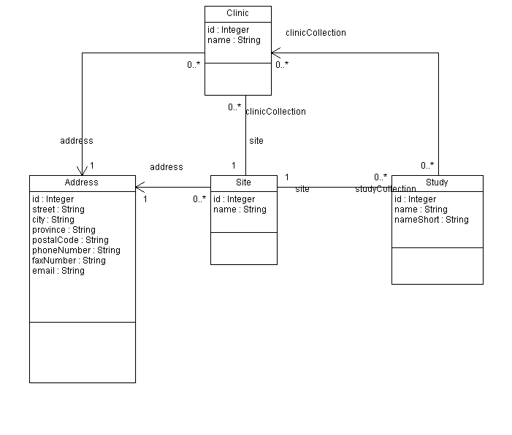Illustration 3: Clinic Class Diagram
The Clinic object has an address that stores the physical address as well as telephone and email address.

Patient
The Patient class stores information about an individual patient.
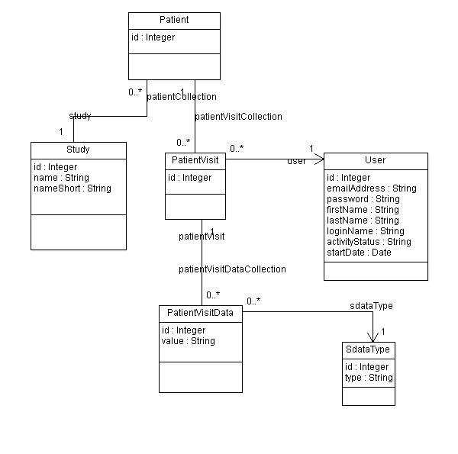Illustration 4: Patient Class Diagram
The diagram shows that a Patient object is associated with one or more PatientVisit objects. The patient visit information is stored in a collection of PatientVisitData objects and correspond to the information that is configured for a particular study type.
The PatientVisit object is associated with the User object to record the user (usually the technician) that recorded the patient visit in the system.

Sample
The Sample class stores the information for a biological specimen.
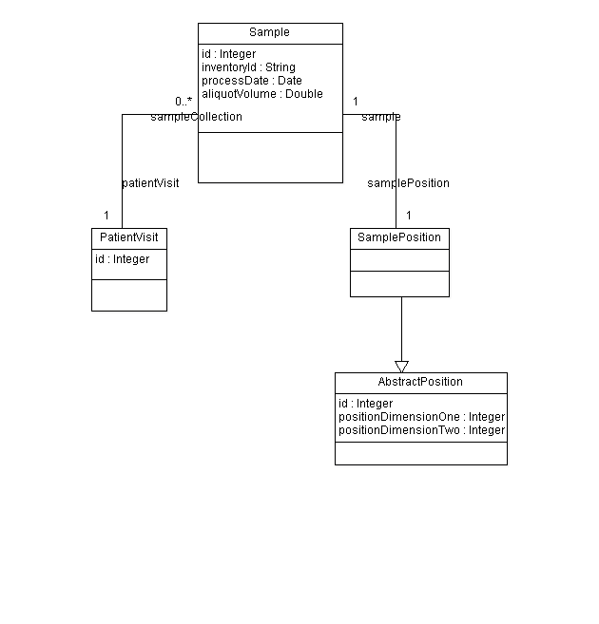Illustration 5: Sample Class Diagram

The patient visit associated with the sample can be accessed withe the patientVisit association. The position of the sample in a container is specified in a SamplePosition object.

StorageType
The StorageType object allows users to define different types of containers. The design allows for a storage type to contain other storage types.
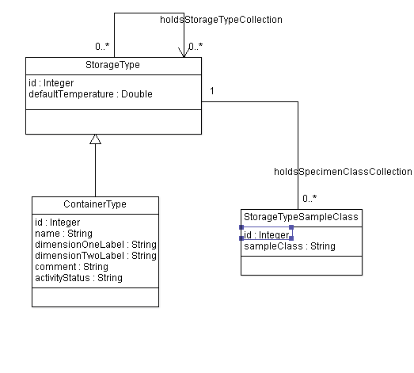Illustration 6: StorageType Class Diagram

This class allows the administrator to define storage containers of different types and how containers are associated. For example: a sample is stored in a freezer box, which is stored in a freezer rack, which is then stored in a particular freezer.
Also the sample types that a containter type may contain can also be configured.
The capacity of a container is defined in two dimensions.

StorageContainer
The StorageContainer class is used to define the containers used at a particular site. With the use of StorageType the site administrator can define all the storage containers used at a particular Bio Bank.
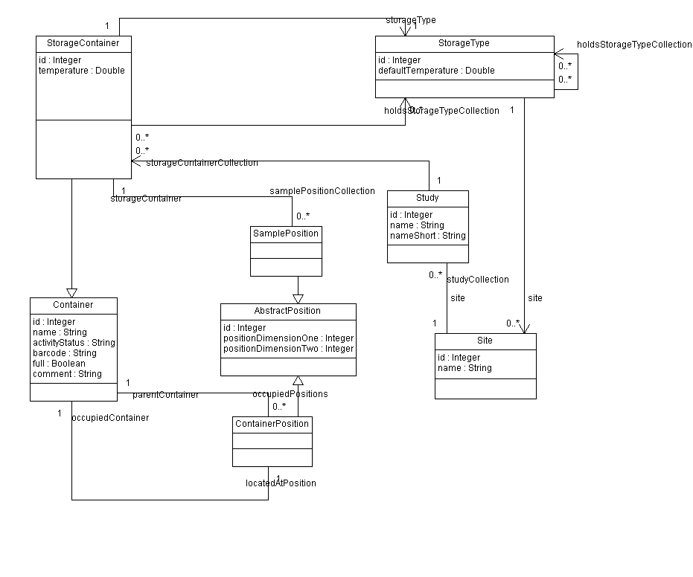Illustration 7: StorageContainer Class Diagram
When defining storage containers, the administrator can define the containers types ans sample types that can be contained within.

User
The User object stores information about the user that is accessing the system.
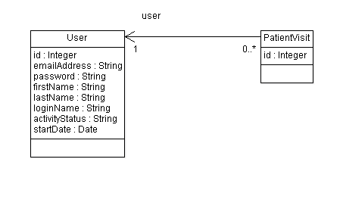Illustration 8: User Class Diagram

Java Client
The Java Client is an Eclipse Rich Client Platform application that utilizes the BioBank 2 web application to configure and store BioBank information.
The Java Client uses the Java API created by caCORE SDK on the object model.
The client software allows the use of a scanner to read the barcode on vials and associate the barcode information to samples.
More details will be provided in the next version of the document.

Appendix A – References
[1] Jason Badry, Bsc, I.S.P. “BBPDB Software Specification”. September 4, 2008.
[2] National Cancer Institute. “caCORE Software Developer Kit (SDK) Version 4.1 – Programmer's Guide”. November 14, 2008.
[3] caTissue Suite V 1.1 – Technical Administration Guide.

Appendix B – Software Repository Information
The source code for the BioBank 2 application is stored in a software repository. The sofware repository uses Git, a free distributed revision control system (http://git-scm.com/).
The URL for this repository is:
- ssh://aicmltec@kingman.cs.ualberta.ca/compsci/abee/cshome/aicmltec/GitRepository/biobank2.git
An ssh key is required to access the repository. Please contact AICML to be allowed access to the repository.

*** The repository will be made freely available in the future.

Appendix C - Instructions for Running caCORE SDK
To build model with caCORE SDK:
- download caCORE SDK from here:
http://ncicb.nci.nih.gov/infrastructure/cacoresdk
- move file to <proj_dir>/caCORE
- uncompress file in <proj_dir>/caCORE/sdk
- move <proj_dir>/deploy.properties to <proj_dir>/caCORE/sdk/conf
- change <proj_dir>/caCORE/sdk/conf/deploy.properties to suit your system. In particular the following variables:
    - DB_CONNECTION_URL
    - DB_USERNAME
    - DB_PASSWORD
    - DB_DRIVER
    - DB_DIALECT
- in directory <proj_dir>/caCORE/sdk issue command: ant build-system
- to generate database schema: cd to <proj_dir>/schema and run ant
- copy <proj_dir>/caCORE/sdk/output/biobank2/package/webapp/biobank2.war to $JBOSS_HOME/server/default/deploy
- copy <proj_dir>/caCORE/sdk/output/biobank2/build/jar/biobank2-beans.jar to <projdir>/eclipse_ws/biobank2/lib

MySQL Server
- my.cnf must have "lower_case_table_names=1" assigned.

