Dispatch Demo
Prepared by Alberta Ingenuity Centre for Machine Learning
September 27, 2010
Document History
Document Date | Author | Description
11/01/09 |  |  |  | N. Loyola

Table of Contents
Document History 2
1 Configure Site for Sending Dispatches 5
2 Sending a Dispatch Shipment 7
3 Receiving a Dispatch Shipment 10

Illustration Index

Configure Site for Sending Dispatches
- Log into the BioBank2 Java Client as a user in the Website Administrator group.
- From the “Administration” view, edit the site that is to send dispatches.
- Click on “Add Dispatch Relation”.
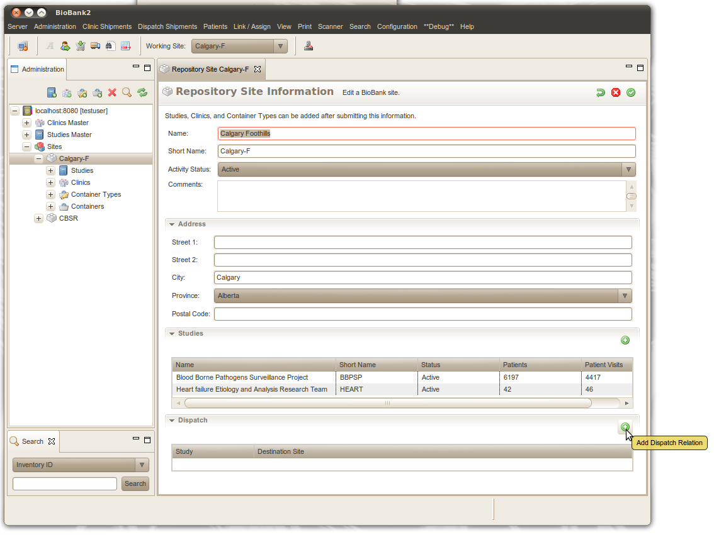
- From the dialog box the pops up, select the study associated with the site and the destination site for the shipments.
- Press OK.
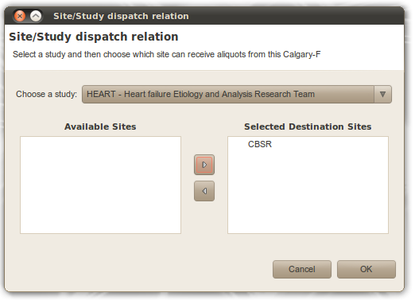
- If there are more studies that dispatch from this site go to step 3.

Sending a Dispatch Shipment
- Log into BioBank2 Java Client as a user in the Website Administrator group (which user groups should be allowed to create dispatch shipments?).
- In the “Working Site” pull down select the site that is to send the dispatch shipment.
- Select “Dispatch Shipment” view from the “View” sub menu in the main menu or with the toolbar icon.
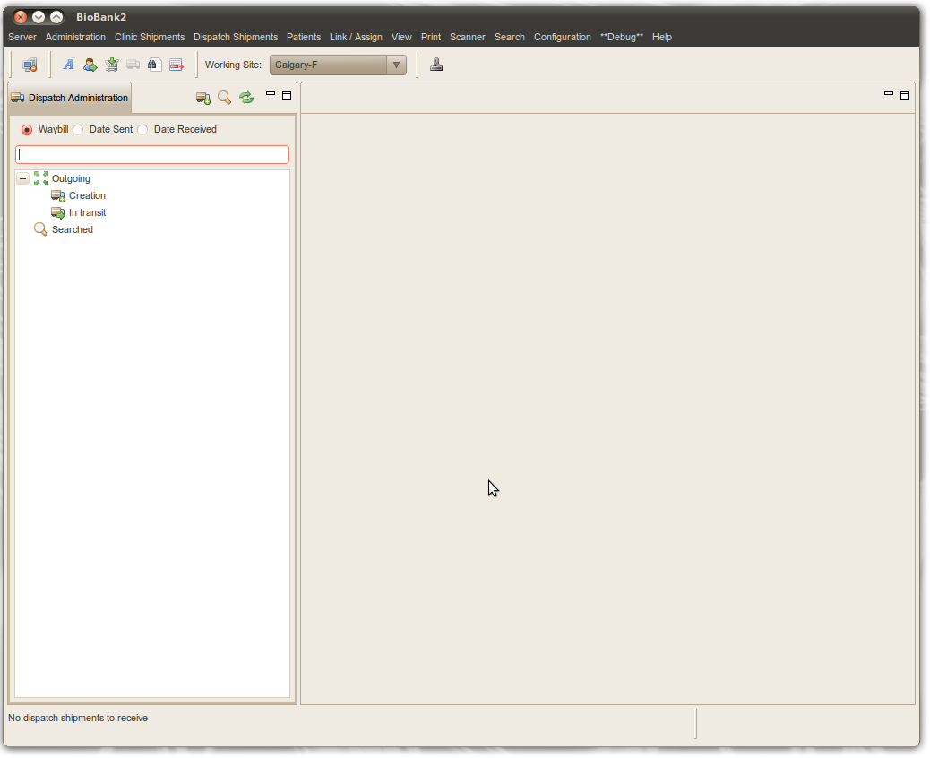
- Select “Add Dispatch Shipment” from the “Dispatch Shipments” sub menu or from the toolbar icon.

- In the form click on the “open scan dialog” button to scan assign aliquots into the dispatch shipment.
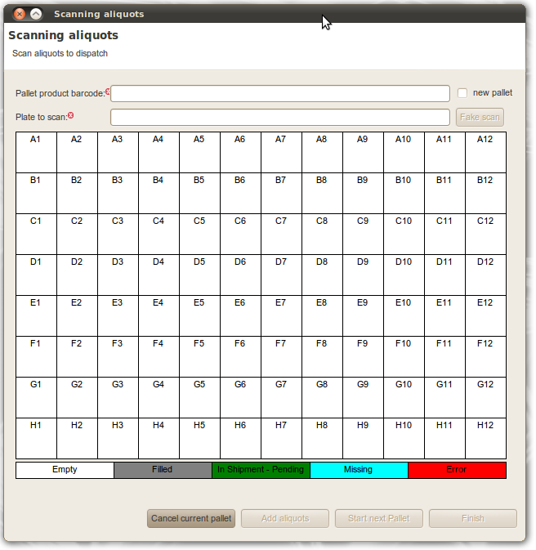
- If more pallets are to be added, press “Start next Pallet”.
- Once all pallets have been added press “Finish” to close the dialog box.
- Press confirm on the “Shipment Information” entry form to finish entering the dispatch shipment.
- If more aliquots should be added to the shipment press the “Edit” button and go to step 4.
- If the dispatch shipment is ready press the “Send” button to have the shipment enter the “In Transit” state.
- In the dialog box that pops up, enter the shipping method, the waybill number if applicable, and the date shipped if different from the default value.
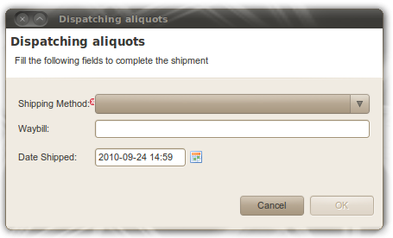
- Now the shipment is ready to be received by the receiving site.

Receiving a Dispatch Shipment
- Log into BioBank2 Java Client as a user in the Website Administrator group (which user groups should be allowed to create dispatch shipments?).
- In the “Working Site” pull down, select the site that is to receive the dispatch shipment.
- Select “Dispatch Shipment” view from the “View” sub menu in the main menu or with the toolbar icon.
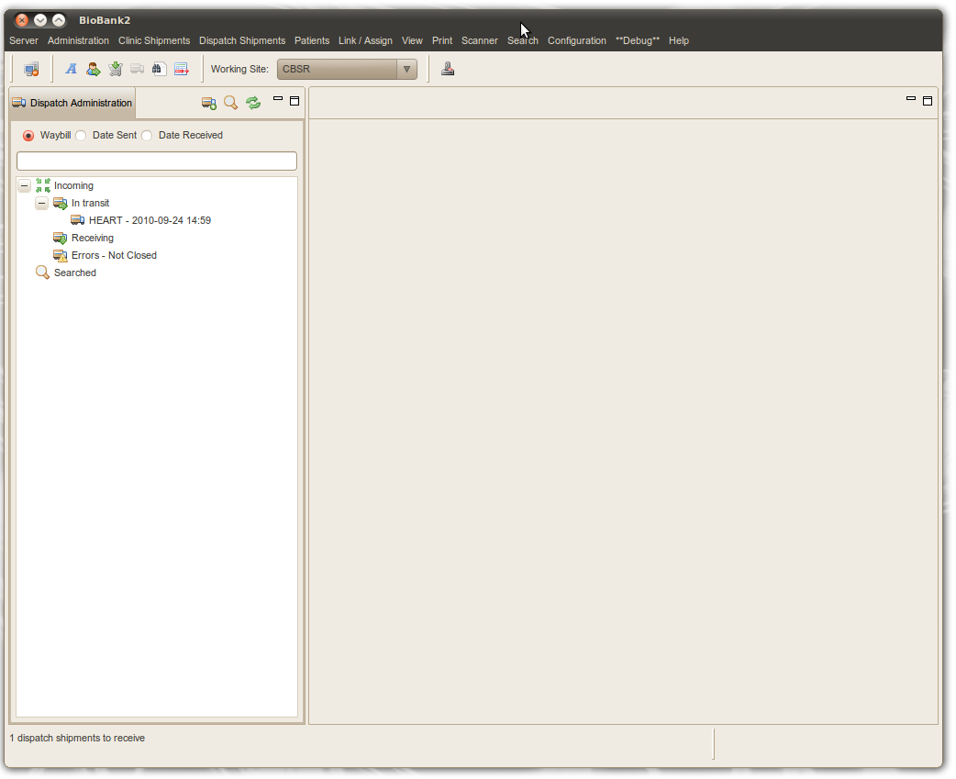
- In the tree view the user is presented with:
  - The dispatch shipments that are in transit to the selected working site.
  - The dispatch shipments that are in “Received” state, which means the ones that are currently being processed.
  - The dispatch shipments that have errors associated with them.
- A dispatch shipment can have the following actions applied to it: “Receive” or “Receive and Process”. Received means that the shipment will be removed from the “In Transit” list and moved to the “Receiving” list. Receive and Process means that in addition to Receive the user will also scan assign the dispatch shipment.
- To Receive a shipment that is in transit, the user has two options:
  - Right click on it and select “Receive”
  - double click on it and from the form that is displayed press the “Receive” button.
- To Receive and Process a shipment that is in transit the user can:
  - Right click on it and select “Receive and Process”
  - double click on it and from the form that is displayed press the “Receive and Process” button.
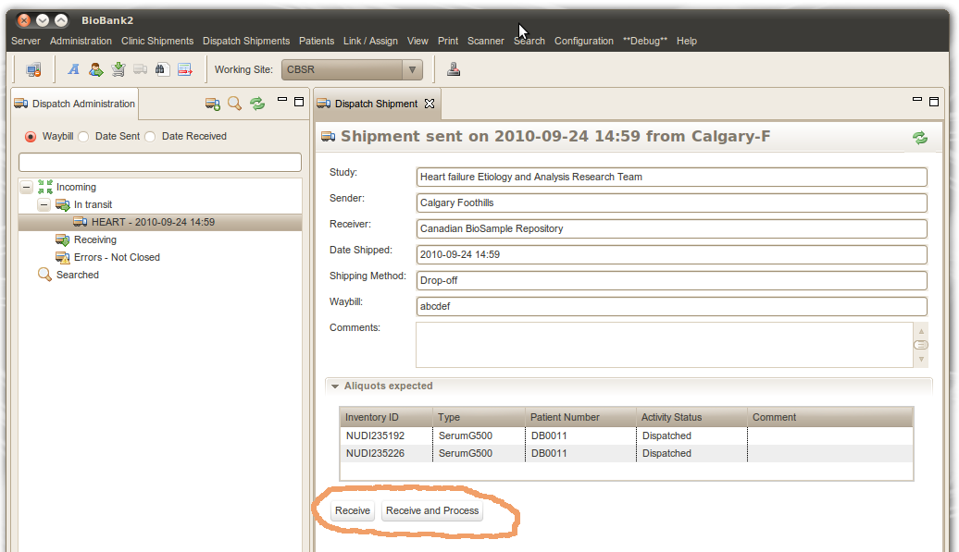

- Once a dispatch shipment has been received, it's aliquots can be accepted. Two options are available: the flatbed scanner can be used to accept multiple aliquots at the same time, or individual aliquots can be entered using the hand held 2D bar code scanner.
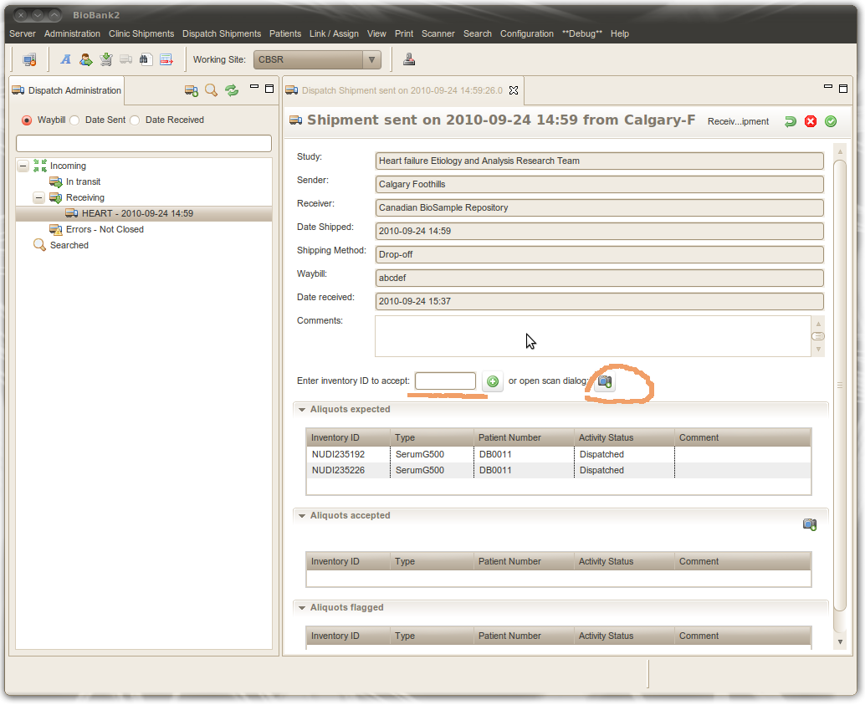

- If using the flatbed scanner, the press the “scan dialog” button.

- To use the hand held scanner, first click on the “Inventory ID” text box and then scan the aliquot.
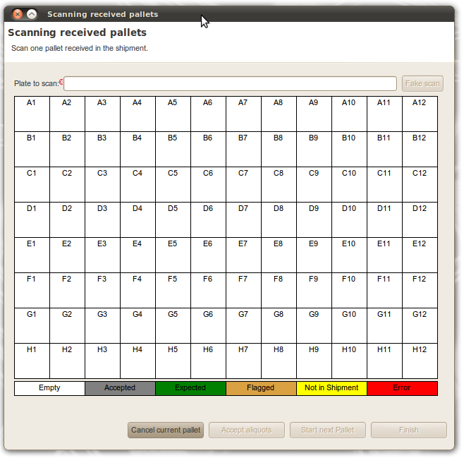
- If there are no errors and all aliquots have been scanned, press the “Confirm” button. Once the button is pressed the dispatch shipment view form is displayed.
- To close the dispatch shipment press the “Close” button. The dispatch shipment is no longer displayed in the tree. However, closed dispatch shipments can be searched for by using the waybill number, date sent or date recevied.

