z/OS Stand Alone Utilities (ZZSA)

The ZZSA utility is an open source tool that is available for IPL in an emergency to make updates to system datasets if the system is not able to IPL completely due to a typographical error in a key system dataset (e.g. PARMLIB or PROCLIB). The capabilities are minimal but adequate and while the interface isn’t robust, it does somewhat mirror those found in ISPF.

A test version of ZZSA is available on the L drive and can be used to experiment and learn how to use ZZSA before it is required in an emergency.

This test environment uses the open source Hercules z system emulator to run a emulated z environment under which ZZSA is IPL’d.

Credit to:

1. Sam Golob for putting together this package – http://www.cbttape.org
2. The authors and contributors of the Hercules emulator - <http://www.hercules-390.org/>
3. Jan Jaegger for the ZZSA stand alone utilities - <http://www.cbttape.org/~jjaeger/>

To use open the Windows command window and change to the L drive. Then change to the SysProgTeam\Doc\zzsa directory.

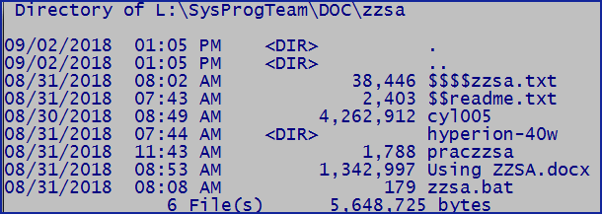

Within this directory are several files:

$$$$zzsa.txt is the user documentation for how to use ZZSA

$$readme.txt explains how to use it in this test environment.

cyl005 is a small 5 cylinder 3390 that contains a single dataset – PRACTICE.ZZSA which is a PDS with several system members for use. This 3390 also has the ZZSA utility installed as IPLTEXT so that it can be IPL’d and used.

hyperion-40w is the release of Hercules that will be used

praczzsa is the Hercules parameter files

zzsa.bat is used to run the practice environment

After getting into the directory enter zzsa.bat to begin:

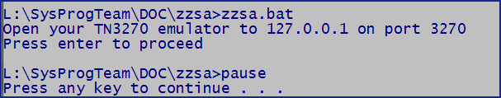

You will need to create a new TN3270 session that points to 127.0.01 and port 3270. No other configuration changes are needed – no security is required.

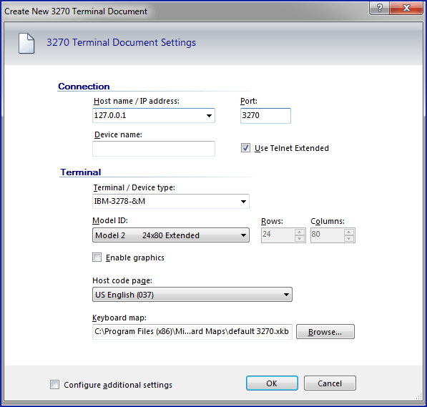

Press enter once your TN3270 emulator is ready – it won’t connect yet as the system has not been IPL’d.

After pressing enter you will see the Hercules system console:

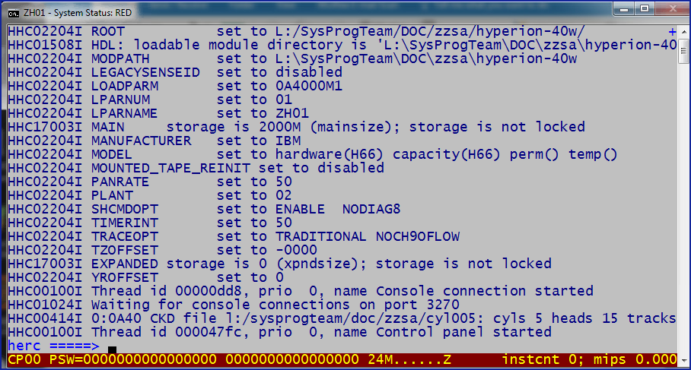

At this point you can connect (or start) your TN3270 emulator:

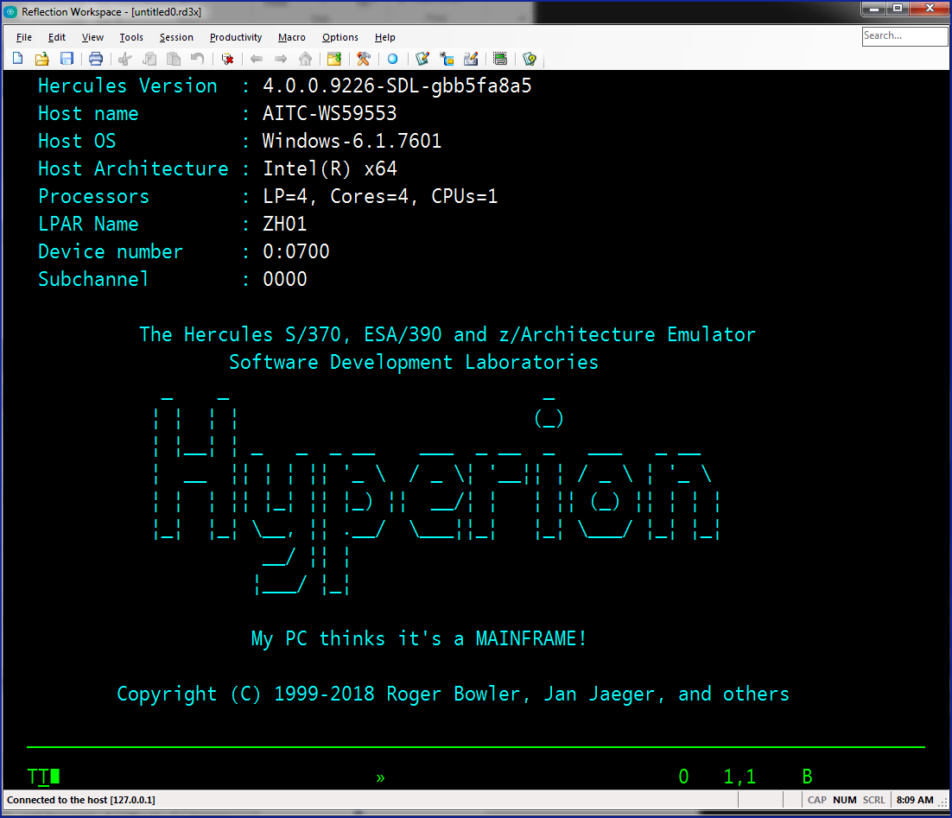

At this point you are ready to IPL – enter IPL A40 on the system console:

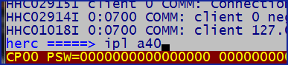

The IPL is quick:

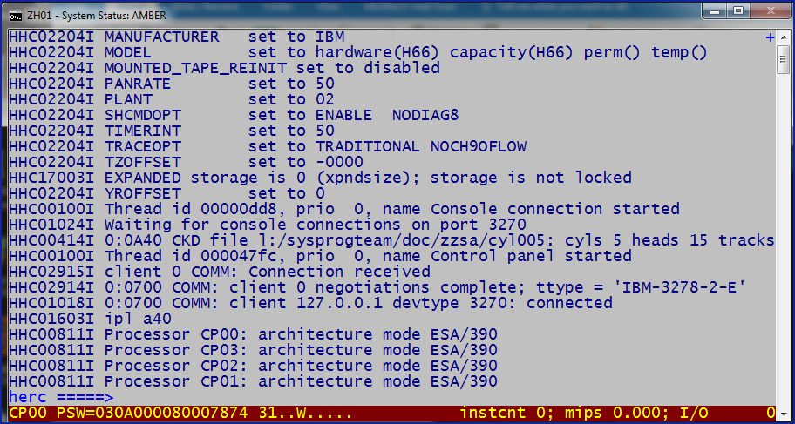

At this point you should press the Enter key on your TN3270 emulator and your TN3270 should look like

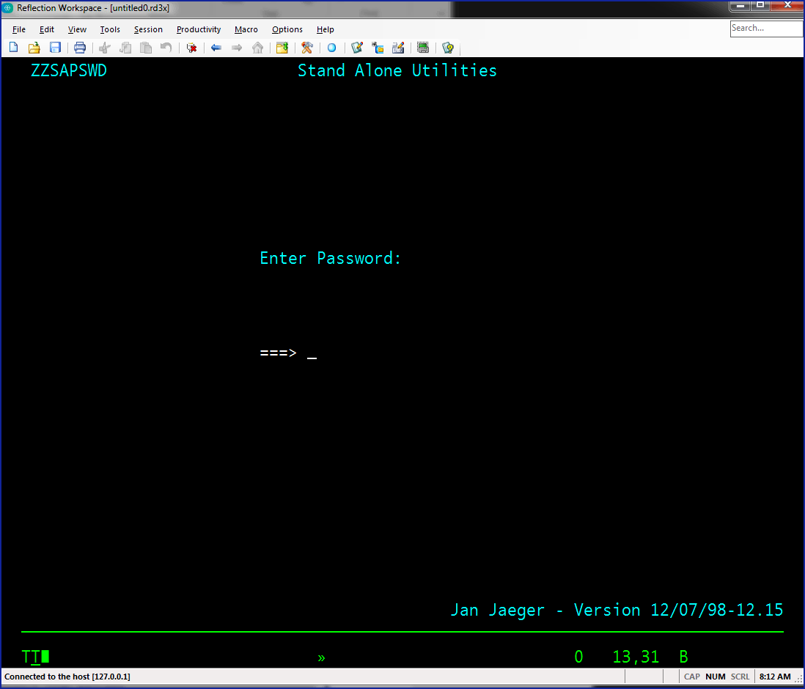

Now enter the password: zzsecret and you will see the ZZSA menu:

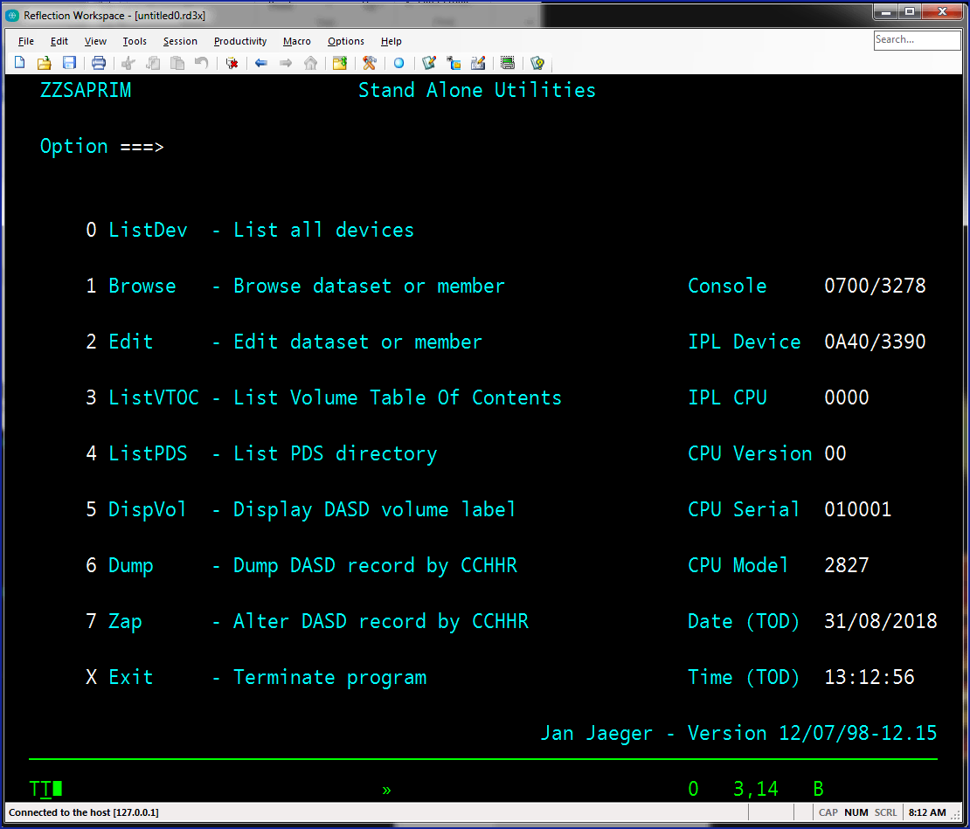

Option 0 produces a list of all defined devices.

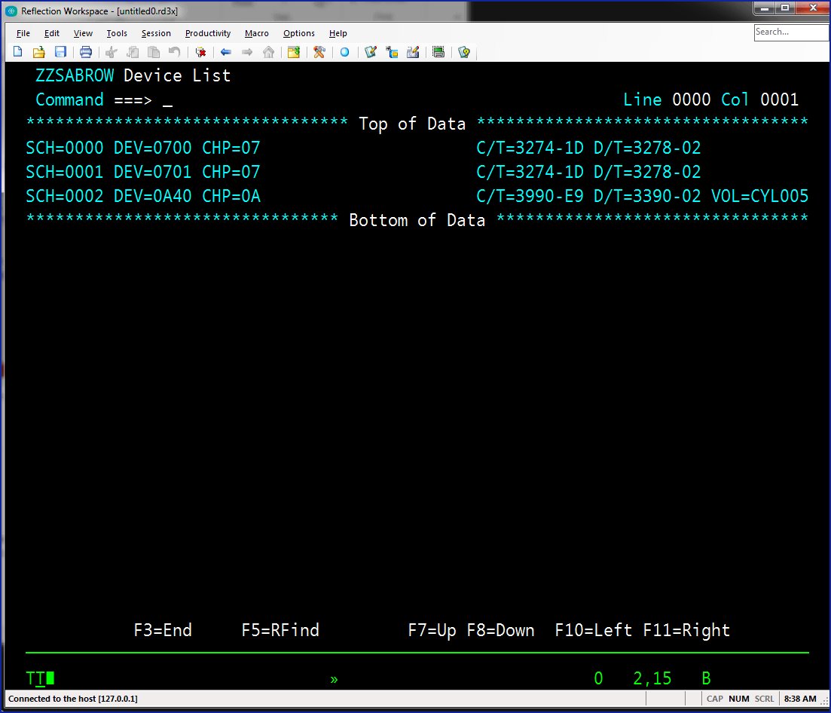

Option 3 is next to be used as you will want to find out which data sets are on the volume. Enter the device address – all 4 characters. The volser is optional:

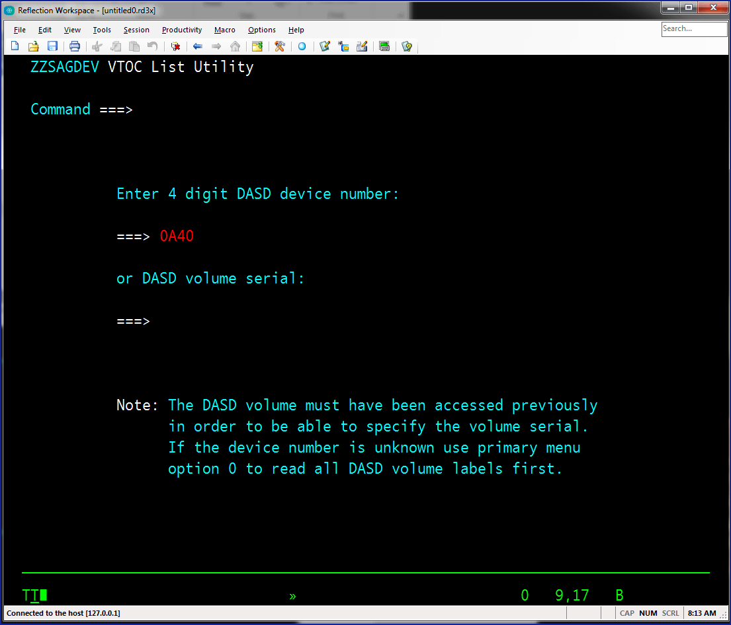

And you will see the vtoc listing. PRACTICE.ZZSA is the PDS that is used for experimentation:

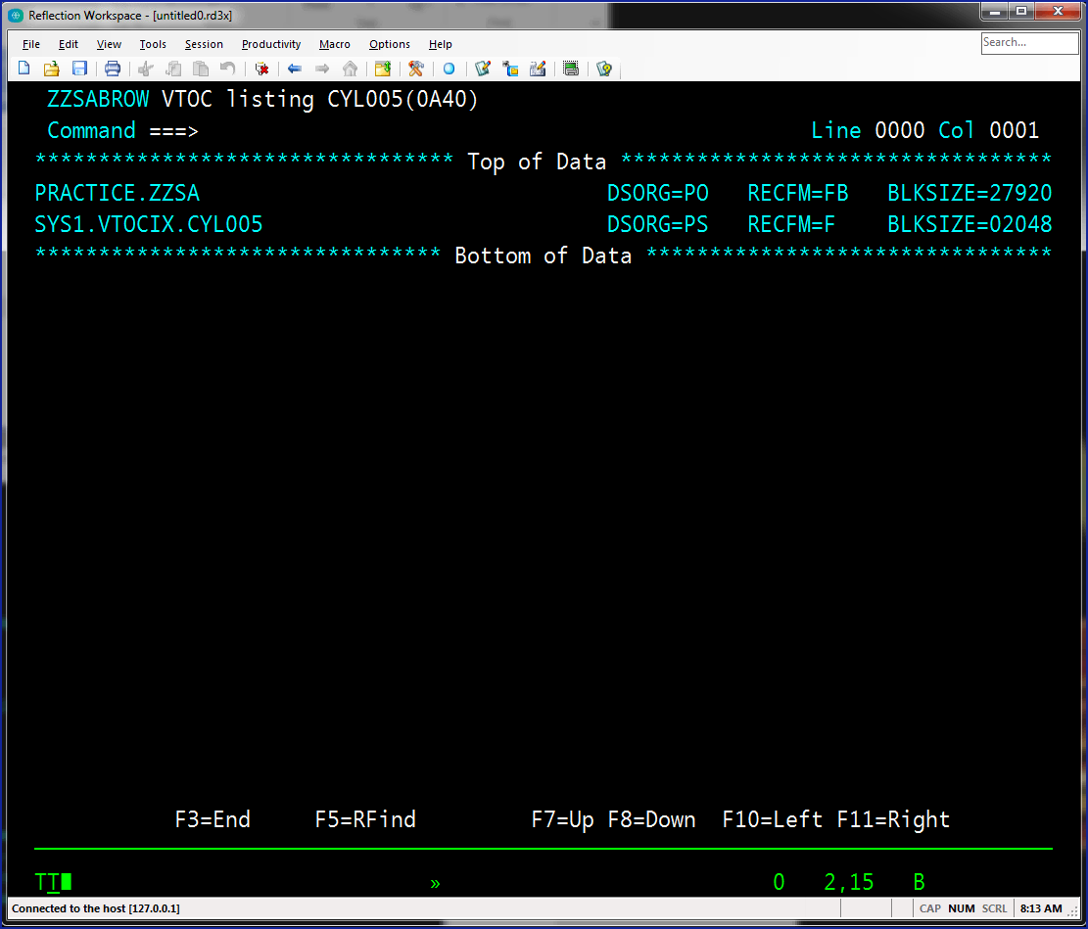

Option 4 is now used to list the members of the PDS. Enter the data set name and the device address:

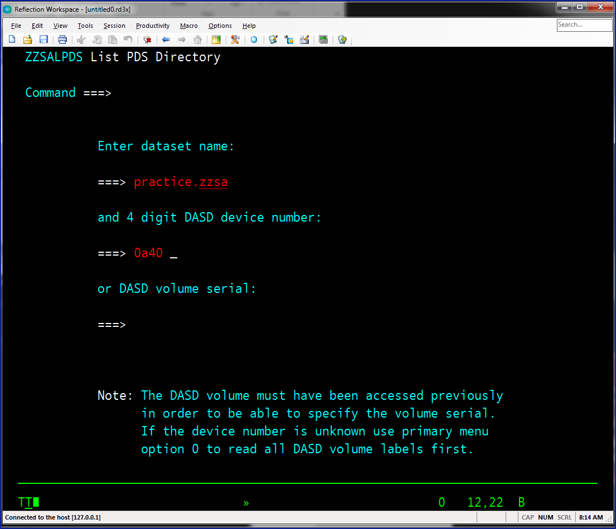

This is the display of the PDS members:

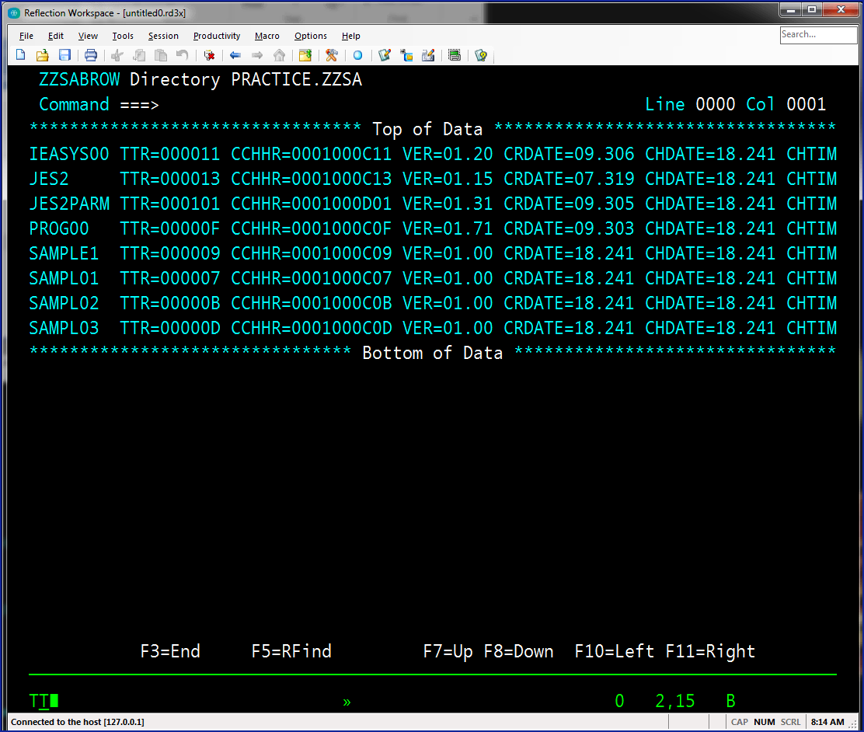

Option 1 will let you browse the dataset. If the data set is a PDS then a member name is required. The device address also needs to be entered:

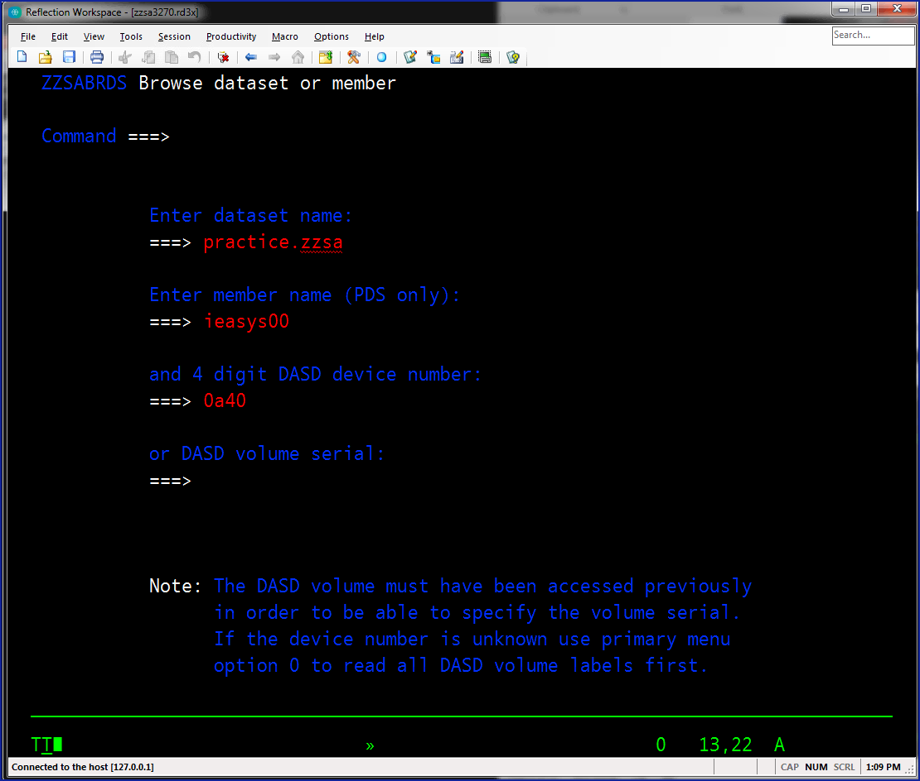

And here is the browse display.

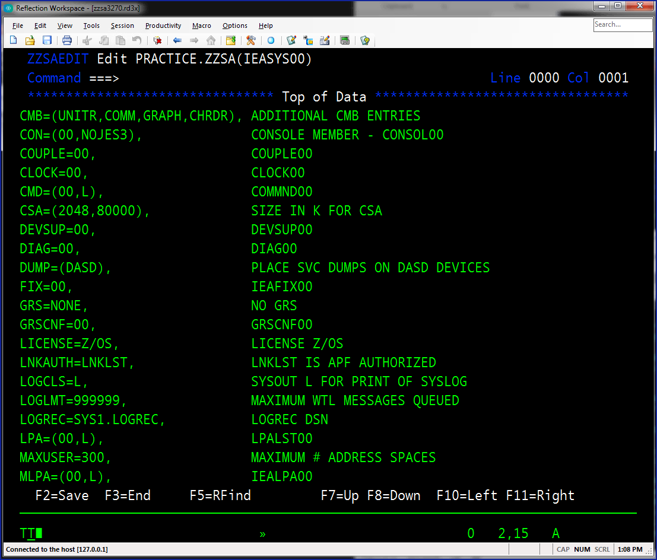

The following commands work in Browse:

* MAX , M
* TOP, T
* BOTTOM, BOT, B
* UP, U
* DOWN, D
* FIND, F
* RFIND, RF
* LEFT, L
* RIGHT, R
* SORT
* SAVE
* FILE
* END, CANCEL
* EXIT

Option 2 is Edit and is similar to Browse but it allows you to change the data:

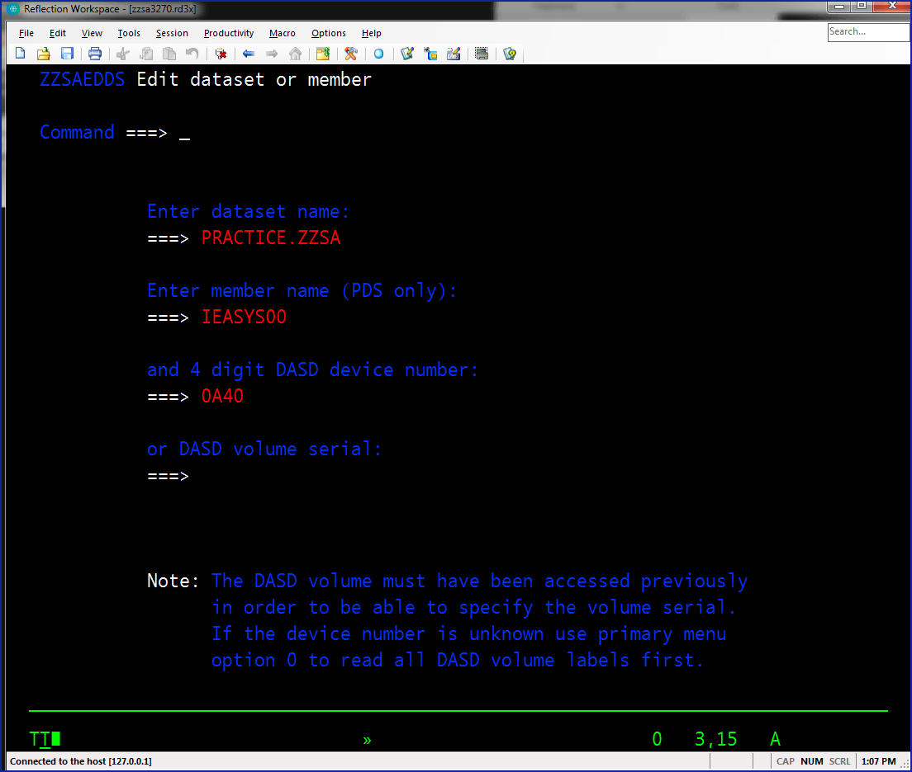

While in Edit you can use all the commands that are available to Browse along with SAVE. Only datasets with RECFM=FB and LRECL=80 are supported by ZZSA in Edit.

To make changes move the cursor to the location and make the changes on the record. ZZSA does not support inserting or deleting records.



When completed using ZZSA enter X from the menu and you will see this:

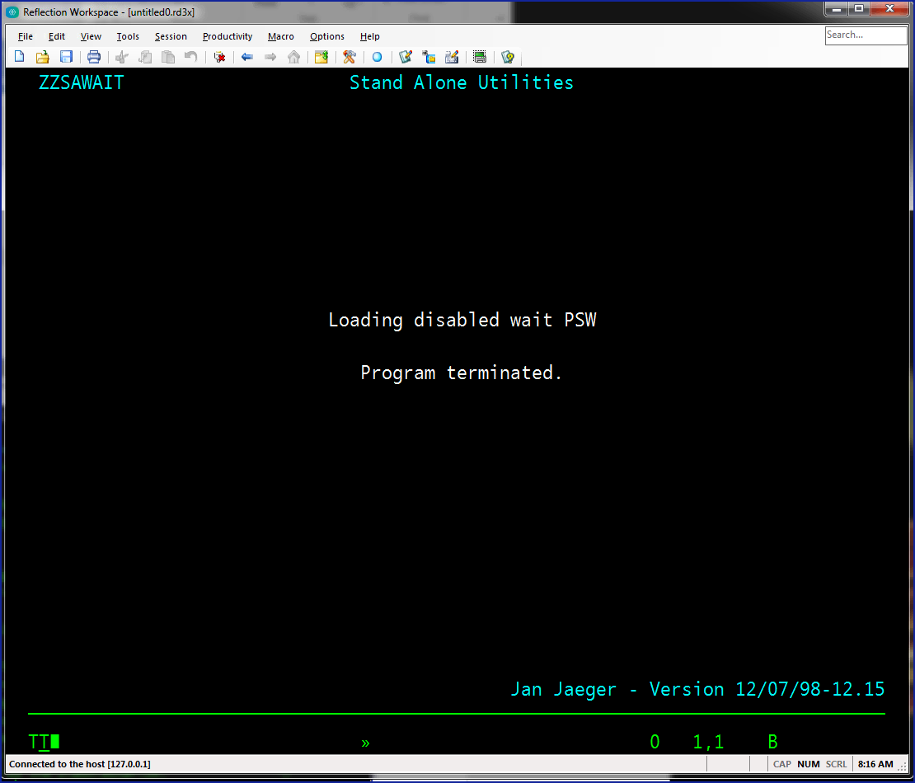

At this point enter QUIT in the system console to exit the Hercules emulator and you can close your TN3270 emulator.