What Is Your Road - Final Project
Drew Tomashek, Connor Bangs, Jadyn Irish
2026-05-10

United States Map
This section creates a map of the United States with all the counties using tigris which allows us to download U.S. Census Bureau boundary shapefiles without downloading each individually. ## Then we attached the counties to our map files of the contiguous U.S. The contiguous United States is 48 states excluding Alaska, Hawaii, and any other U.S territories.
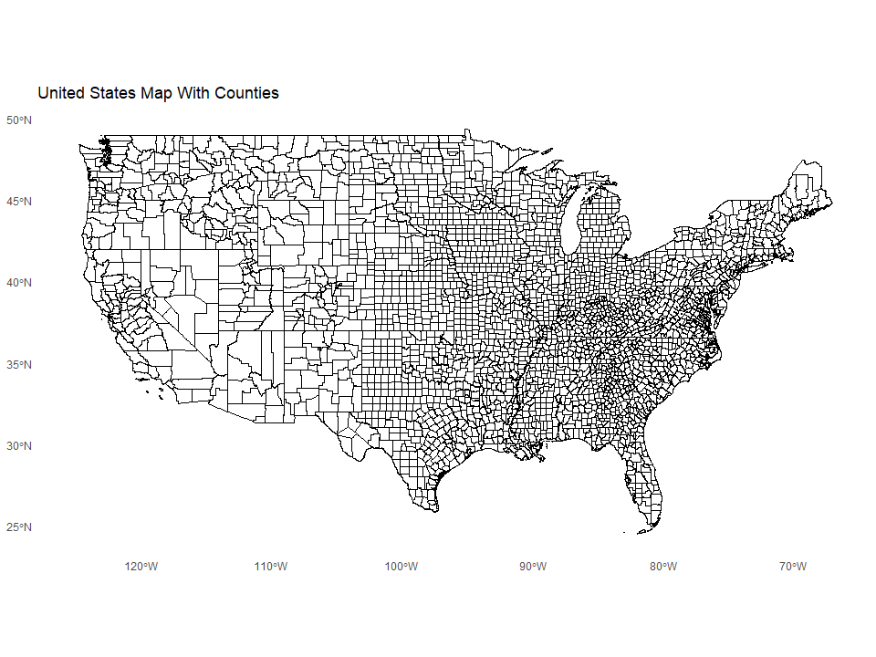

Glimpse of Data within CSV File
## GEOID suffix n
## 1 1001 RD 604
## 2 1003 RD 1789
## 3 1005 RD 605
## 4 1007 RD 513
## 5 1009 RD 1037
## 6 1011 RD 336
## 7 1013 RD 779
## 8 1015 ST 1031
## 9 1017 RD 612
## 10 1019 RD 1210
These are the first 10 counties and their most popular road suffix. GEOID is a five digit code that is assigned to each county to link its corresponding road data. The suffix is the most popular road suffix in that county, and n is how many roads are of that suffix. There is a total of 3,233 GEOID’s.

Map of Most Popular Road Suffix
Our first plot investigates the most popular road suffix for U.S counties from our data that we got above. This will focus on the United States contiguous states.
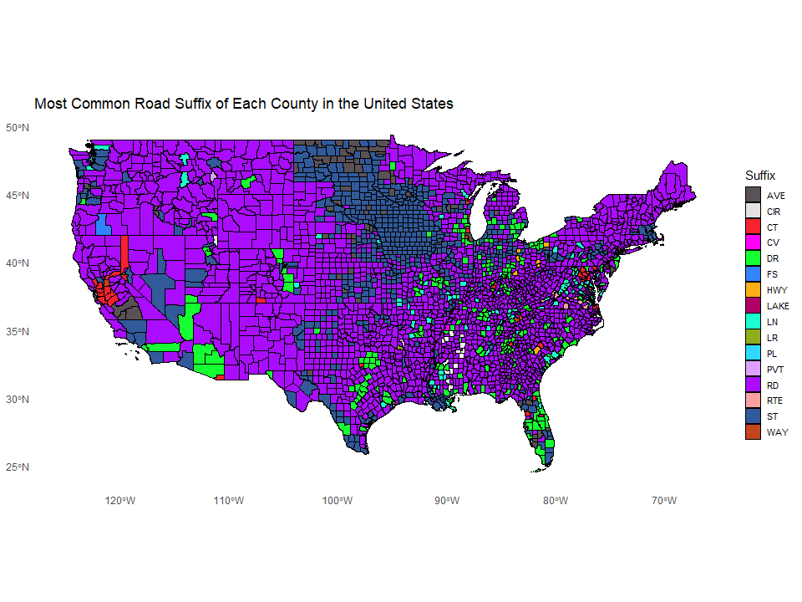
The plot shows Rd is the most popular in the majority of counties with St coming in second. There are also other common suffix like Dr and Ave that have are popular. There are some unusual road suffix that are popular in certain counties like Fs, Cir, and Pl. St is a very popular suffix in the Midwest region. In general most of the rural areas have Rd as the most popular and urban areas have St or Dr.

Bar Chart and Distribution Plot
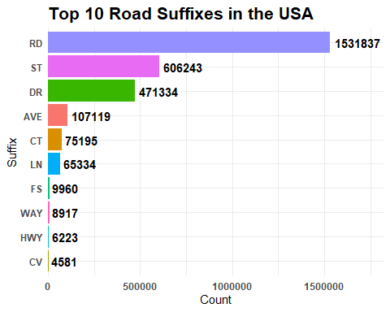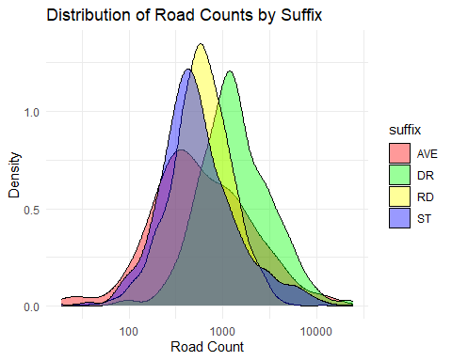
The first plot shows that a small number of road suffixes dominate street naming in the United States. Road (RD), Street (ST), Drive (DR), and Avenue (AVE) appear far more often than the other suffixes, with a noticeable drop in frequency after the top few categories. This suggests that the road names across the country are heavily concentrated around common suffixes.
The second plot shows the spread of counts for the four most common suffixes. Most places have lower road counts, while only a few places have very high counts. The curves overlap a lot, which means the suffixes have similar patterns overall. Even though the suffixes are different, their road counts are spread out in similar ways.

