Name: Christian Banks

GSP390: Week 7 Lab

Date: 10/19/14

Shader: Toon/cel/cell shader

Glass Texture Images

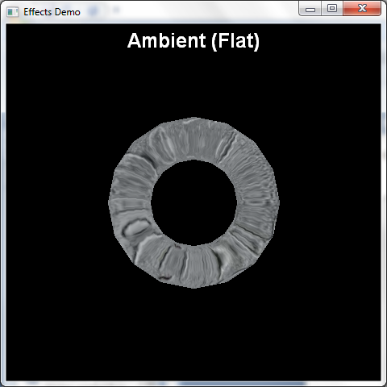

Screenshot showing a torus with Ambient and flat lighting.

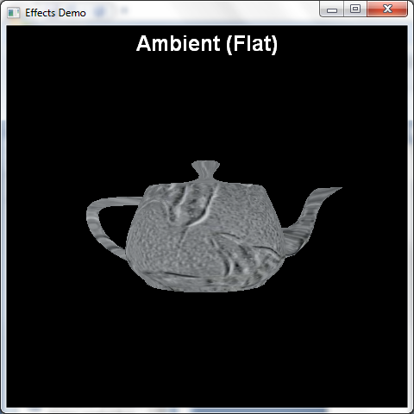

Teapot showing ambient lighting.

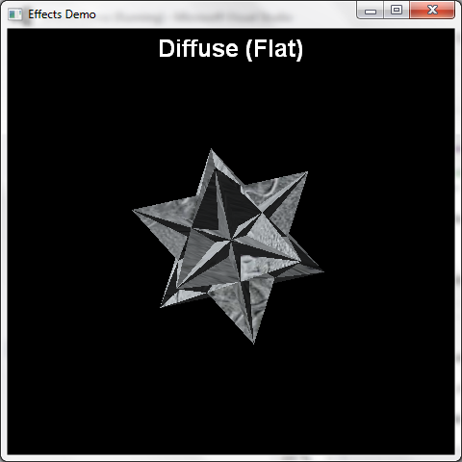

Screenshot showing diffuse component with flat lighting.

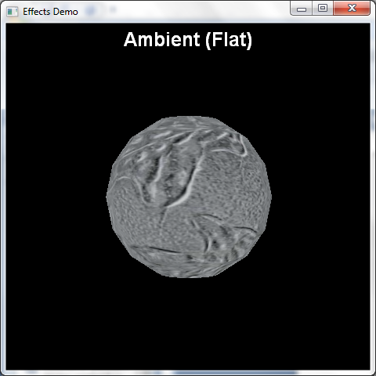

Dodecahedron (with Glass Texture)

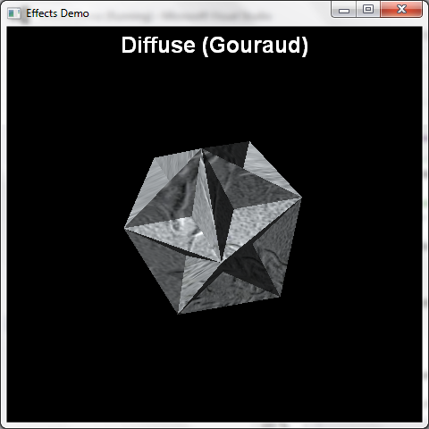

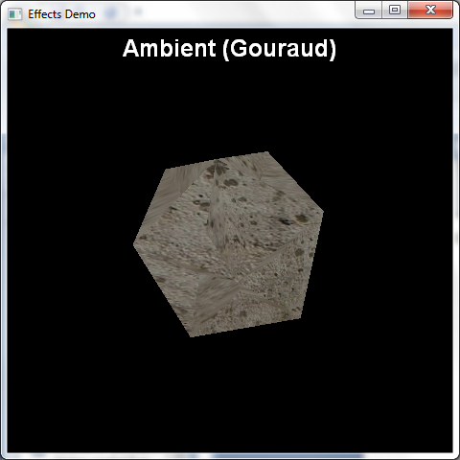

ScreenShot showing the Ambient with Gouraud lighting

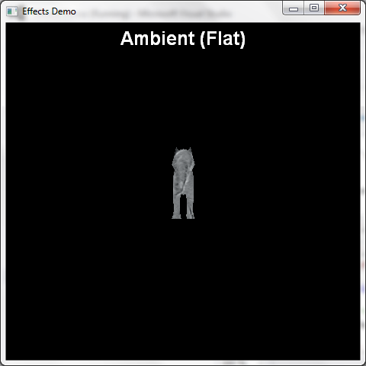

Loads a tiger into the demo with the ambient flat lighting.

ScreenShots Showing a toon shader:

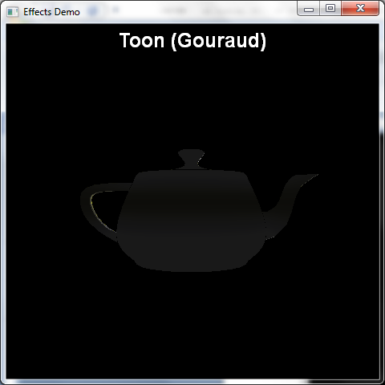

Loads a teapot with the toon shader with Gouraud lighting. Note: All the toon shaders have the same effect besides the actual shape, the lighting makes no difference in any of the demonstrations from here because the effect has been created in a specific way to ignore ambient and specular lighting.

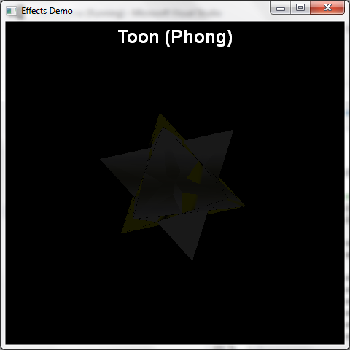

The Toon shader particularly didn’t work well for this object with this particular texture which can be seen in it’s appearance. Like the above, the lighting didn’t make much of a difference here.

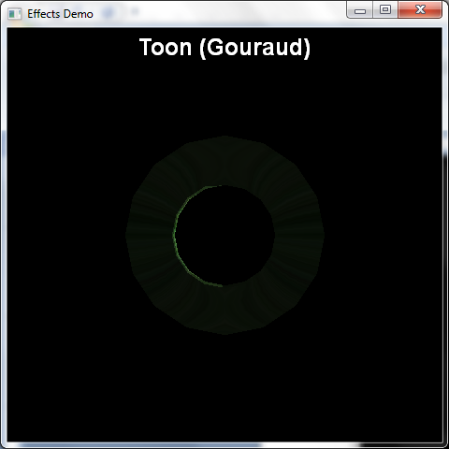

Implements the toon shader using a different texture, with gouraud lighting. This one was okay.

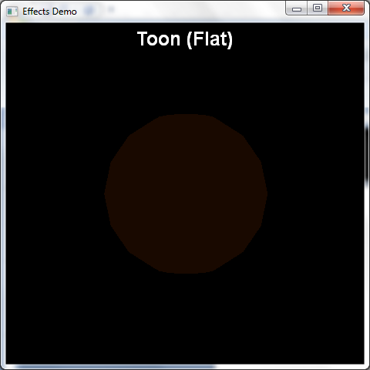

This one implements a toon shader with the basic sphere mesh and a orange texture.

The effect file that was implemented here was obtained from this website: <http://rbwhitaker.wikidot.com/toon-shader>

The intended purpose of this effect is to give off that cartoonish feeling on a mesh in a scene. The technique takes two passes to render correctly and creates that toon feeling that’s showcased here.mAs you’ve seen though with one of the textures, depending on the texture this method isn’t always sufficient. Also because of the background the outlines on the meshes are hard to see since they are the same color.