-- Question 1

select StudentGrade,

LastName,

FirstName

from Students;

Sorted by Grade , LastName, and FirstName



-- Question 2

select

TypeID,

LastName,

FirstName

from Students

order by TypeID, LastName, FirstName;

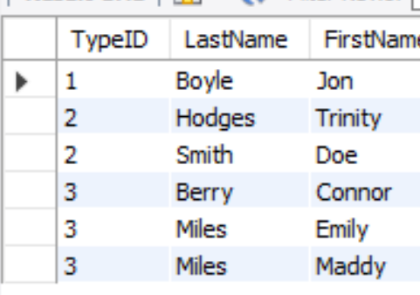

-- Q3

SELECT

tr.TransDate,

COUNT(tr.TransID)as 'Total Meals',

COUNT(tr.TransID) \* 3 AS 'Day Price',

Round(Sum(((tr.TransTotal)/(tr.TransTotal)) \* mt.Price) , 2) AS 'Amount Charged'

FROM Transactions tr

INNER JOIN Students st

ON st.StudentID = tr.StudentID

INNER JOIN MealType mt

ON mt.TypeID = st.TypeID

GROUP BY tr.TransDate;

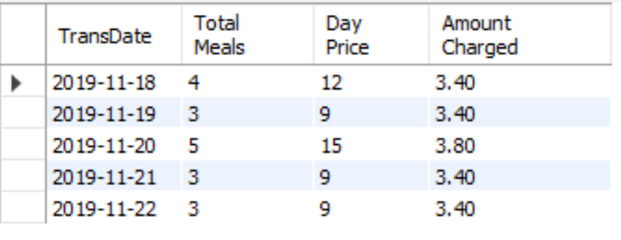

-- Q4

SELECT

max(tr.TransTotal) as 'Total Free Meals',

max(tr.TransTotal) \* 3 AS 'Cost',

max(tr.TransTotal) \* mt.Price AS 'Amount Paid'

FROM Transactions tr

INNER JOIN Students st

ON st.StudentID = tr.StudentID

INNER JOIN MealType mt

ON mt.TypeID = st.TypeID

WHERE mt.TypeID = 1

GROUP BY st.StudentID;

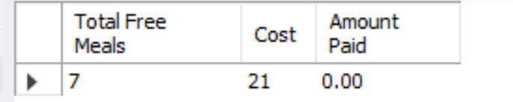

-- Question 5

SELECT

max(tr.TransTotal) as 'Total Reduced Transactions',

max(tr.TransTotal) \* 3 as 'Cost',

max(tr.TransTotal) \* mt.Price as 'Amount Paid'

FROM Transactions tr

Inner Join Students st

ON st.StudentID = tr.StudentID

Inner Join MealType mt

ON mt.TypeID = st.TypeID

WHERE mt.TypeID = 2

GROUP BY st.StudentID;

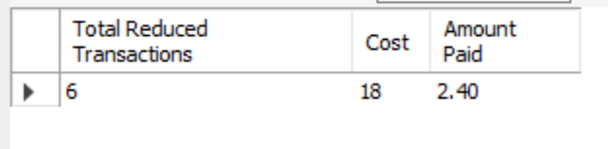

-- Question 6

SELECT

st.StudentID,

concat(st.LastName, ', ' , st.FirstName) as 'Student Name',

sum(pa.PayAmount) as 'Payments'

FROM Students st

Inner Join Payments pa

on pa.StudentID = st.StudentID

GROUP BY st.StudentID;

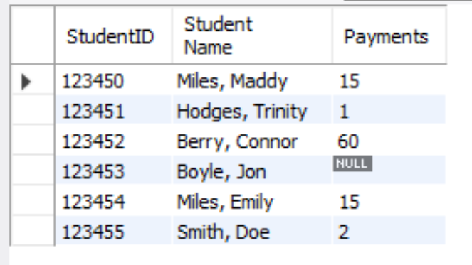

-- Question 7

SELECT

concat(st.LastName, ', ' , st.FirstName) as 'Student Name',

pa.PayAmount as 'Payments',

max(tr.TransTotal) \* mt.Price as 'Student Charges'

FROM Students st

Left JOIN Transactions tr

ON st.StudentID = tr.StudentID

Left JOIN MealType mt

ON mt.TypeID = st.TypeID

Inner JOIN Payments pa

ON st.StudentID = pa.StudentID

GROUP BY st.StudentID;

