Reports of Missing Students Raise Questions

Campus officials deny any connection, but witnesses report unusual activity.
With three students reported missing this month, and several others unaccounted for, concerns are growing about their whereabouts. Campus officials insist the cases are unrelated.
“We have no way of knowing if these missing people are actually tied to the campus, other than being students” said ████ █████████. “People hear stories like this and jump to conclusions. Most of them probably just stopped attending class.”
Authorities have denied comment, citing an ongoing investigation.
One student, ████████ ███████ claims she witnessed her friend disappear. “There were stairs over there. We’d never seen them before. She joked about going up to see what was on the second floor. I didn’t want to. I just wanted to go back to the dor m.”
████████ described her friend pausing on the steps, “like someon e said something to her,” before smiling “way too big” and rushing upward. “I called for her, but she didn’t answer. When I came back around the corner…the stairs were gone. It felt like they’d never been there at all.”
Others remain skeptical. “Stude nts are stressed. Finals are coming up. People get confused,” said ████. “She’ll show up.”
Several staff members dismissed the rumors as a hoax or an old campus legend. One professor, who asked to remain anonymous, said, “I’ve been teaching here for over a decade. These stories come up sometimes. There are no stai rs in this building.”
He added, “If you’re that worried, just don’t go up the stairs, no matter how much they call to you.”

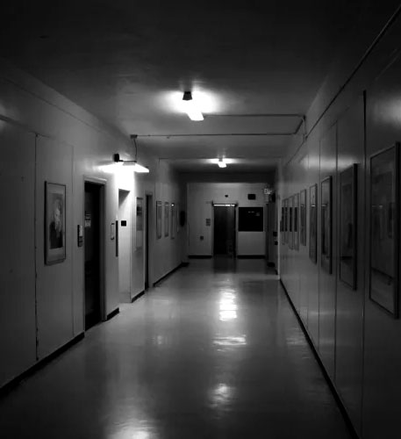
Facilities reports no stairwells have ever existed in this bui lding.
Paid advertisement
Office of Architectural Continuity
---Preserving Spatial Compliance---

We’re hiring!

Help keep your community safe, maintained, and continual! Apply today!
Learn more below:



