An examination of the benefits of petting dogs before exams

Cylcia Bolibaugh1

1 University of York

Author note

Add complete departmental affiliations for each author here. Each new line herein must be indented, like this line.

Enter author note here.

The authors made the following contributions. Cylcia Bolibaugh: Conceptualization, Writing - Original Draft Preparation, Writing - Review & Editing.

Correspondence concerning this article should be addressed to Cylcia Bolibaugh, University of York, UK. E-mail: [my@email.com](mailto:my@email.com)

Abstract

This is an example manuscript used to demonstrate a reproducible, collaborative workflow using RMarkdown, Github, and the Papaja and trackdown packages.

*Keywords:* reproducible manuscripts, collaborative workflow

*Word count:* X

An examination of the benefits of petting dogs before exams

A recent study suggested that spending time with a pet acts as a buffer against psychological stress (Ratschen et al., 2020). Imagine that we conducted an experiment to explore whether this effect generalised to stress caused by university exams. Specifically, we hypothesised that students who spent time with a university health and wellbeing dog before an exam would have fewer feelings of stress relative to students who only looked at pictures of dogs before an exam.

In order to test the hypothesis we recruited 200 students who had imminent exams and self-reported that they felt stressed, and assigned half of them to pet the university dog, and half to look through a catalogue of dog pictures. We then assessed how stressed they felt on the Stress-o-metre Scale (1-100).

# 1 Methods

## 1.1 Participants

We recruited two hundred undergraduate students. All students were screened to ensure that they planned to sit an exam within the next 5 days, and that they reported feeling stressed.

## 1.2 Material

We randomly assigned half of the participants to pet the university dog, and half to look through a catalogue of dog pictures. We then assessed how stressed they felt on the Stress-o-metre Scale (1-100).

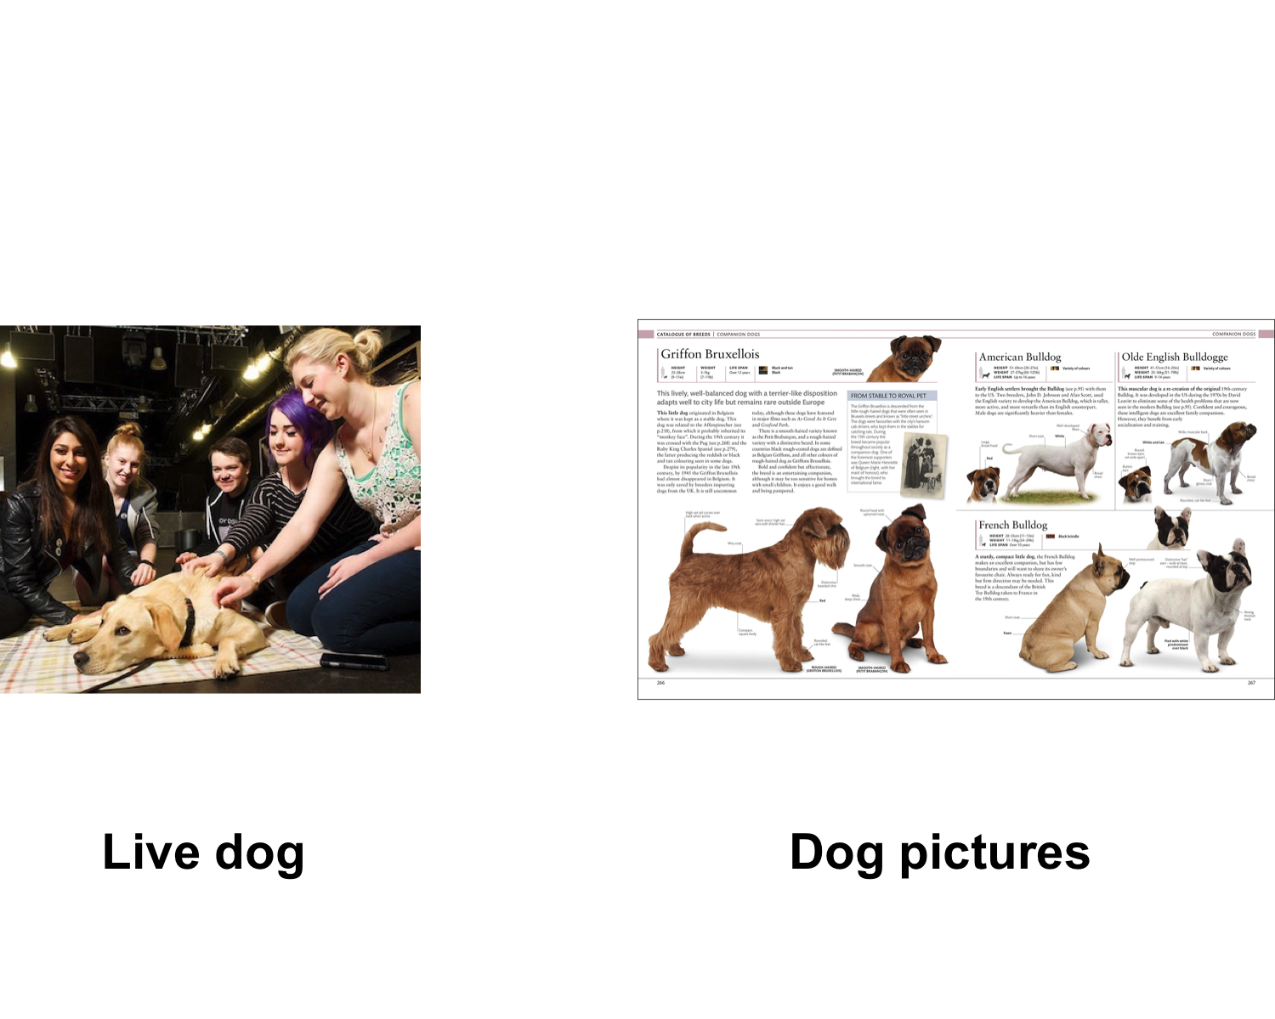

*Figure* *1.*  This is a test

## 1.3 Procedure

Our imaginary students were randomly assigned into the “Live Dog” condition or the “Dog Pictures” condition. Each participant sat the intervention and test individually. They spent 5 minutes either petting the dog, or looking at dog pictures. They then completed the Stress-o-Metre self-assessment in a quiet room.

## 1.4 Data analysis

The distribution of scores of the Stress-o-Metre scale from the “Live Dog” and “Dog Pictures” groups are depicted in Figures 2 and 3 below. The reliability of the Stress-0-metre Scale has not been established.

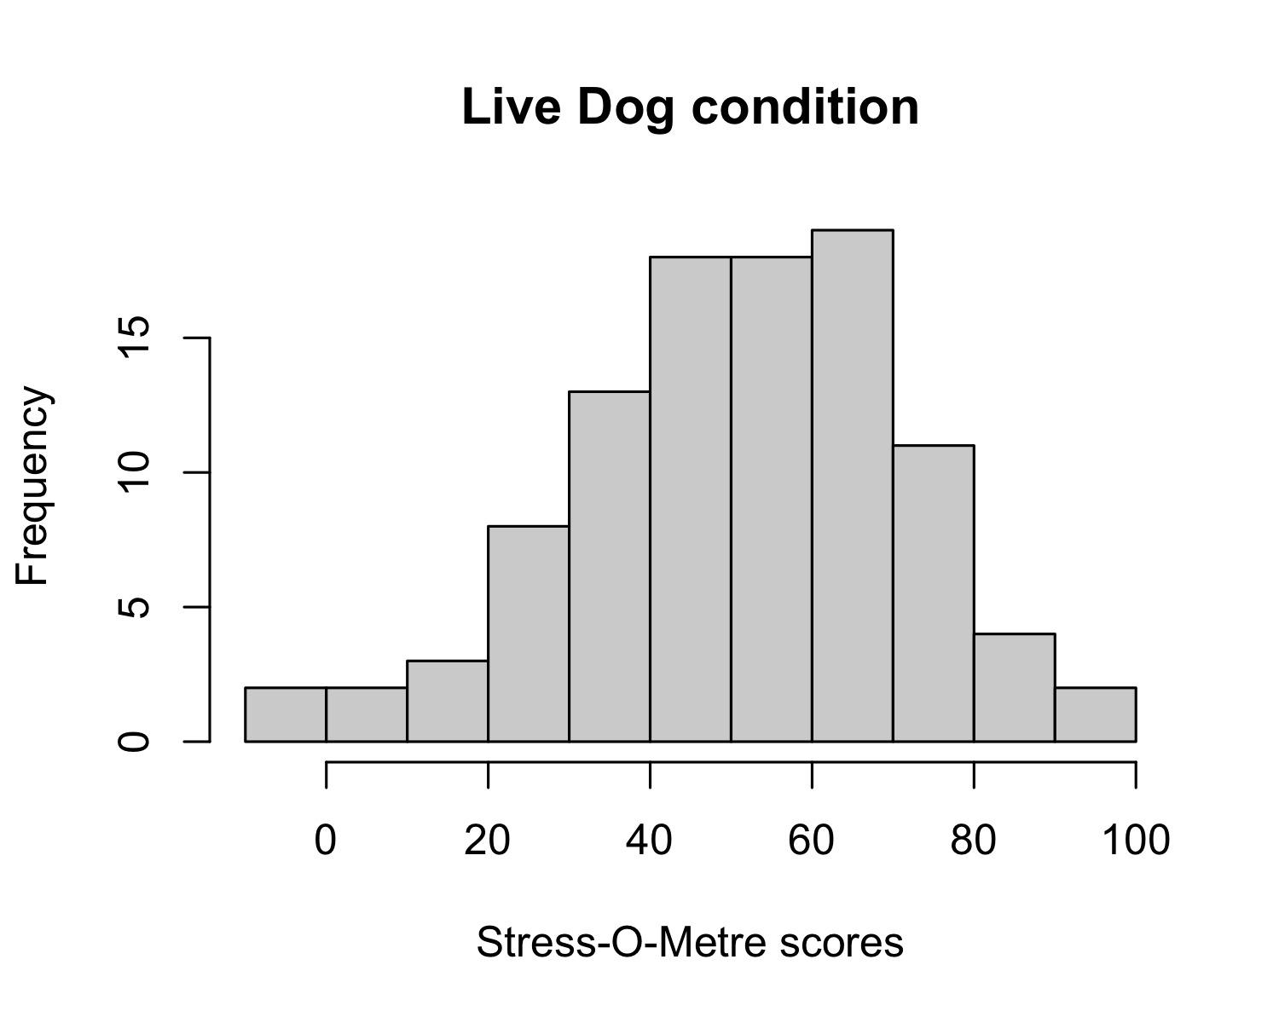

*Figure* *2.*  Distribution of scores from Live dog condition

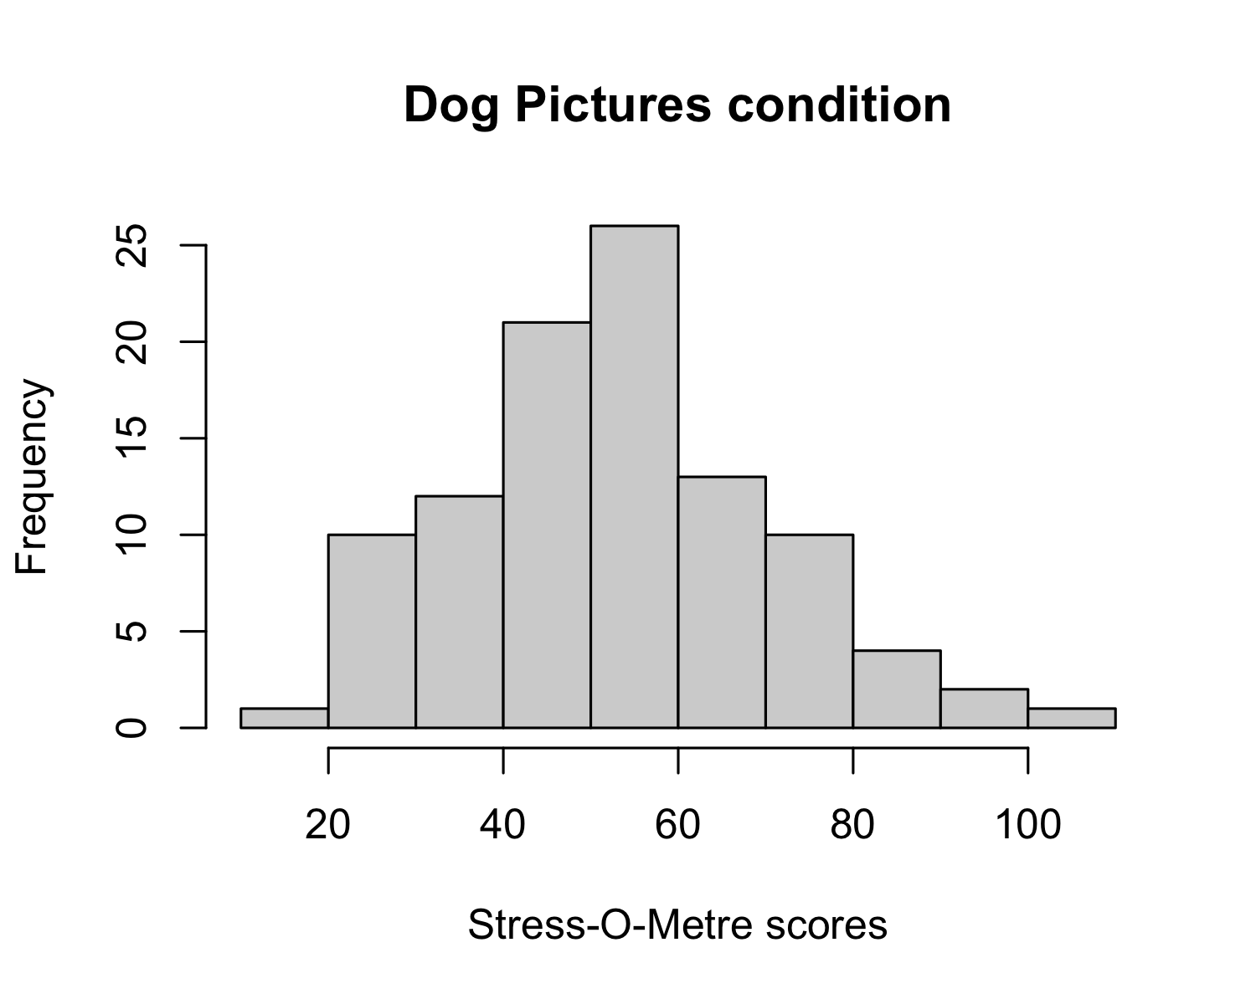

*Figure* *3.*  Distribution of scores from Dog pictures condition

We used R [Version 4.0.2; R Core Team (2020)] and the R-packages *cowplot* [Version 1.1.1; Wilke (2020)], *dplyr* [Version 1.0.6; Wickham, François, Henry, and Müller (2021)], *forcats* [Version 0.5.1; Wickham (2021a)], *ggplot2* [Version 3.3.3; Wickham (2016)], *here* [Version 1.0.1; Müller (2020)], *papaja* [Version 0.1.0.9997; Aust and Barth (2020)], *purrr* [Version 0.3.4; Henry and Wickham (2020)], *readr* [Version 1.4.0; Wickham and Hester (2020)], *stringr* [Version 1.4.0; Wickham (2019)], *tibble* [Version 3.1.2; Müller and Wickham (2021)], *tidyr* [Version 1.1.3; Wickham (2021b)], and *tidyverse* [Version 1.3.1; Wickham et al. (2019)] for all our analyses.

# 2 Results

A Welch Two Sample t-test indicated that participants who pet dogs (*M* = 50.65, *SD* = 20.83) did [not] score significantly lower than participants who looked at pictures of dogs (*M* = 53.25, *SD* = 18.08), *t*(194.18) = -0.94, *p* = 0.35 on the Stress-O-Metre Scale.

These results can be seen in Figure 4.

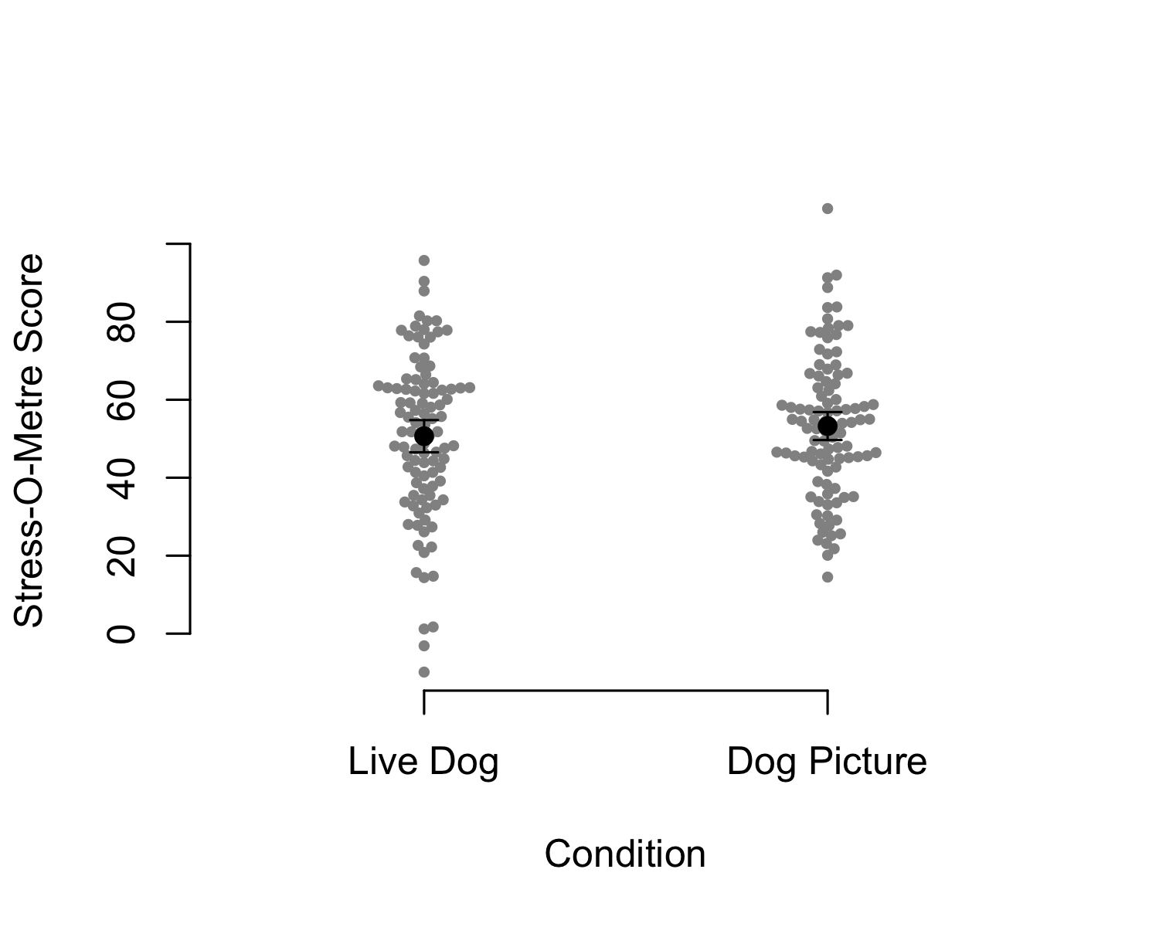

*Figure* *4.*  Stress after petting dog or looking at dog pictures

# 3 Discussion

This is a poorly designed study with multiple confounds. In future research, the materials and intervention will need to be validated, and the Stress-O-Metre’s reliability established. The design would benefit from a pre-test as well.

# 4 References

Aust, F., & Barth, M. (2020). *papaja: Create APA manuscripts with R Markdown*. Retrieved from <https://github.com/crsh/papaja>

Henry, L., & Wickham, H. (2020). *Purrr: Functional programming tools*. Retrieved from <https://CRAN.R-project.org/package=purrr>

Müller, K. (2020). *Here: A simpler way to find your files*. Retrieved from <https://CRAN.R-project.org/package=here>

Müller, K., & Wickham, H. (2021). *Tibble: Simple data frames*. Retrieved from <https://CRAN.R-project.org/package=tibble>

R Core Team. (2020). *R: A language and environment for statistical computing*. Vienna, Austria: R Foundation for Statistical Computing. Retrieved from <https://www.R-project.org/>

Wickham, H. (2016). *ggplot2: Elegant graphics for data analysis*. Springer-Verlag New York. Retrieved from <https://ggplot2.tidyverse.org>

Wickham, H. (2019). *Stringr: Simple, consistent wrappers for common string operations*. Retrieved from <https://CRAN.R-project.org/package=stringr>

Wickham, H. (2021a). *Forcats: Tools for working with categorical variables (factors)*. Retrieved from <https://CRAN.R-project.org/package=forcats>

Wickham, H. (2021b). *Tidyr: Tidy messy data*. Retrieved from <https://CRAN.R-project.org/package=tidyr>

Wickham, H., Averick, M., Bryan, J., Chang, W., McGowan, L. D., François, R., … Yutani, H. (2019). Welcome to the tidyverse. *Journal of Open Source Software*, *4*(43), 1686. <https://doi.org/10.21105/joss.01686>

Wickham, H., François, R., Henry, L., & Müller, K. (2021). *Dplyr: A grammar of data manipulation*. Retrieved from <https://CRAN.R-project.org/package=dplyr>

Wickham, H., & Hester, J. (2020). *Readr: Read rectangular text data*. Retrieved from <https://CRAN.R-project.org/package=readr>

Wilke, C. O. (2020). *Cowplot: Streamlined plot theme and plot annotations for ’ggplot2’*. Retrieved from <https://CRAN.R-project.org/package=cowplot>