Q_01

CT_2021_001

Code:

package Q_01;  
  
import javax.swing.JFrame;  
  
public class window {  
 public static void main(String[] args) {  
 JFrame frame = new JFrame();  
 frame.setSize(800, 600);  
 frame.setTitle("Test Window");  
 frame.setDefaultCloseOperation(JFrame.*EXIT_ON_CLOSE*);  
 frame.setVisible(true);  
 }  
}

Output:

Q_02

Code:

package Q_02;  
  
import javax.swing.JFrame;  
import java.util.Scanner;  
  
public class Display_name {  
 public static void main(String[] args) {  
 Scanner name = new Scanner(System.*in*);  
  
 System.*out*.print("Enter first name: ");  
 String firstName = name.nextLine();  
  
 System.*out*.print("Enter last name: ");  
 String lastName = name.nextLine();  
  
 String fullName = firstName + " " + lastName;  
  
 JFrame frame = new JFrame();  
 frame.setSize(800, 600);  
 frame.setTitle(fullName);// Display Title as a window  
 frame.setDefaultCloseOperation(JFrame.*EXIT_ON_CLOSE*);  
 frame.setVisible(true);  
  
 name.close();  
 }  
}

Output:

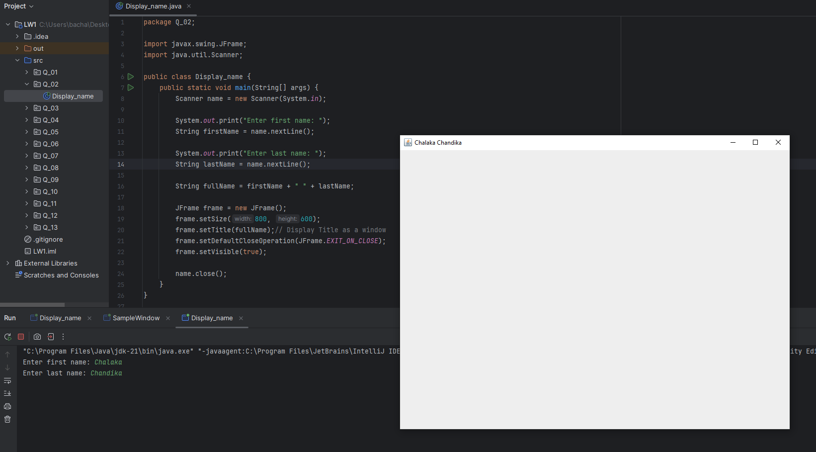

Q_03

Code:

package Q_03;  
  
import java.util.Scanner;  
  
public class F_Name {  
 public static void main(String[] args) {  
 Scanner name = new Scanner(System.*in*);  
  
 System.*out*.print("Enter first name: ");  
 String firstName = name.nextLine();  
  
 System.*out*.print("Enter middle name: ");  
 String middleName = name.nextLine();  
  
 System.*out*.print("Enter last name: ");  
 String lastName = name.nextLine();  
  
 String full_name = firstName + " " + middleName.substring(0,1) + ". " + lastName;  
 System.*out*.println("Full Name: " + full_name);  
  
 name.close();  
 }  
}

Output:

Q_04

Code:

package Q_04;  
  
import java.util.Date;  
import java.text.SimpleDateFormat;  
  
public class DateDisplay {  
 public static void main(String[] args) {  
 Date today = new Date(); // Get current date  
  
 // Define the date format  
 SimpleDateFormat formatter = new SimpleDateFormat("d MMM yyyy");  
 // Format the date  
 String formattedDate = formatter.format(today);  
 System.*out*.println("Today's Date: " + formattedDate);  
 }  
}

Output:

Q_05

Code:

package Q_05;  
  
import java.text.SimpleDateFormat;  
import java.util.Date;  
  
  
public class DateWithDay {  
 public static void main(String[] args) {  
 Date today = new Date();  
 SimpleDateFormat formatter = new SimpleDateFormat("EEEE, MMM d, yyyy");  
 String formattedDate = formatter.format(today);  
 System.*out*.println("Today's Date: " + formattedDate);  
 }  
}

Output:

Q_06

Code:

package Q_06;  
  
import javax.swing.JFrame;  
import java.util.Scanner;  
  
public class newFrame {  
 public static void main(String[] args) {  
 Scanner scanner = new Scanner(System.*in*);  
  
 System.*out*.print("Enter width of frame (W): ");  
 int width = scanner.nextInt();  
  
 System.*out*.print("Enter height of frame (H): ");  
 int height = scanner.nextInt();  
 scanner.nextLine(); // Consume newline  
  
 System.*out*.print("Enter frame of title: ");  
 String title = scanner.nextLine();  
  
 JFrame frame = new JFrame(title);  
 frame.setSize(width, height);  
 frame.setDefaultCloseOperation(JFrame.*EXIT_ON_CLOSE*);// application terminates after closing thw window  
 frame.setVisible(true);  
  
 scanner.close();  
 }  
}

Output:

Q_07

Code:

package Q_07;  
  
import javax.swing.JFrame;  
import java.time.LocalTime;  
import java.time.format.DateTimeFormatter;  
  
public class Display_Time {  
 public static void main(String[] args) {  
 LocalTime currentTime = LocalTime.*now*();  
 DateTimeFormatter formatter = DateTimeFormatter.*ofPattern*("hh:mm:ss a");  
 String timeString = currentTime.format(formatter);  
  
 JFrame frame = new JFrame(timeString);  
 frame.setSize(500, 300);  
 frame.setDefaultCloseOperation(JFrame.*EXIT_ON_CLOSE*);// application terminates after closing thw window  
 frame.setVisible(true);  
 }  
}

Output:

Q_08

Code:

package Q_08;  
  
import java.util.Scanner;  
public class SplitString {  
 public static void main(String[] args) {  
 Scanner scanner = new Scanner(System.*in*);  
  
 System.*out*.print("Enter a sentence with an exclamation mark (!): ");  
 String input = scanner.nextLine();  
  
 int index = input.indexOf('!');  
 //In here display error message  
 if (index == -1) {  
 System.*out*.println("Error: There is no any exclamation mark found.");  
 } else {  
 String firstPart = input.substring(0, index);  
 String secondPart = input.substring(index + 1);  
  
 System.*out*.println("First part: " + firstPart);  
 System.*out*.println("Second part: " + secondPart);  
 }  
 scanner.close();  
 }  
}

Output:

Q_09

Code:

package Q_09;  
  
import java.util.Scanner;  
  
public class StringInfo {  
 public static void main(String[] args) {  
 Scanner scanner = new Scanner(System.*in*);  
  
 System.*out*.print("Enter a string: ");  
 String input = scanner.nextLine();  
  
 int length = input.length();  
 char first_C = input.charAt(0);  
 char last_C = input.charAt(length - 1);  
  
 System.*out*.println(length);  
 System.*out*.println(first_C);  
 System.*out*.println(last_C);  
  
 scanner.close();  
 }  
}

Output:

Q_10

Code:

package Q_10;  
  
import java.util.Scanner;  
  
public class MiddleCharacter {  
 public static void main(String[] args) {  
 Scanner scanner = new Scanner(System.*in*);  
  
 System.*out*.print("Enter an odd-length word: ");  
 String word = scanner.nextLine();  
 //check  
 if (word.length() % 2 == 0) {  
 System.*out*.println("Error: The word must have an odd number of characters.");  
 } else {  
 int middleIndex = word.length() / 2;  
 System.*out*.println("Middle character: " + word.charAt(middleIndex));  
 }  
  
 scanner.close();  
 }  
}

Output:

Q_11

Code:

package Q_11;  
  
import java.util.Scanner;  
  
public class NameFormatter {  
 public static void main(String[] args) {  
 Scanner scanner = new Scanner(System.*in*);  
  
 System.*out*.print("Enter your full name (First Middle Last): ");  
 String fullName = scanner.nextLine();  
 String[] nameParts = fullName.split(" ");  
  
 if (nameParts.length != 3) {  
 System.*out*.println("Error: Please enter your name in the correct format (First Middle Last).");  
 } else {  
 String firstName = nameParts[0];  
 String middleInitial = nameParts[1].charAt(0) + ".";  
 String lastName = nameParts[2];  
  
 System.*out*.println(lastName + ", " + firstName + " " + middleInitial);  
 }  
  
 scanner.close();  
 }  
}

Output:

Q_12

Code:

package Q_12;  
  
import javax.swing.JFrame;  
  
public class MyFirstFrame {  
 public static void main(String[] args) {  
 // create a new frame with the given title  
 JFrame frame = new JFrame("My First Frame");  
 frame.setSize(300, 200);  
 // set the position 50 pixels from the top, 100 pixels from the left  
 frame.setLocation(100, 50);  
 frame.setDefaultCloseOperation(JFrame.*EXIT_ON_CLOSE*);  
 frame.setVisible(true);  
 }  
}

Output:

Q_13

Code:

package Q_13;  
  
import javax.swing.*; // Import Swing library for GUI components  
  
class SampleWindow {  
 public static void main(String[] args) {  
 // Declare a JFrame object  
 JFrame myWindow;  
  
 // Initialize the JFrame object  
 myWindow = new JFrame();  
  
 // set the size of the window to 500x250 pixels  
 myWindow.setSize(500, 250);  
  
 // set the title of the window to "UOK"  
 myWindow.setTitle("UOK");  
  
 // Make the window visible  
 myWindow.setVisible(true);

// pause execution for 500 milliseconds (0.5 seconds)  
 try {  
 Thread.*sleep*(500);  
 } catch(Exception e) {  
 // Exception handling for sleep interruption (ignored here)  
 }  
 // hide the window  
 myWindow.setVisible(false);  
  
 // pause execution again for 500 milliseconds  
 try {  
 Thread.*sleep*(500);  
 } catch(Exception e) {  
 // exception handling for sleep interruption (ignored here)  
 }  
  
 // make the window visible again  
 myWindow.setVisible(true);  
 }  
}

Output:

