Nirmal B.A.C.C CT/2021/001

Q_01

package Q_01;  
  
  
import java.util.Scanner;  
public class Q_1 {  
 public static void main(String[] args) {  
 Scanner scanner = new Scanner(System.*in*);  
  
 System.*out*.print("Enter first number: ");  
 int a = scanner.nextInt();  
  
 System.*out*.print("Enter second number: ");  
 int b = scanner.nextInt();  
  
 System.*out*.print("Enter third number: ");  
 int c = scanner.nextInt();  
  
 int smallest;  
  
 if (a < b && a < c) {  
 smallest = a;  
 } else if (b < c) {  
 smallest = b;  
 } else {  
 smallest = c;  
 }  
  
 System.*out*.println("The smallest number is: " + smallest);  
 }  
}

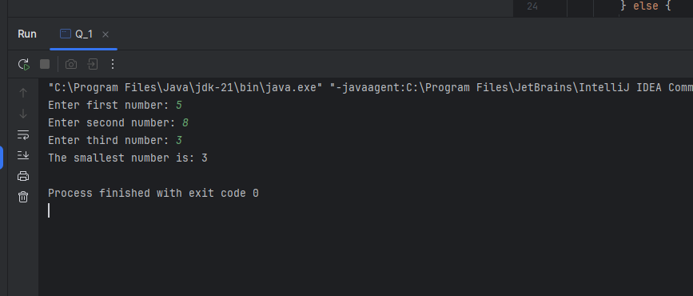

Q_02

package Q_02;  
  
import java.util.Scanner;  
  
public class Q_2 {  
 public static void main(String[] args) {  
 Scanner scanner = new Scanner(System.*in*);  
  
 System.*out*.println("0. Magenta");  
 System.*out*.println("1. Cyan");  
 System.*out*.println("2. Red");  
 System.*out*.println("3. Blue");  
 System.*out*.println("4. Green");  
 System.*out*.println("Select one color from the above list:");  
  
 int selection = scanner.nextInt();  
  
 switch (selection) {  
 case 0:  
 System.*out*.println("You selected Magenta");  
 break;  
 case 1:  
 System.*out*.println("You selected Cyan");  
 break;  
 case 2:  
 System.*out*.println("You selected Red");  
 break;  
 case 3:  
 System.*out*.println("You selected Blue");  
 break;  
 case 4:  
 System.*out*.println("You selected Green");  
 break;  
 default:  
 System.*out*.println("Invalid selection");  
 }  
 }  
  
}

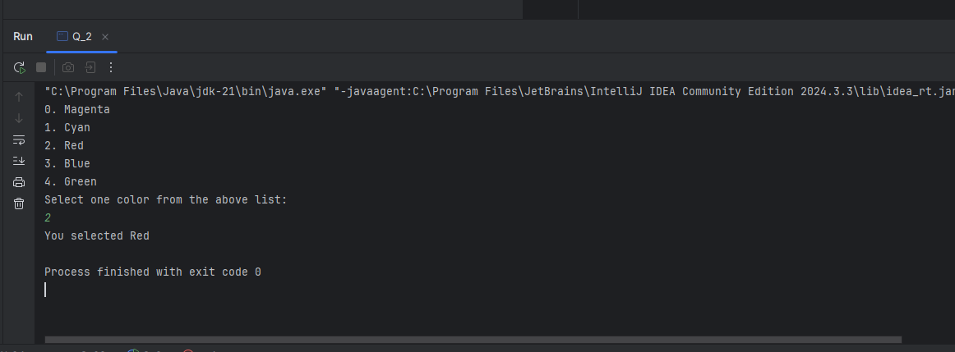

Q_3

package Q_03;  
import java.util.Scanner;  
public class Q_3 {  
 public static void main(String[] args) {  
 Scanner scanner = new Scanner(System.*in*);  
  
 System.*out*.print("Enter a power of 10: ");  
 int power = scanner.nextInt();  
  
 switch (power) {  
 case 6:  
 System.*out*.println("Million");  
 break;  
 case 9:  
 System.*out*.println("Billion");  
 break;  
 case 12:  
 System.*out*.println("Trillion");  
 break;  
 case 15:  
 System.*out*.println("Quadrillion");  
 break;  
 case 18:  
 System.*out*.println("Quintillion");  
 break;  
 case 21:  
 System.*out*.println("Sextillion");  
 break;  
 case 30:  
 System.*out*.println("Nonillion");  
 break;  
 case 100:  
 System.*out*.println("Googol");  
 break;  
 default:  
 System.*out*.println("No matching number word for this power of 10.");  
 }  
 }  
 }

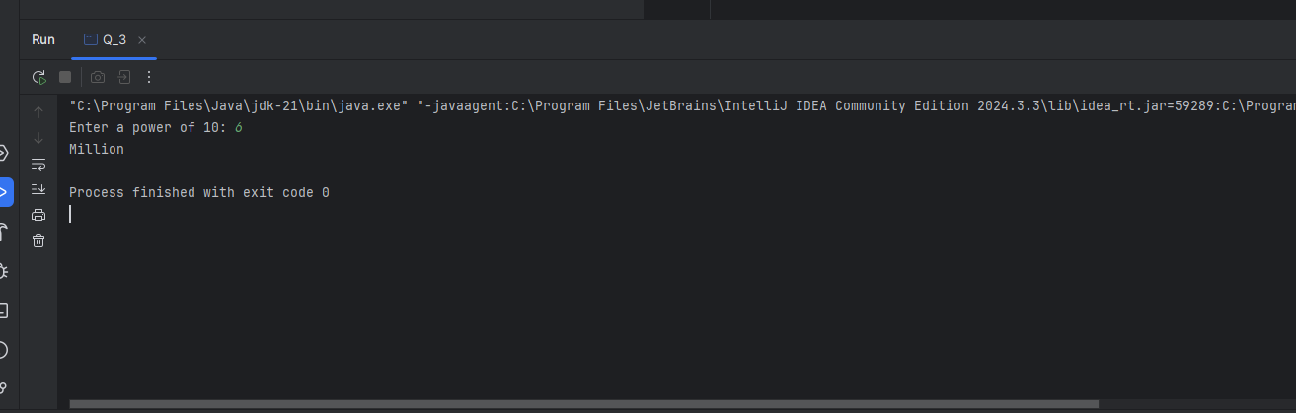

Q_4

package Q_04;  
import java.util.Scanner;  
public class Q_4 {  
 public static void main(String[] args) {  
 Scanner scanner = new Scanner(System.*in*);  
  
 System.*out*.print("Enter a year: ");  
 int year = scanner.nextInt();  
  
 if (year % 4 == 0) {  
 if (year % 100 == 0) {  
 if (year % 400 == 0) {  
 System.*out*.println("Leap Year");  
 } else {  
 System.*out*.println("Not a Leap Year");  
 }  
 } else {  
 System.*out*.println("Leap Year");  
 }  
 } else {  
 System.*out*.println("Not a Leap Year");  
 }  
 }  
 }

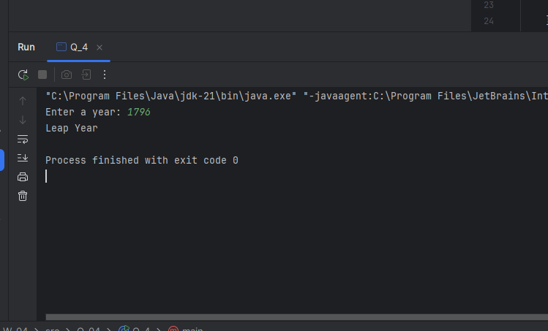

Q_5

package Q_05;  
import java.util.Scanner;  
public class Q_5 {  
 public static void main(String[] args) {  
 Scanner input = new Scanner(System.*in*);  
  
 double total = 0.0;  
  
 // here are the Entree Selection  
 System.*out*.println("Select an Entree:");  
 System.*out*.println("1. Tofu Burger - $3.49");  
 System.*out*.println("2. Cajun Chicken - $4.59");  
 System.*out*.println("3. Buffalo Wings - $3.99");  
 System.*out*.println("4. Rainbow Fillet - $2.99");  
 System.*out*.print("Enter your choice (1-4): ");  
 int entreeChoice = input.nextInt();  
  
 switch (entreeChoice) {  
 case 1:  
 System.*out*.println("You selected: Tofu Burger");  
 total += 3.49;  
 break;  
 case 2:  
 System.*out*.println("You selected: Cajun Chicken");  
 total += 4.59;  
 break;  
 case 3:  
 System.*out*.println("You selected: Buffalo Wings");  
 total += 3.99;  
 break;  
 case 4:  
 System.*out*.println("You selected: Rainbow Fillet");  
 total += 2.99;  
 break;  
 default:  
 System.*out*.println("Invalid choice. No entree selected.");  
 }  
  
 // here are the Side Dish Selection  
 System.*out*.println("\nSelect a Side Dish:");  
 System.*out*.println("1. Rice Cracker - $0.79");  
 System.*out*.println("2. No-Salt Fries - $0.69");  
 System.*out*.println("3. Zucchini - $1.09");  
 System.*out*.println("4. Brown Rice - $0.59");  
 System.*out*.print("Enter your choice (1-4): ");  
 int sideChoice = input.nextInt();  
  
 switch (sideChoice) {  
 case 1:  
 System.*out*.println("You selected: Rice Cracker");  
 total += 0.79;  
 break;  
 case 2:  
 System.*out*.println("You selected: No-Salt Fries");  
 total += 0.69;  
 break;  
 case 3:  
 System.*out*.println("You selected: Zucchini");  
 total += 1.09;  
 break;  
 case 4:  
 System.*out*.println("You selected: Brown Rice");  
 total += 0.59;  
 break;  
 default:  
 System.*out*.println("Invalid choice. No side dish selected.");  
 }  
  
 // here are Drink Selection  
 System.*out*.println("\nSelect a Drink:");  
 System.*out*.println("1. Cafe Mocha - $1.99");  
 System.*out*.println("2. Cafe Latte - $1.90");  
 System.*out*.println("3. Espresso - $2.49");  
 System.*out*.println("4. Oolong Tea - $0.99");  
 System.*out*.print("Enter your choice (1-4): ");  
 int drinkChoice = input.nextInt();  
  
 switch (drinkChoice) {  
 case 1:  
 System.*out*.println("You selected: Cafe Mocha");  
 total += 1.99;  
 break;  
 case 2:  
 System.*out*.println("You selected: Cafe Latte");  
 total += 1.90;  
 break;  
 case 3:  
 System.*out*.println("You selected: Espresso");  
 total += 2.49;  
 break;  
 case 4:  
 System.*out*.println("You selected: Oolong Tea");  
 total += 0.99;  
 break;  
 default:  
 System.*out*.println("Invalid choice. No drink selected.");  
 }  
  
 // here Display Total  
 System.*out*.printf("\nTotal amount: $%.2f\n", total);  
 }  
 }

