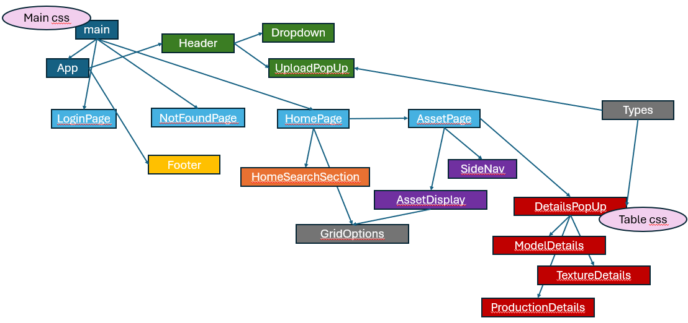

|  |  |
| --- | --- |
| main | Temp arrays, routing paths – home page, login page, asset page, error/not found page |
| app | Scrolls to top when new route/page chosen, sets the header, outlet page, and footer – or the loading page, load user profile/auth/loading page |
| LoginPage | User can login with account name/password in form or through Google oAuth button. Microsoft oAuth is not functional currently. |
| NotFoundPage | Routes to this page when a page is not found or there is an error somewhere |
| HomePage | Links to HomeSearchSection and passes arrays/header/data to GridOptions |
| HomeSearchSection | A large home page image with a search bar (not functional yet). The search icon button currently links to the assets page. |
| GridOptions | Displays arrays in a grid format. Changes right header content and click functions based on what is passed into it. When a grid item is clicked, it either routes to the assets page from the home page, or opens a details pop up from the assets page (ideally, this should be refactored to pass in that click element/ functionality) |
| AssetPage | Links to SideNav and AssetDisplay components (passing in temp arrays currently) |
| SideNav | Displays all projects or asset categories names in the left panel on the assets page. Hardcoded for now until we establish assets/search functionality then they will become links that pull all assets related to that project or asset category. |
| AssetDisplay | Fetches data from the database and passes the array of assets to GridOptions. There is also a ‘sort by’ dropdown and a few fields to display what was searched/how many results there are (just hardcoded for now) |
| DetailsPopUp | Pulls information from MongoDB based on the ID passed to it to display asset general details and details specific to the object type/format. The image previews can be cycled through by clicking on the left/right side of the image or a carousel circle below it. This is where the user can download an item. |
| ModelDetails | Displays table of model metadata in DetailsPopUp if applicable |
| TextureDetails | Displays table of texture metadata in DetailsPopUp if applicable |
| ProductionDetails | Displays table of production metadata in DetailsPopUp if applicable |
| Types | Interfaces – object requirements (or optional declaration) showing properties and data types for Session, SessionUser, User, Asset, Model, Texture, and Production |
| Header | Displays site title, search bar (not functional), upload button which triggers the UploadPopUp form, and the user profile image which offers dropdown options if clicked |
| Dropdown | Currently just has a sign out button |
| UploadPopUp | Form which adds object properties from input fields, adds additional fields to fill in based on the format of the main file uploaded (model, texture, or production type), fills in width/height of textures automatically, allows user to remove items from tags/ image previews that were added by accident, and validates information before submission (refactor later: split out validation and object format types) |
| Footer | Contains VARLab logo on bottom right |

Tailwind CSS used, React App,

Vite, MongoDB